LINCOLNSHIRE HISTORIC FARMSTEADS GUIDANCE

LOCAL DISTRICT SUMMARIES & PLANNING CONTEXT

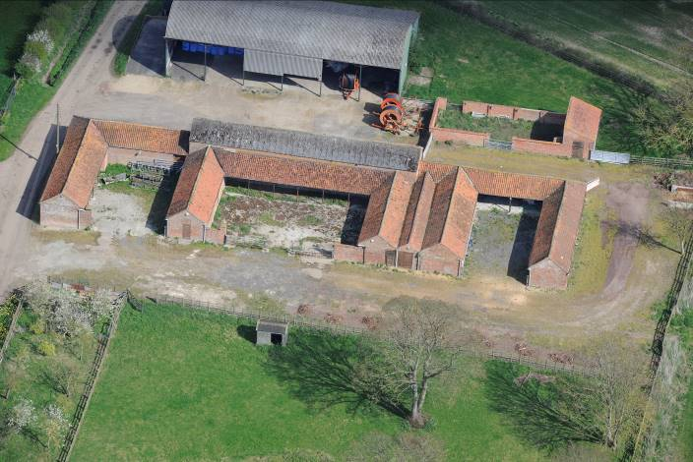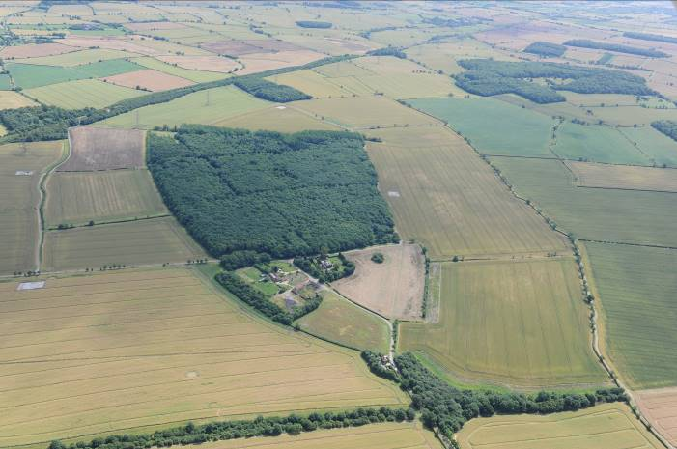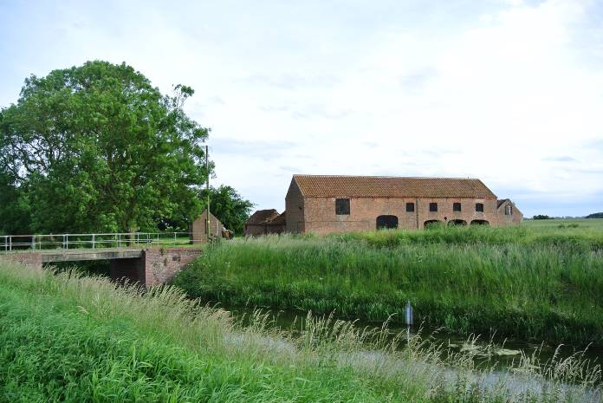
INTRODUCTION
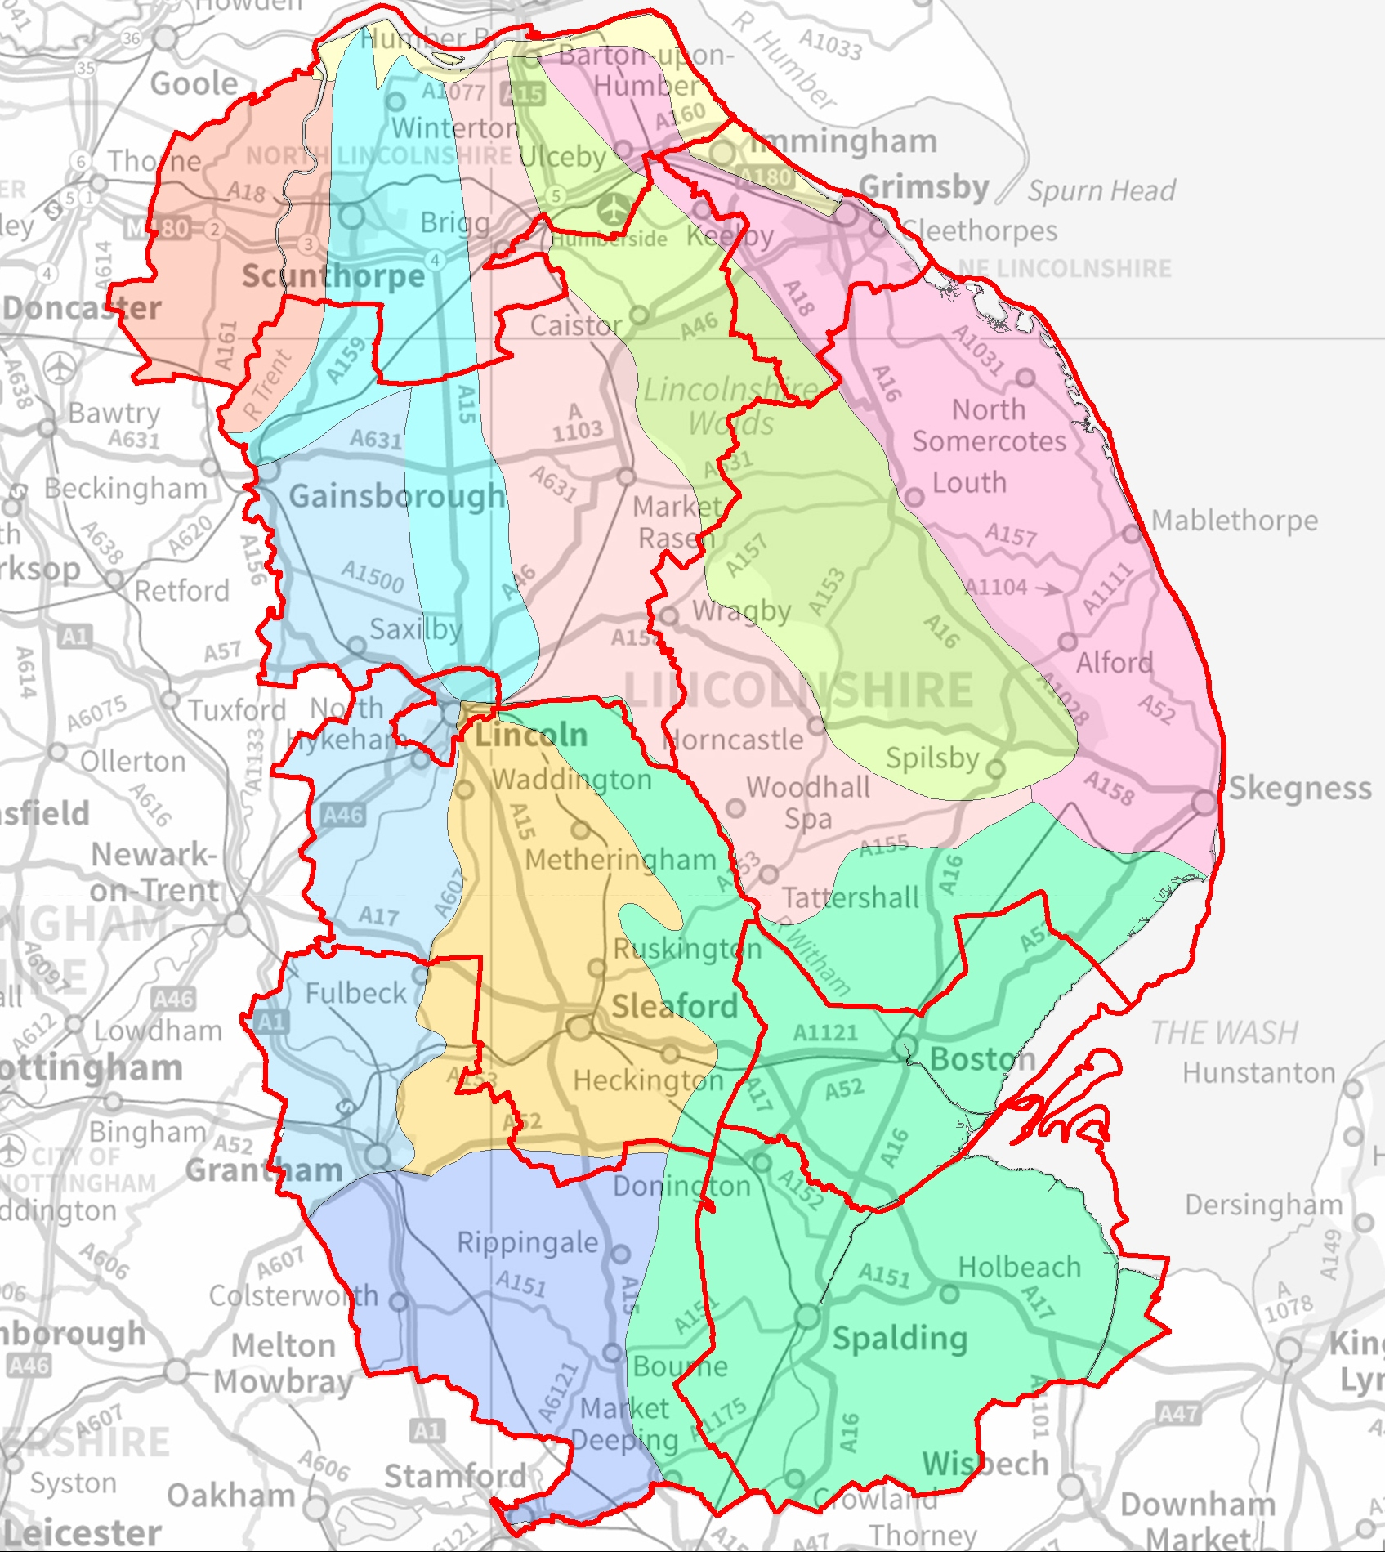
This quick reference guide is a useful starting point for understanding the character and significance of historic farmsteads in Lincolnshire, North Lincolnshire and North East Lincolnshire. It summaries some of the historic significance of historic farmsteads alongside some of the issues facing them, and the relevant national and local planning polices associated with their sustainable development.
CONTENTS
An initial discussion of planning policy and guidance is provided on Page 2.
A series of page summaries for each Local Authority Area provide the following information:
- Historic farmstead character – the type and character of farms that are typically found in the landscape, including their location, age, layout, function and material construction.
- Historic significance – a brief insight into important and standout elements of historic farmsteads in the landscape and the reasons behind their creation and adaptation
- Present and future issues – an overview of the current condition and use of historic farmsteads in the landscape and future trends for change
- Local Authority Planning Policies – a summary of the main local policies, relevant to the historic character of farms, that need to be considered when their development
National Character Areas – Lincolnshire is made up of 10 distinct landscape areas (see right). Useful reports about the farmstead and landscape character of each of these ‘National Character Areas’ have been produced and are available from relevant local authorities.

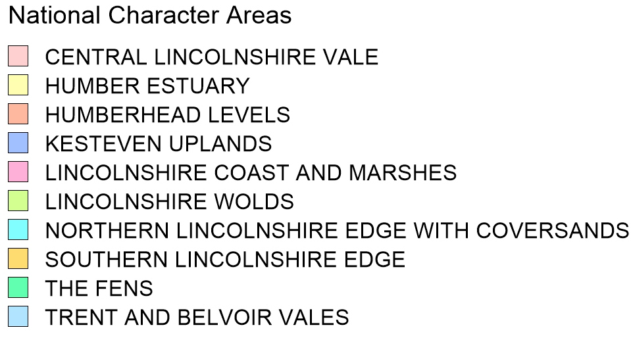
This document forms part of the Lincolnshire Historic Farmsteads Guidance, a series of guidance documents promoting the sustainable development of Lincolnshire’s historic farm buildings. The package of guidance includes:
1 | ASSESSMENT FRAMEWORK AND DESIGN GUIDANCE: A step-by-step approach for owners and applicants when considering the reuse of traditional farm buildings and the sustainable development of farmsteads. It is designed to help identify their historic character, significance and potential for change
2 | LINCOLNSHIRE FARMSTEAD CHARACTER STATEMENT: Detailed and illustrated guidance to help identify the historic character and significance of the county’s farmsteads in their historic and landscape context. It will also be of interest in the history of the county and its historic settlements and buildings
3 | FARMSTEAD AND LANDSCAPE STATEMENTS: Information about the historical development, landscape character and types of farmstead found within each of the natural England National Character Areas in Lincolnshire

POLICY & GUIDANCE
The Lincolnshire Wolds AONB
The Wolds is has a long association with cultivated farming practices, made possible by the area’s fertile chalk and drift soils. From the 18th century the Wolds became a more intensive landscape of rotation cropping. Once open areas of land were divided up into rectilinear fields bound by hedgerows and farms were remodelled or constructed afresh. The landscape of the Wolds and the many 18th and 19th century farms within it bear testament to the agricultural transformation, telling a story or changes in agricultural techniques and the increase mechanisation of the industry.

The area’s development is subject to an elevated level of management and this is recognised both in national and local policies and the in the Lincolnshire Wolds Management Plan 2013-2018.

The five key aims of the plan are to sustain and enhance:
- The Lincolnshire Wolds’ natural beauty and its landscape character
- Farming and land management in the Wolds as the primary activities in maintaining its character, landscape and biodiversity
- Recreational, tourism and interpretive activities and opportunities appropriate to the area
- The economic and social base of the Wolds including the development and diversification of enterprises appropriate to the area
- Partnerships between organisations, the local community, landowners and others with an interest in the Wolds.

For more information see: http://www.lincswolds.org.uk/
National and local planning policies stress the importance of retaining and enhancing local character and distinctiveness and conserving heritage assets in a manner appropriate to their significance, alongside putting them to viable uses consistent with their conservation.
The National Planning Policy Framework (NPPF)
The National Planning Policy Framework sets out the central government’s planning policies for England and defines how they are expected to be applied in the development process. It also sets out the expectations on local authorities. Policies that specifically engage with the sustainable development of historic farmsteads in the landscape include:
- 3. Supporting a prosperous rural economy – Paragraph 28
- 6. Delivering a wide choice of high quality homes - Paragraph 51, 55
- 7. Requiring good design - Paragraph 59, 60, 61, 64,
- 11. Conserving and enhancing the natural environment - Paragraph 109,115
- 12. Conserving and enhancing the historic environment - Paragraph 126, 128, 129, 131, 135, 139

Local Planning Policy
In accordance with the NPPF local planning policies set out a more localised and detailed planning framework for achieving sustainable development in their area. North and North East Lincolnshire are Unitary Authorities, providing all planning services in their areas. Lincolnshire has two levels of local government: The County Council provides planning services for waste and minerals and advice about archaeological and historic buildings, and 7 districts provide all other development and planning in their respective areas.

Local plan policies support the re-use of significant historic buildings, and include specific requirements and planning considerations, particularly in relation to residential additions and alterations, neighbourhood issues and taking account of biodiversity. Summaries of relevant local planning policies are provided within the summaries for each authority area

Further Guidance
National guidance is available to help achieve the sustainable development of historic farmsteads. The Conversion of Traditional Farm Buildings: A guide to good practice can be found at http://www.english-heritage.org.uk/publications/living-buildings-in-living-landscape/. Planning Aid (http://www.rtpi.org.uk/planning-aid/), the Planning Advisory Service (http://www.pas.gov.uk/) and the Planning Portal all offer free and useful advice and guidance about planning and development.
Permitted Development Rights - (under the General Permitted Development Order, amended May 2013 and April 2014)
Owners are also now able to convert some farm buildings to residential and commercial uses and to build new houses without planning permission. Prior Approval must be sought from the local planning authority to ensure that the change of use and any associated works do not create unacceptable impacts in respect of highways, transport and noise impacts, risks of contamination and flooding, location and siting of buildings, and the design and external appearance of buildings. Listed buildings and sites with scheduled ancient monuments are excluded, as is all Article 1(5) land which includes the Lincolnshire Wolds AONB and certain areas specified under the Wildlife and Countryside Act 1981. For further details see http://www.legislation.gov.uk/uksi/2014/564/pdfs/uksi_20140564_en.pdf and for explanatory memorandum http://www.legislation.gov.uk/uksi/2014/564/pdfs/uksiem_20140564_en.pdf
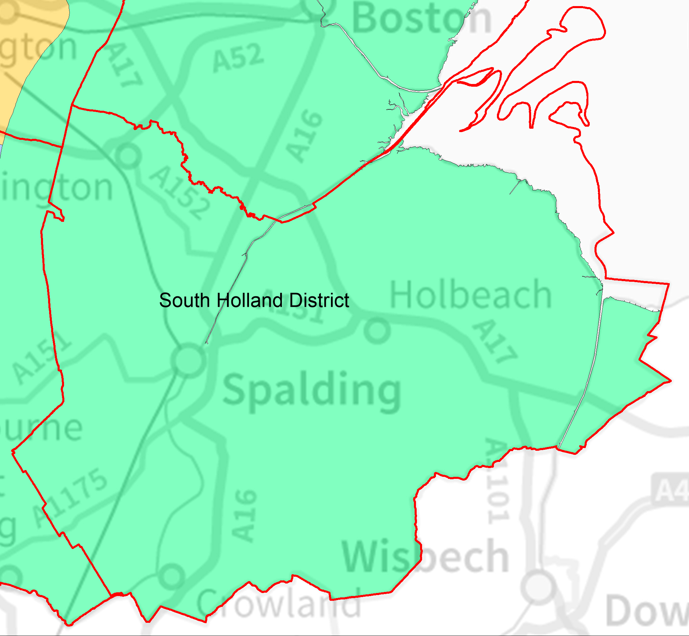
SOUTH HOLLAND FARMSTEAD CHARACTER SUMMARY
Renowned as having one of the most intensively arable and horticultural landscapes in the UK, South Holland is a distinctly rural low-lying agricultural district in which farmsteads are a defining feature. The historic character of the area is intrinsically tied to farming, which continues as the main industry, supporting a range of other related industries. Pressure on land is high and the industry is at the forefront of modern agricultural techniques and practices.
Historic Farmstead Character
The character of traditional farms in the area varies considerably, with a higher variety of plan types (e.g. linear or courtyard) than elsewhere in Lincolnshire. Older 18th century farmsteads are often located near to or within villages/hamlets that have since incorporated them through expansion. These older farms, often built to a common template/design, are built of a reddish/brown brick with pantile roofs to outbuildings and the same or slate to the house. Contemporary or later outbuildings have often been built loosely around a yard, although entire planned regular L or U shaped ranges are also seen as wholesale additions to earlier farms. 19th century farmhouses and outbuildings are constructed in a more reddish brick with slate or pantile roofs. Buff or yellow bricks are occasionally used on larger high status farmsteads. They are found in more isolated areas of the drained fen and marsh, and are more regular in plan form, with buildings typically arranged in planned fashion around a small courtyard.
Historic Significance
The diversity of farms in the district show over 200 years of change and adaptation of agricultural techniques, in particular those associated with intensive arable and horticulture. Dominated by 19th century farmsteads, but with significant numbers of 18th century farms, much of the rural building stock arose in response to the wholesale drainage and reclamation of land, particularly through the introduction of steam driven pumps. Farms with origins earlier than the 18th century are rare, and are often associated with high status medieval sites such as grange farms or manor houses. Farms are relatively small scale for the county. This and the number and diversity of farms reflect piecemeal investment into the area’s drainage and farming form both local people and ‘adventurers’ from the 16th century onwards.
Present and Future Issues
There is a high pressure on traditional farm buildings in the area, with many struggling to adapt to the needs of modern agricultural practices. Consequently only 27% of farms retain more than 50% of their historic form and 40% have been lost entirely or have had their traditional outbuildings completely replaced. Many farms have expanded beyond their original size, incorporating large modern functional buildings. Future advancements in agricultural techniques are likely to form the main pressure on the remaining historic building stock.
Relevant Local Planning Polices:
South Holland District Council is producing the South East Lincolnshire Local Plan in partnership with Boston Borough and Lincolnshire County Councils. Until the joint plan is adopted in August 2016 existing policies of the South Holland Local Plan will continue to apply. Those policies specifically relevant to the sustainable development of historic farmsteads include:
- SG1 General Sustainable Development  - SG14 Design and Layout of New Development  - SG18 Landscaping of New Development  - HS16 Conversion of Redundant Rural Buildings to Residential Use | - HS17 Replacement Dwellings in the Countryside  - EN4 Development Affecting Listed Buildings  - EN12 Scheduled Monuments  - Proposals for the re-use of rural buildings - Supplementary Planning Guidance

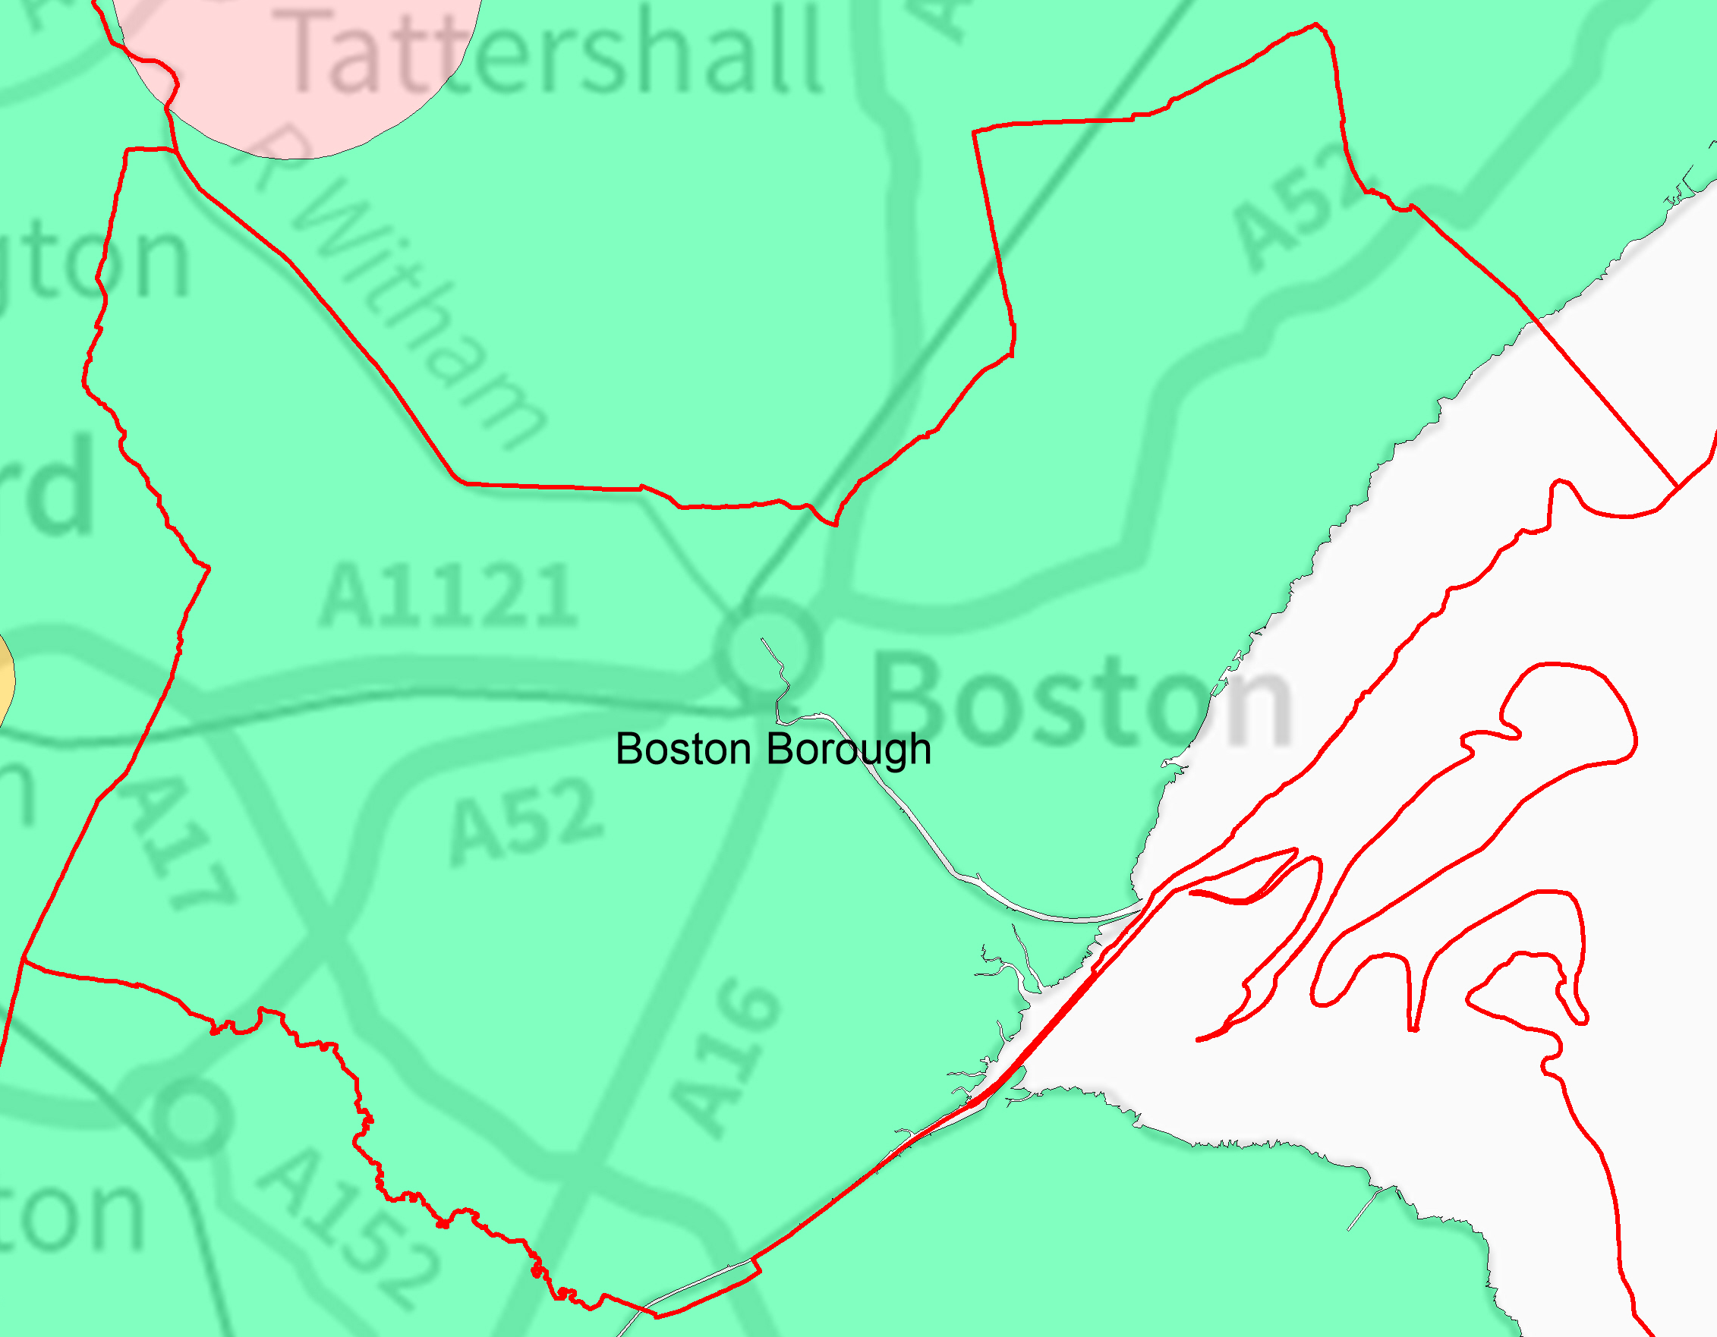
BOSTON FARMSTEAD CHARACTER SUMMARY
Rivalling London as England’s main port in the 16th century the prominent architecture of Boston is testament to the agricultural productivity of its hinterland. Farming is the dominant industry in the district and, using modern agricultural techniques, land is intensively farmed for arable and horticultural use. Land around Boston and nearby villages is subject to development pressures.
Historic Farmstead Character
Older 18th century farmsteads are often located along old drove roads and routes across the fen as well as near to or within villages/hamlets. These older farms, often built to a common template/design, are of a reddish/brown brick with pantile roofs to outbuildings and the same or slate to the house. Contemporary or later outbuildings are often built loosely around small yards, although entire planned L or U shaped ranges have been added. 19th century farmhouses and outbuildings are constructed in a more reddish brick with slate or pantile roofs. Buff or yellow bricks are occasionally used on larger 19th century high-status farms. They are found in more isolated areas of the drained fen and marsh, with buildings typically arranged in planned fashion around a small yard.
Historic Significance
The district has a wide diversity of farms and agricultural buildings reflecting the radical changes and adaptations in the techniques and technology of the last 200 years. Boston’s medieval prosperity was supported by the export of locally produced wool. Farms with origins earlier than the 18th century are rare, and are often associated with medieval wool farming. Today the landscape is dominated by 19th century farmsteads, but with significant numbers of 18th century farms. Much of the surviving rural building stock arose in response to the wholesale drainage and reclamation of land, particularly through the introduction of steam driven pumps. Farms are relatively small scale for the county. This and the number and diversity of farms reflect piecemeal investment into the area’s drainage and farming form both local people and ‘adventurers’ from the 16th century onwards.
Present and Future Issues
There is a high pressure on traditional farm buildings in the area, with many struggling to adapt to the needs of modern agricultural practices. Only 28% of farms retain more than 50% of their historic form and 38% have been lost entirely or have had their traditional outbuildings completely replaced. Many farms have expanded beyond their original size, incorporating large modern functional buildings. Future advancements in agricultural techniques alongside the expansion of Boston and surrounding centres are likely to form the main pressure on the remaining historic building stock.
Relevant Local Planning Polices:
Boston Borough Council is producing the South East Lincolnshire Local Plan in partnership with South Holland District and Lincolnshire County Councils. Until the joint plan is adopted in August 2016 saved polices from the Boston Local Plan will continue to apply alongside polices within the Boston Borough Interim Plan. Policies specifically relevant to the sustainable development of historic farmsteads include:
Boston Borough Interim Plan  - G1 General Considerations  - G2 Agricultural Land  - H8 Quality Of Housing Development  - H14 Extensions and Alterations  - CO1 Development In the Countryside  - CO2-3 Re-Use of Buildings in the Countryside for Employment/ Residential | - CO7 Replacement Dwellings  - CO8 Farm Diversification  - E4 Local Distinctiveness  - E5 Historic Landscapes  - E6 Determining Archaeological Significance | Local Plan saved policies  - G1 Amenity  - H3 Quality of Housing Development  - H10 Extensions and Alterations  - CO1 Development in the countryside  - Re-Use of Buildings in the Countryside for Employment/ Residential Use  - CO9 Agricultural Buildings  - CO12 Replacement Dwellings

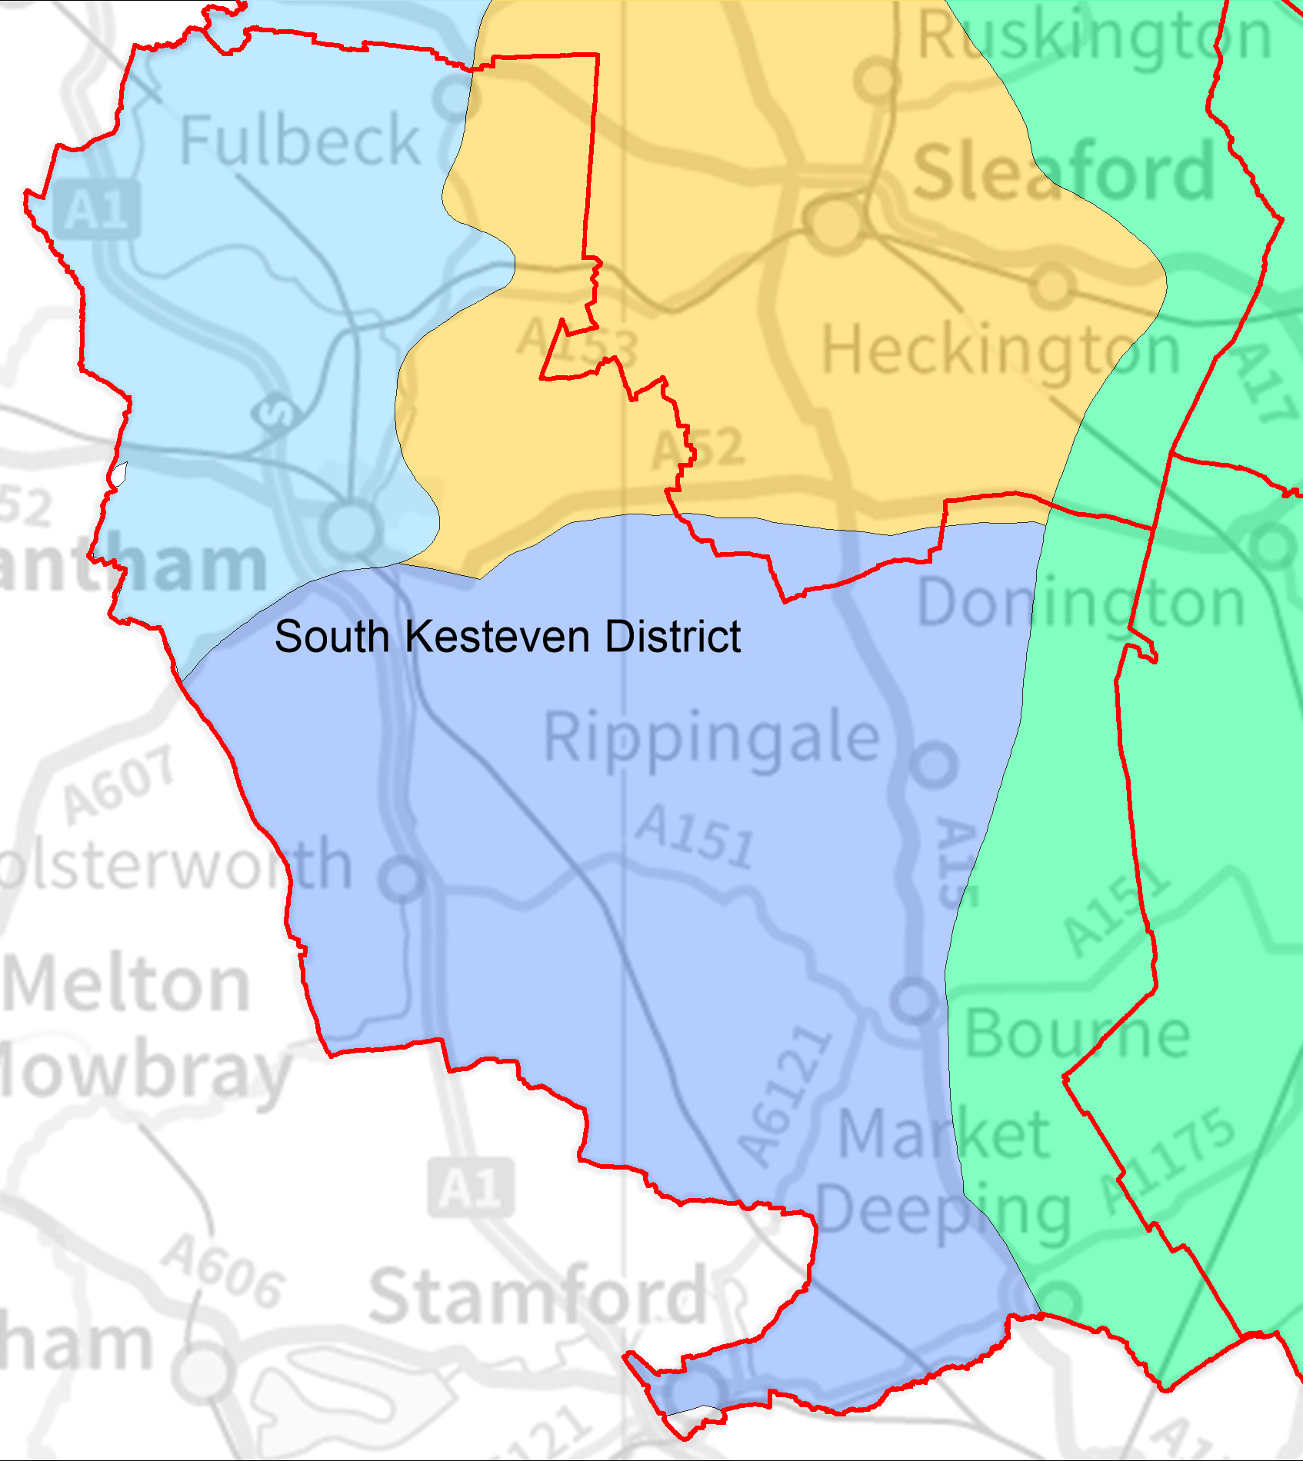
SOUTH KESTEVEN FARMSTEAD CHARACTER SUMMARY
The active and productive landscape of rolling uplands, broad heaths in the west and fenland in the east gives rise to a varied farming landscape including upland pasture and intensive Fenland arable cultivation. Estates have a strong influence on land management and the district is well-wooded, with large areas of ancient woodland as well as 19th century plantations.
Historic Farmstead Character
South Kesteven has many large historic estates with extensive holdings of land and farm buildings. Their common design and character are a key element of the area’s distinctive character. The prosperity of the rural economy from the 17th century is reflected in the rural architecture. There is a mixture of farmstead types across the area. Throughout the area earlier farms are typically found in villages and are often built loosely around courtyards with their outbuildings. 19th century farms are typically located in isolated areas and have more regular planned forms. In upland areas these are likely to be larger than the county average. Locally available limestone is the dominant building material in upland areas, whereas brick and pantile are increasingly found in lowland areas. Mixtures of materials mark the transition between uplands and lowlands.
Historic Significance
Due to its high survival of particularly old farm buildings, South Kesteven has by far the highest proportion of listed farm buildings of all local authorities in Lincolnshire. 9.5% of listed farm buildings in the area are pre-19th century in origin. Farmhouses and buildings of the 17th and 18th century are likely to be associated with historic sheep-rearing farms. Many are well preserved and there is potential for older buildings to remain at the core of larger and later complexes. By contrast, 19th century farms typically reflect large-scale industrial arable farming in both upland and lowland areas, made possible by investment and improvement of the thin soils of the heath and the drainage of the fens and valleys. These include examples of planned model farms constructed to demonstrate the wealth and technical proficiency of landowners in the area.
Present and Future Issues
Of all Lincolnshire’s local authorities, South Kesteven currently retains the highest proportion of extant or little altered farm buildings with just over 60% retaining half or more of their traditional buildings and 76% retaining at least some of their historic character. However, there remain considerable pressures on farm buildings in the area, including the proximity to commuter centres and transport routes, and the resulting high demand for residential conversions.

Relevant Local Planning Polices:
South Kesteven District Council adopted its Core Strategy in 2010. Those policies specifically relevant to the sustainable development of historic farmsteads include:
- SP1 Spatial Strategy
- EN1 Protection and Enhancement of the Character of the District
- EN4 Sustainable Construction And Design
- H1 Residential Development
- E1 Employment Development
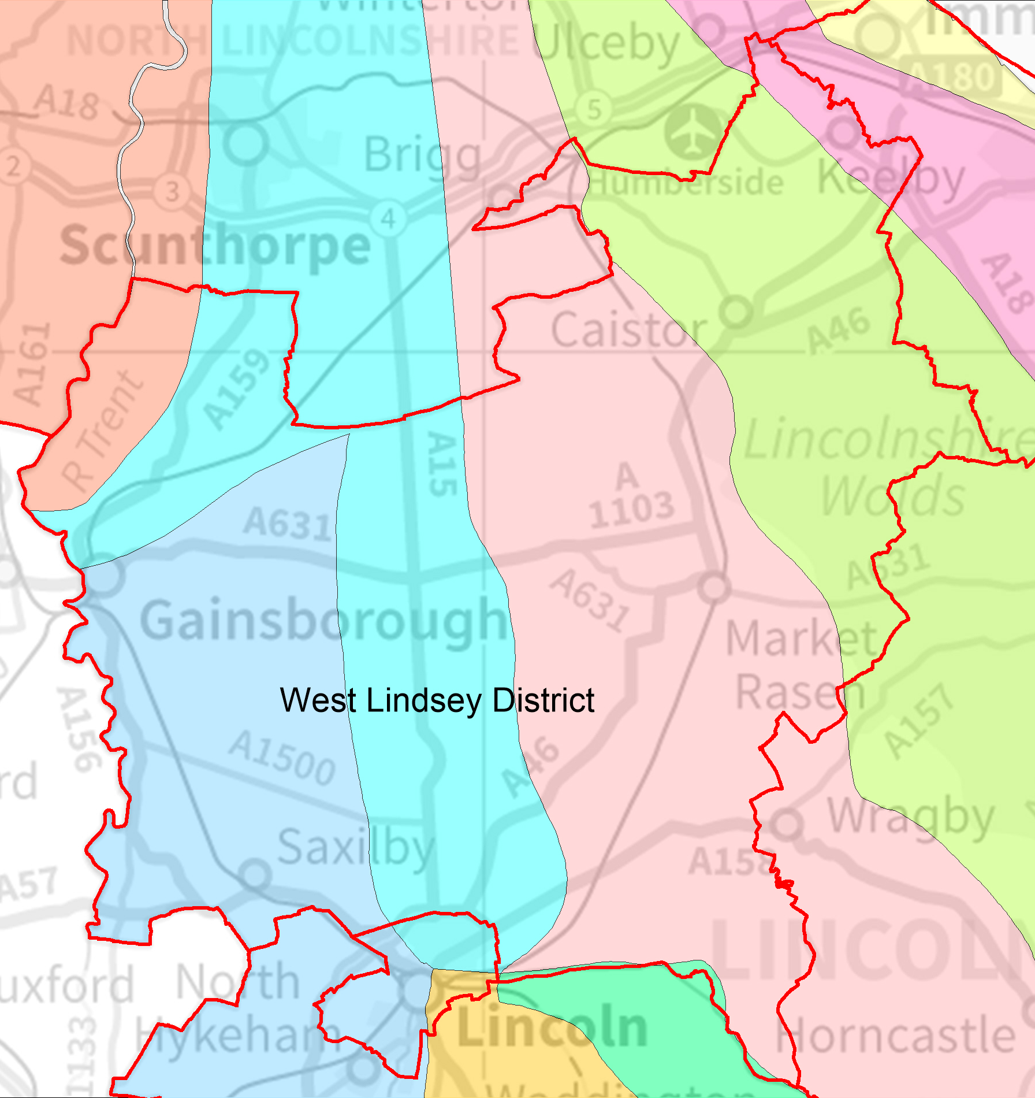
WEST LINDSEY FARMSTEAD CHARACTER SUMMARY
The large district covers a wide variety of landscapes, from the uplands of the Wolds and the heath to low-lying drained wetlands around the Trent and towards the coast. The farming landscape is predominantly arable, although there are several large cattle and sheep farms especially in The Wolds. The area’s economy is strongly linked to agriculture, but is experiencing diversification both through tourism and its proximity to large settlements and transport infrastructure.
Historic Farmstead Character
Throughout the area, earlier farmsteads of 18th century date are often found in and around villages, reflecting historic settlement patterns dating back to the Saxon period. These farms are typically arranged loosely around courtyards. Later farmsteads are more likely to be found in isolated locations away from settlement centres, such as drained lowlands or upland heaths. These are generally more regular and planned in form. Building materials generally reflect the local availability of materials. In the lowlands red brick and pantile roofs are common. In upland landscapes farms are often stone built, although brick is often used alongside for detailed construction. Slate roofs are common throughout the area on farm buildings of the later 19th century.
Historic Significance

Relevant Local Planning Polices:
West Lindsey District Council is producing the Central Lincolnshire Local Plan in partnership with the City of Lincoln, North Kesteven District and Lincolnshire County Councils. Until the joint plan is adopted in 2016 saved polices from the West Lindsey Local Plan will continue to apply. Those policies specifically relevant to the sustainable development of historic farmsteads include:
- STRAT 1 Development Requiring Planning Permission  - RES 1 Housing Layout and Design  - RES 8 Replacement Dwellings in the Open Countryside  - RES 9 Conversion and Re-Use of Buildings for a Residential Use in the Open Countryside  - RES 12 Extensions to Dwellings in the Open Countryside | - STRAT 12 Development in the Open Countryside  - ECON 4 Farm Diversification  - NBE 7 Ancient Monuments, Sites and Remains of Archaeological Importance  - NBE 9 The Lincolnshire Wolds - Area of Outstanding Natural Beauty  - NBE 10 Protection of Landscape Character in Development Proposals  - NBE 20 Development on the Edge of Settlements

Present and Future Issues
Historic farmsteads in West Lindsey are subject to many pressures, including the ongoing conversion of pasture to arable cultivation and the consolidation of farms into larger units. Both of these factors have the potential to cause traditional buildings to become obsolete and disused. 50% of traditional farmsteads in the area retain over half of their historic form, however 28% have either been reduced to a single farmhouse or have been completely demolished.

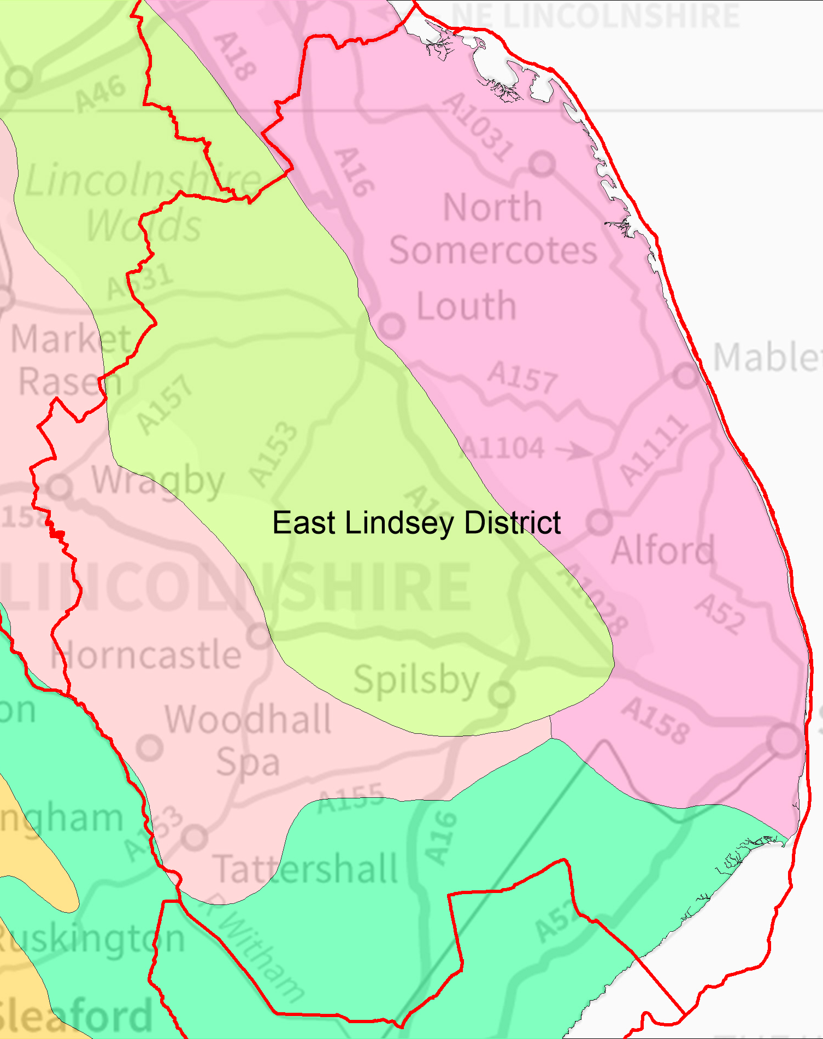
EAST LINDSEY FARMSTEAD CHARACTER SUMMARY
With some of the most productive farmland in Lincolnshire, the landscape of East Lindsey is incredibly diverse. Lowland areas of reclaimed marsh and fen along the coast and adjacent to the Wash are complemented by the rolling hills and vales of the Wolds. The farmsteads of the area are equally diverse, reflecting their surroundings and the prevailing methods of farming.
Historic Farmstead Character
Much of the area comprises former wetland, where villages are rare and settlement is scattered. In these areas farm buildings are typically found both in isolated locations and interspersed with domestic settlement along east-west aligned drove roads. They comprise a diverse mixture of plan forms depending on their age and are generally quite small by county standards. They are typically built in red brick and pantile, with later examples in buff brick and slate. In the uplands of the Wolds older farms, generally built loosely around courtyards, are often found in and around historic villages. By contrast, more recent farmsteads of the 19th century are more likely to be found in isolated hilltop locations and are typically planned and regular in form. Upland farms are also more likely to be large scale. Building materials include local limestone, brick and combinations of the two.
Historic Significance
Early farm buildings throughout the area may have origins in medieval sheep farming, both in upland pasture and on the wet grazing of the lowlands. Farmsteads of the mid to late 19th century were often purpose built for the scientific farming practices of the industrial revolution. Some of these were built in a single phase, although many older farmsteads were adapted to new techniques by conversion and by the extensive addition of new buildings. East Lindsey includes several large estates, especially on the Wolds, where farming practice has been directed and unified for 200 years or more.
Present and Future Issues
Traditional farmsteads in East Lindsey are increasingly under pressure from changing agricultural practices on the one hand and development pressures related to nearby settlements and industry on the other. At present, over 36% of farmsteads in the authority have been reduced to only a farmhouse or have been completely lost. However, 44% retain more than half of their traditional buildings, providing opportunities for retaining and improving their contribution to the landscape. The proximity of the Lincolnshire Wolds AONB and the resort towns of Skegness and Mablethorpe provides a potential market for holiday lets or residential conversion, with the potential to secure an ongoing future for some farm buildings.

Relevant Local Planning Polices:
East Lindsey District Council is currently preparing a new Local Plan. Until this is adopted in 2015/16 saved polices from the East Lindsey Local Plan will continue to apply. Those policies specifically relevant to the sustainable development of historic farmsteads include:
A5 Quality and Design of Development  ENV24 Protection of Open Spaces and Frontages  C5 Historic Buildings  C7 Historic Landscapes  C11 Lincolnshire Wolds Area of Outstanding Natural Beauty and AGLV  C12 Protection of Buildings in the AONB and AGLV  DC5 Replacement Dwellings In The Countryside | DC6 Re-Use Of Old Buildings In The Countryside  DC7 Conversion of Farm Buildings into Houses  T11 Conversion to Provide Holiday Accommodation in the Countryside  H5 Housing in Hamlets and Other Small Settlements  H12 Design of New Housing  Supplementary Planning Guidance : Agricultural Occupancy

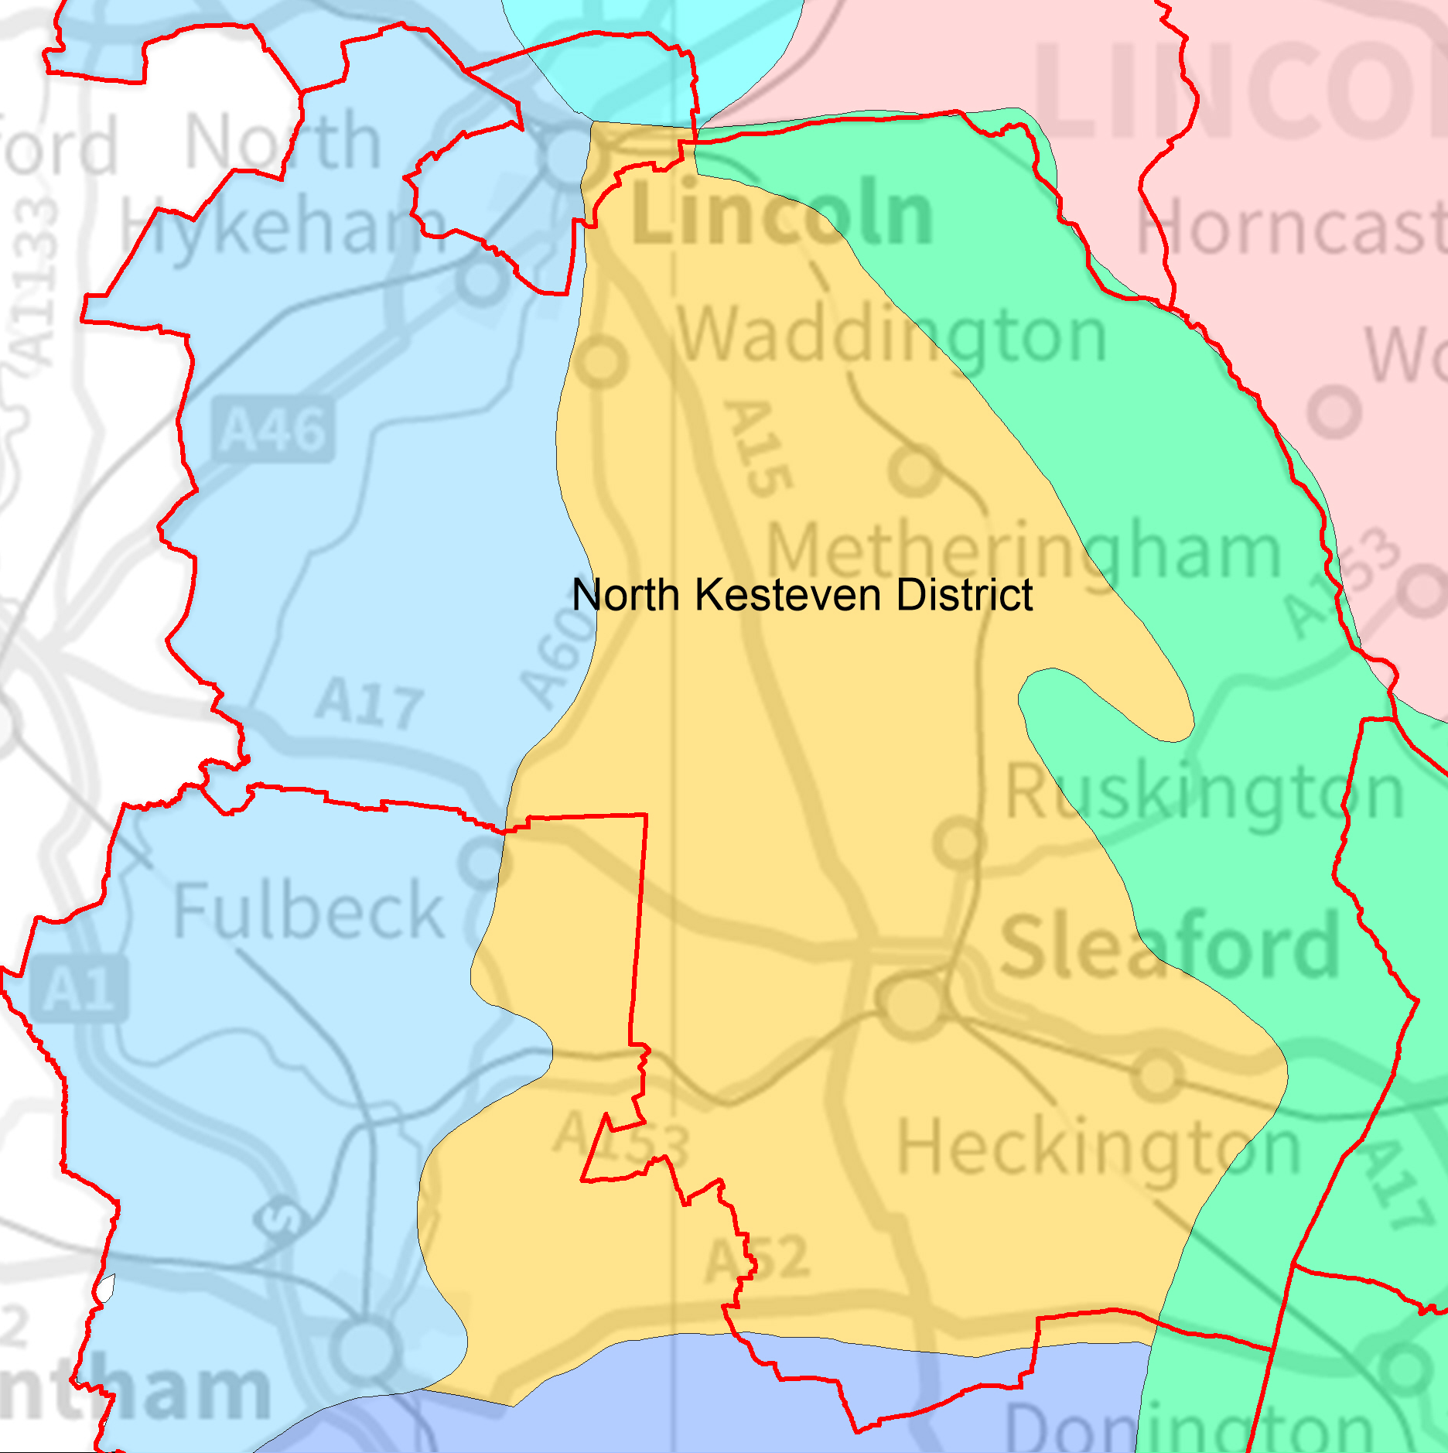
NORTH KESTEVEN FARMSTEAD CHARACTER SUMMARY
The landscape of North Kesteven is broadly characterised by open, level countryside with small areas of scattered woodland. The area is highly productive, with intensive arable cultivation on the fens and mixed arable and pastoral farming in upland heath areas.
Historic Farmstead Character
The prevailing historic character of farming in the area is arable, although upland farmsteads may have origins in earlier sheep farming by manorial estates or religious orders. Upland farms are more likely to be large and planned in character, while those in the fens are typically smaller and loosely built around yards. Farm buildings are constructed of a variety of materials, depending on local availability. In upland areas, stone is common, including the locally-sourced Ancaster limestone. Brick and pantile is more common in the Fens and the Trent Vale, although some larger and more important farmhouses in these areas are of stone construction.
Historic Significance
Before the 19th century much of the area was used for sheep farming, both on the heath and in the fens, and earlier farm buildings may reflect this use. Although most farmsteads in the area are of 19th century date, North Kesteven has a relatively higher proportion of 17th and 18th century farmsteads than the county as a whole. The area around the Witham Fens is known for the large and powerful monasteries that controlled crossing points and causeways. “Grange” farms associated with these monasteries were a common feature of the area, and some of these farms persist to the present day. Later arable farmsteads of the 19th century often include a range of associated buildings such as cartsheds for transport, and granaries and large barns for processing and storage. These represent the majority of farmsteads in the area.
Present and Future Issues
Rural buildings in North Kesteven are subject to ongoing issues of redundancy and dereliction due to mechanisation and amalgamation of farm holdings. The possible direction of farming in the area is indicated by recent plans for the creation of so-called “super dairies” on the Heath, which will require modern sheds and infrastructure rather than traditional buildings. At present, 47% of the district’s farmsteads retain over half of their traditional buildings, with associated opportunities for conversion and re-use. Conversely, over 26% of farmsteads have been completely lost, amply demonstrating the fragility of the built resource.
Relevant Local Planning Polices:
North Kesteven District Council is producing the Central Lincolnshire Local Plan in partnership with the City of Lincoln, West Lindsey District and Lincolnshire County Councils. Until the joint plan is adopted in 2016 saved polices from the North Kesteven Local Plan will continue to apply. Those policies specifically relevant to the sustainable development of historic farmsteads include:
- C2 Development in the countryside  - C3 Agricultural land quality  - C18 Design  - C19 Landscaping  - H1 Housing  - H2 Design and layout of residential development  - E4 Employment development in the countryside  - E5 Conversion of buildings in the countryside to non-residential use | - E6 Farm Diversification  - DC1 Agricultural or forestry development  - DC2 Agricultural and forestry workers’ dwellings and dwellings associated with rural based enterprises  - DC4 New housing in the countryside  - DC5 Replacement dwellings in the countryside  - DC6 Conversion of buildings in the countryside to residential use

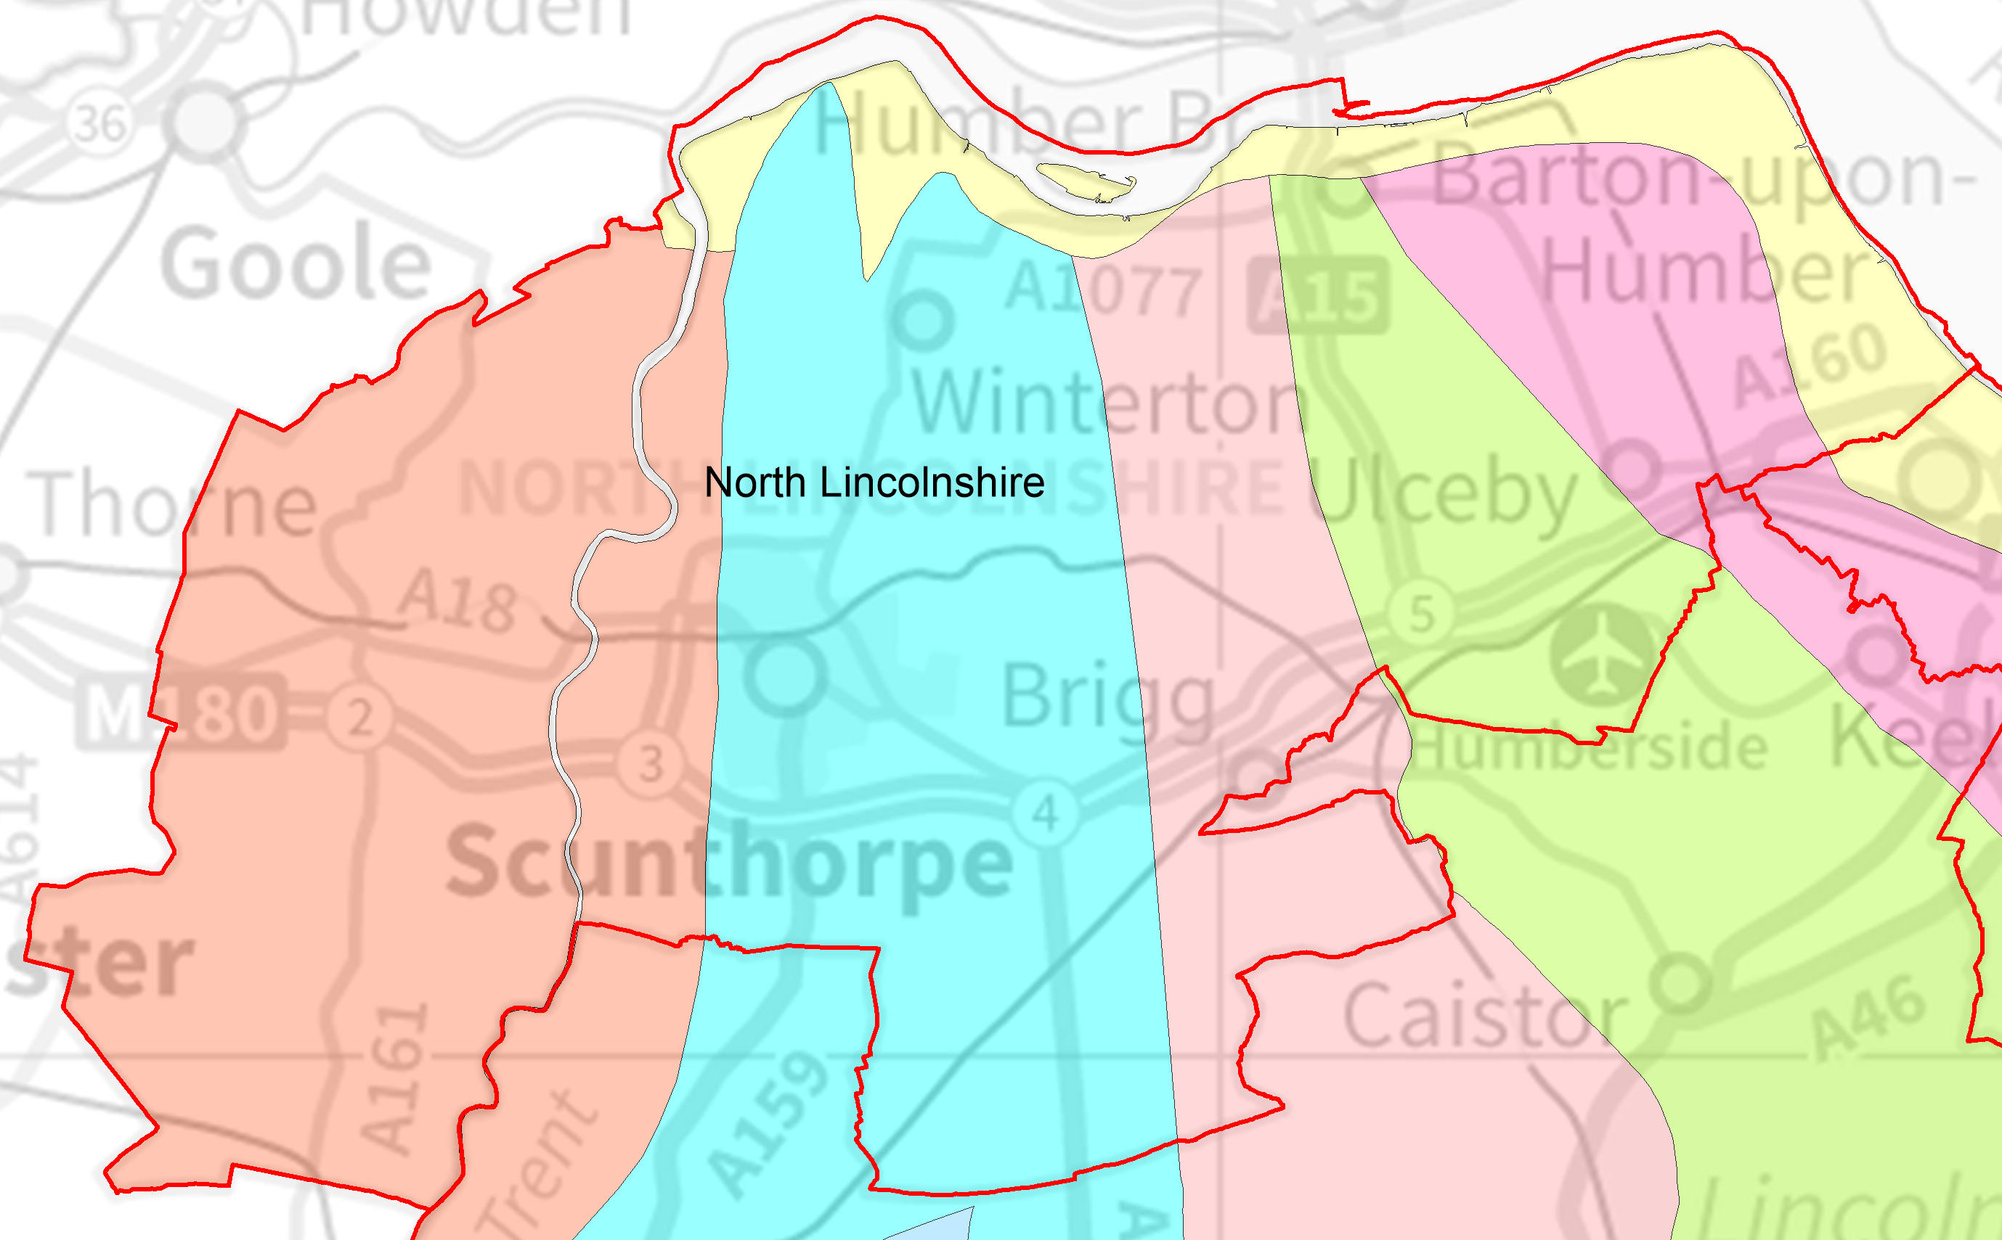
NORTH LINCOLNSHIRE FARMSTEAD CHARACTER SUMMARY
North Lincolnshire includes the historic landscape of open fields and turbaries on the Isle of Axholme, as well as large areas of reclaimed marshland and rolling upland heath. There are areas of rich arable land around the Humberhead levels and the Trent and Humber Rivers to rival any in the country.

Historic Farmstead Character
19th century planned farmsteads, typified by connected ranges enclosing large courtyards for livestock management, are found across North Lincolnshire, and almost exclusively so in areas of reclaimed marsh, the cliff top heath and in the carrland of the central vale. Older farmsteads are seen to a much lesser extent, except in villages around the Isle of Axholme and along the spring-line of the Wolds where they are often tightly packed. These farms have a more organic character with buildings of different ages, scales and materials. Farm buildings are typically built in red brick with pantile roofs, but there are many examples of stone-built farms in upland areas.
Historic Significance
Relevant National Character Areas in North Lincolnshire are shown in colours – see front page for key
Planned 19th century courtyard farms with combination barns, cow-sheds and cartsheds, are notably large for the historic county. They are indicative of industrial scale arable farming around the time of the Agricultural and Industrial Revolutions. 18th century farms found in villages on the Northern Cliff, in the Wolds and the Humberhead Levels are fewer in number. With an older threshing barn at their core they, through extensions and adaptation, illustrate smaller scale and earlier approaches to agriculture as well as over 150 years of changes in farming practice. Medieval buildings are exceptionally rare, and the area is notable for its 18th and 19th horse engine houses.
Present and Future Issues
Relevant Local Planning Polices
North Lincolnshire’s Core Strategy adopted in 2011 sets the strategic direction for the authority. Relevant strategic polices include CS1: Spatial Strategy for North Lincolnshire (Part c), CS5: Delivering Quality Design in North Lincolnshire and CS6: Historic Environment. Until replaced, saved policies from the North Lincolnshire Local Plan (2003) will continue to apply. Those policies specifically relevant to the sustainable development of historic farmsteads include:
- H8 - Housing Design and Housing Mix  - RD2 Development in the Open Countryside  - RD6 Re-Use and/or Adaptation of Rural Buildings for Industrial and Commercial Uses in the Open Countryside  - RD9 Re-Use and/or Adaptation Of Rural Buildings For Residential Use In The Open Countryside  - RD10 Replacement, Alteration And Extensions to Dwellings in the Open Countryside  - HE8 Ancient Monuments  - HE9 Archaeological Excavation | - LC7 Landscape Protection  - LC12 Protection Of Trees, Woodland And Hedgerows  - LC13 Parks, Gardens and Landscapes Of Special Historic Interest  - LC14 Area of Special Historic Landscape Interest  - LC15 Landscape Enhancement  - LC16 Lincoln Edge Scarp Slope Landscape Enhancement Area  - Landscape Character Assessment & Guidelines Supplementary Planning Guidance  - Countryside Design Summary Supplementary Planning Guidance  - Design in the Countryside Supplementary Planning Guidance

44% of farmsteads retain over 50% of their historic form, and around 40% retain only the farmhouse or have been lost entirely. Whilst demonstrating that traditional farms contribute strongly to the area’s distinctive character the figures also show the fragile and degraded nature of the resource. Conversion of farms to residential or domestic use will need to reinforce their historic character in order to ensure that they persist as distinctive features within the area’s rural landscape. Retaining and securing sustainable uses of outbuildings in particular, whether continuing in agricultural use or through conversion, is a key issue.
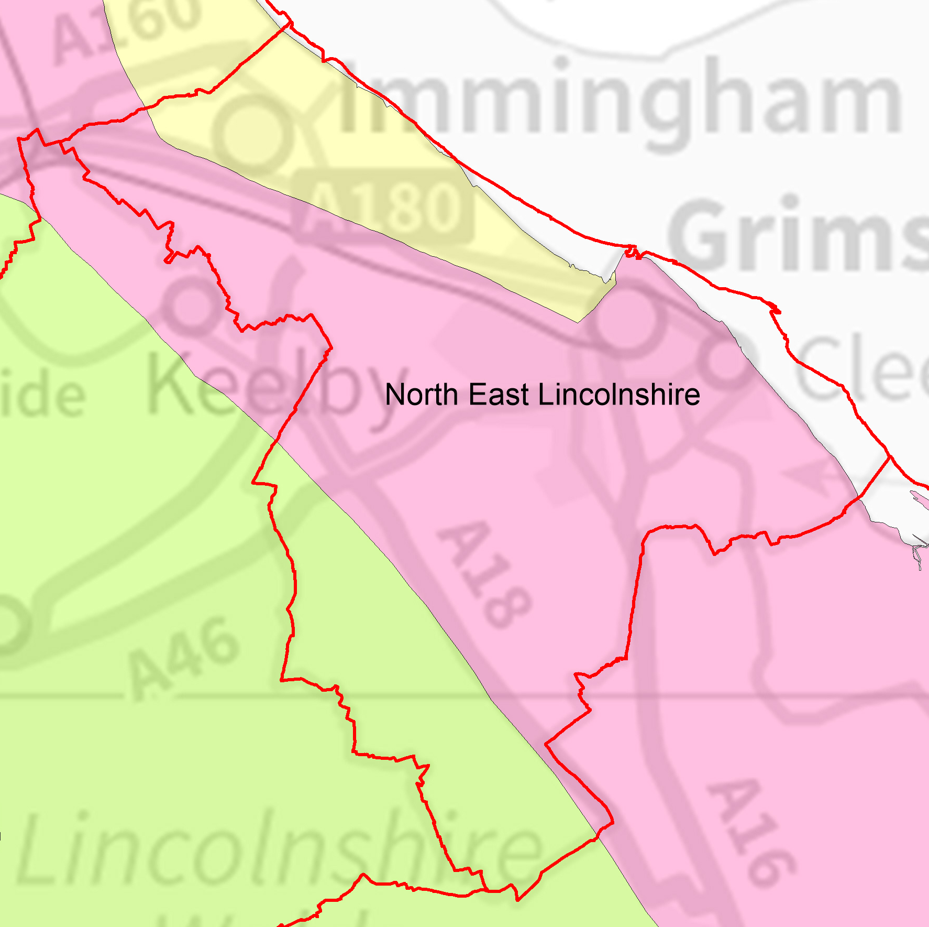
NORTH-EAST LINCOLNSHIRE FARMSTEAD CHARACTER SUMMARY
North East Lincolnshire Unitary Authority is situated on the interface between the North Sea coast of Lincolnshire and the Humber estuary. The area includes rural settlements in the Wolds Area of Outstanding Natural Beauty and areas of prime arable land on the reclaimed marshes by the coast. Much of the area is urban, and 20th century expansion has enveloped some formerly rural farm buildings.
Historic Farmstead Character
Farmsteads in coastal areas are typically isolated and set among arable fields in drained marshland, and typically have regular plan forms. Further inland, historic farmsteads cluster around village centres, especially in the Wolds and in villages along the main roads through reclaimed marsh, and these are typically more loosely built around irregularly planned yards. Regular courtyards are also a typical feature of estate farms throughout the area. Farmsteads are typically larger in this character area than the county average and built of locally-made red brick and pantiles. Larger upland farmsteads may incorporate limestone or ironstone in their construction.
Historic Significance
Most farmsteads are isolated and date from the 19th century planned enclosure of the marshes and the high wold. These large arable farms typically have regular yards for managing livestock, and large combination barns and cartshed ranges for storing and transporting grain. More irregular farmsteads may be indicative of earlier pastoral farming dating from the 18th century or earlier, and are typically found in village centres in the Wolds. It is also possible that earlier farm buildings have been enveloped within later developments of farmsteads into regular forms, and may not be immediately apparent.
Present and Future Issues
Rural buildings and landscapes in North-East Lincolnshire are increasingly pressurised by the expansion of the urban area of Grimsby and the extensive industrial areas around Immingham and the coast. In particular, traditional farm buildings may be affected by the loss of their setting or by redundancy and demolition. With over 52% of traditional farmsteads having been reduced to a farmhouse or having been completely demolished, the remaining resource is of greater significance than ever. Approximately 35% of farmsteads in the area retain over half of their traditional buildings, providing potential for conversion to other uses, especially given the proximity of major employment and cultural centres such as Immingham and Grimsby.
Relevant Local Planning Polices:
North East Lincolnshire Council is in the early stages of producing a new Local Plan. Until the new plan is adopted in 2017 saved polices from the 2003 Local Plan will continue to apply. Those policies specifically relevant to the sustainable development of historic farmsteads include:
- GEN1 Development Areas  - GEN2 Development in the Open Countryside  - GEN3 Development and Landscaping  - E19 Farm Diversification  - H9 Replacement or Restoration of Dwellings in the Countryside  - BH9 Traditional Farm Buildings | - BH11 Retention of Important Archaeological Remains  - BH12 Evaluation of Archaeological Remains  - NH6 Protection of Hedgerows  - NH8 Area of Outstanding Natural Beauty  - NH9 Landscape Areas of Strategic Importance  - Landscape Design Supplementary Planning Guidance

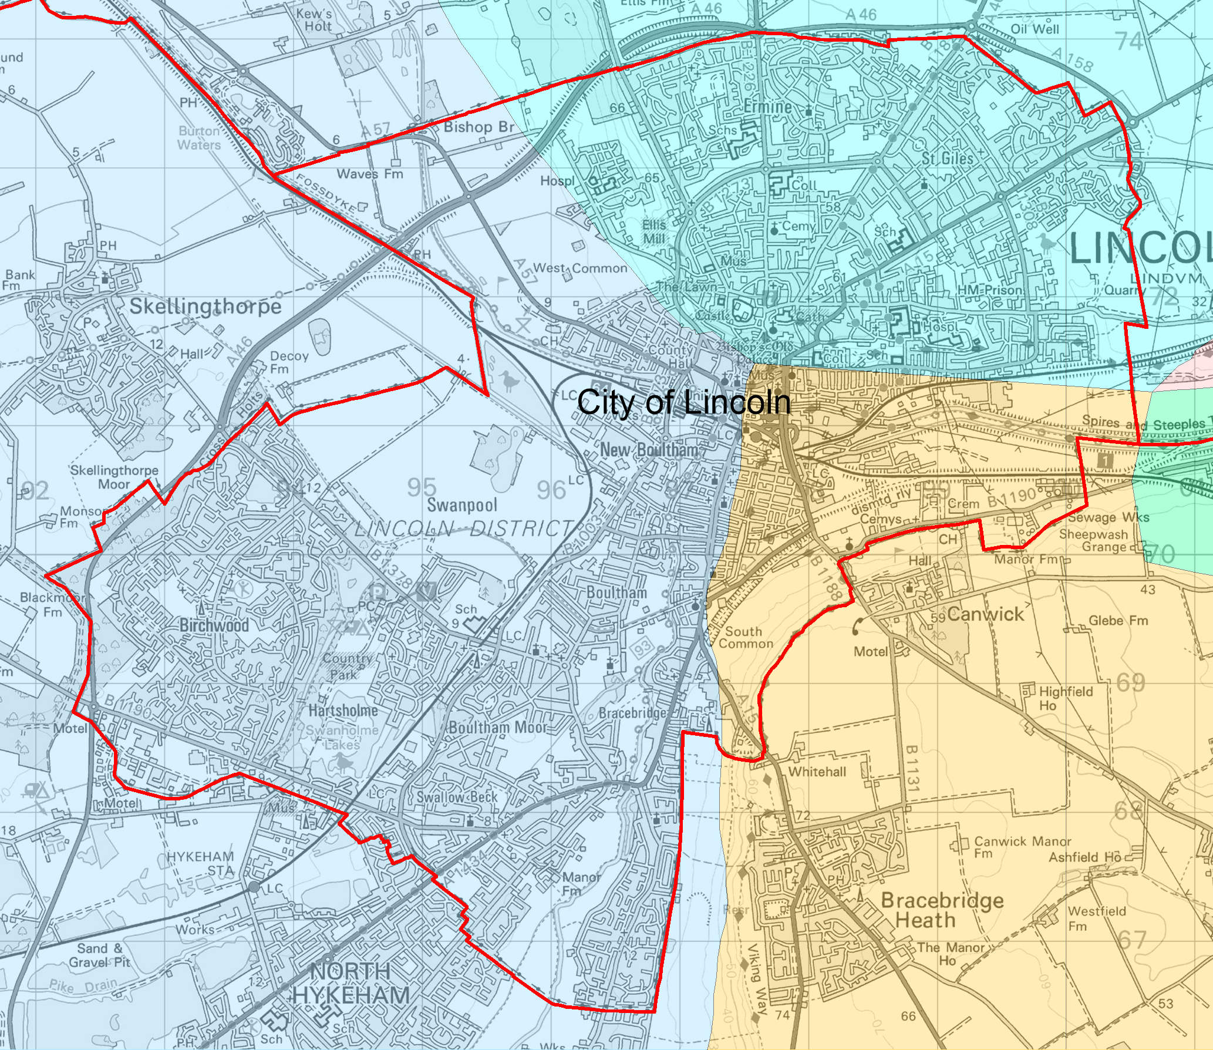
CITY OF LINCOLN FARMSTEAD CHARACTER SUMMARY
Lincoln is a market centre sitting at the heart of one of England’s must rural counties. Its growth and success, seen in its extraordinary historic architecture owes much to the agriculture of the county. Although the city has expanded significantly from the mid-19th century several traditional farmsteads can be found within its urban areas and in remaining open space within its tight political boundary.
Historic Farmstead Character
Only a handful of historic farmsteads (c.27) have been identified in the city, and the majority of these have been adapted for alternative uses as they have been enveloped by the expanding city. Farms include a variety of types. Regular planned farms dominate, but there are also historic examples of rare linear and L-plan farmsteads as well. 18th century farms and those within the centre of the city are typically built of local limestone, whereas later buildings are mainly of brick, especially in the lower lying areas of the city.
Historic Significance
Lincoln has two farmsteads of known 18th century origins, both of which are now public houses. The rest are likely to be of 19th century origin, although earlier features may be masked by extension or redevelopment. Lincoln was an important centre for wool processing and export by monastic houses in the medieval period, and there may be archaeological evidence of Grange farms associated with Lincoln’s monasteries that fulfilled this purpose. Surviving agricultural buildings are important elements of the cityscape, demonstrating the rural origins of the 19th and 20th century expansion.
Present and Future Issues
Lincoln is a growing city, with extensive areas of its remaining farmland being designated as potential locations for housing. There is therefore significant potential for historic farmbuildings on the edge of the city to be subsumed within suburban development, leading either to a significant loss of their setting or to demolition to make way for new development. Only 42% of Lincoln’s traditional farmsteads retain any trace of their historic character, the rest having been lost. This makes them a particularly vulnerable part of the city’s heritage, a situation that could potentially be addressed by finding new uses for them in the changing cityscape.
Relevant Local Planning Polices:
The City of Lincoln Council is producing the Central Lincolnshire Local Plan in partnership with the North Kesteven District, West Lindsey District and Lincolnshire County Councils. Until the joint plan is adopted in 2016 saved polices from the Lincoln Plan will continue to apply. Those policies specifically relevant to the sustainable development of historic farmsteads include:
- 34 Design and Amenity Standards  - 35 Design of New Residential Areas  - 43 Green Wedges and Other Major Open Spaces  - 44B Basic Natural Stock  - 45A Trees and Other Ecological and Landscape Features on Development Sites | - 47A Agricultural Development  - 56A New Housing (self-contained)  - 64 House Extensions, Domestic Garages and Other Developments within the Curtilage of a Dwelling  - 84 Hotels, Guest Houses and Bed and Breakfast Accommodation

