
GREATER LINCOLNSHIRE FARMSTEAD GUIDANCE
Farmstead and Landscape Summary Statements

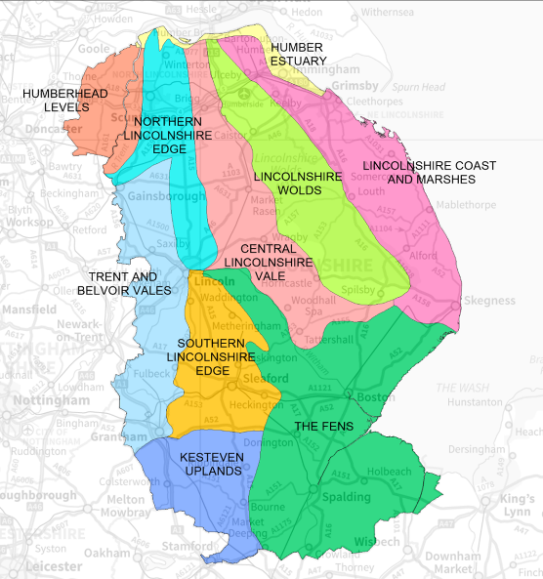
Appendix to the Lincolnshire Farmsteads Character Statement

Adam Partington, Alastair MacIntosh
& Jeremy Lake


THE GREATER LINCOLNSHIRE FARMSTEADS GUIDANCE
This document forms part of the Greater Lincolnshire Farmsteads Guidance, which aims to inform the sustainable development of historic farmsteads, including their conservation and enhancement. The guidance, which applies to the area of Greater Lincolnshire, including Lincolnshire, North Lincolnshire and North-East Lincolnshire, is made up of:
THE FARMSTEAD ASSESSMENT FRAMEWORK
A step-by-step approach for owners and applicants considering the re-use and sustainable development of traditional farm buildings based on an understanding of their historic character, significance and potential for change. Annexes include useful information about designation, recording and further research.
GREATER LINCOLNSHIRE FARMSTEADS CHARACTER STATEMENT
Detailed and illustrated guidance that helps identify the character and significance of historic farmsteads including the contribution they make to landscape character. Part 2 includes a full illustrated glossary of farm building types.
LOCAL AUTHORITY SUMMARIES
Short summaries for each local planning authority in Greater Lincolnshire providing an overview of historical development, farmstead character, drivers for change and relevant local planning policies. Helpful to both planners and applicants when developing and scrutinising proposals.
FARMSTEAD AND LANDSCAPE STATEMENTS
Informative statements about ten different areas of the county defined according to their landscape character by Natural England (e.g. The Wolds). Each statement provides information about the historical development of farms in the landscape, landscape character and the types of farmstead found in each area. They are a useful evidence base for decision-making and development in context.

Sustainable Development: The National Planning Policy Framework (2012) presumes in favour of sustainable development, which it defines as ‘positive growth – making economic, environmental and social progress for this and future generations’.

Front Cover: National Character Areas in Lincolnshire
CONTENTS
Humberhead Levels 4
Humber Estuary 7
Lincolnshire Coast and Marshes 10
Lincolnshire Wolds 13
Central Lincolnshire Vale 16
Northern Lincolnshire Edge with Coversands 19
The Fens 21
Southern Lincolnshire Edge 24
Trent and Belvoir Vales 26
Kesteven Uplands 28

This guidance note has been prepared by Adam Partington and Alastair MacIntosh (Locus Consulting) and Jeremy Lake (Historic England)

First published by Historic England July 2015.

All images © Historic England unless otherwise stated.

Historic Mapping: Crown Copyright and Landmark Information Group Ltd (All rights reserved 2012) Licence numbers 000394 and TP0024.

www.HistoricEngland.org.uk/advice/caring-for-heritage/rural-heritage/farm-buildings/

Humberhead Levels

NATIONAL CHARACTER AREA 39
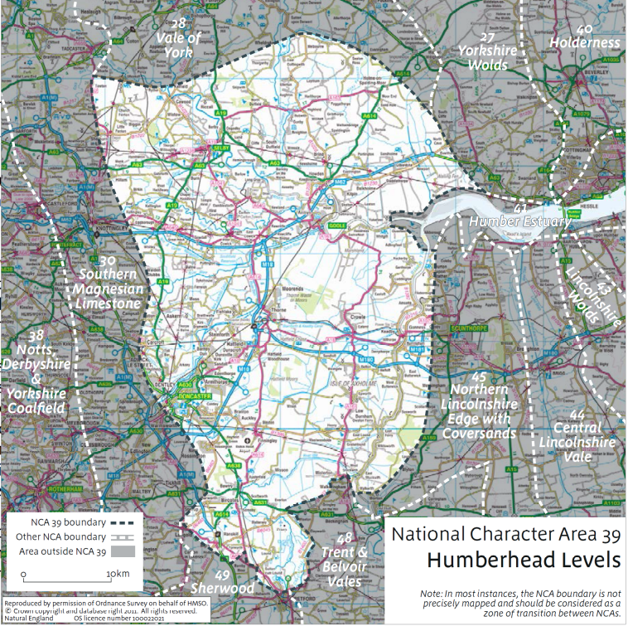
The Humberhead Levels
Total | 507
Outfarms | 12
Farmsteads | 495

The Humberhead Levels is a low-lying agricultural landscape including the floodplains of a number of rivers which drain into the Humber Estuary. Isolated pockets of high ground exist throughout the character area on outcroppings of bedrock or gravel terraces. The land is intensively farmed and is characterised by large open rectilinear fields usually divided by ditches rather than hedgerows. There is a mix of built-up areas, industrial land and dereliction, and farmed open country. Approximately 7% is classed as urban, 78% is agricultural and 4% is woodland. 3% falls within SSSI designations.

SUMMARY

HISTORIC CHARACTER
- Predominantly arable landscape, with large open fields resulting from 17th century wetland reclamation.
- Strong contrast between regular planned fieldscapes on floodplains and ancient irregular enclosure on higher ground
- Regular courtyard farmsteads are widespread in reclaimed and planned former wetlands
- There is a regionally high concentration of small-scale loose courtyard and dispersed plan farmsteads with 18th Century and earlier buildings on higher ground around villages and in the vicinity of early enclosure of common land
- Most 19th century farm buildings are brick and pantile, supplied by the local brick and tile works on the southern bank of the River Humber and on the Isle of Axholme

SIGNIFICANCE
- The area has an average survival of traditional farmsteads from around 1900 – 44% have high heritage potential with more than 50% of their historic form surviving (42.85% in Lincolnshire) and 23% with some heritage potential (28% in Lincolnshire), retaining some but less than 50% of their historic form.
- 4.52% of these are associated with a listed building either a farmhouse or in rare cases a listed working building. These are predominantly of 18th century origin although there is a single example of a 16th century listed farmhouse in the area

Survival | Numbers | Percentage | County Average
Extant | 71 | 14.34% | 9.73%
Altered (less than 50%) | 146 | 29.5% | 33.12%
Altered (more than 50%) | 75 | 15.15% | 19.04%
House Only | 39 | 7.88% | 9.38%
Demolished | 77 | 15.6% | 13.26%
Lost | 87 | 17.58% | 15.48%

- Isolated planned farmsteads of regular courtyard plan sit within their contemporary 19th century fieldscape, combining to form a landscape character that illustrates 19th century approaches to land reclamation and planning farming landscapes of rectilinear planned fields enclosed by drains accompanied by high banked warping ditches with their working buildings and areas.
- Some 19th century isolated farmsteads in the reclaimed land around the Isle of Axholme which may be on the sites of the “Adventurers’ Farms” which were constructed immediately after drainage and reclamation of land in the 17th century.
- Village farmsteads on the Isle of Axholme are a significant component of the open-field farming system that survives to this day.
- High concentration of moated sites relating to high status medieval occupation of choice farmland
- Small farmsteads, usually of loose courtyard form, and smallholdings were a typical feature of this area, and are now very rare.

PRESENT AND FUTURE ISSUES
- Historically important open field farming strips around villages are vulnerable to amalgamation due to change of use, especially for horse-rearing and liveries
- The area includes some of the most productive soils in the country, most comprising free-draining sandy, loamy or clay soils
- There is a marked contrast between large farm holdings (those over 100ha in size comprise 72% of the farmed area) and small farms under 5ha, which have declined considerably in recent years.
- This decline has led to a high level of dereliction or conversion of traditional buildings, as well as the construction of new sheds and farm workers’ accommodation
- There is a below-average proportion of listed working farm buildings converted to non-agricultural use (24.4%, the national average being 32%) in this character area.
- There is also an above-average proportion of listed working farm buildings that show obvious signs of structural disrepair (23.3%, the national average being 7.5%)

Humber Estuary

NATIONAL CHARACTER AREA 41
The Humber Estuary
Total Records | 106
Outfarms | 6
Farmsteads | 100

The Humber Estuary is an expansive low-lying estuarine landscape dominated by the River Humber. The area is a predominantly reclaimed intertidal landscape with arable farming and coastal mudflats, and other wetland and coastal habitats important to biodiversity. There are urban and industrial influences especially around Hull and on the south bank. 31% is defined as urban, 55% is cultivated and only 0.5% is woodland. 5% is designated as SSSI. The area shares many characteristics with the much larger Humberhead Levels (Area 39) to the north and west.

SUMMARY

HISTORIC CHARACTER
- The area has a varied and generally modern character of rural, urban and industrial land uses
- The development of the area has been strongly influenced by the River Humber, which has provided transportation, communication and, through the practice of warping, a means of agricultural improvement
- The area was extensively enclosed in the 18th and 19th centuries, with associated redevelopment and construction of farm buildings in villages and in the open countryside
- Isolated farmsteads in the area generally adhere to a regular courtyard plan, arguably reflecting the 19th century improvement of farmland and its subsequent exploitation
- Building materials typically include locally produced brick and pantile, especially those manufactured in Barton upon Humber. Stone is limited and is likely to be a high-status material, as it is unavailable within the area, and is typically decorative where used.

SIGNIFICANCE
- The area has an average survival of traditional farmsteads from around 1900 – 46% have high heritage potential with more than 50% of their historic form surviving (43% in Lincolnshire) and 14% with some heritage potential (28% in Lincolnshire), retaining some but less than 50% of their historic form
- None of the farmsteads recorded in this area are associated with a listed building
Survival | Numbers | Percentage | County Average
Extant | 20 | 20% | 9.73%
Altered (less than 50%) | 26 | 26% | 33.12%
Altered (more than 50%) | 10 | 10% | 19.04%
House Only | 4 | 4% | 9.38%
Demolished | 11 | 11% | 13.26%
Lost | 29 | 29% | 15.48%

- Isolated planned farmsteads of regular courtyard plan sit within their contemporary 19th century fieldscapes, combining to form a landscape character that illustrates 19th century approaches to land reclamation and planning farming landscapes of rectilinear planned fields enclosed by drains accompanied by high banked warping ditches with their working buildings and areas
- Some older farmsteads are located within or adjacent to medieval moats
- Almost all farm buildings date from rebuilding in the 19th century, although some mid-late 18th century barns and possibly stables survive
- Local brick and pantile reflect the proximity of early industry in the area, providing a link between the historic rural and industrial economies.

PRESENT AND FUTURE ISSUES
- Strong pressures associated with industrial expansion and sprawl, in particular around the Killingholme refinery, potentially reducing agricultural holdings and accelerating the conversion of agricultural buildings to other uses
- Move to arable cultivation away from 18th and 19th century pastoral regimes leading to a risk of obsolescence amongst many significant farm buildings such as cowhouses and stables
- The area is seeing an ongoing increase of tenanted and managed farms, with an associated decrease in the number of principal farmers
- High potential for residential conversion of buildings due to close location with major infrastructure and urban areas
- This area contains a below-average proportion of listed working farm buildings converted to non-agricultural use (25%, the national average being 32%).There is also an above-average percentage (16.7%, the national average being 7.5%) of listed working farm buildings that show obvious signs of structural disrepair.

Lincolnshire Coast and Marshes

NATIONAL CHARACTER AREA 42

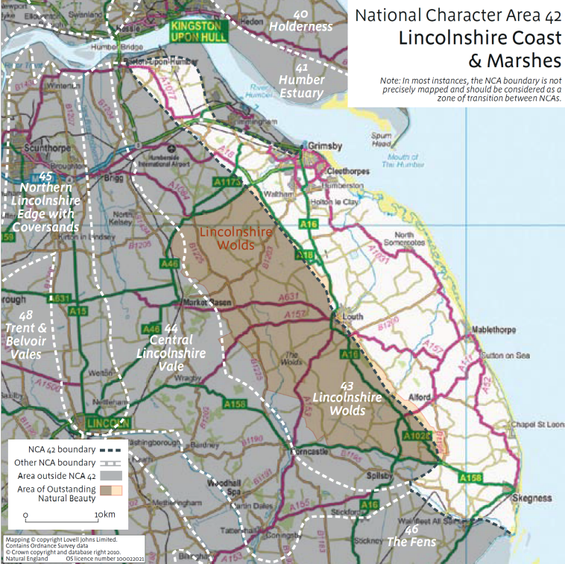
Lincolnshire Coast and Marshes
Total Records | 1557
Outfarms | 34
Farmsteads | 1523

A wide coastal plain which extends from Grimsby in the north to Skegness on the edge of The Wash. It is bounded inland by the edge of the Lincolnshire Wolds. The character area is 8.1% urban, with the principal settlements being located along the coast. It has no land-based national designations, but there are several coastal areas that are designated as Special Areas of Conservation, or as Ramsar Sites.

SUMMARY

HISTORIC CHARACTER
Two parallel landscapes, both with high densities of farmsteads, exist in the character area:
- Historic middle marsh landscape of nucleated settlements and former strip farming in the west
- Reclaimed Outmarsh landscape of wide, low-lying plains intersected by creeks and man-made drainage channels in the east
- Historic economy was based on salt production and grazing of cattle on rich marshland grass
- Extensive reclamation began with the by-products of industrial scale medieval salt making, known as saltern mounds, on which temporary settlements were established
- Settlement is broadly dispersed, with straggling linear settlements adhering to higher ground, such as former sea-banks
- Settlement and colonisation spread from west to east as land was reclaimed, resulting in series of ‘daughter settlements’ forming staged and parallel linear patterns to their parent villages (e.g. Saltfleetby St. Peter).

SIGNIFICANCE
- The area has an average survival of traditional farmsteads from around 1900 – 44% have high heritage potential with more than 50% of their historic form surviving (43% in Lincolnshire) and 27% with some heritage potential (28% in Lincolnshire), retaining some but less than 50% of their historic form.
- 58 farmsteads in the area are associated with a listed farmhouse or working building, of which 79% date from the 18th century or earlier (Lincolnshire - 73%).
Survival | Numbers | Percentage | County Average
Extant | 178 | 11.69% | 9.73%
Altered (less than 50%) | 496 | 32.57% | 33.12%
Altered (more than 50%) | 295 | 19.37% | 19.04%
House Only | 129 | 8.47% | 9.38%
Demolished | 211 | 13.85% | 13.26%
Lost | 214 | 14.05% | 15.48%

- Isolated pastoral farmsteads occur along historic drove roads connecting the Middle Marsh and Outmarsh landscapes, and leading up to the neighbouring uplands of the Wolds
- There is a clear distinction preserved between traditional nucleated settlements and village farmsteads in the middle marsh and the dispersed pattern of linear settlements and isolated farmsteads in the Outmarsh
- Many farmsteads are in proximity to medieval and post-medieval features, such as monastic sites, moated sites, and deserted settlements
- Historic grazing land is common in the Outmarsh and currently undergoing restoration in several areas
- Strong influence of estates, especially in the north of the area, with associated architectural motifs.
- Extensive rebuilding in brick and pantile in later 18th and 19th centuries, leaving some traces of earlier mud and stud as rare survivals of a regional building tradition that has been largely swept away.

PRESENT AND FUTURE ISSUES
- Ongoing transition from mixed and pastoral farming to large-scale arable cropping, leading to redundancy of buildings and decline in livestock numbers
- Expansion of coastal settlements and resort towns into rural areas around existing settlements
- Industrialisation of the coastal landscape around Grimsby and Humberston continues due to growth of energy facilities, including gas terminals and power stations
- Increased tourism and leisure use of the coastal area may lead to change of use and conversion of agricultural buildings
- The total farmed area has shown signs of increasing-whilst farm ownership has reduced between 2000 and 2009. There has been a loss of medium-size farm enterprises which have largely been edged out
- A below-average proportion of listed working farm buildings in the area have been converted to non-agricultural uses (25%, the national average being 32%). There is also a significantly above-average proportion of listed farm buildings showing obvious signs of structural disrepair (25%, compared to a national average of 7.5%)
- Climate change may lead to changes in flood management, increased instances of flooding in the coastal area, and may also alter the types of crops that can profitably be grown
- Onshore and offshore wind energy may impact upon the setting of historic farm buildings and their associated agricultural landscapes.

Lincolnshire Wolds

NATIONAL CHARACTER AREA 43

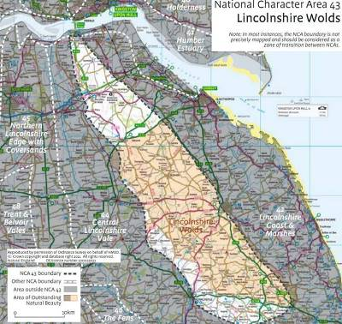
The Lincolnshire Wolds
Total Records | 917
Outfarms | 48
Farmsteads | 869

The Lincolnshire Wolds is a rolling upland landscape in the eastern half of Lincolnshire. An open, mainly arable area (only 4% is wooded), its distinctive topography and geology give rise to an interesting range of farmed landscape features. Only a tiny part of the area (1.5%) is urban and 62% is within the Lincolnshire Wolds AONB.

SUMMARY

HISTORIC CHARACTER
- Extensive evidence of prehistoric activity in the form of barrows and trackways
- Major market towns such as Caistor and Horncastle are of Roman origin
- Nucleated settlement pattern established in the early medieval period by Saxon and Danish settlement of the upland areas
- Settlements often established in dry valleys or along spring-lines in order to access water sources
- Early farmsteads and agricultural buildings occur within or adjacent to settlements
- Earlier isolated farmsteads often result from settlement shrinkage or desertion, in which case they are associated with significant archaeological remains
- More recent isolated farmsteads often date from the 19th century “High Farming” tradition, and exhibit specialised building types and pattern book designs
- 19th century landscape features remain highly legible, such as well-preserved planned enclosure fieldscapes and associated straight enclosure roads
- The wolds is notable for its high proportion of courtyard farmsteads, many of which show evidence of expansion and addition in the later 19th century. These additions include cartsheds, granaries and animal shelter, demonstrating the move towards high intensity arable cultivation following enclosure
- Extensive rebuilding in brick and pantile with some use of chalk and Ironstone.

SIGNIFICANCE
- The area has an above average survival of traditional farmsteads from around 1900 – 50% have high heritage potential with more than 50% of their historic form surviving (43% in Lincolnshire) and 28% with some heritage potential (28% in Lincolnshire), retaining some but less than 50% of their historic form
- 72 farmsteads in the area are associated with a listed farmhouse or working building, of which 75% date from the 18th century or earlier (Lincolnshire - 73%)
Survival | Numbers | Percentage | County Average
Extant | 102 | 11.74% | 9.73%
Altered (less than 50%) | 332 | 38.20% | 33.12%
Altered (more than 50%) | 193 | 22.21% | 19.04%
House Only | 46 | 5.29% | 9.38%
Demolished | 110 | 12.66% | 13.26%
Lost | 86 | 9.9% | 15.48%

- The Wolds is one of the most distinctive estate landscapes of the Agricultural Revolution in England, broadly comparable in terms of the date of the changes and their patterns (large fields and courtyard-plan farmsteads) with the Yorkshire Wolds to the north
- Isolated farmsteads derived from shrunken or deserted medieval settlements are an important link to former patterns of settlement and land use, especially where they preserve the names of lost villages, and can be found in the many dry valleys
- Several examples of planned and model farmsteads can be found in the area, demonstrating the application of 19th century industrial ideals within the historic rural landscape
- Some very rare examples of C18 yards and buildings for cattle such as at Psalter Farm, Skendleby
- Some very rare surviving examples of mud and stud construction, usually clad in brick.

PRESENT AND FUTURE ISSUES
- The Lincolnshire Wolds AONB remains a desirable place to live, potentially increasing demand for conversion of farm buildings to commercial and/or residential use
- More farmers and landowners are looking into micro-generation involving individual wind turbines or solar farms – more understanding is needed of the impacts and opportunities presented by these developments
- Diversification of farm use increasingly includes quasi-industrial features, new residential accommodation, and associated traffic impacts. These present opportunities for traditional buildings, but will require an understanding of potential impacts
- The numbers of principal farmers and full-time farm employees have dropped significantly since 2000, indicating an ongoing trend for amalgamation and efficiency
- Construction of irrigation reservoirs to support cropping will impact upon local setting and character
- The character area contains a below-average proportion of listed working farm buildings converted to non-agricultural use (16.7%, the national average being 32%), indicating an active agricultural industry in the character area. There is also an above-average percentage (20%, the national average being 7.5%) of listed working farm buildings that show obvious signs of structural disrepair.

Central Lincolnshire Vale

NATIONAL CHARACTER AREA 44

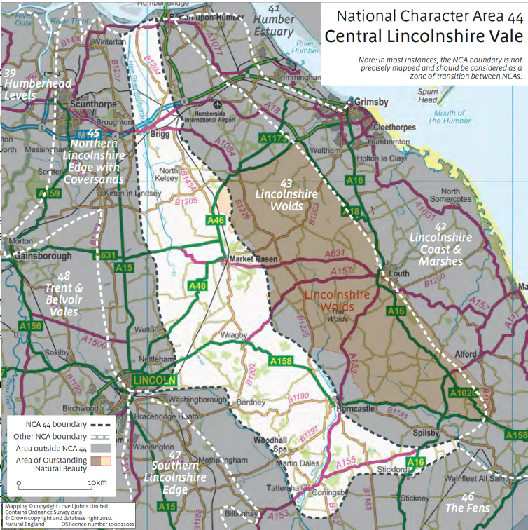
Central Lincolnshire Vale
Total Records | 1219
Outfarms | 50
Farmsteads | 1169

A low lying vale divided into two parts by a central watershed running east/west. The northern half drains through the River Ancholme into the Humber and the southern part into the River Witham, through the Fens and into the Wash. This is a deeply rural landscape and only 2.5% of the character area is urban. It just clips the Lincolnshire Wolds AONB (1% of the character area falls within the AONB).

SUMMARY

HISTORIC CHARACTER
- Sparsely populated medieval landscape of small nucleated settlements and small village farmsteads on high ground
- High concentration of former monastic sites and associated granges set within their former landscapes in the south of the area
- Isolated farmsteads mostly date from 19th century and occupy reclaimed wetland along River Witham or enclosed former waste
- The area is dominated by courtyard farmsteads, although there is a relatively higher proportion of linear and dispersed types than in neighbouring character areas. Buildings are typically reflective of 19th century arable cultivation, including cartsheds, large combination barns and granaries. Farmhouses may have earlier origins, and often display extension or rebuilding
- Outfarms and field barns are more common than in other Character Areas, reflecting the distance between settlements and farmsteads
- Extensive rebuilding in later 18th and 19th centuries, mostly in local brick and pantile with some limestone.

SIGNIFICANCE
- The area has an above average survival of traditional farmsteads from around 1900 – 47% have high heritage potential with more than 50% of their historic form surviving (43% in Lincolnshire) and 29% retain some heritage potential (28% in Lincolnshire), but less than 50% of their historic form
- 56 farmsteads in the area are associated with a listed farmhouse or working building, of which 68% date from the 18th century or earlier (Lincolnshire - 73%).
Survival | Numbers | Percentage | County Average
Extant | 135 | 11.55% | 9.73%
Altered (less than 50%) | 416 | 35.59% | 33.12%
Altered (more than 50%) | 222 | 18.99% | 19.04%
House Only | 118 | 10.09% | 9.38%
Demolished | 125 | 10.70% | 13.26%
Lost | 153 | 13.09% | 15.48%

- Some farmsteads retain strong links with monastic origins, either in their landscape setting or in their place names
- There is potential for farmsteads to relate to earlier medieval settlement
- Gentry estates and parkland have a strong influence on built forms across the area through the influence on design and material selection
- The Limewoods represent England’s biggest concentration of ancient small-leaved lime-dominated woodland, and have associated historic features such as farmsteads and fieldscapes
- Some rare examples of pre-1750s brickwork and mud and stud.

PRESENT AND FUTURE ISSUES
- Change from pastoral to arable farming leading to the obsolescence of livestock-related farm buildings (especially remote outfarms)
- Construction of energy infrastructure, such as wind turbines or oil exploration facilities, may impact the setting of farm buildings
- Continuing decrease in numbers of principal farmers and farm labourers - amalgamation of farms may cause disuse of farmsteads as larger holdings are administered from fewer centres
- Purchase of farmland as an investment or a commodity potentially leading to redundancy of farmsteads
- There is a relatively low proportion of listed working farm buildings converted to non-agricultural use in this character area (18.2%, the national average being 32%). There is also an above-average percentage (25%, the national average being 7.5%) of listed working farm buildings that show obvious signs of structural disrepair.

Northern Lincolnshire Edge with Coversands

NATIONAL CHARACTER AREA 45

Northern Lincolnshire Edge with Coversands
Total Records | 588
Outfarms | 18
Farmsteads | 570

This character area describes the northern part of the Lincolnshire Edge, a distinctive limestone ridge running north-south through Lincolnshire from Whitton on the Humber Estuary to Grantham in the south. A high proportion of the character Area is urban, including the major settlements of Lincoln and Scunthorpe . None of the area is within an AONB or National Park and no part of the character area falls within a Less Favoured Area.
SUMMARY

HISTORIC CHARACTER
- North-south linear scarp of limestone running the length of Lincolnshire, with open former heath landscape to the east
- Nucleated medieval settlement pattern following major routes, including the Roman Ermine Street, and spring lines along the scarp
- Variations in landscape can be observed reflecting the geological differences between the Scarp itself, the coversands around Scunthorpe and the heath.
- Isolated farmsteads that have retained their historic form, almost all of a regular planned form, generally reflect 19th century post-enclosure mixed agriculture and ‘high farming’. Older farmsteads in villages have a more organic and less planned character, and are often associated with irregular pasture fields nearby.
- 19th century farm buildings are generally indicative of arable and mixed farming, incorporating large combination barns, cartsheds, granaries and livestock shelter.

SIGNIFICANCE
- The area has an average survival of traditional farmsteads from around 1900 – 45% have high heritage potential with more than 50% of their historic form surviving (43% in Lincolnshire) and 30% retain some heritage potential (28% in Lincolnshire), but less than 50% of their historic form
- 51 farmsteads in the area are associated with a listed farmhouse or working building, of which 71% date from the 18th century or earlier (Lincolnshire - 73%)

Survival | Numbers | Percentage | County Average
Extant | 76 | 13.33% | 9.73%
Altered (less than 50%) | 181 | 31.75% | 33.12%
Altered (more than 50%) | 130 | 22.81% | 19.04%
House Only | 39 | 6.84% | 9.38%
Demolished | 61 | 10.70% | 13.26%
Lost | 83 | 14.56% | 15.48%

- The area is notable for high-quality architecture evidencing rebuilding from the 17th century of houses and barns, including fine manor houses dating from the late medieval period, and country houses with their estates. Local estates influenced village development and continue to contribute to local distinctiveness and architectural design
- Some timber-framed houses and farm buildings exist in the character area, but are typically refronted or re-roofed.

PRESENT AND FUTURE ISSUES
- Isolated farmsteads on the peripheries of Lincoln and Scunthorpe continue to be subsumed within suburban development
- The area has experienced a high level of centralisation and amalgamation of farming complexes, leading to several historic farms being run from a single farmhouse. Some farm buildings retained for storage but farm houses at greater risk of becoming disused
- Population movement from villages in the area to larger settlements such as Lincoln and Scunthorpe
- The Northern Lincolnshire Edge NCA (45) contains a medium proportion of listed working farm buildings converted to non-agricultural use (21.4%, the national average being 32%). The Northern Edge also recorded an above-average percentage of listed working farm buildings that show obvious signs of structural disrepair (9.1%, the national average being 7.5%).

The Fens

NATIONAL CHARACTER AREA 46

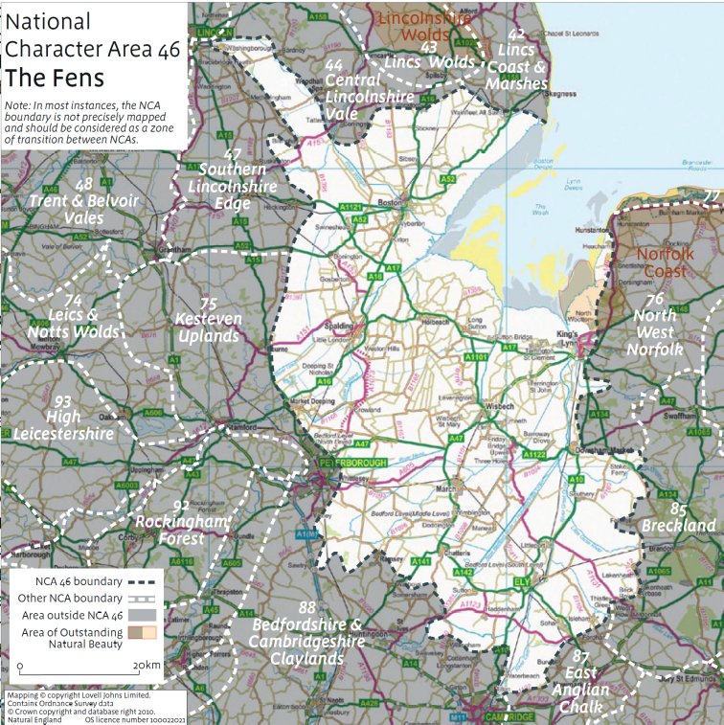
The Fens
Total Records | 3660
Outfarms | 103
Farmsteads | 3557

This area surrounds, and extends inland north, south and west, from the open waters of The Wash (England’s largest tidal estuary). Mostly reclaimed from both freshwater fen and sea-marsh, The Fens is a large scale, open and expansive low lying landscape. It is a very rural character area and, agriculturally, hugely productive. Almost 97% of this character area is open countryside with 91% of that land cultivated. Woodland is sparse, covering less than 1% of the total area. 3% of the landscape is urban and just under 1% of the character area falls within the Norfolk Coast AONB.
SUMMARY
HISTORIC CHARACTER
- Farmsteads divide into two broad groups – village farmsteads on relatively elevated (c.3m OD) silt or gravel banks, and isolated farmsteads in the former fens and marshes
- Village farmsteads are often set within areas of anciently enclosed land, reflecting patterns of early medieval colonisation and associated arable cultivation
- In areas of reclaimed land the location of farmsteads is strongly tied to the historic patterns of drove roads and flood embankments
- Isolated smallholdings show much evidence of enlargement and improvement on a piecemeal basis, perhaps reflecting growing prosperity and capabilities
- The character area incorporates a much wider variety of farmstead types than any other in the county. In particular, there are high levels of survival of dispersed, linear and L-plan farmsteads of potentially early date. Many farmsteads show evidence of expansion and alteration, including the addition of granaries and combination barns, demonstrating adaptation to new farming methods
- Stone is exceptionally rare and is almost entirely limited to high-status, civic and ecclesiastical buildings.

SIGNIFICANCE
- The area has a low survival of traditional farmsteads from around 1900 – 29% have high heritage potential with more than 50% of their historic form surviving (43% in Lincolnshire) and 32% retain some heritage potential (28% in Lincolnshire), but less than 50% of their historic form
- 116 farmsteads in the area are associated with a listed farmhouse or working building, of which 68% date from the 18th century or earlier (Lincolnshire - 73%)
Survival | Numbers | Percentage | County Average
Extant | 164 | 4.61% | 9.73%
Altered (less than 50%) | 882 | 24.80% | 33.12%
Altered (more than 50%) | 665 | 18.70% | 19.04%
House Only | 476 | 13.38% | 9.38%
Demolished | 650 | 18.27% | 13.26%
Lost | 720 | 20.24% | 15.48%

- Farm buildings pre-dating 1750 are rare in the drained fens away from village cores, due to the marginal quality of the land until steam-powered drainage was introduced in the 19th century
- Historic farmhouses in villages are often well preserved, although outbuildings occasionally suffer from dereliction or neglect
- Surviving structures associated with historic agriculture include occasional field barns and outfarms, as well as 19th century farm workers cottages in varying states of repair
- The area has notable examples of inter-war smallholdings.

PRESENT AND FUTURE ISSUES
- Agricultural intensification in this highly productive landscape leads to amalgamation of many holdings, and the expansion and modernisation of farm infrastructure
- Holdings of more than 100ha make up 77% of farmed land with holding sizes on an increasing trend. Consequently there are ongoing requirements for large scale sheds and a decline in the number of small to medium scale enterprises
- Erosion and shrinkage of peat soils leads to structural instability and subsequent repairs, especially adjacent to field drains and dykes
- Dispersed settlement pattern creates issues for the delivery of services and utilities to more remote dwellings and businesses
- The Photo Image Project (2006) recorded a medium proportion in this National character area of listed working farm buildings converted to non-agricultural use (29.6%, the national average being 32%).

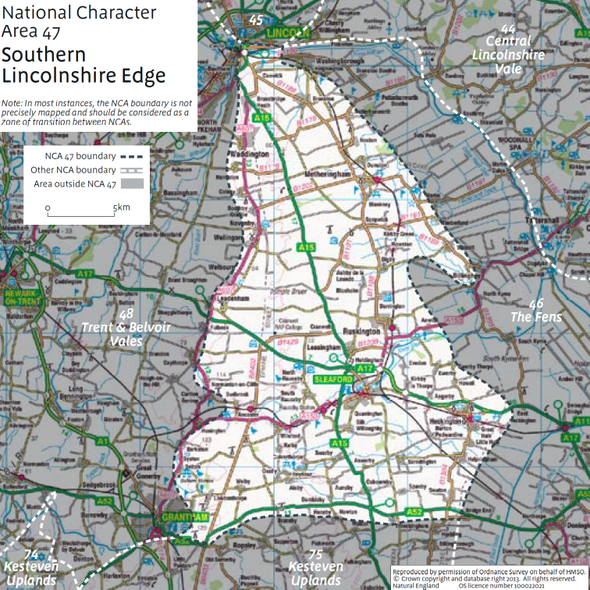
Southern Lincolnshire Edge
Total Records | 681
Outfarms | 23
Farmsteads | 657

Southern Lincolnshire Edge

NATIONAL CHARACTER AREA 47
This character area describes the southern part of the Lincolnshire Cliff, a limestone scarp that runs along the north-south axis of the county. It shares many features in common with the Northern Cliff character area described above. The area is dominated by large scale arable farming, with many farm holdings exceeding 100ha. There are no national parks or AONBs in the area.
SUMMARY

HISTORIC CHARACTER
- North-south linear scarp of limestone running the length of Lincolnshire, with open former heath landscape to the east
- Nucleated medieval settlement pattern following major routes and spring lines along the scarp
- Numerous isolated farmsteads, especially in enclosed former heathland
- Transitional zone of lower ground to the east of the area along the border with the Fens
- The area incorporates a variety of farmstead types. Older farmhouses, typically found in villages, are often stone built and have seen the addition of 19th century working buildings in brick. Away from villages, isolated farmsteads on the former heath are generally of 19th century origin and are brick built
- Although courtyard plan farmsteads are more dominant, village farmsteads often have linear or L-shape plans, with the house attached to former working buildings.

SIGNIFICANCE
- The area has a high survival of traditional farmsteads from around 1900 – 54% have high heritage potential with more than 50% of their historic form surviving (43% in Lincolnshire) and 29% retain some heritage potential (28% in Lincolnshire), but less than 50% of their historic form
- 72 farmsteads in the area are associated with a listed farmhouse or working building, of which 72% date from the 18th century or earlier (Lincolnshire - 73%)
Survival | Numbers | Percentage | County Average
Extant | 73 | 11.11% | 9.73%
Altered (less than 50%) | 283 | 43.07% | 33.12%
Altered (more than 50%) | 150 | 22.83% | 19.04%
House Only | 44 | 6.7% | 9.38%
Demolished | 40 | 6.09% | 13.26%
Lost | 67 | 10.2% | 15.48%

- Isolated farmsteads generally reflect 19th century post-enclosure mixed agriculture and ‘high farming’
- Some older farmsteads on the heath may occupy the sites of former specialist estates and monastic granges
- Older farmsteads in villages have a more organic and less planned character, and are often associated with irregular pasture fields nearby
- Local estates influenced village development and continue to contribute to local distinctiveness and architectural design

PRESENT AND FUTURE ISSUES
- Redundancy and subsequent dereliction of obsolete farm buildings due to mechanisation and farm amalgamation
- Centralisation and amalgamation of farming complexes leading to several historic farms being run from a single farmhouse. Some farm buildings retained for storage but farm houses at greater risk of becoming disused
- Future development of wind energy facilities and infrastructure along the top of the cliff
- Plans have been proposed for large “super-dairy” farms on the southern heath, requiring new large modern sheds and related infrastructure
- The Southern Edge contains an above average proportion of listed farm buildings still in agricultural use (35.3%, the national average being 32%)

Trent and Belvoir Vales

NATIONAL CHARACTER AREA 48

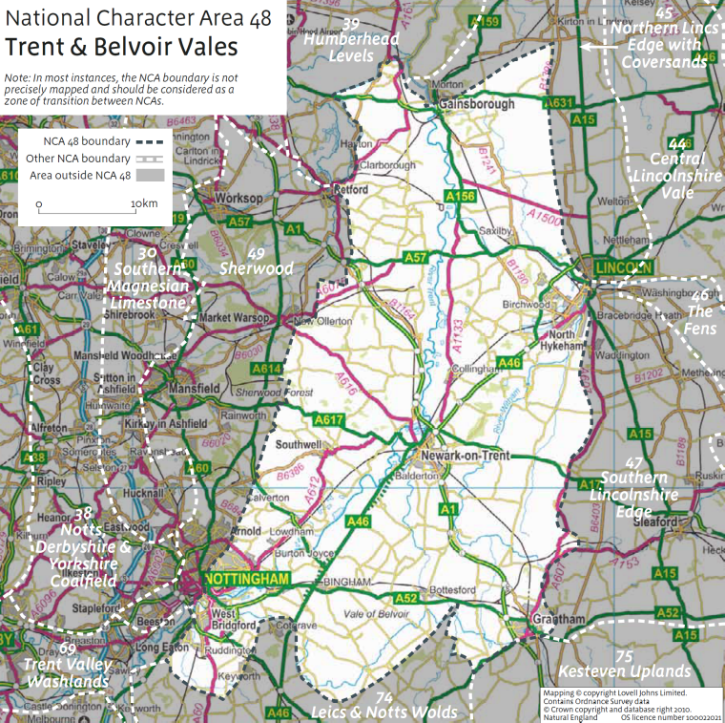
Trent and Belvoir Vales
Total Records | 983
Outfarms | 38
Farmsteads | 945

This area of farmland is centred on the River Trent (as it flows north between Nottingham and Gainsborough) and the Rivers Witham and Till to the east. 7% of the area is ‘urban’, the remainder is characterised by undulating, strongly rural arable farmland. It is an open landscape, with less than 3% woodland cover.

SUMMARY

HISTORIC CHARACTER
- Former medieval landscape of nucleated villages and open fields
- Pre-enclosure (date) farmsteads occur at the edges of settlements, often in proximity to early irregular enclosures for sheep rearing and stock control, with linear or L-plan forms
- The area was extensively enclosed during the late c18th and early 19th, often by Act of Parliament
- Heavy clay soils required extensive drainage and improvement before becoming viable for tillage, resulting in extensive patterns of ditched field boundaries
- Regular planned farmsteads occur in isolated locations, often indicating mixed arable and pastoral farming regimes of the mid to late 19th century.
- Farm buildings are typically brick built, and include threshing barns, granaries and cartsheds indicative of productive arable cultivation. These are often associated with cattle sheds and yards for the production of manure.
- Long, straight east-west aligned droves lead from the Trent floodplain up to the Lincoln heath, occasionally punctuated by brick built outfarms and field barns
- Smaller sub-areas of historic wooded landscape are found across the area, especially on higher sand and gravel terraces

SIGNIFICANCE
- The area has a high survival of traditional farmsteads from around 1900 – 55% have high heritage potential with more than 50% of their historic form surviving (43% in Lincolnshire) and 24% retain some heritage potential (28% in Lincolnshire), but less than 50% of their historic form
- 85 farmsteads in the area are associated with a listed farmhouse or working building, of which 75% date from the 18th century or earlier (Lincolnshire - 73%)
Survival | Numbers | Percentage | County Average
Extant | 111 | 11.75% | 9.73%
Altered (less than 50%) | 409 | 43.28% | 33.12%
Altered (more than 50%) | 169 | 17.88% | 19.04%
House Only | 60 | 6.35% | 9.38%
Demolished | 76 | 8.04% | 13.26%
Lost | 120 | 12.7% | 15.48%

- 19th century enclosure landscape features, such as straight roads, rectilinear field boundaries and isolated farms, are the dominant historic characteristics
- Earlier, pre-enclosure features remain legible, including developed farmsteads on village edges and elements of former medieval landscapes, such as the relict open fields in Laxton
- Post enclosure mixed farming regimes are readable in the survival of livestock ranges within and around farmsteads, outfarms, and irregular pasture enclosures adjacent to villages
- Nationally important cob buildings survive in the Vale of Belvoir, including free-standing dovecotes.

PRESENT AND FUTURE ISSUES
- Agricultural intensification leading to conversion of pastoral land to arable cultivation, accompanied by continuing decrease in numbers of farms
- Sand and gravel extraction takes areas of agricultural land out of cultivation
- There is a medium proportion of listed working farm buildings converted to non-agricultural use (29.6%, the national average being 32%) in this National Character Area. There is also an above-average percentage (12.2%, the national average being 7.5%) of listed working farm buildings that show obvious signs of structural disrepair.

Kesteven Uplands

NATIONAL CHARACTER AREA 75

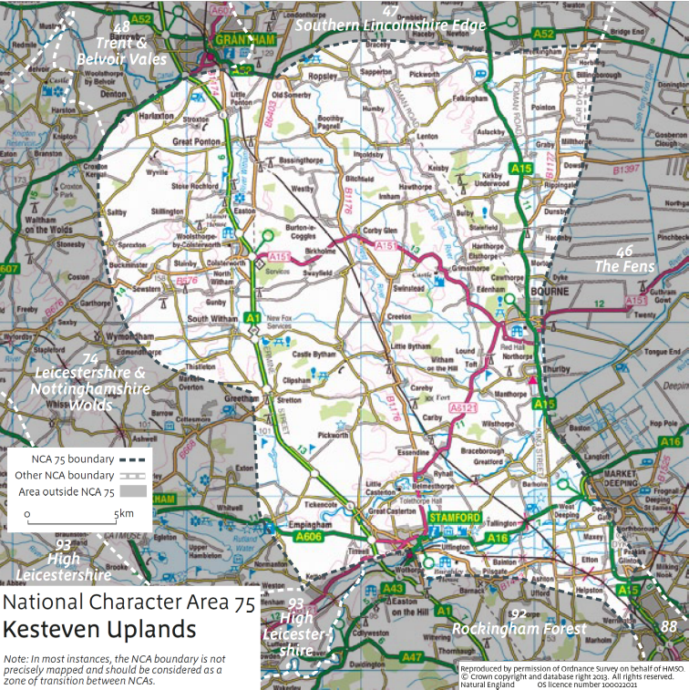
Kesteven Uplands
Total Records | 640
Outfarms | 29
Farmsteads | 611

The Kesteven Uplands is a rolling mixed farmland landscape dissected by the Rivers Witham and East and West Glen. It overlooks the flat Fens to the east and borders Rockingham Forest to the south, the Leicestershire Wolds to the west and the Lincolnshire Edge to the north. This is a deeply rural landscape which has only 2.6% of its area classified as ‘urban’.

SUMMARY

HISTORIC CHARACTER
- A heavily wooded area containing many examples of medieval sheep enclosures, especially around villages and on ‘marginal’ soils
- Heathland to the west of the Character Area was largely enclosed in 18th and 19th centuries, displaying a rectilinear pattern of fields with associated isolated farmsteads
- Many villages include stately homes, parkland, and estate buildings from the 16th to 19th centuries, reflecting the historic wealth of the area
- There are several examples of planned 19th century farmsteads established by ‘improving’ landowners, and these are frequently well preserved
- The area retains proportionally many more pre-18th century farm buildings than any other in Lincolnshire, and these typically exhibit a much greater level of survival. They are generally stone built, although re-fronting in brick is commonplace
- Working buildings from the 18th century or earlier are rare, but many early farmsteads were expanded by the addition of 19th century ranges for arable cultivation and livestock accommodation. These are also often stone built, but with brick detailing where necessary
- Farmsteads are typically arranged around loose or regular courtyards, although there may have been extensive redevelopment of older linear and dispersed farmsteads into these forms throughout the area, reflecting change and adaptation from sheep farming to arable cultivation.

SIGNIFICANCE
- The area has an extremely high survival of traditional farmsteads from around 1900 – 65% have high heritage potential with more than 50% of their historic form surviving (43% in Lincolnshire) and 20% retain some heritage potential (28% in Lincolnshire), but less than 50% of their historic form
- 103 farmsteads in the area are associated with a listed farmhouse or working building, of which 80% date from the 18th century or earlier (Lincolnshire - 73%)
Survival | Numbers | Percentage | County Average
Extant | 91 | 14.89% | 9.73%
Altered (less than 50%) | 305 | 49.92% | 33.12%
Altered (more than 50%) | 89 | 14.57% | 19.04%
House Only | 29 | 4.75% | 9.38%
Demolished | 31 | 5.07% | 13.26%
Lost | 66 | 10.80% | 15.48%

- Potential for continuity of settlement from monastic granges through to 18th and 19th century planned farmsteads on certain sites
- Some isolated farmsteads potentially sit on earlier sheep rearing sites, raising the possibility of enhanced legibility of medieval pastoral farming landscapes
- Several older farmsteads are examples of post-medieval yeomen houses associated with the early development of independent farming
- Buildings are often constructed of local limestone and other high quality materials. As a result earlier buildings survive well in this area due to their durability and historic character
- More recent farmsteads in isolated areas are built to patternbook designs, reflecting the influence of 19th century ‘high farming’ principles
- Strong influence of estates in parkland landscapes with associated design and architectural motifs employed on farm buildings.

PRESENT AND FUTURE ISSUES
- Proximity to commuter centres and transport routes leading to increased land and property values
- High demand for residential conversions of historic farm buildings, including holiday accommodation
- Continued drive for more efficient operations and larger arable farming operations, resulting in redundancy and loss of obsolete buildings
- Ongoing expansion of mineral extraction industry throughout the area
- Stewardship and management regimes
- Conversion of historic outbuildings, such as dovecotes, to alternative agricultural uses
- This NCA contains an average proportion of listed working farm buildings converted to non-agricultural use (30.4%, the national average being 32%).

Photo Image Project 2006
Photo Image Project 2006
Photo Image Project 2006
Photo Image Project 2006
Photo Image Project, 2006
Photo Image Project 2006
Photo Image Project 2006
Photo Image Project 2006

