BAMBURGH RESEARCH PROJECT



MANOR HOUSE HOTEL,
HOLY ISLAND,
NORTHUMBERLAND

REPORT OF ARCHAEOLOGICAL
MONITORING AND RECORDING

Compiled for Mr John Barlow by The Bamburgh Research Project: Commercial Projects Section

BRP 07/16 January 2008
Contents:

SUMMARY 3

- Introduction 4

2.0 THE SITE 4
2.1 Location 4

2.2 Archaeological background 4

3.0 METHODOLOGY 5
3.1 Monitoring during excavation 5
3.2 Contingency 5
3.3 General standards 5

4.0 RESULTS 6
4.1 Monitoring during excavation 6

5.0 CONCLUSIONS 8

REFERENCES 9

APPENDIX I WSI 10

Figure 1 Holy Island Village showing location of Figure 2
Figure 2 Plan of the development

Plate 1: North to south construction trench, facing north
Plate 2: Construction trenches and exposed boundary wall, facing south

SUMMARY

This report has been compiled by The Bamburgh Research Project for Mr John Barlow and sets out the results of archaeological monitoring undertaken during January 2008.

The development comprised the construction of an extension to the Manor House Hotel, Holy Island Village. The extension, located in the south-east corner of the building required the excavation of the foundation trenches and limited underpinning of the standing building. The site is located on the north side of the priory and churchyard, off Church Lane, in the south part of Holy Island Village, Northumberland, (NGR NU 1261 4182) (Figures 1 and 2).

Excavation of the foundation trench for the extension was undertaken under archaeological supervision on January 9th 2008. The area occupied by the extension measured 4.3m east to west by 5.7m north to south. Topsoil (100), a very dark grey-brown sandy silt, was excavated to a depth between 0.8m and 1.1m. This layer extended undifferentiated to the full depth of the excavation within the trenches with the exception of a layer of stone rubble (101) encountered towards the base of the north to south oriented trench. This rubble contained frogged brick fragments indicating a date no earlier than the mid 19th century. Although shell fragments were apparent within the soil no features of archaeological interest were encountered and no finds of pre-modern date recovered. The wall that demarks the boundary between the Manor House Hotel and the Priory was exposed to its foundations in the southern foundation trench. It was revealed to be a single phase of build and composed of roughly dressed irregularly coursed sandstone blocks.

The excavation revealed what is almost certainly the upper, post medieval, part of a midden sequence known to be present in the centre of the village from evaluation and monitoring undertaken in the area of the Winery and Village Hall and at Castlereigh on Prior Lane, to the north and west.

MANOR HOUSE HOTEL,
HOLY ISLAND,
NORTHUMBERLAND

REPORT OF ARCHAEOLOGICAL MONITORING

- Introduction

    - This report has been compiled by The Bamburgh Research Project, Commercial Section for Mr John Barlow. The document sets out the results of the monitoring of the groundworks associated with the construction an extension to the Manor House Hotel, Holy Island Village, Lindisfarne, Northumberland.

1.0.2 The work was undertaken in compliance with a Written Schedule of Investigation compiled by the Bamburgh Research Project in November 2007 in response to a brief issued by the Northumberland County Council Conservation Team. The Planning Authority reference number is: 07/B/0891 and the Northumberland County Council Conservation Team reference number is: B21/2; 7809.

2.0 THE SITE

2.1 Location

2.1.1 The Manor House Hotel is located on the north side of the priory and churchyard, off Church Lane, in the south part of Holy Island Village, Northumberland. The hotel lies within its own grounds with the new extension to be erected in the south-east corner of the standing building (NGR NU 1261 4182) (Figures 1 and 2).

  - Archaeological background

2.2.1 Mesolithic activity on the island is demonstrated by the presence of midden deposits at Ness End, on the northern side of the island, adjacent to Jenny Bell’s Well and in the vicinity of the Fort on the Heugh. Neolithic activity within the village is indicated by a ¹⁴C date for a single post-hole identified off Marygate, an un-provenanced find of a Neolithic axe near to St Cuthbert’s Square and a rock carving from the Palace.

2.2.2 The Anglo-Saxon monastery on Lindisfarne was founded in AD 635 as a daughter house to the Monastery on Iona, Scotland. The focus of the monastery almost certainly lay beneath the later medieval priory site but the monastic enclosure would originally have been much more extensive. O’Sullivan has proposed the line of Marygate as the northern boundary to the site. The aceramic structural remains identified during the evaluation of the Winery site by Northern Archaeological Associates in 2000 are likely, in part, to be early medieval in date and would support this hypothesis as they are more likely to be monastic than secular (NAA 2001). The site lies only 40m to the south of the winery site, almost certainly within the monastic boundary.

    - The village on Holy Island existed from at least the medieval period, possibly being founded to service the early medieval monastery. Evidence for complex medieval archaeology was identified at the Castle Hotel Gardens and during the Winery evaluation (NAA 2001). This indicated the presence of stratified medieval archaeology within 40m of the proposed development.

    - Excavation beneath the Priory Museum, 30m to the west of the site, undertaken by English Heritage in the 1970s revealed the presence of substantial archaeological remains dating back to the medieval period and possibly some limited remains of earlier date. The archaeology in this instance being encountered at a relatively shallow depth. A watching brief undertaken during the construction of an extension of the hotel on its west side in 2006 revealed no evidence of deposits of archaeological interest, however, the ground disturbance associated with the development was limited and a pre-existing underground cistern would have truncated any archaeological remains that could have survived at a deeper level. A further watching brief undertaken at the rear of Castlereigh, some 80m to the north-west, in September 2007 revealed the presence of deep layers of midden soil similar to those encountered in the vicinity of the Winery.

3.0 METHODOLOGY

3.1 Monitoring during excavation

3.1.1 A suitably experienced archaeologist, familiar with the archaeological background to the site, was to be present to record any items of interest that were revealed. The excavation was undertaken by hand. All work was carried out in compliance with the codes of practice of the Institute of Field Archaeologists (IFA) and followed the IFA Standards for Watching Briefs. The work undertaken conformed to the methodology listed below.

3.2 Contingency

3.2.1 In the event of the discovery of unexpected archaeological remains, work was to cease and the County Archaeological Officer/representative of the developer would be notified in order that an assessment of the importance of the remains and any provision for their recording could be made.

    - A contingency for excavation comprising up to 20 person days could have been invoked following consultation with the County Archaeologist.

3.3 General standards

3.3.1 All archaeological features identified during the monitoring, or following the implementation of the contingency would be sample excavated according to their type and form:

50% of all discrete features.
50% of waterlogged deposits.
25% of stratified deposits.
25% of the area of linear/curvilinear features with a non-uniform fill
10% of the area of linear/curvilinear features with a uniform fill

3.3.2 A 40 litre bulk palaeoenvironmental sample would be taken from all features recognised as suitable for the preservation of palaeoenvironmental remains.

3.3.3 Secure contexts would be sampled for dating where appropriate, whether on site or as sub samples of bulk samples.

3.3.4 Pottery and Animal Bone would be collected as bulk samples whilst significant artefacts would be three-dimensionally recorded prior to processing. All finds would be recorded and processed according to the BRP system and submitted for post-excavation assessment. Finds recovery and storage strategies were in accordance with published guidelines (English Heritage 1995 and IFA Guidelines for Finds Work). Had artefacts of gold or silver been recovered the would be treated in accordance with the 1996 Treasure Act and appropriate procedures would be followed.

3.3.5 In the event of Human burials being revealed they would be left in situ and treated in an appropriate manner. Consultation with the County Archaeological Officer would be sought to determine further action.

3.3.6 Any archaeological features encountered would be hand-cleaned, excavated and recorded:

- A photographic record of the site was taken using black and white print, colour slide film at 35mm format. In addition a digital photographic record was compiled.

- A written description of features was compiled using the BRP pro forma context recording system.

3.3.8 Arrangements will be made with the appropriate museum for the deposition of the site archive within 6 month of the completion of the post-excavation report.

4.0 RESULTS

  - Monitoring during excavation

    - Excavation of the foundation trench for the extension was undertaken under archaeological supervision on January 9th 2008. The area occupied by the extension measured 4.3m east to west by 5.7m north to south. Excavation was conducted using a mini-digger with a toothless ditching bucket.

4.1.2 Topsoil (100), a very dark grey-brown sandy silt, was excavated to a depth between 0.8m and 1.1m. This layer extended undifferentiated to the full depth of the excavation within the trenches with the exception of a layer of stone rubble (101) encountered towards the base of the north to south oriented trench. The rubble contained frogged brick fragments indicating a date no earlier than the mid 19th century. Although shell fragments were apparent within the soil no features of archaeological interest were encountered and no finds of pre-modern date recovered. The wall that demarks the boundary between the Manor House Hotel and the Priory was exposed to its foundations in the southern foundation trench. It was revealed to be a single phase of build and composed of roughly dressed irregularly coursed sandstone blocks.

- CONCLUSIONS

5.1 The excavation revealed what is almost certainly the upper, post medieval, part of a midden sequence known to be present in the centre of the village from evaluation and monitoring undertaken in the area of the Winery and Village Hall and at Castlereigh on Prior Lane, to the north and west. The wall between the Manor House Hotel grounds and the priory site in this area was a single phase of build and unlikely to be of a pre-modern date.

Text and illustrations: Graeme Young
BRP 07/16 January 2008
REFERENCES

Published and unpublished sources

BRP Finds Manual, 2000
BRP Health and Safety Document
English Heritage Management of Archaeological Projects 2, 1991.
English Heritage A strategy for the Care and Investigation of Finds. Ancient Monuments Laboratory, 1995.
IFA 2000 Code of Conduct
IFA 2001 Standard and Guidance for Archaeological Field Evaluation.
APPENDIX I

MANOR HOUSE HOTEL,
HOLY ISLAND,
NORTHUMBERLAND

ARCHAEOLOGICAL WATCHING BRIEF
WRITTEN SCHEDULE OF INVESTIGATION

- Introduction

1.0.1 This Written Schedule of Investigation has been compiled by The Bamburgh Research Project, Commercial Section for Mr John Barlow. The document sets out the project design for an archaeological watching brief to be undertaken during groundworks associated with the construction of an extension to the Manor House Hotel, Holy Island Village, Northumberland. The Planning Authority reference number is: 07/B/0891 and the Northumberland County Council Conservation Team reference number is: B21/2; 7809.

1.0.2 The Written Schedule of Investigation details the proposed scheme of works for the watching brief. The document has been prepared in order to fulfil a requirement for the planning application, as laid out in the brief issued by The Northumberland County Council Conservation Team.

2.0 THE SITE

2.1 Location

2.1.1 The Manor House Hotel is located on the north side of the priory and churchyard, off Church Lane, in the south part of Holy Island Village, Northumberland. The hotel lies within its own grounds with the new extension to be erected in the south-east corner of the standing building (NGR NU 1261 4182) (Figures 1 and 2).

  - Archaeological background

2.2.1 Mesolithic activity on the island is demonstrated by the presence of midden deposits at Ness End, on the northern side of the island, adjacent to Jenny Bell’s Well and in the vicinity of the Fort on the Heugh. Neolithic activity within the village is indicated by a ¹⁴C date for a single post-hole identified off Marygate, an un-provenanced find of a Neolithic axe near to St Cuthbert’s Square and a rock carving from the Palace.

2.2.2 The Anglo-Saxon monastery on Lindisfarne was founded in AD 635 as a daughter house to the Monastery on Iona, Scotland. The focus of the monastery almost certainly lay beneath the later medieval priory site but the monastic enclosure would originally have been much more extensive. O’Sullivan has proposed the line of Marygate as the northern boundary to the site. The aceramic structural remains identified during the evaluation of the Winery site by Northern Archaeological Associates in 2000 are likely, in part, to be early medieval in date and would support this hypothesis as they are more likely to be monastic than secular (NAA 2001). The site lies only 40m to the south of the winery site, almost certainly within the monastic boundary.

    - The village on Holy Island existed from at least the medieval period, possibly being founded to service the early medieval monastery. Evidence for complex medieval archaeology was identified at the Castle Hotel Gardens and during the Winery evaluation (NAA 2001). This indicated the presence of stratified medieval archaeology within 40m of the proposed development.

    - Excavation beneath the Priory Museum, 30m to the west of the site, undertaken by English Heritage in the 1970s revealed the presence of substantial archaeological remains dating back to the medieval period and possibly some limited remains of earlier date. The archaeology in this instance being encountered at a relatively shallow depth. A watching brief undertaken during the construction of an extension of the hotel on its west side in 2006 revealed no evidence of deposits of archaeological interest, however, the ground disturbance associated with the development was limited and a pre-existing underground cistern would have truncated any archaeological remains that could have survived at a deeper level. A further watching brief undertaken at the rear of Castlereigh, some 80m to the north-west, in September 2007 revealed the presence of deep layers of midden soil similar to those encountered in the vicinity of the Winery.

2.3 Impact of the development

    - The planned work involves alterations to the south-east corner of the hotel to create a dining/restaurant area within an extension to the present building. Ground disturbance associated with the foundations of the new build are expected to extend to a depth of at least 0.8m below the present ground level and the disturbance associated with the new floor level to a depth of 0.3 to 0.4m (Figure 2).

    - The proposed scheme of works would indicate potential to impact on undisturbed stratigraphy, should it be present, during the excavation of the foundations.

    - The location of the development within the historic village of Holy Island clearly indicates the potential for the works undertaken to impact on existing stratigraphy associated with the prehistoric, early medieval, medieval and post medieval periods.

3.0 OBJECTIVES

3.1 In the light of the potential for the construction works to impact upon preserved archaeological remains it is proposed that a continuous watching brief be conducted during the ground work. Provision will be made for the archaeological consultant to suspend works to allow for the rapid investigation and recording of objects or features encountered. Should archaeological material be encountered the consultant will keep the Assistant County Archaeologist informed.

4.0 METHODOLOGY

4.1 Watching brief during excavation

    - During all excavation activity a suitably experienced archaeologist, familiar with the archaeological background to the site, will be present to record any items of interest that area revealed by these excavations. All work will be carried out in compliance with the codes of practice of the Institute of Field Archaeologists (IFA) and should follow the IFA Standards for Watching Briefs. This watching brief will conform to the following methodology.

4.1.2 A contingency of up to 20 person days of investigation can be invoked following consultation with the Assistant County Archaeologist, the client and the monitoring archaeologist.

4.2 General standards

4.2.1 All archaeological features identified during the monitoring will be sample excavated according to their type and form.

4.2.2 A 40 litre bulk palaeoenvironmental sample will be taken from all features recognised as suitable for the preservation of palaeoenvironmental remains.

4.2.3 Secure contexts will be sampled for dating where appropriate, whether on site or as sub samples of bulk samples. Any concentrations of charcoal or other carbonised material recovered on site will usually be retained.

4.2.4 Pottery and Animal Bone will be collected as bulk samples whilst significant artefacts will be three-dimensionally recorded prior to processing. All finds will be recorded and processed according to the BRP system and submitted for post-excavation assessment. Finds recovery and storage strategies will be in accordance with published guidelines (English Heritage 1995 and IFA Guidelines for Finds Work). Should artefacts of gold or silver covered by the 1996 Treasure Act be recovered, appropriate procedures will be followed.

4.2.5 In the event of Human burials being revealed they will be left in situ and treated in an appropriate manner. After consultation with the County Archaeological Officer, if excavation is required, work will comply with the relevant home Office regulations.

4.2.6 Any archaeological features encountered will be hand-cleaned, excavated and recorded:

- A photographic record will be taken using black and white print, colour slide film at 35mm format. In addition a digital photographic record will be compiled.

- A written description of features will be recorded using the BRP pro forma context recording system.

- All features will be drawn at an appropriate scale using pre-printed permatrace. Plans will normally be drawn at a scale of 1:20 and sections at a scale of 1:10.

4.2.7 All archaeological features and horizons will be accurately tied into the Ordnance Survey grid. All levels will be tied in to Ordnance Datum.

4.2.8 Arrangements will be made with the appropriate museum for the deposition of the site archive within 6 month of the completion of the post-excavation report.

5.0 MONITORING

5.1 Access will be made available at all reasonable times to the archaeological representatives of the Northumberland County council Conservation Team to inspect the excavation site.

5.2 Access to the site will be on the basis of prior notification and subject to any relevant health and safety considerations.

6.0 POST-EXCAVATION WORK, ARCHIVE AND REPORT COMPILATION

6.1 On completion of the excavation an assessment of the site records and finds will be undertaken in accordance with English Heritage (1991) guidelines. This will include:

- collation of all site records
- compilation of a report
- production of context, photographic, finds and illustration databases
- analysis of the finds assemblage by relevant specialists
- environmental assessment of selected bulk samples

6.2 The assessment report, with each page and paragraph numbered and with cross referenced illustrations, will include:

- summary of the project background
- site location
- methodology
- results of the watching brief
- site location plans and illustrations of results at appropriate scales
- interpretation of the results in an appropriate context
- post-excavation assessment of the site archive
- catalogue and assessment of the artefactual archive
- catalogue and assessment of the faunal remains
- catalogue and assessment of the palaeoenvironmental samples recovered
- appendix containing a list and summary of each recorded context

6.3 A copy of the report should be submitted by the archaeologist to the commissioning client, and the County SMR within 2 months of completion of the work. A summary will be prepared for 'Archaeology in Northumberland' and an article will be submitted to a local or national journal if appropriate.

6.4 The site archive will be prepared to the standard specified in the Management of Archaeological Projects, appendix 3 (HBMC 1991) and in accordance with the Guidelines for the Preparation of Excavation Archives for Long Term Storage (UKIC 1990). A summary account of the context record will be included and written by the supervising archaeologist. The archive will be deposited at the specified museum within 6 months of completion of the work on site.

6.5 An online OASIS form will be completed for the project as part of the post-excavation assessment process.

7.0 PERSONNEL

7.1 The designated project manager Graeme Young, is one of the five directors of the Bamburgh Research Project. A graduate of Newcastle University, with 19 years of experience in field archaeology including directing a number of excavations of urban medieval sites in Newcastle and Durham. He is an Associate Member of the Institute of Field Archaeologists.

7.2 Additional field staff, with appropriate archaeological experience, will be engaged as required.

8.0 SUB-CONTRACTED SPECIALISTS

    - Although it is not possible to predict the range of artefacts that may be recovered provision has been made for the analysis of the most common artefacts.

Material Specialist
Medieval pottery Jenny Vaughan
Post-medieval pottery Jenny Vaughan
Prehistoric pottery Blaise Vyner
Roman Pottery Blaise Vyner/ John Dore
Animal bone Durham University Archaeological Services
Palaeoenvironmental Durham University Archaeological Services
Conservation Karen Barker
9.0 HEALTH AND SAFETY

9.0.1 The Bamburgh Research Project complies with the 1974 Health and Safety Act and its subsequent amendments in all its operations. The SCAUM manual and the Bamburgh Research Project Health and Safety Policy Document is followed for all site works. A designated and appropriately trained first aider is present at all times during working hours. A First Aid kit, Accident Book and telephone are provided for each project. Safety footwear is mandatory on all excavation sites. Where required safety helmets and reflective jackets are provided. It is policy for a vehicle to be present at an excavation and staff must be appropriately equipped for bad weather.

9.0.2 All staff undergo a safety induction prior to commencing work on site. A written risk assessment is undertaken specific for each site. The safety assessment is reviewed on a daily basis and changes to the working conditions monitored continually during adverse weather conditions.

Text: Graeme Young.
BRP 07/16 November 2007
REFERENCES

Published and unpublished sources

BRP Finds Manual, 2000
BRP Health and Safety Document
English Heritage Management of Archaeological Projects 2, 1991.
English Heritage A strategy for the Care and Investigation of Finds. Ancient Monuments Laboratory, 1995.
IFA 2000 Code of Conduct
IFA 2001 Standard and Guidance for Archaeological Field Evaluation.
Northern Archaeological Associates (2001) The Winery & Village Hall, Holy Island: Archaeological Post-Excavation Assessment NAA report 01/4.
O’Sullivan D. and Young R. Lindisfarne, Holy Island. English Heritage. 1995.

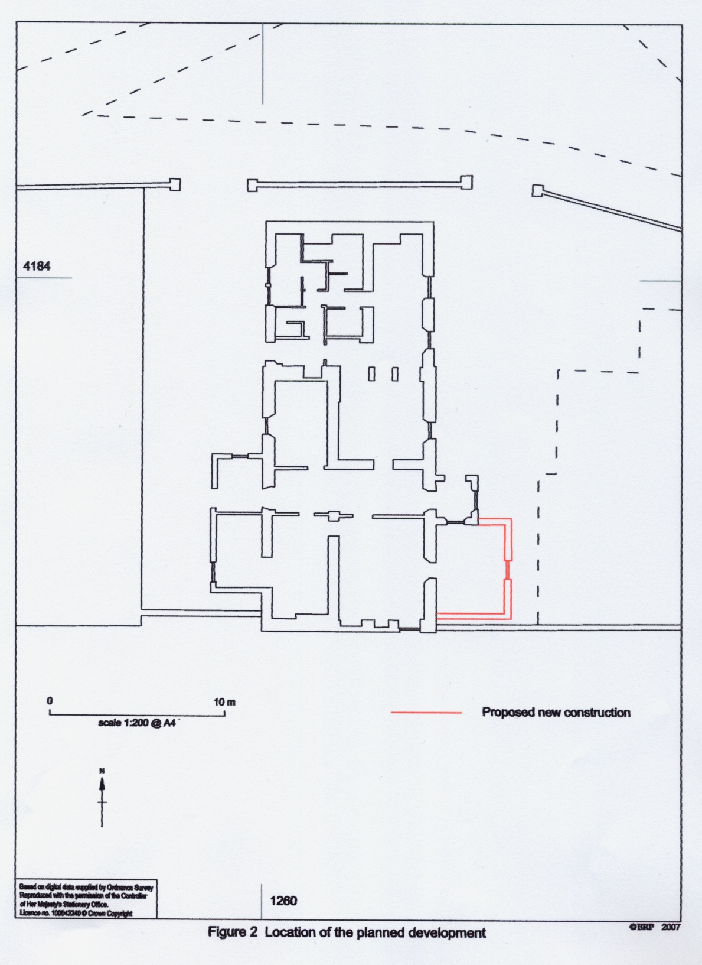

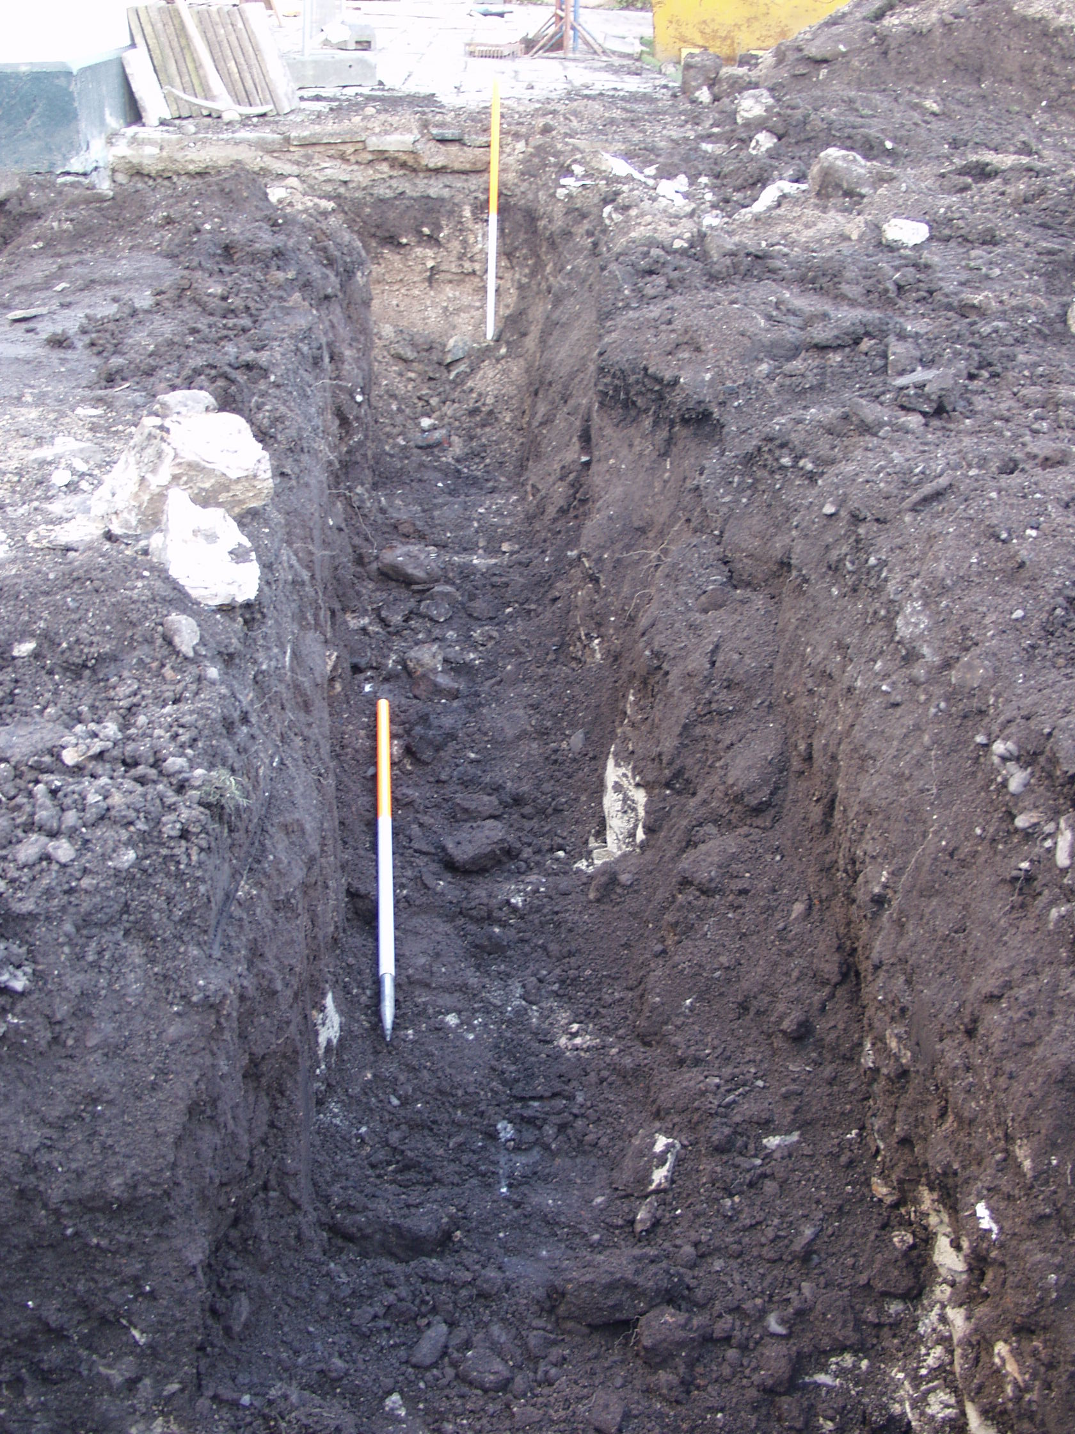

Plate 1 North to south construction trench, facing north

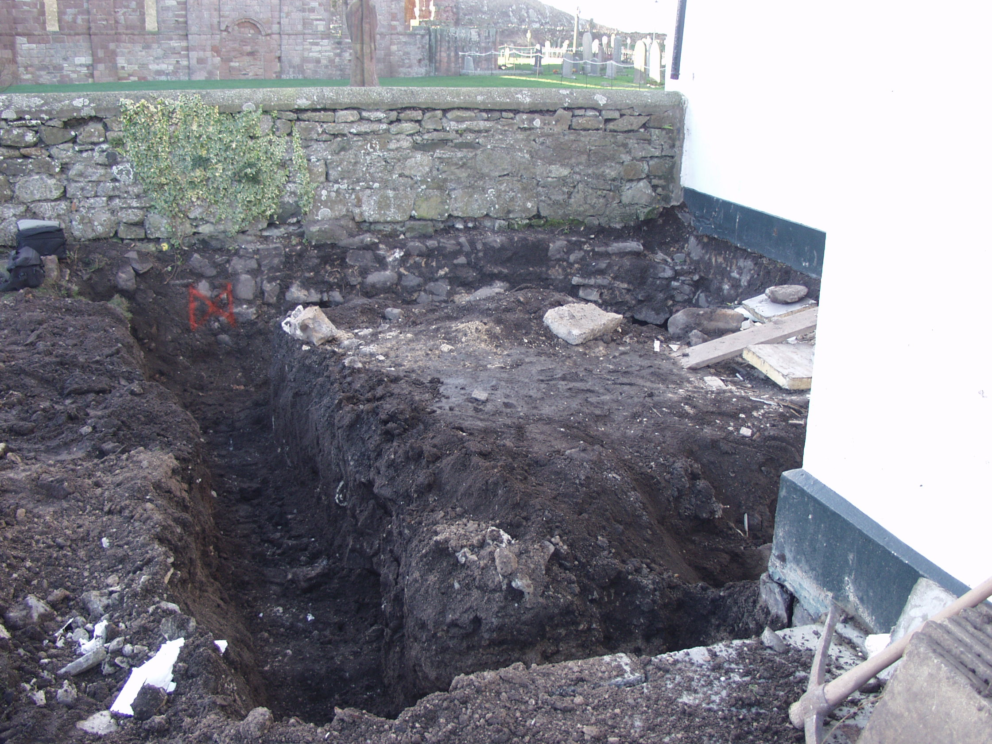

Plate 2 Construction trenches and exposed boundary wall, facing south

