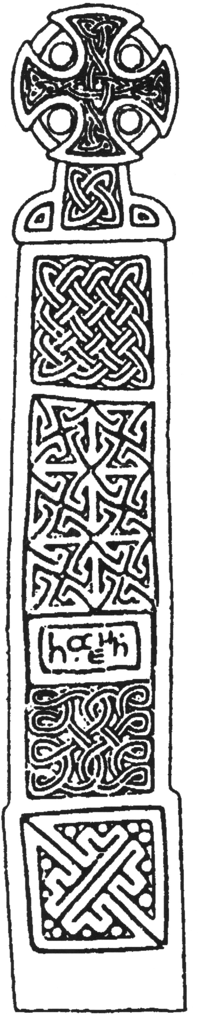
Archaeological Evaluation

Park House Cottage

Church Stretton

Shropshire

NGR: SO 45256 93711

BORDER ARCHAEOLOGY

Head Office
PO Box 36
Leominster
Herefordshire
HR6 0YQ
Tel: 01568 760453
E-mail: enquiries@borderarchaeology.com

Technical Services
Chapel Walk

Burgess Street
Leominster
Herefordshire
HR6 8DE
Tel: 01568 610101
Tel/fax: 01568 616900
E-mail: borderarch@btconnect.com

Southern Office
Southgate Chambers
37/39 Southgate Street
Winchester
Hampshire
SO23 9EH
Tel: 0845 6015506

BORDER ARCHAEOLOGY
Head Office

PO Box 36
Leominster
Herefordshire
HR6 OYQ

Technical Services
Chapel Walk
Burgess Street
Leominster
Herefordshire
HR6 8DE

May 2004

NGR:
Report No.
BA0551BOCS March 2006
Contents
1. Non Technical Summary 3
2. Introduction 4
2.1 Soils & Geology 4
3. Site Specific Historical & Archaeological Background 5
4. Methodology 6
5. Results 6
5.1 Trench 1 6
5.2 Trench 2 10
6. Conclusion 12
7. Copyright 12
8. Bibliography 12
9. Cartography 13
10. Context Register 14

Report specification:
Project manager: Graham Cruse BA
Draft Report: Graham Cruse BA & Stephen Priestley MA
Artwork: Michelle Bithell BA
Report editing: George Children MA
Approved: Neil Shurety
- Non Technical Summary

The evaluation at Park House Cottages, Church Stretton, comprised two trenches located on the east side of the property on an area of scrub garden (Trench 1: 6m N-S x 2.5m E-W) and at the front of the property, to the west of the driveway (Trench 2: 2.4m E-W x 1.4m N-S).

Trench 1 produced no definite evidence of activity predating the post-medieval period. One of the earliest features revealed appears to have been either a natural watercourse or a holloway. Two later pit features appeared to be 19th century or later and were still active during a phase of activity possibly relating to the demolition and subsequent levelling of the probable barn or stable building fronting onto Church Way recorded on the Church Stretton tithe map of 1840-41, which appears to have been taken down by 1883.

Trench 2 did not contain any evidence of the structure recorded on the tithe map of 1840-41. This is likely to be due to the structure having shallow foundations, which were fully truncated during the demolition process represented by (202).

- Introduction

Border Archaeology was instructed by Border Oak Design & Construction Ltd on behalf of Mrs Forbes, Park House Cottage, Church Way, Church Stretton, Shropshire, to carry out an archaeological evaluation at Park House Cottage (NGR SO 45256 39711).

Copies of this report will be submitted to the client, Mr M Watson (Historic Environment Officer, Shropshire County Council) and the Shropshire County Council Sites & Monuments Record (SMR).

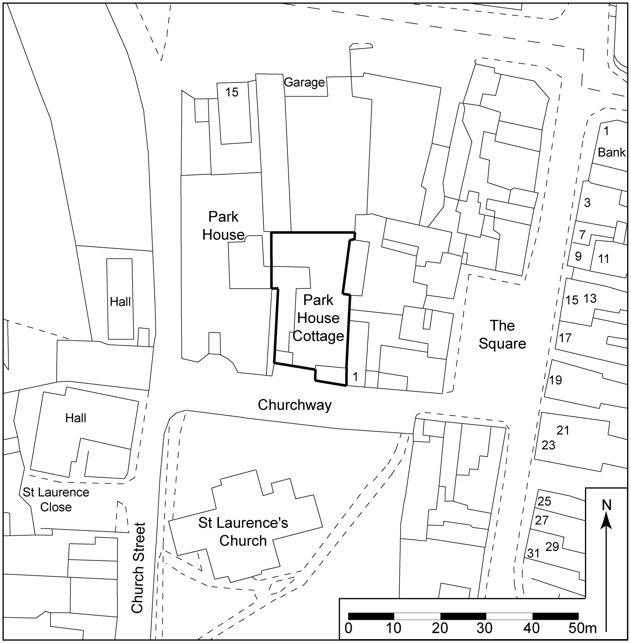

Fig. 1: Site Location Plan (NGR SO 45256 39711)

Soils & Geology
The majority of the town lies within an area of stagnogleyic argillic brown earths of the SALWICK series (572m), consisting of deep reddish fine loamy soils and some deep well-drained coarse loamy soils overlying reddish till and glacio-fluvial drift. The western area of the town comprises typical brown podzolic soils of the WITHNELL 2 series (611e), consisting of well-drained loamy soils, sometimes reddish and shallow locally, over pre-Cambrian sandstone, siltstone and conglomerate.

- Site Specific Historical & Archaeological Background

The site is located on the N side of Church Way, immediately opposite the parish church of St Lawrence, close to the centre of the historic settlement of Church Stretton. Prehistoric activity is the surrounding area is well attested, including finds of Mesolithic and Neolithic date, a significant number of Bronze Age barrows and an Iron Age hillfort at Caer Caradoc.

The present settlement, first recorded as Stratun in the Domesday survey of 1086, derives its name from the Roman road Watling Street, which passes to the E of the road and may have originated as an Anglo Saxon settlement just off this major routeway (Mills, 2003, 443). The church of St Lawrence (SMR Ref. 10070), which is mentioned in the Domesday survey, is situated immediately S of the site and consists of a large cruciform structure of largely 12th-13th century date, heavily restored in the mid 19th century (Pevsner, 1958, 100-101)

By the early 12th century, Church Stretton had become a royal manor. The inhabitants of Church Stretton received a market charter from King John in 1214 and a new planned urban settlement was possibly laid out at this time (Buteux, 1996). The street plan of the medieval settlement at Church Stretton seems to have remained in use throughout the post-medieval period with relatively little change, even in spite of a serious fire in 1593 that destroyed a large number of buildings in the town (Bilbey, 1985; Currie, 1998). The original medieval street layout is still clearly traceable on Rocque’s map of 1752, the 1840-41 tithe map and the OS 1st edition 6-inch map of 1883 and probably consisted of Church Street and the narrow lanes shown to the E and W of the High Street, including the present Church Way (denoted as Cub Lane on the tithe map).

The Park House Cottage property originally formed part of an estate belonging to Park House, an 18th century house situated to the N of Church Way. Park House itself probably originated as a parker’s or warrener’s lodge belonging to a mansion called The Hall, built in the early 17th century by Bonham Norton, a wealthy London stationer, and which was demolished in 1818 (Currie, 1998). From about 1840 to 1870 Park House was used as a school.

The tithe map of 1840-41 shows that the site was then occupied by an L-shaped complex of outbuildings immediately SE of Park House, consisting of an oblong building aligned N-S, at right angles to which was a long rectangular structure aligned E-W (probably a barn or stables) directly fronting onto Cub Lane. By the early 1880s, this long rectangular structure had been demolished leaving only the oblong structure (present-day Park House Cottages) aligned N-S as shown on the OS 1st edition 6-inch map of 1883.

- Methodology

Two evaluation trenches were opened at Park House Cottage, the first of which (Trench 1) was located to the E side of the property on an area of scrub garden and measured 6m N-S x 2.5m E-W. The second trench (Trench 2) was located at the front of the property, to the W of the driveway, and measured 2.4m E-W x 1.4m N-S, these dimensions being governed by the presence of service lines.

Full written and drawn records of all excavated contexts were made in accordance with archaeological practices set out by the Institute of Field Archaeologists (1994; revised 2001). Archaeological deposits, features and structures were recorded in plan at a scale of 1:20 and in section or elevation at a scale of 1:10. All features and structures within the trenches were photographed using a 4.0 mega-pixel digital camera.

A detailed stratigraphic record was made using a context numbering system. This took the form of a three digit number beginning at (x01) - where x represents the trench number - and continuing sequentially.

A temporary benchmark was established on the site (value 197.96m OD).

- Results

Trench 1

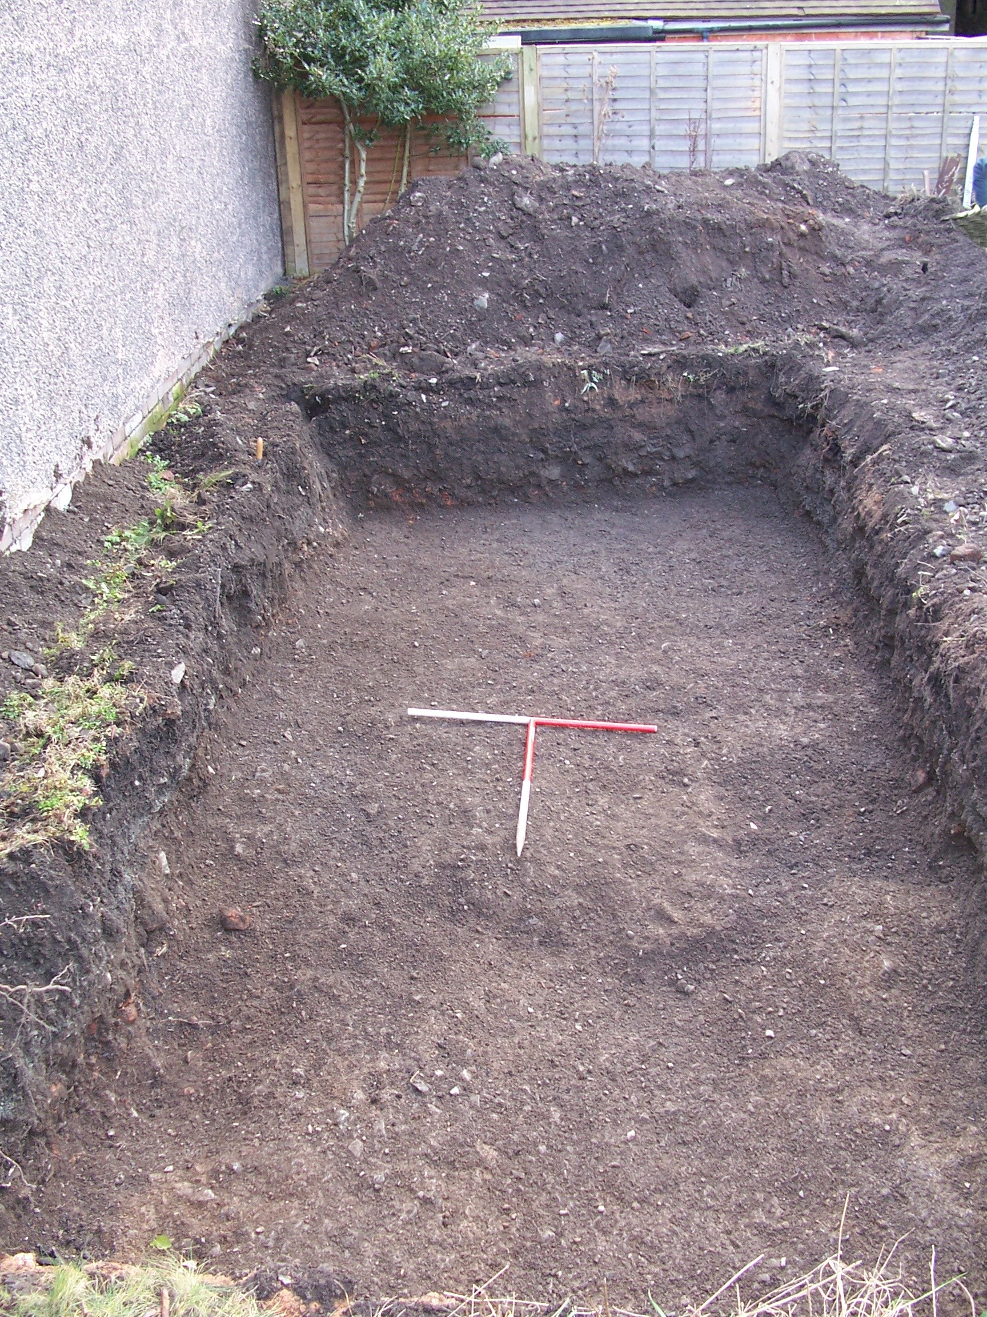

Plate 1: Trench 1, upper deposits removed, looking S
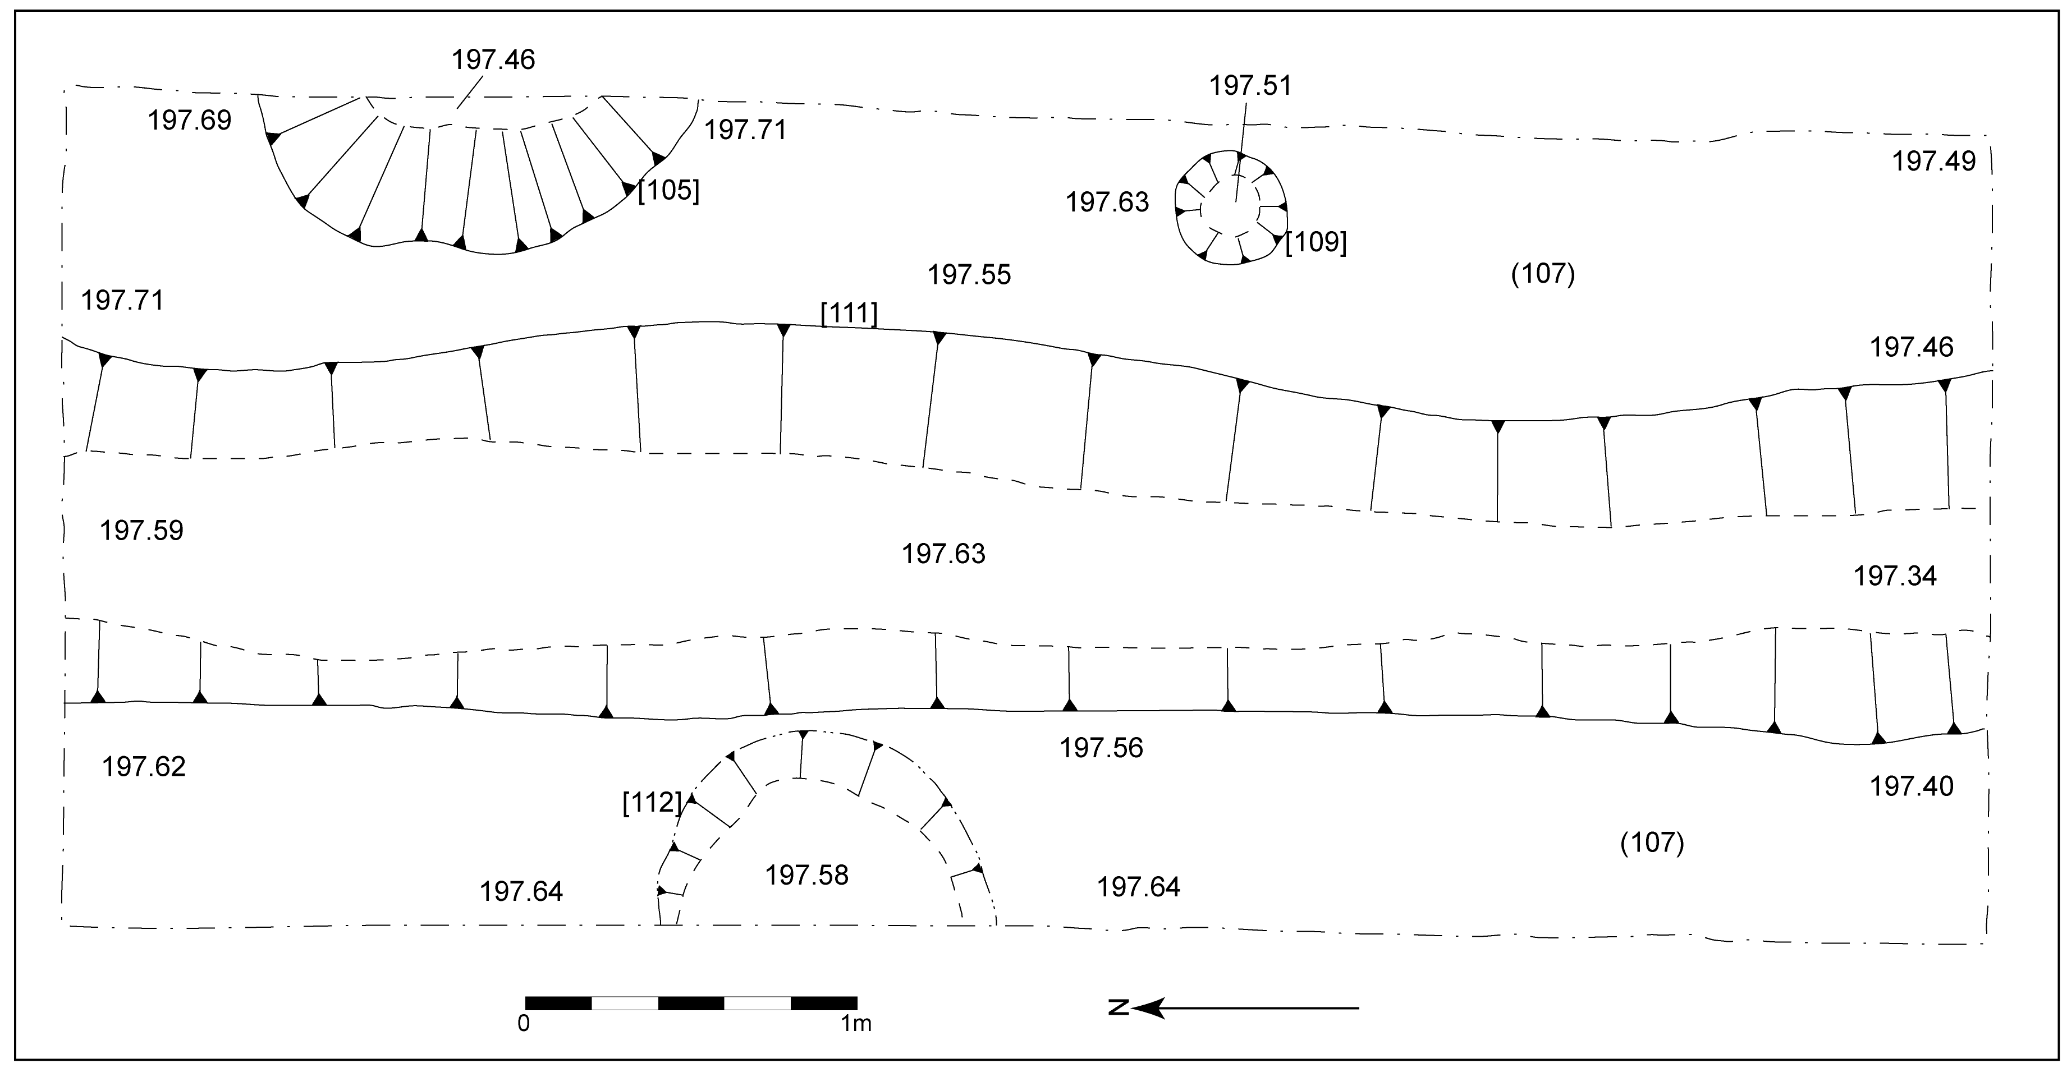

Fig. 2: Plan of Trench 1 showing location of features

Trench 1 produced 11 contexts, the uppermost of which was a loosely compacted dark brownish-grey silty sand with frequent black gravel and a maximum thickness of 0.45m (101). This was covered by a thin skim of topsoil and grass 0.02m thick and overlay a loose light grey gravel (102) with a maximum thickness of 0.06m. Both of these gravel layers probably represented an attempt to make up the ground level prior to the construction of Park House Cottage or the neighbouring property to the E.

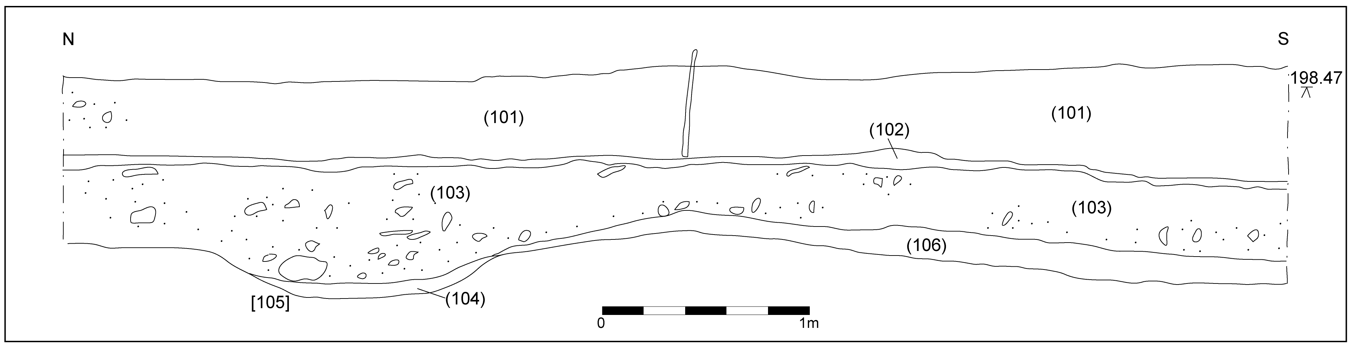

Fig. 3: W-facing section of Trench 1

Below (102) was a friable dark brownish-grey clayey sand (103) measuring a maximum of 0.58m in thickness. This appeared to be a demolition layer - or levelling deposit utilising demolition material - and overlay fill (104) in [105], a domestic waste pit protruding from the E baulk of Trench 1, its visible extent measuring 1.34m N-S x 0.45m E-W. Fill (104) was a friable mid greyish-brown sandy silt with occasional small angular stones and was only 0.08m thick, although [105] was cut to a depth of 0.23m, the remainder of the pit being filled by (103), suggesting that the pit was still in use at the time of demolition relating to (103). Fill (104) contained post-medieval material, including china and clay pipe, indicating an 18th/19th century date, or later.

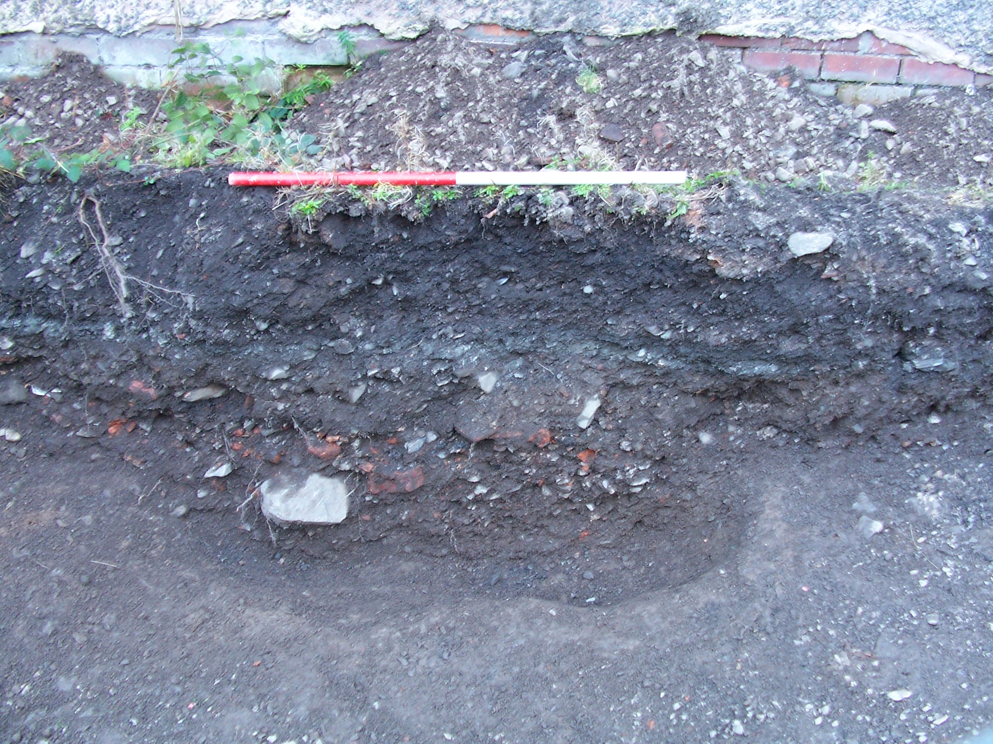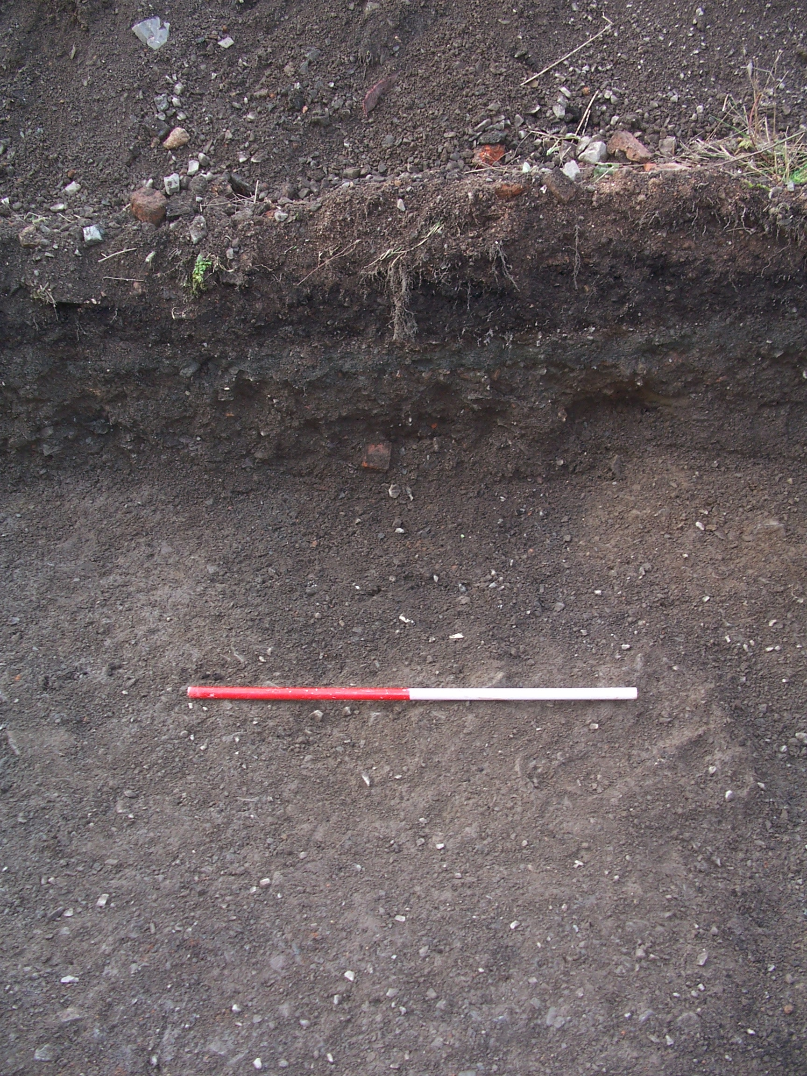

Plate 2: W-facing section of pit [105] Plate 3: E-facing section of pit [112]

On the W edge of the trench, protruding from the baulk, was what appeared to be a semicircular feature [112]. This feature cut into (106) and, as seen, measured 1.02m N-S x 0.56m E-W x 0.04m. The feature was backfilled by (103) and was thus probably open during the demolition/levelling episode represented by (103).

Pit [105] cut through a layer of loose, dark brownish-grey silty sand and gravel with a maximum thickness (at the southern end) of 0.18m, which contained occasional CBM fragments dating from no earlier than the 18th century (106). The northern end petered out, broadly where the feature was truncated by [105]. It is likely that this layer represented an attempt to level the ground, which sloped naturally to the S from the northernmost point of (106).

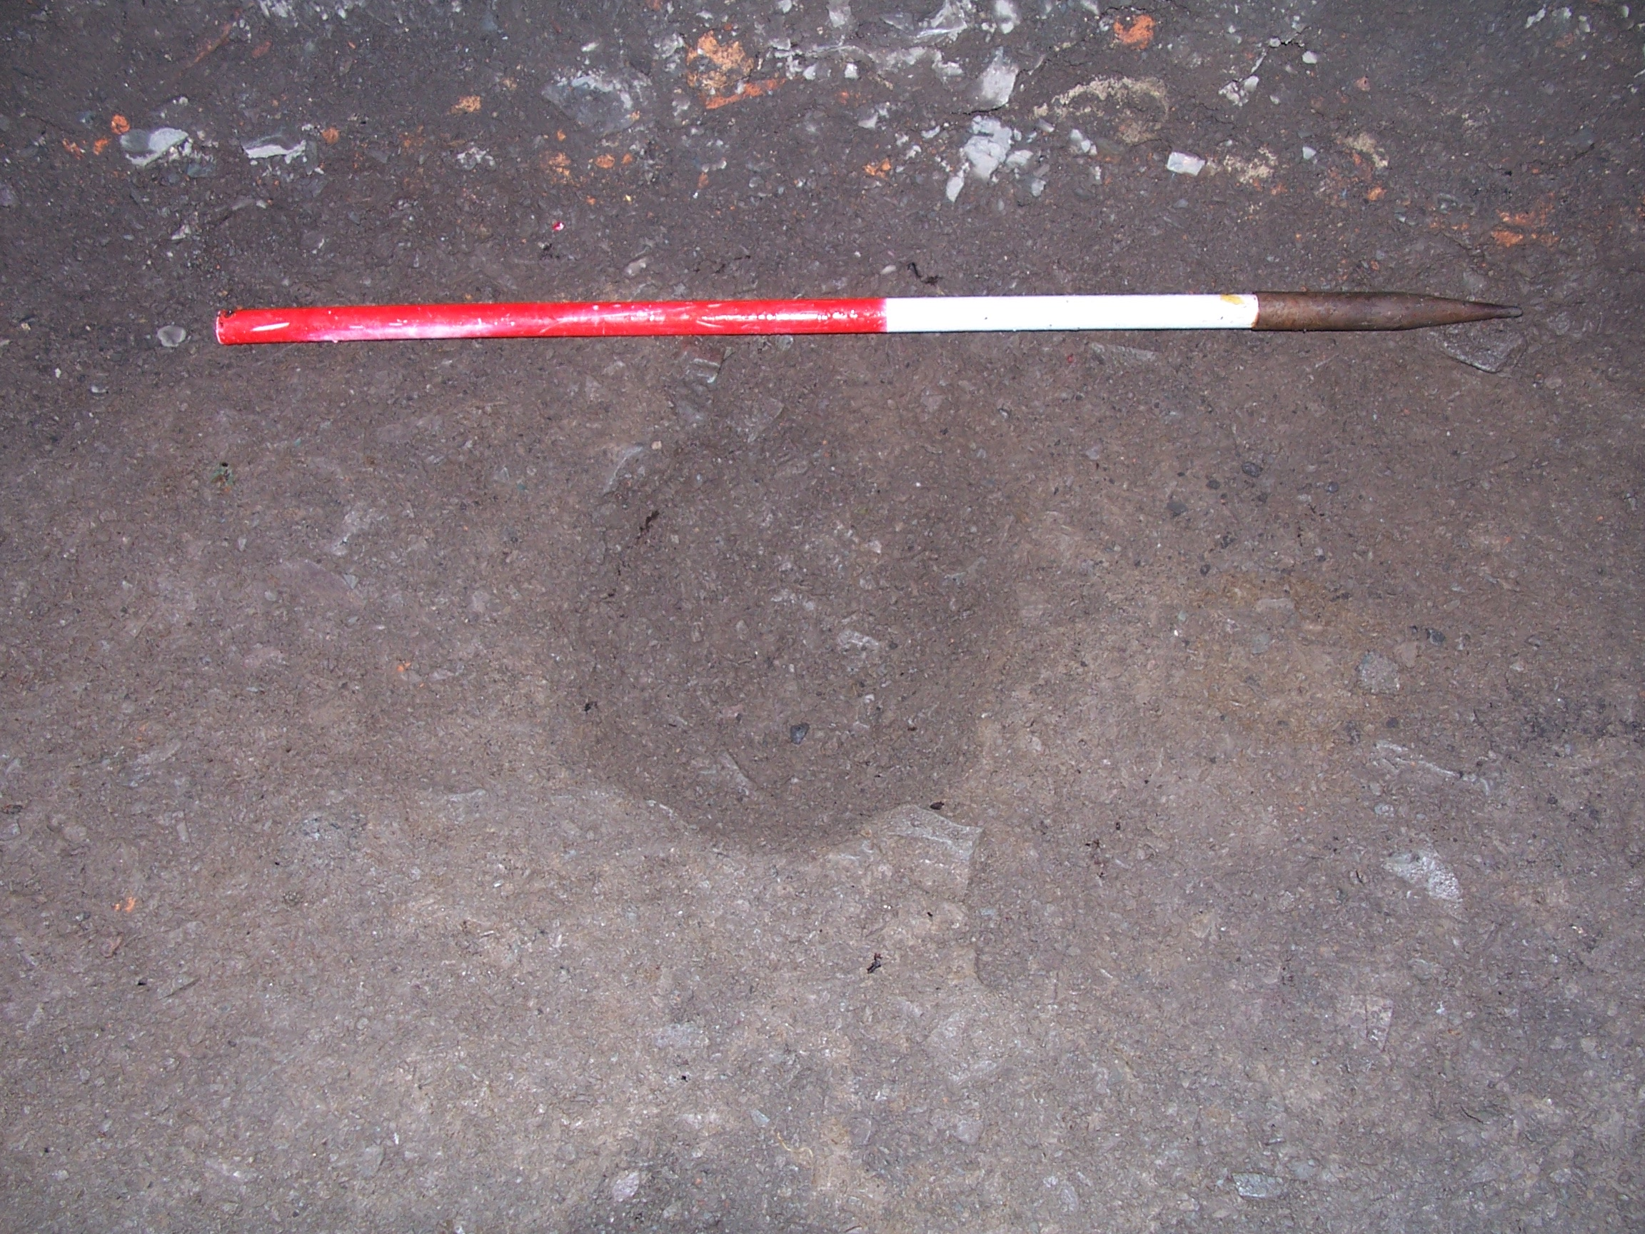

Plate 4: Circular feature [109], looking E

Layer (106) covered two features, [109] and [111]. The first of these [109] was a small circular feature, 0.35m in diameter and 0.14m deep, which was backfilled with a loose, dark brownish-grey sand and fine gravel deposit (108). No finds were recovered from this fill to help date or assign a function to [109], although it appeared to be a truncated pit or posthole.

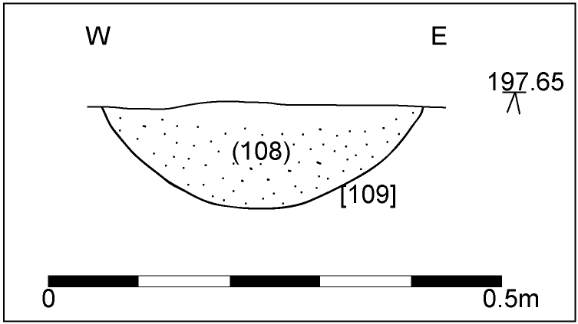

Fig. 4: S-facing section showing feature [109] in Trench 1

The second feature [111] was a N-S linear extending beyond the trench. As seen, it measured 5.7m N-S x 1.4m E-W (at maximum) x 0.15m and its E and W edges were poorly defined and irregular. The single fill consisted of a friable mid greyish-brown sandy silt with occasional small angular stones (110); no finds were recovered to date the feature. Its irregular nature suggests [111] may have been a natural feature, such as a watercourse; alternatively, it may have been a holloway. If the latter, then it was presumably a track leading to the church and it is notable that this ‘track’ ran perpendicular to Church Way.

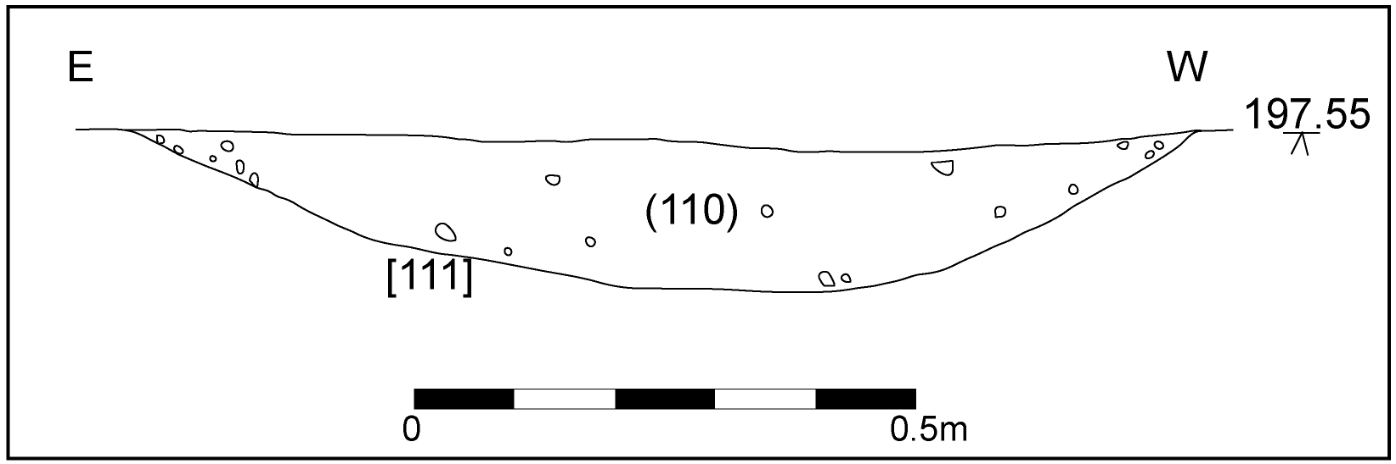

Fig. 5: N-facing section of feature [111] in Trench 1

Both [109] and [111] were cut into (107), a firm mid yellowish-brown clayey sand with very frequent small-to-medium angular sandstone fragments. This was densely compacted and was interpreted as natural material.

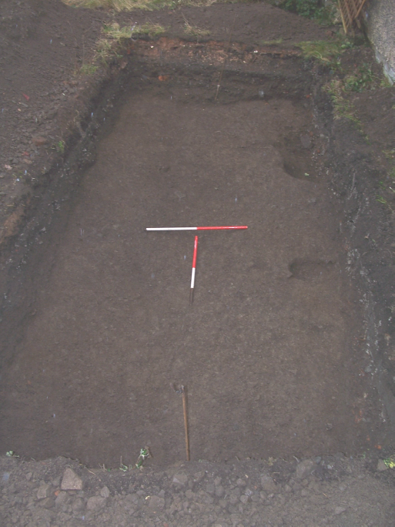

Plate 5: Looking N along alignment of [111]

Trench 2

This was a small trench measuring 2.4m E-W x 1.4m N-S, its dimensions being restricted by the presence of cabling. The trench produced five contexts, the uppermost of which (201) comprised concrete slabs, concrete sub-base and a thin capping layer of tarmacadam. The layer was 0.16m thick and overlay a friable dark brownish-grey silty sand with occasional CBM fragments (202), which was a maximum of 0.13m in thickness and appeared to be a demolition or levelling layer.

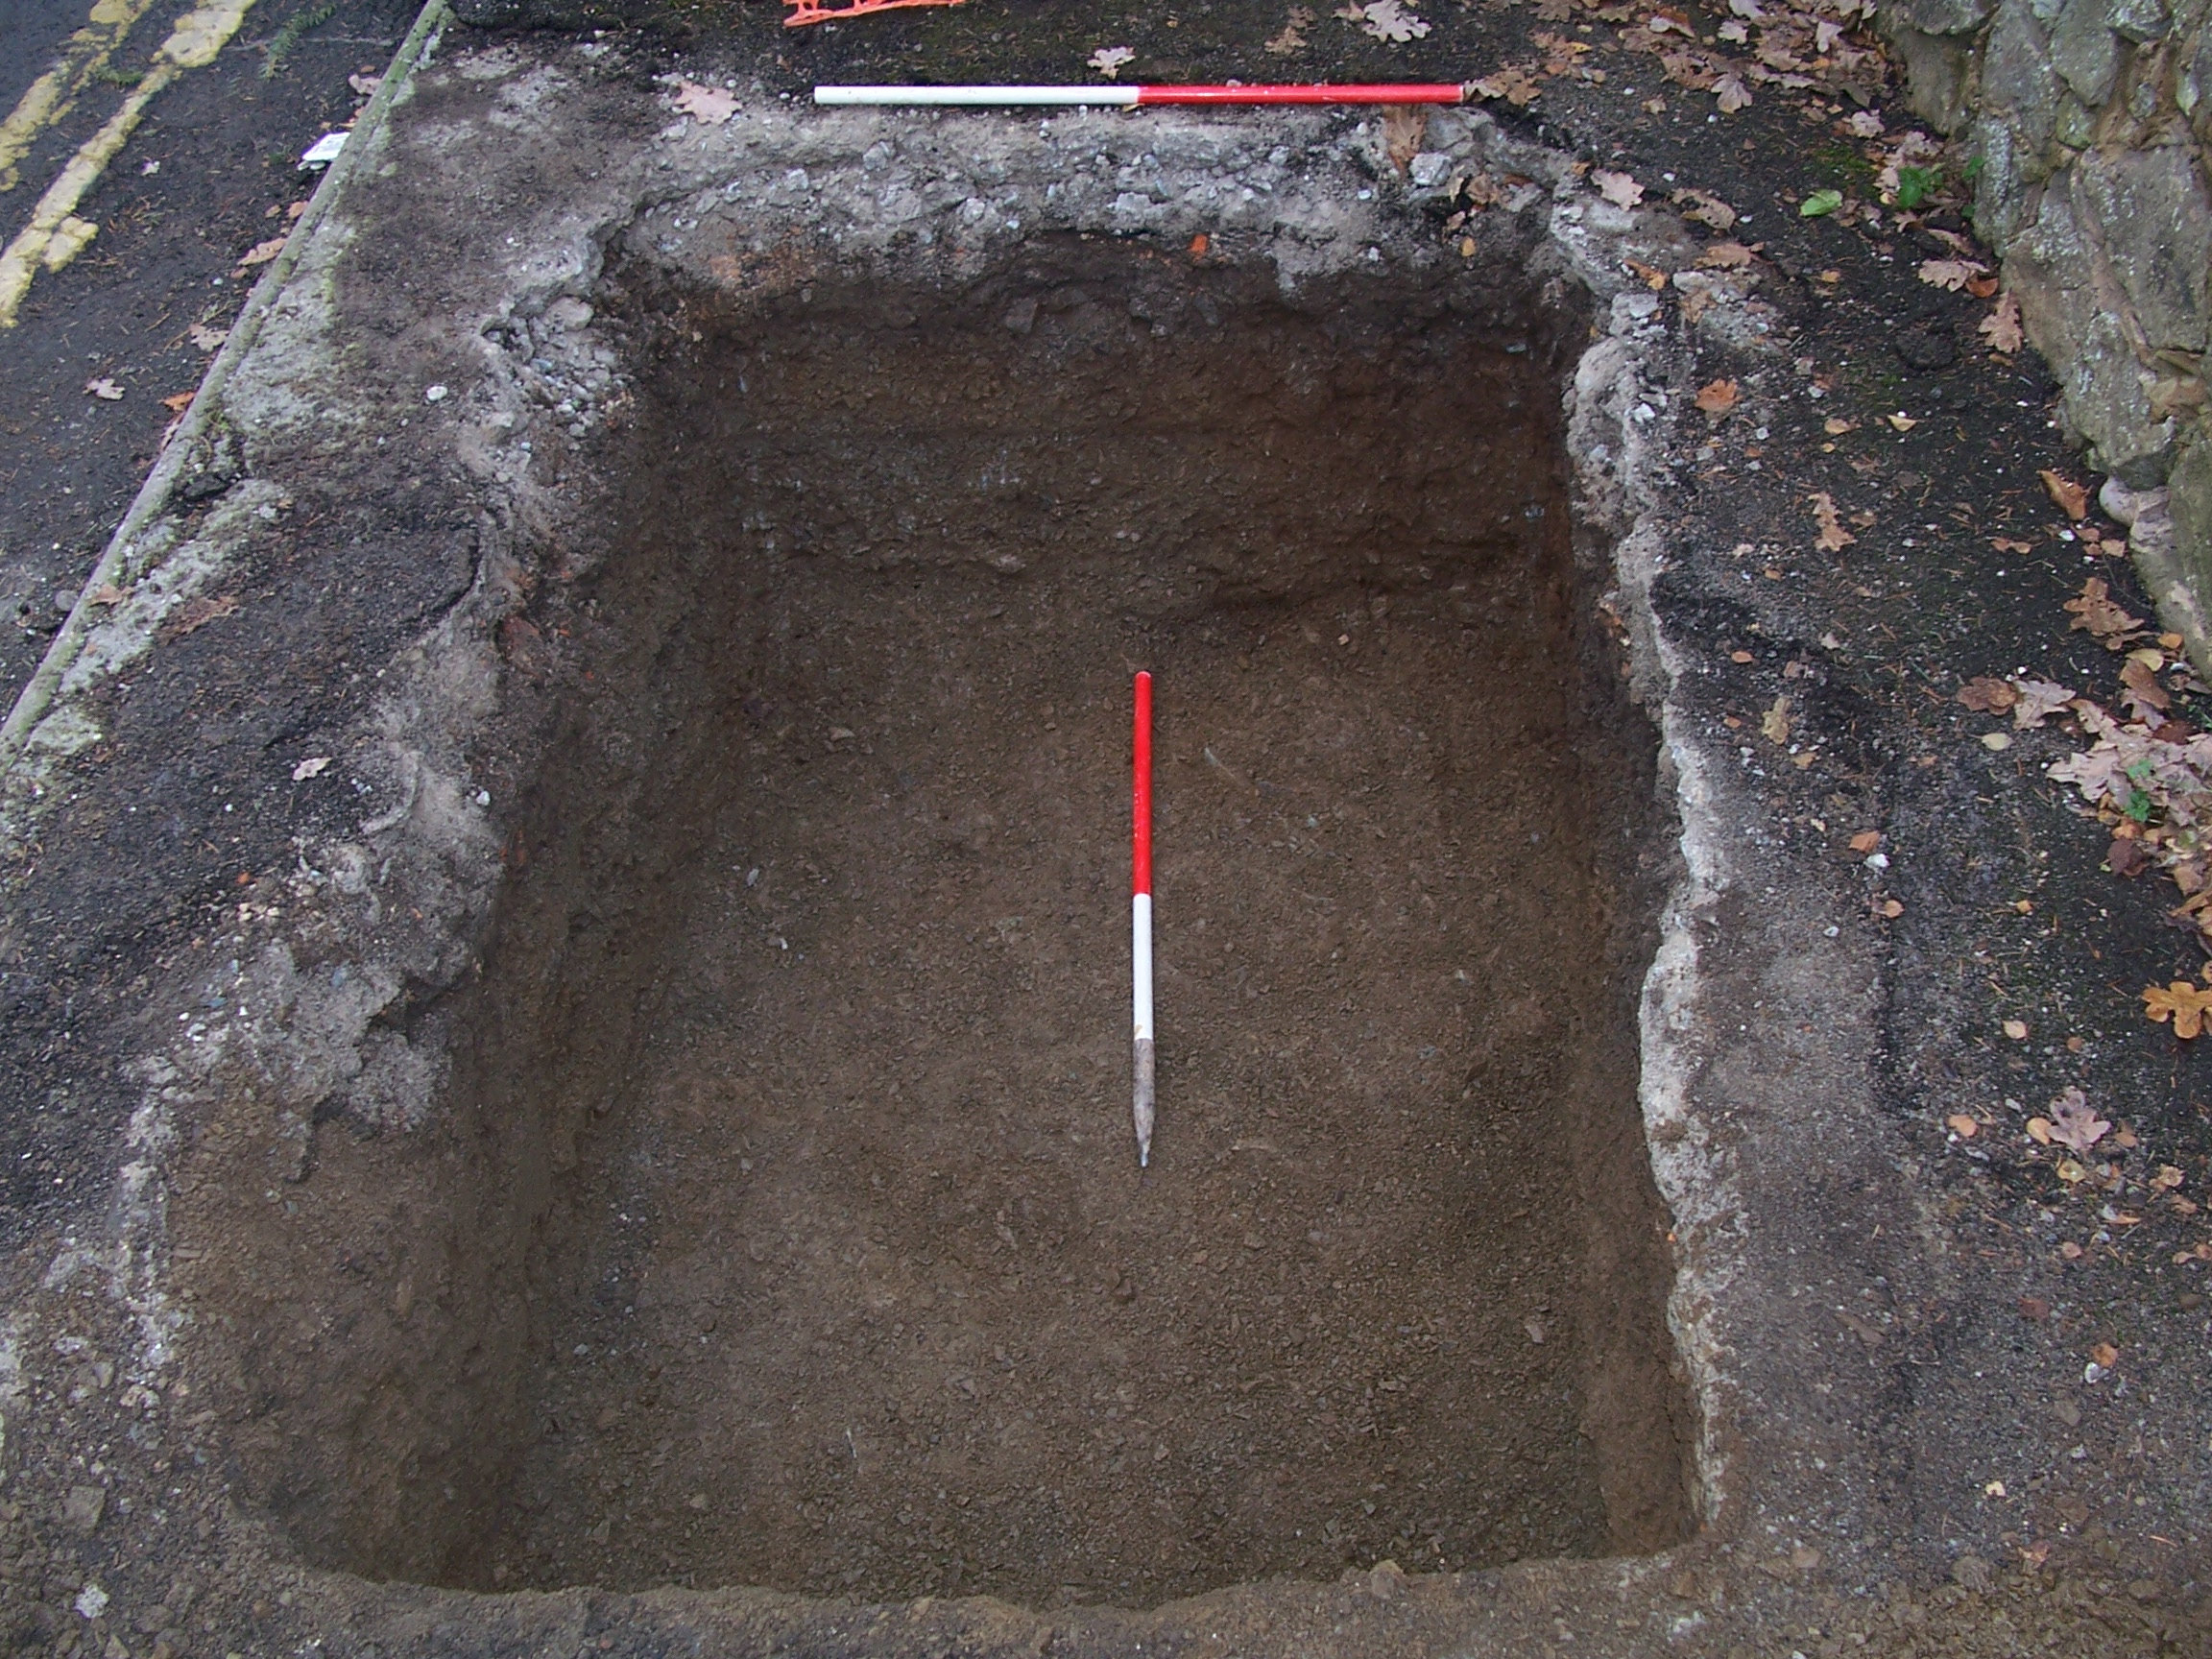

Plate 6: Trench 2, looking W

Below (202) were two gravel layers, (203) and (204). The first of these (203) was a loose dark yellowish-brown clayey sand with frequent gravel. This overlay a loose mid bluish-grey, slightly clayey sand with abundant gravel (204) on a steep incline, reminiscent of a cut feature. It was determined that this was not a cut feature based solely on the clean, undisturbed nature of the two deposits. These two deposits were interpreted as truncated colluvial deposits, with (203) being the later colluvium.

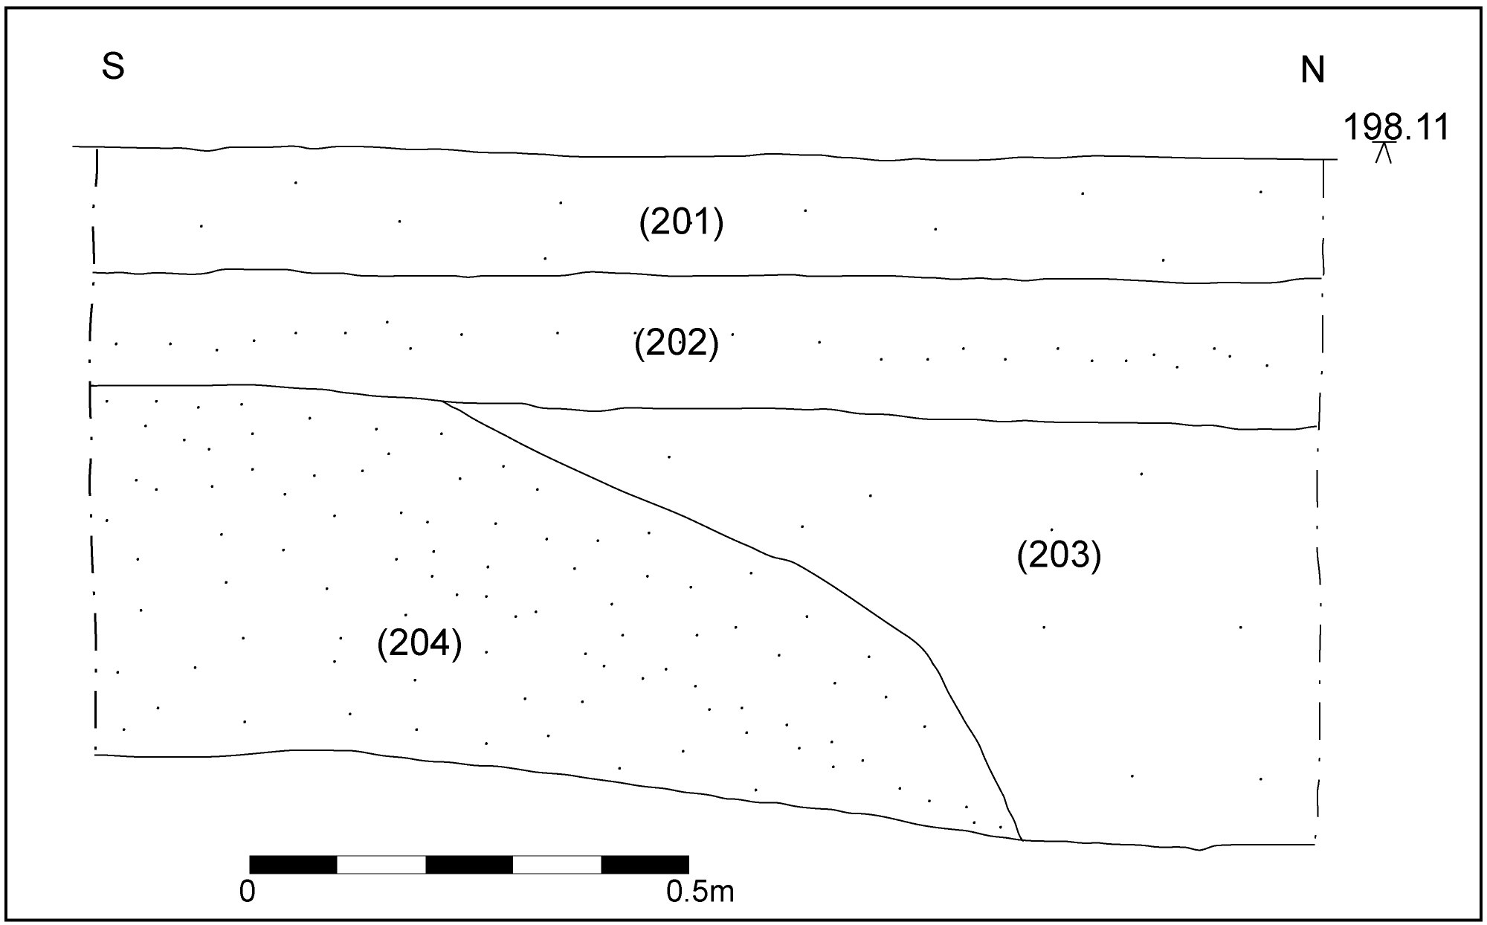

Fig. 6: E-facing section of Trench 2

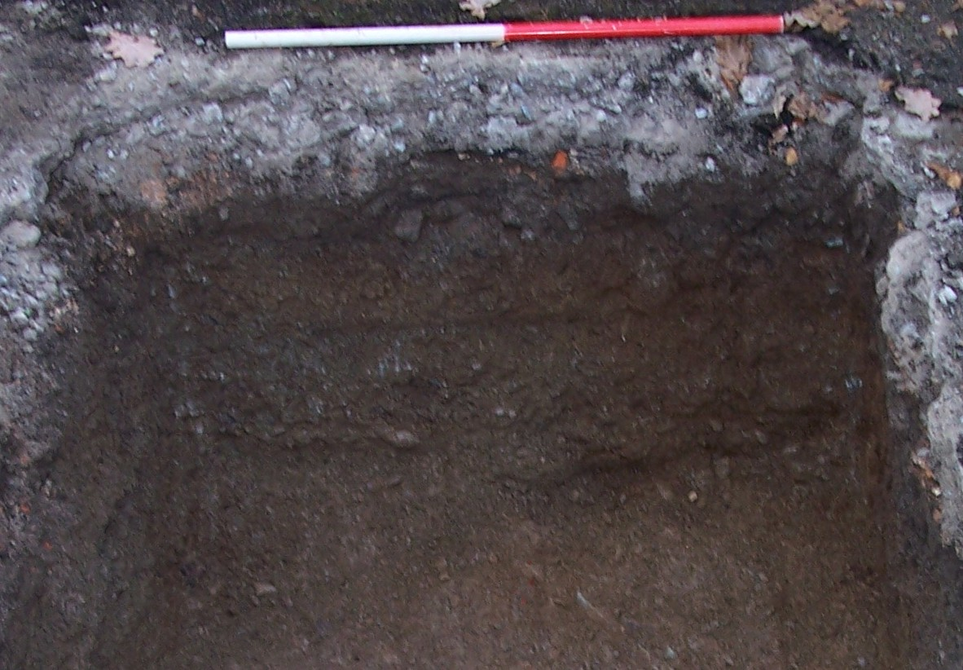

Plate 7: E-facing section of Trench 2, showing relationship of (203) and (204)

Deposit (204) overlay an extremely firm mid brownish-grey clayey sand with frequent small-to-medium angular stones and moderate gravel. This was interpreted as natural material.

- Conclusion

Trench 1 produced no definite evidence of activity predating the post-medieval period. The two earliest features discovered, [109] and [111], contained no material that could be used to ascertain their nature or date.

The two later pit features, [105] and [112], appeared to be 19th century or later and were still active during the demolition phase represented by (103). This may well relate to the demolition of the structures recorded on the tithe map of 1840-41 and subsequent levelling of the site.

Feature [111] appears to have been a natural watercourse or possibly a holloway running N-S towards the church of St Lawrence. However, no documentary or cartographic evidence has been found to confirm the existence of such a feature during the medieval or post-medieval periods.

Trench 2 did not contain any evidence of the structure recorded on the tithe map of 1840-41. This is likely to be due to the structure having shallow foundations, which were fully truncated during the demolition process represented by (202).

Layers (203) and (204) appear to have represented natural deposition, their relationship being caused by colluvial deposition.

- Copyright

Border Archaeology shall retain full copyright of any commissioned reports, tender documents or other project documents, under the Copyright, Designs & Patents Act 1988 with all rights reserved; excepting that it hereby provides an exclusive licence to the client for the use of the report by the client in all matters directly relating to the project as described in the Project Specification.

- Bibliography

Shropshire County Council: Sites and Monuments Record

Bilbey, D. 1985, Church Stretton: A Shropshire Town and Its People

Buteux, V., 1996, Central Marches Historic Towns Survey: Archaeological Assessment of Church Stretton, Shropshire

Currie, C.J.R. (ed.), 1998, Victoria County History of the County of Shropshire: Volume X: Munslow Hundred (pp. 72-120 Church Stretton)

Mills, A.D., 2003, Oxford Dictionary of British Place Names, Oxford

Pevsner, N., 1958, The Buildings of England: Shropshire, London

Thorn, F. & Thorn, C. (eds.), 1983, Domesday Book: Shropshire, Chichester

SSEW, 1983, Soil Survey of England and Wales, Silsoe

- Cartography

John Rocque’s Map of Shropshire – 1752

Church Stretton Tithe Map – 1840-41

OS 1st edition 6-inch map – 1883 (Shropshire 48 SE)

OS provisional edition 6-inch map – 1954 (Shropshire 48 SE)

OS 1: 10500 map - 1980

- Context Register

TRENCH 1
(101) | Loose dark brownish-grey silty sand with frequent gravel, covered by thin (0.02m maximum thickness) skim of topsoil. Maximum 0.45m thick. Overlies (102)
INTERPRETATION | Sand and gravel dump, apparently a levelling layer, perhaps relating to the construction of Park House Cottage or its neighbour to the E
(102) | Loose light grey gravel. Maximum 0.06m thick. Underlies (101). Overlies (103)
INTERPRETATION | Thin layer of gravel with no discernable function, may have been an initial dump of material prior to deposition of (101)
(103) | Friable dark brownish-grey clayey sand with moderate CBM fragments & small-medium angular stones, moderate gravel, occasional charcoal flecks and lumps. 0.58m thick at thickest. Underlies (102). Overlies (104)
INTERPRETATION | Demolition material, possibly rubble relating to demolition of earlier structures on site
(104) | Friable mid greyish-brown sandy silt with occasional small angular stones. 0.08m thick. Finds include china, clay pipe, CBM, pottery and animal bone. Underlies (103). Fills [105]
INTERPRETATION | Shallow fill of pit [105]. The fact that this pit was only partially filled with this material prior to the deposition of demolition material (103) suggests that the feature may still have been active at the time of demolition. The finds are indicative of domestic waste
[105] | Semicircular cut protruding into trench from E section. As seen, measures 1.34m N-S x 0.45m E-W x 0.23m, break of slope top sharp, sides steep and concave, break of slope base gradual, base, as seen, concave. Filled by (104). Cuts (106)
INTERPRETATION | Domestic waste pit, probably still active at the time of demolition relating to layer (103)
(106) | Loose, dark brownish-grey silty sand, frequent gravel, occasional CBM fragments. Maximum 0.18m thick. Extends over southern extent of trench. Cut by [105]. Overlies (108) and (110)
INTERPRETATION | Gravel spread of uncertain function. The nature of this is curious, as it is peters out to the N and becomes thicker to S. As ‘natural’ (107) slopes away to S, this may be an attempt to level that layer, although prior to what is unclear
(107) | Firm mid yellowish-brown clayey sand with very frequent small-medium angular sandstone fragments. Not excavated. Cut by [109] & [111].
INTERPRETATION | Natural deposition
(108) | Loose dark brownish-grey sand and fine gravel, i.e. small (maximum 10mm diameter) angular shale fragments. Maximum 0.14m thick. No finds recovered. Underlies (106). Fills [109]
INTERPRETATION | Loose gravelly fill of small feature [109]. Appears to be a deliberate backfill with this material, although for what function is unclear
[109] | Circular cut, 0.35m (diameter) x 0.14m (depth), break of slope at top sharp, sides gradual and concave, break of slope at base non-perceptible, base concave. Filled by (108). Cuts (107)
INTERPRETATION | Small shallow cut. May be the truncated base of a posthole or pit, although the purpose of either is uncertain
(110) | Friable mid greyish-brown sandy silt with occasional small angular stones. 0.15m thick. Underlies (106). Fills [111]
INTERPRETATION | Natural silting of linear [111]
[111] | N-S linear, irregular poorly defined edges, extends N & S beyond limit of Trench 1. As seen measures 5.7m N-S x 1.4m E-W (at maximum) x 0.15m, break of slope at top sharp, sides uneven generally gradual and straight, break of slope at base varies between gradual and non-perceptible, base uneven generally concave or flat. Filled by (110). Cuts (107)
INTERPRETATION | Irregular linear, possibly naturally formed, such as a water channel. Another possibility is a worn holloway, heading toward the church, although no evidence remains to support this and the alignment of the feature is skewed from that of the church
[112] | Semicircular cut protruding from W edge of trench. 1.02m N-S x 0.56m E-W x 0.04m as seen, break of slope at top sharp, sides shallow and straight, break of slope at base sharp, base flat. Underlies (103). Cuts (106)
INTERPRETATION | Truncated remains of a waste pit. No extant fill, backfilled by material from layer (103) during demolition/levelling episode. May simply be a depression in (106) which has given the impression of a feature
TRENCH 2
(201) | Concrete pavement surface capped by a thin layer of tarmacadam. Concrete adhered to a crumbly concrete sub-base material, the whole of which is 0.16m thick (maximum). Overlies (202)
INTERPRETATION | Concrete and (patchy) tarmacadam pavement
(202) | Friable dark brownish-grey silty sand, occasional CBM fragments, frequent small-medium angular stones, moderate charcoal flecks. 0.13m thick (maximum). Underlies (201). Overlies (203)
INTERPRETATION | Demolition rubble including C19th fabrics and C20th plastics. No finds retained from this layer
(203) | Loose dark yellowish-brown clayey sand, frequent gravel. 0.4m thick (maximum). Very clean – no finds or inclusions other than gravel. Underlies (202). Overlies (204)
INTERPRETATION | Gravel layer. Overlies (204) in a sharp descent similar to a cut yet material appears to be a natural deposit and it seems likely that (203) and (204) are two phases of colluvial deposition
(204) | Loose mid bluish-grey slightly clayey sand, abundant gravel. 0.56m thick (maximum). Underlies (203). Overlies (205)
INTERPRETATION | Gravel layer. Underlies (203) in a sharp edge similar to a cut, yet material appears to be a natural deposit, and it seems likely that (203) and (204) are two phases of colluvial deposition
(205) | Firm mid brownish-grey clayey sand, frequent small-medium angular stones, moderate gravel. Unexcavated. Underlies (204)
INTERPRETATION | Natural material similar in nature to (107) but with a slightly different colour and slightly higher gravel content.

Document Control

Job title | Park House Cottage Church Stretton Shropshire | Job No | BA0551BOCS
Report written by | Graham Cruse BA & Stephen Priestley MA
Report edited by | George Children MA
Issue No | Status | Date | Approved for issue
1 | Final | March 2006 | Neil Shurety

