.

Archaeological Observation

Tuckers Place

Newport

Shropshire

NGR: SJ 74520 19018

BORDER ARCHAEOLOGY

Head Office
PO Box 36
Leominster
Herefordshire
HR6 0YQ
www.borderarchaeology.com

Technical Services
Chapel Walk
Burgess Street
Leominster
Herefordshire
HR6 8DE
Tel: 01568 610101
Tel/Fax: 01568 616900
E-mail: borderarch@btconnect.com

Southern Office
Southgate Chambers
37/39 Southgate Street
Winchester
Hampshire
SO23 9EH
Tel: 0845 6015506

BA0523HCATP October 2005

Contents

1. Non Technical Summary 3
2. Introduction 4
2.1 Soils & Geology 5
3. Site Specific Historical & Archaeological Background 5
4. Methodology 5
5. Archaeological Observation 7
5.2 Test pit observations 7
5.3 Foundation strip observations 8
5.3.1 Plot 1 8
5.3.2 Plot 2 8
5.3.3 Plot 3 9
6. Conclusion 10
7. Copyright 10
8. Bibliography 11

Report specification

Archaeological observation & report compilation: Stephen Phillips BA
Historical research: Stephen Priestley MA
Report editing: George Children MA
Approved: Neil Shurety

- Non Technical Summary

Border Archaeology carried out archaeological observation of seven test pits and foundation trenching at Tuckers Place, situated within the medieval core of Newport. The site occupies part of a rear area of former medieval tenement plots but was heavily developed with the construction of small-scale factory buildings in the early 20th century.

Due to the site’s history of intensive industrial use, it is probable that any earlier archaeological features or deposits would have been heavily impacted. The groundworks revealed a large amount of demolition material together with modern domestic waste and scrap metal indicative of significant disturbance. No evidence of activity predating the 20th century was identified.

The archaeological observation thus confirms that no archaeology was damaged or disturbed by the groundworks.

- Introduction

Border Archaeology was instructed by Mr J Beaman of Acorn Homes to carry out archaeological observation of groundworks at Tuckers Place Newport Shropshire (Planning Application Ref. W2005/0043).

The site was first visited on August 9th 2005 to observe the excavation of seven test pits by the developer, these being to ascertain soil depth and composition prior to construction.

The site was visited again on October 12th & 13th to monitor the excavation of ‘all ground disturbance works associated with the erection of plots 1 to 8, where these works involve strip foundations’ (as specified in the amended brief dated September 5th issued by Shropshire County Council Historic Environment Officer Michael Watson). Plots 4 to 8 were to be pile-driven foundations and thus did not facilitate archaeological observation.

Copies of this report will be submitted to Acorn Homes, Shropshire County Council and the county Sites and Monuments Record.

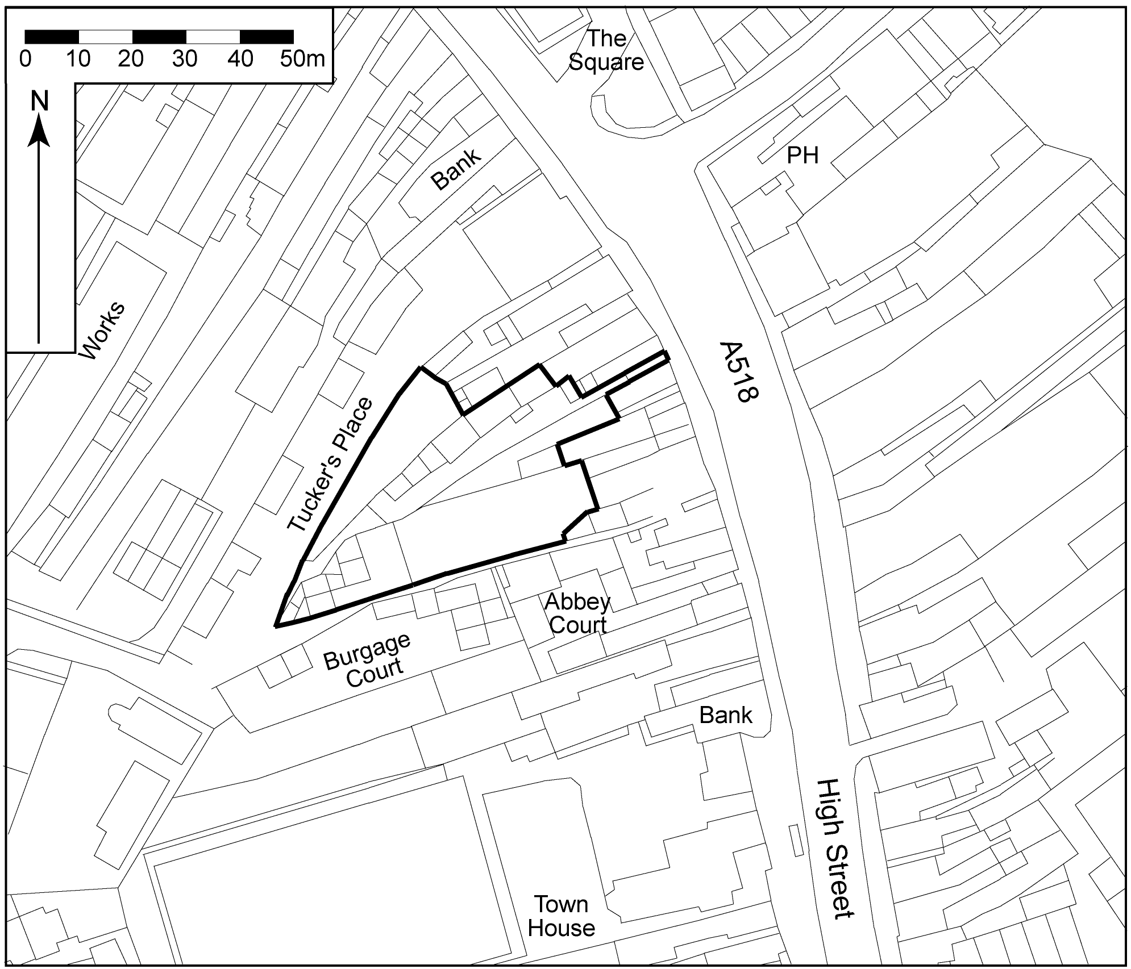

▲Fig. 1: Site location plan

Soils & Geology

No information was obtainable concerning the geology of the study area, which is classed as unsurveyed in the Soil Survey of England and Wales (SSEW, 1983) on account of its heavily urbanized location.

The predominant soil type in the area immediately N and E of Newport consists of the typical brown sands of the NEWPORT 1 (551d) series, comprising deep well drained coarse and loamy soils; the underlying geology consisting of glaciofluvial drift.

- Site Specific Historical & Archaeological Background

The site is located within the historic town of Newport, an urban settlement of medieval origin established as a borough by King Henry I in the early 12th century. The street plan of the medieval town is clearly traceable and consists of regularly distributed long narrow burgage plots on either side of the High Street, the main N-S route through the town. This road probably predates the town and may be Roman in origin (Buteux et al., 1996).

The boundaries to the rear of the burgage plots on the W side of the High Street (in the vicinity of Tuckers Place) are curvilinear and may have been formed by a stream or the edge of marshy ground to the W of the town. The OS 1st edition 6-inch map of 1881 shows some building activity to the rear of the burgage plots (garden sheds and some small workshops). However, it was not until the early 20th century that the area was heavily developed with the construction of a number of small-scale factory buildings.

The specific site at Tuckers Place is shown on the OS 1st edition map of 1881 as occupying an area to the rear of one of the medieval tenement plots at the S end of the High Street. At this time the area seems to have been used as a garden and a small rectangular building (presumably a storage shed) is depicted in the SE corner of the plot. It appears not to have been developed for industrial use at that date. At some point in the early 20th century a light industrial works was erected on the site, which continued in occupation at least until the late 1970s.

- Methodology

The aim of the programme of archaeological work was to locate and record any archaeological remains revealed during the course of groundworks.

The area of the proposed development was machine excavated under archaeological supervision. A toothless bucket was used to excavate plots 1-3; the test-pit excavations, however, required the use of a toothed bucket due to the large amount of modern brick and concrete encountered.

All associated spoil was scanned for artefacts, which were recorded but not retained.

The depth and complexity of deposits were assessed and written and photographic records of all machine-excavated areas where archaeological observation was required were made in accordance with best archaeological practice. Records included an overall construction trench and site plan (Fig.2).

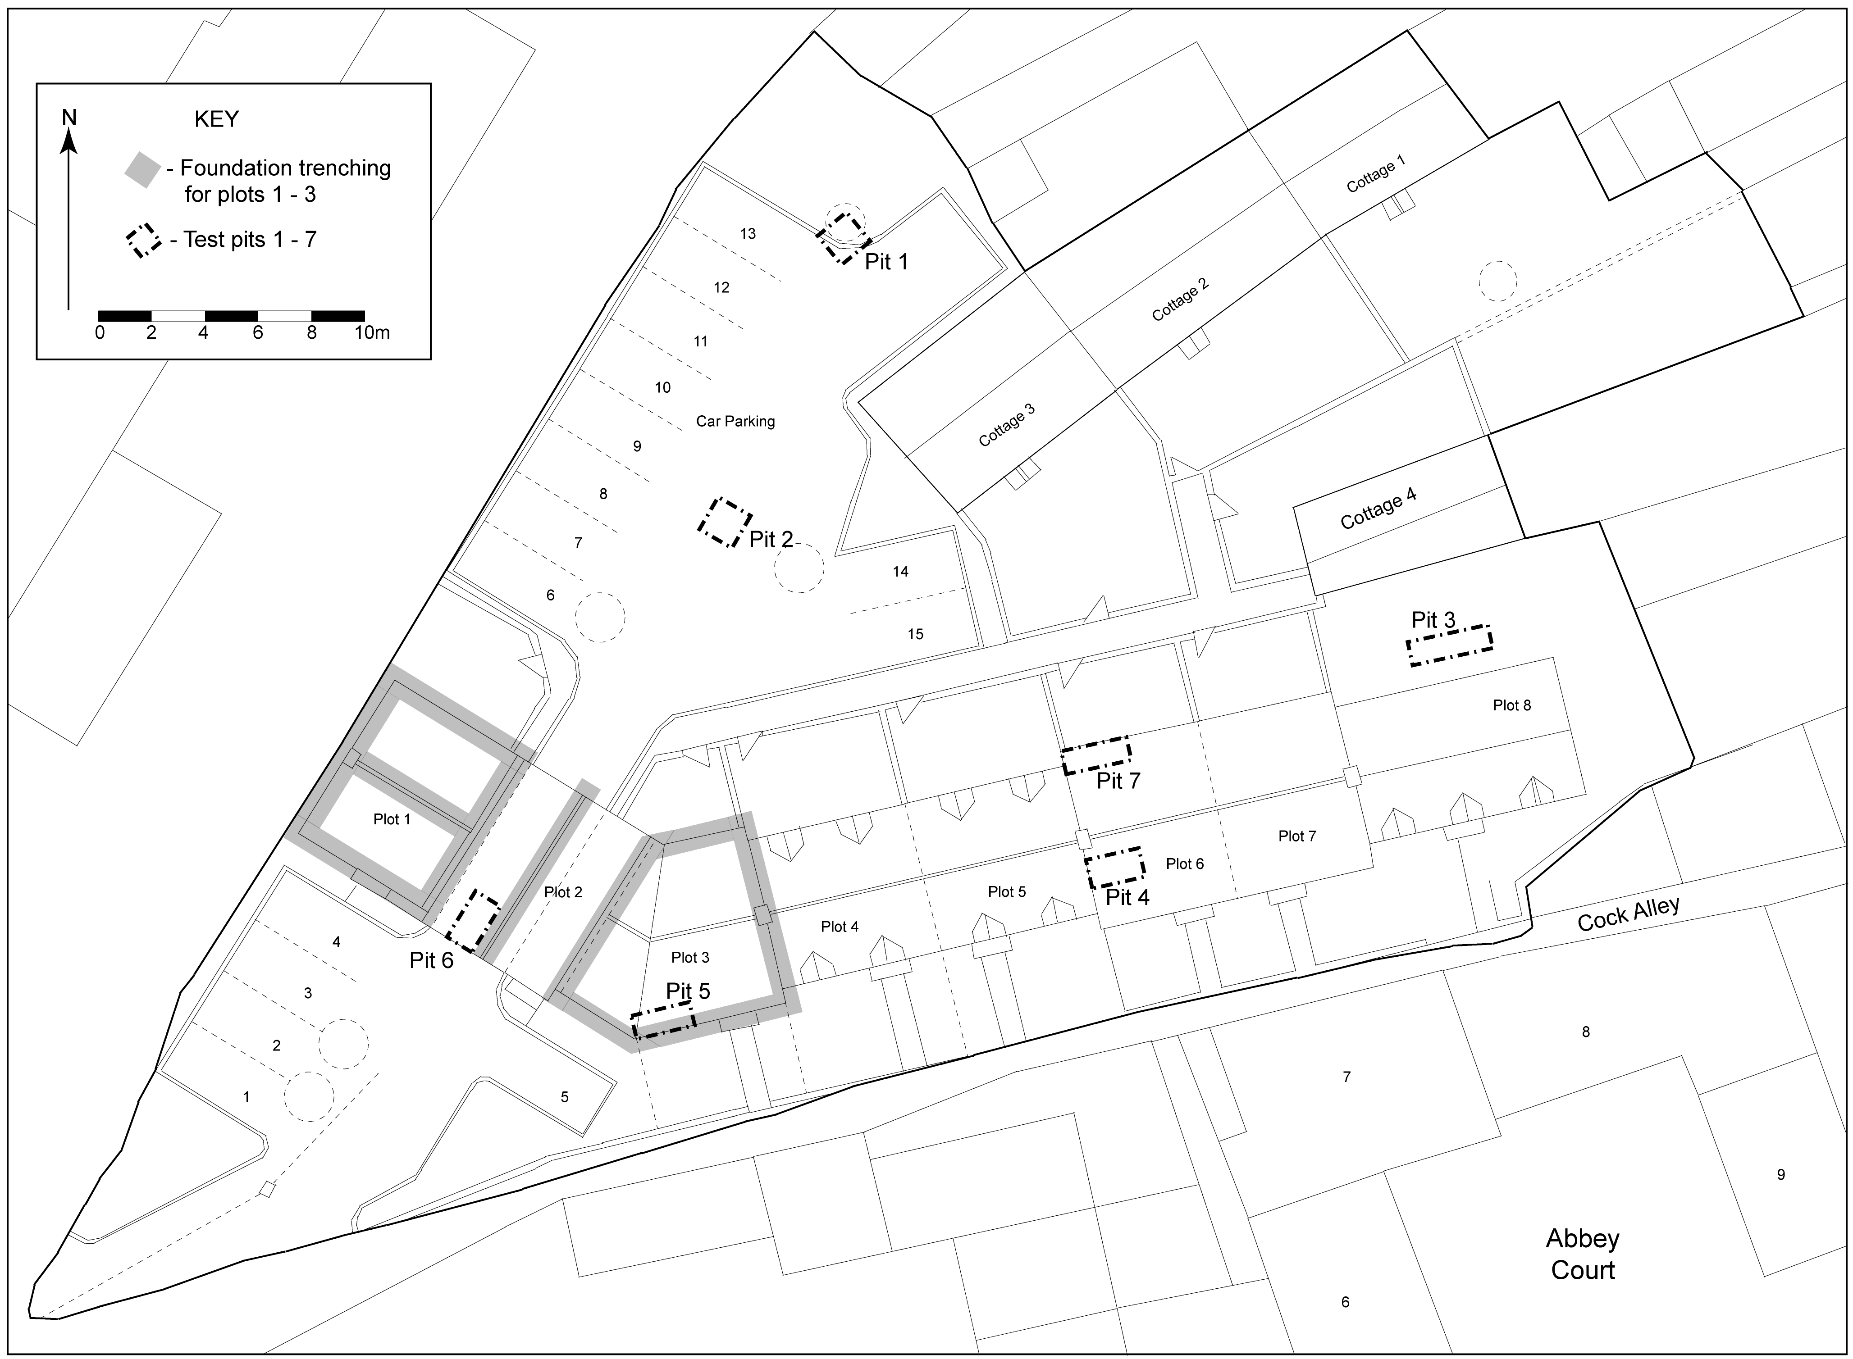

▲Fig. 2: Plan of site showing location of foundation trenching and test pits

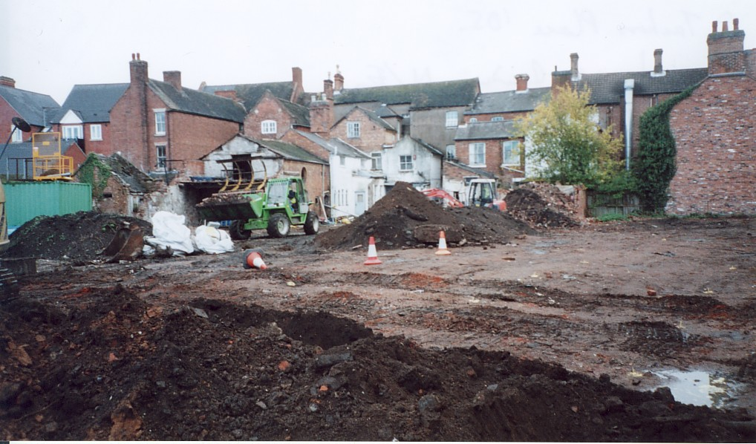

▲Plate 1: View of site facing NE

- Archaeological Observation

Seven test pits were excavated for engineering purposes to ascertain the depth and composition of the underlying soils. Following the removal of topsoil, foundation (or footing) trenches for plots 1-3 were excavated to a depth of 0.95-1m below existing ground level.

Test pit observations

The following table details the findings of the seven test-pit excavations carried out on 9th August 2005. All pits were excavated by machine.

Date | Grid Ref/Pit No. | Location | Description | Assessment
09/08/2005 | SJ 74539 19039 Pit 1 | N end of site near existing cottage 3 | Blackish-grey friable loamy sand with very frequent C20 CBM & metal, occasional charcoal & plastic >> brownish-grey friable loamy sand, heavy root action, occasional charcoal & CBM >>mid brown moderately compacted sandy clay loam, occasional charcoal. | No significant archaeology
09/08/2005 | SJ 74528 19031 Pit 2 | Approximately 7m SW of existing cottage 3 | Blackish-grey friable loamy sand, root action, frequent C20 CBM >>orange-brown moderately compacted sandy clay, occasional charcoal >> orange-brown moderately compacted sandy clay. | No significant archaeology
09/08/2005 | SJ 74559 19032 Pit 3 | W end of site, 3.8m from wall of existing cottage 4 | Grey friable sand/grit, frequent modern CBM >> stone & brick floor >> floor sub-base stone >> dark brownish-grey moderately compacted sandy loam & grit (20%), occasional CBM & charcoal >>light brown moderately compacted silty sand, heavily disturbed >> light brown moderately compacted silty sand. | No significant archaeology
09/08/2005 | SJ 74540 19017 Pit 4 | Approximately 8m from Cock Alley on Plot 6 | Brownish-grey friable sand/grit topsoil, frequent CBM >>brick dump deposit & industrial C20 glass cased batteries, loose compaction. Brick wall on E side running NE-SW. | Industrial dumping deposit, probably early C20
09/08/2005 | SJ 74528 19011 Pit 5 | Approximately 5m from Cock Alley on Plot 3 | Brownish-black friable sand & grit deposit, frequent modern CBM >>concrete floor >>brown friable sand & grit, ash deposits (5%) >> dark brown moderately compacted sandy loam deposit, moderate ash, occasional CBM >> light brown moderately compacted silty sand. | No significant archaeology
09/08/2005 | SJ 74520 19018 Pit 6 | Entrance to site on Plot 2 | Demolition brick deposit, 20% sand/grit, friable soil compaction >> dark brown friable sandy loam, occasional CBM, ash lense >>mid brown moderately compacted silty sand. | No significant archaeology
09/08/2005 | SJ 74543/19016 Pit 7 | On Plot 6 approximately 4.7m N of Pit 4 | CBM dumping deposit with c.25% dark brown friable sandy loam soil >> mid brown moderately compacted sandy silt loam. | No significant archaeology

Foundation strip observations

Border Archaeology carried out further archaeological observation on the 12th and 13th October during the excavation of strip foundations for plots 1-3.

Plot 1
This comprised 30m of strip foundation trenching measuring approximately 1m in width, although this was subject to variation due to trench wall collapse.

The trenching revealed 20th century demolition material consisting of blackish-grey friable sandy loam containing frequent grit (25%) inclusions and frequent modern CBM (101) extending to a depth of approximately 0.84m and throughout the foundation area.

Underlying this was an apparent natural deposition consisting of orange-brown friable sand with occasional patches of sandy clay (102) extending to the base of the trenching at a depth of 0.97m.

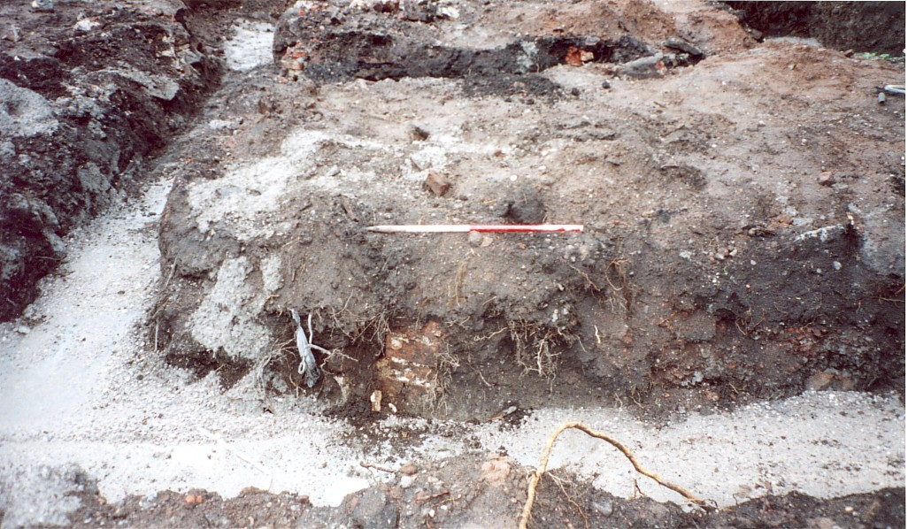

▲Plate 2: Plot 1 foundation trench facing SW

Plot 2

The trenching comprised approximately 8m of strip foundation measuring 0.8m wide.

A deposit of 20th century demolition material consisting of blackish-grey friable sandy loam with moderate grit (15%) inclusions and frequent modern CBM & concrete (201) extended throughout the trenching to a depth of approximately 0.72m.

Underlying this was an apparent natural deposit of orange-brown friable sand with occasional patches of sandy clay (202) extending to the base of the trenching at a depth of 0.95m.

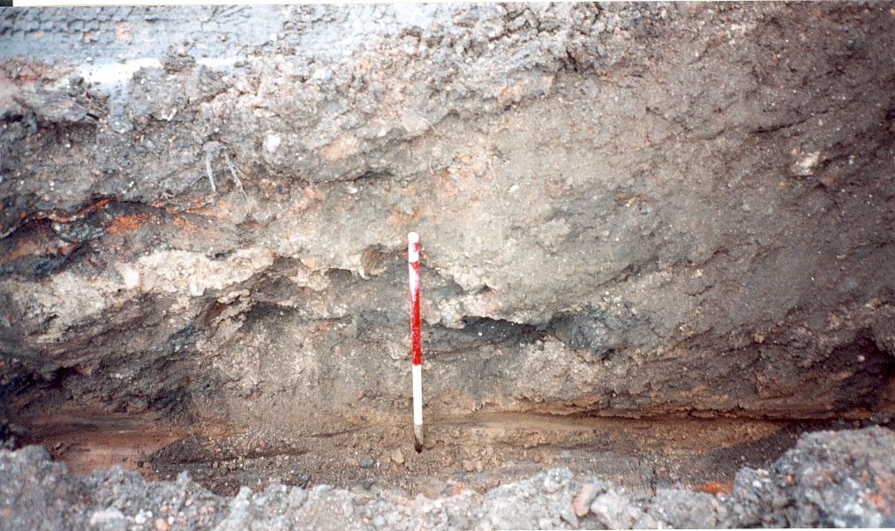

▲Plate 3: Plot 2 foundation trench facing SE

Plot 3

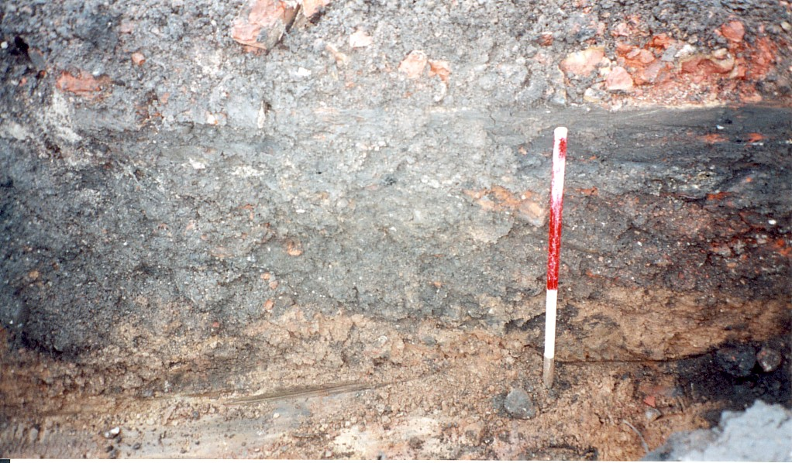

▲Plate 4: Plot 3 foundation trench facing SW

The trenching comprised approximately 25m of strip foundation measuring 0.85m wide.

The uppermost deposit was a blackish-grey friable sandy loam with moderate grit (15%) inclusions and frequent modern CBM & concrete extending throughout the trenching to a depth of approximately 0.7m. This again represented 20th century demolition material.

This material overlay orange-brown friable sand with occasional patches of sandy clay (302) extending throughout the area to a depth of 0.98m.

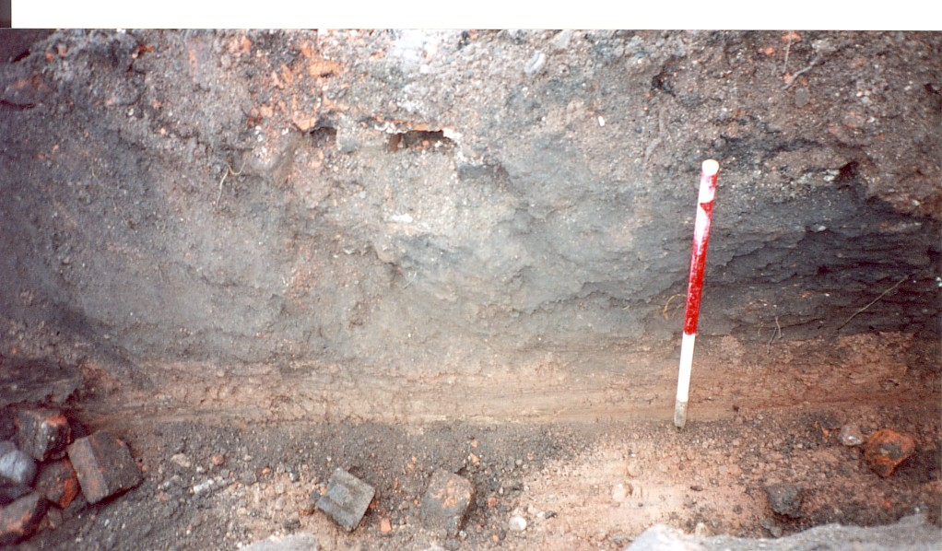

▲Plate 5: Plot 3 foundation trench facing S

- Conclusion

The deposition observed above natural sand primarily comprised demolition material relating to industrial buildings of probable early 20th century date. No indications of earlier activity were identified.

Due to its history of intensive industrial use and the extent of demolition deposits revealed, it is probable that any earlier archaeological features or deposits would have been heavily impacted.

A large amount of modern domestic waste and scrap metal was found throughout the development area, indicating the site has been subjected to significant disturbance.

- Copyright

Border Archaeology shall retain full copyright of any commissioned reports, tender documents or other project documents, under the Copyright, Designs and Patents Act 1988 with all rights reserved; excepting that it hereby provides an exclusive licence to the client for the use of the report by the client in all matters directly relating to the project as described in the Project Specification to use the documentation for their statutory functions and to provide copies of it to third parties as an incidental to such functions.

- Bibliography

Buteux, V et al., 1996, Archaeological Assessment of Newport, Shropshire
Pevsner, N., 1958, The Buildings of England: Shropshire, London

Soil Survey of England and Wales, 1983, Silsoe, England

OS 1st edition 6-inch map - 1881

Document Control

Job title | Tuckers Place Newport Shropshire | Job No | BA0523HCATP
Report written by | Stephen Phillips BA & Stephen Priestley MA
Report edited by | George Children MA
Issue No | Status | Date | Approved for issue
1 | Final | November 2005 | Neil Shurety

