Archaeological Excavation

St Mary’s Church
Linton
Ross-on-Wye
Herefordshire

Report No: BA0315LIN

BORDER ARCHAEOLOGY
PO Box 36
Leominster
Herefordshire
HR6 OYQ

Contents

1. Non-Technical Summary 3
2. Introduction 4
3. Historical & Archaeological Background 4
4. Methodology 5
5. Results 6
5.1 Trench 1 6
6. Summary 9
7. Bibliography 9
8. Copyright 9
Appendix1: Site Summary 10

REPORT SPECIFICATION

Project management: Paul Jones BA
Draft report: Paul Jones BA
Artwork: Paul Jones BA
Report editing: George Children MA

Non-Technical Summary

The initial presumption that the presence of human remains would require manual excavation of the trench was understandably correct and, despite the narrowness of the trench, five inhumations were revealed.

These formed a series of burials that probably date to the 18th and early19th centuries.

Disarticulated human remains found during the programme of excavation seem to imply that the churchyard was used continuously for burial prior to these dates.

The inhumations in situ were carefully protected before the trench was used and reburial of one individual was subsequently undertaken.

Introduction

Border Archaeology was commissioned by Bartosch & Stokes on behalf of the Parochial Church Council to excavate a drain trench and soak-away within the southern area of the churchyard of St Mary’s Church, Linton, near Ross-on-Wye, Herefordshire (NGR: SO 660 253), extending from the southwest corner of the external façade of the chancel, the aim being to facilitate the laying of the drains by the appointed contractor and to determine the existence of human remains.

The work followed usual on-site procedures that complied with standards set by the Health and Safety Executive (HSE).

This Report has been produced according to guidelines issued by the Institute of Field Archaeologists (1994; revised 2001) and reflects planning legislation & guidance notices. Copies will be submitted to the PCC, Bartosch & Stokes and to the Herefordshire Sites and Monuments Record.

2.1 Geology

The soils surrounding St Mary’s Church are of the BROMYARD 571b association and consist of well drained reddish fine silty soils overlying parent shale and siltstone.

Historical & Archaeological Background

There is evidence of human activity in the vicinity of Linton dating from the Neolithic or Early Bronze Age. A large quantity of flint cores, rough scrapers and other flint implements, mostly of Neolithic date, have been found in a site located 0.25 miles NW of Linton Church, suggesting the existence of an occupation site or working floor during this period (Herefordshire Archaeology SMR Record 822). Situated close to this Neolithic occupation site is an earthwork feature, of unknown date, consisting of a ditch with outer bank some 130 yards long and a slightly scarped platform to the S (Herefordshire SMR Record 821).

Linton is recorded as a royal demesne manor, in the hands of William the Conqueror, at the time of Domesday Book (1086), when it was valued at £10. The manor was held by King Edward the Confessor before the Conquest and originally appears to have been a substantial land-holding. However, the extent and revenues of the manor, post-Conquest, are described in Domesday as having been ‘greatly reduced’. The church at Linton is recorded in Domesday (implying its existence before the Conquest) and is said to have been held by the French Benedictine house of Cormeilles. The existing church incorporates fabric dating from the 12th century (including parts of the nave, the N aisle and arcade) and the 13th century (chancel, porch, S arcade and aisle), while the W tower was added in the late 14th century. The church was extensively restored in 1875 and the spire repaired in 1904 and 1913 (Herefordshire Archaeology SMR 7309).

Linton was subsequently granted in about 1160 by Henry II to Richard de Talbot, who built a motte and bailey castle at nearby Eccleswall, situated approximately 1.25 miles SSW of Linton Church. Eccleswall Castle was subsequently abandoned by the Talbots in the 1340s, when they acquired Goodrich Castle. However, the Talbots (and their descendants, who became earls of Shrewsbury) retained possession of Linton until well into the 16th century.

Methodology

A trench was located within the southern area of the churchyard extending from the SW corner of the external façade of the chancel (Fig. 1). The trench, measuring 15.00m x 0.40m, was oriented SW-NE. The depths of the trench varied from 0.45m to c.1.00m below existing ground level due to the gradient needed for the fall of the intended drain. All trenching was hand excavated (Plate 1).

At the termination of the SW section of the trench a single trial pit measuring 1.20m x 1.20m, with a depth of c.1.30m, was excavated by hand. This formed the area for the insertion of an associated soak-away.

If any burials were encountered, the depths being dependent on the relative graded depths of the trench, then total excavation of that inhumation would be implemented. Burials not likely not to be impacted by the insertion of the services only entailed a very limited recording procedure.

Full written and drawn records of all excavated contexts were made in accordance with archaeological practices set out by the Institute of Field Archaeologists. The trench was photographed using monochrome, colour print and colour transparency film.

A detailed stratigraphic record was made using the following context numbering system: Trench 1 (001)-(007). All trenching was excavated by hand to the first significant archaeological horizon or natural deposits (whichever was encountered first).

The trench was surveyed using a benchmark located in the northwest corner of the chancel (value 114.91m OD). A Temporary Bench Mark (value 115.60 OD) was established on the site. A value of 114.27m OD was recorded at the base of the trench.

FIG. 1 - Site and Trench Location

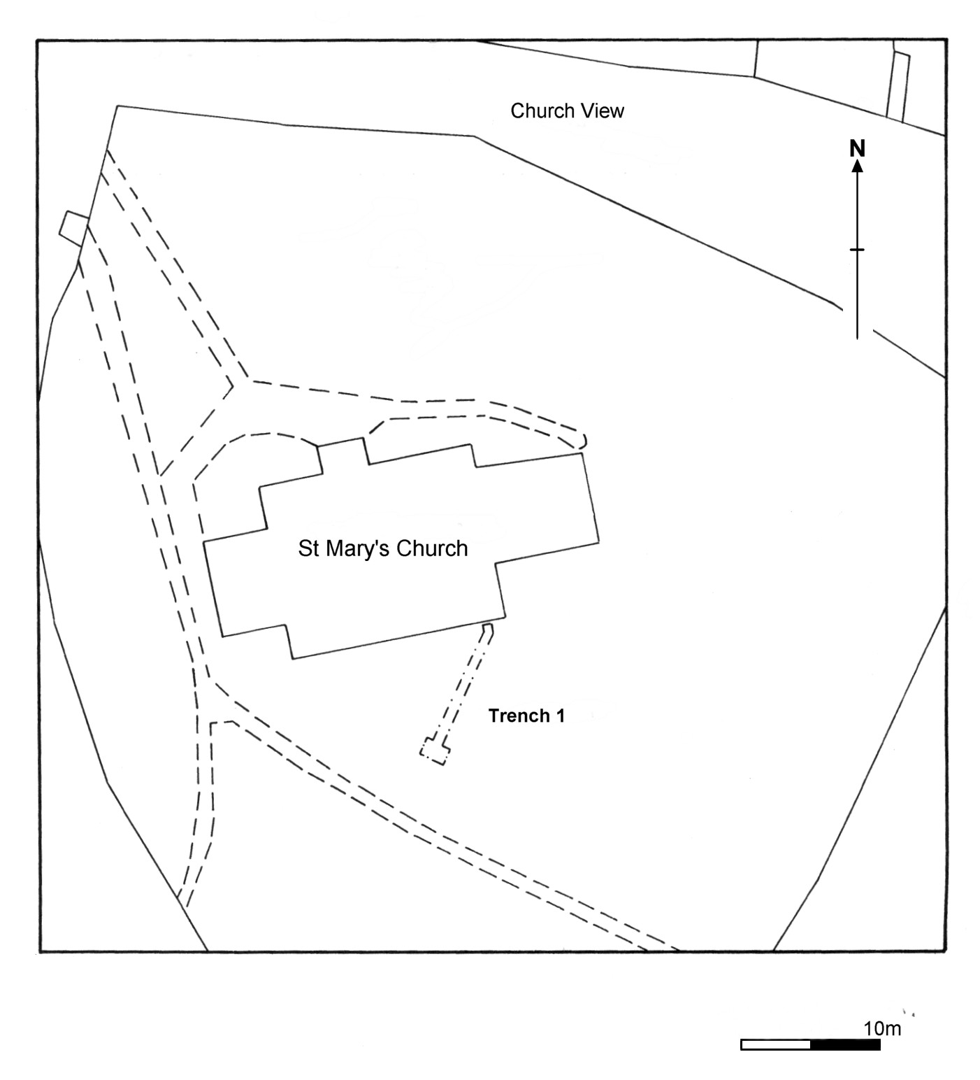

Results

The first section of trenching extending away from the chancel required the lifting of two reused ledger stones. Of 19th century date, these formed part of a pathway extending around the exterior of the church.
A total of seven contexts were revealed within the trenching. Of these, five were in-situ inhumations.

5.1 Trench 1

The first context encountered (001) was a fine silty, moderately compacted dark brown organic soil which was interpreted as a turf deposit. This deposit measured approximately 0.25 in thickness. A number of 19th century pottery sherds and disarticulated human bone fragments were recovered. Underlying this deposit was a reddish-brown, tightly compacted sandy clay deposit (002) which formed the base of the trench and was recorded at depths of between 0.45m and c.1.00m below the existing ground level. This also contained fragments of disarticulated human bone. Exposed at depths of between 0.30m and 1.00m were five individual inhumations.
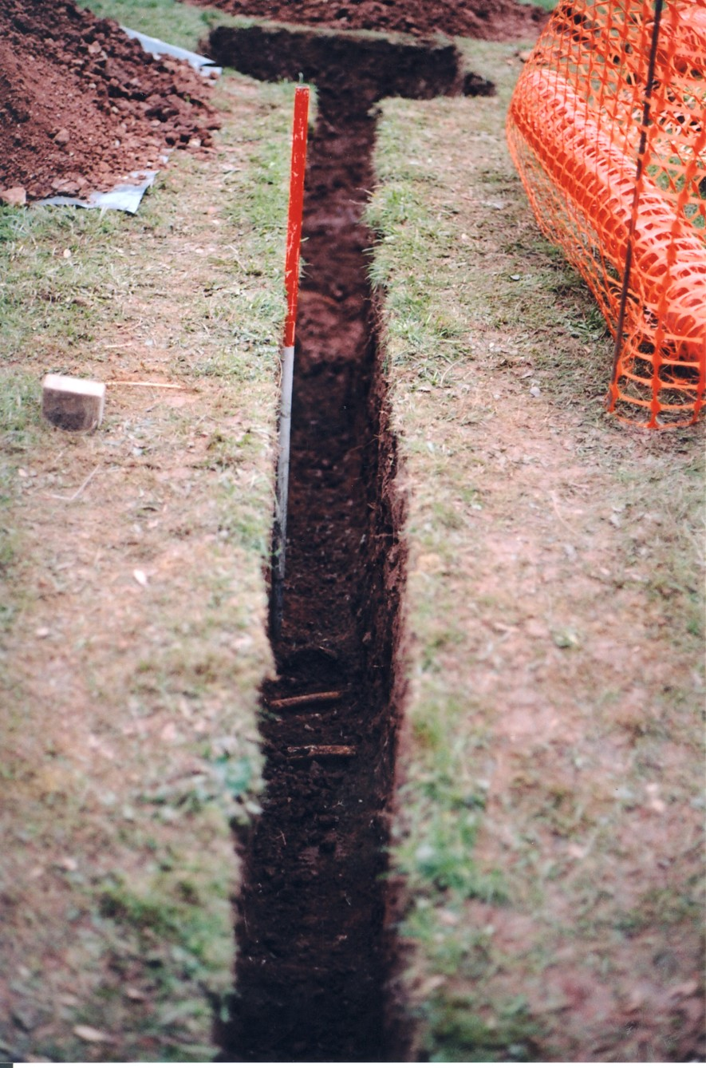
The first of these (003) was located c.1.3m from the southern edge of the chancel. Due to the shallow nature of this inhumation total exposure and lifting was essential. This burial was oriented E-W and consisted of a single extended supine post-juvenile male. It was possible to observe this individual within a short burial sequence consisting of the insertion of a later burial truncating much of burial (003). The later burial had taken away the lower part of the individual below the lumbar vertebrae. It should be noted that this later burial, truncating burial (003), was not located within the direction of the proposed trench and therefore was not recorded. Around burial (003) were observed a series of regularly spaced reddish stains which can be interpreted as decayed iron nails indicating that this individual had been placed in some form of coffin, probably a shouldered and tapered type.
PLATE 1: ABOVE - View of trench looking southwest
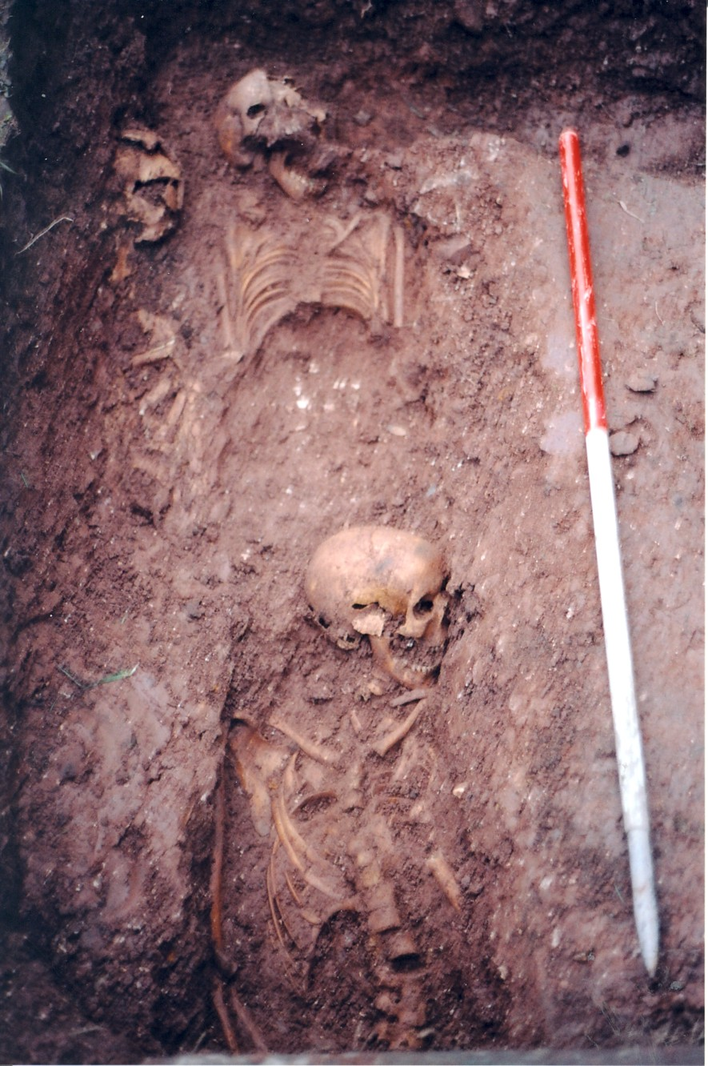
PLATE 2: LEFT – Burial (003) (top) looking west, showing truncation by later grave

All other inhumations exposed during the excavation were observed at a depth of c.1m. The general width of the trench (c.0.4m) exposed only the lower portions of these individuals, consisting of the tibia, fibula and femur. Oriented E-W they are probably comparable to burial (003). No associated grave furniture was observed, indicating either that these individuals were deposited as shroud burials or that their limited exposure masked any evidence of furniture.
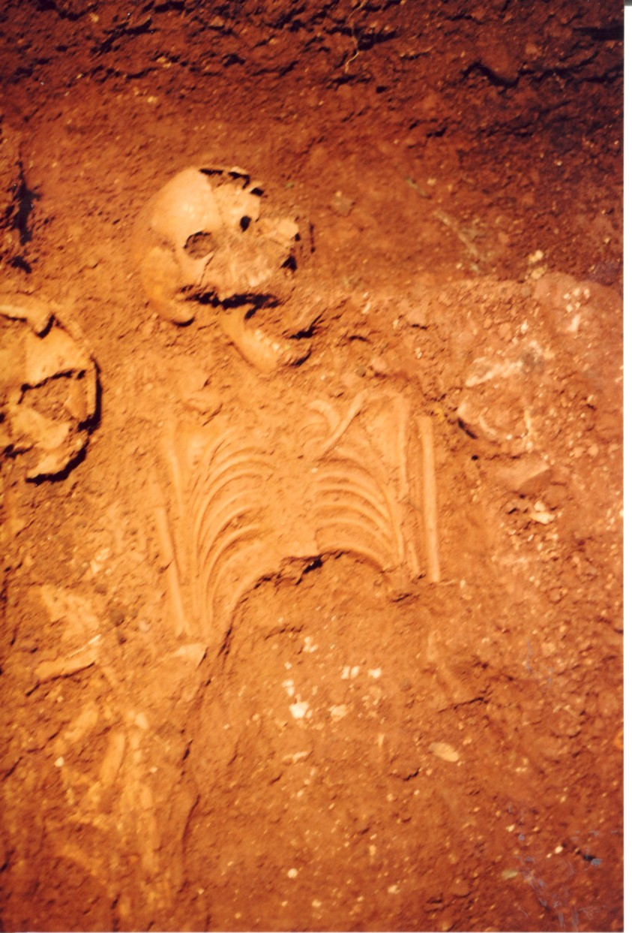

The test pit area of trenching for the soak-away exposed a continuous sequence of soil types found throughout the 15.00m x 0.40m of trenching, consisting of deposits (001) and (002). Inclusions consisted of disarticulated human bone and 19th century pottery fragments.

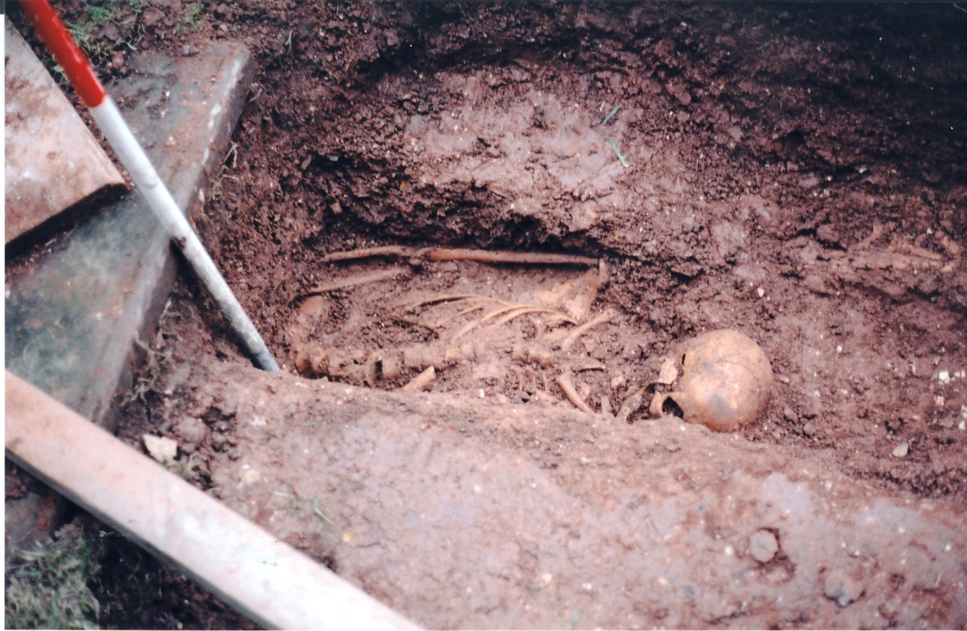
PLATE 3: ABOVE – Burial (003)

PLATE 4: RIGHT – Later burial truncating (003)

Summary

The excavation revealed a series of burials that probably date to the 18th and early 19th centuries. Certain anomalies suggest that at some period during the 19th century this area of the churchyard was landscaped to some degree. This is indicated by the shallowness of burial (003), probably denoting a reduction of soil for the insertion of the ledger stone pathway. Other evidence for this is shown in the present position of the vertical grave ledgers and their non-alignment with the other four burials exposed.

Disarticulated human remains found during the programme of excavation imply that the churchyard of St Mary’s has been used for the continuous deposition of burials prior to the 18th/19th century sequence. No ethical or formulaic approach would have been used for the insertion of these 18th and 19th century burials with pre-existing burials. This can be clearly shown with the apparent truncation of burial (003) by a slightly later c.19th century burial.

Bibliography

Brown, A.E., ‘Records of Surface Finds made in Herefordshire 1951-1960’, Transactions of the Woolhope Naturalists Field Club, Vol.37 (1961)

Duncumb, J., Collections towards the history and antiquities of the county of Hereford, 5 vols (Hereford, 1804-1912).

Pevsner, N., Herefordshire (London 1963).

RCHM, Inventory of Monuments, Herefordshire East, Volume II (London 1932)

Robinson, C.J., The Castles of Herefordshire and their Lords (1867)

SSEW (1983) Soil Map of England and Wales

Yeates, S.J, Linton, Saint Mary’s: Church or Minster, unpublished B.A. Dissertation Sheffield University (2000)

Copyright

Border Archaeology shall retain full copyright of any commissioned reports, tender documents or other project documents, under the Copyright, Designs and Patents Act 1988 with all rights reserved; excepting that it hereby provides an exclusive licence to the client for the use of the report by the client in all matters directly relating to the project as described in any relevant Project Specification.

Appendix1: Site Summary

Title of Report | Archaeological excavation at St Mary’s Church, Linton, Nr Ross-on-Wye, Herefordshire
Contractor | Border Archaeology, PO Box 36, Leominster, Herefordshire, HR6 OYQ
Site Name | St Mary’s Church
Site Name | Grid Ref. NGR SO 660 253 |  | Planning App. No: N/A
SMR number(s) of site | 7309
Date of Field Work | November 2003
Date of Report | February 2004
NUMBER AND TYPE OF FINDS
Pottery | Period N/A |  | Period N/A
Other | Number of sherds N/A |  | Quantity N/A
NUMBER AND TYPE OF SAMPLES COLLECTED
Sieving for charred plant remains | No of features sampled |  | N/A
Sieving for charred plant remains | No of buckets |  | N/A
C14/scientific dates | No and Type |  | N/A
C14/scientific dates | Result |  | N/A
Pollen | No of Columns/spot samples |  | N/A
Pollen | Name of pollen specialist |  | N/A
Bone | Number of  buckets  sieved for  bone | N/A | Quantity  Recovered | N/A
Bone | Number of  buckets  sieved for  bone | N/A | Period | N/A
Insect | No of Columns/spot  samples |  | N/A
Insect | Name of pollen specialist |  | N/A
Other | Type and specialist |  | N/A
REPORT SUMMARY
The excavation revealed a series of burials that probably date to the 18th and early 19th centuries. Certain anomalies suggest that at some period during the 19th century this area of the churchyard was landscaped to some degree. This is indicated by the shallowness of burial (003), probably denoting a reduction of soil for the insertion of the ledger stone pathway. Other evidence for this is shown in the present position of the vertical grave ledgers and their non-alignment with the other four burials exposed.

Disarticulated human remains found during the programme of excavation imply that the churchyard of St Mary’s has been used for the continuous deposition of burials prior to the 18th/19th century sequence. No ethical or formulaic approach would have been used for the insertion of these 18th and 19th century burials with pre-existing burials. This can be clearly shown with the apparent truncation of burial (003) by a slightly later c.19th century burial.

