

Archaeological Observation

Sunnyhill
Luston
Herefordshire

NGR: SO 48564 63412
SMR No. 43211

BORDER ARCHAEOLOGY

Head Office
PO Box 36
Leominster
Herefordshire
HR6 0YQ
Tel: 01568 760453
www.borderarchaeology.com

Technical Services
Chapel Walk
Burgess Street
Leominster
Herefordshire
HR6 8DE
Tel: 01568 610101
Tel/Fax: 01568 616900
E-mail: borderarch@btconnect.com

Southern Office
Southgate Chambers

37/39 Southgate Street
Winchester
Hampshire
SO23 9EH
Tel: 0845 6015506

BA0531DTSHL December 2005

Contents
1. Non-Technical Summary 3
2. Introduction 4
2.1 Soil Characteristics & Geology 5
3. Methodology 5
4. Site Specific Historical & Archaeological Background 5
5. Archaeological Observation 6
6. Conclusion 10
7. Copyright 10
8. Bibliography 10

Report specification

Archaeological observation and report compilation: Nigel Reade BSc
Historical research: Stephen Priestley MA
Report editing: George Children MA
Approved: Neil Shurety
- Non-Technical Summary

The site is located immediately north of Sunnyhill and is shown on the Ordnance Survey map of 1888 as an irregular quadrilateral enclosure planted with trees.

The groundworks comprised the stripping of topsoil and the levelling of the site to the designated construction depths. The topsoil strip revealed a reddish-brown silty clay extending across the site, within which was a post-medieval pit containing ashy waste and charcoal flecking. No significant archaeological structures, features or deposits were revealed; however, the archaeological observation confirmed that no archaeology was damaged or disturbed during the programme of works.

- Introduction

Border Archaeology was instructed by G P Thomas Building Contractors to carry out archaeological observation of groundworks relating to the development of land at Sunnyhill Luston Herefordshire.

The groundworks were carried out between September 8th and September 12th 2005.

Copies of this report will be submitted to G P Thomas Building Contractors, Herefordshire Archaeology and the county Sites and Monuments Record.

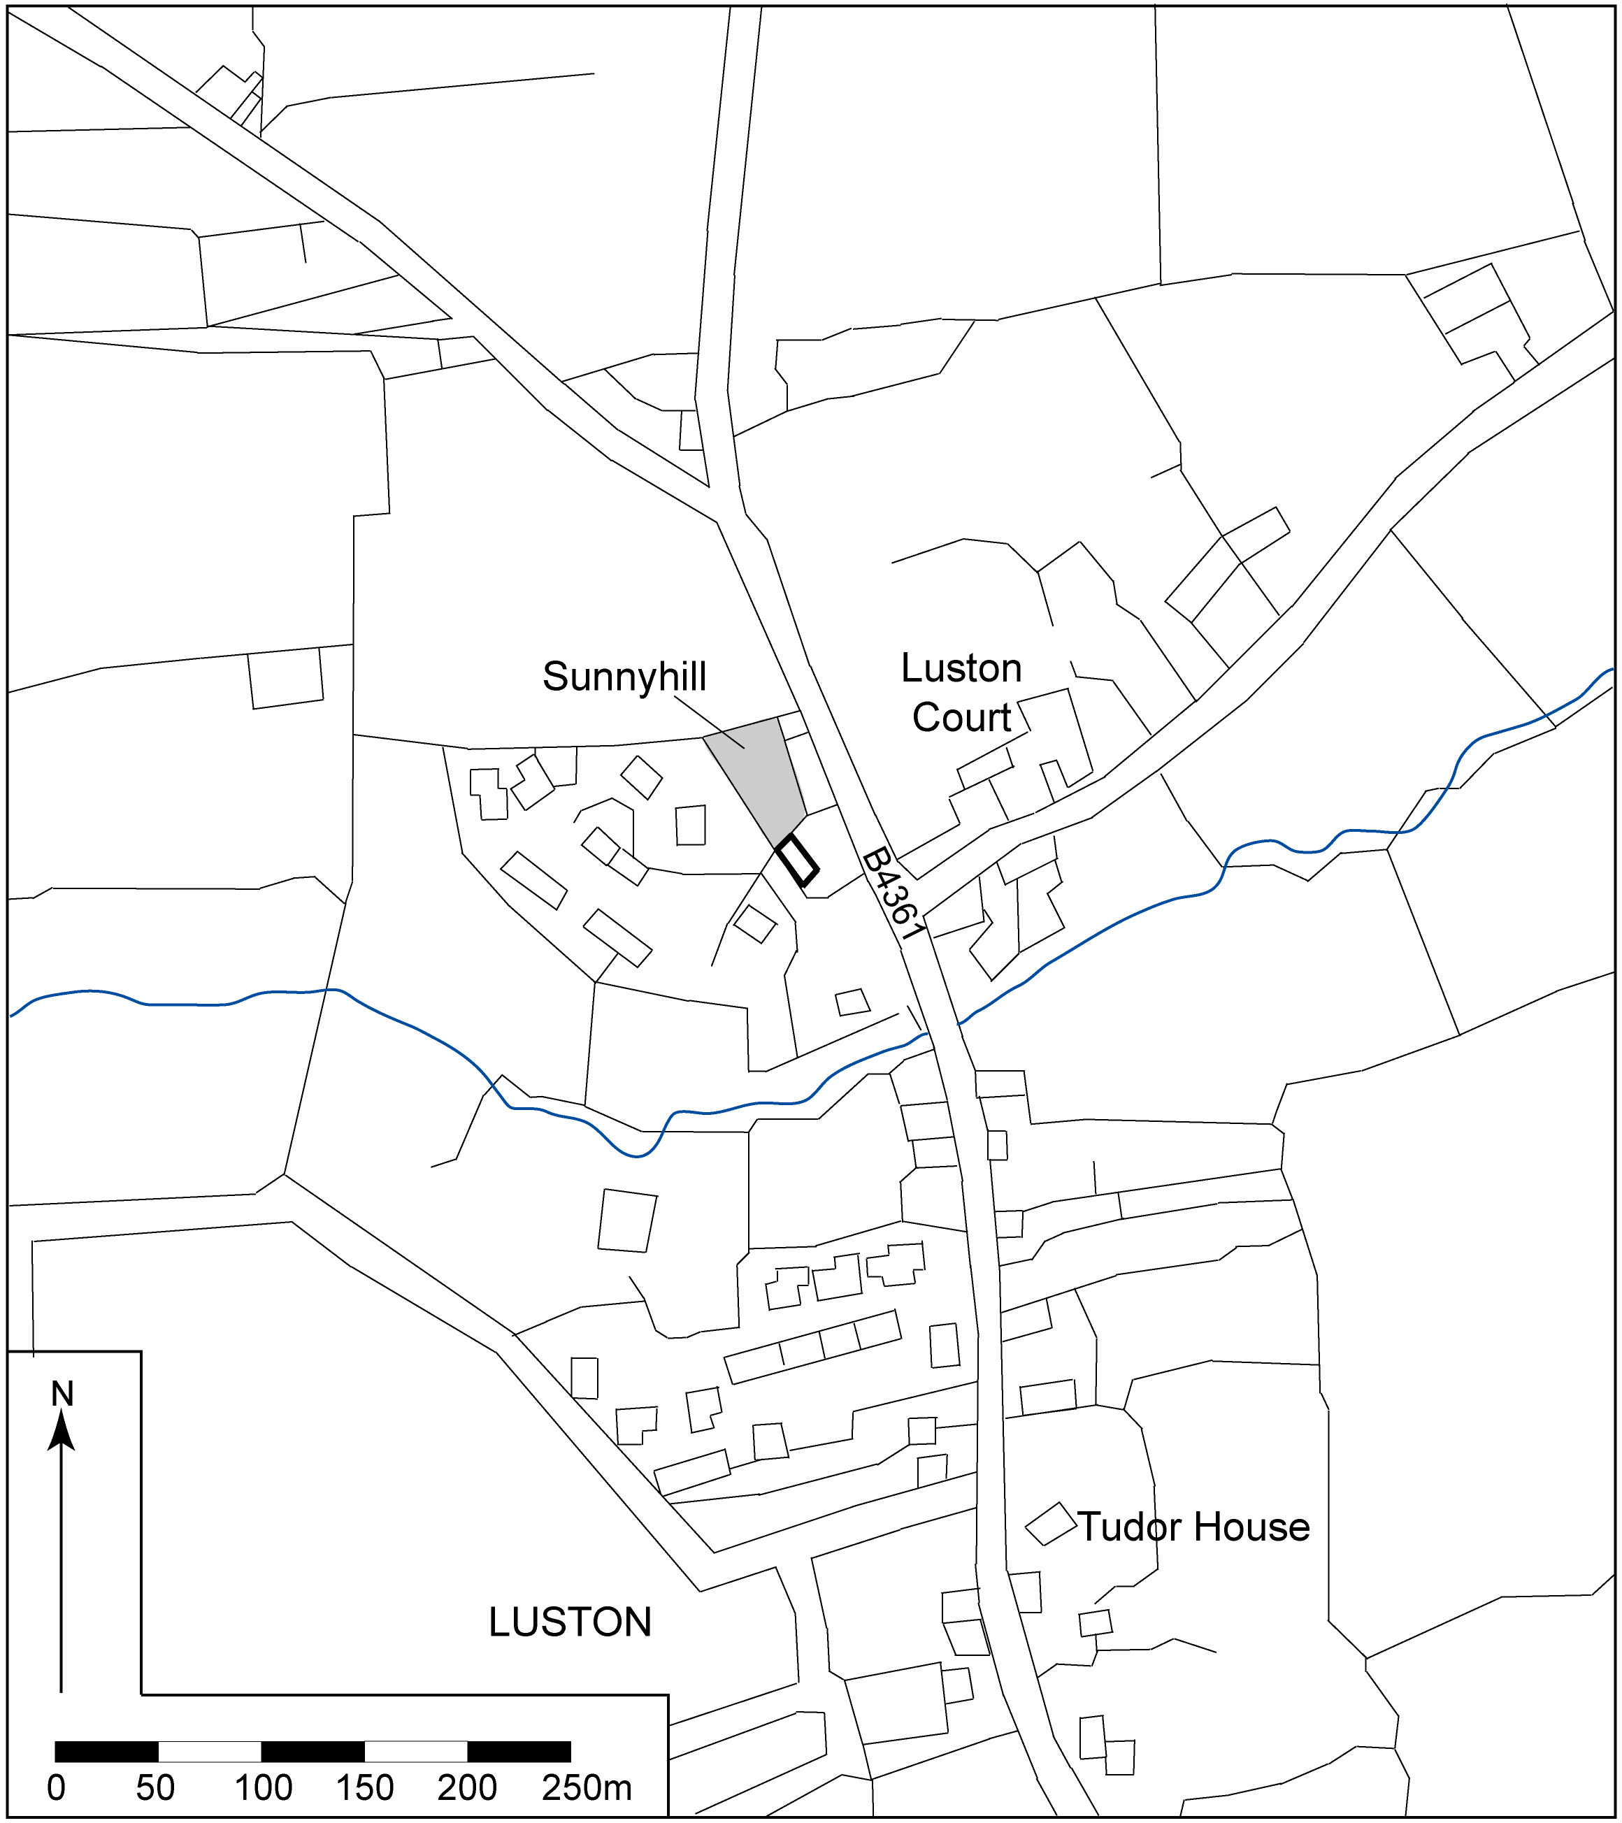
▲Fig. 1: Site location plan

Soil Characteristics & Geology

The site lies within an area of typical alluvial gley soils of the CONWAY series (811b) consisting of deep stoneless fine silty and clayey soil variably affected by groundwater; the underlying geology comprises river alluvium (Soil Survey of England and Wales 1983).

- Methodology

The aim of the programme of archaeological observation was to locate and record any archaeological remains revealed during the course of the groundworks and to confirm that no impact on the archaeological resource occurred without recording.

All groundworks were excavated by machine and toothless bucket under archaeological supervision and associated spoil was scanned for artefacts.

The depth and complexity of deposits across the site was assessed and a written & photographic record maintained.

- Site Specific Historical & Archaeological Background

The origins of the present village of Luston, a linear settlement situated on the B4361 3km N of Leominster, can be traced back to the medieval period. First mentioned in the Domesday Survey of 1086, it then formed a manor within the substantial estates of Leominster Priory, an important pre-Conquest religious house founded in the mid-7th century AD (Hillaby, 1987). Luston was an estate of some importance during the medieval period; one of the four major granges of Leominster Priory was established at Bury Farm (SMR Ref. 8920; SO 4880 6260). A number of buildings containing fabric dating from the medieval or early post-medieval period have survived at Luston, including Bury Farm (15th-16th century), Tudor House (early 17th century), the Hollies (15th-17th century) and Luston Court, a half-timbered building of 17th century date situated some 50m to the E of the site at Sunnyhill (RCHME, 1934, 138-140).

Little documentary evidence has been found specifically relating to Sunnyhill. The name ‘Sunnyhill’ was attached to the property quite recently (probably not earlier than c.1950) and it is not specifically named on the OS 1st edition 6-inch map of 1888 or in the census returns for 1841-1901. The OS map of 1888 shows the existing house, a rectangular building aligned NW-SE situated within a rectangular enclosure to the W of the present B4361 road with an irregular quadrilateral enclosure planted with trees immediately to the N. A feature marked as a 'Holy Well', possibly of medieval date, is also marked on the 1888 map, situated approximately 20m S of Sunnyhill.

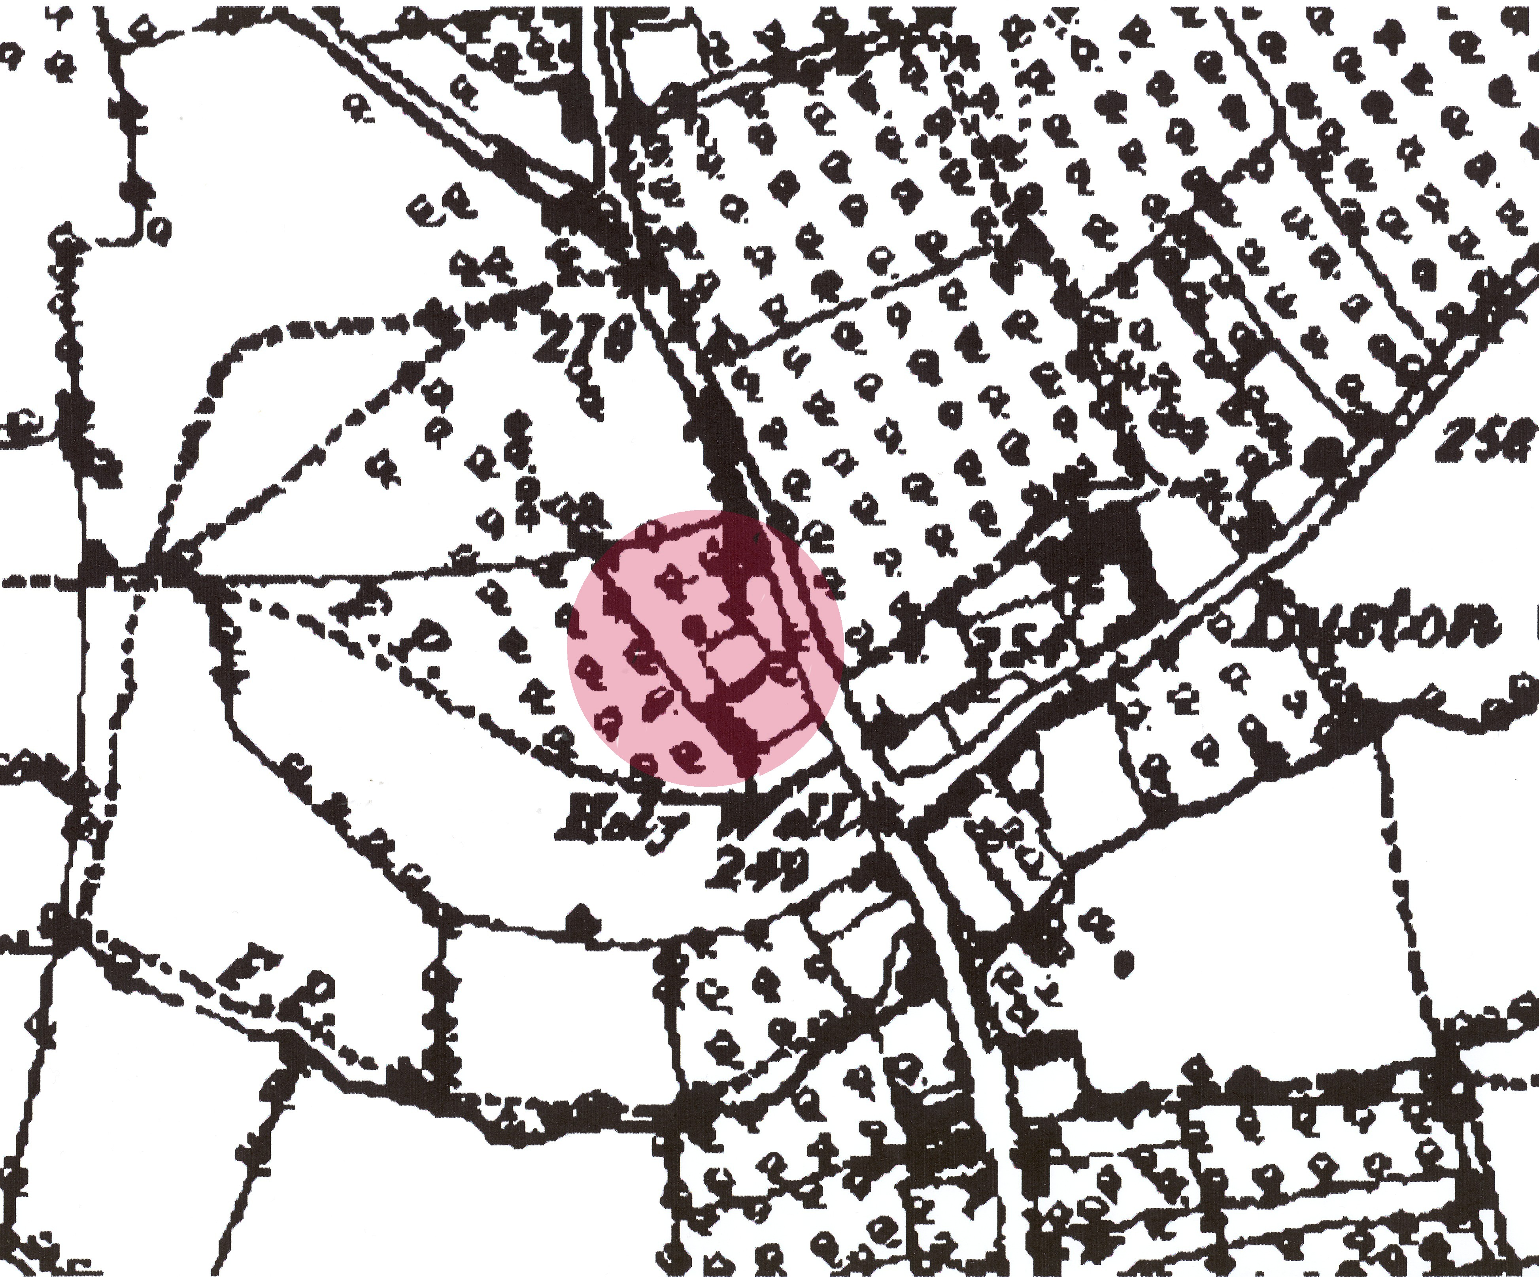

▲Fig. 2: 1888 OS map showing the location of Sunnyhill and the site located immediately to the N

- Archaeological Observation

The groundworks included site clearance prior to the stripping of topsoil (Plates 1-4). Following topsoil removal, the subsoil level was reduced to the designated depths (Plates 5-7).

The uppermost deposit (001) comprised a loosely compacted dark brown silty clay containing large & medium angular and subangular stones, which extended across the whole of the excavated area. This topsoil deposit measured approximately 0.4m in depth and contained frequent post-medieval waste material, including glass, CBM and pottery.

Underlying (001) was a firmly compacted reddish-brown silty clay (002) extending across the excavated area. Cut into this natural subsoil in the NE corner of the site was a feature [003] with a regular oval plan measuring approximately 1.8m (N-S) x 2.7m (E-W), which was partially sectioned by the machine on its southern side. The northern section was not excavated as it lay beyond the limit of excavation. The feature was filled by a loosely compacted blackish-brown sandy silt clay (004) to a visible depth of 0.8m. The fill contained occasional ashy deposits and charcoal flecking, suggesting that it was used for the disposal of domestic/garden waste. No finds were recovered from the fill.

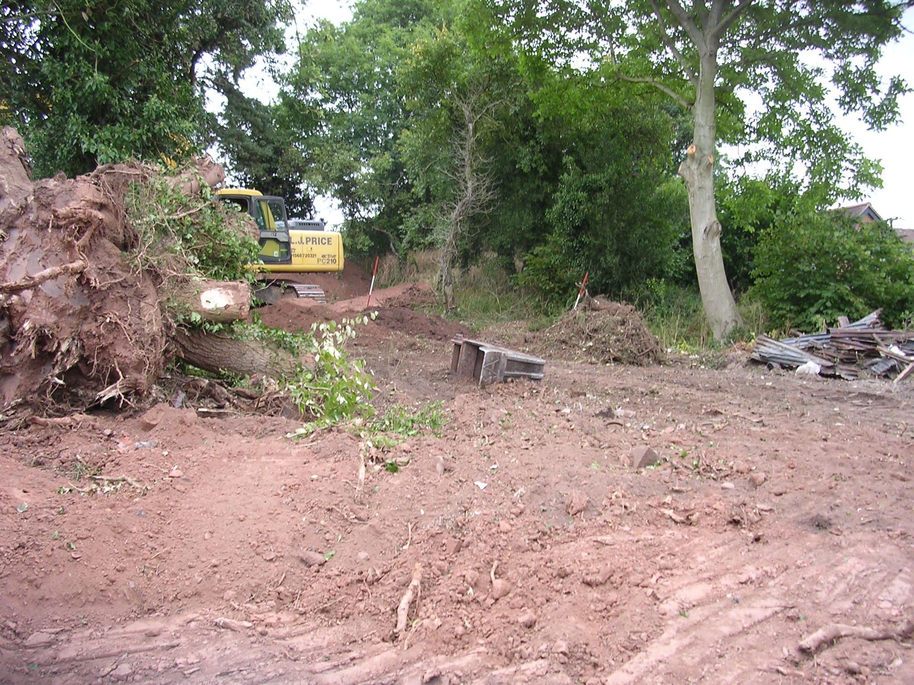

Plate 1: View of the site looking NE prior to levelling

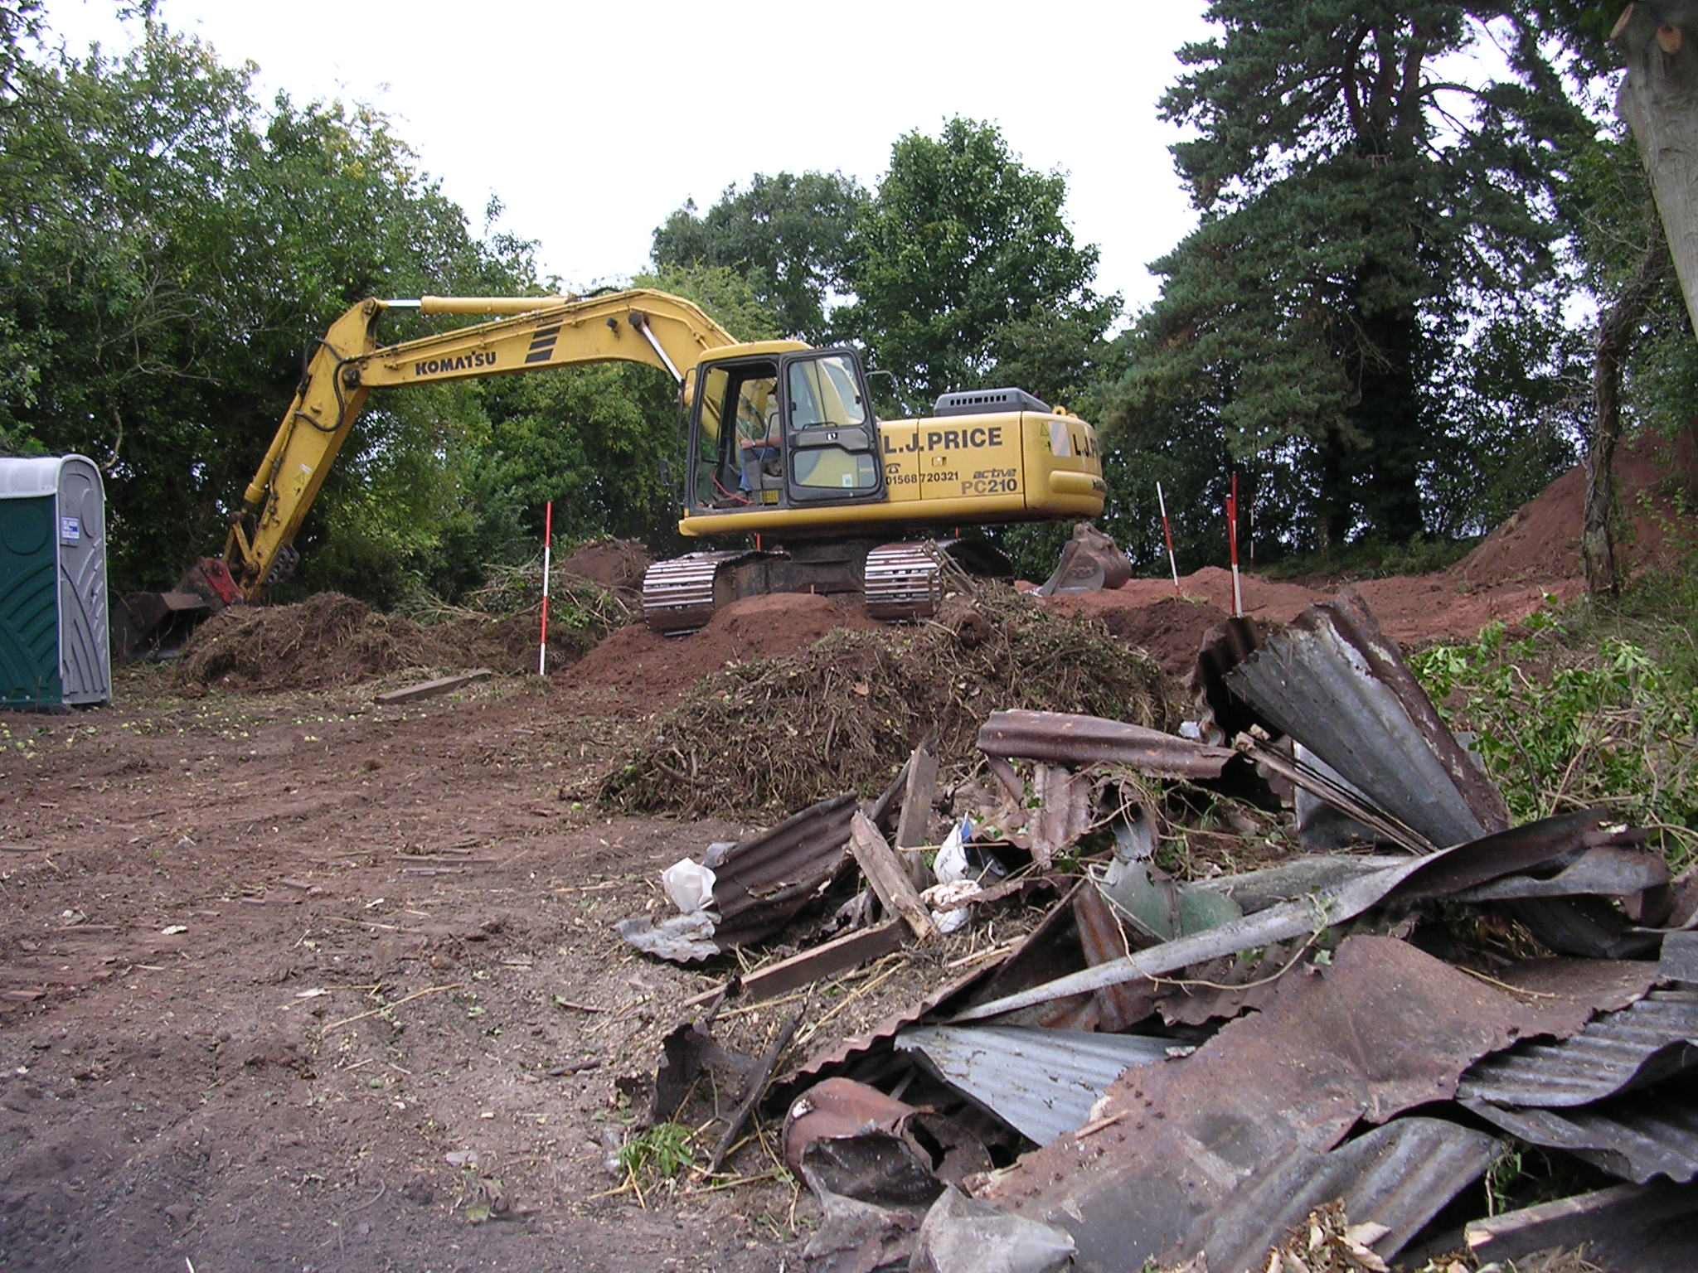

Plate 2: View N showing site clearance in progress

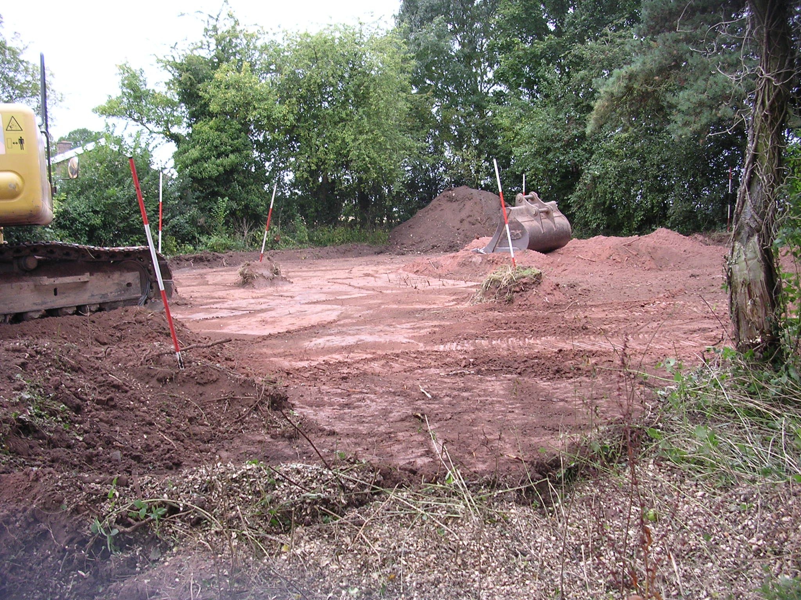

Plate 3: View NW showing topsoil removal

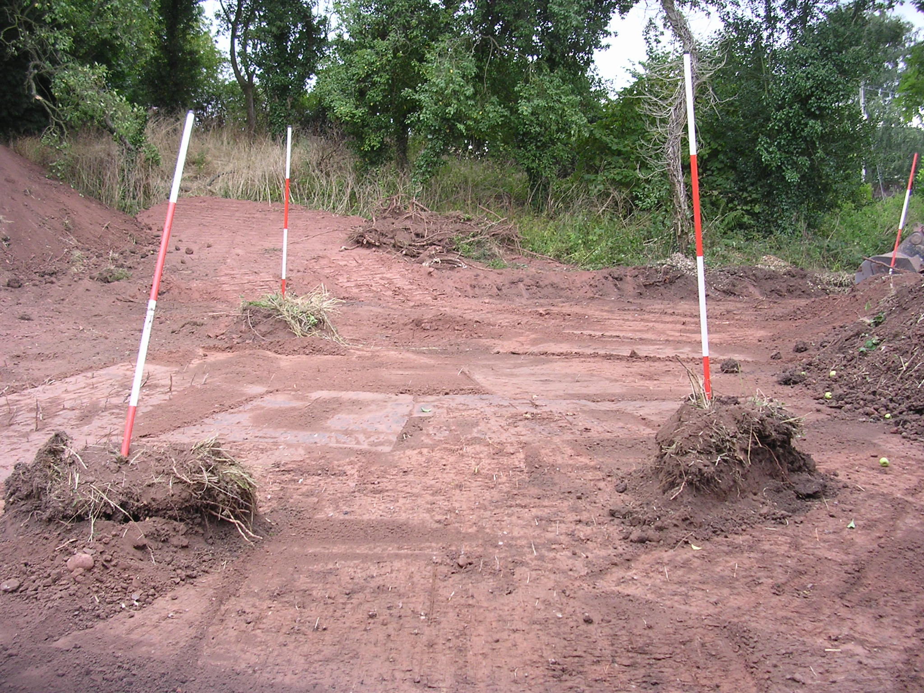

Plate 4: View E showing topsoil removal

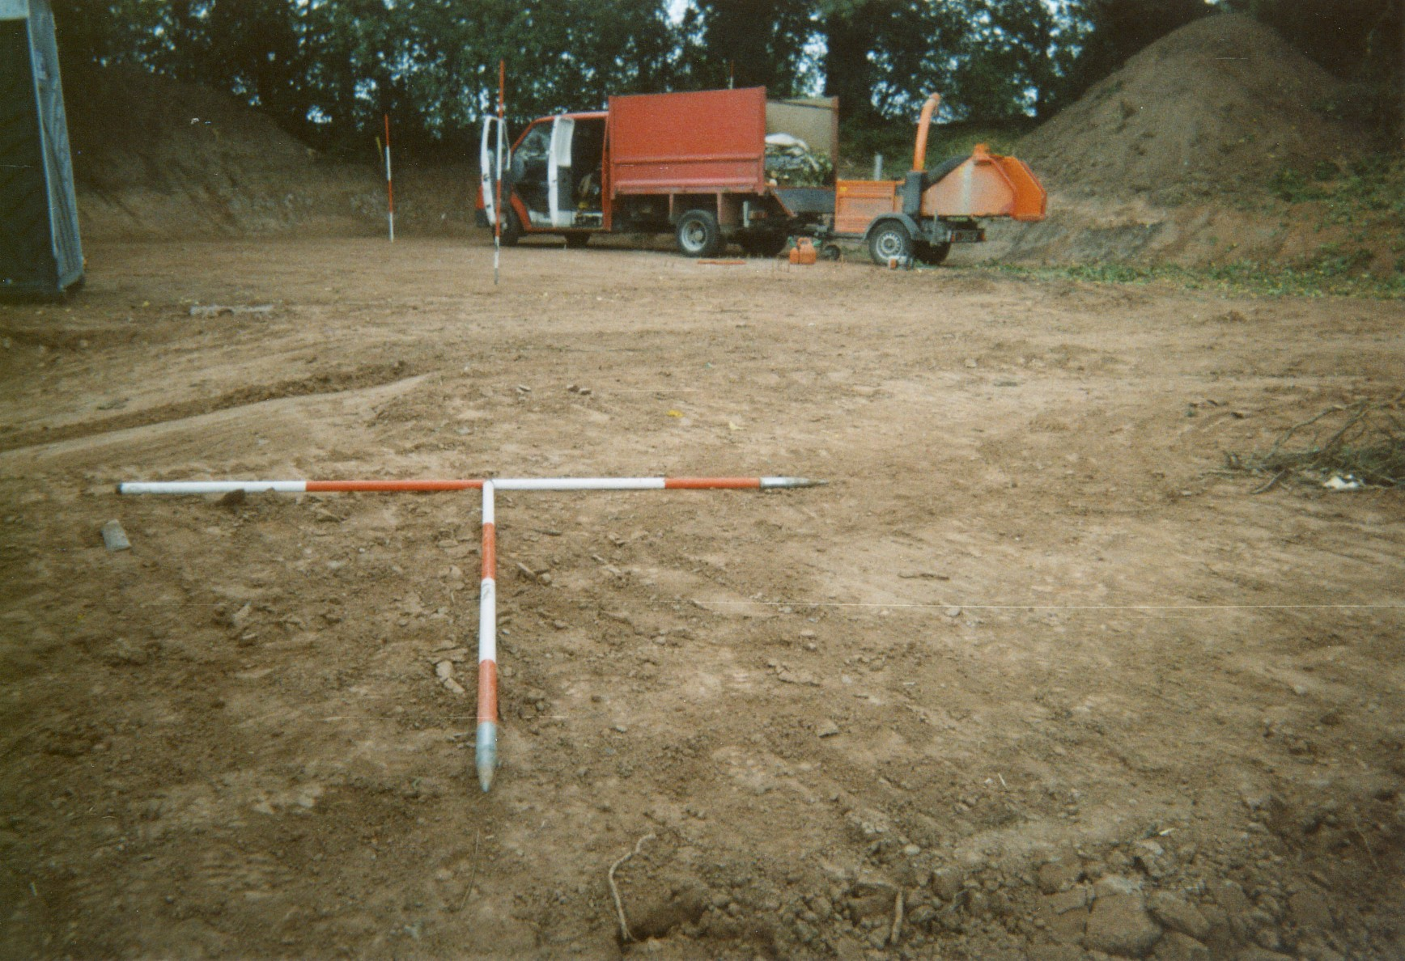

Plate5: View N showing platform 1

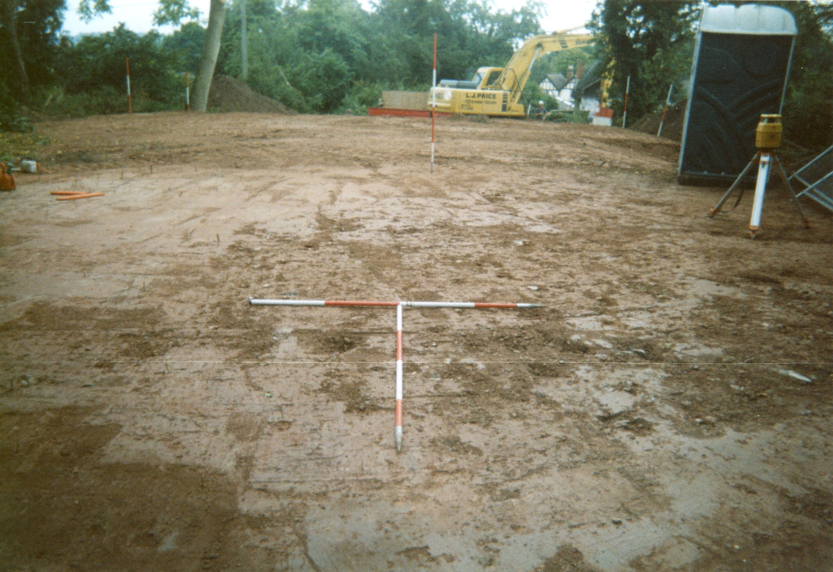

Plate6: View S showing platform 1

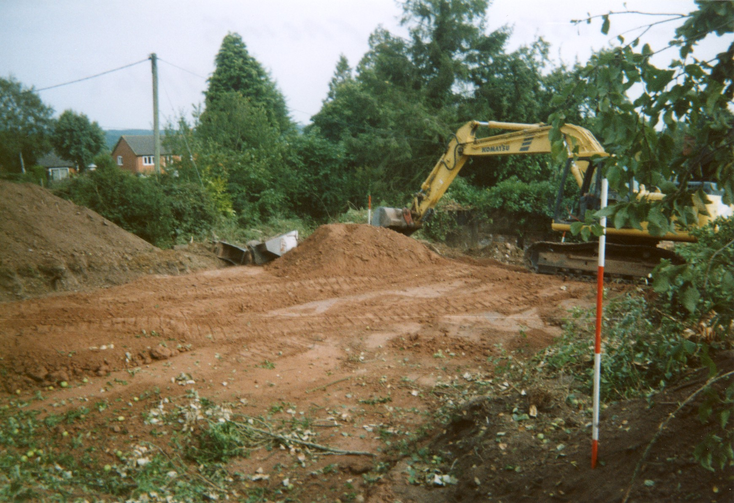

Plate7: View SE showing platform 2

- Conclusion

Despite the historic nature of the settlement of Luston, and specifically the post-medieval dwelling and gardens of Sunnyhill, the archaeological observation revealed only slight evidence of activity in the form of a waste pit of probable late post-medieval date.

However, the observation confirmed that no archaeology was damaged or disturbed during the programme of works.

- Copyright

Border Archaeology shall retain full copyright of any commissioned reports, tender documents or other project documents, under the Copyright, Designs and Patents Act 1988 with all rights reserved; excepting that it hereby provides an exclusive licence to the client for the use of the report by the client in all matters directly relating to the project as described in the Project Specification.

- Bibliography

Herefordshire Archaeology Sites and Monuments Record (SMR)

Hillaby, J., ‘Early Christian and Pre-Conquest Leominster: An Exploration of the Sources’, Transactions of the Woolhope Naturalists Field Club, 45, pt.3 (1987), 557-685.

Pevsner, N., The Buildings of England: Herefordshire (London 1963)

RCHM, Inventory of the Ancient and Historical Monuments in Herefordshire, Vol. 3: North West (London 1934)

Soil Survey of England and Wales (1983) Silsoe

Appendix A: Context Register

CONTEXT NO. | DESCRIPTION
(001) | Loosely compacted dark brown silty clay, with frequent post-medieval glass, CBM, pottery, large & medium angular stones, extended across site to a depth of 0.4m. Overlies (002)
INTERPRETATION: | Topsoil
(002) | Firmly compacted reddish-brown silty clay, with occasional large angular & subangular stones, extended across site to a minimum depth of 3m. Underlies (001), cut by [003]
INTERPRETATION: | Subsoil
[003] | Cut – oval in plan; 1.8m (N-S) x 2.7m (E-W), not fully excavated, approximately NE-SW orientation, partially sectioned by the machine. Cuts (002), filled by (004),
INTERPRETATION: | Post-medieval refuse pit
(004) | Loosely compacted blackish-brown sandy silt clay, with occasional charcoal flecks; 1.8m x 2.7m x visible depth of 0.8m. Underlies (002), fills [003].
INTERPRETATION: | Fill of post-medieval pit

Site Summary

Report Name  and Title | Archaeological Observation at Sunnyhill Luston Herefordshire
Contractors Name and Address | Border Archaeology, PO 36, Leominster, Herefordshire, HR6 OYQ
Site Name | Sunnyhill Luston Herefordshire
Grid Reference  (8 fig) | SO 48564 63412 Planning Application  Number: —
SMR number/s of site | 43211
Date of Field Work | September 8th - 12th 2005
Date of Report | December 2005
 | NUMBER AND TYPE OF FINDS
Pottery  Other | Period: — Number of sherds —  Period: — Quantity —
 | NUMBER AND TYPE OF SAMPLES COLLECTED
Sieving for charred plant remains | No of Features sampled N/A  No of buckets N/A
Pollen | No of Columns/spot samples N/A  Name of pollen specialist N/A
Bone | Number of buckets sieved for bone N/A  Quantity Recovered N/A Period N/A
Other | Type and specialist N/A
Summary of the report | The archaeological observation revealed only slight evidence of activity in the form of a waste disposal pit of probable late post-medieval date. No significant archaeological structures, features or deposits were revealed.

Document Control

Job title | Sunnyhill Luston Herefordshire | Job No | BA0531DTSHL
Report written by | Nigel Reade BA
Report edited by | George Children MA
Issue No | Status | Date | Approved for issue
1 | Final | November 30th 2005 | Neil Shurety

