 | Archaeological Research & Consultancy at the University of Sheffield  Research School of Archaeology  West Court  2 Mappin Street  Sheffield S1 4DT Phone 0114 2225106 Fax 0114 2797158

Project Report 882b.1

An Archaeological Watching Brief at
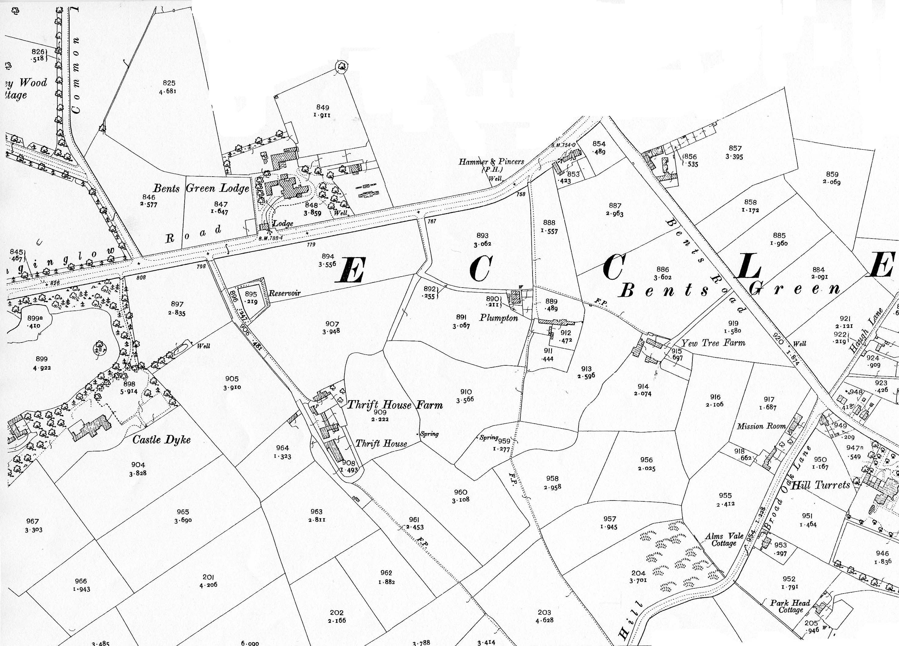
Silverdale School, Sheffield

September 2005

By Mark Stenton

Prepared For:
Kier Build Ltd
Tempsford Hall
Station Road
Sandy, Bedfordshire
SG19 2BD

