PLATES
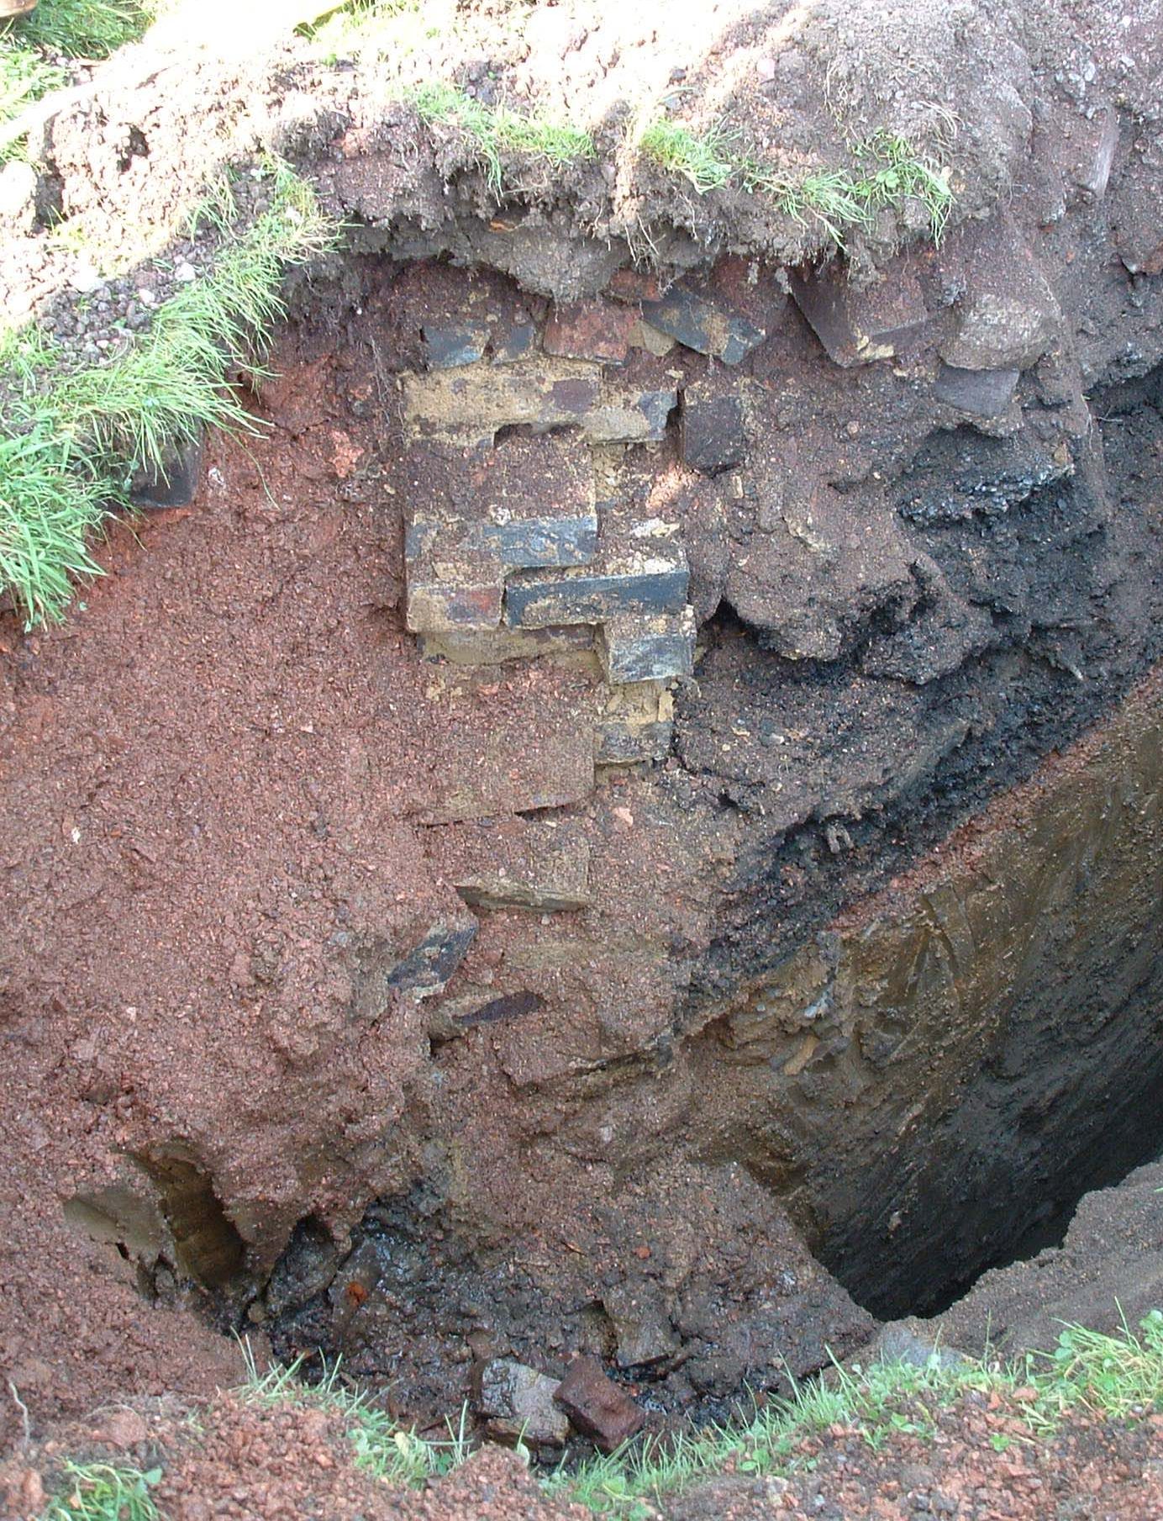
Plate 1 – wall [205.6] associated with former tennis courts, with possible former court surface [205.7] at left and demolition rubble/levelling layers [205.2] and [205.3] at right.
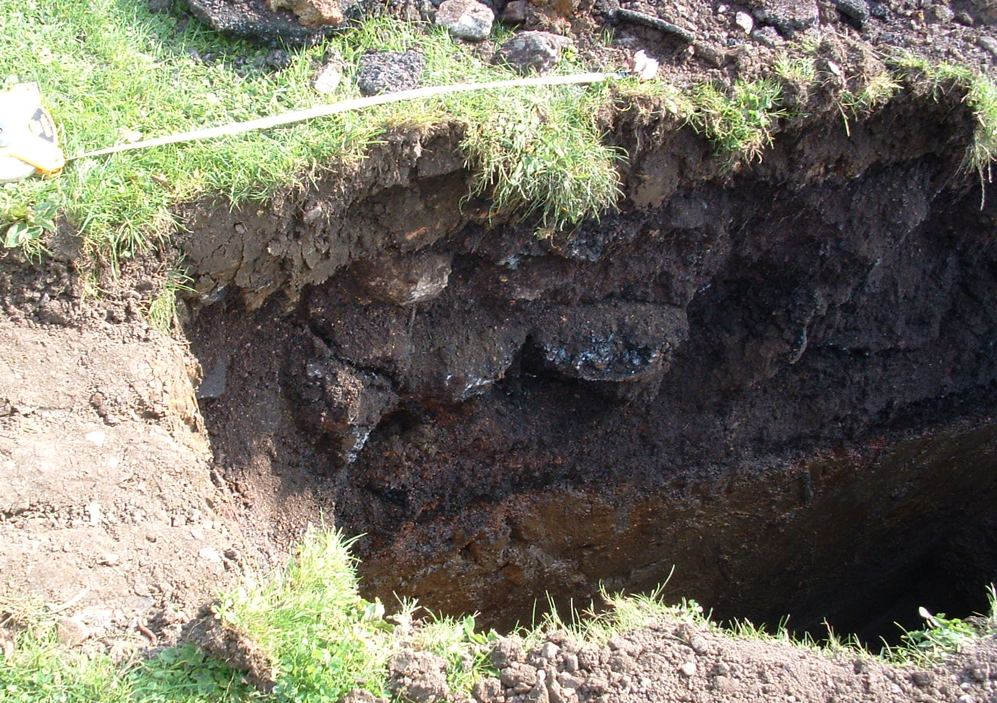
Plate 2 – TP205. SE-facing section showing [205.1-5].

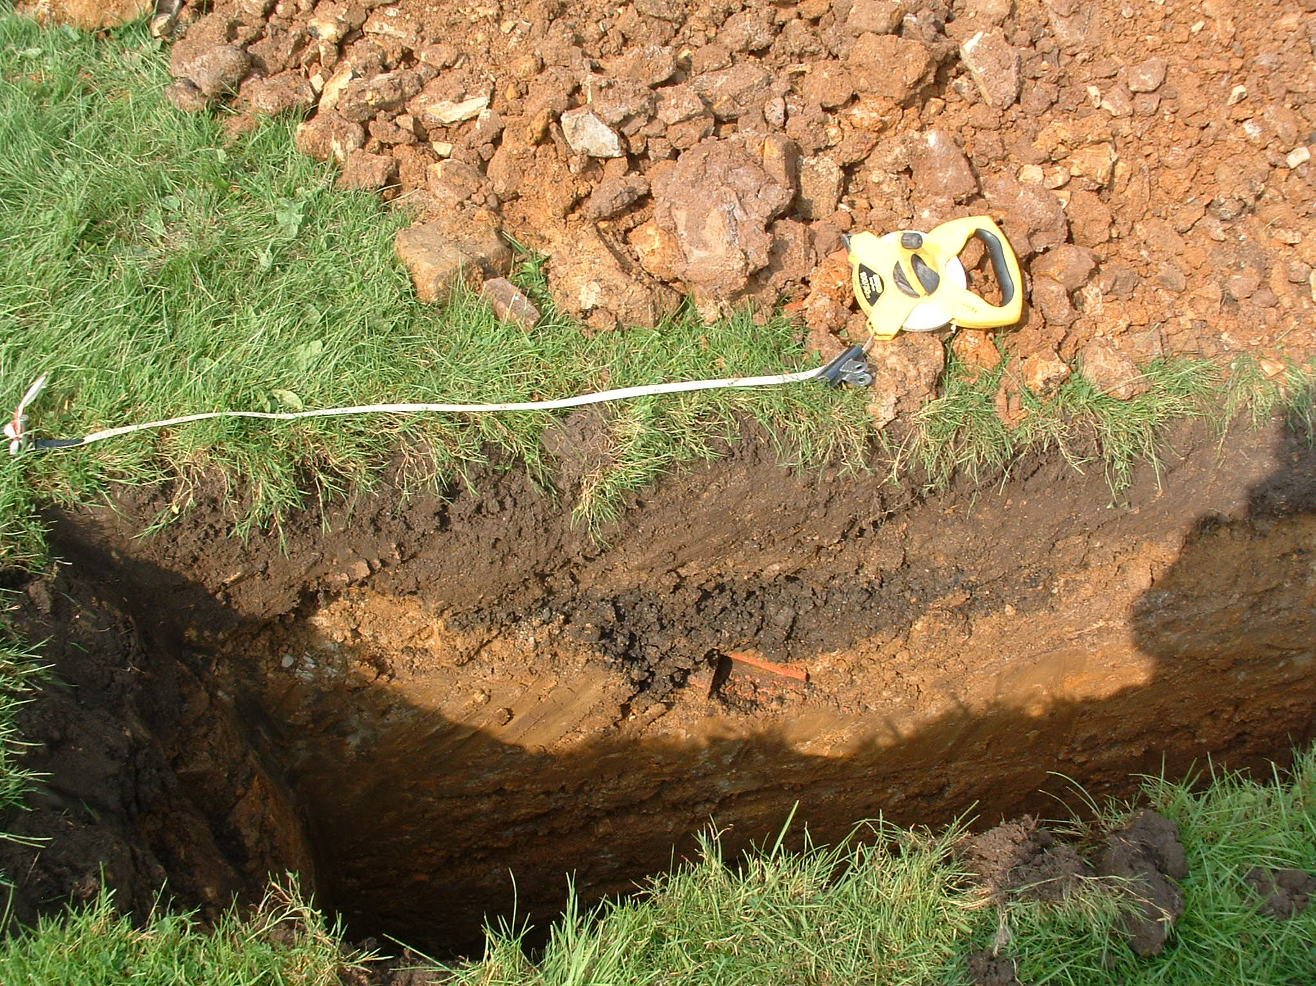
Plate 3 – TP207. SE-facing section showing modern land drain.
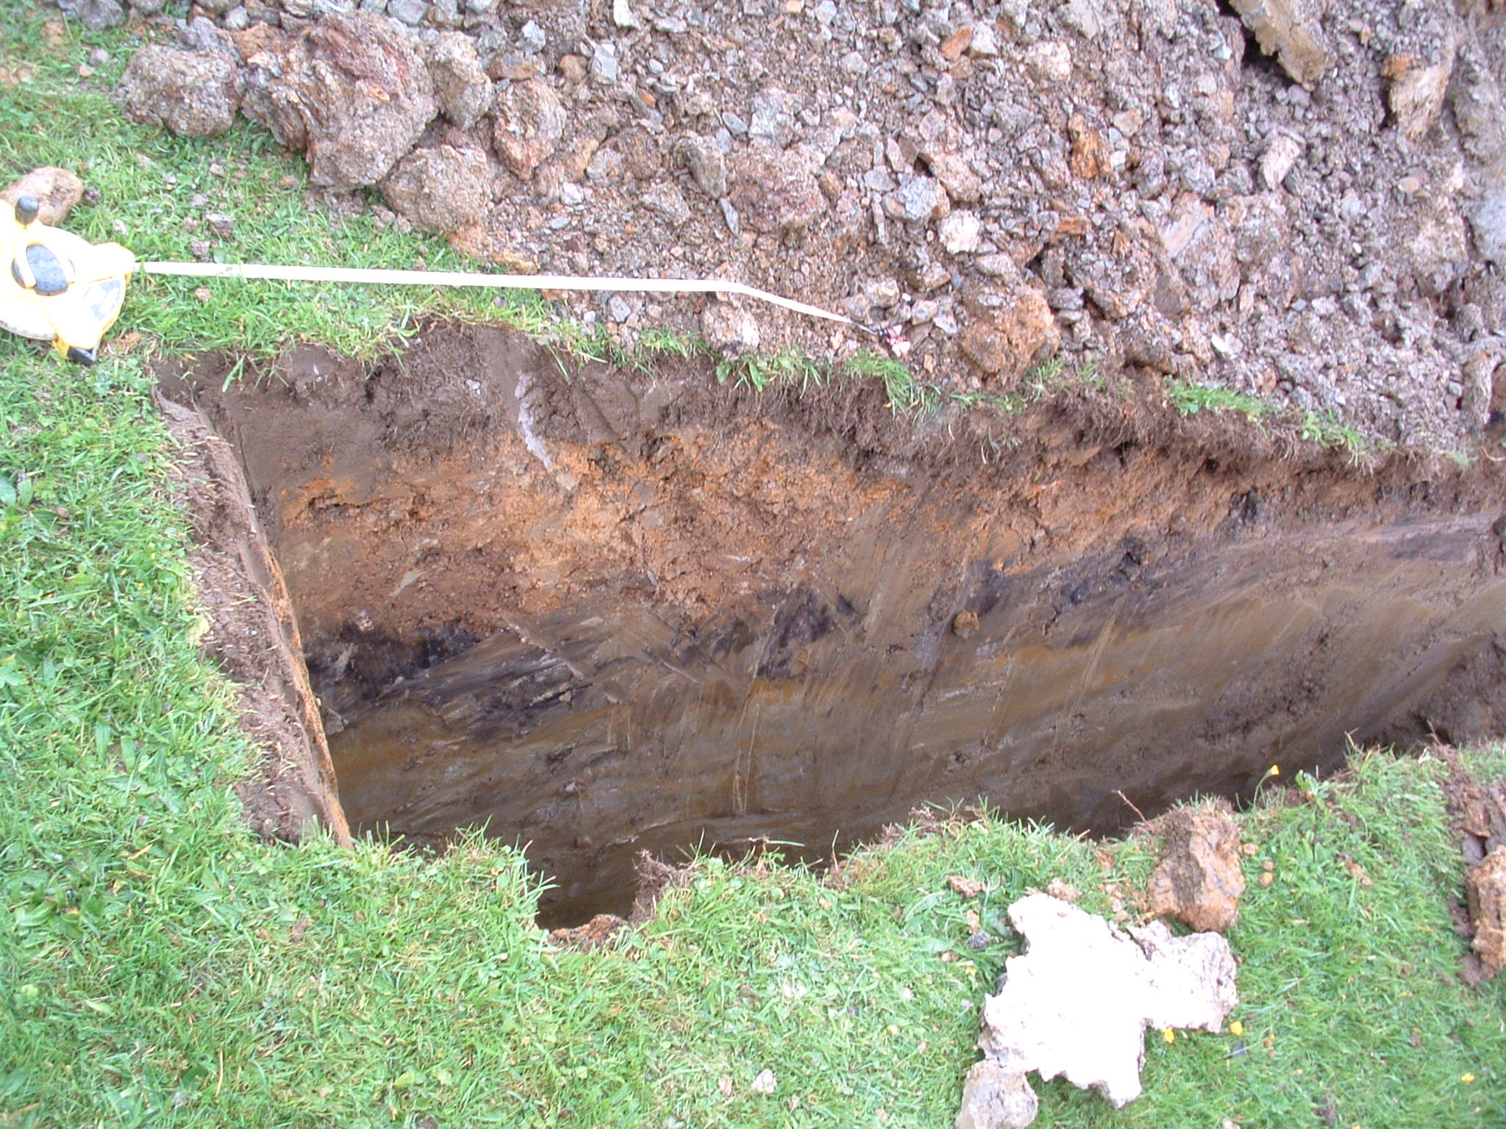
Plate 4 – TP210. SE-facing section showing levelling layers [210.2-4] used in construction of landscaped incline.
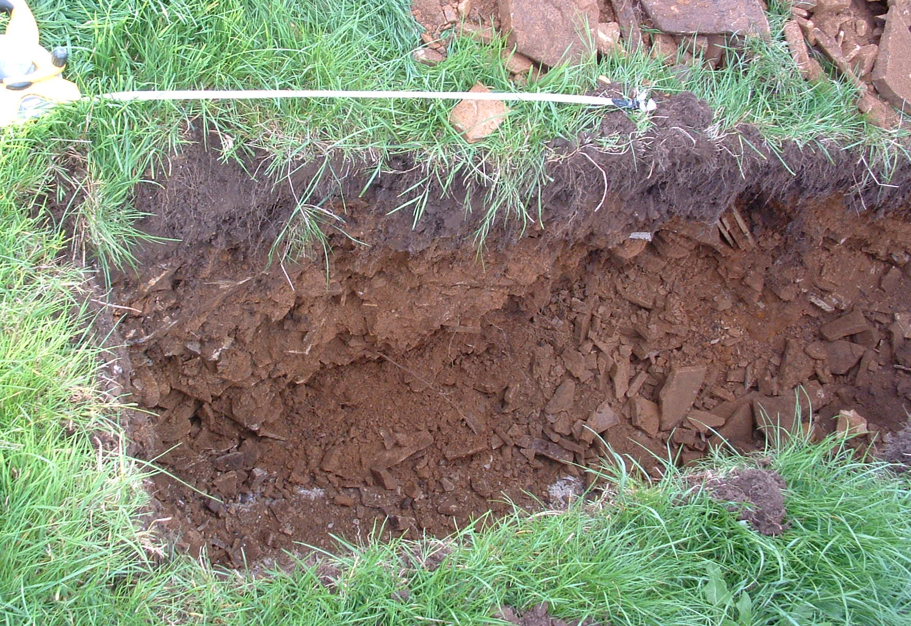
Plate 5 – TP209. NE-facing section showing absence of levelling layers.

