1 SUMMARY …………………………………………………………………1

2 INTRODUCTION …………………………………………………………2
2.1 Site Location …………………………………………………………………2
2.2 Planning Background …………………………………………………………2
2.3 Archaeological Background………………………………………………… 2

3 STRATEGY………………………………………………………...................4
3.1 Aims of the Investigation…………………………………………………… 4
3.2 Methodology…………………………………………………………………..4

4 RESULTS…………………………………………………………………......7

5 CONCLUSIONS……………………………………………………………..14
5.1 Statement of potential.......................................................................................14
5.2 Publication requirements..................................................................................14
5.3 Storage and curation.........................................................................................14

6 REFERENCES……………………………………………………………….15

LIST OF FIGURES
Figure 1 Site Location……………………………………………………….....16
Figure 2 Detailed site location................................................................... .........17
Figure 3 Plan of tombstones................................................................................18
Figure 4 Plan of coffins.......................................................................................19

APPENDICES
Appendix A Burial information.................................................................................20
Appendix B GLSMR/RCHME NMR form.......................................................
........27

1 SUMMARY

This document summarises the results of an archaeological watching brief conducted by AOC Archaeology Group on behalf of Lend Lease Ltd. The watching brief was carried out in conjunction with Toop Exhumation Services Ltd. during the exhumation of the Jesuit Cemetery, Whitelands College, Roehampton, London Borough of Wandsworth. A total of 108 bodies and 82 headstones were recovered. These were recorded and then re-buried in another area of the site. Due to the preservation of soft tissue and clothing, and a request for non-invasive study by the Jesuit’s, no osteological recording was undertaken.

2 INTRODUCTION

2.1 Site Location (Figures 1 & 2)

The site is centred at NGR TQ 522191 173612, and is accessed from Holybourne Avenue. The site covers approximately 289.5m² and is situated adjacent to Parkstead House within land owned by Whitelands College. The land covers approximately 14 acres and is bound to the north, south and east by residential buildings of the Alton Estate. Maryfield Convent lies to the northwest, and the western and south-western boundaries of the site comprise part of the eastern wall of Richmond Park.

2.2 Planning Background
A watching brief was carried out as a requirement of a condition attached to planning consent (Planning Reference: 2002/3673) for the redevelopment of the property at Whitelands College (Manresa House), Roehampton, otherwise known as Parkstead House, Holybourne Avenue SW15.

2.3 Archaeological Background
An Archaeological Appraisal was prepared by Arup Geotechnics (2002) which outlined the archaeological and historical background to the application site. The results of this appraisal are summarised below by period:

Prehistoric
Scattered finds of earlier prehistoric artefacts have been recovered in the vicinity of the site, along with evidence of Bronze Age or Iron Age domestic structures.

Roman
Roman activity is known from the general area but not in the immediate vicinity of the site.

Saxon
Saxon place names are known from Battersea and Wandsworth, but so far no evidence for Saxon activity in Roehampton has been found.

Medieval
Increased trade along the Thames in the medieval period led to the development of Putney. Part of the Parish of Putney was known as Roehampton or Roughampton, although the population remained low until the post-medieval period.

Post-Medieval
The increased prosperity of the area resulted in the purchase and enclosure of the land by rich land-owners, who then built country houses and formal gardens in the large estates so formed. Manresa House was one such property and was constructed in 1761, although there is some evidence that a house existed on the site since at least 1674. Some of the earlier fabric may have been incorporated into the later build. The local area underwent rapid development in the late 19th and 20th centuries, and Manresa House had become a Jesuit college by 1865. This situation persisted until after the Second World War, during which the south wing of the house was destroyed by a direct hit from a bomb. Part of the estate was compulsorily purchased for the construction of the Alton Estate. The last Jesuit priest was interred in 1962, the year in which the Society sold the property to the London County Council. Since then, various educational establishments have occupied the buildings. The buildings have remained unoccupied in the last few years.

Previously an archaeological watching brief was undertaken by AOC Archaeology in another area of the site (AOC 2003b). The site revealed little in the way of archaeological features or layers. All the remains that survived dated from the post-medieval period or later and consisted of drains and made ground associated with the construction of the foundations for Manresa House. The natural across the site was dark brownish grey clay and reddish yellow sandy gravel.

3 STRATEGY

3.1 Aims of the Investigation

The aims, reproduced from the Written Scheme of Investigation (WSI), are: to determine the location, extent, date, character, condition, significance and quality of any surviving archaeological remains liable to be threatened by the proposed development. This applies to remains of all periods, and includes evidence of past environments.

The following specific objectives will also be addressed:
- to establish the minimum number of individuals interred;
- to establish the development of the cemetery through time, as inferred from the observed stratigraphic sequences and the obtained biographical data;
- to establish what forms of cemetery management can be identified, e.g. stacking and charnel management;
- to identify any Jesuit funerary rites and processes pertaining to the treatment of the dead;
- to research any available biographical and historical sources to obtain further data about the use of the cemetery and the individuals interred;
- to identify individuals from coffin plates and relate them to the biographical data;
- to collect osteological data where available which will contribute to understanding the demography of the sample, and of any pathologies present;
- to compare biological assessment of the sample with the historical data;
- to identify any evidence for activity peripheral to Manresa House, and dating to pre-cemetery use

The final aim was to make available to interested parties the results of the investigation subject to any confidentiality restrictions.

3.2 Methodology

It was agreed prior to the commencement of works that archaeological monitoring would be undertaken on all intrusive ground works both upon the college buildings and within the grounds of the college. It was agreed that the follow operational elements constitute the project:

- Archaeological watching brief on the clearance of the cemetery in association with an exhumation contractor, recording the funerary monuments, the coffin, coffin-plates and coffin furniture, the funerary practices
- Basic osteological recording of each individual prior to re-burial where appropriate
- Re-burial as individuals for future research
- Documentary research to enhance information recovered during the watching brief
- Full reporting
- Publication if warranted

A unique site code (MHY03) was obtained from the Museum of London. A grave yard plan of the area was provided by the Jesuit’s prior to commencement of works. The plan showed the location of each plot and details of the individual in that plot. The following items required specific recording systems be instituted for the fieldwork:

3.2.1 Headstones

Each headstone was given a unique denominator code (context number) which will be transferred with the tombstone to the area of reburial. The form of the headstone, dimensions, decoration and inscription and condition were recorded and then photographed with a digital camera. The location of the tombstones within the graveyard was recorded using an electronically-mediated recording system.

3.2.2 Coffin and coffin fittings

Wooden and lead coffins and any associated coffin fittings and furniture were recorded on the coffin recording sheets. Details of coffin plate inscriptions were recording sheet and then photographed with a digital camera. The location of the coffins within the graveyard were recorded using an electronically-mediated recording system.

3.2.3 Funerary practice

Each burial was given a set of unique denominator codes (context numbers). The position, orientation and alignment of the body were recorded. The type of burial was noted i.e. single inhumation of multiple stack burial. Any grave goods or clothing/shrouds present were recorded. The grave was photographed before lifting.

3.2.4 Osteological recording

Originally, in the WSI (AOC 2003a) it was agreed that some minimal osteological recording be carried out on the remains. However, as work progressed on site it has necessary to make an amendment to the WSI. A number of individuals were found to have soft tissue and the majority had items of clothing present. It was felt that analysis (and therefore disturbance of the bodies within coffins) was not appropriate in these circumstances. The Jesuit’s had also requested that the remains be disturbed as little as possible. This was approved by the GLAAS monitor, Rob Whytehead. Therefore no osteological recording was undertaken on the material.

Preservation and condition of the remains was assessed.

3.2.5 Re-burial

The remains and tombstones were re-interred in another area of the site. The remains were re-buried as separate individuals with the relevant context numbers and with any associated clothing or grave goods. The location of re-interment was recorded in order that the new location will remain known

All excavation and recording was carried out in accordance with English Heritage AGP 3: Standards and Practices in Archaeological Fieldwork. The works were monitored by Rob Whytehead of English Heritage Greater London Archaeology Advisory Service.

3.3 Health and Safety

The exhumation was carried out with the assistance of Dr Susan Young as health advisor. The archaeologists on site were examined by Dr Young for evidence of the small pox vaccine. The archaeologists were not passed and consequently were advised not to come into contact with any soft tissue remains and to keep a safe distance.

Where coffins were sealed, they remained so and were re-interred at the first opportunity. PPE level 3 were worn at all times on site.

4 RESULTS

In some instances full archaeological recording could not be carried out on the burials. This was because either the burials were at a depth unsafe for hand excavation without shoring or because the archaeologists were recommended not to handle soft tissue by the health advisor Dr Susan Young.

4.1 Headstones

The headstones were preserved flat, below the topsoil (0.3m-0.5m deep). A total of 82 headstones were present, located in ten rows, on an east-west alignment. Row 1 was orientated west–east (base at the west) face up. The tombstones in the remaining rows, 2 to 10, were orientated east-west (base at the east) and face down. Each single inhumation or stack burial bar one was capped with a headstone. The grave of Fr. P Widdowson, the last burial to take place in the cemetery, had no headstone. It is likely this burial was intended as the first of a stack burial and a tombstone would have been have been placed on the burial at a later date when the addition burials had taken place.

All the headstones were limestone and of the ringed cross design. The majority were flat-topped and step-shouldered with a ringed cross incorporated into the top (Fig 3). These tombstones were relatively uniform in size ranging in length from 1.28m-1.57m, width 0.65m-0.86m and thickness 0.10m-0.12m. Tombstone (292) that of Archbishop Goodier was more squat in appearance and had a substantial concrete base attached. Three of the tombstones (095, 097 196) differed slightly in that they consisted of a ringed cross with a roughly square base with no text panel. The length of this tombstone type ranged from 1.26m-1.46m with a width of 0.46m-0.6m and a depth of 0.10m-0.14m.

The condition of the tombstones was variable. The inscribed faces of the tombstones that were positioned face up were more eroded than those positioned face down. A number of these had parts of illegible text. For a number of tombstones the ringed cross had broken and separated from the main section of the tombstone.

The tombstones generally lacked decoration. At the centre of the each ringed cross IHS was inscribed, this was occasionally interwoven. IHS is the monogram of the name of Jesus and was adopted by St. Ignatius of Loyola in his seal as general of the Society of Jesus and thus it became the emblem of the society. Tombstone (29) had stylised leaves in each corner of the panel. Only one tombstone had a makers mark. This was located at the bottom left of the tombstone and read: GLYNN, KEN. GRN. (presumably Kensal Green).

On some of the later tombstones it was apparent that a ‘marble’ wash had been applied. This gave the stone a pink marble-like appearance.

4.2 Inscriptions

The text panel on the tombstones was defined by incised and painted lines. For the majority of the tombstones this was located on the main section of the tombstone, for the three ringed crosses the text was located on the shaft of the cross. The inscriptions on the tombstones were relatively formulaic and repetitive. These tended to consist of ‘orate pro animabus’ (pray for the souls), the name of the individual, their rank in the Jesuit order, their date of birth (‘natus’), their date of death (‘mortui’ or ‘obiit’) and R.I.P. for ‘requiescant in pace’ or ‘may he rest in peace’. The names on the majority of tombstones were Latinised i.e. Henricus for Henry, Carolus for Charles (see Table 1 below for translations).

Table 1. Latinised names and their English translations at Whitelands College

Alfredus | Alfred |  | Henricus | Henry
Andreas | Andrew |  | Jacob | James
Bernardus | Bernard |  | Joannes | John
Carolus | Charles |  | Josephus | Joseph
Danielis | Daniel |  | Lucae | Luke
Eduardus | Edward |  | Martinus | Martin
Ernestus | Ernest |  | Michaeus | Michael
Eustachus | Eustace |  | Patricus | Patrick
Franciscus | Francis |  | Robertus | Robert
Fredericus | Frederick |  | Rogerus | Roger
Georgius | George |  | Timotheus | Timothy
Gulielmus | William |  | Vincentus | Vincent

The following orders were encountered on the tombstones at Whitelands College:

Sacerdotis Societatis Jesu – Priest of the Society of Jesus
Coadjunctoris Temporalis S.J. – Brother (literally assistant in temporal world)
Scholastici S.J. – An individual in training to be ordained (literally student)

The number of individuals in each order can be found in table two below;

Table 2. Number of individuals in each Jesuit order

Order | Number
Ordained Priest | 73
Brother | 26
Priest in training | 4
No data | 5
Total | 108

The names of two individuals were absent from the tombstone capping their stack burial. The quadruple stack burial contained Stanley Jones, James Gallagher, Joseph Gallagher and Bernard Whiteside. However, the details of the latter two are not inscribed on the tombstone. It is not clear why they are not included and it is likely that it was just an oversight.

4.3 Coffin and coffin fittings

All the coffins were shouldered and tapered and all but two of these were constructed of wood, the two remaining coffins were lead (Chart 1). The preservation of the coffins was variable. Generally, as expected, the earlier coffins were more degraded. These were often compressed by the weight of soil above and could measure 0.10m-0.20m in height.

Chart 1 Coffin type
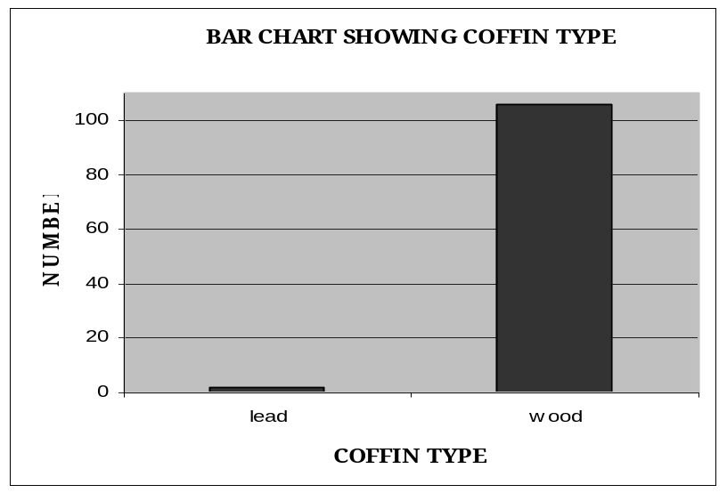

Of the lead coffins, one was associated with Archbishop Goodier and this would be expected for such a high status individual. The coffin had an outer wooden coffin and remained sealed. The other lead coffin was that of a priest and it is quite unusual to find a member of the low clergy buried in such a high status material. The lead coffin was not sealed and had an inner and outer wooden coffin. Three of the wooden coffins (404, 456, 458) were double layered and consisted of an inner and outer coffin. One coffin (250) was quite substantial and was constructed of oak.

The majority of the wooden coffins were lined with tar. Packing material was encountered in the majority of coffins and this consisted of either saw dust or newspaper. One coffin (237) had limestone/chalk packing and another (142) had horse hair present surviving from the coffin padding.

Many of the coffins had associated coffin furniture. This tended to consist of grips and grip-plates, crucifixes and coffin/breast-plates. Associated coffin/breast- plates were found in 47% of the burials (Chart 2).

Chart 2. Coffin/breast-plates
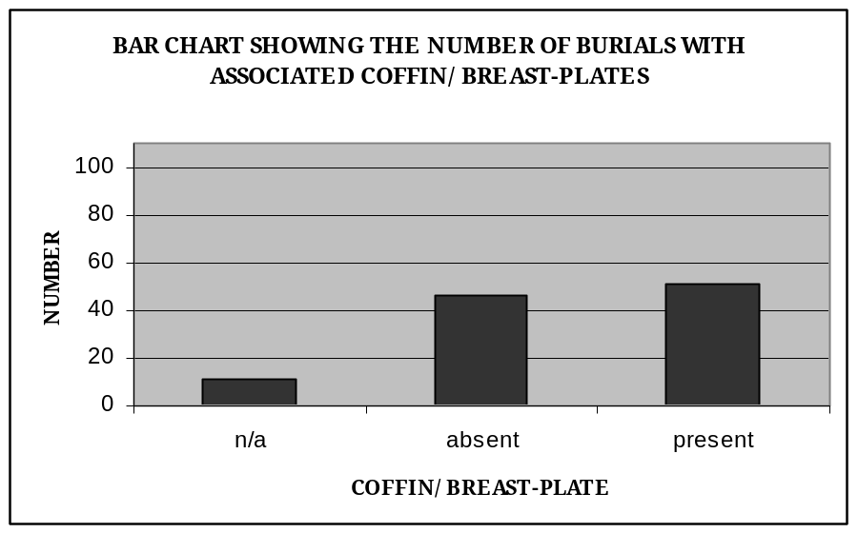

These were either in the form of a cross or a rectangular or shield-shaped panel. The plates were made of lead, iron, copper alloy of brass. Typically the lead and iron plates were often heavily corroded and in a poor state of preservation. Only nine coffin plates were legible; 5 copper alloy, 2 lead and 2 brass. These were recorded in full. Generally the plates were repetitive of the information on the tombstones. Some additional information was gained from the coffin plate of Archbishop Goodier. The plate was inscribed with the following text:

THE MOST REVERED ALBAN GOODIER
ARCHBISHOP OF HIERAPOLIS
FORMERLEY ARCHBISHOP OF BOMBAY INDIA
WHO DIED ON THE 13TH MARCH
1939
AGED 69 YEARS
R.I.P.

No decoration was present on any of the plates.

A number of coffins had crucifixes located on the lid at the head end. These were made of lead, copper or iron. In the instances where the crucifixes were lead or iron they were heavily corroded and friable.

4.4 Funerary practice

As is the practice in Christian cemeteries, all 108 individuals were buried in coffins on an east-west alignment. The orientation of individual in the grave does differ (Chart 3). The majority (80%) of individuals were orientated east-west and 18% were orientated west-east. The deepest burial was encountered at a depth of 34.16m OD some 3.24m below ground height.

Chart 3. Orientation
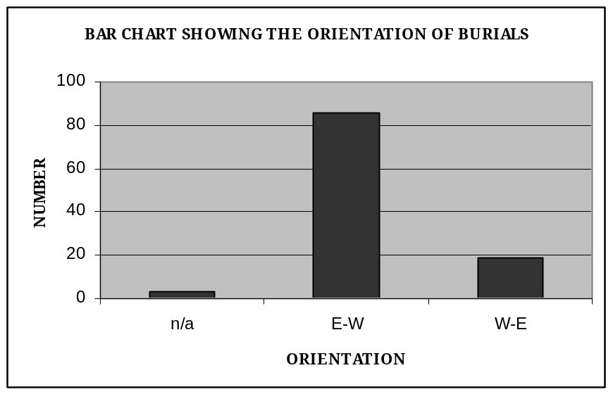

Individuals were buried either in single inhumations or stack burials containing two, three, or four coffins (Fig 4). A total of 60% (65) of individuals were buried in single inhumations (Chart 4). There were 12 double stack burials (24 individuals), five triple stacks (15 individuals) and one quadruple stack (four individuals). There appears to be a correlation between the stack burials and the more recent burials. This is likely to be due to the fact that the land was at a premium or may be related to the growth of the college at that time.

Chart 4. Inhumation type
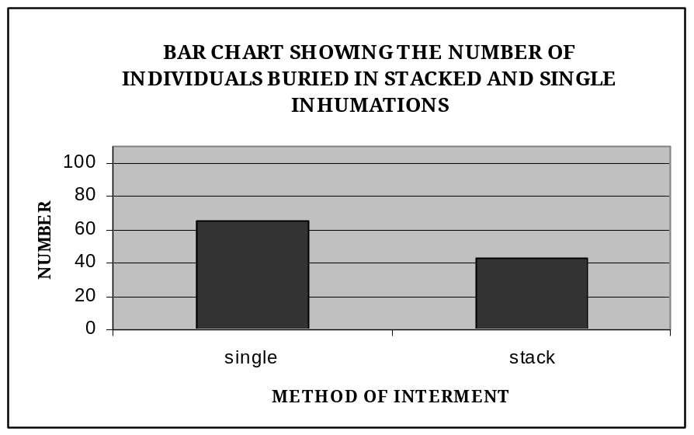

All individuals were buried supine in the coffin with their legs extended and their arms either extended by the sides or crossed on the torso. Where material had survived, (64% of individuals), individuals were buried clothed in their vestments rather than in a shroud (Chart 5). Clerical collars were often visible. These vestments appeared to be quite ornate with embroidery and in two cases (445, 451) gold thread had survived. In many cases socks and shoes were preserved.

Chart 5. Clothing
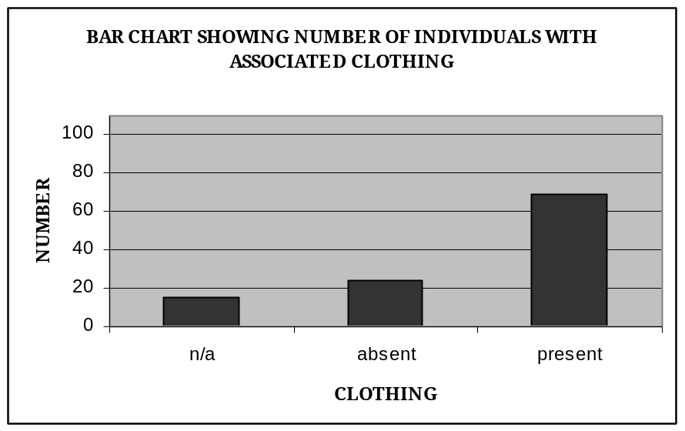

Individuals (32%) were often buried with a rosary or crucifix (Chart 6). The rosary was most commonly wooden or occasionally plastic. The crucifix was occasionally copper alloy or a copper alloy Christ on a wooden cross. These were located either around the neck, in the hands or placed on the torso. The crucifix of Archbishop Goodier was particularly ornate and on a metal chain, possibly silver.

Chart 6. Crucifix/Rosary
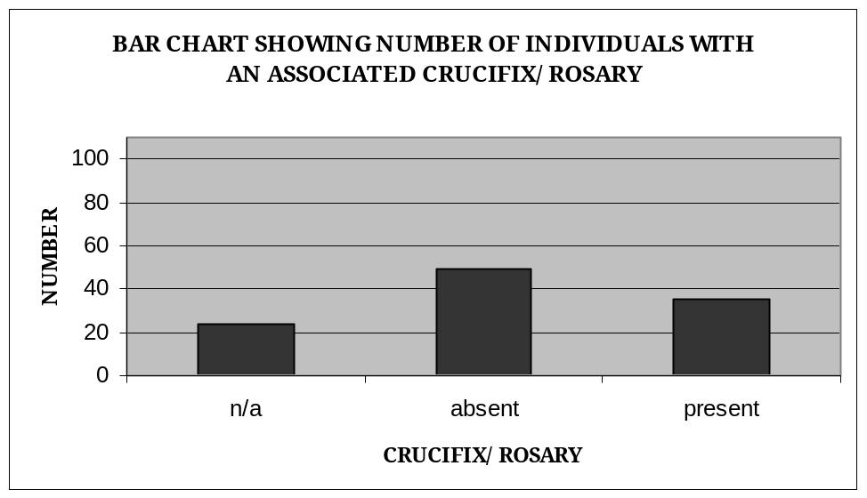

4.5 The dead

No osteological recording was carried out on the individuals as soft tissue was occasionally present and clothing was often present. It was decided that any osteological recording would be invasive and thus disrespectful.

Soft tissue was present in 12 individuals. Hair and finger nails were also relatively common. This good preservation was due to the recent nature of the burials and the fact that a number were waterlogged, which slows decomposition. The level of preservation for each individual was assessed and the results can be found in Chart 7 below.

Chart 7. Preservation
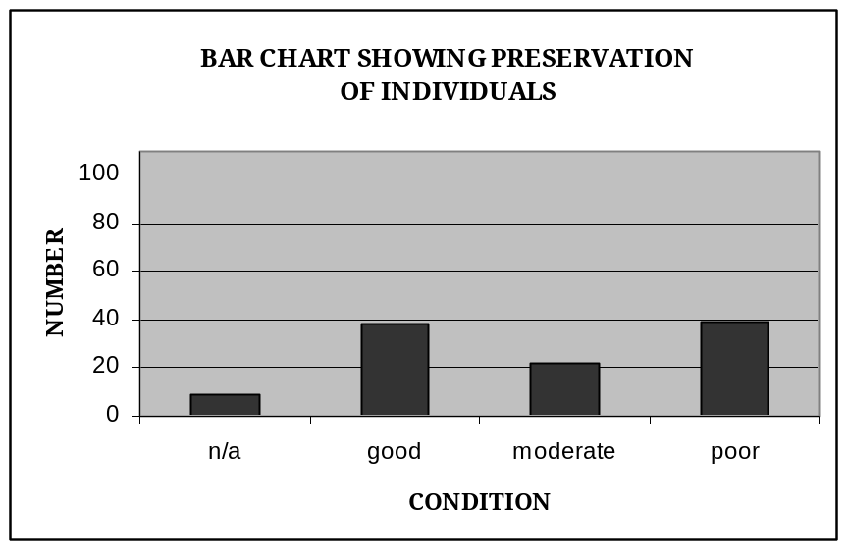

Although there a high number displayed good preservation some 36% were in poor condition (the bone was degraded and friable). Largely, this appears to be due to compression of the soil and coffin lid collapse. Often coffins were compressed to a depth of 0.10m-0.20m. Dentures were found in 7 instances.

4.6 Re-burial

The individuals were re-buried in another area of the site (see Fig 2) in one rectangular cut. Individuals were buried at a depth of approximately 2.5m in bags with durable labels giving reference to their name and relevant context numbers. These were then covered by a layer of soil, approximately 0.20m before placing the tombstones flat on top. Depending on the depth of the cut, these were stacked two-four tombstones high. Again these tombstones were sleeved in plastic and buried with durable labels with the relevant context number.

5 CONCLUSIONS

A total of 108 individuals were interred at the Jesuit cemetery at Whitelands College. The first interment was on 4th September 1867 and that last was on 29th June 1962. The cemetery was in use for some 95 years. The people who were buried at the site consisted of 73 ordained priests, 26 brothers and 4 priests in training. Included in the ordained group were Archbishop Alban Goodier and Bishop Charles Gordon.

5.1 Statement of potential

Jesuit cemeteries in Britain are rare; there are no records in the GLSMR/NMR of any Jesuit cemeteries. Therefore the site is of local, regional and national significance. However this potential is limited by a number of factors. The cemetery is relatively recent in date (1867-1962.) and thus of reduced significance. In addition the fact that no osteological recording was performed significantly reduces the potential of the data. Skeletal collections with associated biographic data are invaluable, however this potential could not be realised. The site is valuable in terms of Jesuit burial practice and should any future research be carried out into Catholic burial practice, this can be utilised as a data set.

5.2 Publishing requirements

It is recommended that the findings be reported as a short article in the London Archaeologist. It is estimated the report will be submitted for publication within 2 months.

5.3 Storage and curation

No finds were retained from the watching brief. It is recommended that the site records be archived in the Museum of London. It is estimated that the site will be archived within 6 months.

6 REFERENCES

AOC Archaeology Group (2003a) Whitelands College (Manresa House), Roehampton, London Borough of Wandsworth. Archaeological Watching Brief Written Scheme of Investigation.

AOC Archaeology Group (2003b) An Archaeological Watching Brief carried out at Whitelands College (Manresa House), Roehampton, London Borough of Wandsworth.

Arup Geotechnics (2002). Whitelands College. An Archaeological Appraisal of Manresa House, Roehampton, London Borough of Wandsworth. Ove Arup & Partners Ltd. October 2002.

English Heritage London Region (1998)
Archaeological Field Guidance Papers 2, 3 and 5.

Appendix A – Burial information

Name of individual | Date of birth | Date of death | Skeleton number | Coffin number | Tombstone number | Row number | Stack | Single inhumation | Coffin type | Associated coffin/ breast plate | Alignment | Pres. of individual | Clothing | Associated crucifix/  rosary
Fr Charles Collins | 31/07/1862 | 13/04/1950 | 5 | 6 | 1 | 1 | 1 | 0 | 1 | 2 | 1 | 3 | 2 | 2
Br John Griffin | 12/07/1864 | 02/04/1949 | 18 | 14 | 1 | 1 | 1 | 0 | 1 | 2 | 1 | 3 | 2 | 1
Fr Jacob Flynn | 28/01/1887 | 10/01/1949 | 21 | 22 | 1 | 1 | 1 | 0 | 1 | 2 | 1 | 0 | 0 | 0
Fr William Hudson | 12/12/1856 | 25/04/1898 | 23 | 67 | 12 | 1 | 0 | 1 | 1 | 1 | 1 | 3 | 2 | 1
Fr James Mathieson | 23/05/1879 | 27/11/1948 | 32 | 33 | 2 | 1 | 1 | 0 | 1 | 2 | 2 | 1 | 1 | 2
Br James Mc Bride | 13/03/1904 | 27/11/1948 | 35 | 36 | 2 | 1 | 1 | 0 | 1 | 2 | 2 | 2 | 2 | 1
Fr Roger Clutton | 13/07/1870 | 15/11/1945 | 37 | 38 | 3 | 1 | 0 | 1 | 1 | 2 | 1 | 2 | 2 | 2
Fr Henry Harford | 13/11/1837 | 28/12/1896 | 42 | 43 | 10 | 1 | 0 | 1 | 1 | 1 | 2 | 3 | 2 | 1
Fr James McSwiney | 30/06/1827 | 15/04/1905 | 46 | 47 | 11 | 1 | 0 | 1 | 1 | 1 | 2 | 3 | 2 | 1
Fr Patrick Hogan | 28/02/1816 | 01/11/1904 | 52 | 51 | 197 | 5 | 0 | 1 | 2 | 1 | 2 | 1 | 2 | 0
Fr John Bapista di Pietro | 10/02/1820 | 15/12/1883 | 54 | 55 | 15 | 1 | 0 | 1 | 1 | 1 | 1 | 3 | 2 | 1
Fr Bernard Hudson | 16/01/1844 | 31/03/1924 | 58 | 59 | 49 | 1 | 0 | 1 | 1 | 2 | 2 | 1 | 2 | 2
Fr J O'Sullivan |  | 24/06/1897 | 61 | 62 | 8 | 1 | 0 | 1 | 1 | 1 | 2 | 3 | 2 | 1
Fr James Walker | 06/09/1819 | 07/06/1887 | 64 | 65 | 9 | 1 | 0 | 1 | 1 | 1 | 1 | 3 | 2 | 1
Fr Bernard Addis | 28/02/1791 | 06/10/1879 | 73 | 74 | 16 | 1 | 0 | 1 | 1 | 1 | 2 | 3 | 2 | 1
Fr A Dignam | 08/05/1838 | 26/09/1891 | 79 | 80 | 13 | 1 | 0 | 1 | 1 | 0 | 0 | 0 | 0 | 0
Fr Bernard J Weaver | 12/02/1894 | 04/02/1952 | 102 | 103 | 70 | 2 | 1 | 0 | 1 | 2 | 1 | 1 | 1 | 1
Fr Edward O'Connor | 05/11/1874 | 23/02/1954 | 106 | 107 | 71 | 2 | 1 | 0 | 1 | 2 | 1 | 2 | 2 | 2
Fr J Leycester King | 02/07/1896 | 28/12/1952 | 109 | 110 | 71 | 2 | 1 | 0 | 1 | 2 | 1 | 3 | 2 | 2
Fr Ernest Hull | 09/09/1864 | 19/07/1952 | 111 | 112 | 71 | 2 | 1 | 0 | 1 | 2 | 1 | 2 | 2 | 1
Fr John Sinnoti | 04/02/1896 | 04/10/1951 | 113 | 114 | 70 | 2 | 1 | 0 | 1 | 2 | 1 | 2 | 2 | 1
Fr Bernard Butler | 24/02/1870 | 22/05/1950 | 115 | 116 | 70 | 2 | 1 | 0 | 1 | 2 | 1 | 0 | 2 | 0
Fr Joseph Jerrard | 05/07/1816 | 16/11/1896 | 118 | 119 | 26 | 2 | 0 | 1 | 1 | 1 | 2 | 3 | 2 | 1
Br James Stanley | 13/01/1835 | 23/04/1896 | 121 | 122 | 27 | 2 | 0 | 1 | 1 | 1 | 2 | 2 | 2 | 1
Fr John Walford | 27/03/1831 | 09/01/1894 | 126 | 127 | 28 | 2 | 0 | 1 | 1 | 1 | 1 | 2 | 2 | 1
Br Patrick Fogherty | 02/04/1839 | 07/07/1885 | 130 | 131 | 29 | 2 | 0 | 1 | 1 | 1 | 1 | 3 | 2 | 2
Br John Coupe | 13/03/1792 | 03/12/1880 | 133 | 134 | 30 | 2 | 0 | 1 | 1 | 1 | 2 | 3 | 2 | 1
Fr John Errington | 04/07/1817 | 11/03/1925 | 138 | 139 | 83 | 3 | 0 | 1 | 1 | 2 | 1 | 2 | 2 | 2
Fr John Moore | 24/10/1835 | 13/02/1925 | 142 | 143 | 69 | 2 | 0 | 1 | 1 | 1 | 1 | 2 | 2 | 2
Br Charles Faulkner | 30/06/1860 | 05/10/1892 | 146 | 147 | 25 | 2 | 0 | 1 | 1 | 0 | 1 | 1 | 2 | 0
Br Michael Goodge | 15/06/1815 | 25/11/1886 | 150 | 151 | 24 | 2 | 0 | 1 | 1 | 1 | 2 | 3 | 1 | 1
Fr William Anderton | 26/12/1816 | 28/07/1890 | 154 | 155 | 84 | 3 | 0 | 1 | 1 | 0 | 0 | 0 | 0 | 0
Br Henry Foley | 09/08/1811 | 19/11/1891 | 158 | 159 | 85 | 3 | 0 | 1 | 1 | 1 | 1 | 3 | 2 | 1
Fr George Kingdom | 30/11/1821 | 01/01/1893 | 162 | 163 | 86 | 3 | 0 | 1 | 1 | 1 | 2 | 3 | 1 | 2
Br Frederic Williams | 11/01/1851 | 18/02/1893 | 166 | 167 | 87 | 3 | 0 | 1 | 1 | 1 | 1 | 3 | 1 | 1
Br Michael Fearn | 27/05/1819 | 13/11/1895 | 170 | 171 | 88 | 3 | 0 | 1 | 1 | 1 | 1 | 2 | 1 | 2
Fr Walter Clifford |  | 29/07/1892 | 174 | 175 | 89 | 3 | 0 | 1 | 1 | 1 | 2 | 3 | 1 | 2
Br Charles Meyer | 10/06/1886 | 17/02/1887 | 178 | 179 | 82 | 3 | 0 | 1 | 1 | 1 | 1 | 3 | 1 | 1
Fr Anselm Marques | 09/08/1899 | 22/02/1959 | 182 | 183 | 90 | 3 | 1 | 0 | 1 | 2 | 1 | 2 | 1 | 1
Fr Eustace Dudley | 11/09/1883 | 30/07/1956 | 184 | 185 | 90 | 3 | 1 | 0 | 1 | 2 | 1 | 1 | 2 | 1
Fr Luke Bellanti | 18/10/1882 | 04/03/1955 | 186 | 187 | 90 | 3 | 1 | 0 | 1 | 2 | 1 | 1 | 1 | 2
Br John Wolfe | 18/05/1857 | 04/04/1879 | 217 | 218 | 99 | 4 | 0 | 1 | 1 | 0 | 1 | 3 | 2 | 0
Br W Payne | 25/06/1855 | 27/03/1878 | 221 | 222 | 98 | 4 | 0 | 1 | 1 | 0 | 0 | 0 | 0 | 0
Br Alexander Byrne |  | 25/04/1874 | 225 | 226 | 95 | 4 | 0 | 1 | 1 | 0 | 1 | 2 | 1 | 0
Fr Henry Edwards | 18/11/1810 | 24/05/1878 | 229 | 230 | 97 | 4 | 0 | 1 | 1 | 1 | 1 | 3 | 1 | 1
Fr John Baptist Bodoano | 03/12/1832 | 15/07/1868 | 233 | 234 | 94 | 4 | 0 | 1 | 1 | 2 | 1 | 3 | 1 | 1
Fr Thomas Knight | 18/12/1830 | 04/04/1899 | 237 | 238 | 92 | 4 | 0 | 1 | 1 | 0 | 2 | 2 | 1 | 1
Fr John Collins | 18/09/1848 | 10/10/1909 | 241 | 242 | 91 | 4 | 0 | 1 | 1 | 1 | 2 | 3 | 1 | 1
Fr John Pollen | 22/09/1858 | 28/04/1925 | 245 | 246 | 96 | 4 | 0 | 1 | 1 | 0 | 1 | 3 | 0 | 0
Br Joseph Melling |  | 04/09/1867 | 249 | 250 | 93 | 4 | 0 | 1 | 1 | 2 | 1 | 1 | 2 | 0
Br John Murden | 26/05/1850 | 25/09/1913 | 260 | 261 | 193 | 5 | 0 | 1 | 1 | 1 | 2 | 3 | 1 | 2
Br Joseph Whelar | 05/03/1863 | 31/05/1914 | 264 | 265 | 195 | 5 | 0 | 1 | 1 | 1 | 2 | 3 | 2 | 1
Br John Meynell | 26/07/1813 | 25/11/1926 | 268 | 269 | 189 | 5 | 0 | 1 | 1 | 0 | 1 | 0 | 0 | 0
Br Martin Ravine | 12/03/1882 | 18/12/1902 | 273 | 272 | 194 | 5 | 0 | 1 | 1 | 1 | 1 | 3 | 1 | 1
Fr William Strickland | 18/07/1819 | 30/05/1901 | 276 | 277 | 191 | 5 | 0 | 1 | 1 | 2 | 1 | 2 | 1 | 1
Fr Joseph Foxwell | 23/01/1830 | 30/04/1906 | 280 | 281 | 190 | 5 | 0 | 1 | 1 | 1 | 1 | 3 | 1 | 1
Fr Wiliam Lightbound | 06/11/1876 | 16/09/1901 | 284 | 285 | 192 | 5 | 0 | 1 | 1 | 1 | 2 | 3 | 2 | 2
Br Ivan Cronin | 31/10/1883 | 02/07/1904 | 287 | 288 | 196 | 5 | 0 | 1 | 1 | 1 | 1 | 3 | 2 | 1
Br J Kelly | 16/07/1850 | 30/06/1920 | 298 | 299 | 206 | 6 | 0 | 1 | 1 | 2 | 1 | 2 | 2 | 2
Fr Francis Green | 07/04/1864 | 24/11/1918 | 302 | 303 | 205 | 6 | 0 | 1 | 1 | 2 | 1 | 3 | 1 | 1
Bp Charles Gordon | 05/03/1831 | 16/11/1911 | 306 | 307 | 203 | 6 | 0 | 1 | 1 | 2 | 1 | 1 | 2 | 2
Fr William Leslie | 17/06/1826 | 28/03/1917 | 310 | 311 | 201 | 6 | 0 | 1 | 1 | 0 | 1 | 3 | 0 | 0
Fr JohnNew | 21/04/1845 | 19/08/1920 | 314 | 315 | 200 | 6 | 0 | 1 | 1 | 1 | 1 | 2 | 2 | 2
Br Michael Sheehan | 11/08/1858 | 23/08/1920 | 318 | 319 | 199 | 6 | 0 | 1 | 1 | 1 | 1 | 3 | 1 | 1
Fr Timothy Courtney | 06/01/1857 | 29/03/1927 | 322 | 323 | 198 | 6 | 0 | 1 | 1 | 0 | 1 | 3 | 0 | 0
Br Joseph Hague | 26/06/1838 | 30/06/1915 | 326 | 327 | 204 | 6 | 0 | 1 | 1 | 1 | 1 | 1 | 2 | 2
Fr John Macleod | 27/07/1836 | 21/07/1914 | 330 | 331 | 202 | 6 | 0 | 1 | 1 | 2 | 1 | 2 | 2 | 2
Fr William Lawson | 22/12/1834 | 28/11/1920 | 334 | 335 | 215 | 7 | 0 | 1 | 1 | 2 | 1 | 2 | 2 | 2
Fr John Turner | 04/08/1880 | 28/04/1960 | 341 | 342 | 338 | 10 | 1 | 0 | 1 | 2 | 1 | 1 | 2 | 0
Fr James Gallagher | 21/10/1887 | 21/12/1960 | 343 | 349 | 337 | 10 | 1 | 0 | 1 | 1 | 1 | 1 | 2 | 2
Fr Patrick Lynch | 17/04/1910 | 29/12/1959 | 344 | 345 | 338 | 10 | 1 | 0 | 1 | 2 | 1 | 1 | 2 | 1
Fr Bernard Whiteside |  | 16/05/1962 | 347 | 348 | 337 | 10 | 1 | 0 | 1 | 2 | 1 | 1 | 2 | 1
Fr P Widdowson |  | 29/06/1962 | 351 | 352 | 0 | 10 | 0 | 1 | 1 | 2 | 1 | 1 | 2 | 1
Fr Joseph Gallagher |  | 21/12/1960 | 354 | 355 | 337 | 10 | 1 | 0 | 1 | 2 | 1 | 1 | 2 | 0
Fr Stanley Jones | 18/11/1882 | 21/12/1960 | 356 | 357 | 337 | 10 | 1 | 0 | 1 | 1 | 1 | 0 | 0 | 0
Fr Ralph Baines | 23/10/1885 | 05/08/1959 | 359 | 360 | 338 | 10 | 1 | 0 | 1 | 2 | 1 | 1 | 2 | 0
Br John Salisbury | 05/12/1896 | 21/05/1959 | 363 | 364 | 339 | 10 | 1 | 0 | 1 | 2 | 1 | 1 | 0 | 0
Br Patrick Mannion | 22/11/1882 | 24/07/1958 | 365 | 366 | 339 | 10 | 1 | 0 | 1 | 2 | 1 | 1 | 2 | 0
Fr Henry Parker | 25/04/1819 | 12/10/1922 | 369 | 370 | 210 | 7 | 0 | 1 | 1 | 1 | 1 | 1 | 2 | 2
Fr J Edge | 31/01/1864 | 10/04/1923 | 373 | 374 | 209 | 7 | 0 | 1 | 1 | 1 | 1 | 3 | 2 | 2
Br Andrew Merchant | 30/11/1850 | 18/04/1923 | 377 | 378 | 208 | 7 | 0 | 1 | 1 | 2 | 1 | 3 | 2 | 2
Fr Wiliam Forbes-Leith | 01/09/1833 | 30/04/1921 | 381 | 382 | 213 | 7 | 0 | 1 | 1 | 2 | 1 | 1 | 2 | 1
Fr Charles Blount | 20/06/1855 | 19/02/1931 | 385 | 386 | 216 | 8 | 1 | 0 | 1 | 2 | 1 | 2 | 1 | 1
Fr Francis Chew | 16/07/1858 | 02/04/1921 | 389 | 390 | 214 | 7 | 0 | 1 | 1 | 1 | 1 | 3 | 2 | 1
Fr Sydney Smith | 11/03/1843 | 05/07/1922 | 393 | 394 | 211 | 7 | 0 | 1 | 1 | 2 | 1 | 1 | 2 | 2
Fr Daniel Considine | 01/01/1849 | 10/01/1922 | 397 | 398 | 212 | 7 | 0 | 1 | 1 | 2 | 1 | 2 | 2 | 2
Fr John O'Fallon Pope | 26/12/1850 | 21/10/1934 | 401 | 402 | 257 | 8 | 1 | 0 | 1 | 1 | 1 | 1 | 0 | 0
Fr Harold Ward | 25/11/1865 | 16/03/1933 | 403 | 404 | 257 | 8 | 1 | 0 | 1 | 2 | 1 | 1 | 1 | 0
Fr Vincent Honeyold | 13/04/1849 | 28/07/1929 | 407 | 408 | 252 | 8 | 1 | 0 | 1 | 2 | 1 | 1 | 2 | 2
Fr George Gruggen | 28/03/1865 | 02/06/1929 | 409 | 410 | 252 | 8 | 1 | 0 | 1 | 1 | 1 | 2 | 2 | 1
Fr Francis McShane | 02/10/1858 | 01/03/1936 | 413 | 414 | 256 | 8 | 1 | 0 | 1 | 2 | 1 | 1 | 2 | 2
Br Thomas Meynell | 04/10/1851 | 26/11/1924 | 415 | 416 | 256 | 8 | 1 | 0 | 1 | 1 | 1 | 1 | 2 | 2
Br Joseph Meyer | 16/02/1868 | 30/01/1931 | 419 | 420 | 253 | 8 | 1 | 0 | 1 | 2 | 1 | 2 | 2 | 1
Br Alfred McAulay | 13/07/1852 | 15/02/1929 | 421 | 422 | 253 | 8 | 1 | 0 | 1 | 1 | 1 | 1 | 0 | 1
Br Augustus Barrow | 24/10/1853 | 17/09/1928 | 425 | 426 | 254 | 8 | 1 | 0 | 1 | 1 | 1 | 1 | 1 | 1
Fr Henry Meyer | 24/04/1864 | 22/04/1928 | 427 | 428 | 254 | 8 | 1 | 0 | 1 | 1 | 1 | 1 | 2 | 2
Fr William Strappini | 16/01/1849 | 31/05/1927 | 431 | 432 | 255 | 8 | 0 | 1 | 1 | 1 | 1 | 1 | 0 | 1
Fr John Wilson | 13/05/1865 | 28/07/1930 | 433 | 434 | 216 | 8 | 1 | 0 | 1 | 2 | 1 | 0 | 0 | 0
Arch Bp. Alban Goodwin | 14/04/1869 | 13/03/1939 | 435 | 436 | 292 | 9 | 0 | 1 | 2 | 2 | 1 | 0 | 0 | 0
Br Robert Hammond | 11/10/1920 | 10/10/1940 | 439 | 440 | 291 | 9 | 0 | 1 | 1 | 1 | 1 | 3 | 2 | 1
Br James Reddington | 25/02/1862 | 20/10/1937 | 443 | 442 | 295 | 9 | 1 | 0 | 1 | 1 | 1 | 1 | 2 | 2
Fr Francis de Juleta | 29/06/1853 | 11/01/1937 | 445 | 446 | 295 | 9 | 1 | 0 | 1 | 2 | 1 | 1 | 2 | 2
Br Bernard Bunker | 26/07/1914 | 16/08/1936 | 449 | 450 | 296 | 9 | 1 | 0 | 1 | 2 | 1 | 3 | 2 | 1
Fr Joseph Flynn | 27/02/1857 | 17/05/1936 | 451 | 452 | 296 | 9 | 1 | 0 | 1 | 2 | 1 | 1 | 2 | 1
Br Charles Ellingwood | 11/03/1871 | 19/10/1938 | 455 | 456 | 294 | 9 | 1 | 0 | 1 | 2 | 1 | 1 | 2 | 2
Fr Theodore Evans | 05/07/1868 | 21/12/1937 | 457 | 458 | 294 | 9 | 1 | 0 | 1 | 2 | 1 | 1 | 2 | 1
Br Henry Godsell | 26/07/1876 | 24/03/1939 | 461 | 462 | 293 | 9 | 1 | 0 | 1 | 2 | 1 | 1 | 2 | 2
Br William Brewer | 21/03/1855 | 13/03/1939 | 463 | 464 | 293 | 9 | 1 | 0 | 1 | 2 | 1 | 1 | 2 | 1

Appendix B
GLSMR/RCHME NMR ARCHAEOLOGICAL REPORT FORM

1. Type of Recording: Evaluation
Excavation
Watching Brief
Other (specify)

2. Address: Whitelands College
Holybourne Avenue
Roehampton
London

Borough: Wandsworth

Site Name: Whitelands College Site Code: MHY03

National Grid Refs: centre of site TQ 522191 173612

limits of site a) b)

c) d)

3. Directed/Supervised by: Melissa Melikian

Address: Unit 7, St Margaret’s Business Centre, Drummond Place
Twickenham, TW1 1JS

For (organisation/department): AOC Archaeology Group

Funded by: Lend Lease

4. Date fieldwork started: 19-11-2003 Date finished: 22-12-2003

Fieldwork previously notified Yes/No

Fieldwork will continue Yes/No

5. Periods represented:

palaeolithic roman

mesolithic saxon

neolithic medieval

bronze age post-medieval

iron age unknown

6. Period Summaries

Post-medieval.

Post-medieval to modern (1867-1961) Jesuit cemetery associated with Manresa House, a Jesuit training college. 108 individuals were exhumed and re-buried in another area of the site. 82 tombstones were recorded and re-buried with the human remains.

7. Natural

Height above Ordnance Datum: n/a

Type (specify): n/a

8. Location of Archive

a) Please tick those categories still in your possession:

NO PH SL MS

PL NG CO

b) All/some records have been/will be deposited in the following museum,
record office, etc.

Museum of London

c) Approximate year of transfer: 2004

d) Location of any copies: AOC Archaeology

e) Has a security copy of the archive been made ?: Yes/No/Will be

If not, do you wish RCHME to consider microfilming ?: Yes/No

9. Location of Finds:

a) In your possession (delete as appropriate) All/Some/None

b) All/some finds have been/will be deposited with the following museum/
other body: n/a

c) Approximate year of transfer: n/a

10. Bibliography:

AOC Archaeology Group (2003) Whitelands College (Manresa House), Roehampton, London Borough of Wandsworth. Archaeological Watching Brief Written Scheme of Investigation.

AOC Archaeology Group (2003) An Archaeological Watching Brief carried out at Whitelands College (Manresa House), Roehampton, London Borough of Wandsworth.

AOC Archaeology Group (2004) An Archaeological Watching Brief of the Exhumation of the Jesuit Cemetery at W Whitelands College, Roehampton, London Borough of Wandsworth.

Arup Geotechnics (2002). Whitelands College. An Archaeological Appraisal of Manresa House, Roehampton, London Borough of Wandsworth. Ove Arup & Partners Ltd. October 2002.

Signature: Date: 16.1.04

