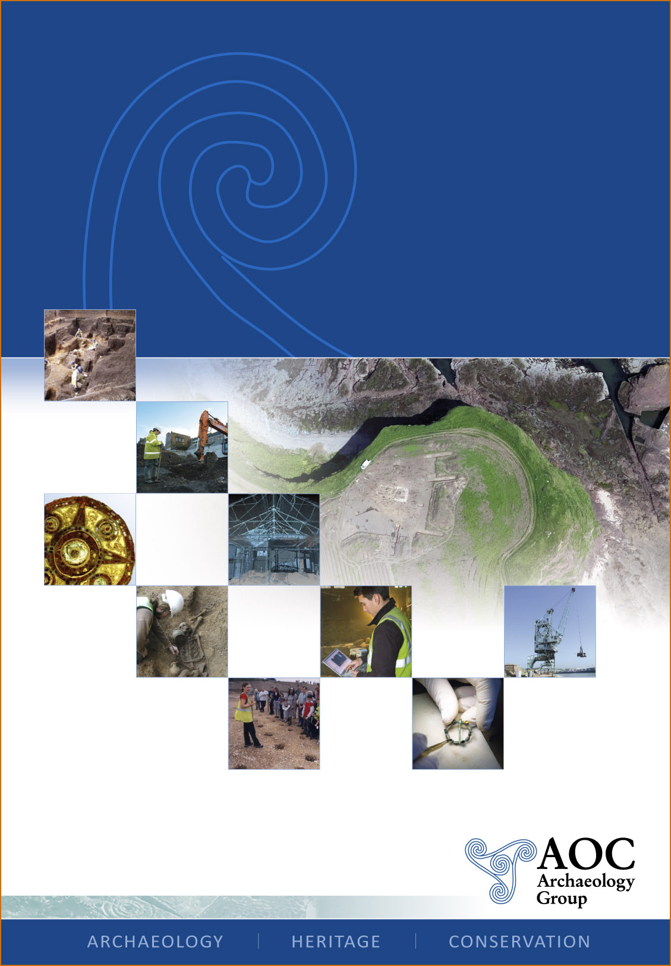

Brize Norton Airfield, Oxfordshire.
An Archaeological Watching Brief Report

National Grid Reference Number: SP 3000 0680
AOC Project no: 7929
Site Code: OXCMS 2007.102
Date: 2008

Brize Norton Airfield, Oxfordshire
An Archaeological Watching Brief Report

On Behalf of: Defence Estates
Environmental Support Team
Bldg 2, Westdown Camp,
Tilshead, Salisbury,
TN3 4RS

National Grid Reference (NGR): SP 3000 0650

AOC Project No: 7929

Prepared by: Paolo Guarino

Illustration by: Jonathan Moller

Date of Excavation: 05/09-09-2007
03/04-03-2008

Date of Report: 20-03-2008

This document has been prepared in accordance with AOC standard operating procedures.

Author: Paolo Guarino Date: 20-03-2008

Approved by: Date:

Draft/Final Report Stage: Date:

Enquiries to: AOC Archaeology Group
Unit 7
St Margarets Business Centre
Moor Mead Road
Twickenham
TW1 1JS

Tel. 020 8843 7380
Fax. 020 8892 0549
e-mail. london@aocarchaeology.com
Contents
Page
List of illustrations iii
1. INTRODUCTION 1
1.1 Site Location 1
1.2 Geology and Topography 1
1.3 Planning Background 1
1.4 Aims and Objectives 1
1.5 Methodology 2
2. ARCHAEOLOGICAL AND HISTORICAL BACKGROUND 3
3. RESULTS 4
3.1 Area A – Aircraft Service Platform 4
3.2 Area B – Drainage Trench 4
3.3 Area C – Newt Pond 4
3.4 Finds 5
4. CONCLUSIONS 6
5 BIBLIOGRAPHY 7
Appendix A 9

List of illustrations
Figure 1: Site Location Plan
Figure 2: Detailed Location Plan
Figure 3: Area C: Proposed Newt Pond

Non-Technical Summary
An archaeological watching brief was undertaken by AOC Archaeology Group at Brize Norton Airfield, Oxfordshire: on behalf of Environmental Advisor (Archaeology) of Defence Estates. The aim of the watching brief was to record any archaeological remains exposed during the development.

The watching brief comprised the archaeological monitoring of ground works at the site between the 5th and 9th September 2007, the 17th January 2008 and 3rd and 4th March 2008. Natural sandy terrace gravels were identified at 74.59mOD Sealing the gravels was a layer of naturally accumulated subsoil, which was in turn sealed by dark organic topsoil.

A ditch, two pits and a stone-lined well were identified during the programme of archaeological monitoring.

- INTRODUCTION
  - Site Location
    - The site is located at Brize Norton Airfield, Oxfordshire (Figure 1). It is irregular in shape and is centred on National Grid Reference (NGR) SP 3000 0650, situated to the southeast of Carterton (Figure 2).
    - Currently the site is occupied by Brize Norton Airfield. The proposed development is for new hard-standings for the RAF fleet.
  - Geology and Topography
1.2.1 The British Geological Survey South Solid map indicates that the site is situated upon Cornbrash but also close to the boundary of the Great Oolite beds to the north.
    - The site occupies a relatively flat area at approximately 80m OD.
    - No geotechnical investigations have been conducted within the proposed development area.
  - Planning Background
1.3.1 The site lies within land occupied by the RAF Air-to-Air Refuelling (AAR) fleet and Strategic Air Support. As such it is not covered by usual planning regulations. The Environmental Advisor (Archaeology) of Defence Estates decided that the groundworks were to be subject to an archaeological Watching Brief.

    - The proposed scheme involves the construction of new hard-standings for the RAF fleet and the construction of a Newt pond to counteract the scheme’s environmental effects. This will involve ground disturbance potentially detrimental to below-ground archaeological deposits. The Brief supplied by Enviros, on behalf of the Environmental Advisor (Archaeology) of Defence Estates stated that the site is partially occupied by the Marsh Haddon Deserted Medieval Village, covering approximately 1 Hectare.

    - A Desk Based Assessment was not required prior to the commencement of the watching brief due to the limited scale of the development.

    - This document reports on the results of an archaeological watching brief undertaken to identify any archaeological remains that might be threatened by the proposed development. All works were undertaken by professional archaeologist in accordance with the Written Scheme of Investigation (AOC 2007).

  - Aims and Objectives
    - The aims of the Watching Brief were defined as being:
- To establish the presence/absence of archaeological remains within the site.
- To determine the extent, condition, nature, character, quality and date of any archaeological remains encountered.
- To record and sample excavate any archaeological remains encountered.
- To assess the ecofactual and environmental potential of any archaeological features and deposits.
- To determine the extent of previous truncations of the archaeological deposits.

1.4.2 The specific objectives of the Watching Brief were to:
- Determine the presence of any remains of Marsh Haddon deserted medieval village.
- Assess the potential of the site to inform on the medieval development and chronology of Marsh Haddon.

    - The final aim is to make public the results of the investigation, subject to any confidentiality restrictions.

  - Methodology
    - An archaeologist was present to observe ground works, positioned outside the working area of the mechanical excavator, in the normal working arrangement, at times entering the trench to carry out close inspection or record limited sections.
    - Machining of the proposed groundworks was undertaken with a flat bladed bucket (toothless) in horizontal spits.
    - Archaeological recording, where not precluded by Health & Safety considerations consisted of:
- The collection of dating evidence from in-situ deposits and spoil scans.
- A scaled photographic recording of representative exposed sections and surfaces, along with sufficient photographs to establish the setting and scale of the ground works.
- A record of the datum levels of all deposits.

    - Records were produced using pro-forma context and trench record sheets and by the single context planning method, compatible with those published by the Museum of London (MoL 1994).

    - A record of the full sequence of all deposits as revealed in the Watching Brief were made, and plans and sections were drawn at an appropriate scale.

2. ARCHAEOLOGICAL AND HISTORICAL BACKGROUND
    - No previous archaeological investigations are known to have occurred on the site. The Brief states that there are a number of entries in the Oxfordshire Sites and Monuments Record (SMR) for archaeological sites, features or chance finds 'outside the wire' but in close proximity to the RAF base. These include an Iron Age settlement (monument OX 157) and an Anglo-Saxon cemetery (Monuments OX 1498 and 1499 - these located at c SP3003 0813 and SP3054 0819). Additionally finds of Prehistoric flints (OX 5461 - SP3110 0815), a Neolithic Axe (OX 15810 - SP31090749), Romano-British pottery (OX 4248 - SP3020 0744 & OX 11880 - SP30510809), and medieval pottery (OX 2279 - SP30070755) would tend to indicate that this is a very rich archaeological landscape.
    - Within the base there is one known entry - to the east. This is D1065 Marsh Haddon Deserted Medieval Village. Located at SP 303 064, this former settlement covers approximately a hectare.
    - The principal feature on site is the airfield. It was established in 1935 and officially opened on 13 August 1937. The Station was used for various forms of flying training until July 1942, when it became the home of the Heavy Glider Conversion Unit (HGCU), later renamed No 21 HGCU, which remained at RAF Brize Norton until 31 December 1945.
    - Between March and October 1944 Brize Norton airfield was used as a base for parachute and glider operations by Nos. 296 and 297 Squadrons, both equipped with Albemarles. These squadrons were used for D-Day landings in June 1944, the assault on Arnhem in September 1944 and contributed to the war-time supply lines.
    - The great change to the use of the airfield was in 1951, when the USAF formally accepted control of RAF Brize Norton. the first American aircraft to arrive at RAF Brize Norton were 21 B36 Convair Peacemaker bombers. The first jet bombers to land here were B47 Stratojets in September 1953. The B-47 was the first line of America's strategic defense in the late 1950s and early 1960s, standing guard with nuclear weapons against the Soviet Union the last one returning to the United States in April 1965.
    - On 1 April 1965 the Royal Air Force took back control of RAF Brize Norton and it became a Transport Command airfield. New hangars were constructed, and the base was home to Nos 10, 53, 99 and 511 Squadrons. Early in 1972, the Station became part of No 46 Group, Strike Command and, in October 1975, became part of No 38 Group, Strike Command. Tactical support for combat rather than Cold-war deterrance was provided by the base duiring the Falklands conflict in 1982.
    - During the First Gulf War of 1991, air-to-air refuelling (AAR) support for the RAF was provided; the US Navy and Marine Corps also benefited. Over the years, the Station maintained its links with the USAF, hosting several large-scale USAF tanker deployments and culminating in a major operational deployment providing support for the Kosovo air campaign. Most, recently, RAF Brize Norton has played a significant role in the campaign against terrorism. The base is still operational *.
*All RAF information taken from http://www.raf.mod.uk/rafbrizenorton/aboutus/history.cfm
3. RESULTS
  - Area A – Aircraft Service Platform
    - The proposed Aircraft service platform is situated within the centre of the base (Figure 2). It was roughly rectangular in shape, measuring about 168 m². No archaeological remains were uncovered from within this area.
    - The stratigraphic model exposed from this excavation comprised natural orange and blue mottled silty clay, overlying a shallow deposit of humic brown topsoil.
3.2 Area B – Drainage Trench
    - The drainage trench ran northwest–southeast, turning northeast-southwest to the east of the aircraft service platform and to the south of the Newt pond (Figure 2).

    - The excavation of the drainage trench revealed a stratigraphy which did not reach the natural clays revealed within Area A. Subsoil was identified between 1m and 0.4m below the surface of the trench; this was mid yellowish brown, loose sandy silt (1/003). Three features cut the subsoil: two pits and a stone lined well were revealed during the excavations of the drainage trench.

    - Due to particular constrains these features were only recorded in section. One pit [1/005] was 2.50m wide and about 1m deep it was filled by loose dark brown sandy silt (1/004); it contained frequent angular stones and occasional fragments of blue Transfer Printed Pottery and therefore was backfilled after the late 18th century. The second pit [1/007] lay roughly 3m to the west of the first; it was about 2m wide and 1.8m deep. This pit was also filled with loose dark brown sandy silt 1/006) which was very similar to (1/004). Both (1/004) and (1/006) had similar appearance to the overlying layer (1/002).

    - About 50m west of the two pits was a stone-lined well with associated lead pipes was recorded. It measured about 1.50m in diameter and 2m in depth. Although no dating artefacts were found the well was dated to the late post-medieval period mainly on the basis of building techniques.

    - The features were sealed by dark brown, loose sandy silt (1/002); a secondary subsoil, and above this was humic, mid brown, clayey silt topsoil (1/001).

3.3 Area C – Newt Pond
    - A circular Newt pond was constructed within the north eastern corner of the aircraft base, to the north of Area B (Figure 2). It measured 10m in diameter and was excavated to a depth of over 2m. It was constructed as a counteractive measure for the proposed schemes environmental effects.

    - During the excavation of the newt pond the natural gravelly clay deposit (2/004) was encountered at a level of 74.59m OD, this was overlaid by 0.30m thick subsoil (2/003), which was moderately compacted, mid grey-brown sandy clay. Above this was a 0.10m thick layer of loose yellow sandy gravel, (2/002) containing post medieval glass, CBM and pot sherds. This was made ground, a-levelling deposit. These deposits were sealed by 0.18m thick topsoil (2/001); this was soft, mid orange-brown clayey silt containing occasional modern building material and metal objects.

    - The excavation of the newt pond revealed a single shallow ditch [2/005] cut directly into the natural gravelly clay (2/004). The ditch was orientated northwest-southeast, running across the centre of the area and measuring 10m in length (maximum length of the trench), 2m wide and only 0.25m in depth. The ditch was filled by firmly compacted mid brown-grey sandy clay (2/006) with frequent sub rounded pebbles and occasional snail shells.

    - Two 1m wide slots were hand excavated in (2/006) fill of ditch [2/005]. No dating materials were recovered from the excavation, but two pig skeletons (2/007) and (2/011) were recovered from the fill.

    - Towards the north edge of the trench a pit [2/010] was recorded that cut through the ditch. The pit was oval in plan; 1.1m long, 0.40m wide and 0.30m deep. It was filled by moderately firm, mid grey-brown sandy silt with occasional roots (2/008). Excavation of this revealed the presence of a third pig skeleton (2/009) which was laid at the bottom of Pit [2/010].

3.4 Finds
3.4.1 The remains of pig skeletons were collected and processed and are now waiting for specialist assessment. No dating artefacts were collected from the fill of the ditch [2/005] and the post medieval materials found (2/002) were noted and discarded on site.

4. CONCLUSIONS

    - The watching brief met its primary objective: to establish the presence or absence of any archaeological remains. The archaeological material on site is dominated by post-medieval features, likely to be of 19th century date or later. The well and pits indicate immediate occupation of the site, but there may have been a degree of horizontal truncation as suggested by the lack of building foundations associated with the features, and by the presence of made ground and levelling layers. The lack of finds from the features with the pig skeletons may suggest a modern date, but limits their archaeological significance.
    - Publication of the results will be through the ADS OASIS form (Appendix B).

5 BIBLIOGRAPHY
AOC Archaeology Group Ltd (2003). Fieldwork Sector On-Site Handbook.

AOC Archaeology Group Ltd (2007).Brize Norton Airfield, Oxfordshire; A Written Scheme of Investigation for an Archaeological Watching Brief.

Council for British Archaeology (1987). First Aid For Finds (Second Edition).

Defence Estates Environmental Support Team (2007). Brize Norton ASP Project – Contractors batching plant, site office and temporary haul road – Brief for Archaeological Recording

Department of the Environment (1990). Planning Policy Guidance: Archaeology and Planning (PPG16).

English Heritage (1991). Management of Archaeological Projects.

English Heritage (1998a). Archaeological Guidance Paper 3: Standards and Practices in Archaeological Fieldwork. (English Heritage London Region).

English Heritage (1998b). Archaeological Guidance Paper 4: Standards and Practices in Archaeological Reports. (English Heritage London Region).

English Heritage (2002). Environmental Archaeology: A guide to the theory and practice of methods, from sampling and recovery to post-excavation.

Institute of Field Archaeology (1992). Standards and Guidance and Guidelines for Finds Work.

Institute of Field Archaeologists (1994, revised 2001). Standard and Guidance for an Archaeological Watching Brief.

Institute of Field Archaeologists (1997). Code of Conduct.

Museum of London (1994). Archaeological Site Manual (3rd ed).

United Kingdom Institute for Conservation (1983). Conservation Guidelines No 2.

United Kingdom Institute for Conservation (1990). Guidance for Archaeological Conservation Practice.

English Heritage (1998): English Heritage London Region Archaeological Guidance Paper 2

Museum of London (1998): Archaeology in Greater London 1965-90: A guide to records of excavations made by the Museum of London.

Museum of London (1999): General Standards for the Preparation of Archaeological Archives Deposited with the Museum of London.



Appendices

Appendix A

OASIS ID: aocarcha1-39567
Project details
Project name | Brize Norton Airfield
Short description  of the project | An archaeological watching brief was undertaken by AOC Archaeology Group at Brize Norton Airfield, Oxfordshire on behalf of Environmental Advisor (Archaeology) of Defence Estates. The watching brief comprised the archaeological monitoring of ground works at the site. A ditch, two pits and a stone lined well were identified during the archaeological monitoring.
Project dates | Start: 05-09-2007 End: 04-03-2008
Previous/future  work | No / No
Any associated  project reference  codes | OXCMS 2007.102 - Sitecode
Type of project | Recording project
Site status | None
Current Land use | Other 15 - Other
Monument type | DITCH Uncertain
Monument type | PITS X2 Post Medieval
Monument type | STONE LINED WELL Post Medieval
Investigation type | 'Watching Brief'
Prompt | Environmental Advisor of Defence Estates decision
Project location
Country | England
Site location | OXFORDSHIRE WEST OXFORDSHIRE CARTERTON Brize Norton Airfield
Postcode | OX18 3
Study area | 168.00 Square metres
Site coordinates | SP 3000 0650 51.7559311087 -1.565321211290 51 45 21 N 001 33 55 W Point
Height OD | Min: 74.52m Max: 74.59m
Project creators
Name of  Organisation | AOC Archaeology
Project design  originator | Environment Agency
Project  director/manager | Andy Leonard
Project supervisor | Dan Eddisford
Project supervisor | Catherine Edwards
Project supervisor | Paul Harris
Type of  sponsor/funding  body | Developer
Name of  sponsor/funding  body | Environmental Advisor of Defence Estates
Project archives
Physical Archive  recipient | NMR
Physical Contents | 'Animal Bones'
Digital Archive  recipient | NMR
Digital Contents | 'Animal Bones','Stratigraphic'
Digital Media  available | 'Database','Images raster / digital photography','Spreadsheets','Text'
Paper Archive  recipient | NMR
Paper Contents | 'Animal Bones','Stratigraphic'
Paper Media  available | 'Context sheet','Drawing','Map','Matrices','Photograph','Plan','Report','Section','Unpublished Text'
Project
bibliography 1
Publication type | Grey literature (unpublished document/manuscript)
Title | Brize Norton ASP Project - Contractors batching plant, site office and temporary haul road - Brief for Archaeological Recording
Author(s)/Editor(s) | Defence Estates Environmental Support Team
Date | 2007
Issuer or  publisher | Defence Estates Environmental Support Team
Place of issue or  publication | UK
Description | A4 bound document
Project
bibliography 2
Publication type | Grey literature (unpublished document/manuscript)
Title | Brize Norton Airfield, Oxfordshire; A Written Scheme of Investigation for an Archaeological Watching Brief.
Author(s)/Editor(s) | AOC Archaeology Group Ltd
Date | 2007
Issuer or  publisher | AOC
Place of issue or  publication | London
Description | A4 bound document
Entered by | Paolo Guarino (paologuarino@hotmail.com)
Entered on | 20 March 2008

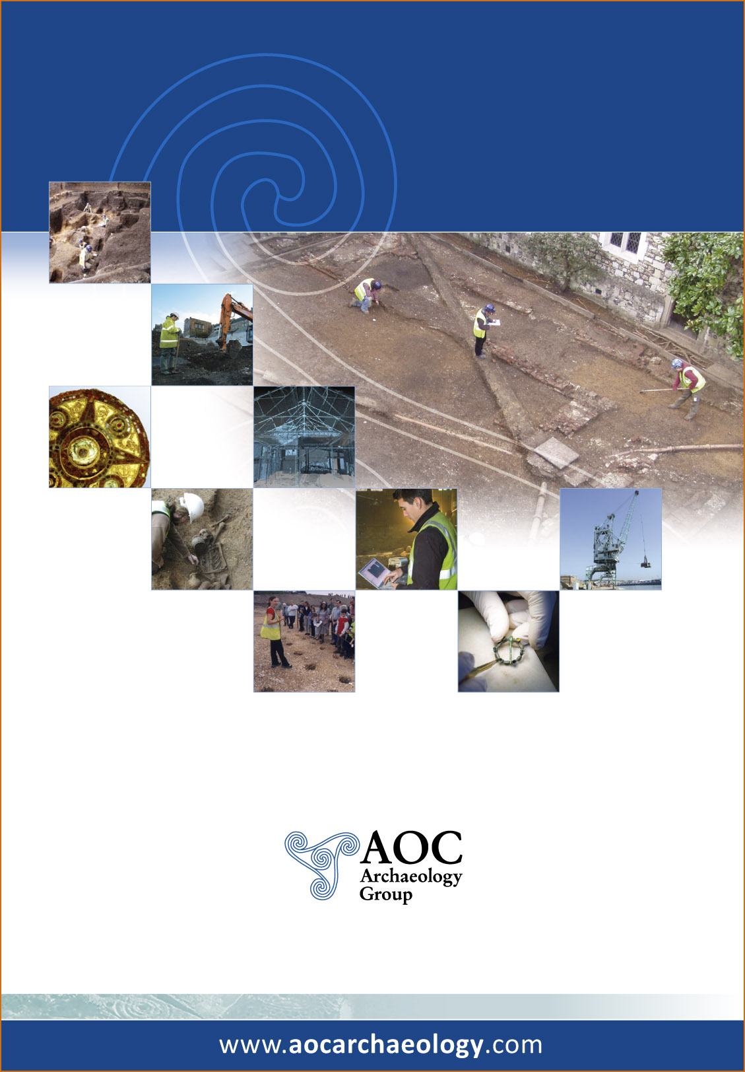

AOC Archaeology Group, Unit 7, St Margarets Business Centre, Moor Mead Road, Twickenham TW1 1JS
tel: 020 8843 7380 | fax: 020 8892 0549 | e-mail: london@aocarchaeology.com

