

3 – 5 Lower Coombe Street, Croydon
London Borough of Croydon
An Archaeological Evaluation Report
Planning Application No: 06/01725/P
National Grid Reference: TQ 3231 6488
AOC Project No: 7777
March 2008

3-5 Lower Coombe Street, Croydon, London Borough of Croydon
An Archaeological Evaluation Report

On Behalf of: MHK Architects
The Pavilions
35a Brighton Road
South Croydon
London
CR2 6EB

National Grid Reference (NGR): TQ 3231 6488

AOC Project No: 7777

Prepared by: Chris Pole

Illustration by: Jon Moller

Date of Excavation: 26th - 27th February 2008

Date of Report: March 2008

This document has been prepared in accordance with AOC standard operating procedures.

Author: Chris Pole Date: 25th March 2008

Approved by: Andy Leonard Date: 25th March 2008

Draft/Final Report Stage: Date: 25th March 2008

Enquiries to: AOC Archaeology Group
Unit 7
St Margarets Business Centre
Moor Mead Road
Twickenham
TW1 1JS

Tel. 020 8843 7380
Fax. 020 8892 0549
e-mail. london@aocarchaeology.com

Contents
Page

List of illustrations iv

List of plates iv

Non-Technical Summary v

1. Introduction 1
1.1 Site Location 1
1.2 Planning Background 1
1.3 Geology & Topography 1

2. Archaeological & Historical Background 2
2.4 Prehistoric (before c.AD43) 2
2.5 Romano-Bristish 2
2.6 Anglo-Saxon 3
2.7 Medieval (c. 1066 – 1485) 3
2.8 Post-medieval (c. 1486– modern) 3

3. Aims and Objectives 4

4. Methodology 4

5. Results 5
5.1 Trench 1 5

6. Finds 5

7. Conclusions and Reccommendations 5

8. Bibliography 6

Appendix A – Context Register 12

Appendix B – OASIS Form 13
List of illustrations
Figure 1 – Site Location
Figure 2 – Detailed Site Location
Figure 3 – Trench Plan and Sample Stratigraphy

List of plates
Plate 1 – Shot of Site
Plate 2 – Trench 1 Overall Shot
Plate 3 – Sample Stratigraphy
Plate 4 – Pit (1/006)

Non-Technical Summary

An archaeological evaluation was undertaken by AOC Archaeology Group between the 16th and 17th of February 2007 at 3-5 Lower Coombe Street, Croydon, London Borough of Croydon (NGR: TQ 3231 6488). The aim of the evaluation was to assess the impact of the proposed development of the site on any surviving archaeological remains.

The evaluation consisted of one trench measuring 13.00m x 8.00m. The evaluation revealed the natural Taplow Gravels at a height of 45.41m OD. These were overlain by a buried soil horizon through which a pit containing 19th century pottery was cut.

1. Introduction
1.1 Site Location

1.1.1 The site is centred on National Grid Reference (NGR) TQ 3231 6488, and is within land bounded by Keen’s Road to the east and residential properties to the north, south and west (Figure 1). The site is elongated and rectangular in shape and measures approximately 125m² (Figure 2, Plate 1).

1.2 Planning Background

1.2.2 The local planning authority is the London Borough of Croydon. Archaeological advice to the council is provided by the Greater London Archaeological Advisory Service (GLAAS).

1.2.3 A Planning Application to undertake development on the site has been submitted (Ref No.: 06/01725/P) and has been made subject to conditions. The Archaeological Condition states that:

“No development including excavations for drainage and foundation work shall take place within the site until the applicant has secured the implementation of a programme of archaeological work in accordance with a written scheme of investigation which has been submitted by the applicant and approved by the Local Planning Authority. The development shall only be carried out in accordance with the agreed programme.”

This condition has been required in accordance with Planning Policy Guidance: Archaeology and Planning (PPG 16) issued by the Department of the Environment in 1990 (DoE, 1990), and was recommended by GLAAS.

1.2.4 The site lies within an Archaeological Priority Zone, as defined by the London Borough of Croydon.

1.2.5 AOC Archaeology Group Ltd were commissioned by MHK Fairbairn to carry out the Archaeological Evaluation. Subsequently a Written Scheme of Investigation (WSI) was prepared (AOC 2008) which detailed how the Evaluation, consisting of one trench would be undertaken.

1.2.6 Prior to commencing work a unique code for the project was provided by the Museum of London (LWC08).

1.2.7 On site field work was undertaken on the 26th and 27th February 2008.

1.3 Geology & Topography
    - The British Geological Survey map (BGS Sheet 270) indicates that the solid geology of the site is chalk, overlain by Thanet beds, Woolwich & Reading beds, Blackheath beds and London Clays (PCA 2006).
    - The drift geology is Taplow terrace gravel deposited from the River Wandle; the site itself lies upon the eastern terrace towards the base of the valley (PCA 2006). An excavation at 11 Coombe Street/ 17 St Andrews Road revealed these gravels at a height of c.45.70m AOD.
    - The site is located on roughly level ground at a height of approximately 46.80m Above Ordnance Datum (AOD).

1.3.4 No geotechnical investigations have been conducted within the proposed development area.

2. Archaeological & Historical Background

2.1 A number of evaluations, excavations, and watching-briefs having been undertaken in Croydon, and there are numerous entries within the Greater Sites and Monuments Record (SMR) for archaeological features or chance finds within the 1km radius of the site.

2.2 The following background information is drawn from the Desk Based Assessment (PCA 2006).

2.3 No previous archaeological investigations have been undertaken on the site itself.

2.4 Prehistoric (before c.AD43)
2.4.1 Mesolithic and Neolithic flint tools have been discovered in the immediate vicinity of the site at St Peters Road, 2-4 Coombe Street, Church Road and Park Lane nearby, representing seasonal activity by hunter-gatherers. A possible redeposited blade at 23-31 Lower Coombe Street may be associated with an undated ditch and gully.

2.4.2 Bronze Age pits and gullies have been found 0.50km northwest of the site at 82 – 86 Park Lane and it has been suggested that these are part of a scattered settlement along the Wandle Valley.

2.4.3 Small amounts of Iron Age pottery have been found 700m north of the site at 2-3 Park Lane.

2.5 Romano-British
    - The Roman road from London to Portslade Way lies relatively close but its exact route is unknown. It may have followed the line of North End and High Street bringing it in close proximity to the site.
    - Archaeological work at 23-31 Lower Coombe Street and 11 Coombe Street/ 17 St. Andrews Road revealed significant Roman remains. The excavation at 11 Coombe Street/ 17 St Andrews Road revealed five 1st century quarry pits associated with the construction of a nearby Roman road, later kept open and used as ponds. Also revealed were two gullies, a ditch and three postholes dating from the 2nd and 3rd centuries. The 4th century saw the ponds and ditch filled with high status material including a bronze lion’s head, imported pottery and hypocaust tiles.
    - Excavations at 17-19 Brighton Road, c.550m to the southeast revealed ditches, large quantities of pottery and a 4th century coin hoard.

2.5.4 It is generally considered that a well established settlement at Croydon existed in the Roman period, however, the nature and extent of the settlement activity has not been defined. This is partly due to the lack of excavated sites in the area registered on the SMR, most evidence coming from chance finds. It has been suggested that as Croydon is only ten miles south of London, it may have been used as a posting station or mutatio.

2.6 Anglo-Saxon

2.6.1 A 5th – 6th century Saxon cemetery was discovered in the 1890’s near to Edridge Road, while evidence of Saxon occupation is known from excavations at 82-86 Park Lane.

2.6.2 It is thought that the Saxon settlement may have been in the vicinity of the parish church. It is not thought likely that the settlement encroaches onto the site. However, two Saxon pot sherds were recovered at 17 St Andrews Road.

2.7 Medieval (c. 1066 – 1485)
2.7.1 The earliest documentary evidence on Croydon dates to the 9th century when Archbishop Aethered exchanged land in “Crogedene” for land belonging to Aelfred in Kent.
2.7.2 The Domesday Survey in 1086 records the Manor of Croydon as belonging to the Archbishop of Canterbury.
2.7.3 Few finds and no features of Medieval date have been found in the vicinity of the site. It is likely that the area was used for agricultural purposes in this period.

2.8 Post-medieval (c. 1485– modern)
    - Croydon continued to develop throughout the post-medieval period and became a large market town at the centre of the “Great North Wood” charcoal burning industry.
    - Maps, including the 1800 Croydon Enclosure map and the 1844 Tithe map indicate the site was clear of buildings. The 1868 Ordnance Survey map shows a small square structure at the southeast corner of the site, and this can be seen on all maps to date.

2.8.3 Two post-medieval ditches have been revealed by excavations on Lower Coombe Street and are believed to be of agricultural use, being outside the fringe of settlement and lacking cultural material within their fills.

2.8.4 Unlike much of Croydon this part of town did not sustain heavy bomb damage in the Second World War.

3. Aims and Objectives

3.1 The aims of the Evaluation were defined as being:
- To establish the presence/absence of archaeological remains within the site.
- To determine the extent, condition, nature, character, quality and date of any archaeological remains encountered.
- To record and sample excavate any archaeological remains encountered.
- To assess the ecofactual and environmental potential of any archaeological features and deposits.
- To determine the extent of previous truncations of the archaeological deposits.
- To enable GLAAS to make an informed decision on the status of the condition on the planning permission, and any possible requirement for further work in order to satisfy that condition.
- To make available to interested parties the results of the investigation in order to inform the mitigation strategy as part of the planning process.

3.2 The specific objectives of the Evaluation are to:
- Determine the presence of any remains of Roman occupation.

3.3 The final aim is to make public the results of the investigation, subject to any confidentiality restrictions.

4. Methodology
4.1 The evaluation comprised the machine excavation of a single trench measuring 9.00m X 1.80m using a wheeled 180° excavator using a smooth bladed ditching bucket under the constant supervision of the Archaeological Project Supervisor. Undifferentiated overburden was removed and the archaeological horizon exposed and inspected for archaeological finds or features.
4.2 Following discussions with the Archaeological Advisor the trench was extended by four metres to the south-west. It was intended that the trench would extend further than this, but spoil management issues prevented further excavation.
4.3 The site code LWC 08 was obtained for the project, and used for all fieldwork.

4.4 All trenches were accurately located to the National Grid. A temporary benchmark with a value of 47.31mOD was established on the site (Figure 2).

4.5 All recording was in accordance with the standards and requirements of the Museum of London’s Archaeological Field Manual (MoL 3rd edition 1994).

4.6 Written descriptions, comprising both factual data and interpretative elements, were recorded on standardised sheets.
5. Results
5.1 Trench 1 (Figure 3, Plates 2-4)

    - Trench 1 measured 13.00m x 1.80m, was roughly aligned northeast – southwest and contained a 19th century pit and a modern brick inspection chamber.

    - The trench revealed natural Taplow Gravels (1/007) at a height of 45.41m OD. These were overlain by the subsoil (1/004) which consisted of river pebbles in a matrix of dark grey silty sand 0.60m thick. This was overlain by a buried soil horizon (1/003), dark brown grey silty sand with frequent river pebbles and occasional CBM fragments 0.52m thick.

    - Cut into the soil horizon was a backfilled modern brick inspection chamber (1/002) which was not fully excavated. Also cut into this layer was a circular pit (1/006). This measured 0.80m in diameter, was 1.00m+ deep and had a single fill, (1/005), soft dark grey silty sand which contained 19th century pottery. The pit could not be fully excavated due to health and safety concerns. These features were sealed by a concrete yard surface (1/001) with a crushed CBM makeup 0.25m thick.

OD Height | Thickness | Context | Description | Interpretation
46.78m | 0.25m | 1/001 | Concrete Slab with crushed CBM makeup. | Yard Surface
46.53m | 0.52m | 1/003 | Soft dark brown grey silty sand. Freq medium sub-rounded river pebbles and occasional CBM fragments. | Buried Soil Horizon
46.01m | 0.60m | 1/004 | Loose dark grey small-medium sub-rounded river pebbles in a silty sand matrix. | Subsoil
45.41m | NFE | 1/007 | Loose orange brown sandy gravel. | Natural Taplow Gravels.

6. Finds
6.1 19th century pottery was recorded in Pit (1/006) but not retained.

7. Conclusions and Recommendations
7.1 The evaluation revealed natural Taplow Gravels at a height of 45.41m OD. These gravels were overlain by a buried 19th century soil horzon, perhaps indicating agruicultural activity in the area. The only feature was a 19th century pit cut through the buried soil.
7.2 The specific aim of the evaluation was to determine the presence or absence of any Roman activity on the site. No Roman finds or features were present and although Roman activity is known from the immediate vicinity, lack of evidence for Roman activity is not surprising given the small nature of the evaluation.
7.3 It is therefore recommended that no further archaeological fieldwork is required to satisfy the archaeological planning condition on this site. However, the final decision regarding any further work will rest with the London Borough of Westminster and its archaeology advisor, Mark Stevenson (GLAAS).

7.4 Publication of the results will be through the ADS OASIS form (Appendix C) with a short summary submitted to the London Archaeologist fieldwork round-up.

8. Bibliography
AOC Archaeology (2008). 3-5 Lower Coombe Street, Croydon, London Borough of Croydon: A Written Scheme of Investigation for an Archaeological Evaluation

English Heritage (1991). Management of Archaeological Projects.

English Heritage London Region (1992). Archaeological Assessment and Evaluation Reports (Guidelines) Archaeological Guidance Paper: 5.

English Heritage (1998a). Archaeological Guidance Paper 3: Standards and Practices in Archaeological Fieldwork. (English Heritage London Region).

English Heritage (1998b). Archaeological Guidance Paper 4: Standards and Practices in Archaeological Reports. (English Heritage London Region).

English Heritage (1998c). English Heritage London Region Archaeological Guidance Paper 2.

English Heritage (2002). Environmental Archaeology: A guide to the theory and practice of methods, from sampling and recovery to post-excavation.

Institute of Field Archaeology (1992). Standards and Guidance and Guidelines for Finds Work.

Institute of Field Archaeologists (1994, revised 2001). Standard and Guidance for Archaeological Field Evaluation.

Institute of Field Archaeologists (1997). Code of Conduct.

Museum of London (1994). Archaeological Site Manual (3rd ed).

United Kingdom Institute for Conservation (1983). Conservation Guidelines No 2.

United Kingdom Institute for Conservation (1990). Guidance for Archaeological Conservation Practice.

Figure 1 – Site Location

Figure 2 – Detailed Site Location Plan

Figure 3 – Trench 1 Plan and Sample Stratigraphy

Plates



Appendices

Appendix A – Context Register

Context | Description | Length | Width | Depth
1/001 | Yard Surface | Trench | Trench | 0.25m
1/002 | Inspection Chamber | 0.80m | 0.80m | NFE
1/003 | Buried Soil Horizon | Trench | Trench | 0.52m
1/004 | Subsoil | Trench | Trench | 0.60m
1/005 | Fill of Pit (1/006) | 0.80m | 0.80m | 1.00m+
1/006 | 19th century Pit | 0.80m | 0.80m | 1.00m+
1/007 | Natural Taplow Gravels | Trench | Trench | NFE

Appendix B – OASIS Form

OASIS ID: aocarcha1-39568
Project details
Project name | 3 - 5 Lower Coombe Street, Croydon
Short description of the project | An archaeological evaluation was undertaken by AOC Archaeology Group at 3-5 Lower Coombe Street, Croydon, London Borough of Croydon. The evaluation consisted of one trench and revealed the natural gravels at a height of 45.41m OD. These were overlain by a 19th century buried soil horizon and a 19th century pit.
Project dates | Start: 16-02-2008 End: 17-02-2008
Previous/future work | No / Not known
Type of project | Field evaluation
Site status | Local Authority Designated Archaeological Area
Current Land use | Other 13 - Waste ground
Project location
Country | England
Site location | GREATER LONDON CROYDON CROYDON 3 - 5 Lower Coombe Street, Croydon, London Borough of Croydon
Postcode | CR10 1AA
Study area | 125.00 Square metres
Site coordinates | TQ 3233 6487 51.3669407087 -0.09884754254570 51 22 00 N 000 05 55 W Point
Height OD | Min: 45.48m Max: 45.49m
Project creators
Name of Organisation | AOC Archaeology Group
Project brief originator | EH GLAAS
Project design originator | AOC Archaeology Group
Project director/manager | Andy Leonard
Project supervisor | Chris Clarke
Type of sponsor/funding body | Developer
Name of sponsor/funding body | MHK Architects
Project archives
Physical Archive Exists? | No
Digital Archive recipient | Museum of London
Digital Media available | 'Images raster / digital photography','Images vector','Text'
Digital Archive notes | Held at AOC until transfer
Paper Archive recipient | Museum of London
Paper Media available | 'Context sheet','Drawing','Microfilm','Photograph','Plan','Report','Section'
Paper Archive notes | Held at AOC until transfer
Entered by | Chris Pole (chris.pole@aocarchaeology.com)
Entered on | 20 March 2008

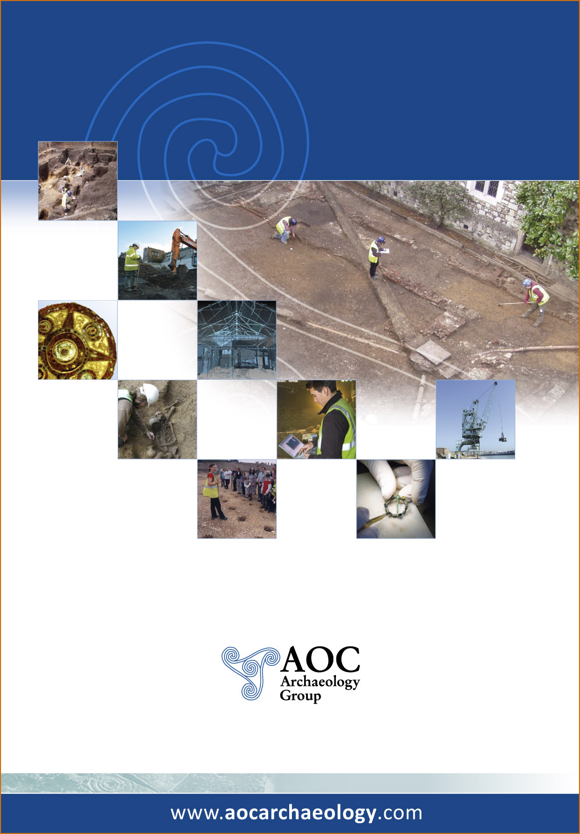

AOC Archaeology Group, Unit 7, St Margarets Business Centre, Moor Mead Road, Twickenham TW1 1JS
tel: 020 8843 7380 | fax: 020 8892 0549 | e-mail: london@aocarchaeology.com

