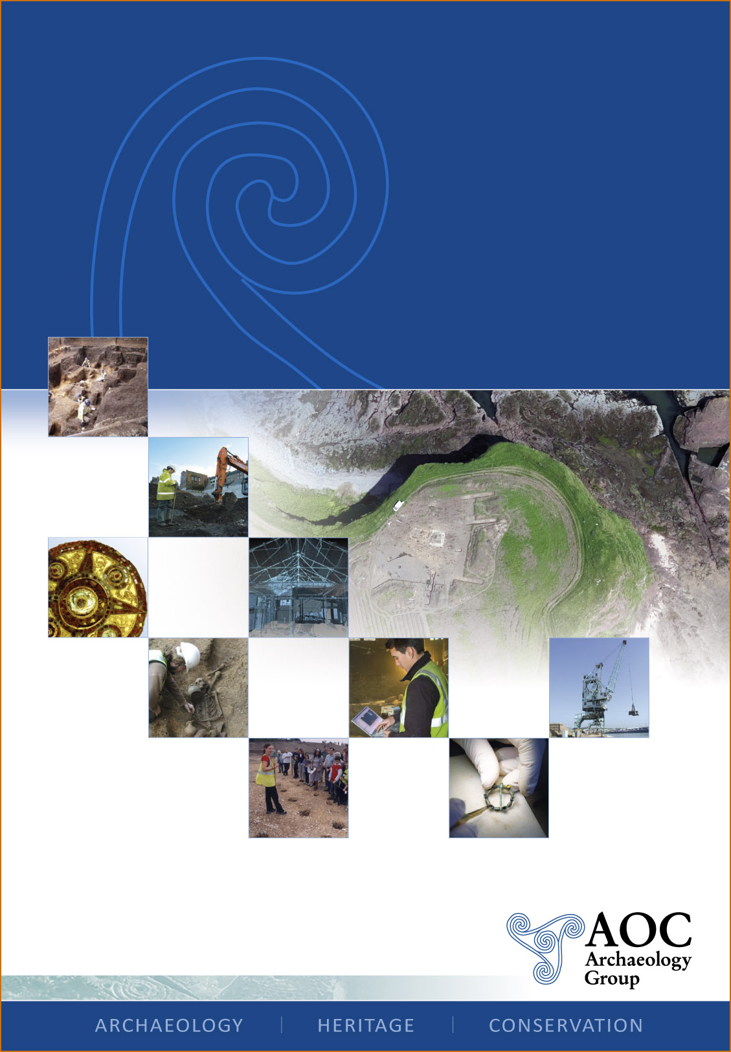

COSTCO, 27 – 29 IMPERIAL WAY, CROYDON, LONDON BOROUGH OF CROYDON
AN ARCHAEOLOGICAL EVALUATION REPORT
Planning Application Number: 06/02499
National Grid Reference Number: TQ 3118 6339
AOC Project no: 30051
Site Code: IMY08

COSTCO, 27 – 29 IMPERIAL WAY, CROYDON, LONDON BOROUGH OF CROYDON
AN ARCHAEOLOGICAL EVALUATION REPORT

Commissioned by: RPS Planning
1st Floor West
Cottons Centre
Cottons Lane
London
SE1 2QG

On Behalf of: Costco Wholesale (UK) Ltd

National Grid Reference (NGR): TQ 3118 6339

AOC Project No: 30,051

Prepared by: Chris Clarke

Illustration by: Jon Moller

Date of Excavation: 3rd to 18th March 2008

Date of Report: March 2008

This document has been prepared in accordance with AOC standard operating procedures.

Author: Chris Clarke Date: March 2008

Approved by: Les Capon Date: April 2008

Draft/Final Report Stage: Date:

Enquiries to: AOC Archaeology Group
Unit 7
St Margarets Business Centre
Moor Mead Road
Twickenham
TW1 1JS

Tel. 020 8843 7380
Fax. 020 8892 0549
e-mail. london@aocarchaeology.com

Contents
Page
List of illustrations iii
Non-Technical Summary iv
1. Introduction 1
1.1 Site Location 1
1.2 Planning Background 1
1.3 Geology and Topography 1
2. Historical and Archaeological Background 2
2.2 Prehistoric (before cAD 43) 2
2.3 Roman (cAD 43 - 410) 2
2.4 Post-Medieval (1485 – Modern) 2
2.5 Modern (1900 - present) 2
2.6 Undated 2
3. Strategy 2
3.1 Aims of the Investigation 2
3.2 Research Design 2
3.3 Methodology 3
4. Results 4
4.1 Trench 1 4
4.2 Trench 2 4
4.3 Trench 3 4
4.4 Trench 4 5
4.5 Trench 5 5
4.6 Trench 6 6
4.7 Trench 7 6
4.8 Trench 8 7
4.9 Trench 9 7
4.10 Trench 10 8
5. Finds 8
6. Conclusion 8
7. Publication 9
8. Archive Deposition 9
9. Bibliography 10
Appendix A – Context Register 12
Appendix B – Trench Matrices 14
Appendix C – OASIS Form 16

List of illustrations
Figure 1 – Site Location
Figure 2 – Detailed Site/Trench Location Plan
Figure 3 – Trenches 1, 2, 4, 6, 7 & 9: Sample Sections
Figure 4 – Trench 3: Plan & Sections
Figure 5 – Trench 5: Plan & Section
Figure 6 – Trench 10: Plan & Section

Non-Technical Summary
An archaeological evaluation was undertaken by AOC Archaeology Group between the 3rd and 18th March 2008 at the site of 27 – 29 Imperial Way, Croydon, on behalf of Costco Wholesale (UK) Ltd and commissioned by RPS Planning. The aim of the evaluation was to assess the impact of the proposed residential redevelopment on any surviving archaeological remains.

The evaluation comprised nine machine excavated trenches, seven of which measured 40m by 1.8m, with the remaining two trenches measuring 35m by 1.8m. Three trenches contained archaeological features. Two features were associated with modern activity associated either with the former Croydon Airport or Ford Motor Works, with a further two features either naturally-formed hollows or tree pits.

The evaluation trenches also showed that modern horizontal truncation of deposits had occurred in the eastern area of the site, while subsoil deposits were present in the western area up to a depth of 1.1m.

Overall, a low density of archaeological features were encountered, all of which are of limited significance. This, taken into account with the significant degree of truncation identified across the eastern side of the site, indicates a limited potential for further archaeological features to survive.

1. Introduction
1.1 Site Location

1.1.1 The site is centred on National Grid Reference (NGR) TQ 3118 6339, and is within land bounded to the west by Imperial Way, to the east by Purley Way, to the north by commercial properties, and to the south by playing fields. The site is roughly square is shape and covers an area of approximately 34,200m² (3.42ha).

1.2 Planning Background

1.2.1 A planning application was submitted for the commercial redevelopment of the site (Planning Application No. 06/02499/P). Condition 8 states that:

‘No development including excavations for drainage and foundation work shall take place within the site until the applicant has secured the implementation of a programme of archaeological work in accordance with a written scheme of investigation which has been submitted to the applicant and approved by the Local Planning Authority. The development shall only be carried out in accordance with the agreed programme.’

1.2.2 The site is located partially within an Archaeological Priority Zone as defined by the London Borough of Croydon.

    - AOC Archaeology Group Ltd were commissioned by RPS to carry out the field evaluation. The methodology was set out in a Written Scheme of Investigation (WSI) produced by RPS (2008) (Report No. JLI 1193 RO1). This document detailed how the evaluation, comprising of ten trenches, would be undertaken.

    - Prior to commencing work a unique code for the project was provided by the Museum of London (IMY08).

    - On site field work was undertaken between 3rd and 18th March 2008.

  - Geology and Topography

1.3.1 The following information has been extracted from the WSI produced by RPS (2008).

1.3.2 The solid geology of the site is recorded as the Chalk Group of the Upper Cretaceous.

1.3.3 The site lies on gentle sloping ground from approximately 70m Above Ordnance Datum (AOD) at its southern edge, to approximately 66m at its northernmost point.

1.3.4 An extensive geotechnical survey of the site, incorporating the use of boreholes, window samples, and test pits was undertaken in 2004. The investigations carried out on site indicated that between 0.16m and 3.10m of made ground was known to overlie the chalk. These results indicate that ground levels vary across site, with some areas demonstrating significant build up, whereas other areas have been truncated.

2. Historical and Archaeological Background
2.1 The information in this section has been drawn from the WSI produced by RPS (2008).

2.2 Prehistoric (before cAD 43)
2.2.1 Several discoveries have been made within the immediate vicinity of the site which indicate prehistoric activity in the area. The majority of records relate to individual finds of burnt and struck flint, located within 200m of the site to the north and south. The most substantial piece of evidence found was a Neolithic/Bronze Age hearth and buried soil horizon identified to the north of the site.

2.3 Roman (cAD 43 - 410)
2.3.1 The line of the London/ Croydon/ Portslade Roman Road, locally known as Mere Bank, is thought to pass the site a short distance to the west. A section was cut through Mere Bank in 1924 revealing a surface constructed of rammed chalk on a bed of flints.

2.4 Post-Medieval (1485 – Modern)
2.4.1 A post-medieval ploughsoil horizon was identified during an evaluation undertaken c150m to the north of the site.

2.5 Modern (1900 - present)
    - The site itself is located on the former Croydon airfield site, which use to incorporate and large area of open ground to the western side of Purley Way.

  - Undated
2.6.1 An undated V-shaped ditch was recorded during an evaluation on the Hilton Hotel site to the north-east of the development.

3. Strategy
3.1 Aims of the Investigation
3.1.1 The general aims of the evaluation, as noted in the WSI (RPS 2008), were recorded as being to establish the character, date and function of any archaeological features within areas of development and to establish the need for a programme (or otherwise) of archaeological mitigation. All works are to link into the existing research framework for the archaeology of Greater London.

3.1.2 Specific research aims for the evaluation were:
- Is there any evidence for prehistoric activity?
- Is there any evidence for the survival of Roman or later remains on the site?

  - Research Design
3.2.1 RPS designed the evaluation strategy, which envisaged the excavation of ten evaluation trenches.

3.2.2 Site procedures were defined in the WSI (RPS 2008). All practices were carried out in accordance with appropriate guidelines (IFA 1994). Provision was made for a report as defined in the Method Statement.

  - Methodology
3.3.1 During the fieldwork modifications were made to the methodology as stated in the WSI (RPS 2008), undertaken in agreement with RPS, owing to on site logistics. Due to issues of access and health and safety Trench 8 was not excavated. All remaining trenches were excavated without significant modification.

3.3.2 Levels for each context were established relative to Ordnance Datum, taken from a Bench Mark on the southeast perimeter fence (72.89m Above Ordnance Datum). A Temporary Bench Mark (TBM) was established in the central area of site at 68.65m AOD.

3.3.3 The evaluation was conducted by the author under the overall management of Andy Leonard. The site was monitored by Josh Williams on behalf of RPS and Mark Stevenson, Archaeological Advisor for the Greater London Archaeological Advisory Service.

- Results
  - Trench 1
4.1.1 Surface of Trench = 68.18m AOD

Level (OD) | Depth  BGL | Context Number | Description
68.18-67.98m | 0.00m | (1/001) | Yard Surface. Concrete slab and sandy made ground.
67.98- 67.78m | 0.20m | (1/002) | Levelling Layer. Compacted chalk and tar.
67.78- 67.38m | 0.40m | (1/003) | Subsoil. Soft, orangey brown, sandy silt.
67.38-66.95m (NFE) | 0.80-1.23m | (1/004) | Natural. Hard, light grey, chalk.

    - The earliest recorded deposit was hard, light grey, weathered chalk (1/004), the natural deposit, and at its highest was observed at 67.38m AOD. This was overlain by a 0.4m thick layer of orange-brown sandy silt subsoil (1/003) with moderate flint inclusions. Lying above the subsoil was a modern levelling layer 0.2m thick (1/002) composed of compacted chalk and a tar-like substance. The sequence was sealed by the current ground surface consisting of concrete slabs and sandy made ground.

    - No finds or features of archaeological significance were identified in Trench 1.

  - Trench 2
4.2.1 Surface of Trench = 68.97m AOD

Level (OD) | Depth  BGL | Context Number | Description
68.97-68.62m | 0.00m | (2/001) | Road Surface. Concrete slab and sandy made ground.
68.62-68.43m (NFE) | 0.35-0.54m | (2/002) | Natural. Hard, light grey, chalk.

    - The earliest recorded deposit was hard, light grey, weathered chalk (2/002), the natural deposit, and at its highest was observed at 68.62m AOD. Numerous modern service trenches truncated the natural deposit. Sealing the natural deposit (2/002) was up 0.35m of concrete and associated sandy made ground.

    - No finds or features of archaeological significance were identified in Trench 2.

  - Trench 3
4.3.1 Surface of Trench = 67.84m AOD

Level (OD) | Depth  BGL | Context Number | Description
67.14-66.74m | 0.70m | (3/010) | Subsoil. Soft, orangey brown, sandy silt.
66.74-66.44m (NFE) | 0.70-1.40m | (3/011) | Natural. Hard, light grey, chalk.

    - The earliest recorded deposit was hard, light grey, weathered chalk (3/011), a natural deposit; at a high point of 66.74m AOD. Overlying this natural deposit throughout the trench was a subsoil layer (3/010) approximately 0.40m thick (up to 0.80m thick in the central area of the trench), consisting of soft orange-brown sandy silt.

    - At the eastern end of Trench 3, the subsoil was sealed by a layer of modern made ground (3/009) 0.35m thick that was a mix of chalk and silty subsoil. The made ground (3/009) had then been truncated by 0.35m wide trench-cut concrete wall foundation [3/008]. Rubble indicating demolition of the wall was sealed beneath the existing concrete slab yard surface (3/007).

    - The subsoil at the western end of Trench 3 had also been sealed by modern activity, consisting of a 0.15m thick compacted chalk levelling layer (3/003), lying beneath a concrete slab and paved surface (3/002).

    - In the central area of Trench 3, the subsoil was truncated by a substantial vertical sided cut [3/006], up to 7.8m wide. The backfill of the cut was firm greyish brown sandy silt (3/005), which contained moderate quantity of Ceramic Building Material (CBM) fragments. Cut into the surface of the backfill were several modern brick features containing a series of redundant metal pipes (3/004) most likely associated with an underground storage tank. Once the pipework (3/004) had become redundant, the ground level in the central area of the trench had been levelled off using a sandy silt demolition deposit (3/001).

    - No finds of archaeological significance were identified in Trench 3.

  - Trench 4
4.4.1 Surface of Trench = 67.82m AOD

Level (OD) | Depth  BGL | Context Number | Description
67.82-67.57m | 0.00m | (4/001) | Yard Surface. Concrete slab and sandy make-up.
67.57- 67.17m | 0.25m | (4/002) | Made Ground. Chalk and sandy silt mix.
67.17- 66.95m | 0.65m | (4/003) | Subsoil. Soft, orangey brown, sandy silt.
66.95-66.90m (NFE) | 0.82-0.87m | (4/004) | Natural. Hard, light grey, chalk.

4.4.2 The earliest recorded deposit was hard, light grey, weathered chalk (4/004), natural at a maximum height of 66.95m AOD. Orange-brown, sandy silt subsoil (4/003) up to 1.0m thick lay above the chalk. Sealing the subsoil was a 0.40m thick layer of modern made ground (4/002) consisting of a mix of chalk and subsoil. Completing the sequence was a concrete slab and its associated sandy made ground (4/001).

    - No finds or features of archaeological significance were identified in Trench 4.

  - Trench 5
4.5.1 Surface of Trench = 68.27m AOD

Level (OD) | Depth  BGL | Context Number | Description
68.27-68.00m | 0.00m | (5/001) | Road Surface. Concrete slab and sandy make-up.
68.00- 67.70m | 0.27m | (5/002) | Made Ground. Chalk and sandy silt mix.
67.70-67.50m (NFE) | 0.57-0.77m | (5/005) | Natural. Hard, light grey, chalk.

    - Weathered chalk natural (5/005), was recorded at 67.70m AOD.

    - Truncating the natural deposit at the southern end of the trench was a large oval feature [5/004] 6.2m in length, and continuing beyond the limit of excavation. The feature had shallow concave sides, with an imperceptible break in slope leading to the rounded base and probable a naturally-formed hollow in the chalk. The fill was soft, mid brown sandy silt (5/003) containing moderate, small, well-sorted fragments of chalk and flint. No cultural material was present.

    - The feature and its fill were sealed by a layer of modern mixed silty chalk up to 0.40m which covered the full extent of the trench. Overlying this was modern concrete (5/001) forming the existing road surface.

    - No finds of archaeological significance were identified in Trench 5.

4.6 Trench 6
4.6.1 Surface of Trench = 69.96m AOD

Level (OD) | Depth  BGL | Context Number | Description
69.96-69.66m | 0.00m | (6/001) | Road Surface. Concrete slab and make-up.
69.66- 69.36m | 0.30m | (6/002) | Made Ground. Chalk and CBM mix.
69.36- 69.01m | 0.60m | (6/003) | Subsoil. Soft, orangey brown, sandy silt.
69.01-68.81m (NFE) | 0.95-1.15m | (6/004) | Natural. Hard, light grey, chalk.

4.6.2 The weathered chalk natural lay at 69.01m AOD. These was sealed by subsoil, typically orange-brown sandy silt (6/003) that was up to 0.35m thick. This was in turn overlain by 0.30m of modern made ground (6/002) consisting of a chalk and Ceramic Building Material (CBM) fragments. Sealing the sequence was 0.30m thick concrete slab and associated sandy made ground (6/001).

4.6.3 No finds or features of archaeological significance were identified in Trench 6.

4.7 Trench 7
4.7.1 Surface of Trench = 66.82m AOD

Level (OD) | Depth  BGL | Context Number | Description
66.82-66.47m | 0.00m | (7/001) | Yard Surface. Concrete slab and make-up.
66.47- 66.37m | 0.35m | (7/002) | Levelling Layer. Compacted chalk and tar.
66.37- 66.07m | 0.45m | (7/003) | Subsoil. Soft, orangey brown, sandy silt.
66.07-66.02m (NFE) | 0.75-0.80m | (7/004) | Natural. Hard, light grey, chalk.

    - The light grey, weathered chalk natural (7/004), lay at 66.07m AOD. Subsoil, as seen in most other trenches, sealed this (7/003) and was a maximum of 0.30m thick, with frequent flinty inclusions. A modern levelling layer (7/002) was deposited above the subsoil, measuring up to 0.10m thick, consisting of compacted chalk and a tar like substance. The last context in the sequence was 0.35m thick layer of concrete and associated sandy made ground (7/001).

    - No finds or features of archaeological significance were identified in Trench 7.

4.8 Trench 8
4.8.1 Trench 8 was not excavated.

4.9 Trench 9
4.9.1 Surface of Trench = 66.06m AOD

Level (OD) | Depth  BGL | Context Number | Description
66.06-65.92m | 0.00m | (9/001) | Yard Surface. Tarmac and make-up.
65.92-65.60m | 0.14m | (9/002) | Made Ground. Sandy silt and chalk mix.
65.60-65.48m | 0.46m | (9/003) | Buried Surface. Cement slabs.
65.48- 65.22m | 0.58m | (9/004) | Made Ground. Firm, mid yellowish brown, silty matrix. Frequent CBM/rubble.
65.22- 64.98m | 0.82m | (9/005) | Subsoil. Soft, orangey brown, sandy silt.
64.98-64.93m (NFE) | 0.82-1.12m | (9/006) | Natural. Hard, light grey, chalk.

    - Natural weathered chalk (9/006), was recorded at 64.98m AOD. Overlying the natural was a deposit of orange-brown sandy silt 0.25m thick, with frequent flinty inclusions (9/005). This was the subsoil. Modern yellowish brown silty made ground (9/004) had been deposited above subsoil to a maximum thickness of 0.35m. The made ground was sealed by a concrete paved surface (9/003). At the eastern end of Trench 9 the ground level had been further made up above the level of the paving by up to 0.30m of mixed silty chalk. The whole sequence was sealed by tarmac and made ground.

    - No finds or features of archaeological significance were identified in Trench 9.

4.10 Trench 10
4.10.1 Surface of Trench = 65.77m AOD

Level (OD) | Depth  BGL | Context Number | Description
65.77-65.42m | 0.00m | (10/001) | Yard Surface. Concrete and make-up.
65.42-65.22m | 0.35m | (10/003) | Buried Floor Surface. Brick surface and make-up.
65.22-64.94m (NFE) | 0.55-0.83m | (10/006) | Natural. Hard, light grey, chalk.

    - The earliest recorded deposit was the, weathered chalk natural (10/006). At its highest the natural was observed at 65.22m AOD.

    - In the central area of Trench 10 was a large oval feature [10/007] truncating the natural, 7.5m in length and continuing beyond the limits of the trench. It had a gentle concave profile, and was filled with soft mid brown sandy silt (10/005). The only inclusions within fill (10/005) were small to medium well sorted chalk and flint fragments. No finds were observed, so this may be a natural hollow eroded into the surface of the chalk. The only other notable feature cutting into the natural was a 1m wide modern service trench [10/004], running at a right angle to the line of trench at its southern end.

    - Both features in Trench 10 were sealed by a red brick floor surface 0.20m thick. With an ashy bedding layer (10/003). At approximately 4.5m intervals four concrete pads [10/002] had been inserted into the brick floor (10/003), all of which appear to run on a roughly north-south alignment. The size and regularity of the concrete pads (10/002) suggest they may have once been part of a large warehouse or hanger like structure. All four concrete pads had been subsequently sealed by a substantial concrete slab and sandy make-up layer (10/001), between 0.35m and 0.60m thick.

    - No finds of archaeological significance were identified in Trench 10.

5. Finds
5.1 No finds were collected during the course of the evaluation.

6. Conclusion
6.1 The evaluation successfully characterised both the stratigraphic sequence and archaeological potential of the site. Natural weathered chalk deposits were observed in all trenches, between a height of 64.98m and 69.01m AOD. This is consistent with the general topography of the land rising gently from west to east.

  - The archaeological evaluation identified that, of the nine trenches excavated, three contained archaeological features, these were Trenches 3, 5 and 10. Modern features were identified in Trenches 3 and 10, with the features in Trench 3 appearing to represent supply facilities for an underground storage tank, with features in Trench 10 representing structural elements for a previously existing warehouse or hanger. Two large oval features were observed in Trenches 5 and 10, with both features of a similar size (between 6.2m and 7.5m in length) and sharing the same type of barren backfill deposit which was very similar to the local subsoil deposits. With these factors taken into consideration, both features were interpreted as being naturally formed in origin.

  - The sequence of deposits recorded in Trench 1, 3, 4, 6, 7 and 9 indicate that a depth of up to 1.1m of subsoil survives beneath layers of modern made ground and concrete surfaces in the western side of site. In contrast, subsoil deposits were not observed in Trenches 2, 5 and 10, the modern deposits lying directly above natural chalk. This pattern of deposits suggests that the horizontal truncation of deposits has occurred across the full area of the site, most likely as part of the construction of facilities for Croydon Airport or Ford Motor Works. This truncation has been more substantial on the eastern side of the site where terracing for the construction of the workshops had been previously undertaken.

  - Of the archaeological features encountered two were modern in origin, probably associated with activity as part of Croydon Airport operations or the later Ford Motor Works. The remaining two features contain no cultural inclusions, and therefore are thought to have formed naturally in the weathered chalk. These features are of limited significance either due to their recent period of use, or their natural formation. No features were observed during the course of the evaluation that relate to the known prehistoric and Roman activity within the vicinity of the site.

  - Overall, a low density of archaeological features were encountered, all of which were deemed to be of limited significance. This, taken into account with the significant degree of truncation identified across the eastern side of the site, indicates a limited potential for further archaeological features to survive.

7. Publication
7.1 Due to the nature of the project, publication is expected to be limited to a summary in the London Archaeology Round-up and publication via the Archaeological Data Service (ADS) (Appendix C).

8. Archive Deposition
8.1 The archive, consisting of paper records, drawings, 35mm and digital photographs, will be deposited with the Museum of London.

9. Bibliography
RPS Planning (2008). Costco. 27 – 29 Imperial Way, Croydon. Archaeological Written Scheme of Investigation. London Borough of Croydon.

Institute of Field Archaeologists (1994). Standard and Guidance for Archaeological Field Evaluations.



Appendices

Appendix A – Context Register
Context No. | Context Description | Length | Width | Depth
1/001 | Yard Surface | 40.00m | 1.80m | 0.20m
1/002 | Made Ground | 40.00m | 1.80m | 0.20m
1/003 | Subsoil | 40.00m | 1.80m | 0.40m
1/004 | Natural Chalk | 40.00m | 1.80m | N.F.E
2/001 | Road Surface | 35.00m | 2.00m | 0.35m
2/002 | Natural Chalk | 35.00m | 2.00m | N.F.E
3/001 | Made Ground | 15.60m | 2.00m | 0.45m
3/002 | Yard Surface | 9.50m | 2.00m | 0.30m
3/003 | Leveling Layer | 9.50m | 2.00m | 0.14m
3/004 | Modern Features | 7.80m | 2.00m | N.F.E
3/005 | Fill of Trench | 7.80m | 2.00m | N.F.E
3/006 | Cut of Trench | 7.80m | 2.00m | N.F.E
3/007 | Yard Surface | 12.60m | 2.00m | 0.40m
3/008 | Wall | 2.00m | 0.35m | N.F.E
3/009 | Made Ground | 12.30m | 2.00m | 0.35m
3/010 | Subsoil | 40.00m | 2.00m | 0.80m
3/011 | Natural Chalk | 40.00m | 2.00m | N.F.E
4/001 | Yard Surface | 40.00m | 2.00m | 0.25m
4/002 | Made Ground | 40.00m | 2.00m | 0.90m
4/003 | Subsoil | 40.00m | 2.00m | 1.10m
4/004 | Natural Chalk | 40.00m | 2.00m | N.F.E
5/001 | Road Surface | 40.00m | 2.00m | 0.40m
5/002 | Made ground | 5.50m | 2.00m | 0.40m
5/003 | Fill of Hollow | 6.20m | 1.50m | 1.05m
5/004 | Cut of Hollow | 6.20m | 1.50m | 1.05m
5/005 | Natural Chalk | 40.00m | 2.00m | N.F.E
6/001 | Tarmac | 40.00m | 2.00m | 0.30m
6/002 | Made ground | 40.00m | 2.00m | 0.30m
6/003 | Subsoil | 40.00m | 2.00m | 0.35m
6/004 | Natural Chalk | 40.00m | 2.00m | N.F.E
7/001 | Yard Surface | 40.00m | 2.00m | 0.35m
7/002 | Made ground | 40.00m | 2.00m | 0.10m
7/003 | Subsoil | 40.00m | 2.00m | 0.30m
7/004 | Natural Chalk | 40.00m | 2.00m | N.F.E
9/001 | Tarmac | 40.00m | 2.00m | 0.14m
9/002 | Made Ground | 19.00m | 2.00m | 0.32m
9/003 | Buried Floor Surface | 40.00m | 2.00m | 0.12m
9/004 | Made Ground | 40.00m | 2.00m | 0.34m
9/005 | Subsoil | 40.00m | 2.00m | 0.24m
9/006 | Natural Chalk | 40.00m | 2.00m | N.F.E
10/001 | Concrete Slab | 36.00m | 2.00m | 0.58m
10/002 | Concrete Pads | 1.50m | 1.50m | N.F.E
10/003 | Buried Floor Surface | 36.00m | 2.00m | 0.20m
10/004 | Service Trench | 2.00m | 1.00m | 0.34m
10/005 | Fill of Hollow | 7.50m | 1.80m | 0.81m
10/006 | Natural Chalk | 36.00m | 2.00m | N.F.E
10/007 | Cut of Hollow | 7.50m | 1.80m | 0.81m

Appendix B – Trench Matrices

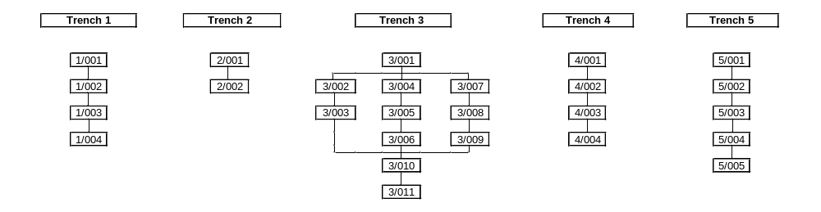

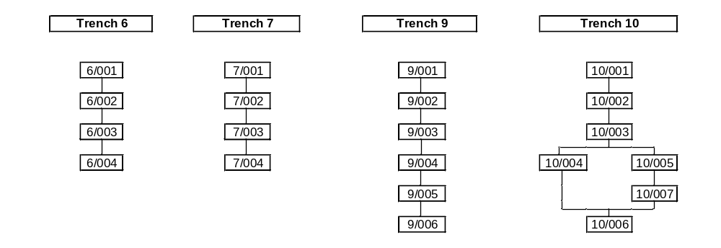
Appendix C – OASIS Form

OASIS ID: aocarcha1-39835
Project details
Project name | 27 - 29 Imperial Way, Croydon
Short description of the project | An archaeological evaluation was undertaken by AOC Archaeology Group between the 3rd and 18th March 2008 at the site of 27 - 29 Imperial Way, Croydon, on behalf of Costco Wholesale Ltd and commissioned by RPS Planning. The evaluation comprised nine machine excavated trenches, Three trenches contained archaeological features. Two features were associated with modern activity associated either with the former Croydon Airport or Ford Motor Works, with a further two features either natural hollows in the chalk or tree pits. Modern horizontal truncation of deposits had occurred in the eastern area of the site, while subsoil was present in the western area up to a depth of 1.1m. Overall, a low density of archaeological features were encountered, all of which were of limited significance..
Project dates | Start: 03-03-2008 End: 18-03-2008
Previous/future work | No / No
Any associated project reference codes | 30051 - Contracting Unit No.
Any associated project reference codes | IMY08 - Sitecode
Type of project | Field evaluation
Site status | Area of Archaeological Importance (AAI)
Current Land use | Industry and Commerce 1 - Industrial
Methods & techniques | 'Sample Trenches'
Development type | Urban commercial (e.g. offices, shops, banks, etc.)
Prompt | Direction from Local Planning Authority - PPG16
Position in the planning process | After full determination (eg. As a condition)
Project location
Country | England
Site location | GREATER LONDON CROYDON PURLEY 27 - 29 Imperial Way, Croydon
Postcode | CR9 4LN
Study area | 3.42 Hectares
Site coordinates | TQ 3118 6339 51.3539060825 -0.115905696708 51 21 14 N 000 06 57 W Point
Height OD | Min: 64.98m Max: 69.01m
Project creators
Name of Organisation | AOC Archaeology
Project brief originator | EH GLAAS
Project design originator | RPS
Project director/manager | Andy Leonard
Project supervisor | Chris Clarke
Type of sponsor/funding body | Developer
Name of sponsor/funding body | Costco Wholesale Ltd
Project archives
Physical Archive Exists? | No
Digital Archive recipient | Museum of London
Digital Archive ID | IMY08
Digital Contents | 'none'
Digital Media available | 'Images raster / digital photography','Images vector'
Digital Archive notes | To be held at AOC until ready to archive.
Paper Archive recipient | Museum of London
Paper Archive ID | IMY08
Paper Contents | 'Stratigraphic'
Paper Media available | 'Context sheet','Photograph','Plan','Report','Section'
Paper Archive notes | To be held at AOC until ready to archive.
Project bibliography 1
Publication type | Grey literature (unpublished document/manuscript)
Title | COSTCO, 27 - 29 IMPERIAL WAY, CROYDON, LONDON BOROUGH OF CROYDON: AN ARCHAEOLOGICAL EVALUATION REPORT
Author(s)/Editor(s) | Clarke, C.
Date | 2008
Issuer or publisher | AOC Archaeology
Place of issue or publication | London
Description | A4 text and illustrations
Entered by | Chris Clarke (chris.clarke@aocarchaeology.com)
Entered on | 27 March 2008

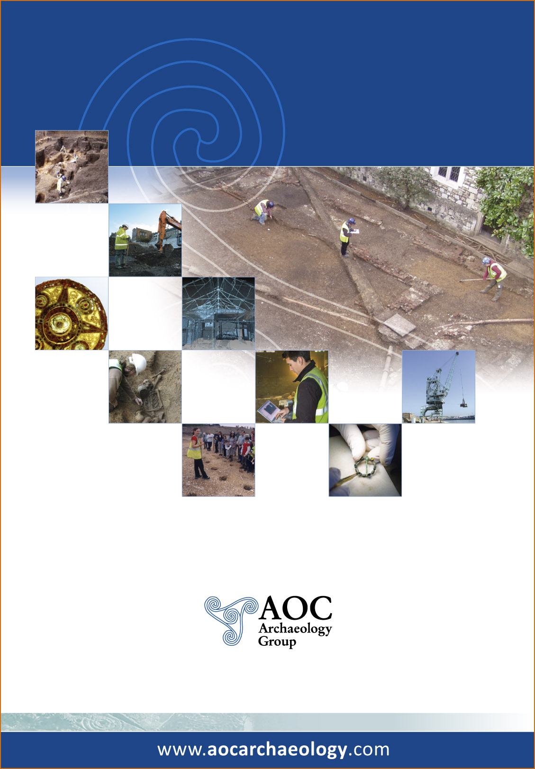

AOC Archaeology Group, Unit 7, St Margarets Business Centre, Moor Mead Road, Twickenham TW1 1JS
tel: 020 8843 7380 | fax: 020 8892 0549 | e-mail: london@aocarchaeology.com

