An Archaeological Evaluation for land adjoining
54 The Green, Donington le Heath,
Coalville Leicestershire. (SK 422 122)

James Harvey

For David Granger Architectural Design Limited
on behalf of JA Ball New Home Limited

Planning Application No. 03/02018/40C

Checked by Project Manager

Signed: ......................………Date:……………

Name:………………………………………

University of Leicester Archaeological Services

University Rd., Leicester, LE1 7RH
Tel: (0116) 2522848 Fax: (0116) 2522614

ULAS Report Number 2004/149 ©2004

Contents Page

1. Summary 1

2. Introduction 1
3. Background 2
4. Aims and Methods 4

5. Results 4
6. Discussion and Conclusions 9
7. Archive 9
8. Acknowledgements 9
9. Bibliography 9
10. Appendix 1 The Pottery 11
Appendix 2 Design Specification 12

Figures

Figure. 1 Site location Scale 1:50000 2

Figure. 2 Site Location showing the proposed development area Scale 1:2800 3

Figure. 3 Trench Location Plan Scale 1:440 5
Figure. 4 Close-up of the east end of Trench 1 7

An Archaeological Evaluation for land adjoining

54 The Green, Donington le Heath,
Leicestershire. (SK 422 122)

By James Harvey

1. Summary
An archaeological evaluation was undertaken by ULAS on behalf of JA Ball New Home Limited on land at 54 The Green, Donington le Heath, Leicestershire (SK 422 122). This work was carried out in advance of proposed residential development.

Three trenches were excavated from which it was concluded that the previous construction of brick terraced properties had caused considerable disturbance and altered the landscape of the site. However, a small area of undisturbed ground to the east of Trench 1 did reveal an earlier stone built wall dated to the late 17th or early 18th century. No other features of archaeological significance were identified.

The site archive will be held by the Historic & Natural Environment Team, Leicestershire County Council (Accession Number X.A235.2004).

2. Introduction

This report presents the results of an archaeological evaluation undertaken by ULAS on land adjoining 54 The Green, Donington le Heath, Leics. (SK 422 122, fig. 1 and 2) which was undertaken in advance of the proposed construction of new dwellings, with associated car parking, access driveways and garden landscaping. The development area has been identified as an area of archaeological potential from information held in the Leicestershire and Rutland Sites and Monuments Record. It indicates that the site it is located within the historic core of Hugglescote and that various medieval sites are known within its vicinity.

North West Leicestershire District Council requested a programme of archaeological work as a condition of planning permission (see Appendix 2). The work was carried out during the 16th and 17th September on behalf of JA Ball New Home Limited and followed the Design Specification for Archaeological Work.

3. Background

Donington le Heath, Coalville is located in the district of North West Leicestershire (SK 422 122, figs. 1 and 2). A desk-based assessment had been undertaken for the proposed development area (George 2004) which has indicated that the site is located within the medieval village core of Hugglescote (LE5477), various sites are known within the vicinity and these include the earthworks relating to the medieval grange of Garendon Abbey (LE4559). Also aerial photographs have demonstrated that Donington is a shrunken medieval village (LE4565) and that Donington le Heath Manor House is a late 13th century stone built house, remodelled in the early 17th century (LE4567). There is also an associated medieval fishpond located near the manor (LE4573). A series of four ponds that are either post-medieval garden features or medieval fishponds are located next to the suggested location of the Manor House at Hugglescote (LE4574). Medieval and post-medieval mill sites have been located the vicinity (LE8330, LE4558) and there are two timber-framed buildings, one medieval and the other early post-medieval that have been recorded in the vicinity (LE4570, LE4571) (George 2004).

One prehistoric and one Roman site have been identified in the vicinity of the proposed development area. Excavation prior to the erection of a reconstructed Iron Age roundhouse revealed several features containing late Neolithic/early Bronze Age pottery, 380m to the northwest (LE10052). An unfinished early Bronze Age arrowhead and an unfinished stone axe were also found in the area. A scatter of Roman pottery indicating an occupation site is located 690m to the southeast (LE5984) (George 2004).
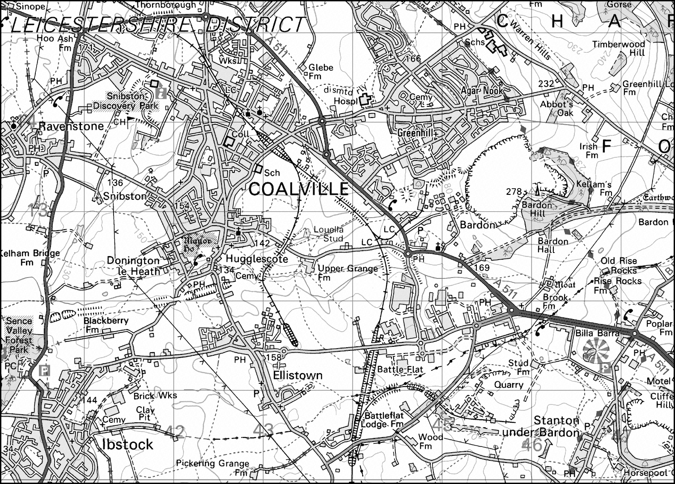

Figure. 1. Site location Scale 1:50000
Reproduced from the Landranger OS map 129 Nottingham and Loughborough area 1:50000 map by permission of Ordnance Survey on behalf of The Controller of Her Majesty’s Stationery Office. © Crown Copyright 2002. All rights reserved. Licence number AL 10002186.
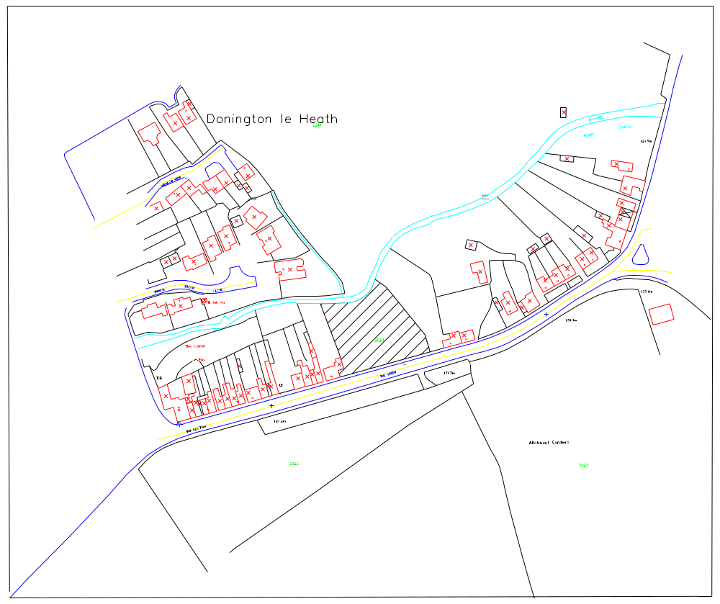
Figure 2 Site Location showing the proposed development area Scale 1:2800

The Domesday Book states that ‘Thorkell holds 3 hides in Donington (le Heath) from Nigel (of Aubigny). Land for 6 ploughs. 1 villager. Meadow, 4 acres; woodland ½ league long and 4 furlongs wide.’ (Morgan 1979). The industrial town of Coalville is less than 200 years old (Poole 2004). The town developed quickly through the coal mining, brick making, engineering and quarrying industries as can be seen by the rapid growth in population; in 1820 residents numbered 100; the 1841 census showed a population of 1200 and by 1871 the population was recorded as 2081 (Poole 2004).

The Enclosure map of 1775 indicates that the development area was being partly owned by Huntingdon, Jonathon Morris and Mary Weight (fig.3). The map of Titheable Lands for Hugglescote and Donington (1838) shows that the area is not tithed and appears to be part of Donington Green. The 1st Edition Ordnance Survey map, 1883, shows the area with dwellings fronting ‘The Green’ and enclosed lots to the rear with various outbuildings. The situation changes little until the area is represented by a clear plot on the 1991 OS map.

The Ordnance survey Geological Survey Of Great Britain Sheet 155 indicates the underlying geology was likely to consist of alluvium and Red Marl with beds of sandstone. The proposed development area that is currently an open plot located on a hillside, consisting of an area of c.0.162 ha of land that slopes away to the north towards the River Sence (approximately from 131.2-127.8m OD).
4. Aims and Methods

This work follows on from the desk-based assessment (George 2004), which together with this evaluation satisfy the specification for archaeological work at the site (see appendices). The purpose of the evaluation was to ascertain by trial trenching whether archaeological deposits were present. If so, the character, extent and date range of any deposits identified would be established, in order to assess their significance (see Appendices, Design Specification). Recording of these deposits would be carried out as appropriate, and an archive would be produced. The work followed the Institute of Field Archaeologists (IFA) Standard and Guidance for Archaeological Evaluations, and adhered to the University’s Health and Safety policy.

The evaluation was to comprise the excavation by a JCB type machine with toothless ditching bucket of trial trenches totalling c. 100 square metres (three 15m x 1.5m and to 11m x 1.5m trenches. However this was changed to three trial trenches totalling 51.5m in length, varying in width from 1.5-2.0m (approx 105 square metres) due to the constraints on site (spoil dumping and type of machinery available) as well as a reduction in the area affected as the garages at the back of the property have been removed from the initial proposed residential development plan. These trenches were excavated under archaeological supervision until archaeological deposits, undisturbed strata or c.1.5m (whichever is higher) were encountered. The trenches were surveyed in, and tied to the site grid using a Topcon GTS303 Total Station EDM (fig. 3).

5. Results

Trench 1

Interval | 0m East | 3m | 6m | 9m | 12m | 15m | 17m East
Topsoil depth | 0.3m | 0.1m | 0.2m | 0.22m | 0.35m | 0.3m | 0.2m
Subsoil depth | Overburden | Overburden | Overburden | Overburden | 0.7m | 0.8m | 1.05m
Top of Natural | 0.9m | 1.1m | Not reached | Not reached | 0.7m | 0.8m | 1.05m
Base of trench | 1.2m | 1.5m | 1.2m | 1.3m | 1.0m | 0.95m | 1.35m

Trench 1 was located along the frontage of ‘The Green’ in the southeast corner of the site (fig. 3). The trench was 17m in length and varied in width from 1.5-2.0m. The trench steps out a 1.5m towards the road at 9.0m to avoid following cellar disturbance. The topsoil measured 0.1-0.3m in depth and consisted of dark brownish grey silt with occasional small sub-rounded stones, frequent charcoal flecks and brick fragments.

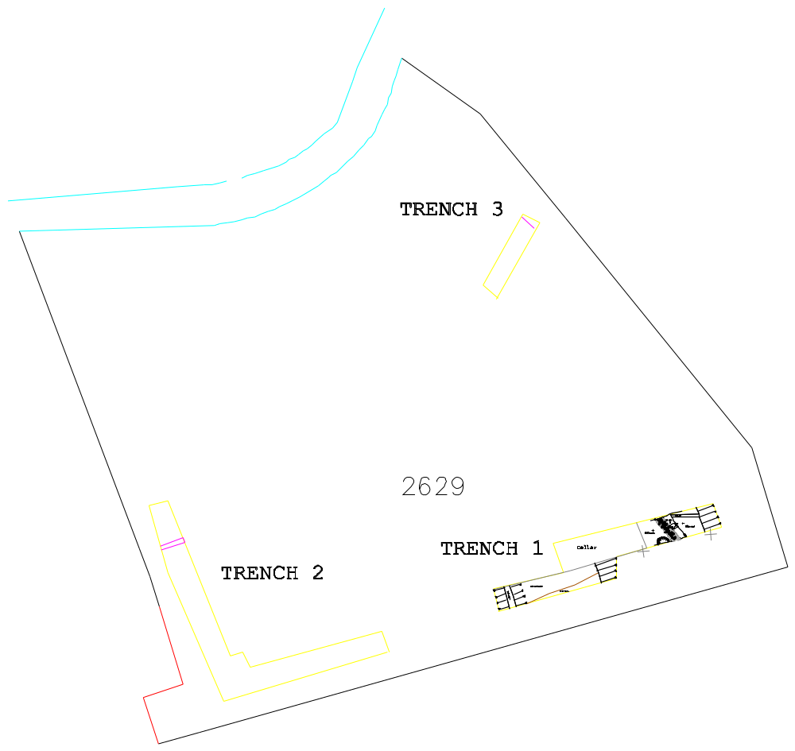Figure 3 Trench Location Plan Scale 1:440m

Modern overburden was observed below this from 0-6m from the east end of the trench at a depth of 0.9-1.1m, beyond which a cellar was located. The overburden was stripped to the natural substratum that consisted of pink clay of Mercia Mudstone group. Three features were located cutting the natural substratum (fig. 4). Firstly, a stone built wall (4) was located on a northwest-southeast orientation. The wall was >2.3m in length, 0.5m wide and was constructed mainly of limestone (50%) and sandstone (40%), with a small quantity of granite (10%). The average size of the stones was 150mm x 150mm and these were bonded with soft greyish yellow mortar. Both sides of the wall were faced with flat stones and within the facing was a core of mixed stone and mortar. Fragments creamware bowls that date from 1780 into the 19th century were recovered from within the mortar. The southwest face of the wall was constructed directly against the natural clay, however, along the northeast face of the wall, a service trench [1] had been cut for a later ceramic drain. The service trench measured 0.65m in width and the backfill (2) consisted of very dark greyish brown sandy silty clay with frequent small sub-rounded stones. A slot was excavated into the backfill of the service revealing a flat base at a depth of 0.35m below the base of the trench. The backfill (2) contained pottery dating from the late 18th to early 19th century as well as clay pipes similar to ones found in Leicester, that gave a deposition date of circa 1820 (Appendix 1; Davies and Sawday 1999).

The removal of the service trench also provided an opportunity to further investigate the form of the wall (4). The slot illustrated that the wall consisted of one or two courses of faced stone that had been constructed on top of a foundation of large unbonded cobbles extending below the base of the service trench. The construction cut [3] of the wall was located within the base of the service. The cut extended 0.1m away from the wall and the backfill of the construction cut (10) consisted of a soft mid grey sandy clay with occasional small sub-rounded stones and charcoal flecks. This feature was not investigated further although a fragment of clay pipe stem was recovered from the top of the deposit.

Finally a pit [5] was located in the south side of the trench section 0.3m west of the wall. The pit measured 1.2m x >0.42m and contained four fills, the primary fill (6) consisted of soft mid grey clay with occasional small flint pebbles and charcoal flecks. The secondary fill (7) consisted of soft mid grey sandy silt, above this there was a firm pink red sandy clay containing occasional small/medium sub-rounded stones (8). The final fill (9) consisted of mixed, friable, mid grey sandy clay containing occasional small/medium sub-rounded stones, charcoal and mixed mortar. No finds were recovered from the pit; however, the cut of the pit suggests that it respects the wall and the fills were very clearly defined which would suggest the pit was fairly modern.

As beyond 6m from the east end of the trench a cellar truncated the natural substratum, the trench was therefore moved towards the road from 9m to avoid the cellar disturbance and followed the cellar wall along its northern side. Pinkish brown clay was observed directly below the topsoil that was initially thought to be the natural substratum. However, when examined, a thin layer of garden soil, 0.15-0.2m thick, this consisted of soft mid grey brown silty sandy clay, containing small sub-rounded stones and charcoal flecks was observed below the clay. Where possible the clay and garden soil was stripped down the natural substratum that consisted of mid orange sand and gravel, located at a depth of 1.0-1.35m. The garden soil was sloping down to the north and is likely to represent the original geological slope of the landscape that has been raised along the frontage of ‘The Green’ to create a level platform using re-deposited natural. This event is likely to be associated with the construction of the brick built properties. No other archaeological features or finds were discovered in this trench.
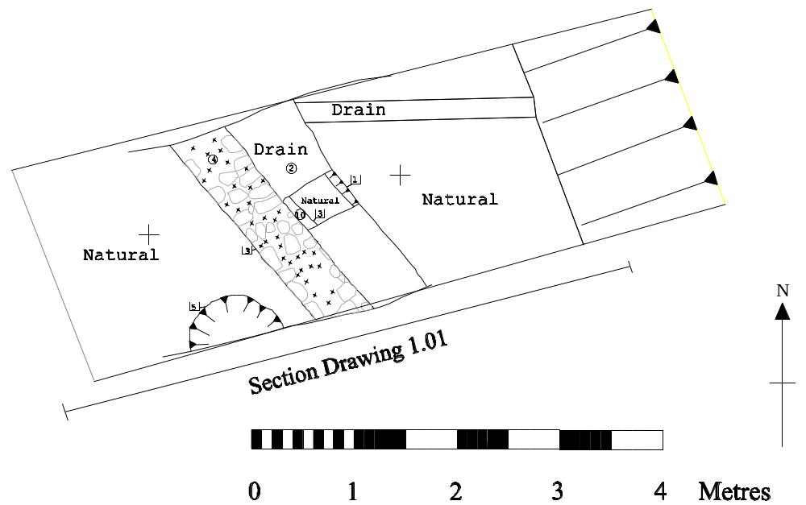
Figure 4 Close-up on the east end of trench 1
Trench 2

Interval | 0m South |  | 4m | 8m | 12m | 15m North
Topsoil depth | 0m |  | 0.25m | 0.3m | 0.2m | 0.3m
Subsoil depth | 0.2m |  | 0.5m | Overburden | Overburden | Overburden
Top of Natural | 0.2m |  | 0.5m | Not reached | Not reached | Not reached
Base of trench | 0.2m |  | 0.5m | 0.8m | 0.9m | 0.8m
Interval | 18m | 21m |  | 24m | 28m East
Topsoil depth | 0.17m | 0.15m |  | 0.2m | 0.35m
Subsoil depth | 0.5 | Overburden |  | Overburden | Overburden
Top of Natural | 0.5m | 0.54m |  | 1.0m | 0.8
Base of trench | 0.5m | 1.2m |  | 1.0m | 1.5m

This trench was located in the southwest corner of the site making an “L” shape fronting along ‘The Green’ and down the side of the property boundary with 54 ‘The Green’ (fig. 3). The trench measured 28m in length and was 1.5m wide. The topsoil was 0-0.24m deep and consisted of dark grey sandy ashy silt with occasional small sub-rounded stones, frequent charcoal flecks and inclusions of brick and modern pottery. This was overlying a firm mid brown sandy silty clay with occasional small sub-rounded stones, charcoal flecks and brick fragments to a depth of 0.2-0.5m at the north end of the trench to 6m. This area was stripped to the natural substratum, which was mid yellowish brown sandy gravel. A stone-lined field-drain was located within this area, on a northeast-southwest alignment at 3m from the end of the trench. Beyond 6m a wall marks the back of the terraced brick build properties previously located on the site. The remainder if the north-south part of the trench was heavily truncated with walls and cellaring. Here the natural substratum was not reached and the trench varied in depth from 0.8-1.0m.

The other part of the trench that was aligned to ‘The Green’ followed a brick wall on its northern side. Brick walls and a ceramic pipe were located in the southwest corner, beyond which there was firm pinkish brown clay which was similar to what was observed in Trench 1. A sondage was dug to 1.5m that showed that below pinkish brown clay (which was found to contain brick) was a layer of garden soil 0.2m thick and similar to the subsoil described previously. As found in Trench 1, the soil was sloping down to the north providing more evidence landscaping as well as confirming that is was a fairly recent event. Where possible the garden soil was stripped down the natural substratum along the remainder of the trench to reveal a pinkish brown clay at a depth of 0.54-1.0m. No archaeological features or finds were discovered in this trench.

Trench 3

Interval | 0m NE | 2m | 4m | 6.5m SW
Topsoil depth | 0.1m | 0.2m | 0.22m | 0m
Subsoil depth | 0.33 | 0.45 | 0.54 | 0.24
Top of Natural | Not Reached | 0.45m | 0.54m | 0.24
Base of trench | 0.33m | 0.45m | 0.60m | 0.3m

The trench was located towards the rear of the site in an area that had recently been stripped of topsoil and measured 6.5m in length and 1.5m in width (fig. 3). The remaining topsoil measured 0-0.22m and consisted of dark brownish grey silt, with rare small sub-rounded stones. This overlaid a soft mid yellowish brown silty sandy clay subsoil containing rare small sub-rounded stones and rare charcoal flecks to a depth of 0.54m. This was stripped down to the natural substratum that consisted of orangey soft sand that came onto yellowish sand and gravel to the southwest. A stone-lined field drain running northeast – southwest across the trench was revealed at the northeast end of the trench. No archaeological features or finds were discovered in this trench.

6. Discussion and Conclusions

No features of archaeological significance were found during the evaluation at Donington le Heath. Trenches 1 and 2 were focussed on the areas that were to be most affected by the proposed development. Here it was found that the ground had been heavily disturbed by the terraced properties that had been previously located on the site these were first recorded on the 1st Edition Ordnance Survey map of 1883. As well as the intrusions caused by substantial brick wall foundations, the properties also contained cellars and there was also clear evidence that the landscape had been altered to create a platform next to ‘The Green’.

A small area of undisturbed ground at the east end of trench 1 did produce evidence of earlier occupation on the site prior to the brick built terracing. Here a fairly substantial stone built wall was located on a northwest – southeast alignment. Pottery from the fabric of the wall dated it to the late 18th or early 19th century (fig. 4). Interestingly, unlike the brick walls that were observed, the wall was not aligned perpendicular to ‘The Green’. This indicates that as well as raising the land next to the road during the construction of the terraced houses, that the actual orientation of the road may also have been altered.

7. Archive

The site archive will be held by Leicestershire County Council, Historic & Natural Environment Team (Accession No.X.A.235.2004). It consists of finds, trench record sheets, site records, plans, and photographs. A brief summary of this report will be published in the Transactions of the Leicestershire Archaeological and Historical Society in due course.

8. Acknowledgements

Fieldwork was carried out by the author with assistance from Steve Jones. Patrick Clay also of ULAS, managed the project. I am also grateful to the client JA Ball New Home Limited for their co-operation during this evaluation.

9. Bibliography

Clay P, . 2004. Design Specification for archaeological evaluation at the Proposed Residential Development, Donington le Heath, Leicestershire (SK 422 122). ULAS Design Specification 05/503
Connor, A., and Buckley, R. 1999. Roman and Medieval Occupation in Causeway Lane, Leicester, Leicester Archaeology Mon. 5.
Davies, S., and Sawday, D., 1999. ‘The Post Roman Pottery and Tile’ in A. Connor and R. Buckley, 1999, 165-213.
Higgins, D. 1999. ‘The Clay Tobacco pipes’ in A. Connor and R. Buckley, 1999, 215-234.
George, S. 2004 . An archaeological Desk-based Assessment for the Proposed Residential Development on Land Adjoining 54 The Green, Donington le Heath, Coalville, Leicestershire (SK 422 122) ULAS Report No. 2004-126.
Morgan, P. 1979. Domesday Book: Leicestershire. Phillimore, Chichester.
Poole, L. 2004 “Coalville History & Profile” http://www.thegoodwood.co.uk/map_history.asp?location_keywords_1=Coalville

10. Appendices
The Pottery and Miscellaneous Finds by D. Sawday

The pottery, forty-six sherds, weighing 1.817 kg, was catalogued with reference to the ULAS fabric series (Davies and Sawday 1999). Seven clay pipe fragments were also recovered from the site. Similar pottery and clay pipes, from Causeway Lane, Leicester, were dated to the later 18th or early 19th century by the range of pottery fabrics and decoration present (ibid, figs.97.178-182), and by the makers marks on the clay pipes from Leicester gave a deposition date of circa 1820 (ibid, 196, 197) (Higgins 1999, fig.101.42).

Site/Parish: the Green, Donington le Heath, Leics.  Accession No/ Doc Ref: …./Donington le h.  Material: pottery & clay pipe  Site Type: village core | Submitter: J. Harvey  Identifier: D. Sawday  Date of Id: 21.09.04  Method of Recovery: evaluation.

Context | Fabric/ware | Sherd  nos. | Weight  grams | Comments

POTTERY
T1 2  drain fill | EA2 – Earthenware 2 | 14 | 1362 | Two wide mouthed bowl or pancheon rims, one upright bowl rim, all glazed internally.
T1 2 | EA6 - Blackware | 1 | 25
T1 2 | EA8 – Creamware/Mocha ware | 9 | 157 | With embossed and mocha decoration.
T1 2 | EA10 | 3 | 58 | White earthenware/china bowls, two painted under glaze.
T1 2 | SW - Stoneware | 1 | 28
4 top of stone wall | EA8 | 18 | 187 | Bowl fragments with horizontal line and mocha decoration.
MISC. |  | Frag. Nos
T1 2 | China clay | 2 |  | Clay pipe bowls, one complete
T1 2 | China clay | 3 |  | Clay pipe, stem fragments, one with spur
T1 2 | Glass | 1 |  | Part of base of bottle
T1 10 | China clay | 1 |  | Pipe stem

Design Specification

UNIVERSITY OF LEICESTER ARCHAEOLOGICAL SERVICES

Design Specification for archaeological evaluation

Proposed Residential Development
54 The Green, Donington le Heath,
Leicestershire (SK 422 122 )

Planning Application: 03/02018/6

For: J A Ball New Homes

1. Definition and scope of the specification

1.1 This specification is for archaeological evaluation by trial trenching in advance of the proposed residential development at 54 The Green, Donington le Heath, Leicestershire (SK 422 122; P.A.03/02018/6) for J A Ball New Homes.

1.2 It partly addresses the planning condition (5) included in the planning permission by North West Leicestershire District Council.

1.3 All archaeological work will adhere to the Institute of Field Archaeologist's (IFA) Code of Conduct and Standard and Guidance for Archaeological Evaluations and the Guidelines and procedures for archaeological work in Leicestershire and Rutland (Leicestershire County Council., Heritage Services).

2.Background

2.1. The proposed development is for the construction of seven dwellings, garages and car parking within an area of c. 0.175 ha (Fig. 1). An archaeological desk-based assessment has been prepared (ULAS Report 2004-126) which indicated that the application area was within the historic core of Donington le Heath and there was potential for the presence of medieval remains. A programme of archaeological work comprising trial trenching is now required to further elucidate the archaeological potential and, if necessary, formulate a mitigation strategy.

3. Objectives

3.1 The objective of the archaeological work is to ascertain whether any significant archaeological remains are present within the area to be developed. If identified a sufficient sample to establish their extent, date, quality, character, form and potential including environmental data will be recorded. Further archaeological recording may be required in the light of the results of this programme.

4 General Methodology

4.1 All work will follow the Institute of Field Archaeologists (IFA) Code of Conduct and adhere to their Standard and Guidance for Archaeological Evaluations.

4.2 Staffing, recording systems, Health and Safety provisions and insurance details are provided.

4.3 Internal monitoring procedures will be undertaken including visits to the sites from the project manager. These will ensure that project targets are being met and professional standards are being maintained. Provision will be made for external monitoring meetings with representatives of J A Ball New Homes and North West Leicestershire District Council. The strategy will be reviewed in the light of the quality of the archaeological resource as revealed at different stages of the fieldwork.

4.4 The site comprises a vacant plot overgrown and with evidence of some dumping.

4.5 Trial trenching

4.5.1 Trial trenching totalling c. 100 sq metres (three 15m x 1.5m trenches and two 11m x 1.5m trenches) is proposed providing a c. 5.7% sample of the area (Fig. 2). The location may be varied according to any constraints on the availability of the area for trenching.

4.5.3 The area will be scanned by a CAT scanner to verify the location of services. Following this the overburden will be removed in spits by machine with a toothless ditching bucket (or similar) under full supervision, until archaeological deposits or undisturbed substrata are encountered.

4.5.4 The location of the trenches will be surveyed using a Total Station Electronic Distance Measurer (EDM) linked to a Psion hand held computer.

4.5.5 Any archaeological deposits located will be hand cleaned and planned as appropriate to addressing the aims and objectives of the evaluation. Samples of any archaeological deposits located will be hand excavated. Measured drawings of all archaeological features will be prepared at a scale of 1:20 and tied into an overall site plan of 1:100. All plans will be tied into the National Grid using an Electronic Distance Measurer (EDM).

4.5.6. Particular attention will be paid to the potential for buried palaeosols in consultation with ULAS's environmental officer. Deposits which may provide radiocarbon dating evidence will be sampled.

4.5.7 All excavated sections will be recorded and drawn at 1:10 or 1:20 scale, levelled and tied into the Ordnance Survey datum. Spot heights will be taken as appropriate.

4.5.8 Any human remains encountered will only be removed under a Home Office Licence and in compliance with relevant environmental health regulations. J A Ball New Homes North West Leicestershire District Council and the coroner will be informed immediately on their discovery.

4.6 Mitigation Strategy

4.6.1 Depending on the results of the trial trenching and following consultation with J A Ball New Homes North West Leicestershire District Council a mitigation strategy may need to be formulated.

5 Recording Systems

5.1 Individual descriptions of all archaeological strata and features excavated or exposed will be entered onto prepared pro-forma recording sheets.

5.2 A site location plan based on the current Ordnance Survey 1:1250 map, enlarged to 1:500 (reproduced with the permission of the Controller of HMSO) will be prepared. This will be supplemented by a plan at 1:200 (or 1:100), which will show the location of the areas investigated.

5.3 Some record of the full extent in plan of all archaeological deposits encountered will be made on drawing film, related to the OS grid and at a scale of 1:10 or 1:20. Elevations and sections of individual layers of features should be drawn where possible. The OD height of all principal strata and features will be calculated and indicated on the appropriate plans.

5.4 An adequate photographic record of the investigations will be prepared. This will include black and white prints and colour transparencies illustrating in both detail and general context the principal features and finds discovered. The photographic record will also include 'working shots' to illustrate more generally the nature of the archaeological operation undertaken.

5.5 This record will be compiled and fully checked during the course of the excavation.

5.6 All site records and finds will be kept securely.

6 Report and Archive

6.1 A report on the fieldwork will be provided following analysis of the records and materials. The full, bound report in A4 format will usually follow within eight weeks of the completion of all fieldwork, and copies will be dispatched to: the Client (2), Leicestershire County Council, Natural and Historic Environment team/Sites and Monuments Record (2) and the planning authority. The report will also be added to the OASIS database.

6.2 The report will include :-

i) A non-technical Summary
ii) An introductory Statement
iii) The aims and purpose of the evaluation
iv) The methodology adopted in the course of the evaluation
v) The nature, location, extent, date, significance and quality of any structural, artefactual and environmental material uncovered
vi) Conclusion, including a confidence statement
vii) Appropriate illustrative material including maps, plans, sections, drawings and photographs.
viii) Supporting data – including as a minimum basic quantification of all artefacts, ecofacts and structural data
ix) The location and size of the archive
x) References

6.2. The copyright of all original finished documents shall remain vested in ULAS and ULAS will be entitled as of right to publish any material in any form produced as a result of its investigations.

6.3 A full copy of the archive as defined in the 'Guidelines for the preparation of excavation archives for long-term storage' (UKIC 1990), and Standards in the Museum care of archaeological collections (MGC 1992) and 'Guidelines for the preparation of site archives and assessments for all finds (other than fired clay objects) (RFG/FRG 1993) will be presented to an appropriate registered museum within six months of the completion of fieldwork. This archive will include all written, disk-based, drawn and photographic records relating directly to the investigations undertaken.

7. Timetable and staffing

7.1. The trial trenching will be undertaken within a one week period and can commence during the week beginning 13.9.2004.

8. Health and Safety

8.1 ULAS is covered by and adheres to the University of Leicester Statement of Safety Policy and uses the Standing Committee of Archaeological Unit Managers (SCAUM) manual, as revised in 1997, as its Health and Safety Manual with appropriate risks assessments for all archaeological work. The relevant Health and Safety Executive guidelines will be adhered to as appropriate. All ULAS staff will follow the site contractors’ Health and Safety policy.

9 Insurance

9.1 All ULAS work is covered by the University of Leicester's Public Liability and Professional Indemnity Insurance. The Public Liability Insurance is with Gerling Insurance Services Policy No. 62/99094/D, Risk Reference LT 35101 while the Professional Indemnity Insurance is with Sun Alliance Insurance Policy No. 03A/5A 001 05978, Risk Reference LT 27229.

10. Bibliography

MAP 2, The management of archaeological projects 2nd edition English Heritage 1991

MGC 1992, Standards in the Museum Care of Archaeological Collections (Museums and Galleries Commission)

RFG/FRG 1993, Guidelines for the preparation of site archives (Roman Finds Group and Finds Research Group AD 700-1700)

SMA 1993, Selection, retention and Dispersal of Archaeological Collections. Guidelines for use in England, Wales and Northern Ireland (Society of Museum Archaeologists)

Patrick Clay
Director
ULAS
University of Leicester
University Road
Leicester LE1 7RH

Tel:0116 252 2848
Fax: 0116 252 2614
Email: pnc3@le.ac.uk

26.8.2004

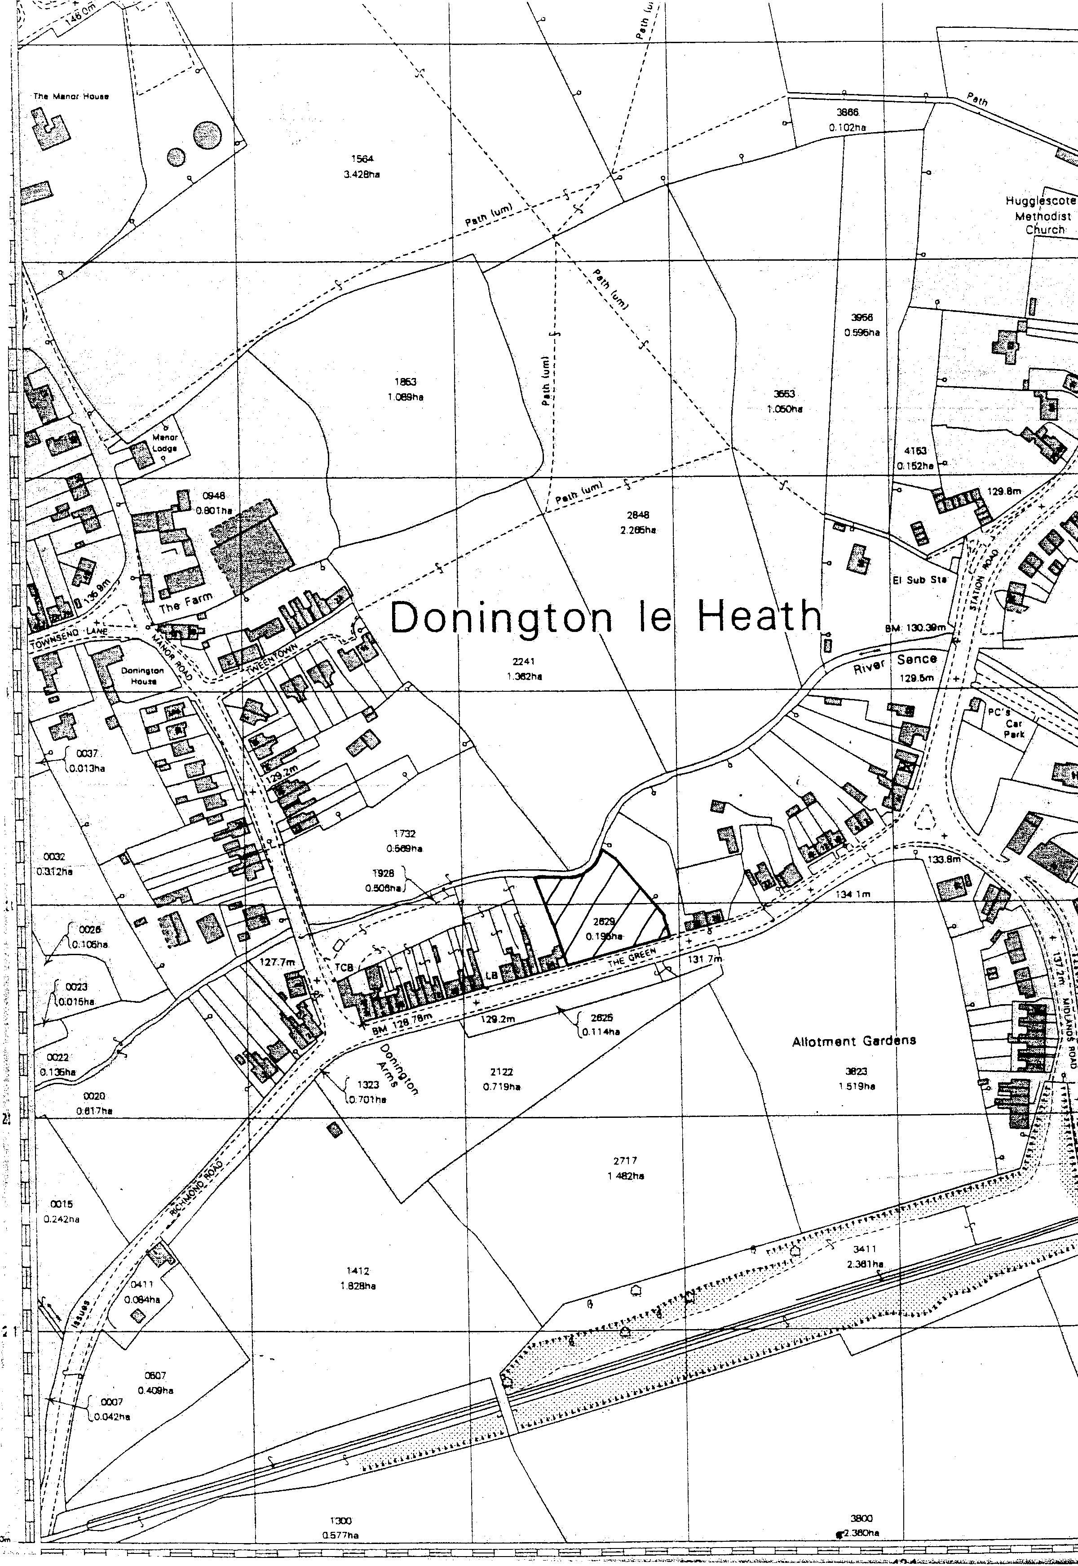

Fig. 1. Location of Application area 1:2500

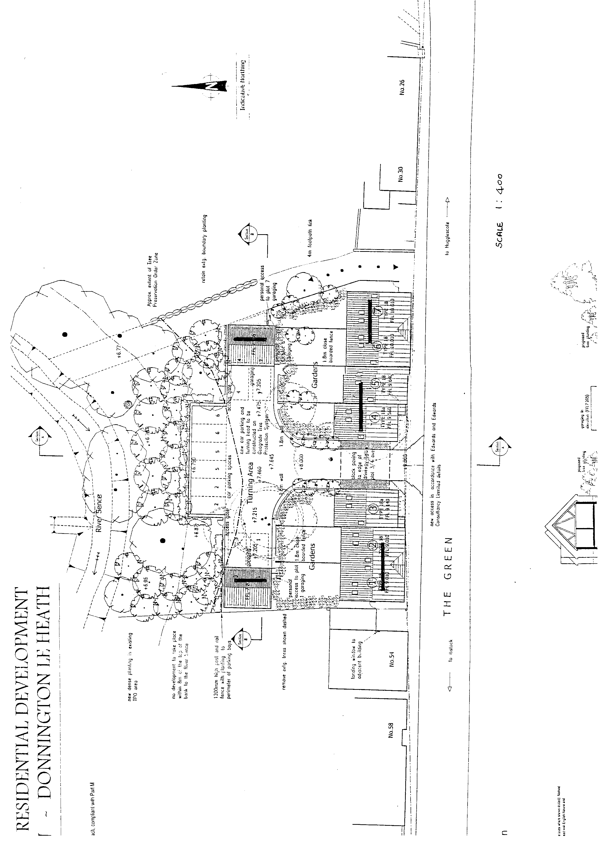

Fig. 2. Application area showing proposed location of trial trenches. 1:400

Draft Project Health and Safety Policy Statement

Proposed Residential Development
54 The Green, Donington le Heath,
Leicestershire (SK 422 122 )

Planning Application: 03/02018/6

For: J A Ball New Homes

1.Nature of the work

1.1 This statement is for trial trenching. It will be revised following the commencement of operations when the extent of risks can be assessed in full.

1.2 The work will involve machine dug trial trenching during daylight hours and recording of any underlying archaeological deposits revealed. Overall depth is likely to be c. 0.2-0.5m. This will involve the examination of the exposed surface with hand tools (shovels, trowels etc) and excavation of archaeological features. All work will adhere to the University of Leicester Health and Safety Policy and follow the guidance in the Standing Committee of Archaeological Unit Managers manual, as revised in 1997, together with the following relevant Health and Safety guidelines, including the following.

HSE Construction Information Sheet CS8 Safety in excavations.
HSE Industry Advisory leaflet IND (G)143 (L): Getting to grips with manual handling.
HSE Industry Advisory leaflet IND (G)145 (L): Watch Your back.
CIRIA R97 Trenching practice.
CIRIA TN95 Proprietary Trench Support Systems.
HSE Guidance Note HS(G) 47 Avoiding danger to underground services. HSE Guidance Note GS7 Accidents to children on construction sites

1.3 The Health and Safety policy on site will be reassessed during the evaluation .All work will adhere to the company's health and safety policy.

2 Risks Assessment

2.1 Working within an excavation.

Precautions. No work will be undertaken beneath section faces deeper than 1.2m. Loose spoil heaps will not be walked on. Protective footwear will be worn at all times. A member of staff qualified in First Aid will be present at all times. First aid kit, vehicle and mobile phone to be kept on site in case of emergency.

2.2 Working with plant.

Precautions. The area will be scanned for services prior to machine excavation commencing. Hard hats, protective footwear and hazard jackets will be worn at all times. No examination of the area of stripping will take place until machines have vacated area. Observation of machines will be maintained during hand excavation.

2.3 Working within areas prone to waterlogging.

Protective clothing will be worn at all times and precautions taken to prevent contact with stagnant water which may carry Vialls disease or similar.

2.4 Working with chemicals.

If chemicals are used to conserve or help lift archaeological material these will only be used by qualified personnel with protective clothing (i.e a trained conservator) and will be removed from site immediately after use.

2.5 Other risks

Precautions. If there is any suspicion of unforeseen hazards being encountered e.g chemical contaminants, unexploded bombs, hazardous gases work will cease immediately. The client and relevant public authorities will be informed immediately.

2.6 No other constraints are recognised over the nature of the soil, water, type of excavation, proximity of structures, sources of vibration and contamination.

17.8.2004

