Time Team ‘Big Dig’

Report on an archaeological excavation at

Clapton Pond
London Borough of Hackney, E5

National grid reference 53490 18600
Time Team site code 1847785

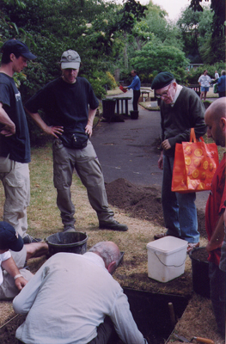

Clapton Pond Neighbourhood Action Group

August 2003

Introduction

This report was compiled by Nick Holder of Clapton Pond Neighbourhood Action Group and describes the results of two archaeological test pits dug at Clapton Pond in the London Borough of Hackney, E5 on Saturday 28th June 2003. The test pits were dug by local residents as part of Time Team’s Big Dig weekend and the report therefore follows the Big Dig format. The archive of research material, records and finds from this work will be deposited at the Museum of London’s London Archaeological Archive and Resource Centre (LAARC).

The prime purpose of the excavation was as a community event designed to increase local use of Clapton Pond. The high level of participation ensured that this was a success: about 25 local residents participated in the dig and over 100 visitors came to watch during the day. The Hackney Gazette published a photo and short article the following week. Later, Clapton Pond Neighbourhood Action Group reported on the dig in its Autumn newsletter distributed to 2000 local addresses (there are copies of both articles at the end of this report).

Location

Two 1m² test pits were dug in the north green of Clapton Pond near the junction of Lower Clapton Road and Newick Road, London E5. The national grid reference is 53490 18600. The two test pits were surveyed by triangulation and located on 1:100 and 1:500 plots of the digital 1:1250 Ordnance Survey map. Levels were calculated using a ‘dumpy level’ and measured from a bench mark of 19.84 metres above Ordnance Datum (sea level) on the wall of the St. John’s Ambulance building/former public toilets at the junction of Millfields Road and the ‘rear arm’ of Lower Clapton Road.

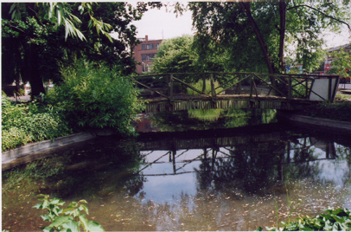

The Landscape

Clapton Pond is a public green space at the centre of Lower Clapton, part of the inner London borough of Hackney. The open space is divided in two by Newick Road and the pond itself is located in the southern half. The two archaeological test pits were located in the northern green.

Pre-excavation research

Clapton Pond is an urban 'village green', first shown on Rocque's map of 1746 but it almost certainly dates back to the medieval period. There are at least two high status Roman cemeteries in the vicinity, in Springfield Park and in Rushmore Road, so it seems likely that there was a wealthy Roman farm or villa in the Clapton area. There is a scatter of prehistoric stone tools found in Clapton, showing that the area was used by Neolithic (new stone age) settlers and, much earlier, by Palaeolithic (old stone age) hunter-gatherers.

The excavation

Both test pits were deturfed the day before the excavation. The first test pit, Test Pit 1, was excavated to a depth of 0.45m. The only layer encountered, numbered context [1], was a sandy gravely garden soil. A similar garden soil was excavated in Test Pit 2, a short distance to the north, and was numbered [2]. The soil layer was excavated to its base at a depth of 0.65m. Below this, a buried sandy subsoil [3] was 0.15m thick and was noticeably less organic than the garden soil above. A layer of gravel, sand and clay [4] was encountered at a depth of 0.80m in Test Pit 2. This is almost certainly the natural Hackney Gravels laid down by the once-wider River Thames around 300,000 years ago.

Table showing levels above Ordnance Datum sea level
 | Test Pit 1 | Test Pit 2
Ground level | 20.60m OD | 20.82m OD
Buried subsoil | not observed | 20.17m OD
Natural gravel | not observed | 20.02m OD

The finds

Most of the archaeological evidence dated to the 18th and 19th century. Contexts [1] and [2], the topsoil of Test Pits 1 and 2 respectively, contained pottery dating predominantly to the 18th century and included a fair quantity of English delftware and also an attractive marbled creamware lid, together with a smaller quantity of 19th-century sherds. Finds included a George III coin (or commemorative token?) with a 'Hibernia' inscription, dated 1779, and a tie pin of probable 20th-century date with a short Hebrew inscription (apparently saying 'mazel’ or 'good luck’).

In addition, the layers included small quantities of clay tobacco pipe, tile, brick, coal or coke, slate, glass, animal bone and oyster. The presence of small quantities of iron slag (waste product) might suggest the local presence of a blacksmith in the 18th or 19th century.

Context [3] was a subsoil below the topsoil in Test Pit 2. This contained a small assemblage of 18th-century pottery including imported Chinese porcelain and some stoneware jug or jar fragments.

There was interesting evidence for the Roman period: a 4th-century coin was found in context [2]. Julian Bowsher of the Museum of London kindly wrote the following report on the coin.

The coin is a copper-alloy follis issued by Constantine I, known as the Great (306–337), at the mint of Ticinum (northern Italy) between 324 and 326 AD. The mint mark is a little indistinct but it may be from the second officina (workshop) of the mint - hence S (secunda) rather than P (prima). There may be something like a wreath in between the letters. The coin is 19mm in diameter.

Obverse [front]: head of Constantine with laurel crown. Inscription reads CONSTAN TINVSAVG
Reverse: inscription reads VOT / X X (within a wreath) CONSTANTINIMAXAVG (mint mark:) S /// T

Prehistoric activity was also hinted at by the presence of a small quantity of burnt flint and struck flint flakes (from contexts [1] and [2]). These could be, but are not necessarily, prehistoric in date.

Conclusions

The dig gave many local residents an insight into both the processes of archaeology and the local history of Clapton Pond. The most significant discovery was the 4th-century Roman coin. As was described above, we know that wealthy Romans were buried in the Clapton area and it is therefore likely that there was a farm or villa nearby. We did not locate this hypothetical villa but the find-spot of the coin may in the future help pinpoint its location. The natural ‘ridge’ of Lower Clapton Road would seem an ideal location for a Roman settlement: the fertile and well-drained land gently slopes down to the east towards the River Lea, and to the west towards the former Hackney Brook.

The 20th-century brooch with the Hebrew inscription is a reminder of a previous ethnic population of Lower Clapton: most of the Jewish population has now left Lower Clapton.

The 18th-century past of Clapton with its wealthy houses fronting onto the village pond and green is evoked by the finds of imported Chinese porcelain and English ‘delftware’ pottery.

The observation of natural Hackney Gravel will be of use to archaeologists and geologists and will assist in understanding the topography of the buried natural landscape.

Acknowledgements

Many members of Clapton Pond Neighbourhood Action Group helped to organise the dig, the barbecue, the clean-up of the pond and the repainting of the former council park-keeper’s hut. Particular thanks are due to Lisa Rigg for organising the archaeologically themed children’s events.
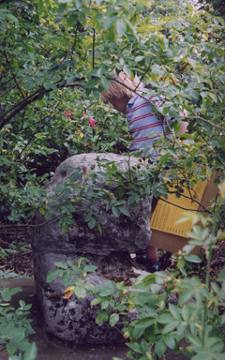

Clapton Pond Neighbourhood Action Group would like to thank the Parks department of the London Borough of Hackney, in particular Gary Thomas and John Zerachi, for giving the group permission to excavate the two test pits. Palm 2 Supermarket, Fairdeal Food Stores and Dünya Restaurant kindly provided food for the volunteers and visitors on the day. Councillor Ian Rathbone helped to arrange permission for the various events.

David Divers of Pre-Construct Archaeology helped the author run the excavation. Ken Pitt (Museum of London) and Catherine Cavanagh (English Heritage) took levels on the site. Vanessa Bunton and Hedley Swain of the Museum of London provided archaeological advice and Rob Whytehead (English Heritage) kindly monitored the site, all on behalf of Channel 4’s Time Team programme. Nigel Jeffries and Julian Bowsher (Museum of London) looked at the finds from the excavation. The Museum of London provided tools and equipment for the excavation.

Finally, many thanks to the 25 local residents, about half of whom were children, who did the actual digging.



