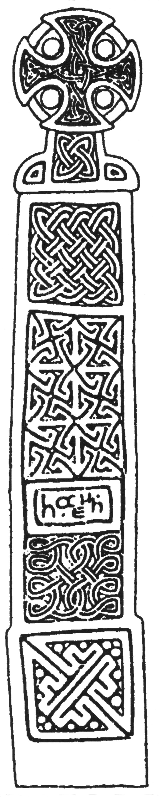

Desk-Based Assessment

North Street Meadow
Kingsland
Herefordshire

NGR (SO 443 617)

SMR No. 38449
Report No. BA0412DTNSM

BORDER ARCHAEOLOGY

Head Office
PO Box 36
Leominster
Herefordshire
HR6 0YQ
Tel: 01568 760453

Technical Services
Chapel Walk
Burgess Street
Leominster
Herefordshire
HR6 8DE
Tel: 01568 610101
Tel/fax: 01568 616900
E-mail: borderarch@btconnect.com

Southern Office
Southgate Chambers
37/39 Southgate Street
Winchester
Hampshire
SO23 9EH
Tel: 0845 6015506

Contents

- Non-Technical Summary 3
- Introduction 4
- Site Location & Description 4
- Geology 5
- Methodology 5
  - Research Aims 5
  - Research Methods 5
- Historical & Archaeological Background 6
  - Prehistory 6
  - Roman Period 7
  - Medieval Period 8
  - Post-Medieval Period 12
  - Site Specific Analysis 13
- Conclusion 18
- Copyright 19
- Bibliography 19

List of Figures and Plates

Fig 1. Site Location Map 4
Fig 2. Map of the Estate of Sir James Bateman in Kingsland 1709 (printed in D. Sylvester The Rural Landscape of the Welsh Borderland (London 1969),
Fig 45.) 9
Fig 3. Kingsland Tithe Map 1841 (HRO Ref. AM84/2) 10
Fig 4. Map of the Bateman Estate at Kingsland 1870 (HRO Ref. K68/39) 11
Fig 5. OS 1st edition 25-inch map (Herefordshire 12.5) 1885 14
Fig 6. OS 2nd edition 25-inch map (Herefordshire 12.5) 1903 16
Fig 7. OS 3rd edition 6-inch map (Herefordshire 12 NW) 1930 17
Plate 1.Aerial photograph showing ring ditches and other enclosure cropmarks in fields to the N of study area at NGR SO 444 618 1990 (Herefordshire Archaeology SMR: CUAP Photo Ref. BUG 34) 7

Report Specification

Historical research: Kristy Cook BA
Draft report: Kristy Cook BA
Report editing: Stephen Priestley MA
Supervising editor: George Children MA

- Non-Technical Summary

Aerial photography has revealed a number of cropmarks in fields to the south of the River Lugg, immediately north of the study area, including two ring ditches of apparent Bronze Age date.

However, the study area itself has revealed no such evidence of prehistoric activity. Indeed, the only physical remains within the field located during a site visit are of 20th century date, namely traces of the foundations of the clubhouse or ‘Recreation Room’ that was built in about 1920.

An essential premise of this Desk-Based Assessment was a response to an English Heritage assertion that the site included earthworks of potential significance. No documentary or visual evidence was found to confirm this assertion.

North Street Meadow may originally have formed part of one of the large open common arable fields of Kingsland during the medieval period. Some time before 1816, it was enclosed and became part of the property of Upper House (now known as Croft Mead) situated immediately to the east, which was built during the late 16th-early 17th century.

From at least c.1800 onwards, North Street Meadow is recorded as having belonged to Croft Mead; the ownership of which changed hands several times during the 19th century. During this period it appears that the study area was occasionally leased to tenant farmers.

- Introduction

Border Archaeology was instructed by David Taylor Consultants Ltd on behalf of Mrs Nicholson to undertake a Desk-Based Assessment of North Street Meadow, Kingsland for the purposes of identifying potential archaeological issues. Copies of this report will be submitted to Mrs Nicholson and David Taylor Consultants Ltd, with a discretionary copy being remitted to Herefordshire Archaeology and the County Sites and Monuments Record (SMR) upon David Taylor’s instruction.
- Site Location and Description

The Parish of Kingsland (NGR SO 44 61) lies approximately 3.5 miles NW of Leominster and occupies a fertile low-lying area between the River Lugg and Pinsley Brook. The study site itself, North Street Meadow (SO 443 617), is located approximately 200m NW from the centre of modern Kingsland and lies within Conservation Area HBA6 (Fig. 1).

Fig. 1: Site Location
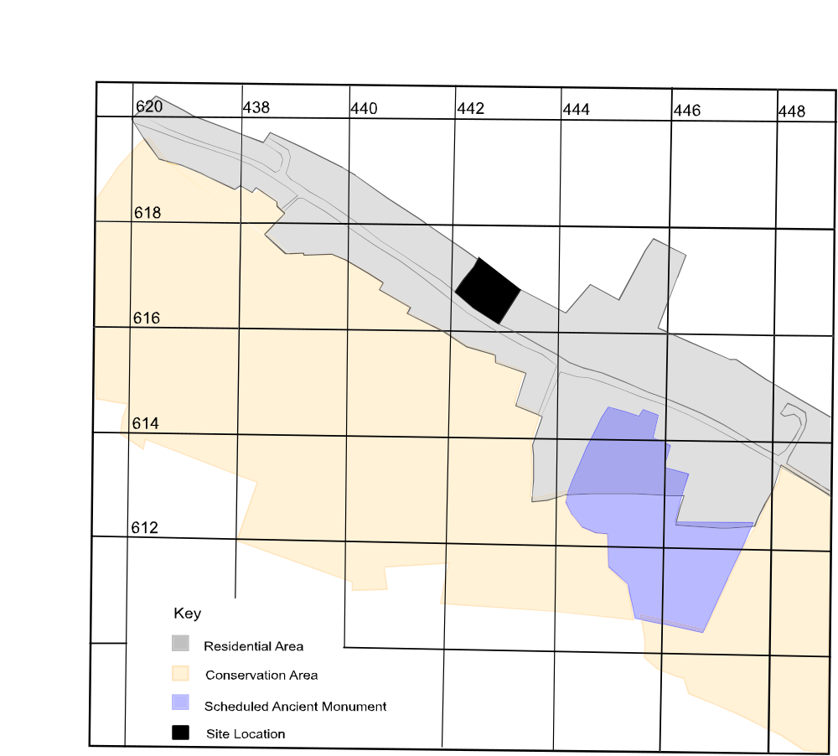

The local landscape has been covered by a Historic Landscape Characterisation survey carried out by Herefordshire Archaeology between 1999 and 2002. Kingsland exhibits evidence of retentive enclosure, where an established pattern of enclosure which has a definable genesis has been retained in an identifiable way, despite later redefinition of boundaries; and of survey planned enclosure, defined as areas shaped by the deliberate reconfiguration or new enclosure of the landscape for the purpose of agricultural improvement during the 18th and 19th centuries (P.White, pers. comm.; White, 2003, 117).

- Geology

The predominant soil type in this area is the 571A Rowton consisting principally of well-drained fine silty loamy soils, locally over gravel. The drift geology consists of glaciofluvial or river terrace gravel and till, while the underlying solid geology is of undivided Old Red Sandstone (Soil Survey of England and Wales, 1983).

- Methodology

Research aims

The purpose of the Desk-Based Assessment is to assess the nature of the archaeological resource.

Research methods

The research carried out for the Desk-Based Assessment consisted of the following elements:

Evaluation and study of archaeological databases:

The Herefordshire Archaeology Sites and Monuments Record (SMR) at Hereford and the National Monuments Record (NMR) at Swindon were both consulted and lists were obtained of all known archaeological sites, listed buildings and scheduled ancient monuments in the study area and any relevant backup files.

Evaluation and study of cartographic and other pictorial evidence:

A detailed map regression analysis of the study area was carried out, examining all available editions of the Ordnance Survey (from the 19th century to the present), a map of the parish of Kingsland made in 1816 and the 1841 tithe map for Kingsland Private estate maps, including plans of the Bateman estate at Kingsland dated 1709 and 1870, were also consulted. This information was obtained from the Herefordshire Record Office and the Public Records Office in London. Collections of aerial photographs relating to the study area were also consulted at the Herefordshire Archaeology Sites and Monuments Record and the National Monuments Record.

Evaluation and study of primary written evidence:

Original written and cartographic records of the manor of Kingsland were consulted at the Herefordshire Record Office, including a terrier of the manor of Kingsland dated 1831; 15th-16th century accounts of the manor of Kingsland held at the Public Records Office in London were also consulted.

Evaluation and study of secondary (published) sources:

All published works relating to sites and structures of archaeological and historical interest within the study area were evaluated, including published and unpublished archaeological reports, local and county histories and appropriate archaeological and historical journals, including the Transactions of the Woolhope Naturalists Field Club.

- Historical & Archaeological Background

Prehistory
Although there is scant evidence for prehistoric activity in Kingsland, in terms of excavated sites or artefactual evidence, aerial photography has revealed a sizeable number of cropmarks in the fields to the S of the River Lugg, immediately N of the specific study area, which has been described as ‘one of the largest cropmark complexes in the county’ (Dinn, 1996; Hemingway & Dinn, 1996) (Plate 1). These cropmarks consist of sub-triangular and linear enclosure ditches and two ring ditches (SMR Record nos. 6008-9; 8308-10) (Plate 1); and were evaluated by Hereford and Worcester County Archaeological Service (HWCAS) in 1995-96 using a combination of auguring, fieldwalking and geophysical survey. Although a small amount of Roman pottery and a single flint was uncovered during the fieldwalking survey, no other evidence of settlement was found; it was concluded that any buried soil layers or occupation surfaces associated with the ditched enclosures had been removed by medieval and later ploughing (Hemingway & Dinn, 1996, 15). No definite evidence was found confirming the date of the ditched enclosures, although the ring ditches were tentatively assigned a Bronze Age date (Dinn 1996, 64).

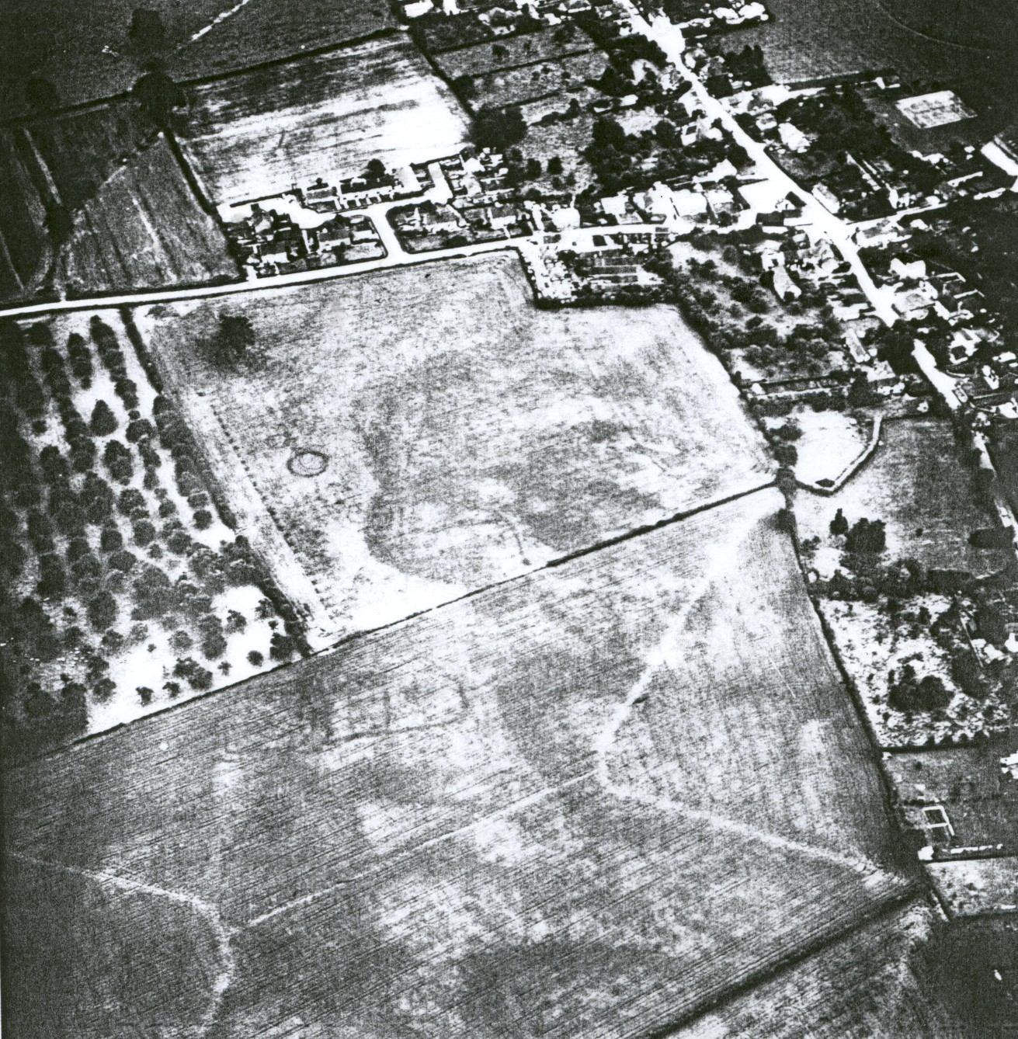
Plate 1: Aerial photograph showing ring ditches and other enclosure cropmarks in fields to the north of the study area at NGR SO 444 618 (1990)

Roman Period (c.43–410 AD)
Kingsland is bounded on the W by the great Roman road which ran N from Caerleon to Chester. Although no Roman forts or marching camps are known in the area around Kingsland, it is possible that there was a Romano-British settlement at the crossing of the River Arrow at Lawton which is located directly S of Kingsland (White 2003, 20). A field-walking survey carried out by Hereford and Worcester County Archaeological Service (HWCAS) in 1996 in fields to the N of the study area produced a small number of abraded Roman sherds and a single piece of burned flint (Hemingway & Dinn, 1996).

Medieval Period (5th-16th century)

The place-name Kingsland is of Anglo-Saxon origin, meaning ‘The king’s estate in Lene’ (Coplestone-Crow 1989; Mills, 2003, 279). Kingsland is one of several place-names in NW Herefordshire incorporating the element ‘lene or leon’, which appears to denote a distinct territorial entity in N Herefordshire, situated between the rivers Lugg and Arrow, which existed in the Anglo-Saxon period (Perry 2002, 32).

During the 6th-7th centuries AD, the region surrounding Kingsland was occupied by the Magonsaete, whose kingdom covered S Shropshire and N Herefordshire. In about 660 AD, Merewald (Merewalh), ruler of the Magonsaete, is reputed to have founded a monastery at Leominster (the predecessor of Leominster Priory), endowing it with substantial estates in N Herefordshire (Hillaby 1987). However, Kingsland was apparently retained by Merewald for his own use and did not become part of the foundation endowment of Leominster Priory. The Tudor antiquarian John Leland, writing in about 1535, also recorded a local tradition that Merewald built a castle or palace at Kingsland, the possible location being in the field adjoining the 12th century castle of Kingsland, called ‘Merwold Croft’ in the early 19th century (Perry, 2002, 49; Shoesmith, 1996, 152-3).

Kingsland is recorded in Domesday Book as being a royal manor before 1066 when it was in the hands of King Edward the Confessor (Thorn & Thorn 1983). However, after the Norman Conquest, large parts of Herefordshire including the manor of Kingsland came into the hands of William Fitz Osbern, Earl of Hereford (d.1071). His successor Earl Roger rebelled against King William I and all his lands, including Kingsland, were forfeited to the Crown.

The Domesday survey records Kingsland as being in the hands of the king. It was evidently a substantial manor, one of the largest royal estates in Herefordshire, assessed at 15 hides (a hide being an area of land roughly estimated to contain 120 acres) and valued at £13 3s, more than twice its value before 1066 (when it was valued at £6). The boundaries of the manor encompassed a much wider area than the present village of Kingsland. Apart from the settlement of Kingsland itself, Domesday identifies five separate estates or sub-manors within the manor of Kingsland: Merestone, Hopleys Green, Street, Lawton and Alac, held by three tenants, Ralph de Mortimer, Roger de Lacy and Ilbert son of Thorold.

The documentary evidence for Kingsland during the 12th and 13th centuries is somewhat patchy. At some point during the reign of Henry I (1100-35), the manor of Kingsland was granted to the de Braose family, lords of Radnor. William de Braose is reputed to have launched a major raid on the town of Leominster from Kingsland in 1210 while in 1216 King John is recorded as staying there when he laid waste to the de Braose lands (Shoesmith, 1996, 152-3). It is likely that the de Braose family were responsible for building the surviving motte and bailey castle at Kingsland, located immediately W of the church.

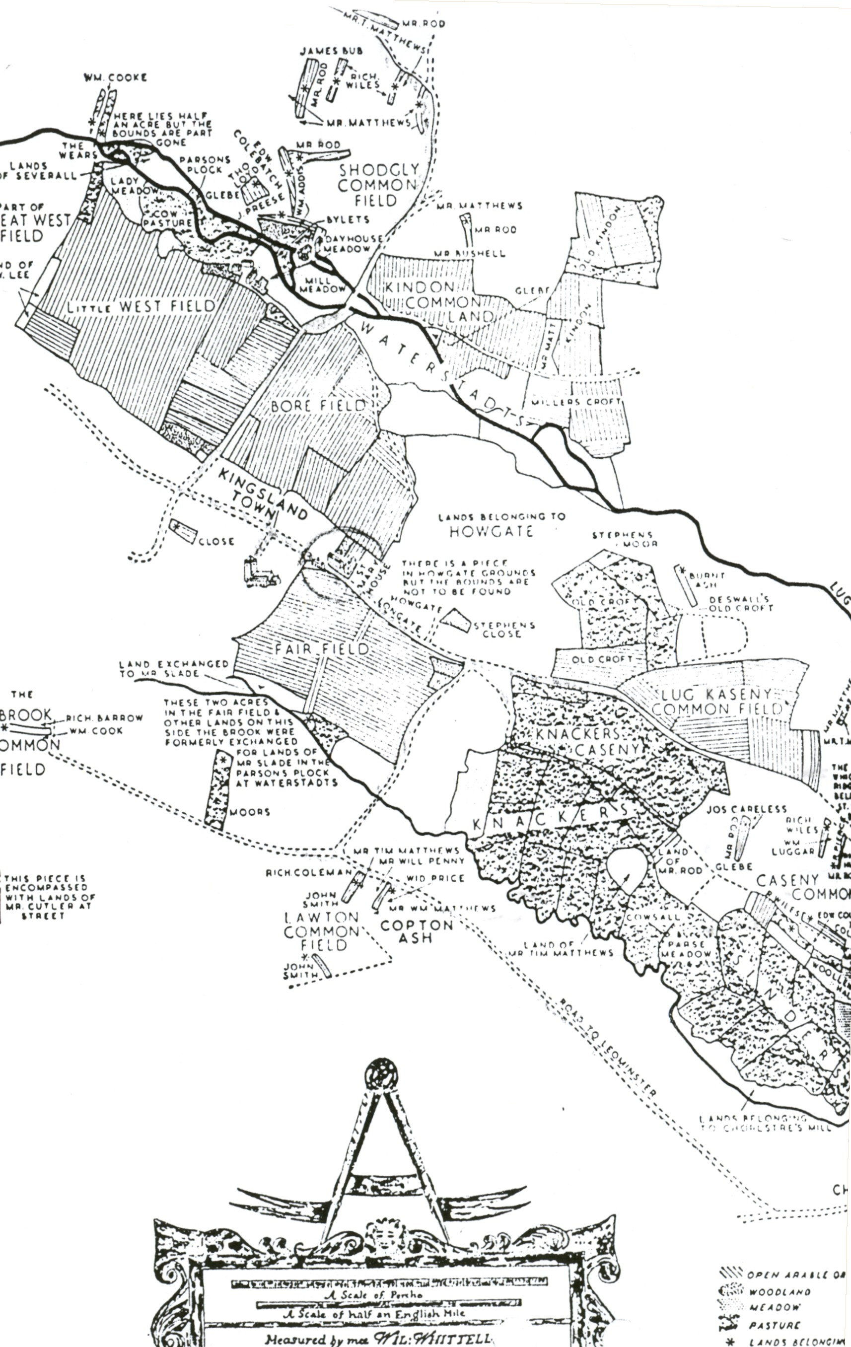
Kingsland Castle (SMR Record No. 340) is an extensive earthwork comprising an irregular oval motte with the remains of a bailey enclosure to the N and E, separated by a transverse ditch (RCHME, 1934, 82; Shoesmith, 1996, 152-3). Remains exist of the partially buried foundations of an octagonal shell keep (suggestive of a late 12th century date) on the motte and there are traces on the NE side of the motte ditch which may represent a bridge abutment or barbican giving access to the keep (Sterling-Brown, 1988, 44). The castle appears to have been abandoned by the early 15th century (Shoesmith, 1996, 153)
Fig. 2: Estate map dated 1709

An archaeological survey of the castle carried out by HWCAS in 1988 discovered pottery dating from the early 12th-late 14th century on the site (Sterling-Brown, 1988, 44). Traces were also found of a ditch to the SE of the castle site, which apparently formed part of a village enclosure (NGR SO 4460 6150), and evidence of what may have been a stone wall surrounding the enclosure (SMR Record Nos. 7278, 11181). This enclosure may represent the main focus of settlement at Kingsland in the 12th century, in close proximity to the castle and parish church. It is not known, however, if this was a post-Conquest development or whether the nucleus of settlement at Kingsland was located in the same place before 1066.

In 1992, a further archaeological evaluation was carried out by Birmingham University Field Archaeology Unit (BUFAU) on land immediately to the W of Kingsland Castle (NGR SO 4430 6130). However, despite the close proximity of the evaluation site to the castle, no medieval remains or archaeological remains of other periods were revealed (Pontin, 1992, 2).

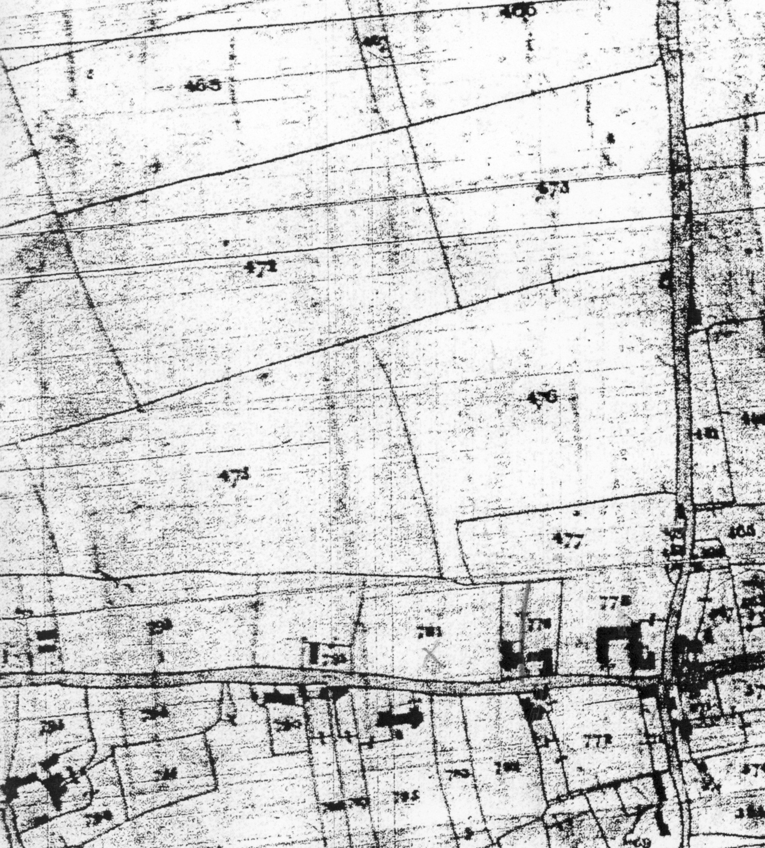
In about 1250, the manor of Kingsland came into the hands of the Mortimer family, who held it until the middle of the 15th century. They were undoubtedly responsible for the construction of the parish church of St Michael (SMR Record No. 8184) (Grade I Listed Building No. 150070), which was largely built in the late 13th-early 14th century, apparently with the assistance of Edmund Mortimer, 7th Lord of Wigmore. This was presumably a rebuilding of an earlier structure on the same site.
Fig. 3: 1841 Tithe Map of Kingsland

It appears that the Mortimers attempted to establish a planned urban settlement at Kingsland in the late 13th-early 14th century, roughly contemporary with the rebuilding of St Michael’s Church. The remains of this settlement essentially consist of rows of houses aligned roughly NW-SE along the road named Longford, with the church as its focus. The Kingsland Tithe map of 1841 (Fig. 3) and early OS maps of the village show long, narrow strips of land to the rear of many of the houses along Longford, which may be indicative of medieval burgage plots.
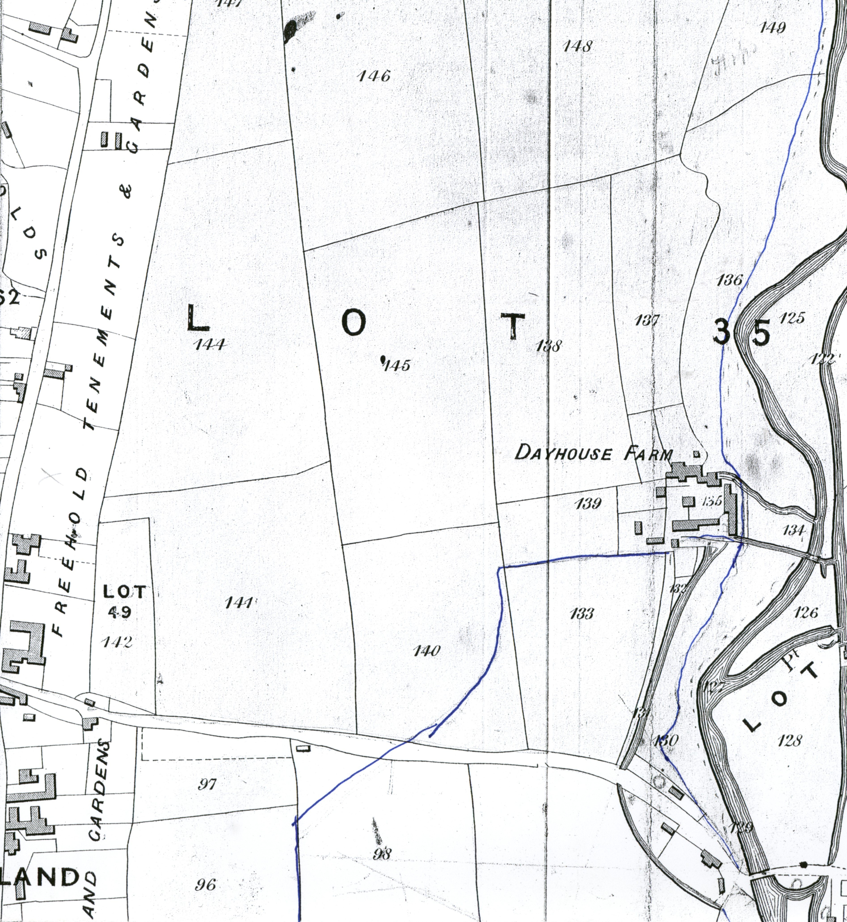
Fig. 4: Map of the Bateman Estate at Kingsland 1870
This may have succeeded the earlier settlement (SMR Record No. 7278) located immediately to the SE of Kingsland Castle. Documentary evidence sheds light on the attempted establishment of a borough at Kingsland by the Mortimers. In July 1306, Margaret, widow of Edmund Mortimer, obtained a charter from King Edward I granting permission for a weekly market and annual fair to be held at Kingsland (Cal. Charter Rolls 1300-26, 68). It is unclear for how long the market continued but it ceased to be held by the late 17th century. In 1675, the Herefordshire antiquarian Thomas Blount noted that the ‘market was lost but the fair continues great and kept always in ye same open field’ (Reeves, 1980, 6). The fair at Kingsland, which was held in the large field immediately E of St Michael’s Church (still known as Fair Field), is recorded in 1617 and 1675 and continued to be held until 1830.

The area surrounding the medieval settlement of Kingsland consisted mostly of large, open common arable fields, such as the Great West Field, the Little West Field (immediately N of the study area), Bore Field, Shodgly Common Field, Lug Kaseny Common Field, Kindon Common Land and Fair Field. These fields are recorded in late medieval documents, such as an account of the bailiff of Kingsland dated 1389-90 (Cole, 1956, 168-76) and appear on an estate map of Kingsland dated 1709 (printed in Sylvester, 1969, Fig. 45) (Fig. 2). They appear to have remained largely unenclosed until about 1800, when substantial enclosure took place. Traces of strip fields and ridge and furrow cultivation (indicative of an open field system) to the NW of Kingsland, in the former Great West Field, have been identified from aerial photography (SMR Record No. 3895).

On 2nd or 3rd February 1461, the Battle of Mortimer’s Cross (SMR Record No. 6335), in which Yorkist forces led by Edward Earl of March decisively defeated the Lancastrian army led by Owen and Jasper Tudor, took place just to the W of Kingsland (Hodges, 1982, 65-72). Contemporary accounts of the battle are somewhat confused; however, the monument built in 1799 to commemorate the battle (NGR SO 4363 6198) may mark the site where the Lancastrians made their last stand. A cottage named Battle Acre still exists, about 200m NW of the monument, and various items such as pieces of armour, bridle bits and stirrups, presumably of late medieval date, have been unearthed in the vicinity of this building (Hodges, 1982, 66).

Post-Medieval Period (16th century to present)

From 1461 until c.1700 the manor of Kingsland remained in the hands of the Crown. Although Kingsland did not develop into a fully-fledged borough, it nevertheless remained a large and moderately prosperous rural settlement throughout the 16th and 17th centuries and is sometimes referred to in documents of that period as a town. Cartographic sources (especially an estate map of 1709, a map of Kingsland parish made in 1816 and the 1841 tithe map) and the evidence of standing buildings suggest a steady westward expansion of settlement at Kingsland between c.1500-1800. The numerous 16th-17th century houses and cottages in Kingsland, such as Croft Mead (Grade II Listed Building 150080) and Croase House (Grade II Listed Building No. 150079), to name only two, further attest to the prosperity of Kingsland during this period.

Documentary evidence shows that the manor of Kingsland was specifically reserved as part of the demesne lands of the Queen of England from the late 15th century until the end of the 17th century. Elizabeth of York, wife of Henry VII, is recorded as being the first Queen in possession of Kingsland (PRO SC6/HEN VII/1205). The last Queen to hold Kingsland was Catherine of Braganza (d.1702), the wife of Charles II, and she retained the estate after her husband’s death in 1685. Shortly after Queen Catherine’s death in 1702, Kingsland was purchased by Lord Coningsby of Hampton Court, whose descendant, Viscount Malden, sold it to Rev. Richard Evans in 1793. The manorial estate remained in the hands of the Evans family until 1871, when it was sold to the Rt Hon. Lord Bateman (Robinson 1872). The Bateman family remained in possession of the manor until 1922.

Although the Batemans, a wealthy London mercantile family, did not acquire the manorial estate of Kingsland until 1871, documentary evidence shows that they had a significant landed interest in Kingsland from the early 18th century onwards. The extent of the Batemans’ property is shown on a map of 1709 (printed in Sylvester 1969, Fig. 45); which shows that they held the Little West Field, one of the open common arable fields in Kingsland, which is situated immediately N of the study area. It is worth noting that, at this date, the Little West Field and many of the other open common fields in Kingsland, were still mostly unenclosed.

During the course of the 19th century, however, it appears that the process of enclosure of the open common fields in Kingsland rapidly gathered pace. A map of the parish of Kingsland drawn up in 1816 (HRO Ref. D26/1) and the tithe map of 1841(HRO Ref. AM84/2) show that extensive enclosure had taken place in the fields lying to the S of the River Lugg (including the Little West Field) during the early 19th century. The orderly, rectilinear nature of the field boundaries in this area is clearly indicative of ‘survey planned enclosure’, probably undertaken by William Hanbury Lord Bateman (d.1845), who was the largest landholder in that particular part of Kingsland. The evidence of later OS maps and an 1870 plan of the Bateman estate in Kingsland (Fig. 4) indicate that further piecemeal enclosure occurred during the second half of the 19th century, although the existing pattern of field boundaries was essentially established by the early 1840s. Some traces of strip field enclosures and ridge and furrow cultivation (associated with the medieval system of open fields) are still visible on recent OS maps and aerial photography of the area, located to the W of Kingsland in the vicinity of the former Great West Field (SMR Record No. 3895).

Site Specific Analysis

Aerial photography has revealed a series of cropmarks indicative of field enclosures and ring ditches, possibly of prehistoric or Roman origin, in two fields known as Croase Meadow and the Wardings situated immediately to the N of the specific study area. These form part of what has been described as ‘one of the most extensive cropmark complexes in Herefordshire’ (Dinn, 1996, 57). These consist of three conjoined enclosures (SMR Record No. 6009), two ring ditches, possibly of Bronze Age date (SMR Record No. 6008, 8308), and a sub-triangular enclosure with an entrance to the N (SMR Record No. 8309).

An archaeological assessment of these fields was carried out by HWCAS in 1995-96, using a variety of techniques, including fieldwalking, auguring and geophysical survey (Hemingway & Dinn, 1996). It was not possible to determine the exact date of these features as any buried soil layers or occupation surfaces associated with the ditched enclosures had apparently been removed by medieval and later ploughing (Hemingway & Dinn, 1996, 14-15). However, a fieldwalking survey of the area produced a small number of abraded Roman sherds and a single piece of flint (Hemingway and Dinn, 1996, 13).
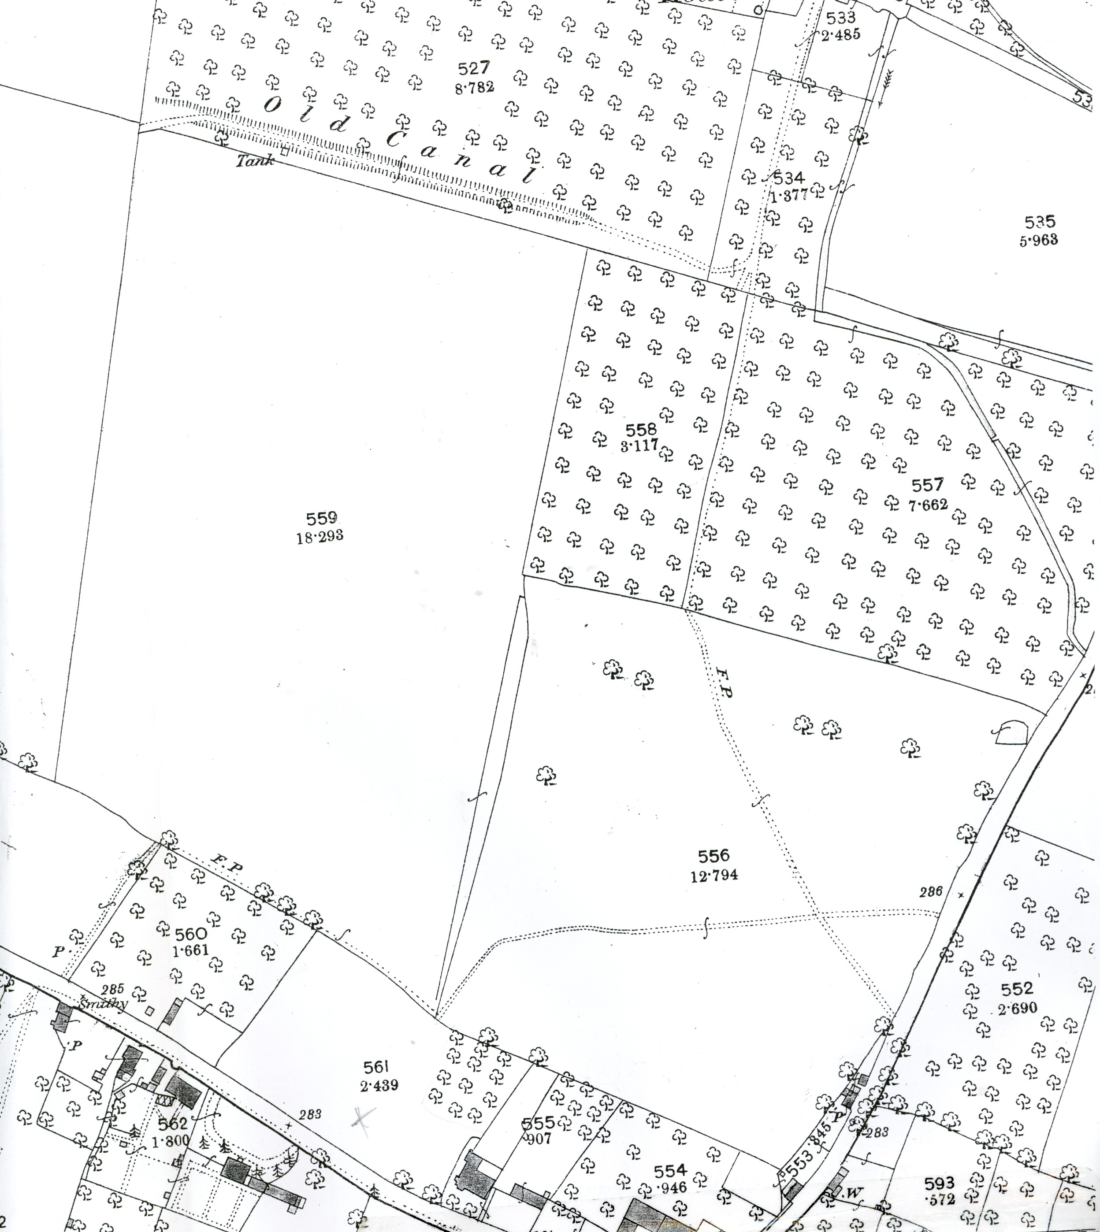
Fig. 5: OS 1st edition 25-inch map (Herefordshire 12.5) 1885

During the medieval period, the specific study area (known by the early 19th century as North Street Meadow) may have formed part of the Little West Field, one of the open common arable fields in the village of Kingsland. The 1709 map of the estate of Sir James Bateman in Kingsland shows that the land immediately N of the study area then formed part of the Little West Field, which is shown as a large field of irregular quadrilateral shape. This property remained in the possession of the Bateman family until its eventual sale in 1870.

Significantly, the 1709 map does not show in detail the land immediately S of the Little West Field, running along North Street, which includes the study area. This land appears to have been occupied by three houses, Croase House, The Wardens (Wardings) and Upper House (now known as Croft Mead), and the remainder enclosed as private gardens and meadows. It is not known whether these three houses were held as tenancies of the manor of Kingsland or as freehold estates in 1709, but all three are recorded as being freehold properties by the early 19th century.

On the basis of the architectural evidence, Croase House appears to be of late 17th-early 18th century date (Grade II Listed Building 150079), while the Wardens is documented from c.1800 onwards. The earliest of the three properties is Croft Mead (Grade II Listed Building 150080), a two storey, L-shaped building, of brick and timber framed construction, of late 16th-early 17th century date (RCHME, 1934, 83). The study area, North Street Meadow, which is located immediately W of Croft Mead, is known to have belonged to the house since 1816 and probably formed part of the same property at a considerably earlier date.

A map of the Parish of Kingsland made in 1816 (HRO Ref. D26/1), which is the earliest surviving plan of the specific study area, North Street Meadow, shows it to be an empty field with no evidence of structures having been built within it. The map also reveals that the Little West Field, lying to the N of the study area, had been enclosed and subdivided into about 10 separate fields.

A Survey and Terrier of Kingsland, which was apparently drawn up to accompany the 1816 map, but is dated 1831, describes North Street Meadow as 2 acres 1 rod and 36 perches of meadow, which was then in the possession of Miss Elizabeth Hayling (the owner of Upper House), while the occupier of the meadow was one George Yapp, a local tenant farmer. Elizabeth Hayling is named in Pigot’s Commercial Directory of Herefordshire as a tanner of Leominster and appears to have been the holder of a fairly sizeable estate in Kingsland, amounting to 29 separate properties, the most important of which was Upper House. The three fields lying immediately N of North Street Meadow (Field nos. 475-77) were then owned by William Hanbury Lord Bateman (1780-1845), owner of Shobdon Court.

The 1841 Tithe Map of Kingsland (HRO Ref. AM84/2) shows the boundaries of North Street Meadow (field no. 781) and the adjacent fields to have remained unaltered since 1816. The accompanying tithe apportionment records that North Street Meadow was still owned by Elizabeth Hayling but now was occupied by Sarah Yapp, widow of George Yapp. The occupier Sarah Yapp also resided in Upper House, described as ‘house, garden and orchard’ in the apportionment.

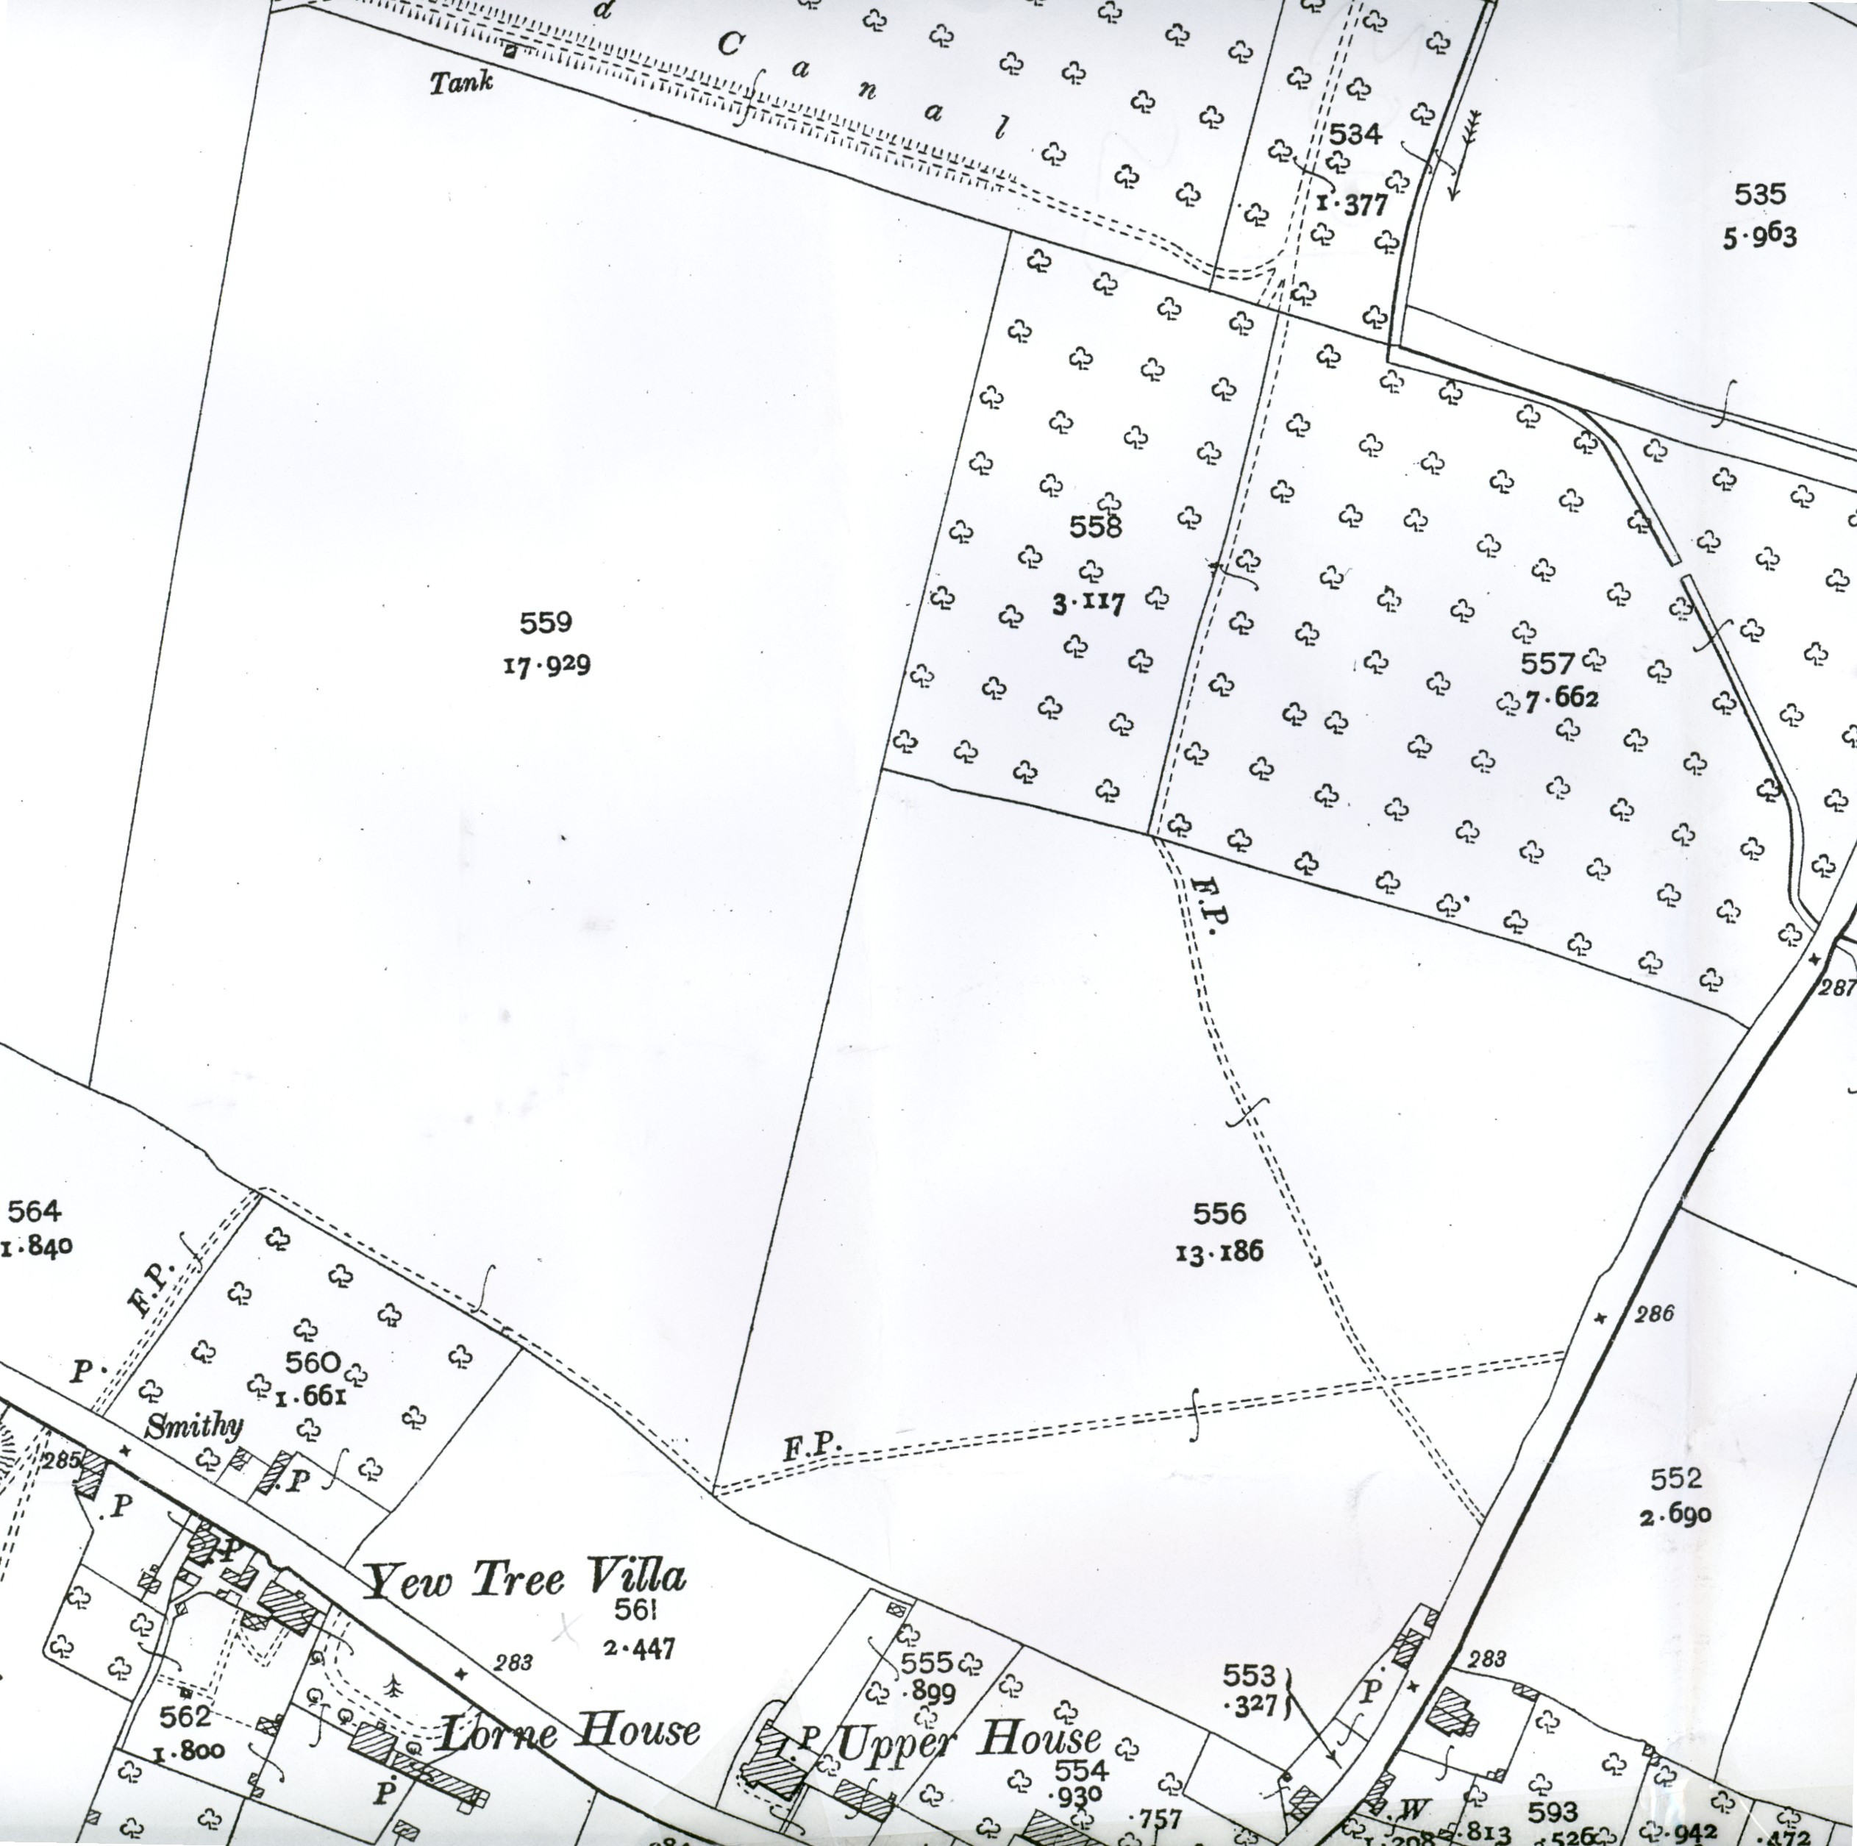
By 1851, Upper House (including North Street Meadow) had come into the possession of Mr Anthony Tymbs Esq. and Mrs Anne Edwards, who are listed as owners of the property in Lascelles Directory and Gazetteer of Herefordshire. The Bateman Estate Plan of 1870 (HRO Ref. K68/39) shows Upper House and the adjacent North Street Meadow as ‘freehold tenements and gardens’ (Fig. 4). However, by 1876 the ownership of Upper House and North Street Meadow had passed to one Mrs M A Weyman (Littlebury’s Directory of Herefordshire, 1876). The Weymans were a leading gentry family in Kingsland and patrons of the parish church, donating a new stained glass window. The Weymans remained in ownership of Upper House until about 1900, after which the property came into the hands of Mr Richard George (d.1928) a noted local estate agent, auctioneer and antiquarian, who held it until 1922 (Reeves, 1980, 67-8).
Fig. 6: OS 2nd edition 25-inch map (Herefordshire 12.5) 1903

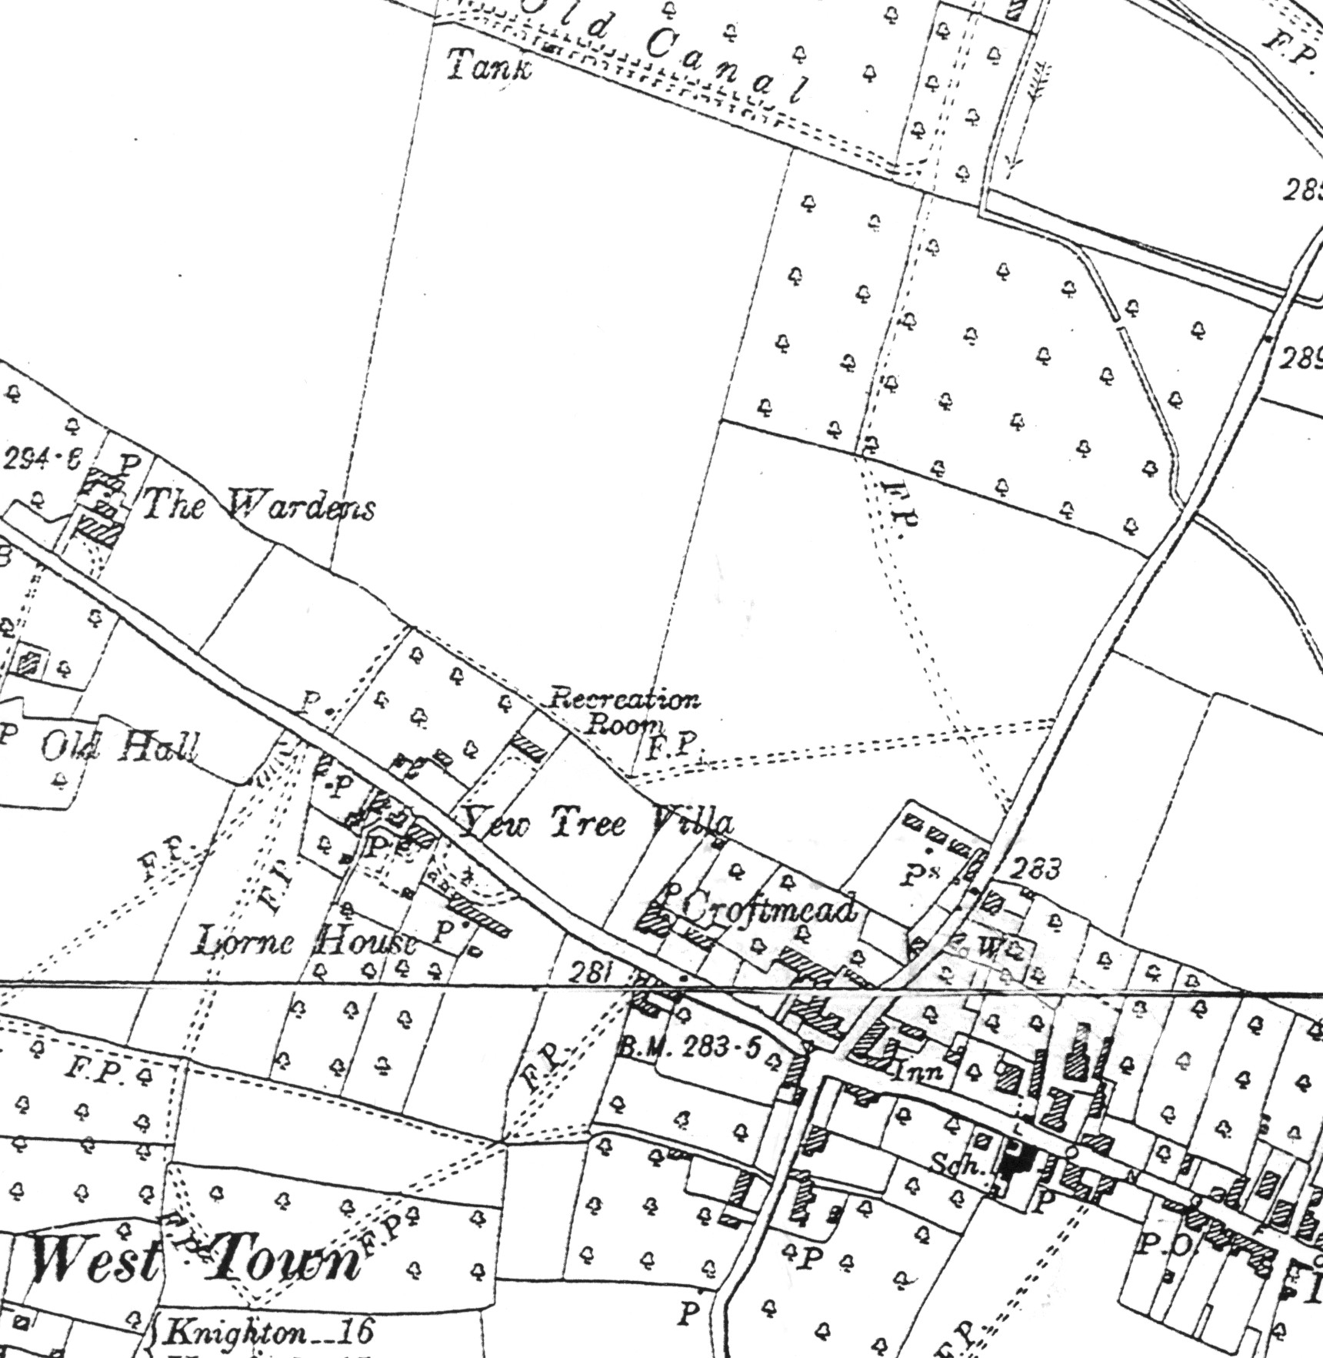
The cartographic evidence reveals that a number of changes were made to North Street Meadow and the adjoining fields during the late 19th-early 20th century. The OS 1st edition 25-inch map of 1885 shows a small plantation of trees in the NE corner of North Street Meadow, which appears to have been planted at some time between 1870 and 1885 (Fig. 5). This small orchard may have been utilised in the production of cider for personal consumption, a tradition common in Herefordshire during the 19th century. The orchard does not appear in the OS 2nd edition 25-inch map of 1903 (Fig. 6), indicating that it was removed at some time between 1885 and 1903.
Fig. 7: OS 3rd edition 6-inch map (Herefordshire 12 NW) 1930

The Land Valuation Survey of 1910 (HRO Ref. AG9/67) names the owner of Upper House and North Street Meadow as Mr Richard George. It appears that North Street Meadow had been leased out to another individual, a local farmer named John Price, presumably for the grazing of livestock. However, shortly after the First World War ended in 1918, Richard George erected a building in North Street Meadow to serve as the headquarters of the Kingsland branch of the ‘Comrades of the Great War’ (of which he was a founder member). The building, marked as a ‘Recreation Room’ on the OS 6-inch map of 1930 (Fig. 7), was a long, rectangular, single storey structure, aligned E-W, brick-built with a slate roof.

After Richard George’s departure from Kingsland in 1922, North Street Meadow and Upper House (thereafter named Croft Mead) came into the hands of the present owners. The ‘Recreation Room’ was then apparently used as a sports clubhouse, and tennis courts were laid out on part of North Street Meadow, immediately S of the tennis club. The tennis courts and clubhouse were accessed from the road by a small gate, which still survives in the SW corner of North Street Meadow. The clubhouse was burnt down during the Second World War and not rebuilt; it does not appear on the 1952 OS map, although substantial remains of the building still survive heavily obscured by trees and undergrowth. Traces of banks and fencing survive in the meadow, which may be associated with the site of the tennis courts.

The 1:2500 OS map of 1972 shows an enclosure to the NE corner of North Street Meadow, which is represented today by beech hedging. Presumably this was a further extension to the gardens of Croft Mead. The 1972 map also shows a small square enclosure in the NW corner of the field. This enclosure appears to be associated with a small shed-like structure, which was used until recently as an animal shelter.
- Conclusion

Evidence of human activity in the locality of the study area dates back possibly to the Bronze Age. Aerial photography has identified two possible ring ditches located in fields immediately N of the study area, which have been tentatively assigned a Bronze Age date. A number of associated sub-rectangular enclosures and linear features have been identified in the same area, which are presently undated but have been cautiously interpreted as evidence of prehistoric or later settlement.

The origins of the present settlement at Kingsland date to the Anglo-Saxon period, it is reputed to have been a residence of Merewald, ruler of the Magonsaete during the 7th century, and it remained a royal manor until the Norman Conquest. After the Norman Conquest, Kingsland came into the hands of the de Braose family. It is probable that the original settlement at Kingsland was situated close to the motte and bailey castle built in the 12th century by the de Braose family.

By c.1300 the layout of the present settlement of Kingsland took shape, probably under the auspices of the Mortimer family who appear to have attempted to establish a borough at Kingsland, as attested by the grant of a market and fair in 1306 and the rebuilding of the parish church on a grand scale. Although Kingsland failed to develop into a fully-fledged borough, it remained a large and relatively prosperous settlement throughout the rest of the Middle Ages and well into the early modern period.

The specific study area (known by the 19th century as North Street Meadow) may have originally formed part of the Little West Field, one of the large open common arable fields of Kingsland during the medieval period. At some point before 1816, it was enclosed and became part of the property of Upper House (now known as Croft Mead) situated immediately to the E, which was built during the late 16th-early 17th century.

From at least c.1800 onwards, North Street Meadow is recorded as having belonged to Croft Mead, the ownership of which changed hands several times during the 19th century. During this period it appears that the study area was occasionally leased out to tenant farmers. At some point between 1918 and 1922, a brick building was erected by Richard George, then owner of Croft Mead, in the NW corner of the meadow as the headquarters of the Kingsland branch of the ‘Comrades of the Great War’. After 1922, this building became a clubhouse or ‘Recreation Room’ and tennis courts were laid out in the meadow. The clubhouse was burnt down during the Second World War and not rebuilt, although substantial traces of the foundations of the building remain.
- Copyright

Border Archaeology shall retain full copyright of any commissioned reports, tender documents or other project documents, under the Copyright, Designs and Patents Act 1988 with all rights reserved; excepting that it hereby provides an exclusive licence to the client for the use of the report by the client in all matters directly relating to the project as described in any relevant Project Specification.
- Bibliography

Primary Sources:

Herefordshire Record Office (HRO), Hereford

1733-1844 Deeds and Wills relating to the Manor and Advowson of Kingsland and other freehold property (C94/58)
1754 Kingsland Lease (B14/15)
1825 (28 June) Will of Richard Hayling of Leominster, (HCC Ref. FHL 91916)
1831 Survey and Terrier of Kingsland Parish by William Galliers, taken for the purpose of assessing a proportional poor rate (B14/4)
1910 Land Valuation Survey (AG9/67)

Public Record Office (PRO), London

SC6/HenVII/1205: Account of the possessions of Queen Elizabeth at Kingsland (Herefs.) and other manors in Herefordshire & Worcestershire (1506-7)

Secondary Sources:

Herefordshire Archaeology: Sites and Monuments Records printout
National Monuments Record, Swindon: NMR database printout
Royal Commission on Historical Monuments, England, An Inventory of the Historical Monuments in Herefordshire, Volume III (1934)
Cole, E.J., ‘The Bailiff’s Accounts for the Manor of Kingsland 1389 to 1390’ Transactions of the Woolhope Naturalists Field Club, (1956), 168-176
Dinn, J., ‘Alluvial Archaeology in the Herefordshire Valleys: an assessment of survey techniques and archaeological potential’ Hereford and Worcester County Council, Report 456 (1996)
Evans, J. G., The Environment of Early Man in the British Isles (London: Book Club Associates, 1976)
George, R. H., ‘Wapley Camp, The Upper Lugg Valley and Kingsland’ Transactions of the Woolhope Naturalists Field Club, (1914), 59-64
Hemingway J. & Dinn, J., ‘The Herefordshire Valleys Survey: evaluation of field techniques on valley sites in Herefordshire’, Hereford and Worcester County Council, Report 458 (1996)
Herefordshire SMR notes on Kingsland, undated and unpublished
Hodges, G., ‘The Battle of Mortimer’s Cross: A Discussion of Literature, Evidence and Sources’ Transactions of the Woolhope Naturalists Field Club, (1982), 65-72
Lascelles & Co. Directory and Gazetteer of Herefordshire (1851)
Littlebury’s Directory and Gazetteer of Herefordshire (1876-77)
Mills, A. D., Oxford Dictionary of British Place Names (Oxford, 2003)
Perry, R., Anglo-Saxon Herefordshire 410AD – 1086AD (Gloucester, 2002)
Pevsner, N., The Buildings of England: Herefordshire (London, 1963)
Pontin, R., Kingsland: Herefordshire, An Archaeological Evaluation, Birmingham University Field Archaeology Unit, Report No. 222 (1992)
Price, J. S., ‘Fourth Whole Day Field Meeting: Great West Field, Kingsland’, Transactions of the Woolhope Naturalists Field Club, (1950), xlix-li
Reeves, N. C., The Leon Valley (Chichester, 1980)
Reeves, N. C. (ed.), The 1675 Thomas Blount Manuscript History of Herefordshire
‘Report on Geophysical Survey: Hyde Farm, Castle Frome, Lower Kinsham and Kingsland’, Hereford & Worcester Archaeology Dept., Report 90/21-4 (1990)
Robinson, C. J., A History of the Castles of Herefordshire and Their Lords (1867)
Robinson, C. J., A History of the Mansions and Manors of Herefordshire (1872)
Shoesmith, R., A Guide to Castles and Moated Sites of Herefordshire (Herefordshire, 1996)
Soil Survey of England and Wales (Silsoe 1983)
Stanford, S. C., The Archaeology of the Welsh Marches (Leinthall Starkes, 2nd ed., 1991)
Sterling-Brown, P., ‘Survey of all known Herefordshire Castles’, Herefordshire Archaeological News, 50 (1988), 44
Sylvester, D., The Rural Landscape of the Welsh Borderland (London 1969)
Thorn, F. & Thorn, C. (eds.), Domesday Book: Herefordshire (Chichester, 1983)
West, J. & M., A History of Herefordshire (Sussex, 1985)
White, P., The Arrow Valley, Herefordshire: Archaeology, Landscape Change and Conservation, Herefordshire Studies in Archaeology, Vol. 2, (2003)

Cartography:

Hereford Record Office (HRO)

1816 Plan of the Parish of Kingsland (D26/1)
1841 Kingsland Tithe Map (AM84/2)
1870 Bateman Estate Plan (K68/39)
1885 OS 1st edition 25-inch map (Herefordshire 12.5)
1888 OS 1st edition 6-inch map (Herefordshire 12 NW)
1903 OS 2nd edition 25-inch map (Herefordshire 12.5)
1930 OS 3rd edition 6-inch map (Herefordshire 12 NW)
1952 OS provisional edition 6-inch map (Herefordshire 12 NW)
1972 OS 1:2500 map (SO 46 SW)
1999 OS 1:25000 map (SO 46 SW)
1999 OS 1:50000 map
Historic Landscape Characterisation Map 2001
Herefordshire Unitary Development Plan 2002 (Inset Map 20: Kingsland)

Aerial Photography held at the Herefordshire Archaeology Sites and Monuments Record was also consulted.

