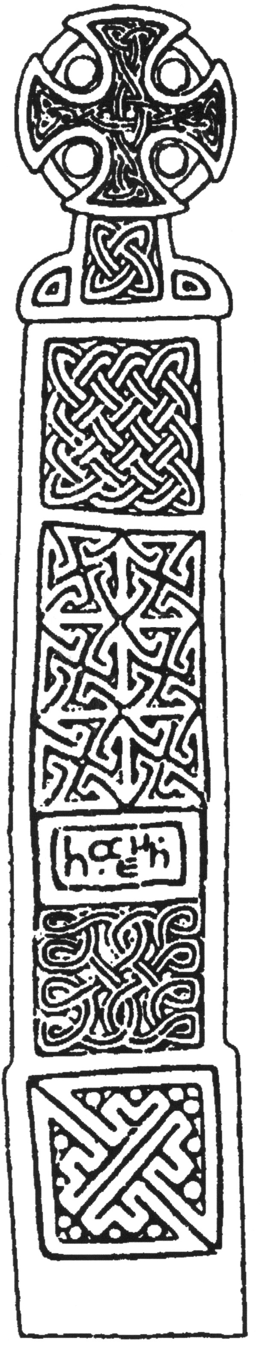
Standing Building Recording & Archaeological Observation

No.33 South Street Leominster

Herefordshire

NGR: SO 4962 5876

BORDER ARCHAEOLOGY

PO Box 36
Leominster
Herefordshire
HR6 0YQ

Technical Services
Chapel Walk

Burgess Street
Leominster
Herefordshire
HR6 8DE

BORDER ARCHAEOLOGY
Head Office

PO Box 36
Leominster
Herefordshire
HR6 OYQ

Technical Services
Chapel Walk
Burgess Street
Leominster
Herefordshire
HR6 8DE

May 2004

NGR:
Report No.

BA0429SFSSL September 2004

Contents

1. Non-Technical Summary 4
2. Introduction 5
3. Standing Building Recording 6
3.1 General Building Plan 6
3.2 Basement 8
3.3 Ground Floor 9
3.4 First Floor 10
3.5 Second Floor 11
3.6 Loft Space 11
4. Summary 12
5. Plates 13
6. Archaeological Observation 19
6.1 Trench 1 19
6.2 Trench 2 20
6.3 Trench 3 (Plates 15 & 16) 20
6.4 Summary 21

List of Illustrations
Plate 1: Early 19th century central stairwell 5
Plate 2: No 33 South Street (W-facing elevation) 6
Plate 3: S-facing elevation indicating eaves and chimneys 7
Plate 4: Main entrance located on W-facing elevation 8
Plate 5: Ventilation shutter/opening within basement 9
Plate 6: Ornate section of handrail of main stairwell 10
Plate 7: Fireplace surround within NE first floor bedroom 11
Plate 8: E- & S-facing elevations 13
Plate 9: Ground floor window on W-facing elevation 14
Plate 10: Key patterned pilastered archway within ground floor hall 15
Plate 11: Section of main stairwell indicating base tread and open string 16
Plate 12: Architrave doorway located on first floor landing 17
Plate 13: Decorative architrave of doorway located on first floor landing 17
Plate 14: Steps of eastern basement entrance 18
Figure 1: Site and trench location plan 19
Plate 15: S-facing section of Trench 3 indicating foundation base incorporating cellar wall 21
Plate 16: Trench 3, S-facing irregularly bonded base for gauged brickwork above cellar foundation 22

Report Specification
Standing Building Recording and Archaeologcal Observation: Paul Jones BA
Draft report and artwork: Paul Jones BA & Michelle Bithell BA
Report edited by: George Children MA
- Non-Technical Summary

No. 33 South Street is a Regency style building typical of the first 30 years of the 19th century, its plan having been developed from a design first established in Britain during the early part of the 17th century. This provided a central circulation connecting each room directly with the entry and raised standards of privacy by making rooms self-contained. The centralized plan also harmonized well with the search for symmetry.

Although only a small percentage of internal detailing remained, it was possible to see this as a form representative of the last phase of Georgian Classicism. The original external detailing shows this more clearly: windows are tall and narrow with very thin glazing bars and their surrounds are plain and clean-cut, a design that enhances the simplicity of the façades.

The archaeological observation revealed a series of dark brown clayey coarse sands and garden soils, together with fragmentary 19th century pottery and animal bone. Trench 3, located within the area of an existing driveway, revealed the foundations of the building and the roughly bonded outer face of the cellar. The foundation coursing suggested the use of locally sourced brick from a demolished structure of early post-medieval date.

- Introduction

Border Archaeology was instructed by Stephen Funge on behalf of Wicks Consultancy, Sherwood House, Oxhey Drive, Northwood, Middlesex, to undertake structural recording and archaeological observation of groundworks on No. 33 South Street Leominster, Herefordshire.

The structural recording was carried out to RCHME Level 2 and included photographs and written descriptions of items of standing building fabric of historical interest.

Copies of this report will be submitted to Wicks Consultancy, Herefordshire Archaeology and the County Sites and Monuments Record.

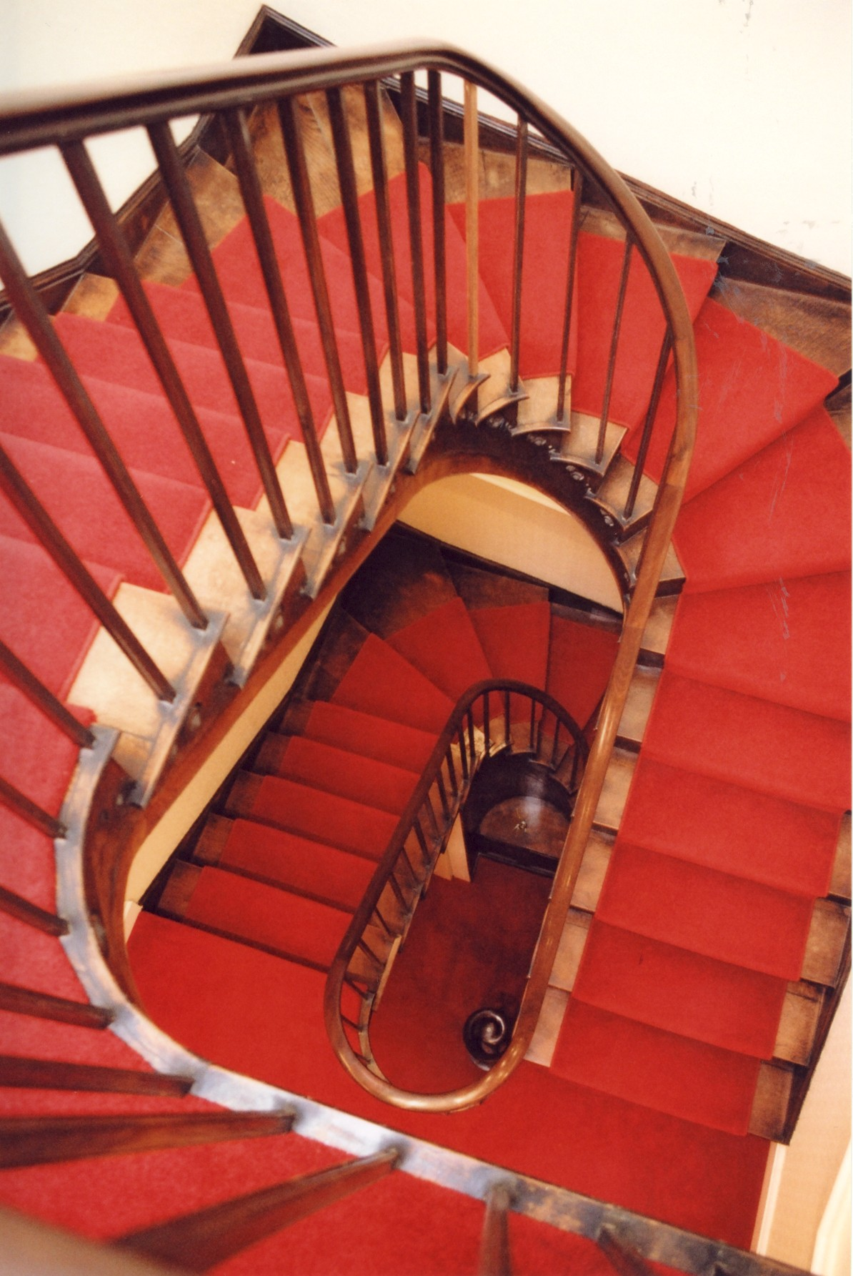

Plate 1: Early 19th century central stairwell
- Standing Building Recording

General Building Plan

Located on the E side of South Street, the building stands within an area of Leominster comprising early to late 19th century and 20th century properties. Originally, the building appears to have been positioned independently due to the non-intrusive appearance of later buildings to the S. The construction and abutment of a late 19th century property to the N has destroyed its original independent cubic plan.

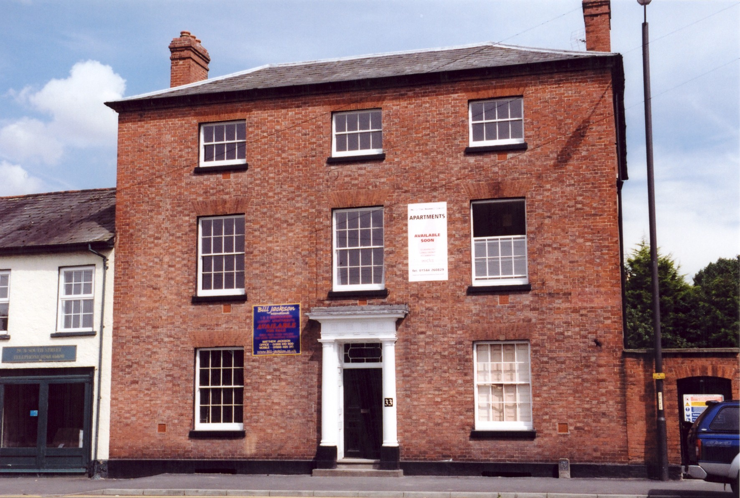

Plate 2: No 33 South Street (W-facing elevation)
The building survey recognised a single building phase for the property. Chronologically, the phase appears to be from the transitional late Georgian and early Regency period (c.1810/20s).

No. 33 comprises three storeys and a cellar of double-pile plan type arranged around a cubic form (Plates 2 & 8). To the right is a wing-wall with a plank door entrance and double doors with ornate wrought-iron screen over. Constructed of Flemish bonded red brick, three independent façades are represented with the front and rear having a neat arrangement of a single doorway with windows either side. Windows are further carried above these entrances on the first and second storeys. No blind windows are present within the S facing elevation and would have complemented the W and E facing openings within these elevations thus completing a symmetrical cubed façade. The building has a thinly slated lead ridged pyramidal hipped roof with continuous brick dentilling at the eaves. Four independent brick lateral stacks are positioned at the N and southern parts of the roof (Plate 3).

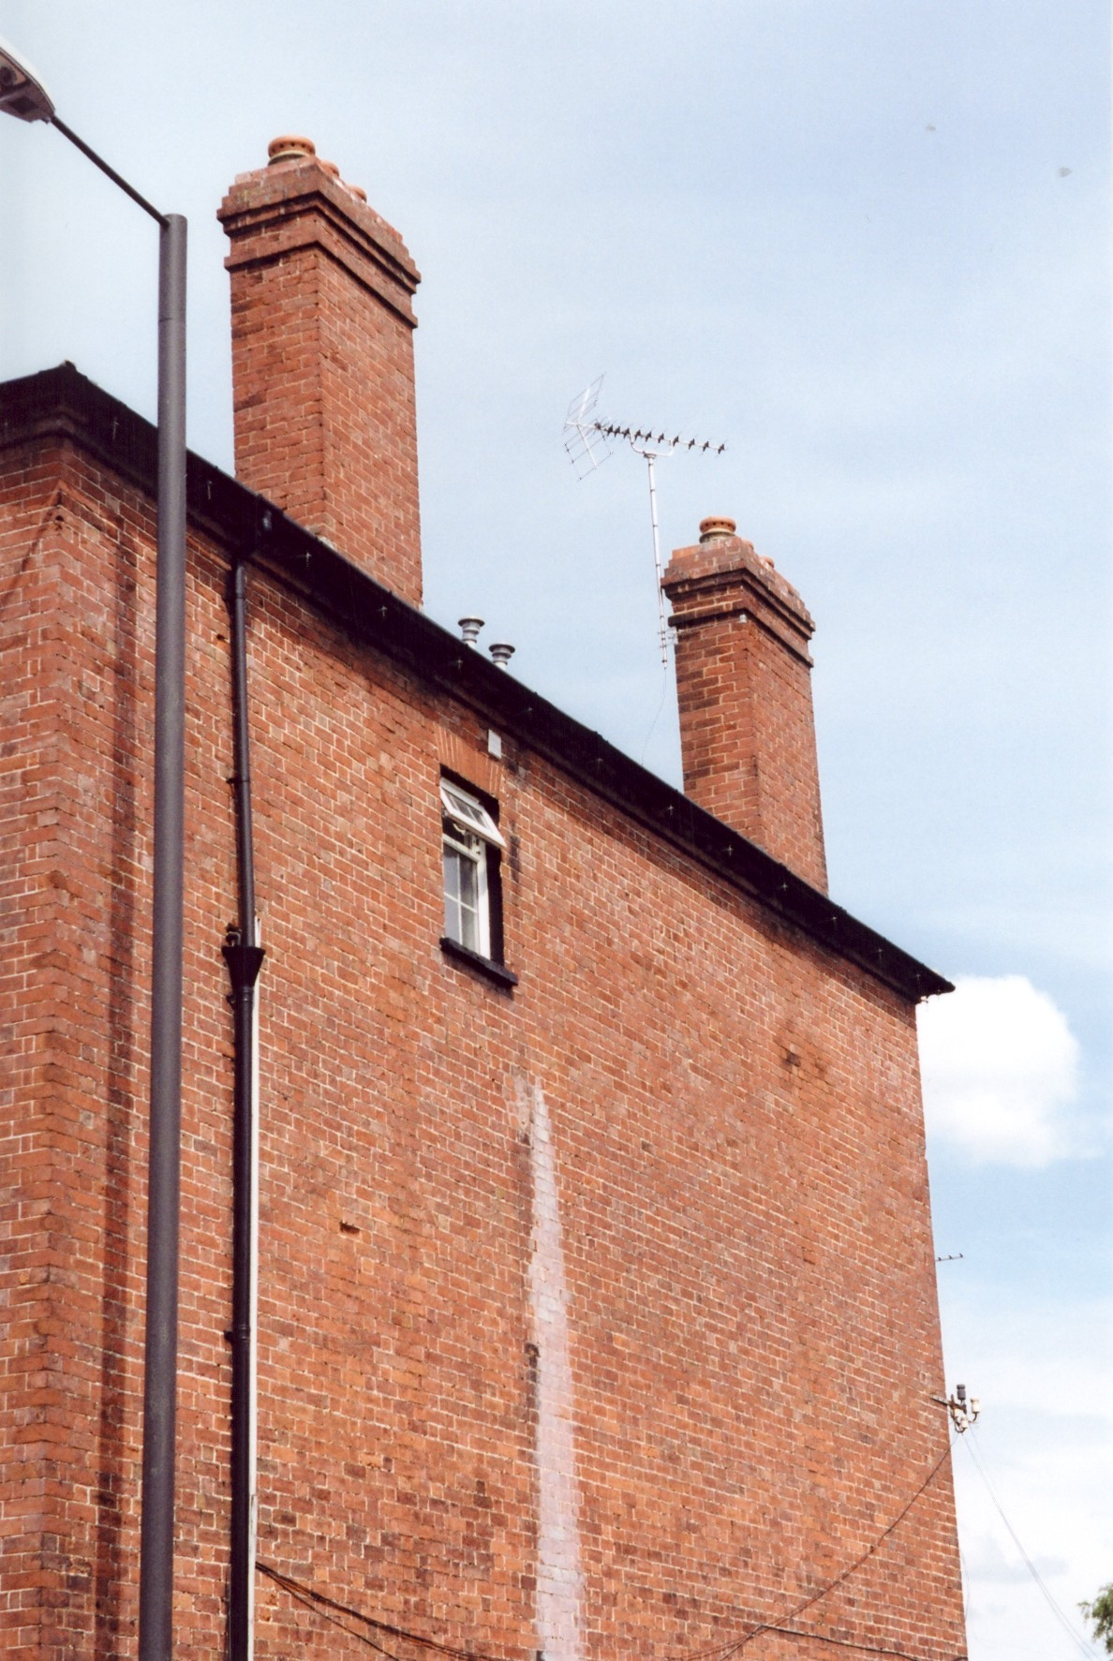

Plate 3: S-facing elevation indicating eaves and chimneys

The windows, although not original, have been sympathetically restored to the original 16-pane double-hung sash type over which are window heads constructed of cut and rubbed brick forming a flat lintel.

The central entrance off South Street consists of an eight-panelled door with coloured glass overlight (Plate 4). Two wooden neo-classical Tuscan type pilasters sit either side of the doorway both supporting an entablatured pediment. The rear entrance within the E facing façade has a fine four-panelled door with thin bar nine glazing encompassing a central hexagonal piece above.

Internal arrangements of the single phase and modern refurbishments are located at various levels throughout the property. These are based on architectural features such as fireplaces, cornicing and door/window openings and their associated furniture. Of the rooms investigated, only a small percentage of original architectural features and furniture remain.

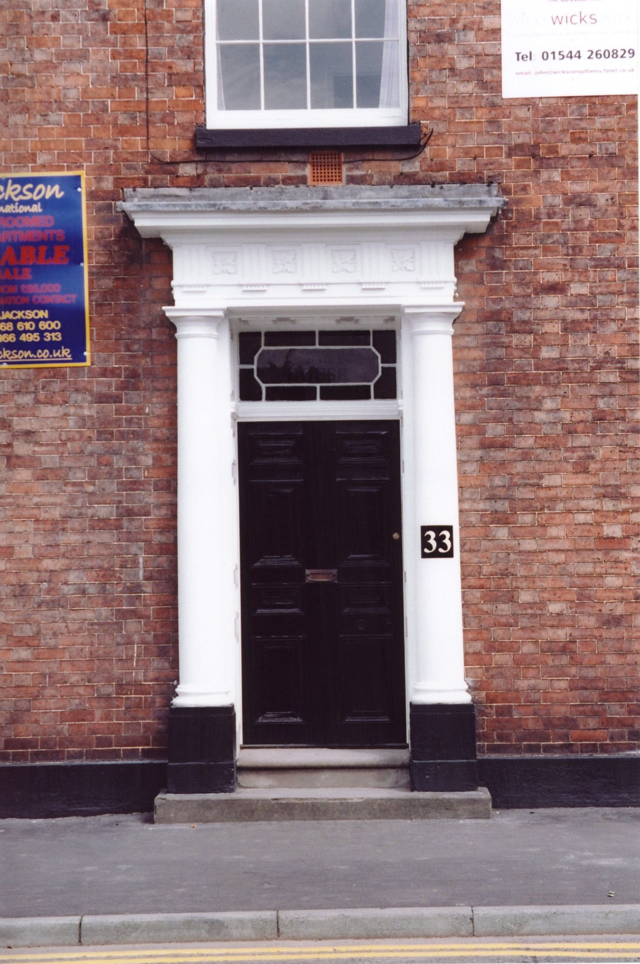

Plate 4: Main entrance located on W-facing elevation

Basement

Entrance to the basement is by means of a stairwell via the ground floor hallway. Positioned within the S, the stairwell is constructed of stone treads and winders built over a half-vault which in turn forms a niche space. Six separate cells are present within the basement. All walls appear to have been initially whitewashed. The openings to each of the rooms would have consisted of a plank-and-batten ledged door with two elongated strap hinges. Examples of two of these doors were present within the basement but were not hung due to their varying states of decay. Flooring within each of the rooms was either uniform stone flags or a composite of stone and strips of cobbling. External openings consisted of two window slits extended onto South Street while a third was located to the rear. This third opening comprised a single stone and brick stairwell leading up into the rear garden plot (Plate 14). Three wooden hatch openings of plank-and-batten type were arranged within the internal wall layout. Measuring c.0.50m x 0.50m, these opened outwards and upwards towards the ceiling and were secured by a metal hook (Plate 5). These appear to be primitive vents allowing the circulation of air for the suspended timber floor of the ground floor and not for increased service accommodation. An internally projecting brick-built coal shute was present within the SE room.

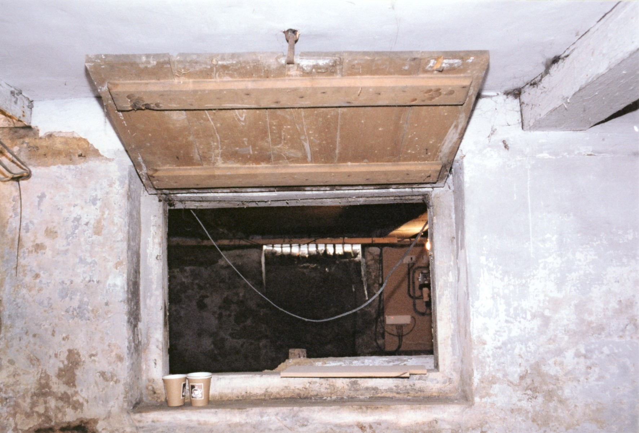

Plate 5: Ventilation shutter/opening within basement

Ground Floor

Four main rooms of equal height are arranged around a quartered plan, the other principal floor, the first, mirroring this arrangement. Originally, each room would have had a separate entrance leading from the hallway. The refurbishment of the property has resulted in the blocking of two of the doorways into the rooms facing onto South Street. Each room as an independent chimneystack positioned at the wall end, although none of the original hearths or surrounds survives. Contemporary window shutters fixed with butterfly hinges complement the large 12-glazed hung-sash windows.

Entering the main hallway, the internal face of the principal doorway opening onto South Street is surrounded by a composite neo-classical squared wooden architrave with regular fluting and circular motifs covering either true mitre. The base of each vertical architrave rests above a rectangular base/stylobate. Other original detailing is found in part of the ceiling cornice and comprises a floral (rinceau) motif.

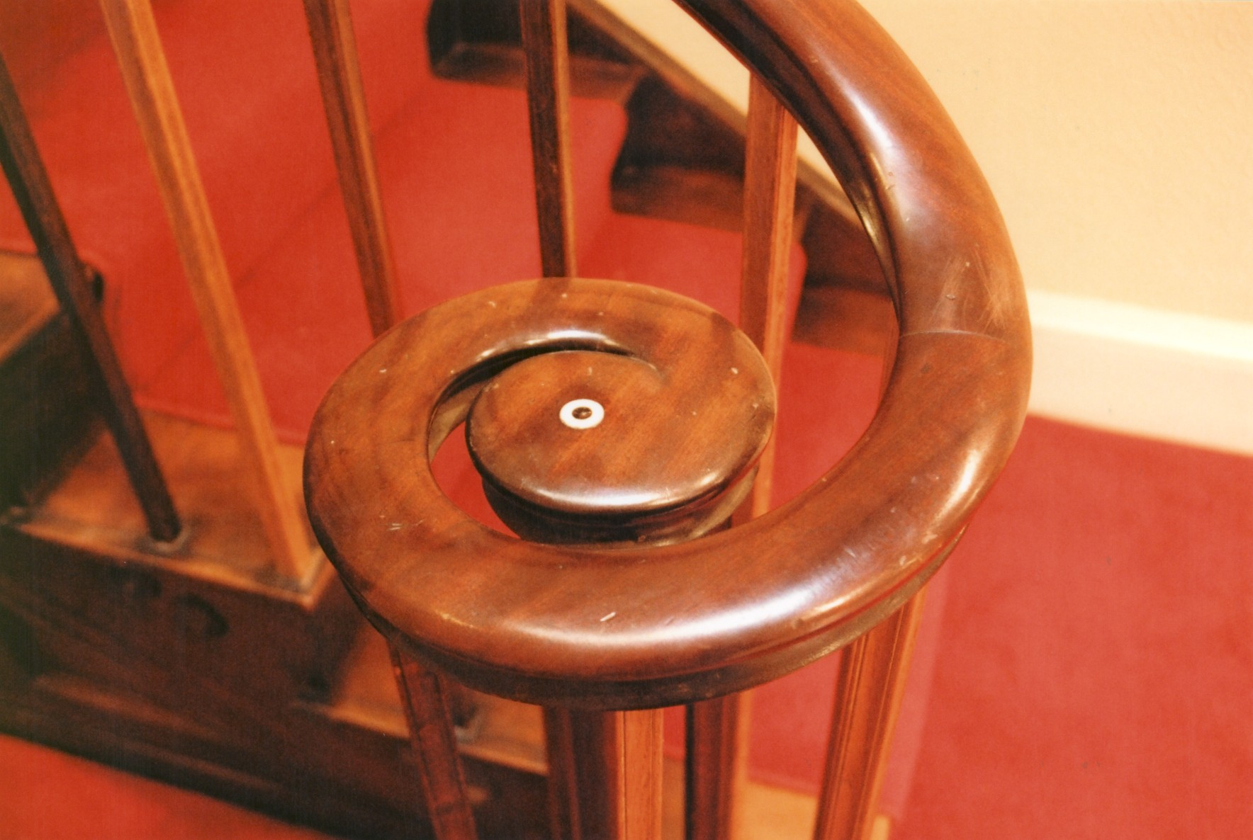

Plate 6: Ornate section of handrail of main stairwell
The hallway has three separate areas, each demarcated by projecting plain plaster pilasters and archways and slight elongated wooden panels with rectangular recessed key pattern ornamentation. The southern part of the hallway has an entrance to the basement and a winding dogleg staircase to the first floor occupying the central position in the design. Constructed of oak, the base tread has an open string with applied brackets built upon it combining a sweeping newel post and baluster, the top of the baluster having a circular ivory inlay (Plates 6 & 11). Each of the open string applied brackets contains a simple ornamental carving of two circular motifs flowing between a plain vitruvian-type scroll.

First Floor

Two separate entrances are presented on the landing, each surrounded by the shouldered architrave shown at the main ground floor entrance. Recent refurbishment and subsequent blocking indicates that an original four-door layout would have led into separate rooms. The independent wall-end chimneystacks present throughout the ground floor appear again in the four-room layout. Any décor and furniture of note within the first floor is located within the NE room and consists of a Regency type hob grate with plain wooden surround (Plate 7). The SE room contains the same type of surround but no grate.

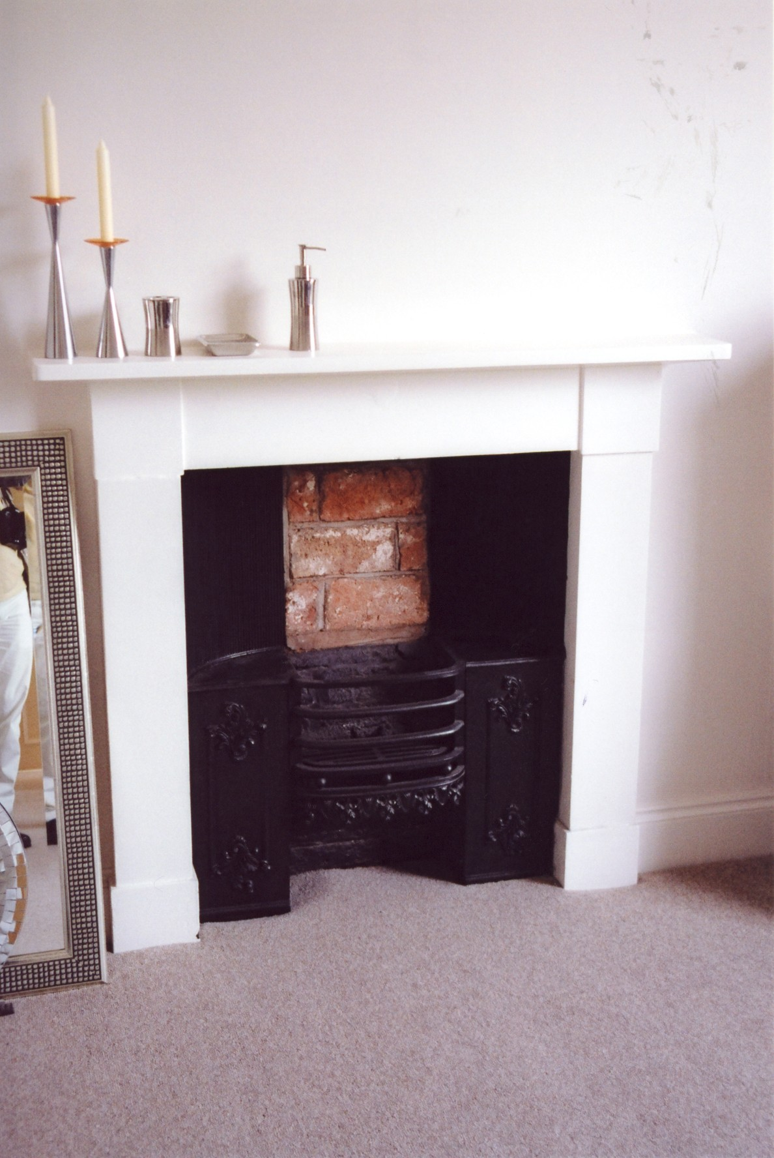

Plate 7: Fireplace surround within NE first floor bedroom

Second Floor

The upper portion of the staircase baluster and handrail terminates at the second-floor landing. The landing and room layout mirrors that of the first floor including those of the latest refurbishment. Modern adaptations have left the whole floor layout devoid of original detailing, with the exception of restored shallow double-hung sash windows.

Loft Space

Entrance to the roof space is by way of a hatch opening in the ceiling of the NW room. A series of regularly spaced roof trusses comprise a tie beam strap-jointed to the king post with principal rafters and angle struts, the principal rafters supporting through-purlins. The upper portion of the king post appears to have been extended to accommodate a ridge purlin.

- Summary

No. 33 South Street has been shown to represent a typically utilitarian domestic building encompassing the Regency style of the first 30 years of the 19th century. The basic plan of the house has been developed from a design first established in Britain during the early part of the 17th century. Such a plan provided a central circulation which connected every room in the house directly with the entry and making every room self-contained, thus greatly raising standards of privacy. The centralized plan also harmonized well with the search for symmetry with the central plan (axial planning) relying on the short axis. Although only a small percentage of internal detailing remained, it was still possible to see this as a form representative of the last phase of Georgian Classicism. The original external detailing shows this in a more visual form in the fenestration: windows are tall and narrow with very thin glazing bars and their surrounds are plain and clean-cut, a design that enhances the simplicity of the facades.

- Plates

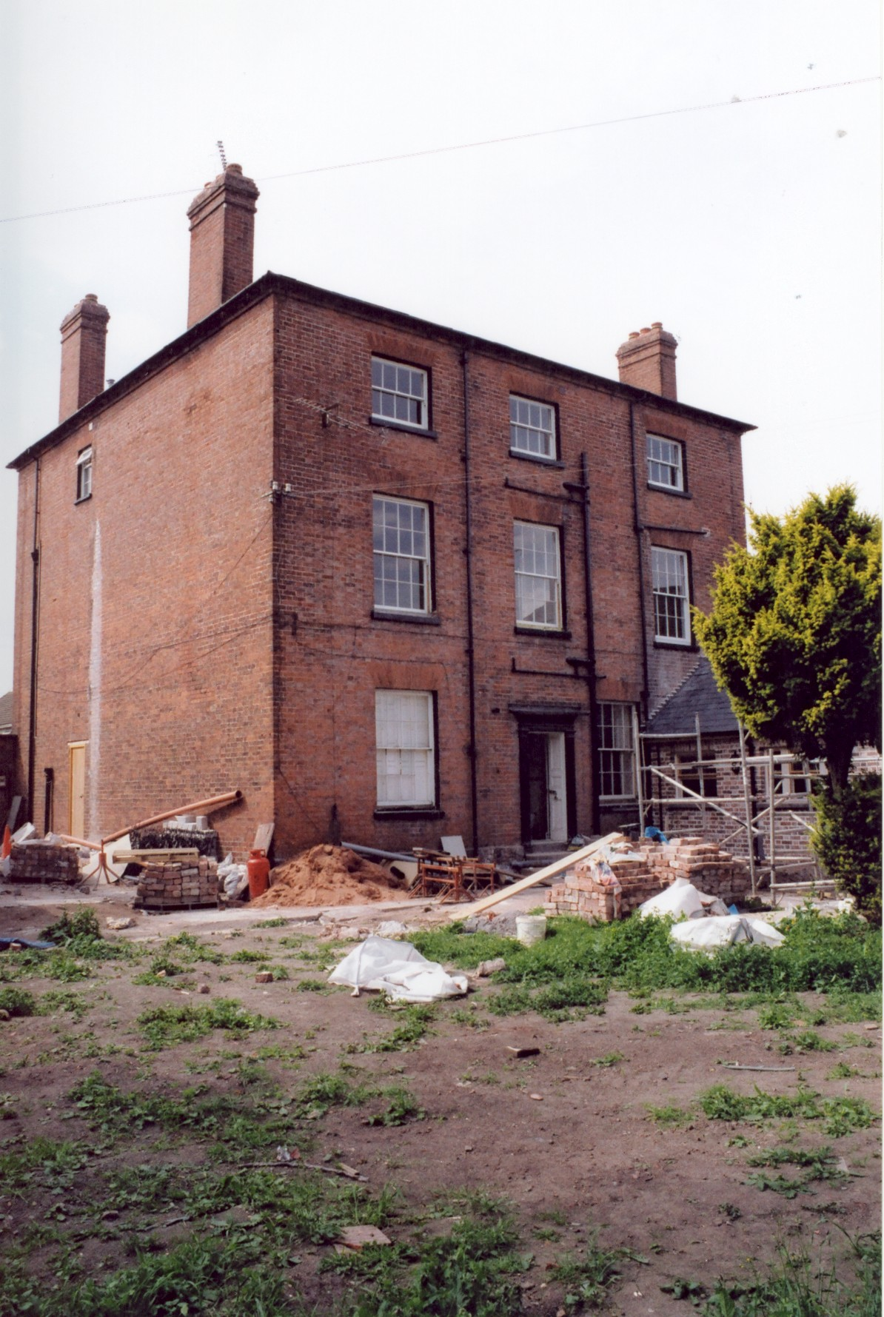

Plate 8: E- & S-facing elevations

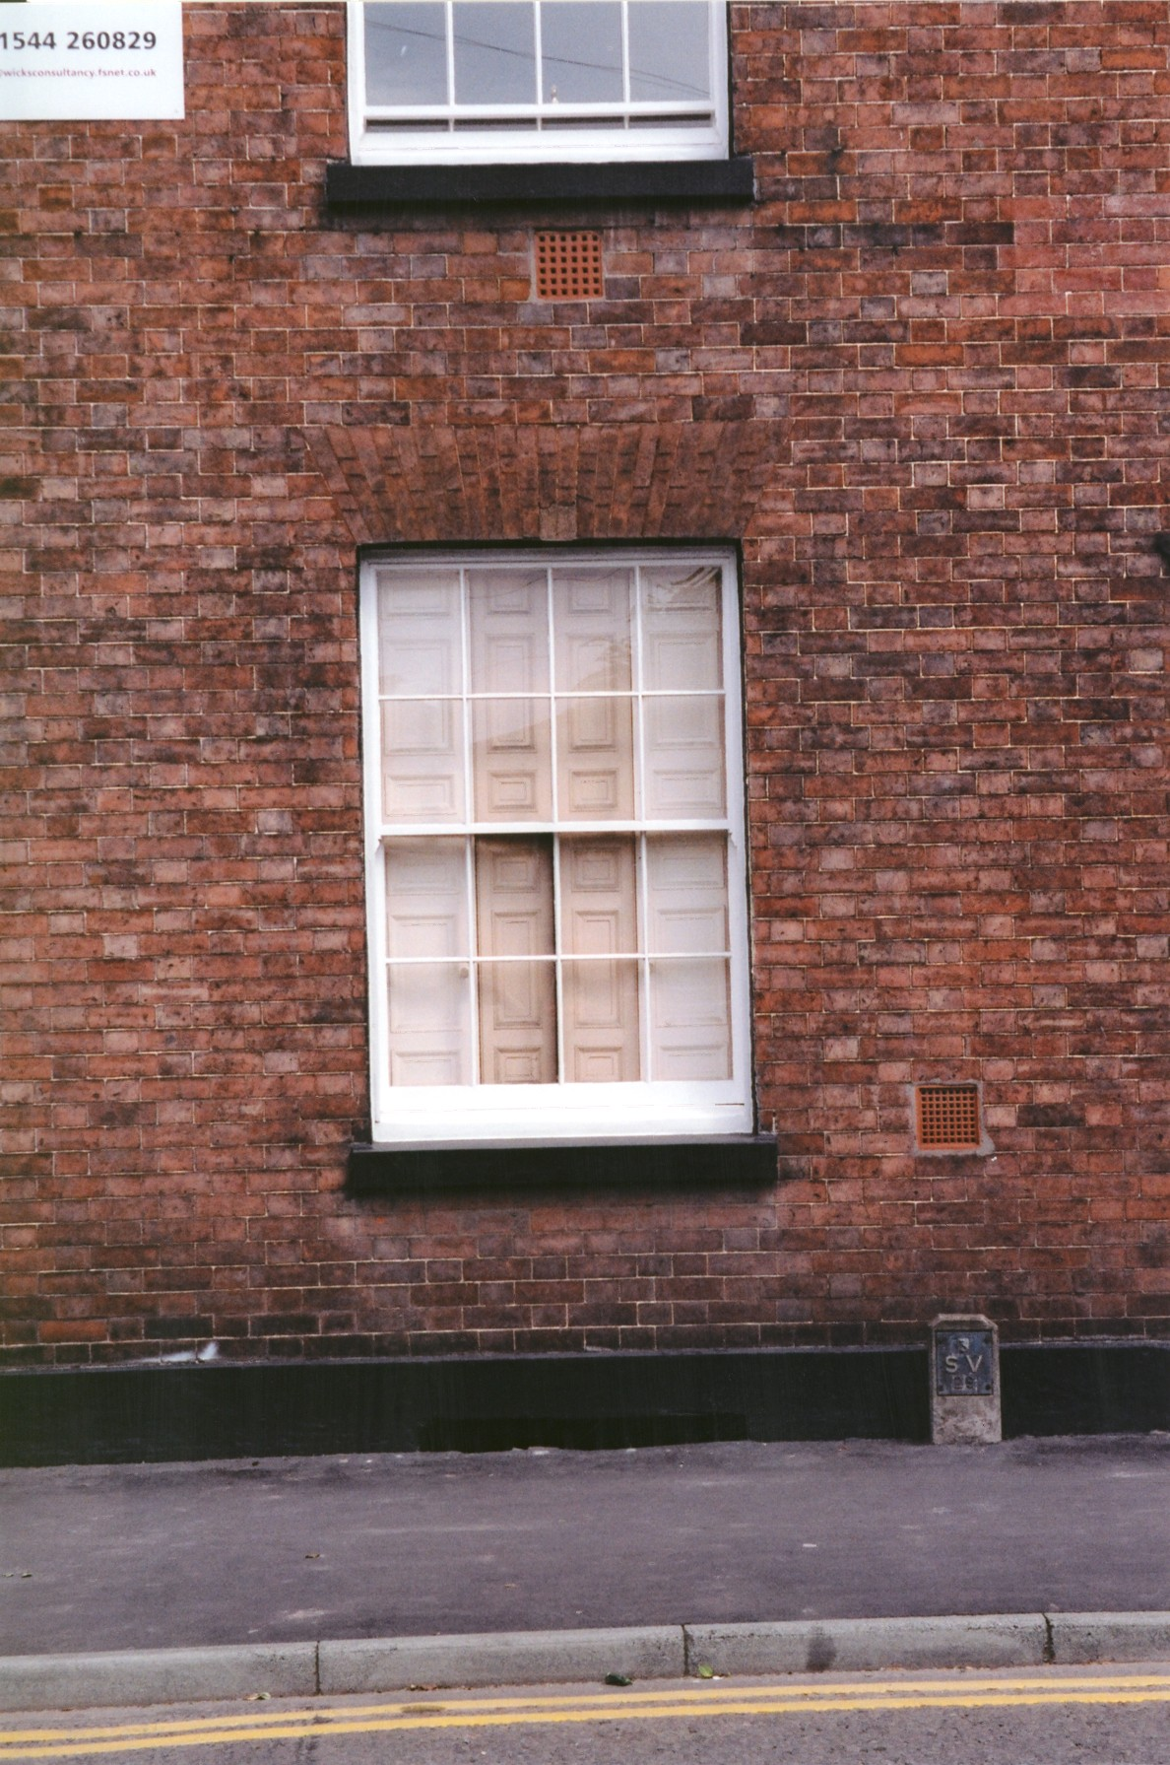

Plate 9: Ground floor window on W-facing elevation
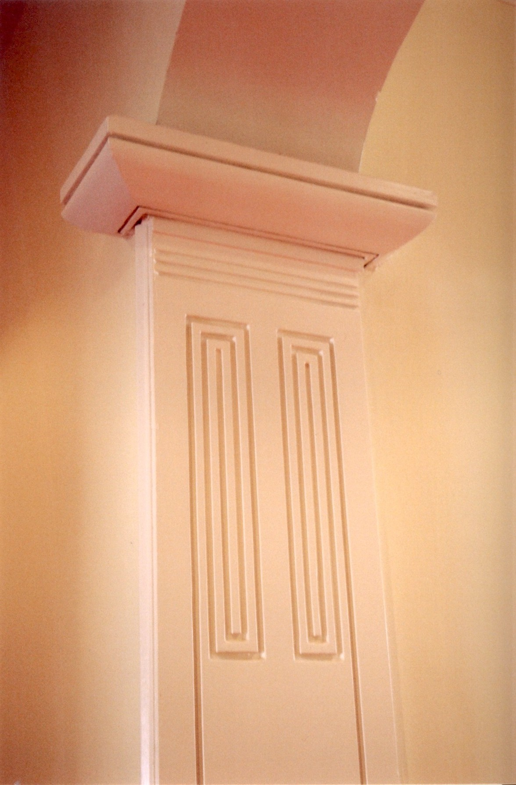

Plate 10: Key patterned pilastered archway within ground floor hall
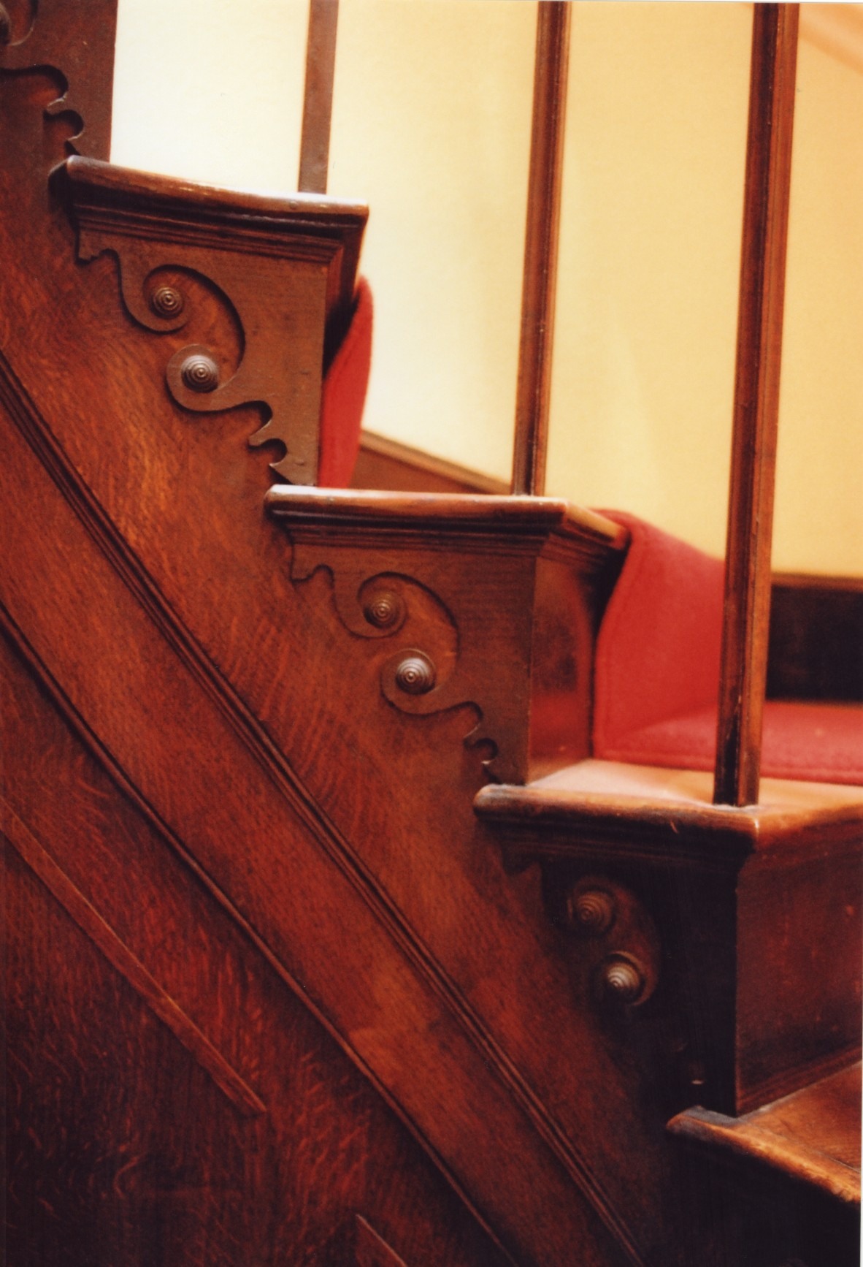

Plate 11: Section of main stairwell indicating base tread and open string
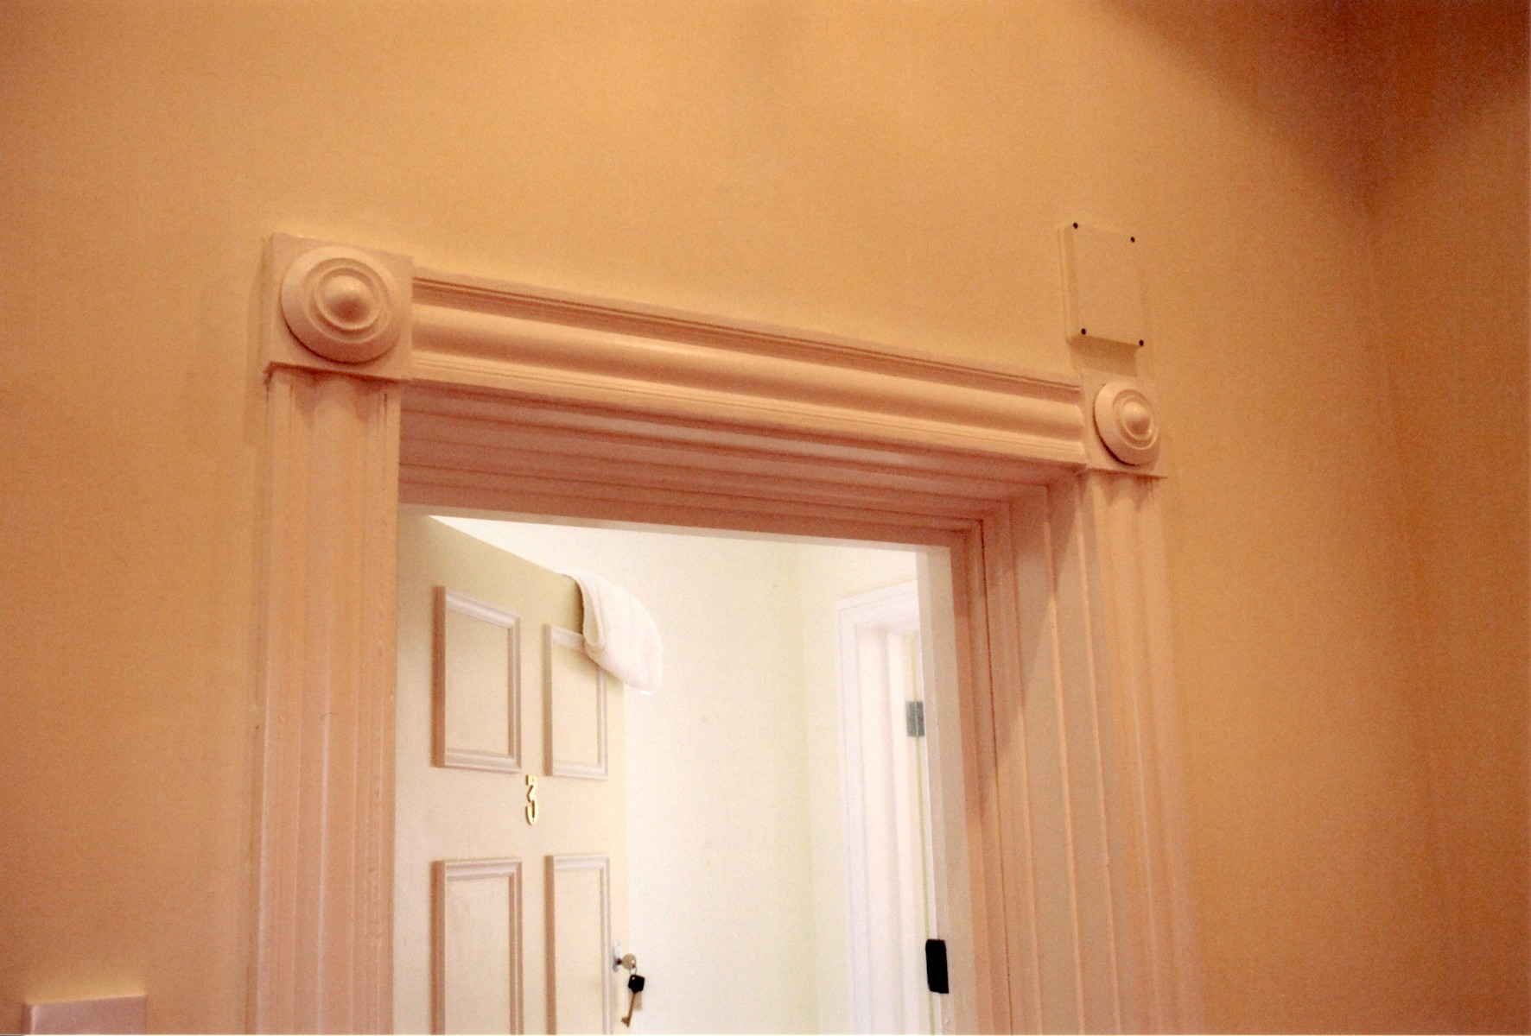

Plate 12: Architrave doorway located on first floor landing

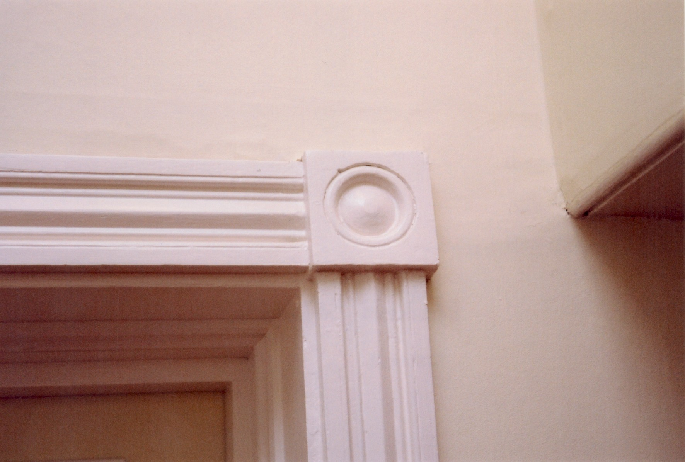

Plate 13: Decorative architrave of doorway located on first floor landing
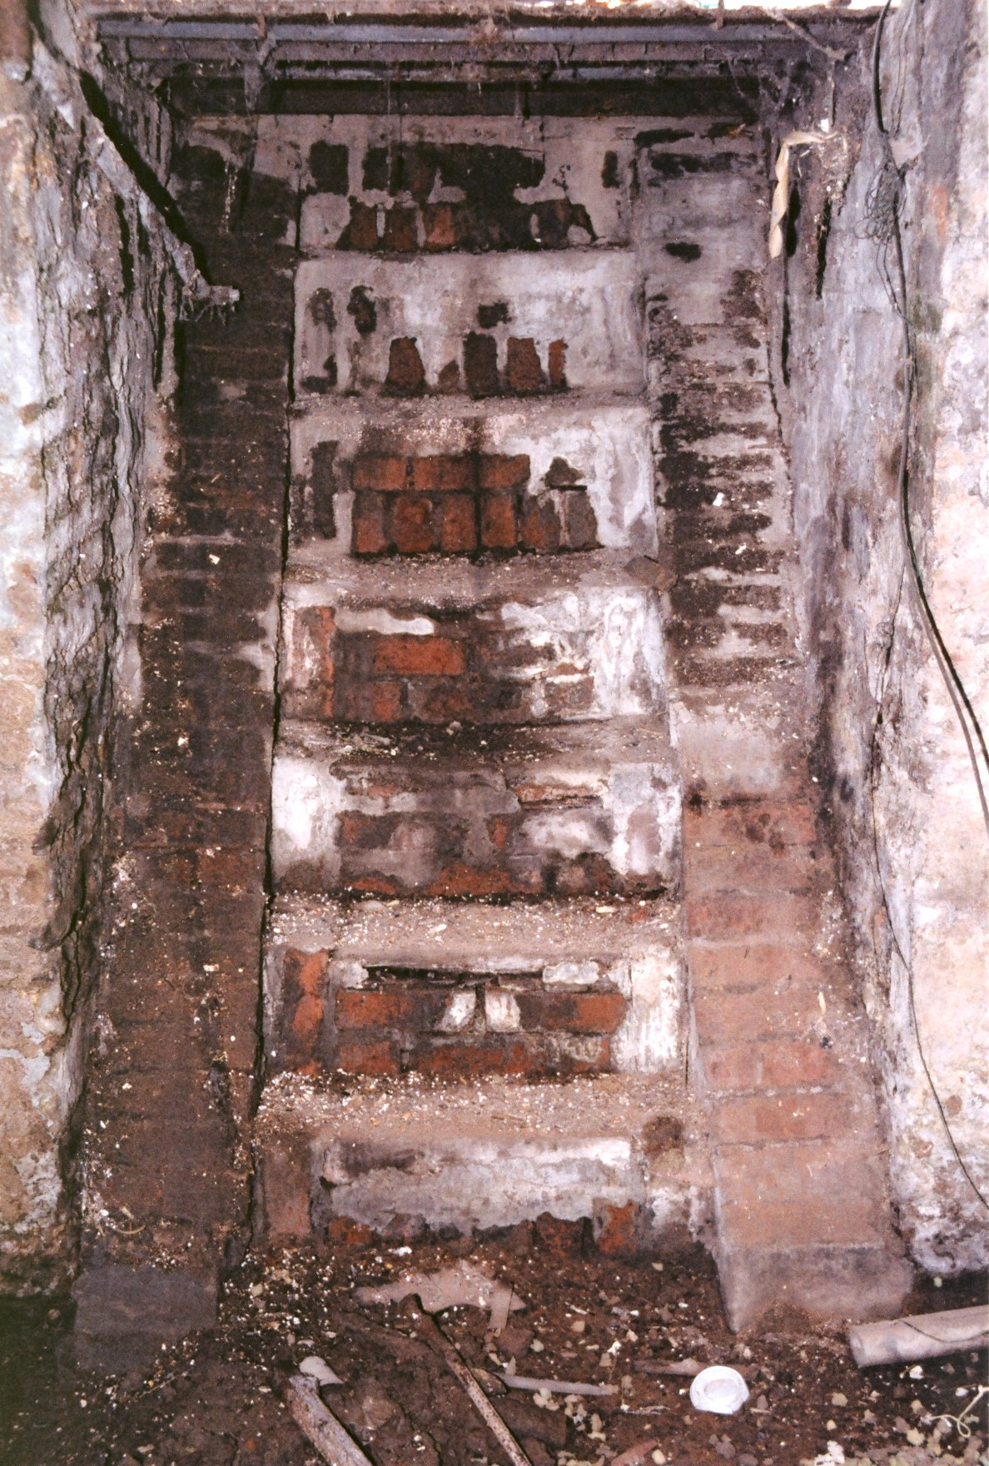

Plate 14: Steps of eastern basement entrance
- Archaeological Observation

A series of three foundation/service trenches were excavated to the E and S of No. 33. Included alongside these trenches were a series of subsidiary pits and extensions. The eastern area was formerly used as gardens while the southern area is currently a driveway.

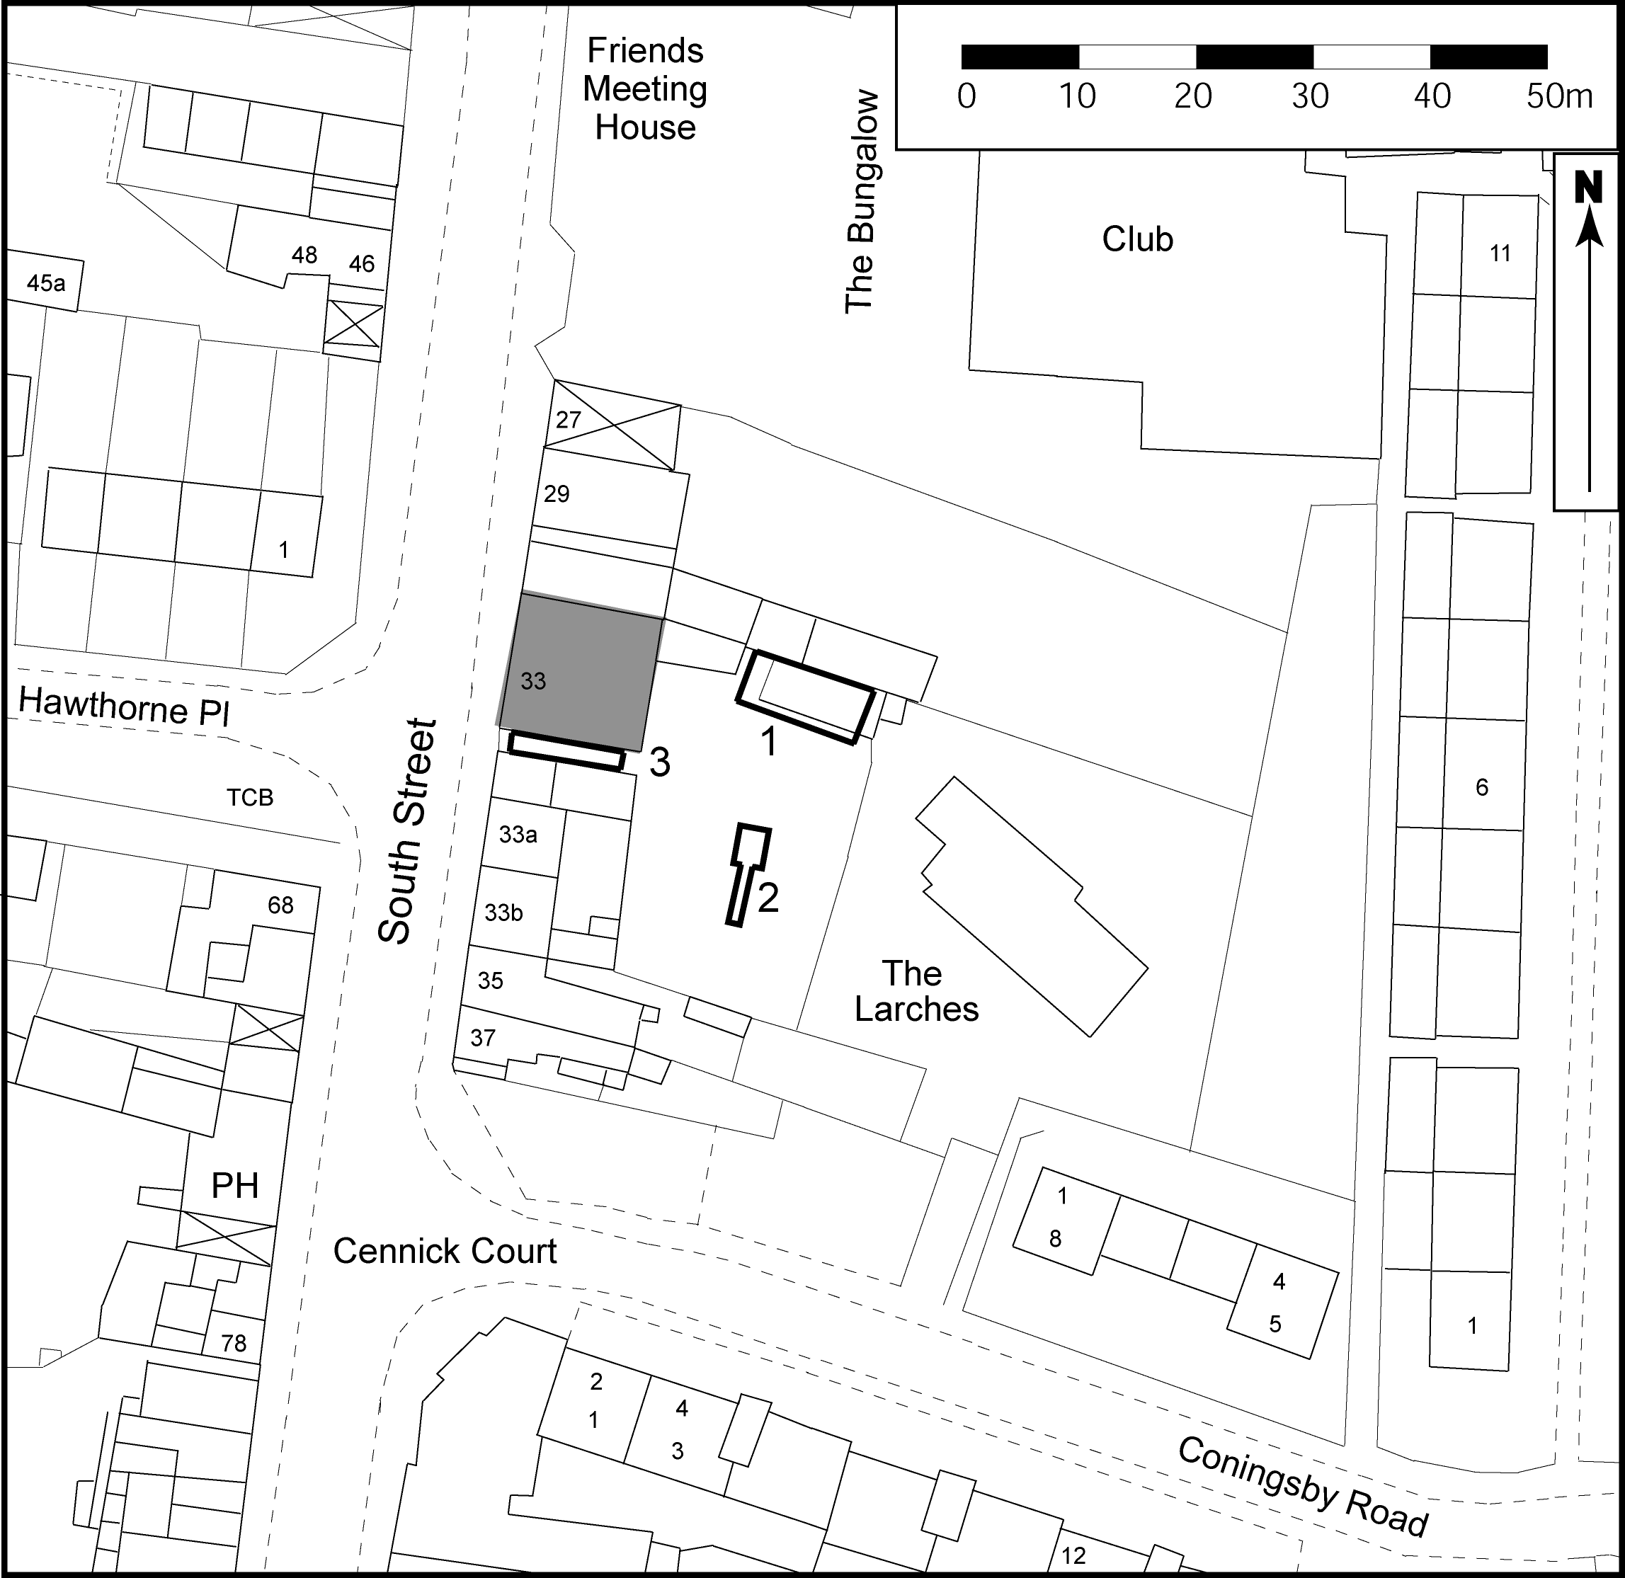

Fig. 1: Site and trench location plan

Trench 1

Trench 1 was excavated within the northeastern area of land to the rear of No 33 South Street. Forming a rectangular foundation trench, it measured (a total of) c.22.00m x c.1.10m x 0.40m (Fig. 1). Exposed within the base and sides of the trench was a uniform deposit consisting of dark brown clayey coarse sands containing charcoal flecking and disarticulated animal bone fragments. A single body sherd of 19th century Staffordshire slipware was also excavated.

Four service/foundation pits were also excavated within the internal area of foundation trench 1. Each of these varied in measurement, ranging from 0.75m x 1.20m x c.0.50m to 0.70m x 4.00m x c.0.50m. Excavation revealed a uniform soil comparable with that found within Trench 1. No inclusions were observed within the composition of this soil.

Trench 2

Located within the central garden area, Trench 2 was oriented N-S and measured 2.80m (N-S) x 1.50m (E-W) x 2.80m. Two soil types were observed, the uppermost extending across all four sections of the trench and measuring 1.32m from the existing ground surface. This consisted of garden soils containing frequent amounts of charcoal staining. Directly below this deposit, extending across all the sections and forming the base of the trench was a series of pinkish-red naturally forming clayey sands representing depositional activity of riverine or glacial origin.

A subsidiary trench was excavated from the N-facing section of Trench 2, extending in a southerly direction and measuring 5.00m x c.0.35m x c.0.50m. The upper soil deposit found within Trench 2 was observed in the sections and sides of this subsidiary trench. This was interpreted as the same type found within the upper soil profile within Trench 2 and showed a uniform continuation of soil across this area of the gardens.

Trench 3 (Plates 15 & 16)

Positioned within the area of the existing driveway, Trench 3 formed a rectangular cut measuring (a total of) c.15.00m x c.0.50m x 2.10-2.20m (Fig. 1). Two soil types were encountered, the upper measuring c.0.90m from the existing ground surface and consisting of irregularly deposited clayey sands containing large amounts of 19th and 20th century ceramic building material. The inclusion of frequent amounts of this type of material interspersed with the clays and sands probably represents the continued insertion of services to No. 33. Two body sherds of 19th century Staffordshire type pottery were also recovered.

Below this deposit and forming the base of the trench were large lenses of naturally occurring gravels combined with clayey sands. The termination of both ends of the N-S trench sections revealed the S-facing foundations to No.33. Below the exposed gauged brickwork was a section of foundation brick material that probably formed a continuous circuit to the whole of the property. Measuring 0.50m in height, the brick appeared to be irregularly bonded, standing in places up to nine courses high. Each brick measured c.0.16m x 0.06m, the foundation coursing probably indicating the use of locally sourced brick from a demolished structure of provisional early post-medieval date.

Underlying this foundation and extending for 1.6m to the base of the trench was the roughly bonded outer face of the cellar of No.33. No apparent construction cut was observed for the insertion of the cellar within the recently exposed soil types. This lack of construction cut represents the foundation build of a trench built type, the primary structure of No.33 being excavated into the immediate soil types with courses built up against the exposed soils. This would also account for the irregular finish of the external side of the cellar wall.

Summary

Trenches 1 & 2, together with subsidiary pits and extensions, revealed, respectively, dark brown clayey coarse sands containing charcoal flecking and fragments of disarticulated animal bone; and garden soils with extensive charcoal staining. Trench 3, located within the area of the existing driveway, revealed the S-facing foundations of No.33 and the roughly bonded outer face of the cellar. The foundation coursing probably indicated the use of locally sourced brick from a demolished structure of early post-medieval date.

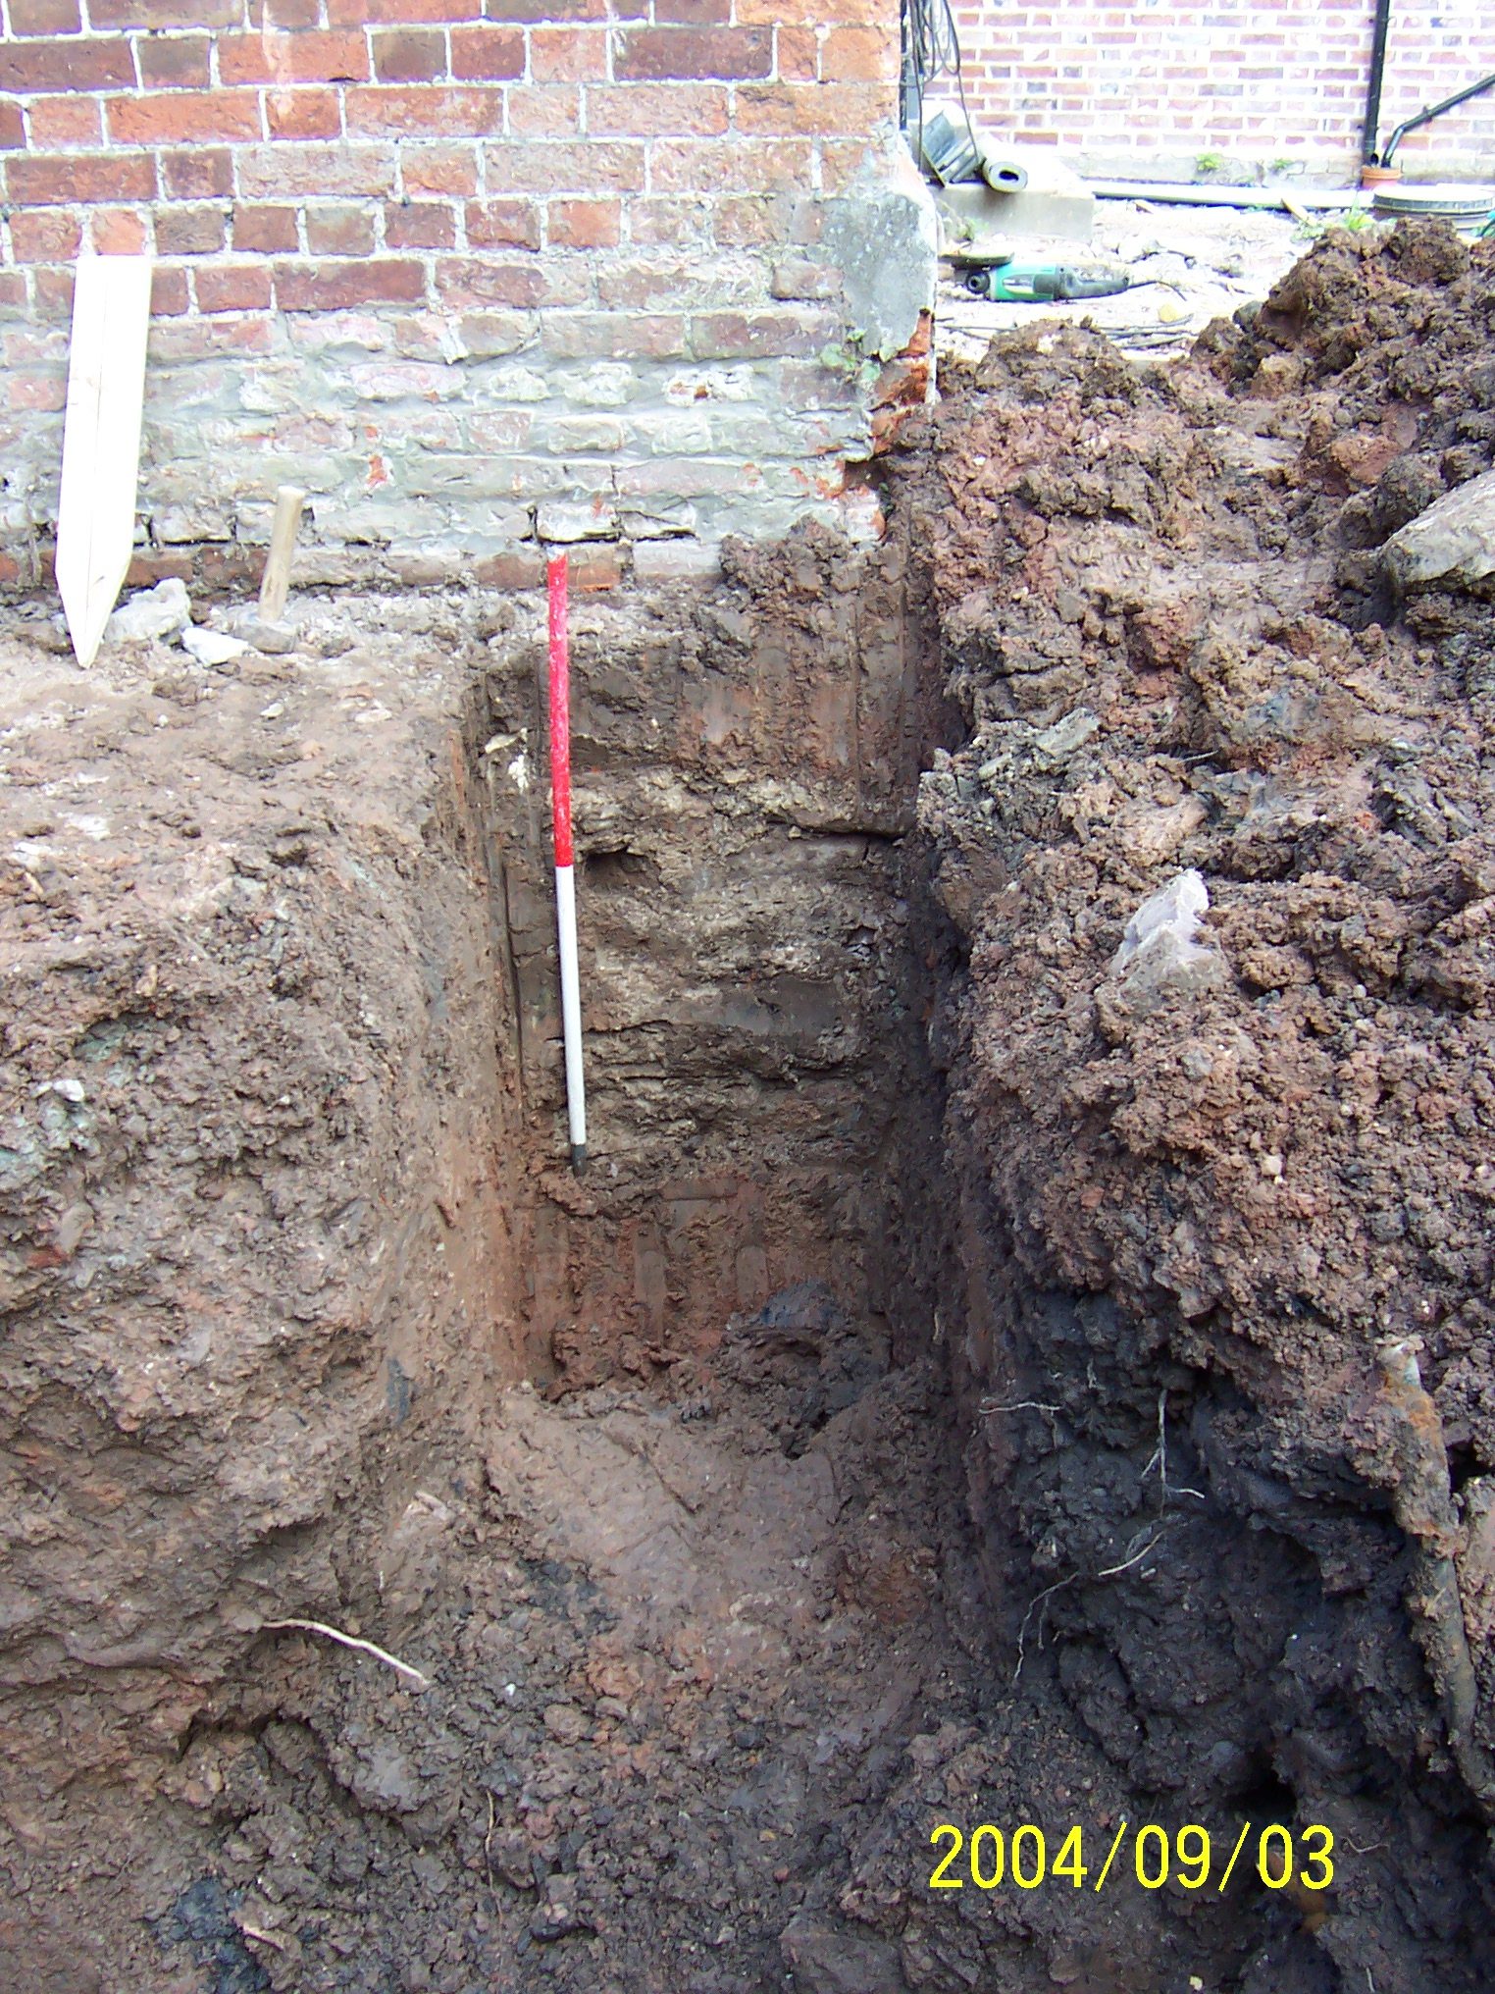

Plate 15: S-facing section of Trench 3 indicating foundation base incorporating cellar wall

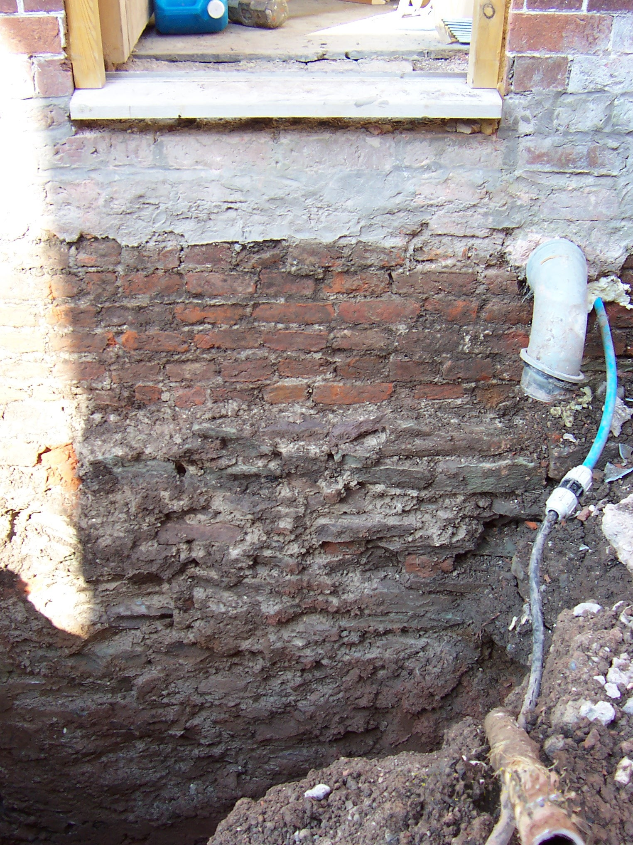

Plate 16: Trench 3, S-facing irregularly bonded base for gauged brickwork above cellar foundation

