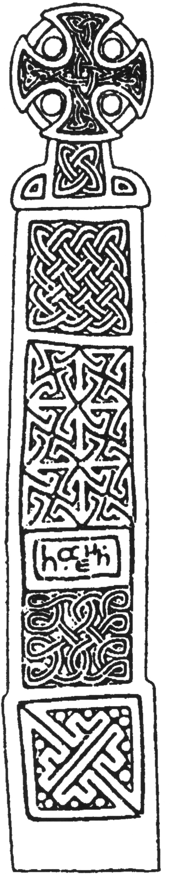
ARCHAEOLOGICAL OBSERVATION

Church House Barn
Richard’s Castle
Herefordshire

NGR: SO 48420 70350

SMR No: 45158

BORDER ARCHAEOLOGY

PO Box 36
Leominster
Herefordshire
HR6 0YQ
E-mail: enquiries@borderarchaeology.com

Technical Services
Chapel Walk

Burgess Street
Leominster
Herefordshire
HR6 8DE
Tel: 01568 610101
Tel/fax: 01568 616900
E-mail: borderarch@btconnect.com

BORDER ARCHAEOLOGY
Head Office

PO Box 36
Leominster
Herefordshire
HR6 OYQ

Technical Services
Chapel Walk
Burgess Street
Leominster
Herefordshire
HR6 8DE

May 2004

NGR:
Report No.
BA0701CSCHB December 2007
CONTENTS
1. Non Technical Summary 3
2. Introduction 4
2.1 Soils & Geology 4
3. Historical & Archaeological Background 4
4. Methodology 9
5. Results 9
5.1 Ground level reduction phase 9
5.2 Trenching excavations 13
6. Interpretation of Findings 16
7. Conclusion 16
8. Copyright 16
9. Bibliography & Cartography 17
9.1 Bibliography 17
9.2 Cartography 17
APPENDIX 1: Context Register 18
APPENDIX 2: Site Matrix 20

Report specification:
Report compilation: Will Logan BA
Artwork: Michelle Bithell BA
Report editing: George Children MA
Approved: Neil Shurety
- Non Technical Summary

Church House Barn is located to the NE of the large motte and bailey fortification known as Richard’s Castle. The archaeological observation identified the possible remains of part of an extensive outer enclosure established to the E of the castle, into which the barn’s outer walls had been cut. The enclosure post-dated the foundation of the castle and was probably established to protect the parish church and a small settlement established under the protection of the castle. No other finds or features were located.

Limited evidence relating to the phasing of the barn was also revealed, comprising three beams or posts that appeared to have formed part of an earlier partitioning arrangement.

- Introduction

Border Archaeology was instructed by Mr & Mrs C. Smith to undertake an archaeological programme of work at Church House Barn, Richard’s Castle, Herefordshire, in pursuance of a brief issued by Julian Cotton of Herefordshire Archaeology (Planning ref: DCNW2006/0812/F). This programme of work included a standing building recording carried out to RCHME Level 2/3, which is the subject of a previous report submitted in January 2007, and archaeological observation of the principal groundworks.

Copies of this report will be submitted to Mr & Mrs Smith, Herefordshire Archaeology and the county Sites and Monuments Record.

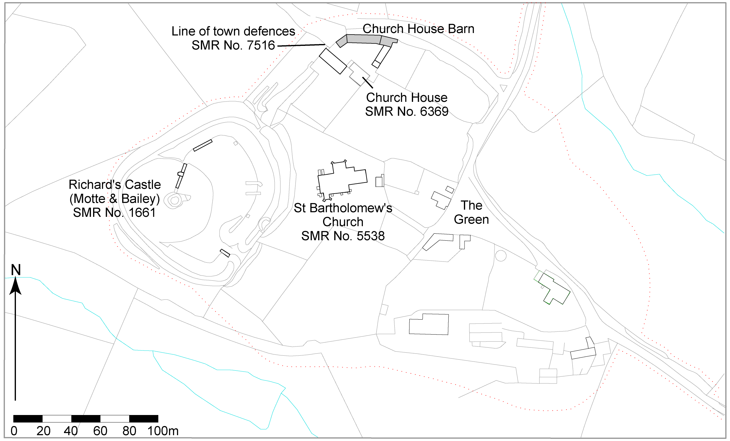

Fig. 1: Site location plan

Soils & Geology
The area is characterised by typical brown earths of the MUNSLOW (541i) series, consisting of well-drained coarse silty soils over siltstone with occasional fine silty and coarse loamy soils. The underlying geology of the area comprises Silurian siltstone (SSEW, 1983).

- Historical & Archaeological Background

Church House Barn forms part of a range of outbuildings attached to Church House, a Grade II* Listed timber-framed farmhouse of late 16th-early 17th century date, and occupies a curvilinear, slightly undulating site on the edge of a steep counterscarp which appears to represent part of the defensive line of an extensive outer enclosure established to the E of the large motte and bailey fortification known as Richard’s Castle.

The castle (SMR Ref. 1661) is believed to have been have been founded in about 1050 by Richard fitz Scrob, one of several Norman lords who were granted estates in the Marches by Edward the Confessor. It is first recorded as the castle of ‘Auretone’ in the Domesday Survey of 1086, a name possibly derived from the nearby hamlet of Overton, and was then held by Osbern fitz Richard and valued at 20s (Thorn & Thorn, 1983, 186d).

The extant remains of the castle (Fig. 2) comprise the substantial earthworks of the motte and bailey castle, an octagonal shell keep standing atop the motte and the remains of a gatehouse, curtain wall and mural towers dating from the 12th-13th centuries. Archaeological evidence suggests that the large outer enclosure to the E, which was evidently designed to protect the parish church (the earliest fabric dating from the 12th century) and a small settlement established under the protection of the castle, post-dated the foundation of the castle and was probably associated with the establishment of a planned urban settlement or borough at Richard’s Castle in the late 12th or 13th centuries (Curnow & Thompson, 1969).

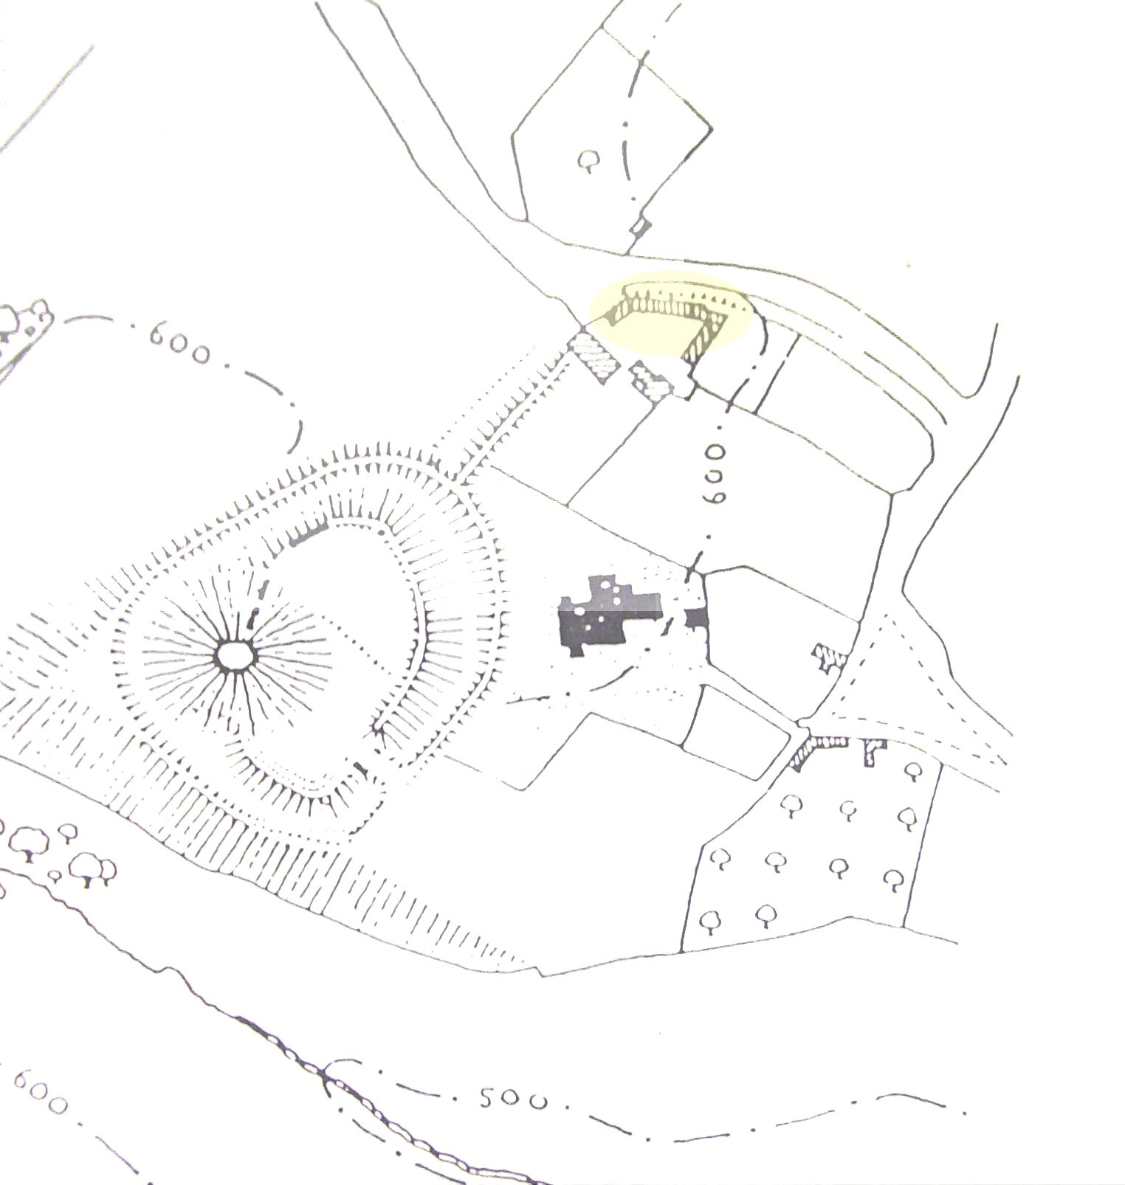

Fig. 2: Extract from RCHME plan of Richard’s Castle (1934) showing barn range to N of Church House, on the N edge of outer settlement enclosure to the E of the castle

Documentary evidence indicates that the settlement adjacent to the castle had developed into a borough by the end of the 13th century. Robert de Mortimer obtained a grant of a fair and a weekly market at Richard’s Castle in 1216 and 103 burgages are recorded there in 1304, clearly implying that the settlement had achieved urban status by the early 14th century.

The subsequent history of the borough of Richard’s Castle is poorly documented but it appears to have declined rapidly during the late medieval period, contemporaneous with the abandonment and gradual dilapidation of the nearby castle. The Tudor antiquarian John Leland, writing in about 1535-40, makes no mention of an urban settlement at Richard’s Castle, suggesting that it had ceased to be regarded as a borough by that date and that the focus of settlement shifted away from the castle during the early post-medieval period (Curnow & Thompson, 1969, 107). The existing pattern of settlement, consisting of a small grouping of farmhouses and cottages to the E and SE of the castle site, appears to have been established by the first half of the 17th century.

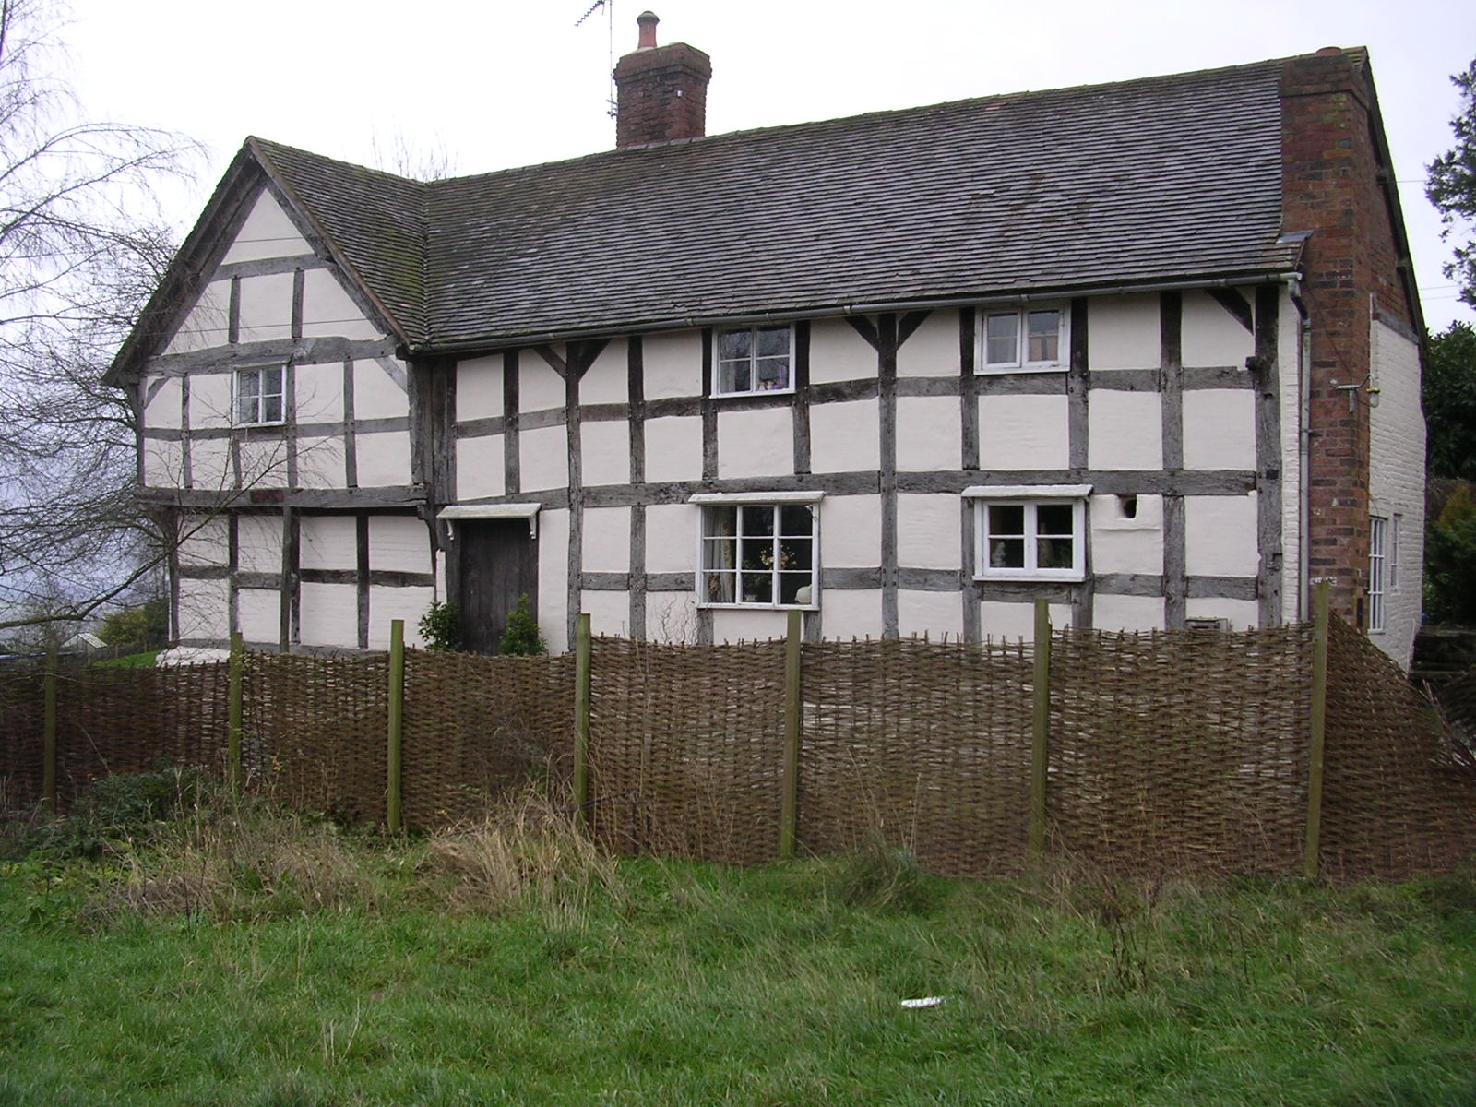

Plate 1: View looking S showing Church House, a late 16th-early 17th century timber-framed farmhouse

Church House (SMR Ref. 6369), situated to the N of the parish church, is a timber-framed, L-plan farmhouse of late 16th-early 17th century date, extended in the late 17th century with some mid 20th century alterations (Plate 1). This house is reputed to have been the former Rectory but there is no documentary evidence to support this assertion. An early 17th century terrier or survey of the glebe of Richard’s Castle makes no mention of Church House, suggesting that if it had once formed part of the glebe (as suggested by its proximity to the parish church), this had ceased to be the case by about 1600.

The earliest documented reference to Church House occurs in the inquisition post mortem of Francis Fox Esq. of Bromfield, dated 17 July 1638, which mentions ‘two messuages in Richard’s Castle called Church House and Church lands’, which appear to have been purchased previously by Richard Fox, the deceased brother of Francis (SRO Ref. 20/14/38).

Church House was in the possession of Matthew Herbert of Oakly Park in 1656 but its subsequent history is unclear until the late 18th century, when it was in the possession of the Syer family of Ludlow. A record of a Land Tax Assessment for Richard’s Castle dated 1783 records it as being owned by one Mrs Syer or Syas and occupied by a tenant named Thomas Howells. The Land Tax Assessments for Richard’s Castle record that Mrs Syer (also referred to as Widow Syer) remained as owner of Church House until 1817, and from 1818-30 John Syer is listed as the owner.

From 1791 to 1810 the house was leased to a tenant farmer named Charles Mapp, whose wife, Mary Mapp, assumed the tenancy after his death and continued in occupation until 1830. The tithe apportionment for Richard’s Castle dated 1839 (HRO Ref. HD L 82) records that Church House, described as a ‘house fold and outbuildings’ was then owned by John Syer Esq. and occupied by Charles Mapp. The property continued to be leased to a series of tenant farmers throughout the 19th and early 20th centuries.

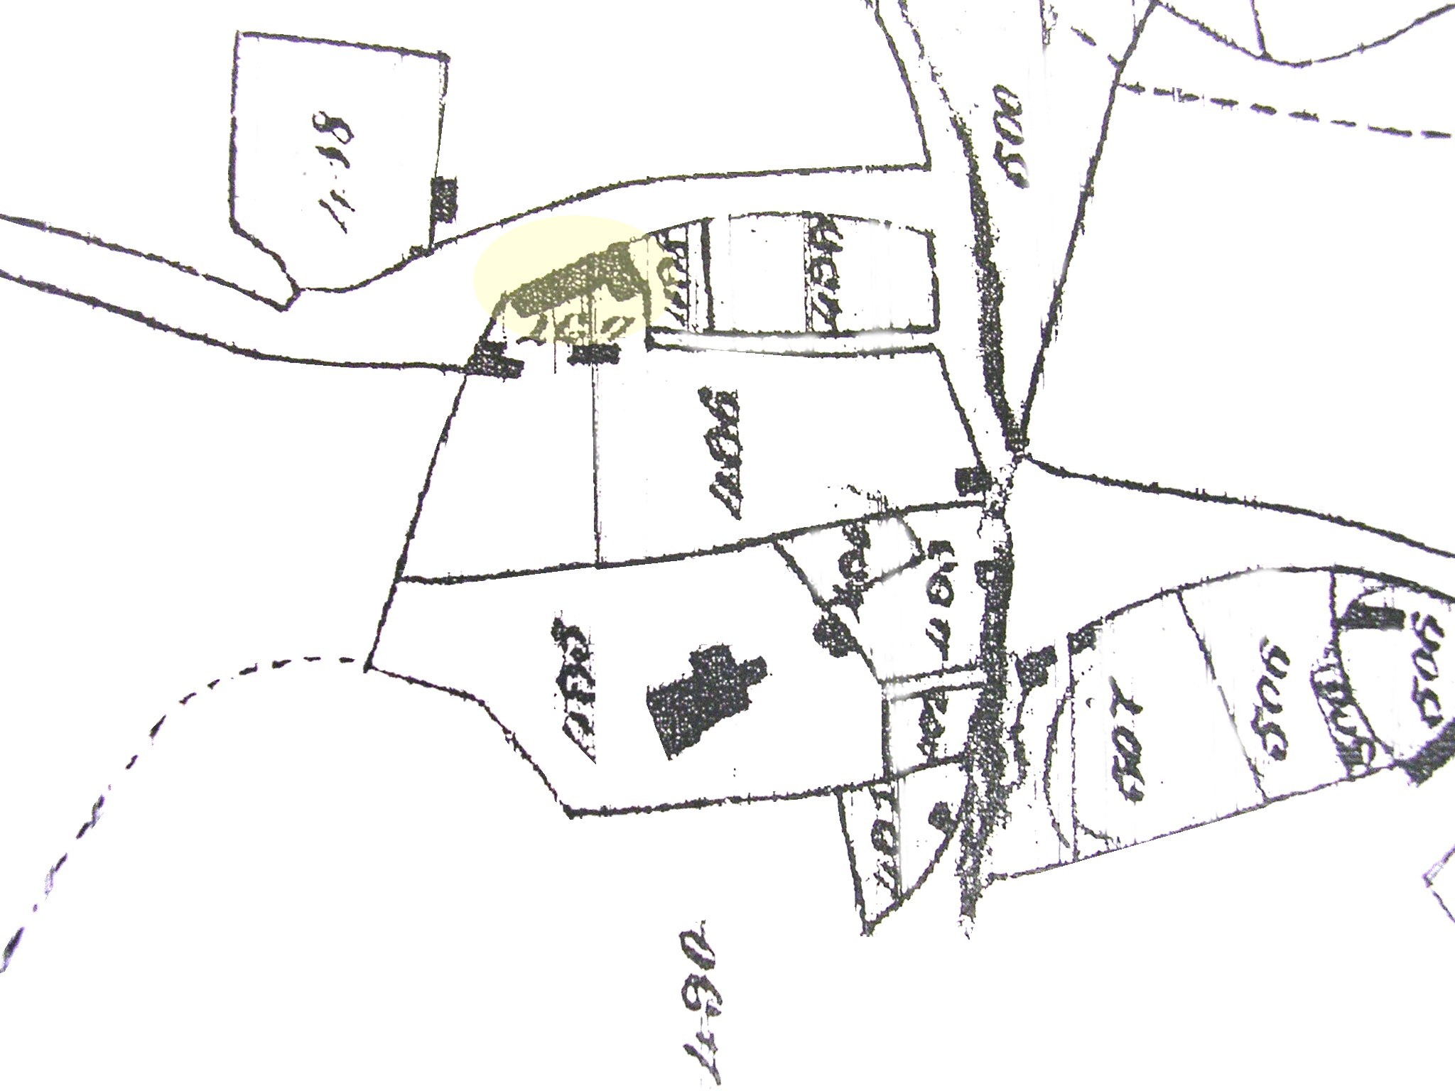

Fig. 3: Extract from tithe map of Richard’s Castle (1839) showing barn to N of Church House
(Reproduced by courtesy of Herefordshire Record Office)

The 1839 tithe map for Richard’s Castle (Fig. 3) provides the earliest accurate cartographic evidence for the barn at Church House and reveals that its layout differed in several important respects from the present structure. The barn is shown as a rectangular structure aligned roughly E-W, respecting the line of the counterscarp overlooking the lane. This structure appears to correspond with the central, timber framed portion of the existing barn, indicating that it was originally constructed before 1839 (and probably well before that date). At the E end of the barn, the tithe map shows a rectangular block projecting S at right angles to the main structure, which does not correspond in any respect to the present building.

Comparison between the 1839 tithe map and the OS 1st edition 6 inch map of 1890 (Herefordshire 7 NE) reveals that the structure of the barn changed significantly between these two dates (Fig. 4). The projecting block at the E end of the barn depicted on the tithe map had disappeared by 1890. The 1890 map also shows that an extension had been constructed to the SW of the barn which appears to correspond with the existing three bay extension, of stone and timber framed construction and that the E end of the barn had also been extended. It would appear then that the layout of the present barn had been essentially established between 1839 and 1890.

The OS 2nd edition 25 inch map of 1903 (Fig. 5) reveals that further alterations were made to the barn between 1890 and 1903. These additions comprised the construction of an oblong range projecting SW from the E end of the barn and the addition of a small shed-like structure at the E end of the barn, which corresponds with the existing brick outhouse. The oblong range projecting from the E end of the barn is shown on an RCHME plan of Richard’s Castle dated 1934 and on OS maps of the site up to 1996. It was largely demolished shortly after 1996, although the footprint of the building is still traceable on the ground and a freestanding, brick-built shed to the SW of the barn appears to represent the vestiges of this structure.

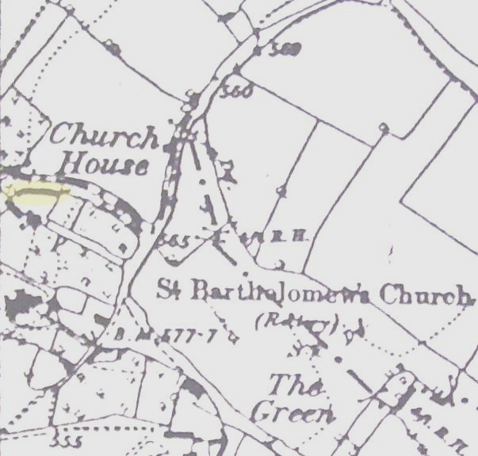

Fig. 4: Extract from OS 1st edition 6 inch map of 1890 (Herefordshire 7 NE)
(Reproduced by courtesy of Herefordshire Record Office)

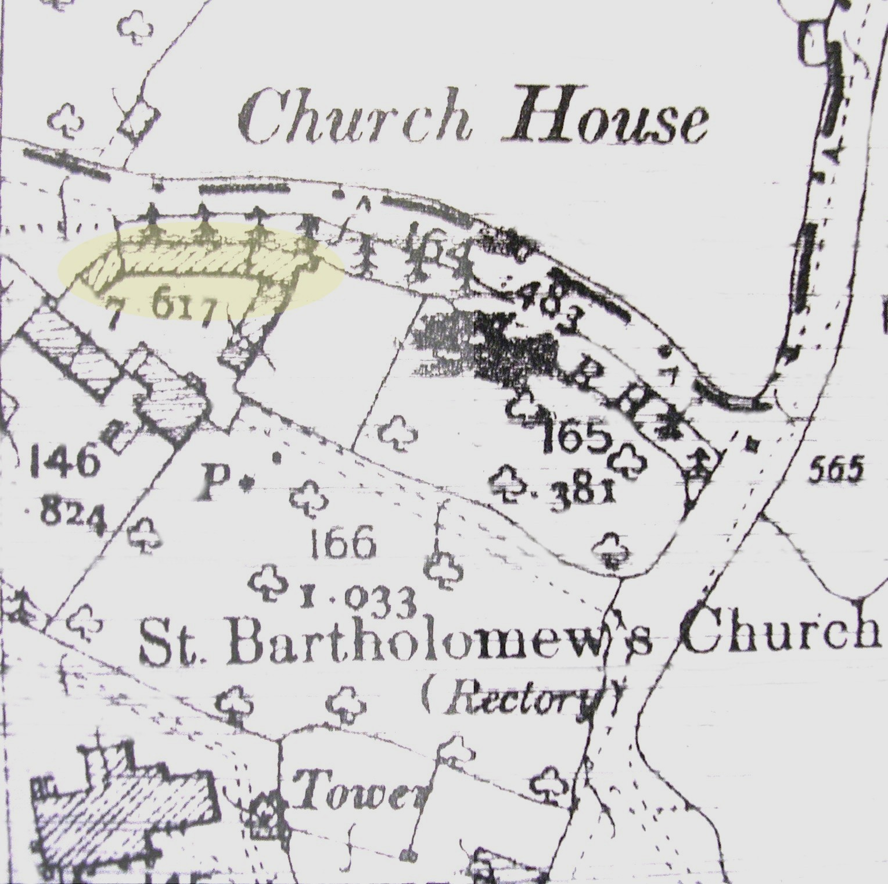

Fig. 5: Extract from OS 2nd edition 25 inch map of 1903 (Herefordshire 7.3)
(Reproduced by courtesy of Herefordshire Record Office)
- Methodology

Full written, drawn and photographic records were made in accordance with archaeological practices set out by the Institute of Field Archaeologists (1994; revised 2001). Archaeological deposits, features and structures were recorded in plan at a scale of 1:20 and in section or elevation at 1:10, as appropriate. All features and structures were photographed using digital and 35mm colour print formats.

A detailed stratigraphic record was made using a sequential context numbering system starting from (101) and a Harris matrix was produced for the site (Appendix 2).

A temporary benchmark of 177.61m OD was derived from an OS benchmark located on St Bartholomew’s Church and from this all site levels were taken.

Machine excavation was carried out using a toothless bucket.

- Results

The results relate to internal ground level reduction and to the excavation of foundation trenching. The internal divisions previously identified during the course of the standing building recording were used here to divide the barn into subsections. Each foundation trench has been assigned a number to assist recording.

Ground level reduction phase

The ground level within Areas B, C, D, E and F of the barn (Fig. 6) were reduced by 0.4-0.5m and several of the barn’s internal partitions were removed and adjustment.

Area B
After the removal of a layer of compacted hay, animal manure and silt (001), a cobbled surface (003) covering the western end of the area was revealed. This surface inclined slightly to the S, presumably to aid drainage of animal waste. The cobbles were set into a firm light brown silt clay with moderate to frequent small, medium and large angular sandstone fragments (004). Cutting into (004) in the centre of the area were the remains of a wooden post or stake (023) / [019] that had been driven into the ground.

Area C
Underlying context (001) was context (004), cutting into which, beneath the partition adjoining Area B, was a post (024)/[020] that formed part of the partition support.

Area D
Underlying a thin deposit of (001) was a brick floor surface (005) orientated N-S with a 0.6m wide drainage channel positioned roughly centrally within the area. Underlying (005) was context (004). Driven into (004) was a degraded oak post or stake (025) / [021].

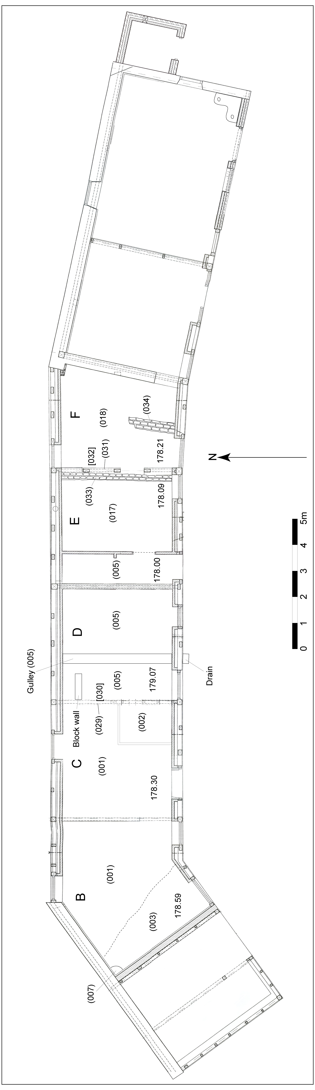

Fig. 6: Site plan

Area E
Underlying a thin deposit of (001) in this area was a cobbled floor surface (017). This was edged with brick (033) along the eastern side, which appeared to relate to the partition wall (031) between Areas E and F that it abutted. Underlying the wall and the small, related cut [032] that it filled was context (004).

Area F
Removal of (001) revealed a post / stake (026) / [022] driven into a firm light brown silty clay containing frequent small angular sandstone fragments (009). This deposit appeared to be redeposited (004) and was cut on the northern and southern sides by walls (011) and (027).

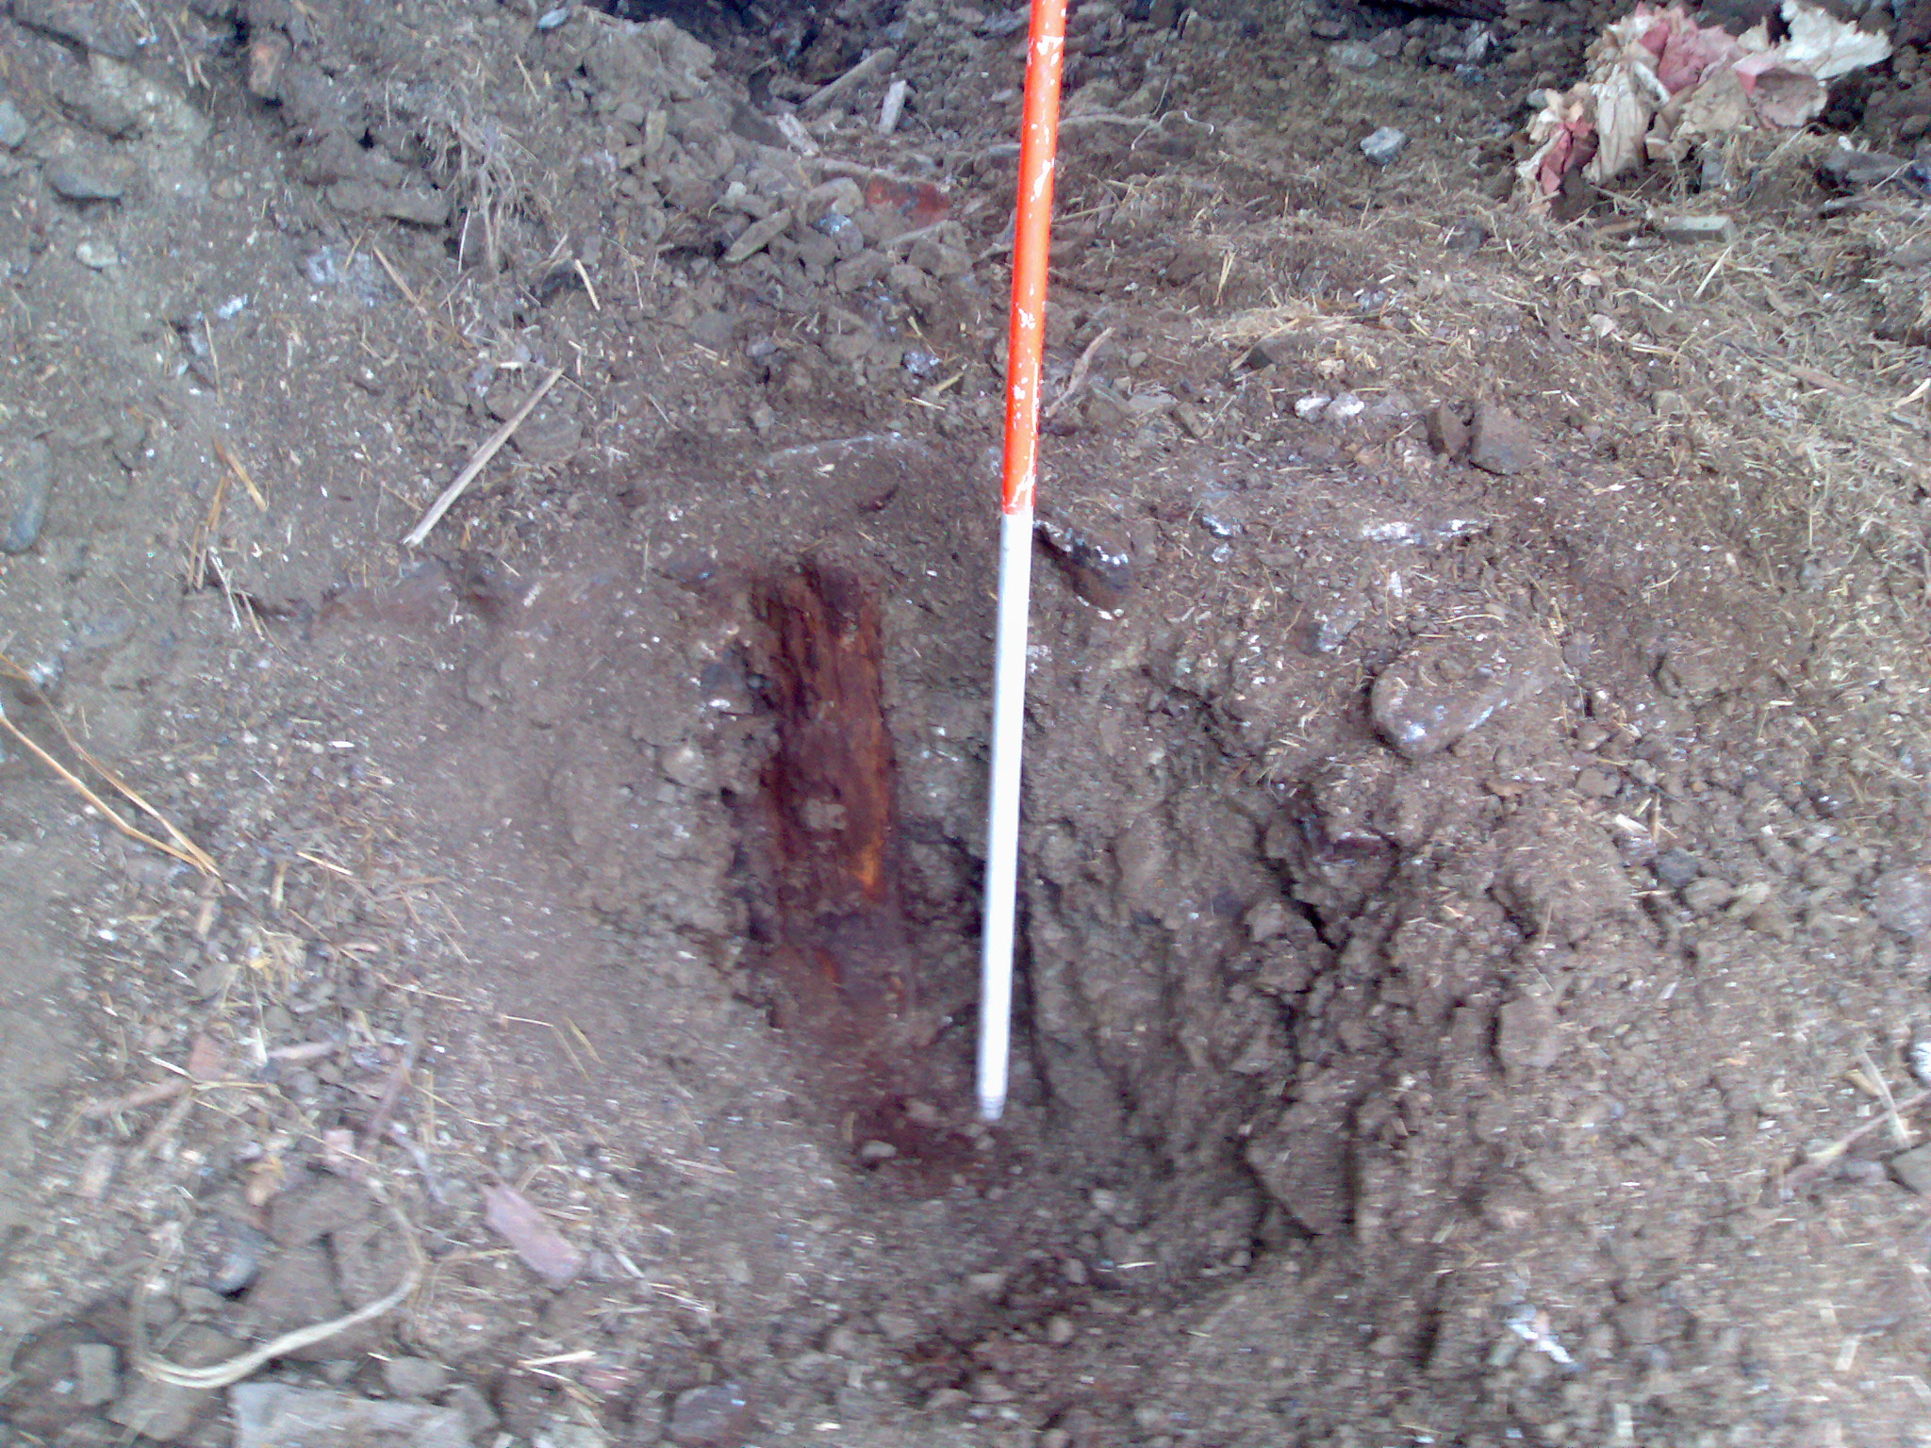

Plate 2. View NE showing post / stake located in Area F

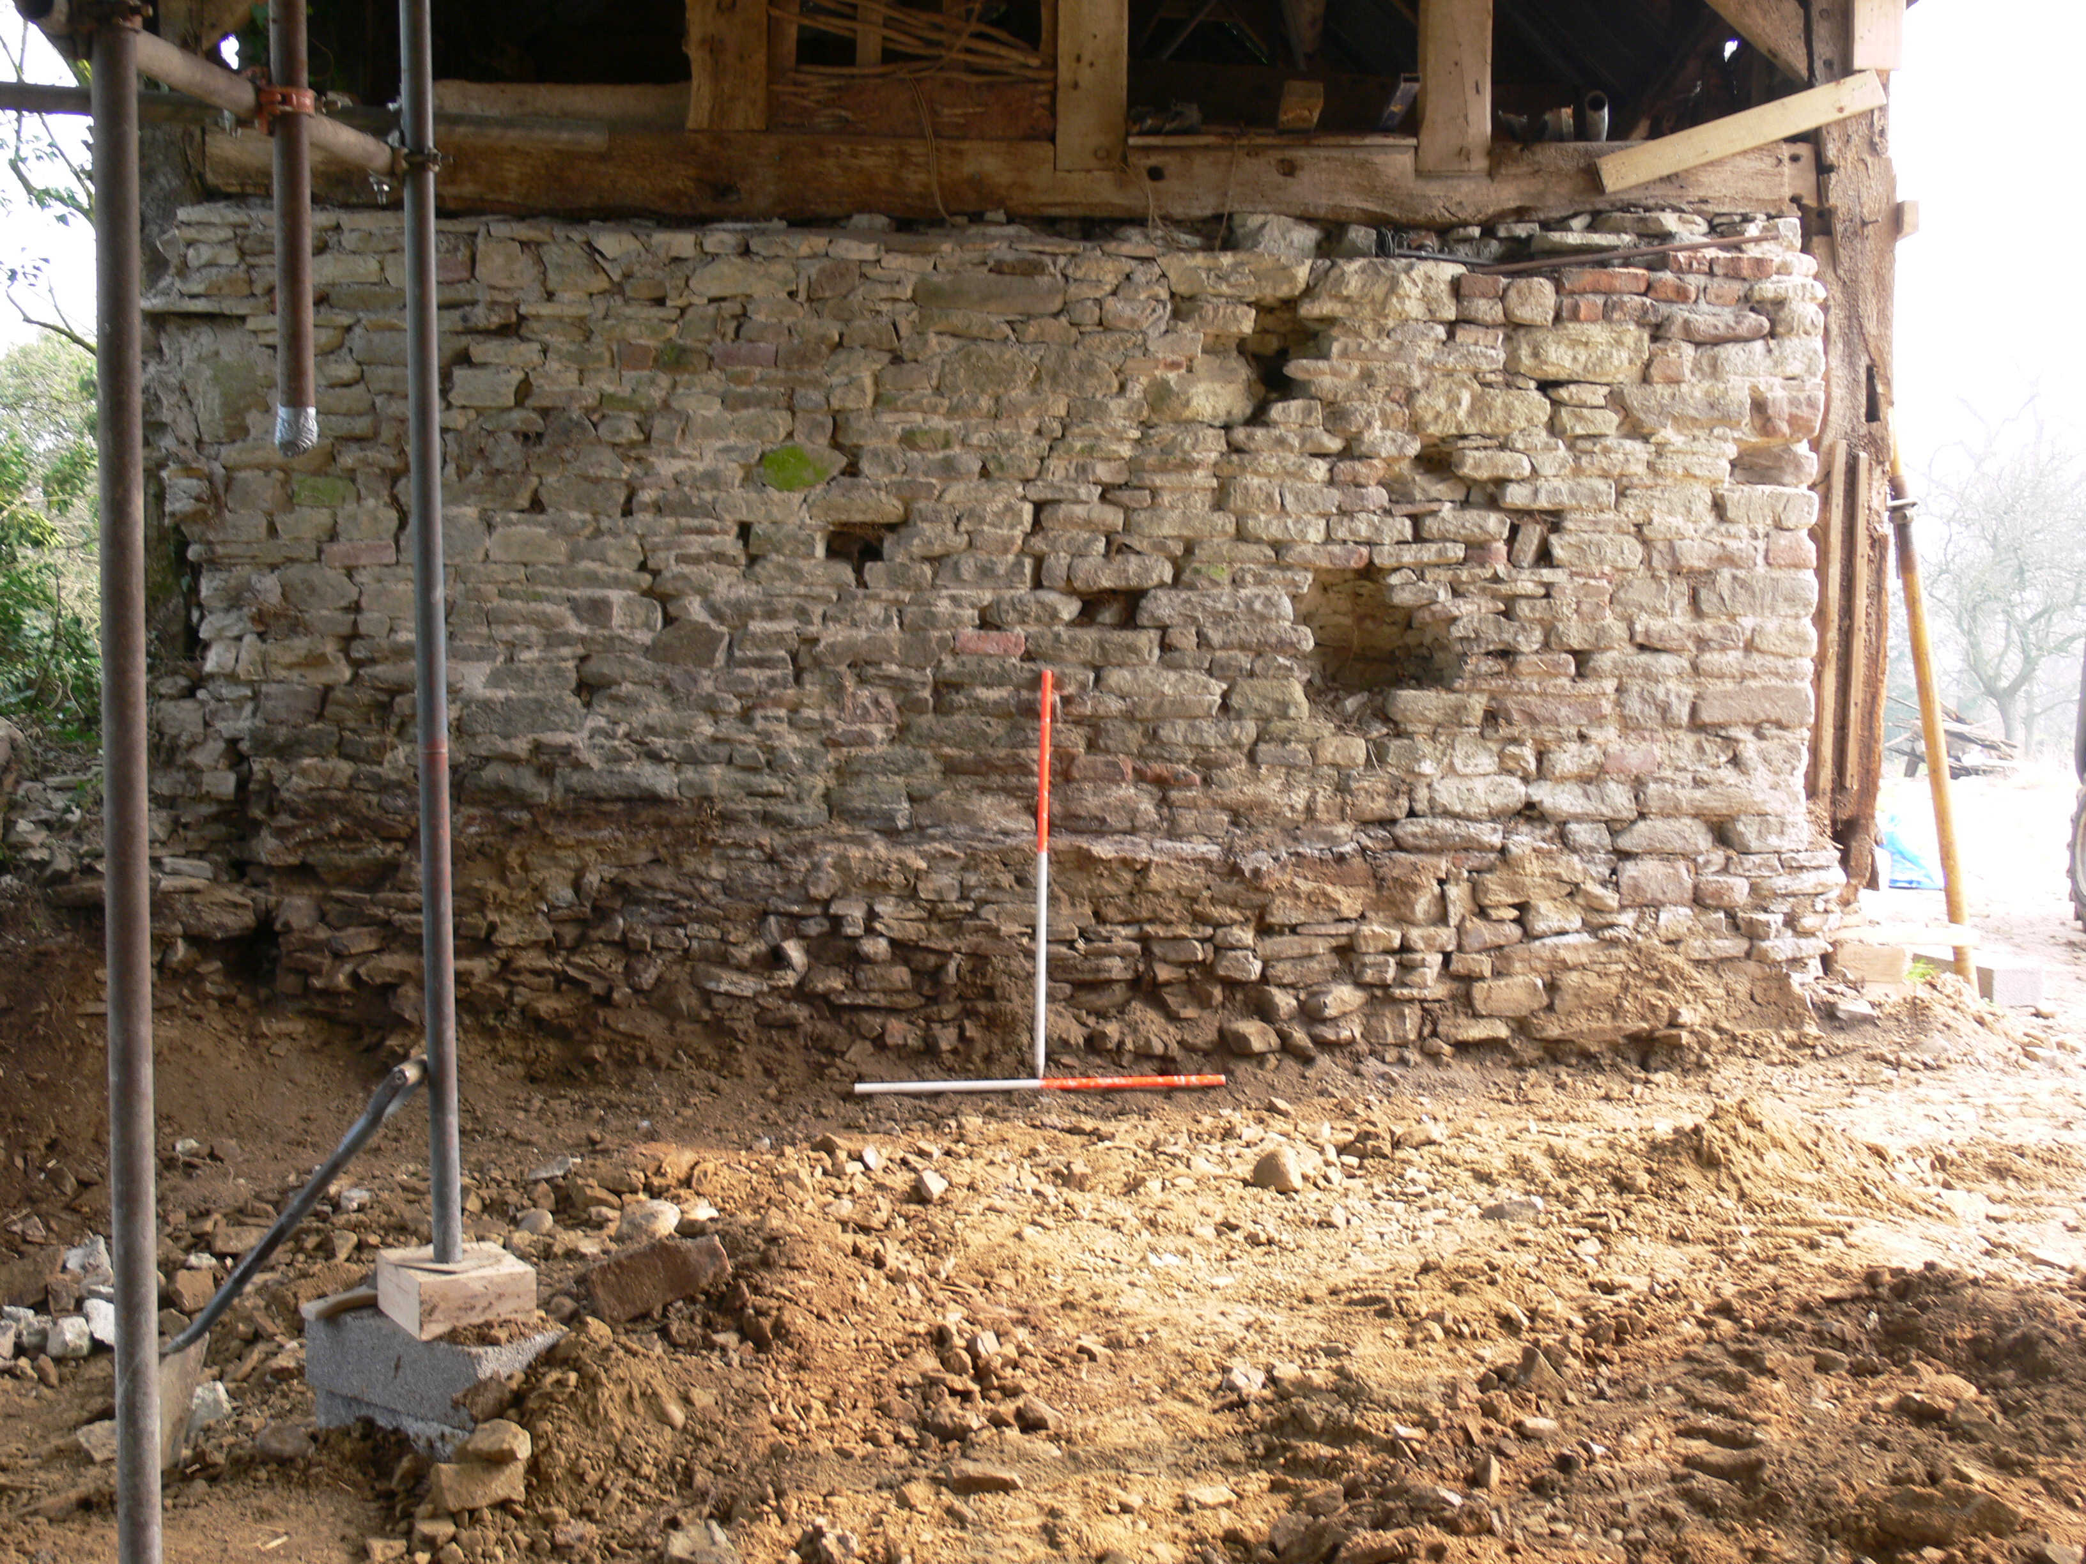

Plate 3. View E showing wall dividing Area F and Area G following ground reduction

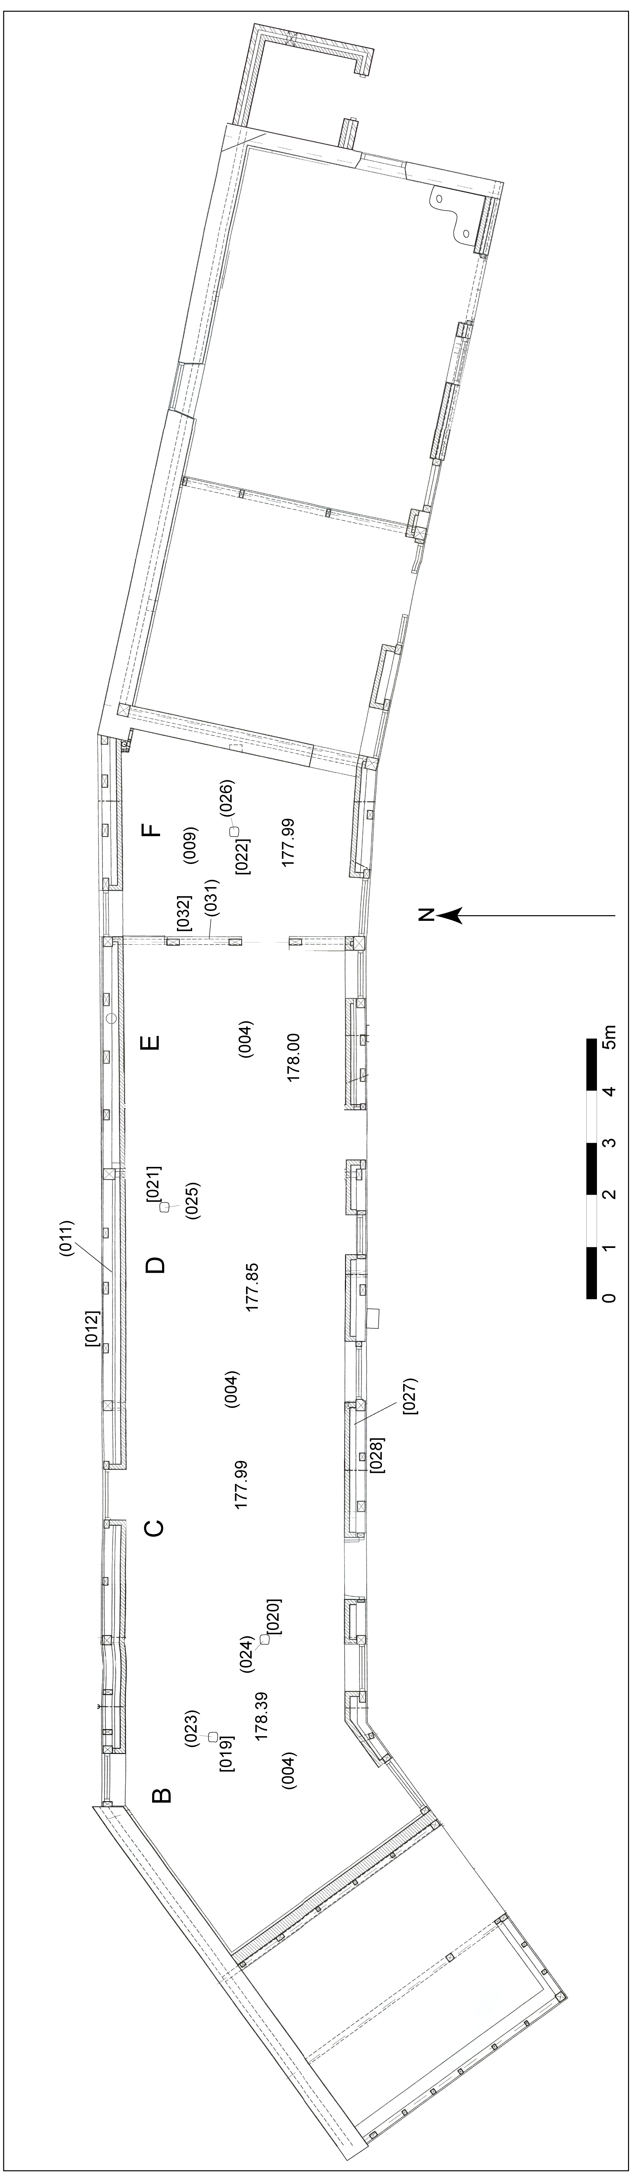

Fig 7. Area plan following initial ground reduction

Trenching excavations

Following ground reduction within the barn, a series of foundation trenches were excavated measuring approximately 0.7m wide and up to 1.1m deep, unless natural bedrock was encountered above this depth, as was the case in Trench 1 (Fig. 8).

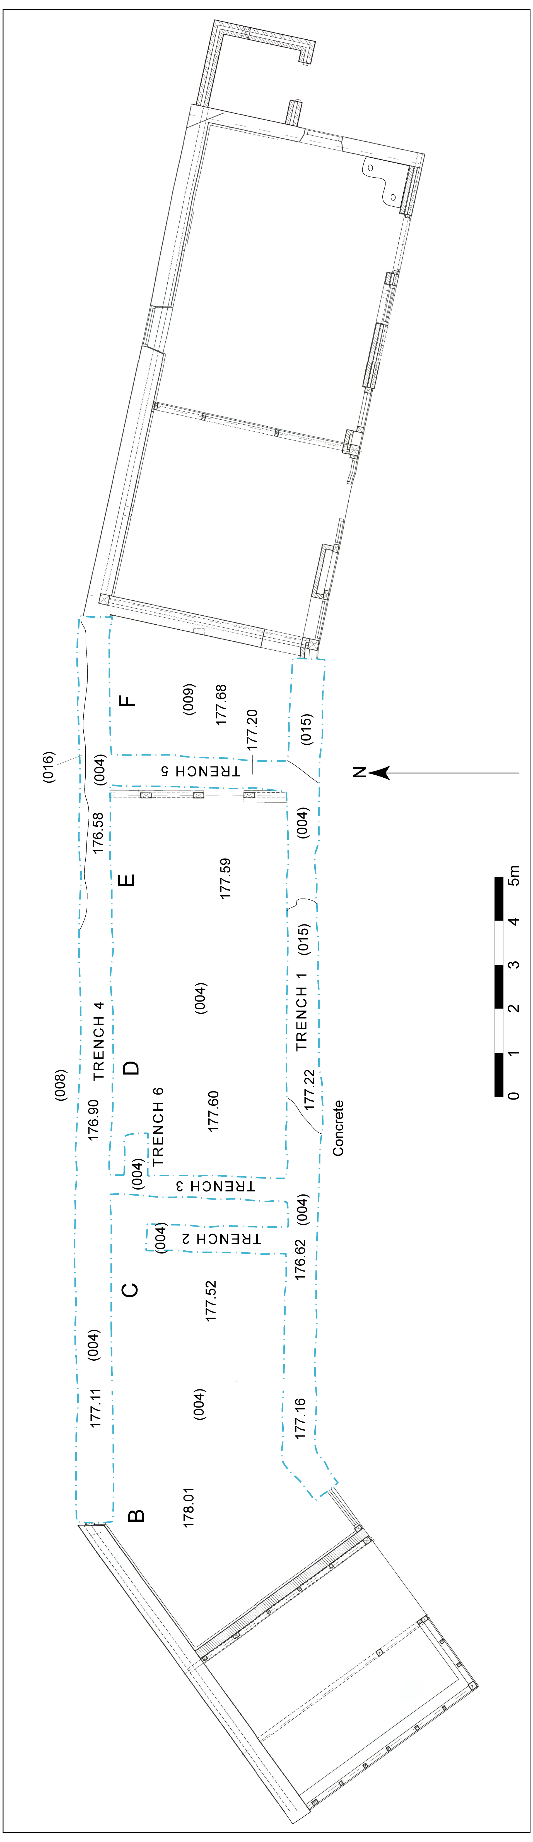

Fig 8. Final excavation plan

Trench 1
Trench 1 was the longest of the trenches excavated as part of wall underpinning work and ran along the southern wall of the barn. The uppermost context at the western end of the trench was a moderately compact mid to dark brown sandy clay with occasional small stones (010); this deposit extended over the entirety of the trench to a depth of 0.3m. Context (010) was cut by the foundation of the southern wall of the barn (011) / [012]. Underlying the wall was a firm sterile light brown silt clay with moderate to frequent small, medium and large subangular and angular sandstone fragments (004), which covered the base of the trench and was 0.9m thick. Underlying this material in Area D and Area E within the building was yellowish sandstone and mudstone (015), which appeared to be the natural bedrock.

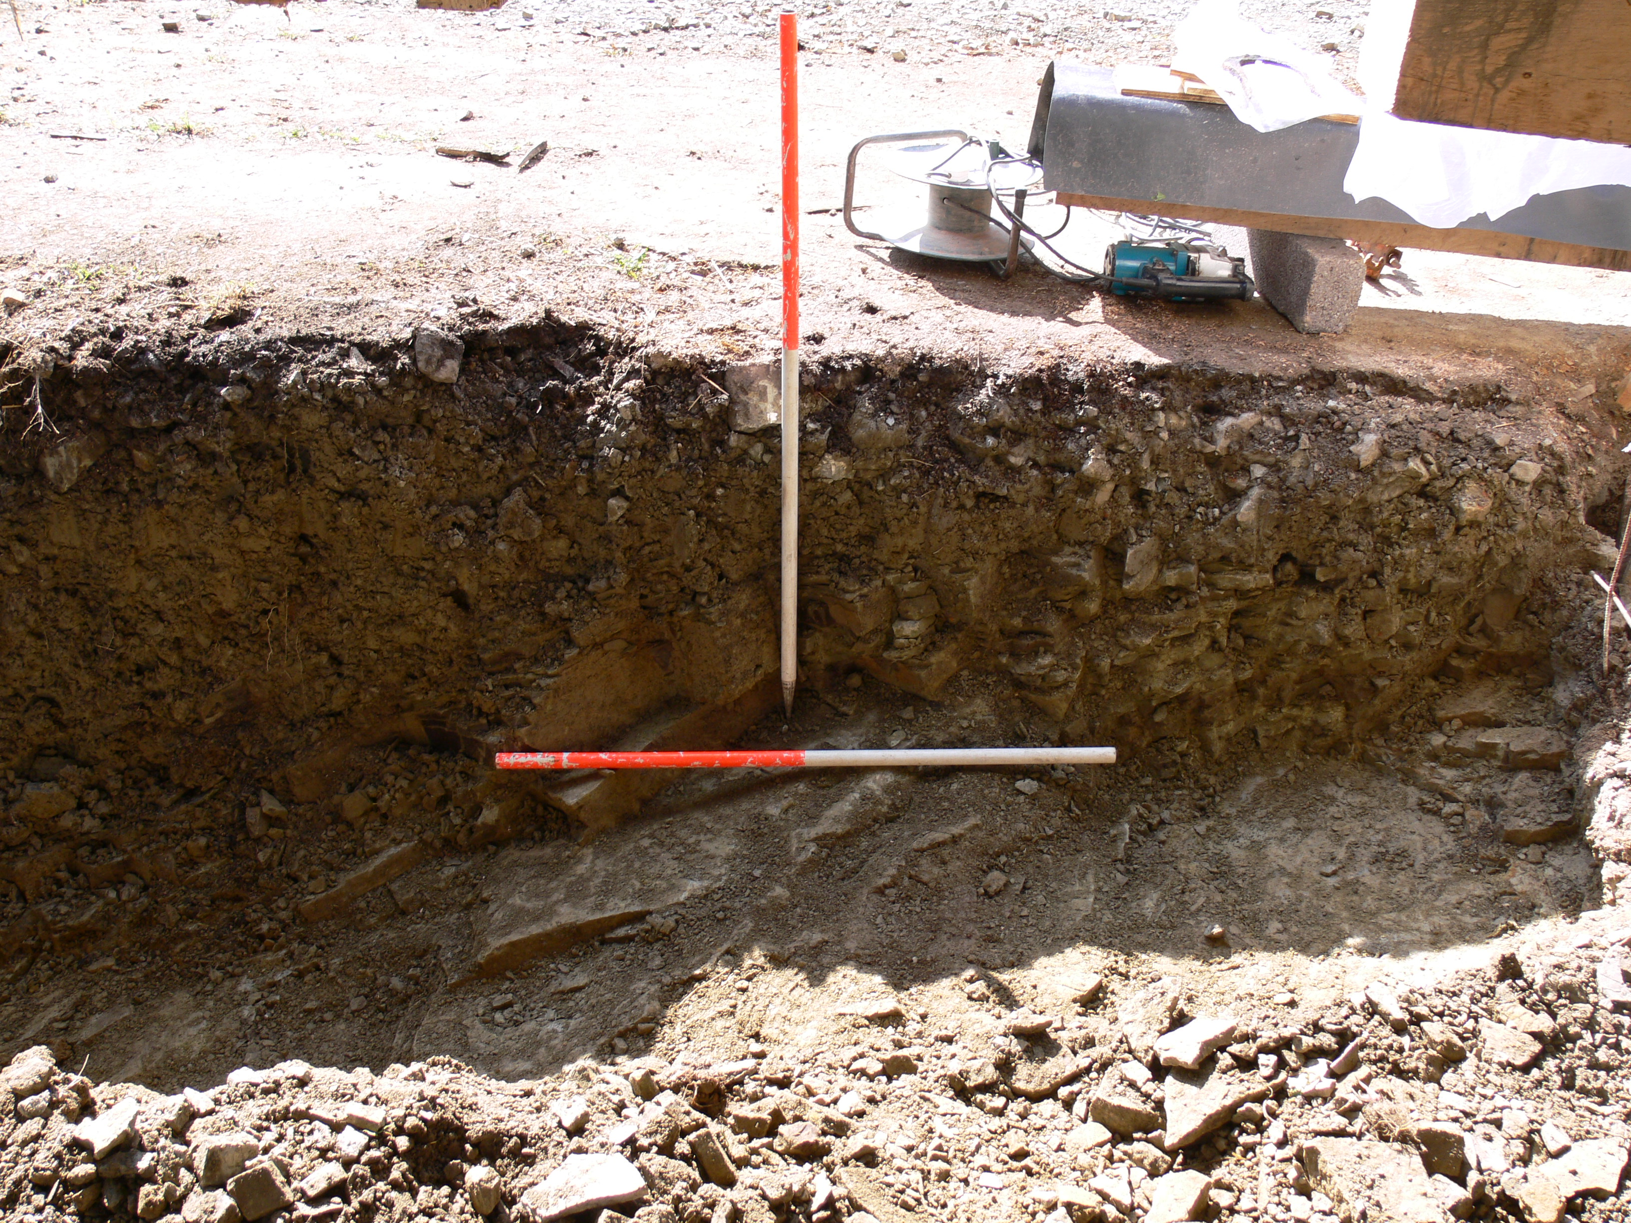

Plate 4. View S showing bedrock within Trench 1

Trench 2
Trench 2 ran at right angles to Trench 1 through Area C in a N-S direction. The uppermost deposit was a brick floor surface (002), which covered the base of a small pen in the SE corner of Area C. Underlying (002) was (010), which overlay (004).

Trench 3
Trench 3 underlay the partition wall between Area C and Area D. Underlying context (002) was context (010), which overlay (004).

Trench 4
Trench 4 was located along the line of the N wall of the barn and ran from Area B to Area F. This area had not been cleared as part of the topsoil strip and was excavated some months after the other trenches had been completed. The uppermost deposit was a moderately compact dark brown sandy clay topsoil (008) that abutted the northern wall of the barn (011). The thickness of (008) increased to the N as the bank defining the extent of the outer bailey sloped away to the N. Underlying this deposit and cut by [020] was context (004).

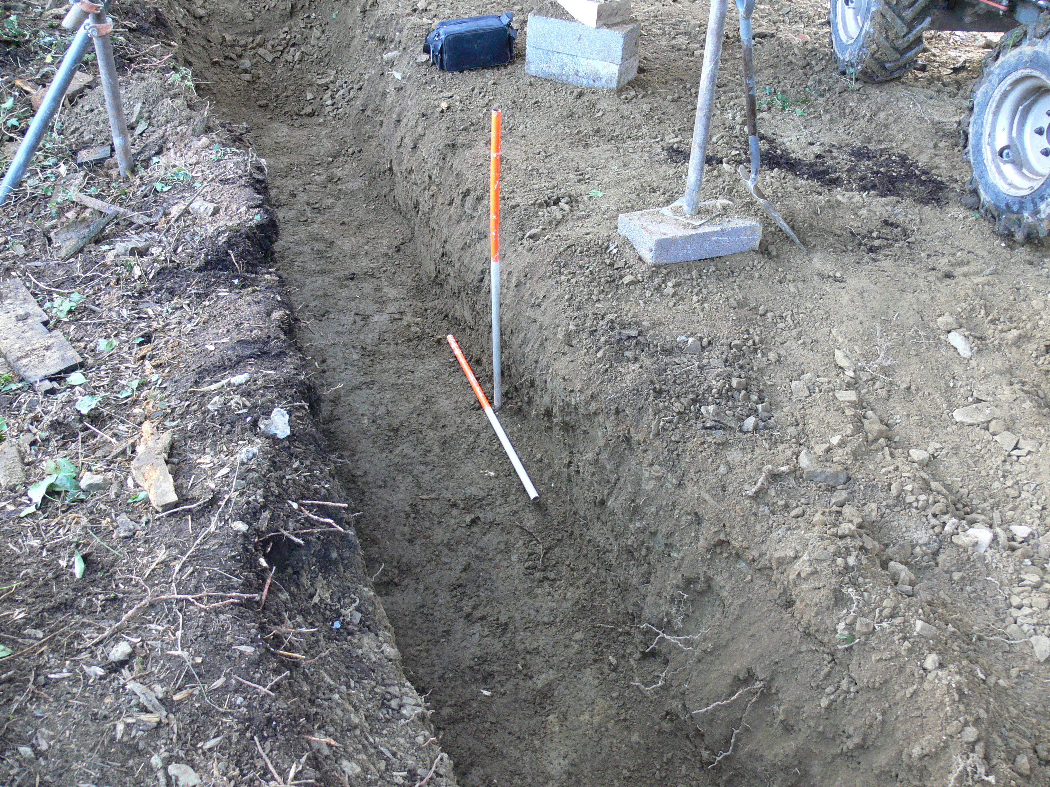

Plate 5. General view SE of Trench 4

Trench 5
Trench 5 was excavated along the partition between Area E and Area F. Most of the deposits had already been reduced in this area during the ground reduction phase. Underlying (009) was the subsoil (009), which overlay a sloping lense of what appeared to be a former topsoil horizon (013), which overlay context (004).

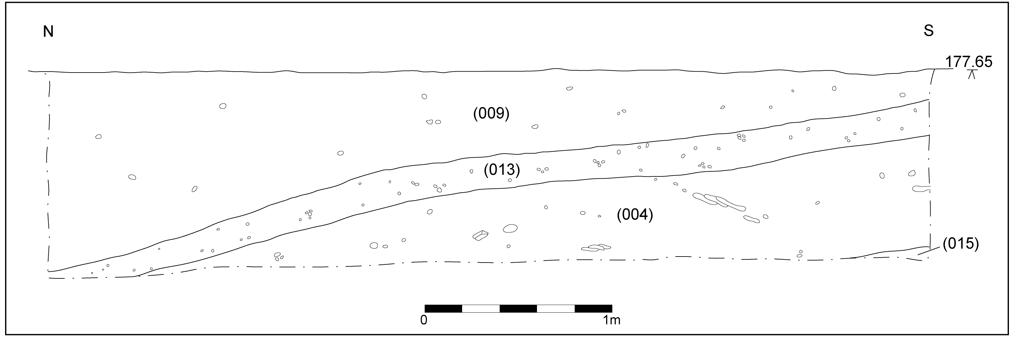

Fig 9. W-facing section of Trench 5

Trench 6
Trench 6 was a small extension to Trench 3 that ran at right angles off the main trench. The deposits in this trench were identical to those in Trench 3.

- Interpretation of Findings

The material (009) within the eastern end of the barn (Area E and Area F) could potentially be of significance. This build-up of soil may simply represent material imported onto the site to level the interior of the barn; however, the similarity of (009) and (004) suggests the material is of local origin and it may thus represent the levelled remains of a bank, possibly relating to the outer defensive enclosure surrounding the settlement attached to the castle.

This interpretation is supported firstly by the alignment of the barn, which follows the curvilinear form of the enclosure as indicated by the archaeological evidence, and secondly by the fact that the barn’s outer walls cut into the bank, indicating, at least, that it predates one of the early construction phases.

Of the oak posts / beams located, contexts (023), (025) and (026) appeared to relate to a former internal partitioning arrangement within the building. This interpretation is directly supported by the evidence of post (024), which appeared to be incorporated into the partition between Area B and Area C. It thus appears that the posts related directly to the barn itself rather than surviving from an earlier structure.

- Conclusion

The archaeological observation revealed little new evidence relating to the phasing of the barn to complement the findings of the previous standing building recording. The discovery of several stake holes suggests a different internal arrangement of partition walls and the observation did confirm that the current partitions were of a later phase than the northern and southern external walls. There was some indication that the barn was built on the levelled remains of a bank, with a 0.5m thick deposit of what appeared to be redeposited natural subsoil situated within the centre of the barn and cut by northern and southern walls.

- Copyright

Border Archaeology shall retain full copyright of any commissioned reports, tender documents or other project documents, under the Copyright, Designs & Patents Act 1988 with all rights reserved; excepting that it hereby provides an exclusive licence to the client for the use of the report by the client in all matters directly relating to the project as described in the Project Specification.

- Bibliography & Cartography

Bibliography

Herefordshire Archaeology Sites and Monuments Record

Herefordshire Council, Listed Building Register –Church House

Brunskill, R.W., 1987, Traditional Farm Buildings of Britain, London

Brunskill, R.W. 1992, Traditional Buildings of Britain: An Introduction to Vernacular Architecture, London

Coplestone-Crow, B., 1989, Herefordshire Place Names, British Archaeological Reports No. 214

Curnow P.E. & Thompson M.W., 1969, ‘Excavations at Richard’s Castle Herefordshire’, Journal of the British Archaeological Association, Vol. 32, 105-27.

Hopkinson, C., & Speight, M., 2002, The Mortimers Lords of the March, Logaston

Mercer, E., 1979, English Vernacular Houses, RCHME, London

Morriss, R.K., 2004, The Archaeology of Buildings, Stroud

Pevsner, N., 1963, The Buildings of England- Herefordshire, London

RCHME, 1934, Inventory of the Ancient and Historical Monuments in Herefordshire, Vol. 3: North-West, London

Robinson, C.J., 1869, A History of the Castles of Herefordshire and their Lords, Hereford

Shoesmith, R., 1996, Castles and Moated Sites of Herefordshire, Logaston

Soil Survey of England and Wales, 1983, Soil Map of England and Wales, Silsoe

Thorn, F. & Thorn, C. (eds.), 1983, Domesday Book: Herefordshire, Chichester

Cartography

(All maps were obtained from the Herefordshire Record Office unless otherwise stated)

1839 – Tithe Map of Richard’s Castle Parish

1890 - OS 1st edition 6-inch map (Herefordshire 7 NE)

1903 - OS 2nd edition 25-inch map (Herefordshire 7.3)

1934 - RCHME Plan of Richard’s Castle

1983 - OS 1:2500 plan of Richard’s Castle

APPENDIX 1: Context Register

CONTEXT | INTERPRETATION
(001) | Loose mid brown silt, occasional cobbles, CBM, wood, sawdust, straw and manure. Extends across Area B & C, < 0.4m thick.
INTERPRETATION: | Accumulated mixture of rubbish & livestock bedding, manure.
(002) | Brick surface measuring 2 x 1.4 x 0.08m, brick size 0.22 x 0.1 x 0.07m (approximately standard gauge), running bond, no bonding material, tightly compacted in sand
INTERPRETATION: | Brick floor surface in SE corner of Area C.
(003) | Cobble surface measuring 4.4 x 1.8 x 0.11m, unworked stones of average size 0.14 x 0.12 x 0.10m set in earth with subsequent concrete repairs.
INTERPRETATION: | Cobbled floor surface in SW end of Area B
(004) | Firm light brown silty clay, moderate to frequent small, medium and large subangular / angular sandstone. Extends across Area B and C, 0.9m thick.
INTERPRETATION: | Subsoil
(005) | Brick surface measuring 4.3 x 4.1 x 0.07m, brick size 0.3 x 0.1 x 0.07m, running bond
INTERPRETATION: | Brick floor surface in Area D.
(006) | VOID
(007) | Loose blackish / dark brown silt, frequent coal and coke lumps, measures 0.6 x 0.6 x 0.6m.
INTERPRETATION: | Deposit of coal /coke
(008) | Moderately compact dark brown organic sandy clay, occasional small angular stones. Extends over top of bank to N of bar / Area C, 0.22m.
INTERPRETATION: | Topsoil.
(009) | Firm light brown silty clay, frequent small angular sandstone, measuring 4.5 x 0.7 x 0.68m
INTERPRETATION: | Subsoil to (009), forms part of bank encircling the site of Richards’ castle.
(010) | Moderately compact mid to dark brown sandy clay, occasional small stones.
INTERPRETATION: | Post-medieval topsoil
(011) | Sandstone masonry (random coursing) / brick (running bond) measuring 17 x 5.4 x 0.7m, size of materials 0.3 x 0.1 x 0.2m, lime mortar & cementatious mortar bonding.
INTERPRETATION: | Foundation plinth for northern wall of barn.
[012] | Linear cut measuring 17 x 5.4 x 0.6m, corners not observed, break of slope top sharp, sides vertical, break of slope base sharp, base flat. Filled by (011).
INTERPRETATION: | Cut of foundation (011).
(013) | Moderately compact grey gritty silty clay, very frequent very small & small angular rounded and angular stones, measures 8 x 5.6 x 0.42m.
INTERPRETATION: | Former topsoil.
(014) | Firm greyish-yellow light brown silt clay, very frequent very small, small and medium rounded and angular stones, measures 4 x 0.7 x 0.6m.
INTERPRETATION: | Natural subsoil (same as (004)).
(015) | Yellowish sandstone & mudstone measuring 8.5 x 1 x 0.36m
INTERPRETATION: | Bedrock outcropping.
(016) | Firm dark reddish-brown silty clay, frequent rounded stones, measures 7.5 x 0.2 x 0.11m.
INTERPRETATION: | Subsoil by Area E and F.
(017) | Cobbles (unworked) / brick (running / stretcher bond) measuring 4.25 x 2.9 x 0.12–0.18m (sloping to S), size of materials 0.2 x 0.18m (cobbles) 0.2 x 0.07 x 0.05m (brick), packed earth & lime mortar bonding
INTERPRETATION: | Cobbled floor
(018) | Cobbles / brick (running bond) measuring 4.4 x 3.8 x 0.14–0.18m, size of materials 0.2 x 0.18m (cobbles) 0.2 x 0.07 x 0.05m (brick), packed earth / lime mortar bonding.
INTERPRETATION: | Cobbled floor
[019] | Square cut measuring 0.5 x 0.1 x 0.1m, right-angled corners, break of slope top sharp, sides vertical, break of slope base acute / sharp, base v-shaped, inclination of axis vertical. Filled by (023).
INTERPRETATION: | Cut of stake hole (023).
[020] | Square cut measuring 0.5 x 0.1 x 0.1m, right-angled corners, break of slope top sharp, sides vertical, break of slope base acute / sharp, base v-shaped. Inclination of axis vertical. Filled by (024).
INTERPRETATION: | Cut of stake hole (024).
[021] | Square cut measuring 0.5 x 0.1 x 0.1m, right angled corners, break of slope top sharp, sides vertical, break of slope base acute / sharp, base v-shaped, inclination of axis vertical. Filled by (025).
INTERPRETATION: | Cut of stake hole (025).
[022] | Square cut measuring 0.5 x 0.1 x 0.1m, right angled corners, break of slope top sharp, sides vertical, break of slope base acute / sharp, base v-shaped, inclination of axis vertical. Filled by (026).
INTERPRETATION: | Cut of stake hole (026).
(023) | Vertical timber measuring 0.5 x 0.2 x 0.14m, square cross section, degraded condition, conversion boxed heart, intentional marks none, surface treatment none.
INTERPRETATION: | Stake or beam probably relating to an earlier phase of partitioning or walling within the barn.
(024) | Vertical timber measuring 0.6 x 0.2 x 0.14m, rectangular cross section, complete, good condition, conversion box quartered, joints & fixings slotted, intentional marks none, surface treatment none.
INTERPRETATION: | Reused timber used as support brace for timber frame of partition between Area B and Area C.
(025) | Vertical timber, rectangular cross section, condition slightly rotten partially broken, conversion box quartered, intentional marks none, surface treatment none.
INTERPRETATION: | Stake or beam probably relating to an earlier phase of partitioning or walling within the barn.
(026) | Vertical timber measuring 0.12 x 0.11 x 0.5m, rectangular cross section, condition rotten partially broken, conversion boxed heart (?), intentional marks none, surface treatment none.
INTERPRETATION: | Stake or beam probably relating to an earlier phase of partitioning or walling within the barn.
(027) | Siltstone masonry with brick repairs measuring 18 x 0.5 x 1m, size of materials irregular 0.3 x 0.1 x 0.2m (av.), stones roughly worked irregularly coursed, orientation E–W, lime mortar bonding
INTERPRETATION: | Southern wall of barn.
[028] | E–W rectilinear cut measuring 18 x 0.5 x 1m, corners not within groundworks area, break of slope top sharp, sides steeply sloping to vertical, break of slope base sharp, base undulating. Filled by (027).
INTERPRETATION: | Cut for southern wall of barn.
(029) | Brick (running / stretcher bond) with occasional siltstone masonry measuring 4 x 0.35 x 0.4m, size of materials 0.21 x 0.1 x 0.065, orientation N–S.
INTERPRETATION: | Foundation plinth betweens Area C and Area D.
(030) | N–S rectilinear cut measuring 4 x 0.35 x 0.25m. Break of slope top sharp, sides steeply sloping, break of slope base sharp, base undulating to flat. Filled by (029).
INTERPRETATION: | Cut of foundation plinth (029).
(031) | Brick (running / stretcher bond) with occasional masonry measuring 4 x 0.35 x 0.45m, size of materials 0.31 x 0.1 x 0.065m, orientation N–S, bonding material cementatious mortar.
INTERPRETATION: | Foundation plinth for partition between areas E and F.
[032] | N–S rectilinear cut measuring 4 x 0.35 x 0.25m. Break of slope top sharp, sides steeply sloping, break of slope base sharp, base undulating. Filled by (031).
INTERPRETATION: | Cut of foundation plinth.
(033) | N–S brickwork (stretcher / running bond) measuring 8 x 0.3 x 0.06m, size of materials 0.3 x 0.09 x 0.065m, bonding material cementatious mortar.
INTERPRETATION: | Brick edging to (017).
(034) | Brickwork (stretcher / running bond) measuring 2 x 0.6 x 0.065m, size of materials 0.3 x 0.09 x 0.065m, bonding material cementatious mortar.
INTERPRETATION: | Brick repair to (018).

APPENDIX 2: Site Matrix

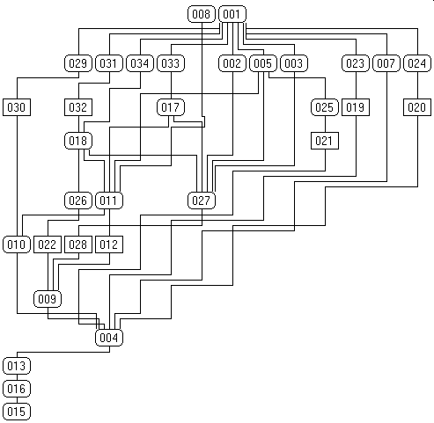

SITE SUMMARY

Report Name & Title | Archaeological Observation: Church House Barn Richard’s Castle Herefordshire
Contractor’s Name and Address | Border Archaeology Chapel Walk Burgess Street Leominster Herefordshire HR6 8DE
Site Name | Church House Barn Richard’s Castle Herefordshire
Grid Reference (8 fig) | SO 48420 70350
Planning Application Number | DCNW2006/0812/F
SMR Number/s of Site | 45158
Date of Fieldwork | Intermittent between February & August 2007
Date of Report | December 2007
NUMBER AND TYPE OF FINDS
Type | Period: | Quantity
Pottery |  | 0
CBM |  | 0
Clay pipe |  | 0
Animal bone |  | 0
Metal finds |  | 0
Other |  | 0
NUMBER AND TYPE OF SAMPLES COLLECTED
Sieving for charred plant remains | No of features sampled | 0
Sieving for charred plant remains | No of buckets | 0
C¹⁴/scientific dates | No and Type | 0
C¹⁴/scientific dates | Result | N/A
Pollen | No of columns/spot samples | 0
Pollen | Name of pollen specialist | 0
Bone | Number of buckets sieved for bone | 0
Bone | Quantity Recovered | 0
Bone | Period | N/A
Other (type and specialist) | 0
Summary of the report:
The archaeological observation located limited evidence relating to construction phasing, principally in the form of three beams / posts that appeared to have been part of an earlier partitioning arrangement. Some insight into the barn’s initial construction was also gained, with the outer barn walls appearing to have been dug into a mound representing either a landscaping / levelling deposit or the flattened remains of a bank relating to an outer enclosure attached to the castle. No other finds or features were located.

Document Control

Job title | Archaeological Observation: Church House Barn Richard’s Castle Herefordshire | Job No | BA0701CSCHB
Report written by | Will Logan BA
Report edited by | George Children MA
Issue No | Status | Date | Approved for issue
1 | Final | December 2007 | Neil Shurety

