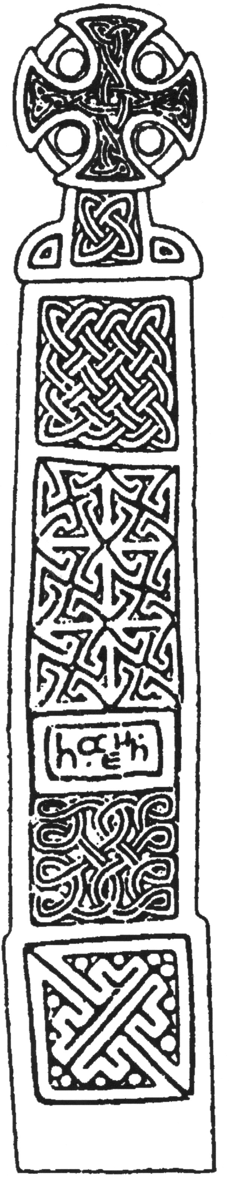
Final Report on the Archaeological Excavation at the Former Welsh Water Site Coughton Ross-on-Wye Herefordshire

NGR: SO 5956 2125
SMR No: 43283

BORDER ARCHAEOLOGY

PO Box 36
Leominster
Herefordshire
HR6 0YQ
E-mail: enquiries@borderarchaeology.com

Technical Services
Chapel Walk

Burgess Street
Leominster
Herefordshire
HR6 8DE
Tel: 01568 610101
Tel/fax: 01568 616900
E-mail: borderarch@btconnect.com

BORDER ARCHAEOLOGY
Head Office

PO Box 36
Leominster
Herefordshire
HR6 OYQ

Technical Services
Chapel Walk
Burgess Street
Leominster
Herefordshire
HR6 8DE

May 2004

NGR:
Report No.
BA0529KRCRW August 2006
Contents

1. Non Technical Summary 3
2. Introduction 5
2.1 Soils & Geology 5
3. Historical & Archaeological Background 6
4. Methodology 9
5. Results 10
5.1 Phase 1 10
5.2 Phase 2 12
5.3 Phase 3 19
5.4 Phase 4 20
5.5 Phase 5 20
5.6 Phase 6 21
5.7 Phase 7 21
5.8 Phase 8 22
5.9 Phase 9 22
6. Interpretation of Findings 23
6.1 Late Iron Age/Romano-British Activity (Phases 1-3) 23
6.2 Post-medieval/modern activity (Phases 4-9) 27
7. Conclusion 29
8. Copyright 29
9. Bibliography & Cartography 29
9.1 Bibliography 29
9.2 Cartography 30
10. Section drawings 31
11. APPENDIX 1: Context Register 35
12. APPENDIX 2: Pottery Analysis 46
1. METHODOLOGY 46
13. APPENDIX 3: Palaeoenvironmental Analysis 53
14. APPENDIX 4: Drawing Register 55
15. Site summary 57
16. Document Control 58

Report specification:
Report written by: Stephen Priestley MA
Artwork: Michelle Bithell BA
Report editing: George Children MA AIFA
- Non Technical Summary

The site is located on the outskirts of the village of Walford, to the rear of Fowbridge Gardens.

The earliest occupation identified appears to date from 1st-3rd centuries AD be of Iron Age-Romano-British date from the, while the upper layers were indicative of late 19th/early 20th century activity, together with more recent activity relating to the construction and demolition of the former Welsh Water facility and subsequent exploratory work in advance of the current development. The early occupation evidence and later activity were separated by a sustained period of flooding or hillwash.

The early features comprised a probable settlement enclosure boundary encompassing a posted structure that was replaced by a roundhouse. The enclosure boundary may also have had a second phase of usage, although this may be misleading. Iron slag and burnt stones found within two pits located in the western portion of the enclosure suggest the presence of light industrial activity within this area.

The early activity continued to the south and west of the excavated area, although it could not be ascertained whether it continued north and east beyond the enclosure boundary. The later activity appeared to extend over the entire site.

A detailed assessment of the pottery assemblage found during the excavation indicates that occupation on the site extended. With regard to the later activity, no datable artefacts were recovered from Phase 4 or Phase 5; however, a number of features within Phase 5 appear to have been excavated by machine, suggesting a 19th or 20th century date. All later phases appear to be mid to late 20th century, except Phase 9, which is very recent.

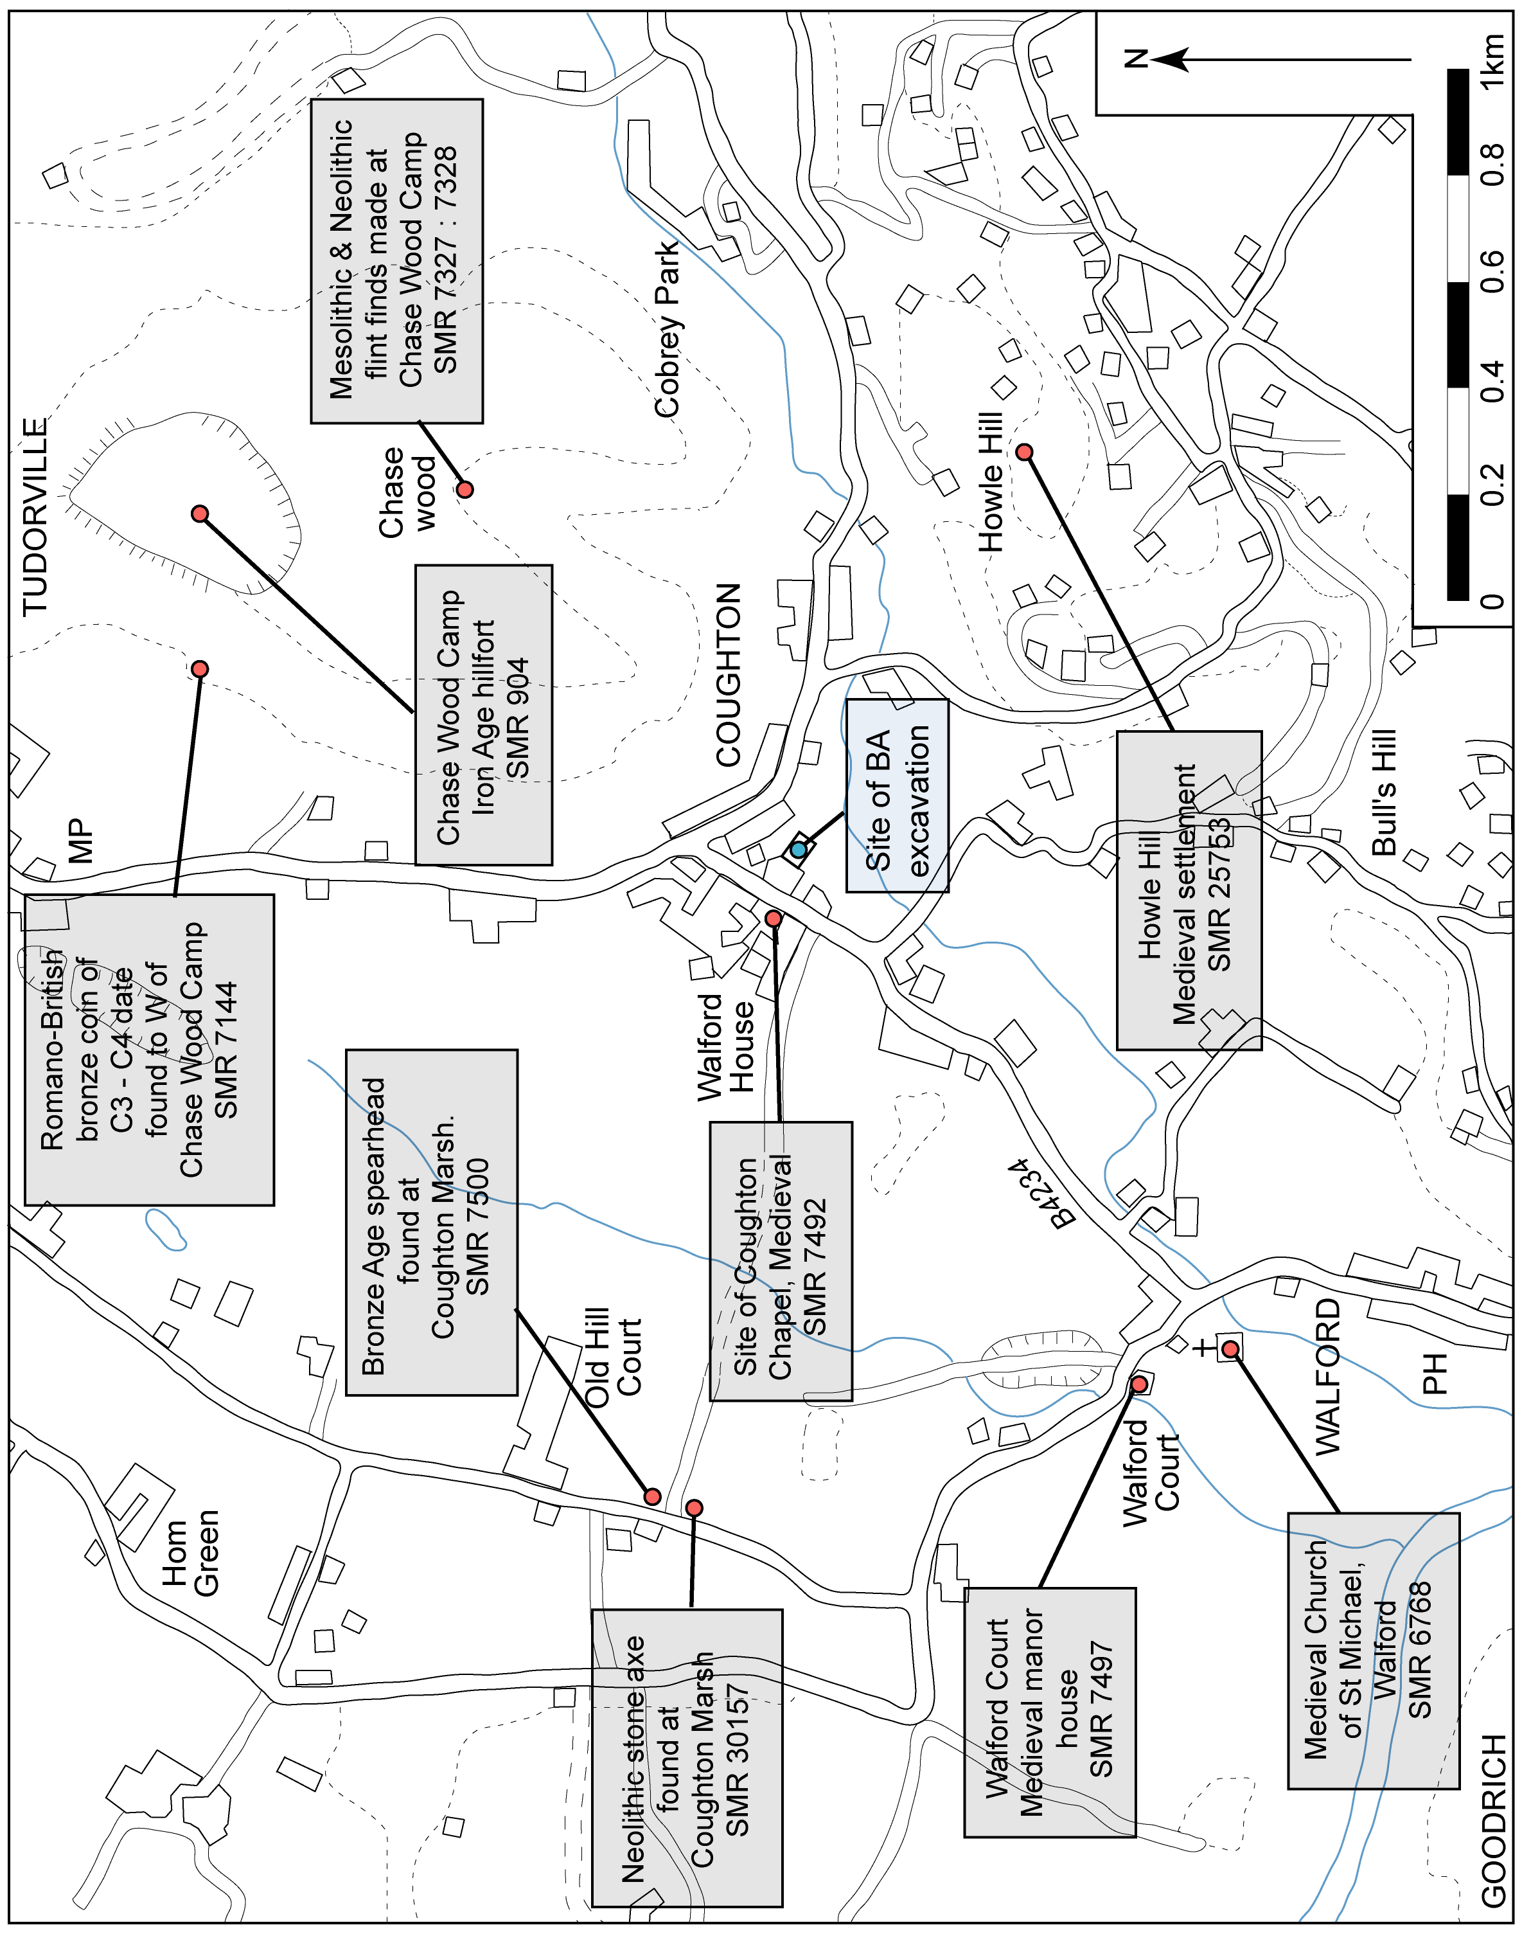

Fig. 1: Plan showing location of site within its wider surroundings

- Introduction

Border Archaeology was instructed by Bluefinch (Herefordshire) Ltd to undertake an archaeological excavation at the former Welsh Water site, Coughton, Ross-on-Wye, Herefordshire, in pursuance of the brief issued by Julian Cotton of Herefordshire Archaeology on 1st August 2005, the precise location and layout of which were delineated by Julian Cotton based on the results of a prior evaluation carried out in 2003-4 (SMR No. 35400; Report No. 37149), which revealed features indicating the presence of possible Romano-British remains at a depth of 0.8m below the existing ground surface.

This Report follows the submission of an Interim Report in March 2006 and incorporates the results of the post-excavation analyses of the pottery assemblage and environmental samples and all relevant interpretative site information.

The site is located on the outskirts of the village of Walford, to the rear of Fowbridge Gardens (SO 5956 2125) (Fig. 1). The excavation area was broadly L-shaped in plan, the widest end oriented SW-NE located near the site access and an area of diesel contamination bounding this area to the S.

Copies of this report will be submitted to Bluefinch (Herefordshire) Ltd, Herefordshire Archaeology and the county Sites and Monuments Record.

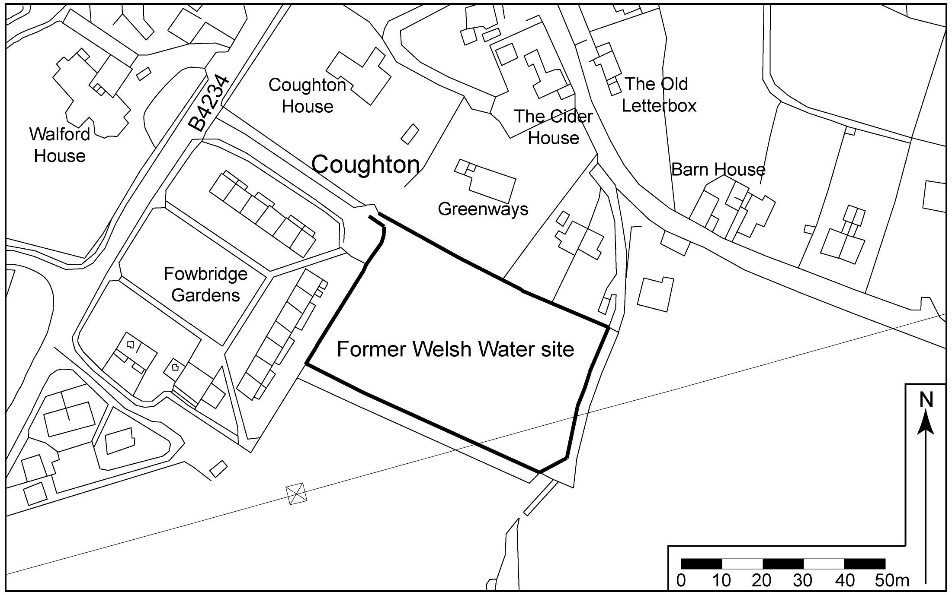

Fig. 2: Site location plan

Soils & Geology
The area predominantly comprises typical brown earths of the EARDISTON 1 series (541c); however, the site itself lies on or very close to a band of typical brown alluvial soils (LUGWARDINE 561d).

The EARDISTON 1 soil association consists of well-drained reddish coarse loamy soils over sandstone, shallow in places, especially on brows, with some reddish fine silty soils over shale and siltstone. The underlying geology is Devonian and Permo-Triassic reddish sandstone, silty shale and siltstone.

The LUGWARDINE soil association consists of deep stoneless permeable reddish fine silty soils with similar coarse silty soils locally, overlying reddish river alluvium

Of these, the EARDISTON 1 soils most closely resembled site natural (105), although a sondage revealed material at a greater depth that was similar to the LUGWARDINE soil association, which may indicate slumping of colluvial EARDISTON 1 material over floodplain material.

- Historical & Archaeological Background

The site, lying adjacent to Fowbridge Gardens at Coughton, is located in an area which exhibits evidence of human activity spanning the prehistoric, Roman, medieval and post-medieval periods (Fig. 1). The earliest evidence of activity in the locality of the site consists of Mesolithic and Neolithic flint finds at Chase Wood Camp (NGR SO 6030 2250) and a small number of Neolithic implements, including a stone hand axe found at Coughton Marsh (SMR No. 30157) and a polished grey stone axe and flint blade found at Bull’s Hill, Walford (SMR No. 41916). Evidence of Bronze Age occupation consists of the remains of a possible Bronze Age barrow found at Walford (SMR No. 8488) and a bronze spearhead of probable late Bronze Age date found during the draining of Coughton Marsh in 1871 (SMR No. 7500).

Significant evidence of settlement activity has been identified in the vicinity of the site dating from the Iron Age and Roman periods. Situated approximately 700m NE of the site are the earthwork remains of a large promontory hillfort of Iron Age date at Chase Wood Camp (SMR No. 904; NGR SO 6030 2250), of irregular oval form covering an area of approximately 27 acres (RCHME, 1932, 167). The hillfort occupies an area which appears to have been settled since the Mesolithic and Neolithic period, judging by the substantial number of flint finds of that date found during recent tree clearance and ploughing (SMR No. 7327, 7328). The discovery of a Romano-British coin dating from the 3rd-4th century AD in cleared woodland immediately W of the hillfort ramparts could suggest that occupation in this area continued well into the Roman period

Of particular importance are the results of an evaluation previously carried out on the site at Fowbridge Gardens in 2003-4 (Archaeological Investigations Ltd. 2004 Report No. 37149; SMR No. 35400), which identified significant evidence of Iron Age and Roman occupation, consisting of a ditch with pottery of late Iron Age date and two large ditches and several other discrete features containing Romano-British Severn Valley ware, dated approximately to the 1st-3rd centuries AD and similar in type to fabrics found at the Roman town of Ariconium (Weston-under-Penyard) located some 4km to the E of the site. Based on the presence of mudstone tempered ware of late Iron Age date in the Coughton assemblage, in contrast to its significant absence from the ceramic material found at Ariconium, it was suggested that the settlement at Coughton probably predated that at Ariconium and that it experienced a steady decline during the Roman period.

Archaeological evidence for occupation in the vicinity of the site during the early medieval period is sparse; however the name Coughton, of OE origin denoting ‘a farmstead near the hillock’ (presumably referring to Chase Hill to the NE) implies the existence of a settlement in this area during the Anglo-Saxon period (Coplestone-Crow, 1989, 198).

Throughout the medieval period Coughton appears to have formed part of the manor of Walford (listed in the Domesday Survey of 1086) and is first documented as a settlement in the early 13th century (Coplestone-Crow, 1989, 198). A medieval chapel is recorded as having stood opposite the site in Fowbridge Gardens, on the other side of the B4234 close to Walford House (SMR No.7492; NGR SO 5940 2120). The chapel is recorded in 1553 and is shown on maps of Herefordshire dated 1754 (Taylor) and 1787 (Cary) respectively but appears to have vanished by about 1840 as it is not shown on the Walford tithe map of that date (Fig. 3).

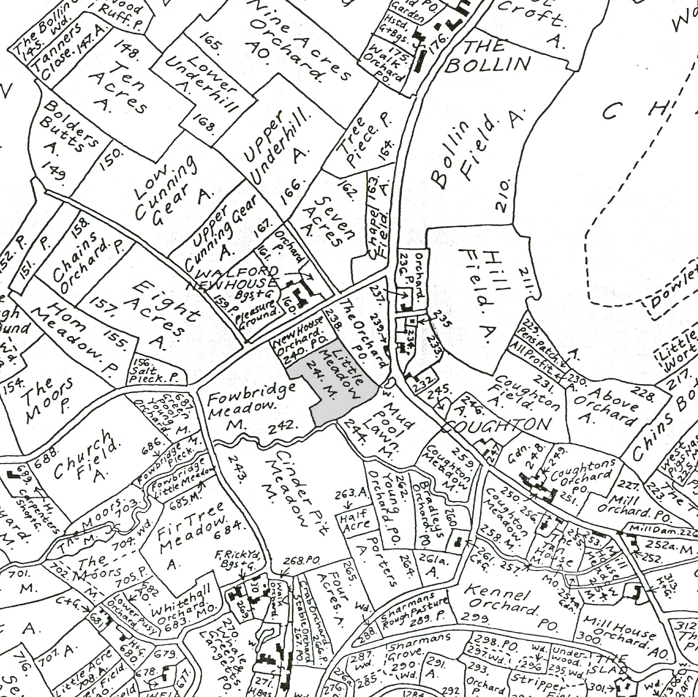

Fig. 3: Extract from Walford tithe map of 1840 showing the site at Little Fowbridge Meadow to the SE of Walford House (Reproduced courtesy of Herefordshire Record Office)

The Walford tithe map of 1840 records the site as being an irregular shaped pasture field called Little Fowbridge Meadow, then under the joint ownership of John Partridge and John Stratford Collins Esquires, owners of nearby Walford House. Immediately W of this was a large irregular L-shaped field called Fowbridge Meadow forming part of the same estate. The site of the modern housing at Fowbridge Gardens, immediately to the NW, was then called ‘New House Orchard’.

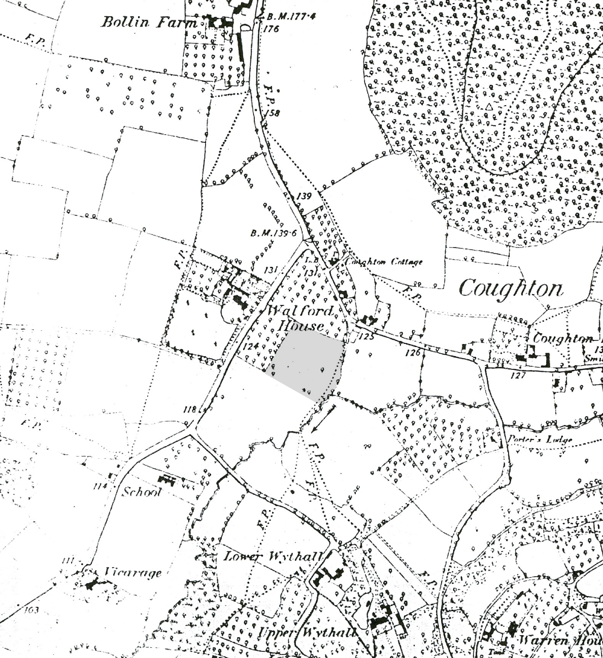

Fig. 4: Extract from OS 1st edition 6 inch map of 1891 (Herefordshire 51 SE) with area of excavation site shaded
(Reproduced courtesy of Herefordshire Record Office)

The OS 1st edition 6 inch map of 1891 (Herefordshire 51 SE) (Fig. 4) shows that the field called Little Fowbridge Meadow in the 1840 tithe map had been absorbed into the larger pasture field to the W and was then bounded by orcharding to the N and W and to the SE by a brook. The OS 2nd edition 25-inch map of 1902 shows that, at some point between 1891 and 1902, the meadow once again had been divided into two enclosures by the establishment of a rectilinear field boundary aligned NW-SE. By the late 1960s, the existing houses at Fowbridge Gardens had been constructed on the site of ‘New House Orchard’ immediately NW of the excavation site.

- Methodology

Full written, drawn and photographic records were made in accordance with archaeological practices set out by the Institute of Field Archaeologists (1994; revised 2001). Archaeological deposits, features and structures were recorded in plan at a scale of 1:20 and in section or elevation at 1:10, as appropriate. All features and structures were photographed using digital and 35mm colour print formats.
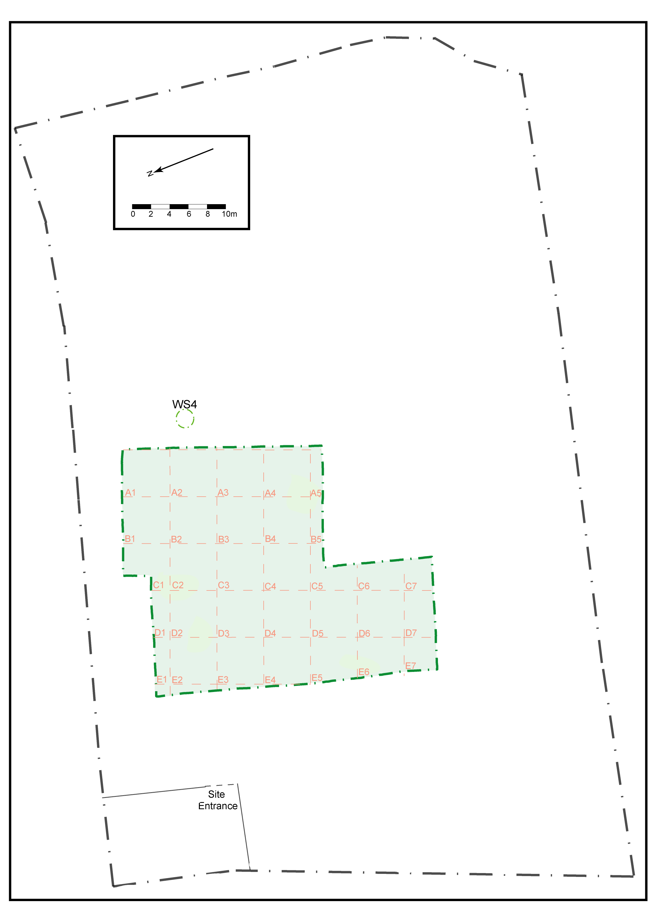
Fig. 5: Site plan

A detailed stratigraphic record was made using a sequential context numbering system starting from (101) and a Harris matrix was produced for the entire site.

A temporary benchmark of 37.58m OD was derived from an OS benchmark located on Hillview Villas Coughton and from this all site levels were taken.

A judgement environmental sampling strategy was employed whereby samples were taken from deposits rich in environmental indicators such as shell and charcoal or from waterlogged deposits.

Initial machine excavation was carried out using a toothless bucket to a depth indicated by the previous evaluation (2003-4). Features were subsequently hand excavated, with large linears sampled approximately every 5m and smaller linears and discrete features either partially (i.e. 50 percent) or fully excavated. Homogenous layers were sampled by hand and fully excavated if found to overlie earlier features; in the absence of any such features no further investigation was undertaken.

The excavation area was bounded to the S by the presence of diesel contamination, to the E by structural foundations and to the N by site access requirements. In addition, a 2m border was established in anticipation of potential depths being reached that would require stepping (Fig. 6).

Finds were retained from sealed contexts revealed at the excavation depth; later finds were noted but not retained.

- Results

The recorded contexts can be divided between nine distinct phases, only four of which apply to the excavated features; the remaining five reflect post-medieval and modern episodes of activity. This report contains the results of the post-excavation analysis of the pottery assemblage and environmental samples.

Site natural (105) consisted of dark reddish-brown sandy gravel with occasional quartzite pebbles, patches of light yellowish-brown silty sand and bands of light reddish-brown sandy gravel. Overlying this in irregular patches - which in plan often had the appearance of features - was a clean, mid reddish-brown sandy clay (111). Several of these areas were excavated to confirm that they were not anthropogenic and all were found to consist of sterile deposition.

Phase 1
Five cut features were assigned to Phase 1. Features [208], [210], [212] and [214] were all small sub-circular pit/posthole features revealed beneath the Phase 2 occupation spread (172) (Plate 1). These features did not appear to form coherent structural remains and if they had indeed related to some kind of structure on the site of the Phase 2 roundhouse then several other posthole features were no longer extant. Feature [208] was 0.3m in diameter and 0.15m deep, [210] 0.2m in diameter and 0.1m deep, [212] ovoid 0.72m x 0.5m x 0.33m (Fig. 17) and [214] 0.5m in diameter and 0.2m deep.

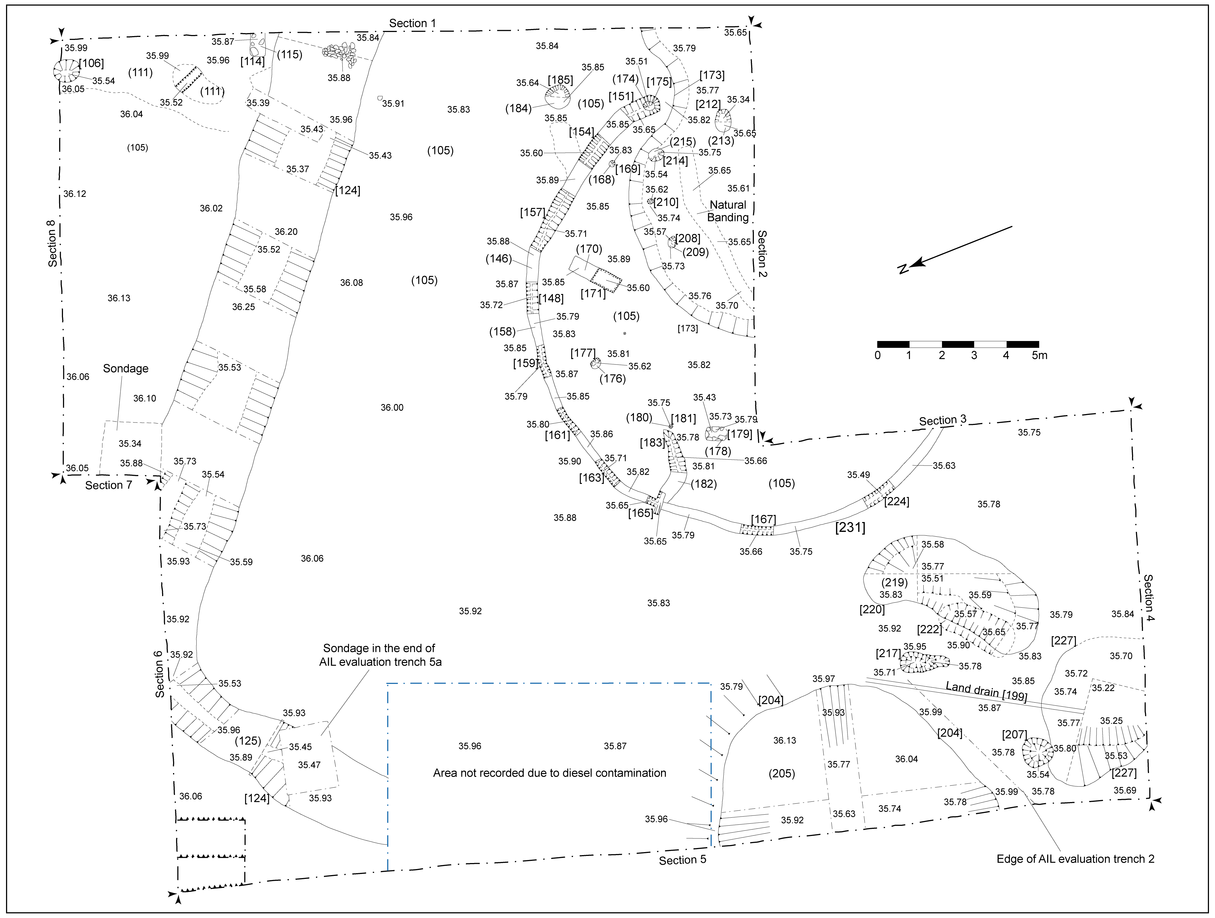

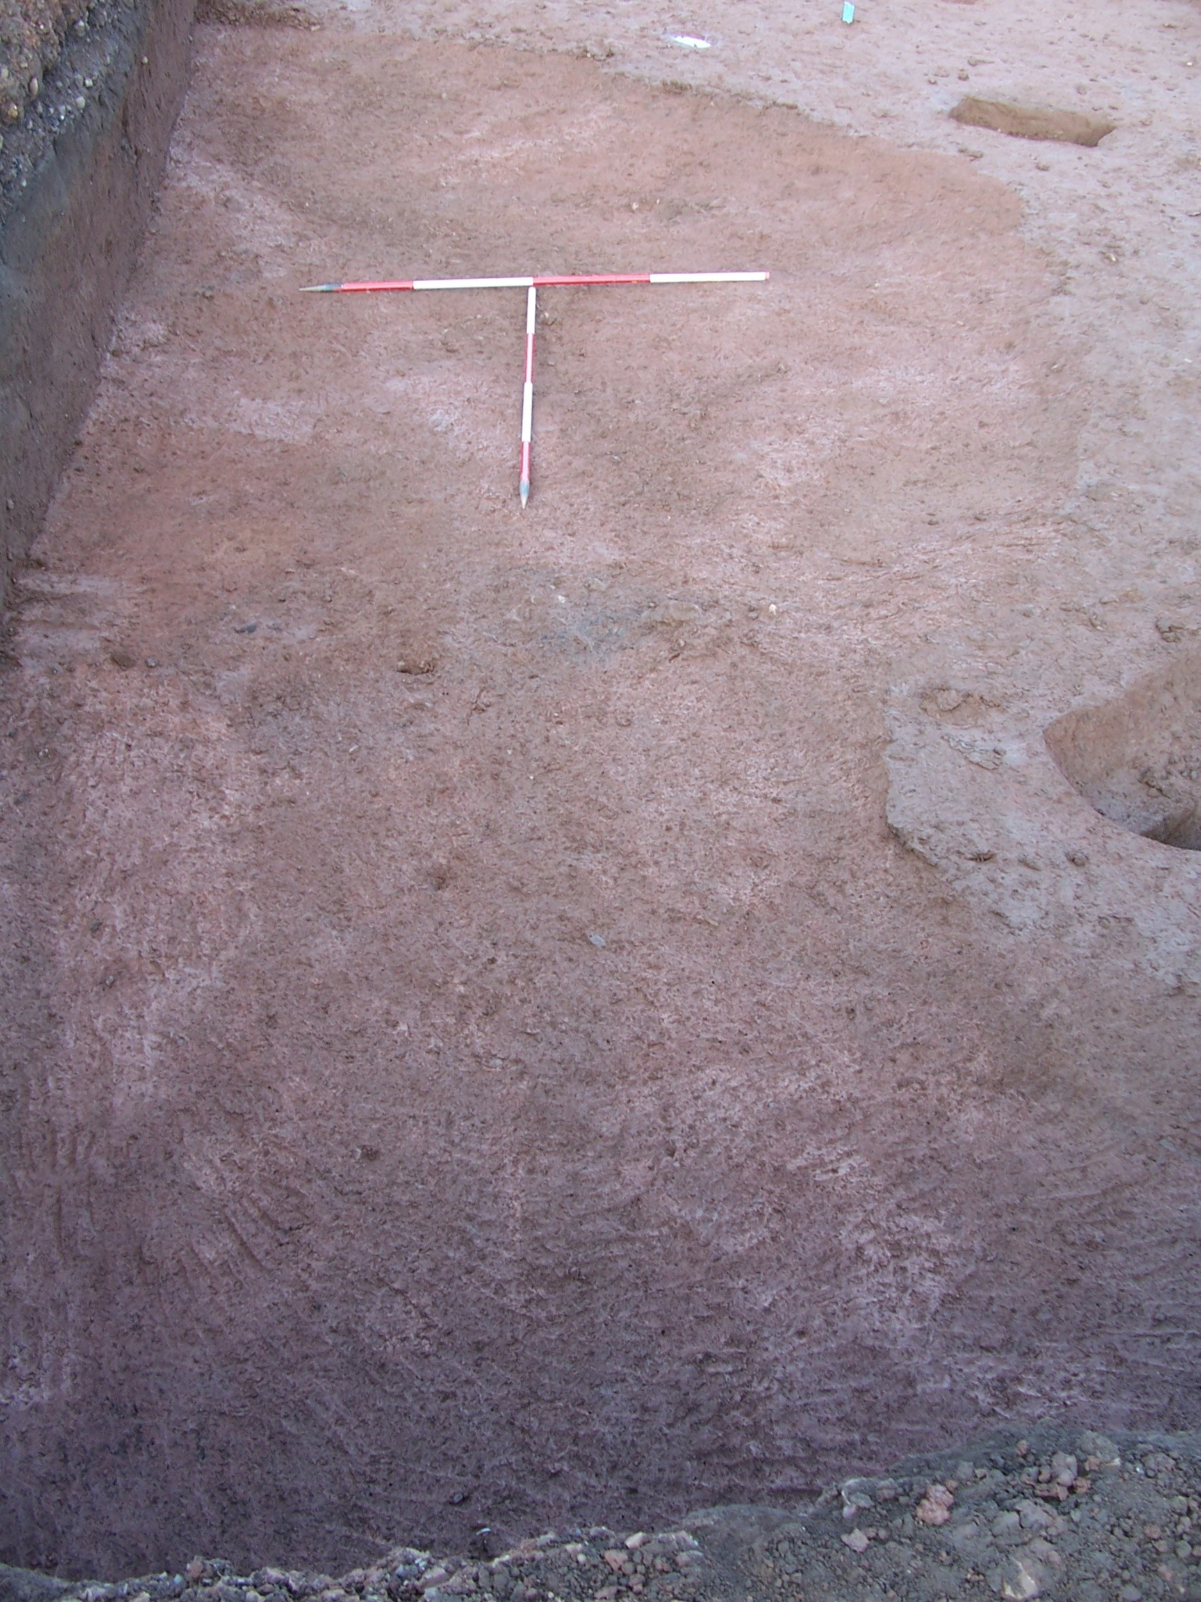

Plate 1: Features revealed below (172), pre-excavation, looking NW

Features [208] and [210] revealed similarities in terms of profile and fills while the other two features resembled truncated pits, with [212] in particular apparently utilised - at least following its abandonment - as a waste disposal pit. It is possible that these features, rather than representing an earlier phase of occupation, related to the construction of the roundhouse. However, if that were the case and all were backfilled simultaneously, a greater similarity of fill deposits would be expected. Only the fill (213) of pit [212] produced finds and these included animal bone, two sherds of handmade native Malvernian limestone wares and a single piece of post-medieval tile.

The fifth feature [222] was a pit measuring 3.08m E-W x 1.15m N-S x 0.36m, which appears to have silted naturally through prolonged exposure to the elements; no finds were recovered from single deposit (221). The function of [222] remains unclear; its profile suggests it may have undergone a significant degree of truncation.

Phase 2
Ten cut features have been placed within Phase 2. Overlying Phase 1 features [208], [210], [212] and [214] was a homogenous spread (172) contained within a depression [173]. Although this depression was assigned a cut number, it probably represented erosion of the friable ground surface through constant use, as in the formation of a holloway, rather than a cut feature. The depression measured 9m SE-NW x 3.3m NE-SW x 0.2m and extended beyond the excavation area to the SE and SW; that it did not shallow significantly at either extent suggests that it continued well beyond the baulks. The material (172) within this depression contained abraded potsherds of late 2nd-3rd century date, animal bone and charcoal patches and appeared to relate to intensive occupation. A sample was taken from (172) but this did not provide any useful palaeoenvironmental evidence relating to the active life of the roundhouse.

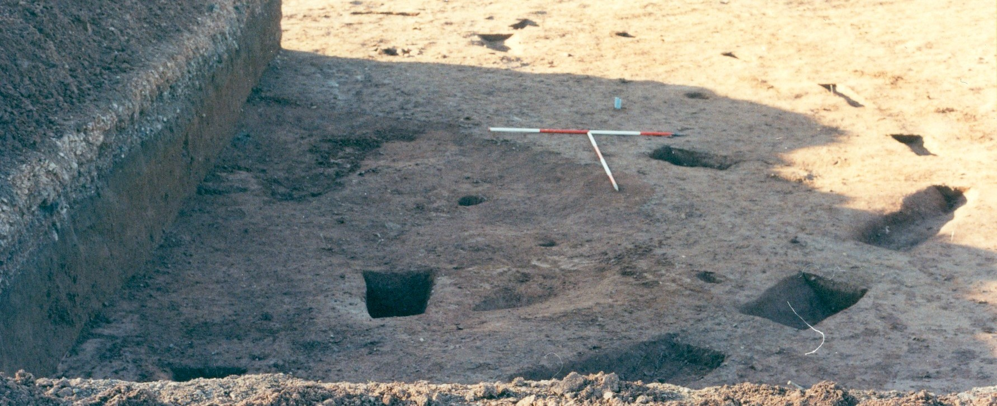

Plate 2: Roundhouse gully [231] and internal features, looking NW

Depression [173] respected the outline of curvilinear [231], which represented approximately 75 percent of a penannular gully having a maximum diameter, width and depth of 14.58m, 0.54m and 0.2m (Plate 2; Fig. 7). The curvilinear was irregular in form with a relatively deep and rounded profile at the visible terminus. The feature became increasingly sharp-sided and irregular before truncation along the northern arc resulted in a much shallower profile; the profile to the W was squarer and resembled a beam slot. The feature was evaluated by 10 segment cuts ([148], [151], [154], [157], [159], [161], [163], [165], [167] & [224]) and in addition to variations in profile these revealed apparent differences in the fills of the NE slots and those on the N and W (Plate 3; Fig. 14). This variation in profile and deposition seems consistent with an interpretation of the feature as a drip gully; that is, a roughly excavated drainage feature that was subsequently weathered and eroded. This would then point to a circular structure within the ring of the gully with an approximate diameter of 12.5–13.5m, allowing for overhang at the eaves.

The penannular form of the gully is unusual, as a drip gully would normally be expected to encircle the roundhouse without a break. This may be explained by the presence of posthole [175] in the gully terminus (Plate 3; Fig. 7). This was 0.28m in diameter and 0.11m deep; no evidence of packing material was found within the half-section excavated and fill (174) seemed similar to the upper fill of segment [151] (Plate 3; Fig. 14). This perhaps suggests that [175] and [151] were contemporary, that the primary fill of [151] - the silting material (150) - was deposited while [175] was in use and that the abandonment backfill (149) was deposited at the same time as (174); that is, the two features were in use and went out of use concurrently.

If so, [175] may have formed a support for a porch at the front of the structure. Such a structure would probably have possessed a gabled roof, which would thus have created a break in the circuit of a drip gully and deeper gullies would have formed at the porch edge, which is the profile seen in [231].

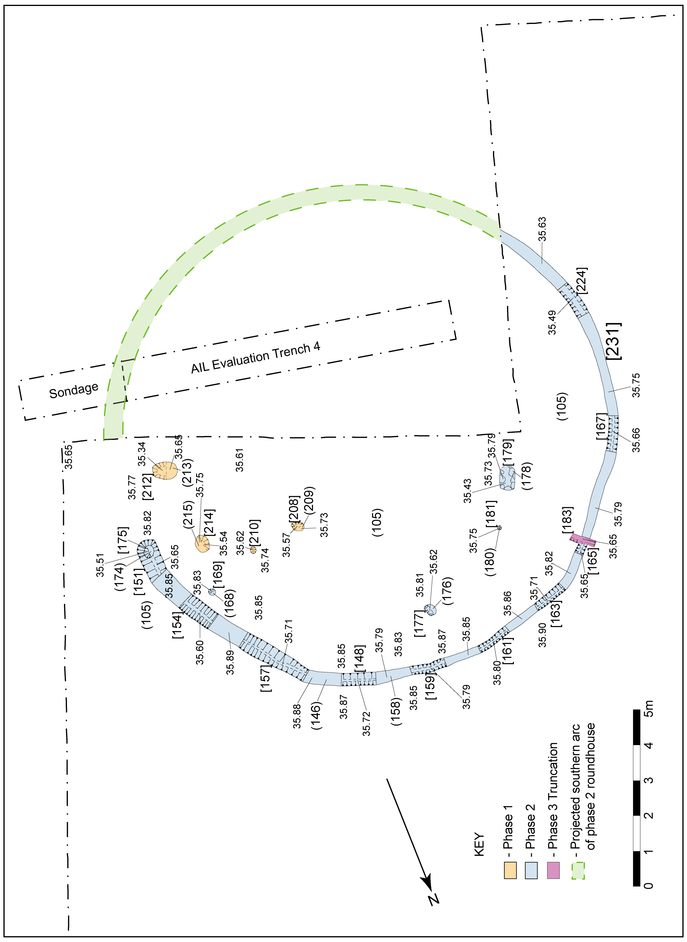

Fig. 7: Plan showing curvilinear [231] and approximate location of evaluation trench (2003-4)

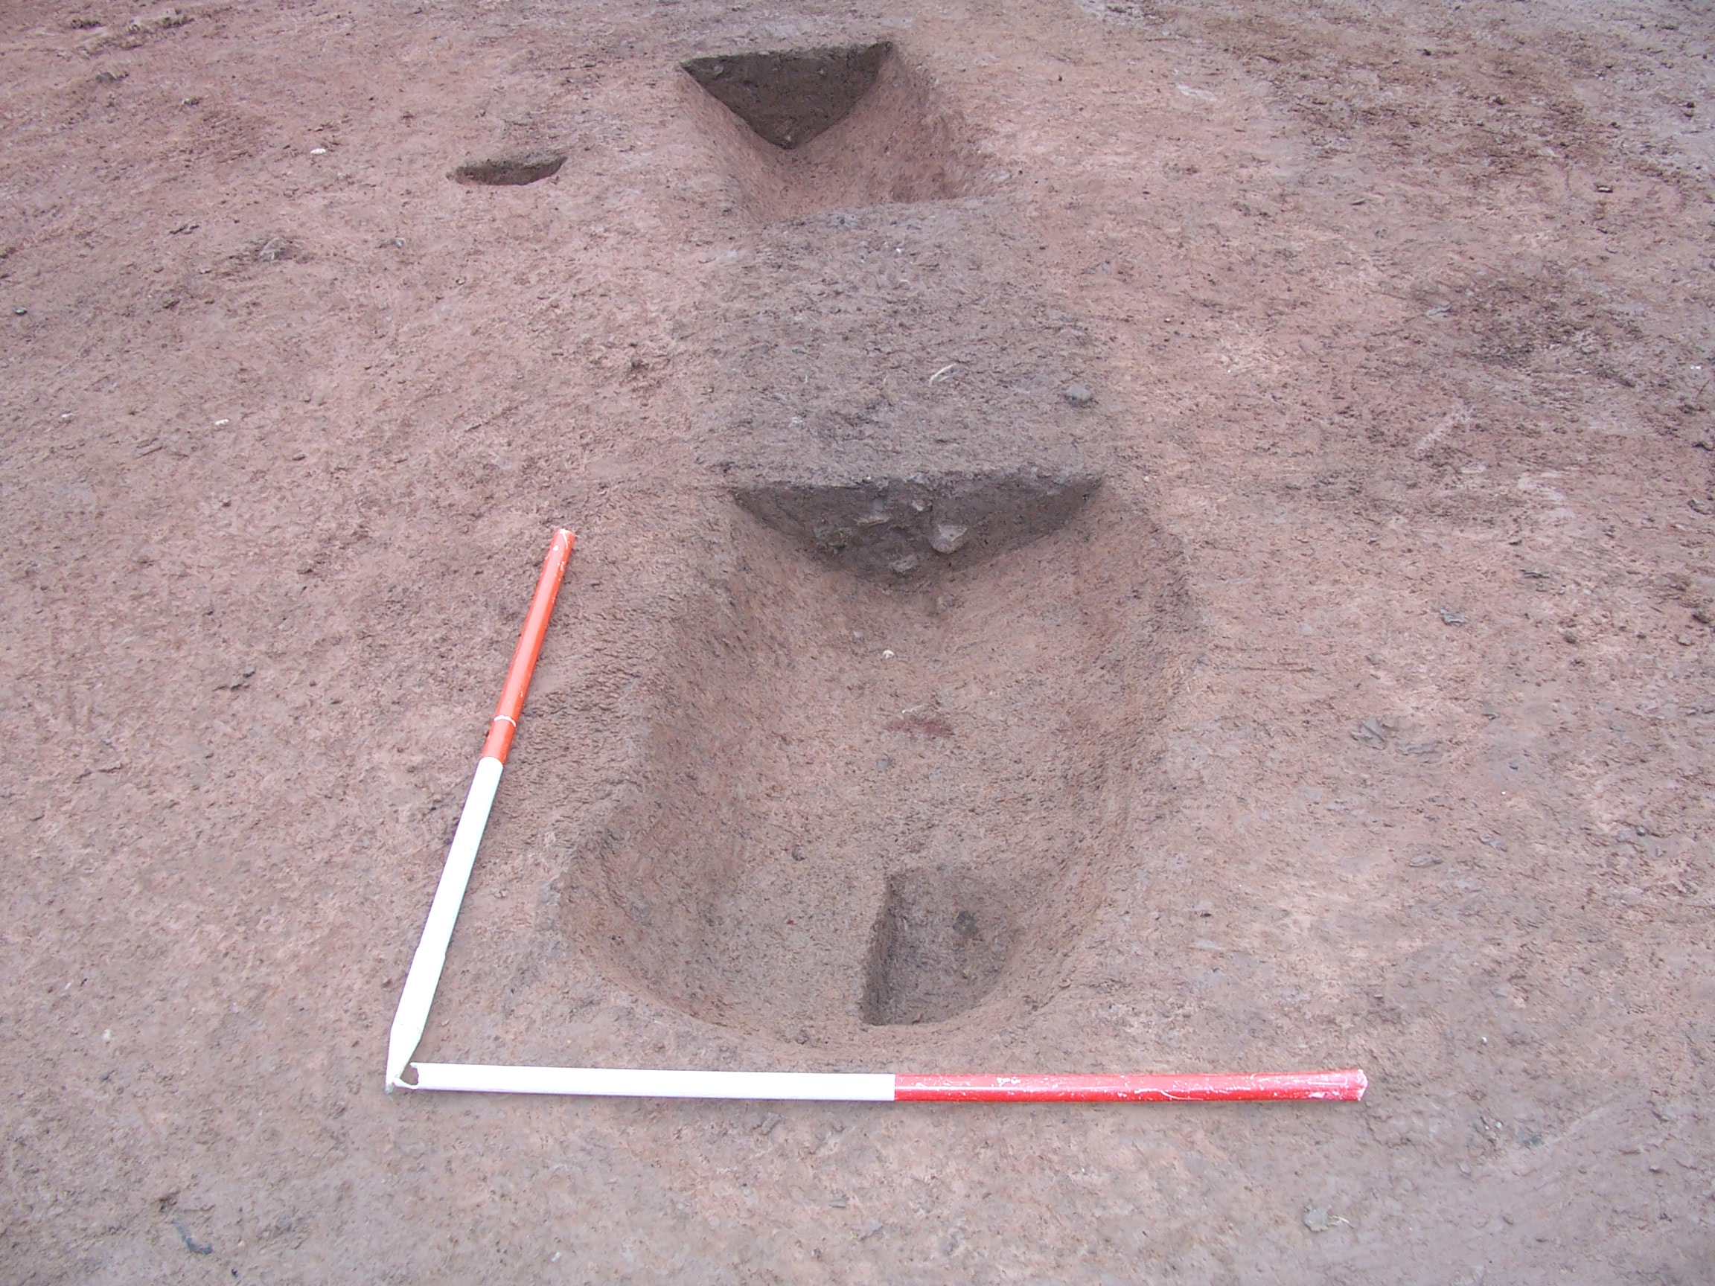

Plate 3: Terminal section [151] through gully [231] showing posthole [175], looking N

Another possibility is that the posthole related to the construction of an effective, weatherproof roof using an A-frame device inclined towards the apex of the roundhouse. Experimental archaeology has shown that thatching material threaded onto an A-frame and moved upwards along the poles will form a tight weave as the structure narrows towards its apex. Posthole [175] had no obvious inclination of axis indicative of such a device; however, the friability of the natural material is such that any visible inclination could easily have been destroyed during removal of the post. A third possibility is that [175] predated [231] altogether and should be included with Phase 1 post features [208], [210], [212] and [214] but this possibility has been discounted because it is unlikely that such a feature would be located precisely within the terminus of the gully. No finds were recovered from [175] and just a few potsherds from the segments across [231], primarily at the terminal end. The western arc of [231] ran S into the baulk beyond the limit of excavation. Assuming a regular gully radius, the southern curve should have passed through the location of Trench 4 of the previous evaluation (2003-4). The fill of [231] was sampled at the terminus as <3> (taken from the terminal fill (149) of [231] in segment [151]); however, subsequent analysis was unable to provide any additional information regarding palaeoenvironmental conditions at the time of deposition.

Within the circuit of [231], but not covered by (172), were four further discrete features ([169], [177], [179] & [181]) (Fig. 15). Features [169] and [177] were similar postholes, both situated about 1m from the internal curve of [231], along its eastern arc. Posthole [169] was 0.24m in diameter and 0.06m deep and [177] was 0.3m in diameter and 0.11m deep. These may have been associated with the Phase 1 postholes rather than the Phase 2 roundhouse but it seems more likely that they related to the latter, either forming part of the structure or playing some role in its construction. Feature [181] was either a small, truncated posthole or a stake-hole. The feature measured 0.18m N-S x 0.12m E-W x 0.09m in an ovoid cut with sloping edges suggestive of a post or stake being levered from its hole. The function of the stake or post is not clear, although it seems likely to have related either to the roundhouse or to the Phase 1 postholes.

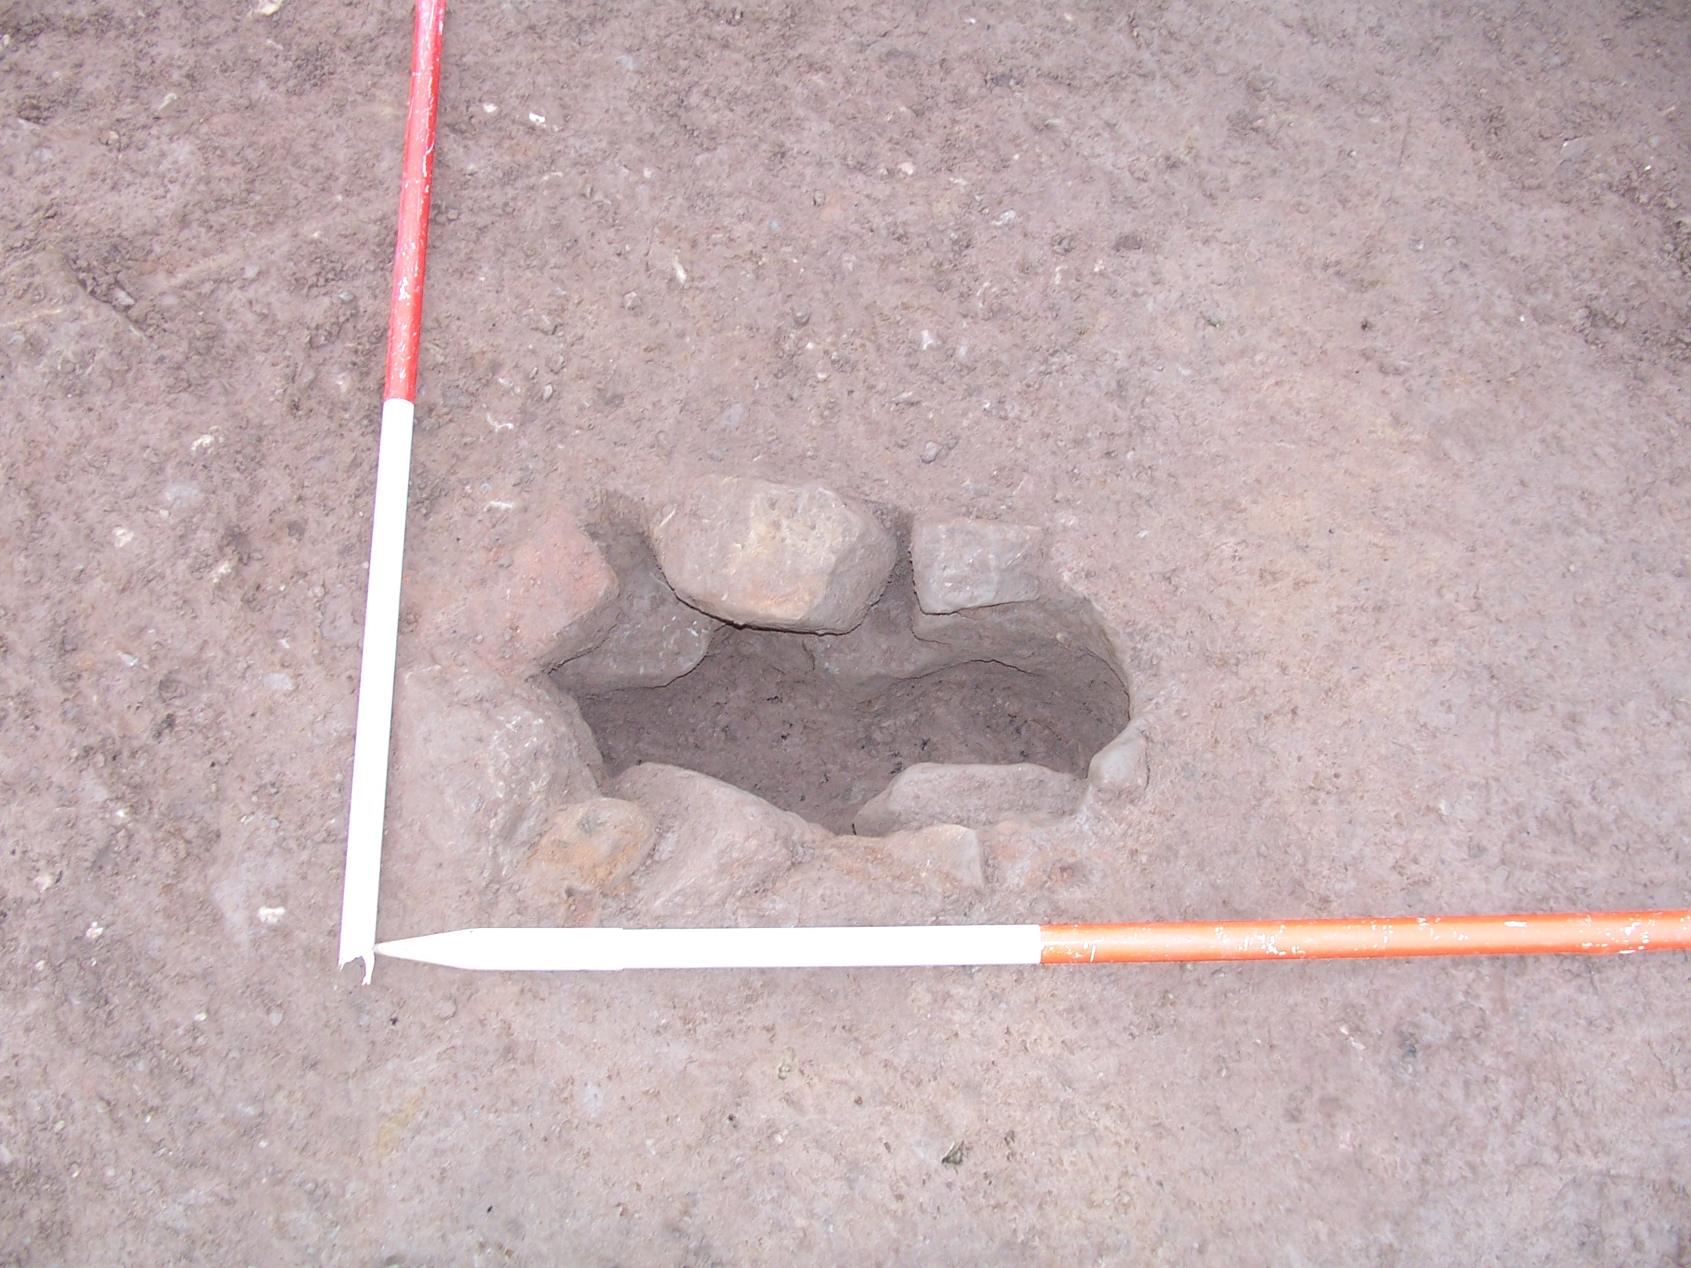

Plate 4: Stone-lined posthole [179]

Feature [179] (Plate 4; Figs. 7 & 15) was a small pit measuring 0.6m E-W x 0.3m N-S x 0.3m and lined with sandstone impressed into natural. The stones did not appear to be burnt and no clear function could be assigned either to the stones or to the feature as a whole. The stones may well have represented packing material for a substantial post but no similar postholes were located within the vicinity; it may be that this represented a substantial supporting post relating to the roundhouse or to earlier activity in the same location.

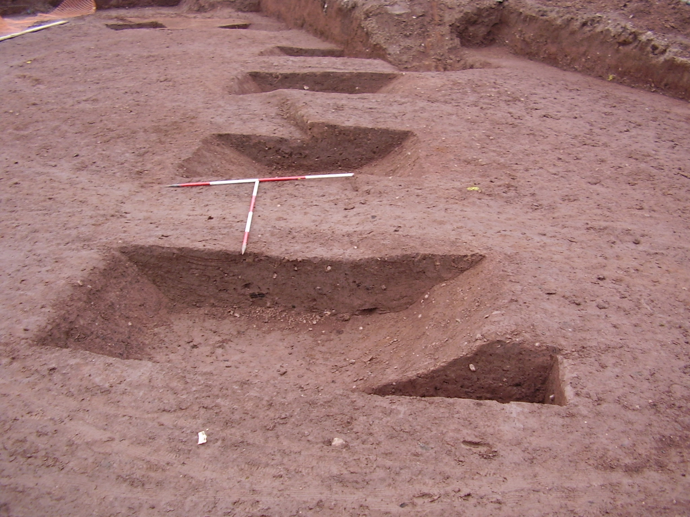

Plate 5: Ditch [124] looking WNW, showing excavated segments

A probable boundary ditch consisting of a linear [124] running WNW-ESE towards the eastern edge of the excavated area (Plate 5; Figs. 11, 12, 13 & 16) measured 20.15m WNW-ESE x 2.9m (maximum) x 0.65m (maximum). At its northernmost visible extent it ran into the baulk and at the same point appeared to turn SW, running a further c.13m NE-SW. If the ditch did turn through 90 degrees at this point, it would seem likely that it formed an enclosure boundary, perhaps a settlement boundary relating to [231]; however, if the NE-SW turn was actually another, conjoined feature and [124] itself continued WNW-ESE, these ditches would most likely be interpreted as field divisions. The similarity in deposition throughout [124] suggests that both the WNW-ESE and NE-SW ditches were open and abandoned at the same time. The ditch produced two fills consistently along its profile.

The upper fill (125) produced a relatively large amount of late 2nd-3rd century Roman pottery and some animal bone but no material was recovered from the primary fill (126). Samples were taken from (125) (<1>) and (126) (<5>) but these did not provide sufficient information to carry out any comparative analysis regarding palaeoenvironmental variation between the deposition of the two fills. Fill (125) may, in fact, relate to a re-cutting or cleaning of the ditch but only one of the ditch profiles suggested any such episode and this may be anomalous; thus, no separate cut number was assigned. It is possible that the early phase of [124] related to the posthole activity in Phase 1 and the later phase to [231] but this could not be confirmed and it seems more likely that (126) represented the active life of the boundary and (125) was the disuse backfill.

Partially truncating Phase 1 pit [222] was a broad kidney-shaped feature [220] that appeared to be the base of a large pit measuring 5.2m NE-SW x 2.1m NW-SE x 0.17m (Plate 6; Fig. 6). The relative shallowness of the feature suggested severe truncation or that the pit was not intended for waste disposal or storage initially. Finds from its single fill (219) included pottery, animal bone and iron slag. The presence of iron slag may indicate a relationship with neighbouring slag-rich feature [227] and that the two features served a similar purpose, although what this might have been is unclear. Feature [227] itself was located in the W corner of the site and was an irregular feature very poorly defined in plan, as fill (226) and natural (105) were barely distinguishable (Plate 7; Fig. 6).

The feature was excavated by means of a slot through the section N of the point of truncation by a land drain and W of where it was truncated by Trench 2 of the previous evaluation (2003-4). As far as could be ascertained, the feature measured 5.08m NW-SE x 3.2m NE-SW x 0.42m and continued SW beyond the excavation area. The evaluation report (Archaeological Investigations Ltd. 2004 Report No. 37149; SMR No. 35400) interpreted the feature as a ditch (2012) running N-S; however, within the slot undertaken during the excavation it appeared to be a pit feature. The upper fill (225) contained frequent angular sandstone, some of which was burnt, as well as a number of fragments of iron slag and several potsherds. The burnt stone and iron slag may have been a form of clinker or furnace residue suggesting the presence nearby of ironworking or the deliberate importing of this material to backfill the upper part of [227], presumably as hardcore. If this was the case, the purpose of this surface is unclear, as it did not appear to form a path or road but was a rather patchy area along the E edge of pit [227].

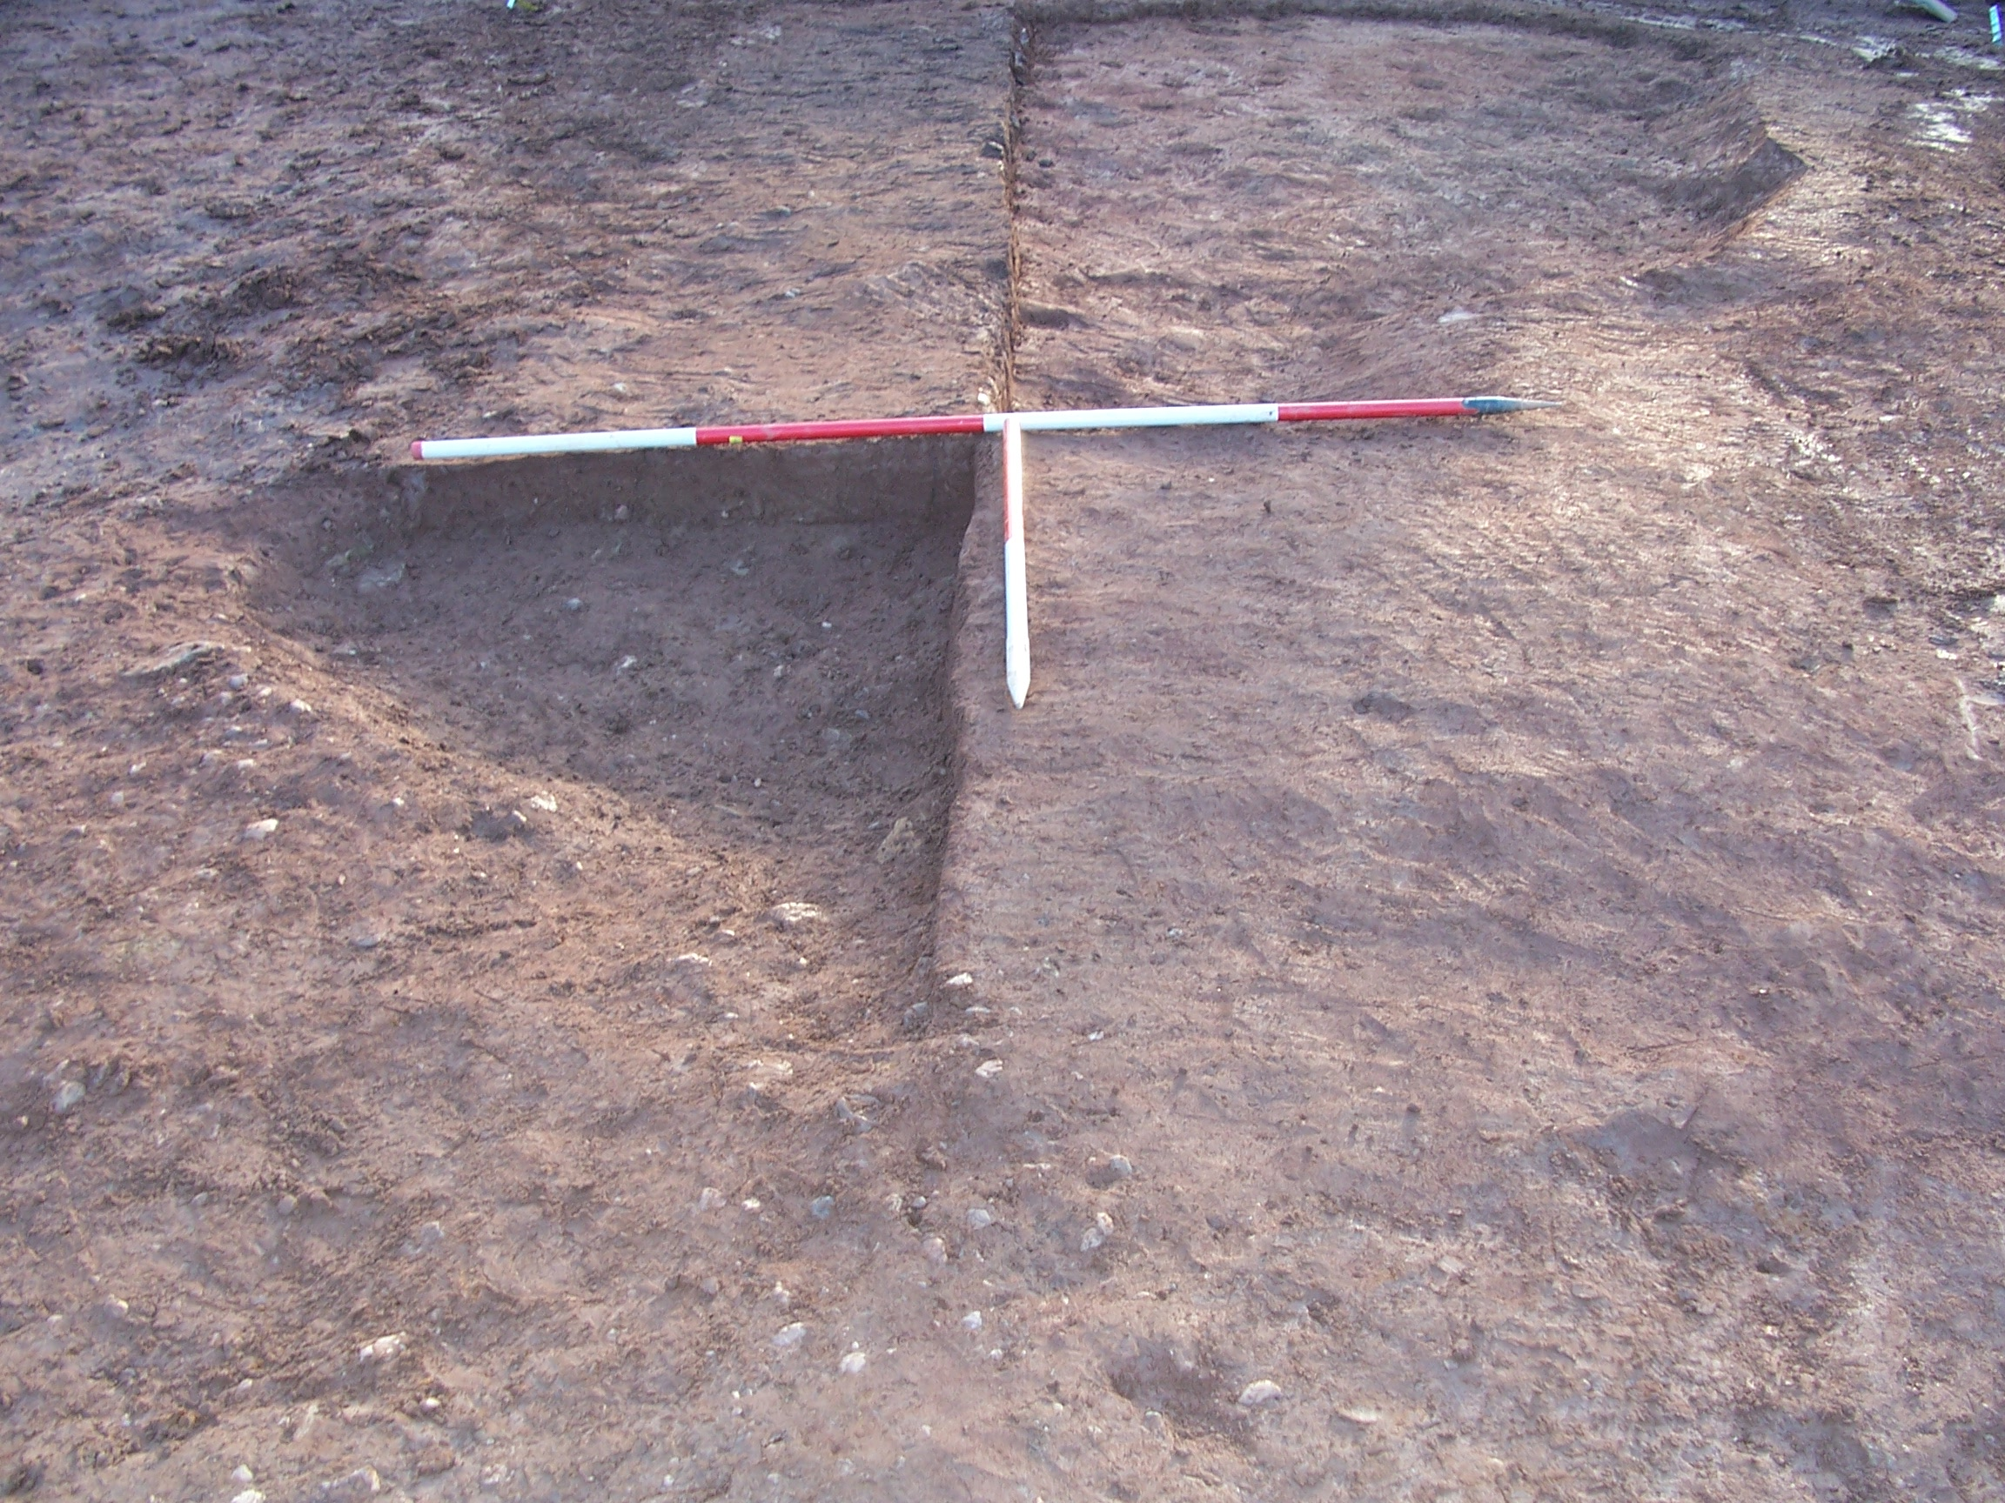

Plate 6: Kidney-shaped feature [220], looking SW

.

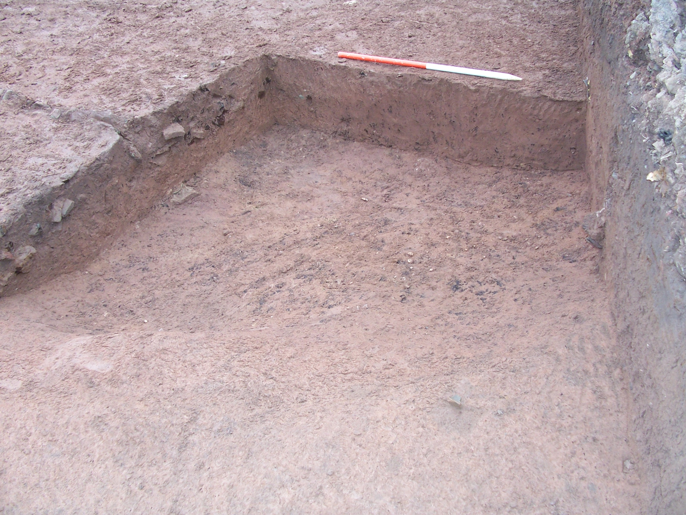

Plate 7: Slot across pit [227], looking E

Over the western and northern extents of the feature was a 0.3m-deep mid reddish-brown sandy silt with occasional charcoal flecks and patches (197) (Fig. 10). This was interpreted as a flooding or artificial levelling layer but its nature remains unclear as it was removed by machine during the initial strip-back and only recorded in section.

Phase 3
Phase 3 comprised five cut features, two of which, [185] and [217] (Fig. 18), had no stratigraphic relationship with any other feature and thus could be assigned to any of phases 1-3. Due to this uncertainty, these features have been assigned to Phase 3, the latest possible phase, to avoid ‘polluting’ earlier phases with later activity. Feature [185] was a pit located 2m NE of the terminus of Phase 2 gully [231], which measured 0.74m in diameter and 0.21m deep. The pit contained a single fill (184), which produced a moderate amount of charcoal, possibly indicative of domestic waste, although no other domestic finds were recovered from the half-section excavated. It is quite possible that this pit was associated with the Phase 2 roundhouse during its active life, or even with the activity represented by the Phase 1 postholes, but no definitive relationships or finds existed to support this interpretation.

A circular pit with a curious sloped gully/edge to the SW [217] may have had a function relating to nearby Phase 2 features [220] and [227] before being utilised as a domestic waste pit after abandonment. The main bowl of the feature was quite sharply defined, with relatively steep edges, and the single fill (218) contained several large pottery fragments, including Severn Valley ware and Dorset black burnished ware, one fragment of which had an acute lattice decoration suggesting a 2nd-century date. The irregular shallow-sloped gully extending 1.5m SW-NE ascended from the SW edge of this bowl. The main bowl measured 0.66m in diameter and 0.23m deep. The presence of such large pieces of pottery suggests deliberate deposition but these pieces were all incomplete and apparently domestic waste. The function of the sloped gully is unclear. Single fill (218) was sampled as <4>; however, this sample was not processed due to diesel contamination.

An ovoid pit cut measuring 0.95m SW-NE x 0.92m NW-SE x 0.22m [207] contained the remnants of a mid reddish-brown clayey silt with frequent flecks and fragments of charcoal, especially around the base of the feature (206). Pit [207] (Fig. 6) cut through (225) in [227] and was almost fully contained within Trench 2 of the 2003-4 evaluation, although the deposit was only partially excavated. The deposit (2007) is described as ‘… a dark brown silty loam with abundant charcoal. The finds present included 2 very small sherds of mudstone tempered ware, dated between the 5th century BC and the latest Iron Age, and an iron object’ (Archaeological Investigations Ltd. 2004 Report No. 37149; SMR No. 35400). No finds were recovered from the remnant fill when the feature was cleaned. During the evaluation, no interpretations of the feature were made based on removal of the bulk of the deposit and from the 10 percent or so that remained little could be gleaned. The most likely interpretation, given the reported small pottery fragments and the visible quantity of charcoal, is that this was a domestic waste disposal pit or perhaps even a raking pit for some nearby burning feature, such as a hearth or light industrial oven.

The visible portion of a large roughly semicircular feature [204] measured 8.8m NE-SW x 4.5m NW-SE x 0.5m, extending NW beyond the excavation area. The feature cut through Phase 2 apparent flooding deposit (197) that overlay [227]. It is possible that this deposit also overlay [207], although the evaluation trench removed any evidence of this. If this were the case, then (197) would move into a phase of its own later than the deposition of (206), which would then be followed by another phase containing just [204]. While this is plausible, it would involve the creation of an unnecessarily extended matrix, which, in the absence of supporting evidence, was deemed inappropriate. Feature [204] itself appeared to be a vast pit or pond that had silted up naturally with a clean silty deposit (205) containing occasional gravel but no finds to suggest a date or function. It was thus interpreted as a natural feature, such as a pond or hollow, which remained open for a prolonged period during which (205) accumulated.

A short curvilinear measuring 2.15m NNW-ESE x 0.5m x 0.1m [183] had a rough irregular profile and form and was likely to have been a natural feature, such as a tree throw (Fig. 6). The hole was subsequently filled by a clean silty deposit (182), which contained no finds. This feature cut across the fill of [231] along its NW curve, in segment cut [165].

Phase 4
In order to attain the depths required to excavate the Romano-British features identified during the previous evaluation (2003-4), all deposits above this level were removed by machine and recorded only where present in the trench sections.

Layer (104) was deposited during Phase 4 and extended across the site. This layer had a maximum thickness of 0.5m and consisted of mid reddish-brown silty sand with occasional small-to-medium angular and rounded stones and charcoal flecking. The nature of this layer was unclear, although it is likely to have been either a flooding deposit, hillwash from the nearby slopes or a mixture of both. As there was no obvious increase in thickness to either the river or hill-slope side of the site, it was impossible to say which, although this uniformity of thickness perhaps suggests alluvial rather than colluvial deposition. However, if the interpretation of site natural as colluvium over river alluvium (see 2.1) is correct, then any combination of these depositional processes is possible.

Deposit (134) was also a mid reddish-brown silty sand with occasional charcoal flecks and patches and this had a maximum thickness of 0.48m. This seemed likely to be the same deposit as (104), although possibly indicative of an earlier phase of flooding or hillwash.

Phase 5
Identified in the trench sections were seven cut features, five of which were cut into (104), with the remaining two cut into (134). Feature [127] was cut into (104) along the SE edge of the site and appeared to be a pit measuring 0.48m wide and 0.25m deep, although, as recording was in section, the form of this feature in plan was uncertain and it may have been linear. The single fill (128) consisted of mid brownish-grey silty sand and the base of the feature was lined with twigs, the function of which remains unclear. A single fragment of oyster shell was found within the deposit.

Also cutting into (104) along the SE edge of the site was a broad deep feature [120] interpreted as either a pit or, more likely, a ditch, which appeared to follow an alignment similar to Phase 2 boundary ditch [124] and may have been a much later re-emphasis of that feature. This probable ditch was backfilled with an homogenous fill (234), from which no finds were recovered, above which was a secondary fill (121) measuring 0.64m wide and 0.35m deep, which appeared to be V-shaped in section, although this is likely to be misleading as the deposit was seen to fluctuate in plan. It may be that this was a secondary feature cut into [120] but this could not be ascertained from the section.

Features [122], [131], [135], [199] and [229] were deep narrow linears, [122] measuring 0.24m wide and 0.52m deep, [131] 0.38m wide and 0.48m deep, [135] 0.36m wide and 0.5m deep, [199] 0.2m wide and 0.6m deep and [229] 0.25m wide and 0.5m deep. All five features were backfilled by medium sized (average 0.1m x 0.1m x 0.06m) angular and rounded sandstone fragments with frequent voids. Features [122], [131] and [229] all cut (104) (Fig. 8), while [135] and [199] cut (134) (Fig. 9). These seemed to comprise an extensive system of land drains, possibly indicating that, following the presumed flooding represented by (104) and (134), the land no longer drained effectively or that smaller scale flooding was more common.

Phase 6
Phase 6 comprises a ‘lumped together’ phase of land-levelling and ground make-up. Thirteen deposits were assigned to this phase, many overlying each other in a series of tips and slumps indicative of the dumping of material from a number of sources, presumably to build up the ground level.

Among these layers, (103) was notable as being a broad layer extending across the site over which many of the other layers accumulated. It consisted of dark greyish-brown silty sand with moderate CBM and stones, occasional charcoal flecking and modern debris and at its thickest it measured 0.6m (Fig. 8).

Deposit (117) was thick and wide and appeared to be contained within a ‘cut’ [216]. This feature was visible only in section and it is probable that, rather than being a cut, it represented a tip of material over the sheer edge of another, in this case (103).

Deposit (196) sat directly over Phase 4 layer (134) and beneath Phase 7 layer (187) (Fig. 10). It appeared to be a deliberately dumped levelling layer, although of all the Phase 6 layers this most closely resembled a naturally accumulated deposit, with little evidence of anthropogenesis, except for the presence of charcoal flecking and patches.

A mid pinkish-grey gravel dump (110) measuring 13m x 12.5m x 0.2m overlay both (117) and (133). Deposit (133) was a mid pinkish-brown sandy silt directly overlying (103) and measuring 1.48m NW-SE with a maximum thickness of 0.22m.

Smaller tips of varying materials were dumped over (103) beneath Phase 7 layer (187). Deposits (190), (191), (192), (193), (194), (195), (228) and (233) represented fairly modern dumps for levelling and make-up: (190), (193) and (228) consisted of sandy gravel while (191), (192), (194) and (233) contained lumps and slabs of tarmacadam (Fig. 10). Deposit (195) was a thick mixed dump of modern material, including plastic sheeting, concrete and the remains of a 1950s motor vehicle.

Phase 7
Overlying (190) and (196) was Phase 7 dumped layer (187), a mid reddish-brown clayey sand with frequent gravel and moderate small-to-large angular stones, which had a maximum thickness of 0.65m. This appeared to be a deliberate dump intended to level the ground surface.

Four features within this phase of activity cut into (103). Cut [106] was sub-circular in form and measured 0.64m x 0.74m x 0.54m. Its single fill (107) contained frequent shards of modern clear window glass and it seems likely that this feature represented the deliberate burial and thus the safe disposal of this material.

A modern pipe trench [118] cutting into (103) measured 0.6m wide and 0.54m deep and its single fill (119) contained a modern plastic pipe, which had been capped prior to the excavation and was broken off to the baulk to allow greater manoeuvrability within the trench. A second modern pipe trench [129] cutting through (103) measured 0.58m wide and 0.28m deep and its single fill (130) also contained a modern capped plastic pipe, which was again broken off to the baulk (Fig. 8). Both pipes appeared to relate to the former Welsh Water works. Context (130) also contained a small quantity of Romano-British pottery sherds dated to the 2nd-3rd centuries AD, which on stratigraphic terms, however, must be considered as residual.

An E-W rectilinear cut with squared corners [171] cut into (103) and measured 1.7m x 0.51m x 0.48m. This was filled by a single mixed deposit (170), which included tarmacadam, CBM and concrete fragments, and was interpreted as a relatively modern test pit, probably relating to ground assessment activity prior to establishing the Welsh Water works.

A modern pit or posthole [188] cut into (104) measured 0.44m wide and 0.38m deep and was exposed only in section (Fig. 11). Within its single fill (189) were lumps of concrete and CBM, which appeared to represent a dump of material within the pit, although it is unclear whether this was deliberate backfilling after the pit had served its purpose or packing to support a post or similar.

Phase 8
Phase 8 comprised 13 deposits that were dumped and tipped to form the works yard. Of these, (116), (137), (138), (139), (140), (141), (142), (143), (144), (186) and (232) were tipping and levelling layers that varied in form and extent, suggesting random deposition using available demolition rubble and the completion of levelling works using imported hardcore material (Figs. 9 & 10). Tarmacadam layer (101) was then laid over the site to a maximum thickness of 0.1m. This overlay a very patchy deposit of sub-base material (102) consisting of reddish gravel with CBM fragments and modern debris measuring up to 0.2m in thickness. To avoid creating many irrelevant context numbers, the same number was assigned each time this material appeared in section, although there may not have been any direct physical relationship with other patches of (102) extant after site stripping.

Phase 9
Three cuts have been included within Phase 9 and these all represented pre-works for the current development. Cuts [108] and [201] represented Trench 5b and Trench 2, respectively, of the previous evaluation (2003-4) and [114] was a test pit, presumably relating to assessment of the ground prior to development. Trench 5a was contained entirely within the excavation area and hence was not recorded in section. Its alignment can be seen in the slight truncation of the side of ditch [124] and a boxed cut across the E-W return of [124].

- Interpretation of Findings

The stripping of the site exposed areas encompassing Trench 2, Trench 5a and Trench 5b of the previous evaluation (Archaeological Investigations Ltd. 2004 Report No. 37149; SMR No. 35400). No further investigation was made of features exposed in Trench 1 and Trench 3 or those in the western end of Trench 2 as these lay outside the designated excavation area. Trench 4 was deemed to be devoid of archaeological activity during the evaluation.

The site was reduced by machine to the level at which Romano-British features revealed during the evaluation were visible. The evidence for occupation on the site, based on the dating of the pottery assemblage, appeared to comprise three phases of activity extending from the 1st century up to the 3rd century AD (Phases 1-3). No artefactual evidence for occupation was found which could be dated with certainty earlier than the 1st century AD or later than the 3rd century AD.

A total of 28 layers and 16 cut features covering six phases of activity were recorded only in section as these post-dated the Romano-British features. These later phases were chronologically close, extending from the 19th century (Phases 4-5) through the 20th century (Phases 6-8) to very recent activity (Phase 9).

Late Iron Age/Romano-British Activity (Phases 1-3)

6.1.1 Phase 1
Activity within this phase consisted of five cut features, four of which were pits and postholes covered by (172) and were thus likely to predate the roundhouse. It is possible that Phase 2 postholes [169], [177], [181] and [179] - and even [175] - were contemporary with these postholes but this could not be confirmed and it was felt that [175] was almost certainly located purposely within the terminus of [231] rather than being truncated by it unintentionally.

Contexts [208], [210] and [214] were all revealed when (172) was excavated and appear to have been the bases of small pits or postholes, presumably truncated by depression [173]. Interestingly, they appeared to follow the northern boundary of [173] to an extent, although this could easily have been coincidental. They probably related to an earlier structure on the site of the Phase 2 roundhouse; however, this would have been considerably smaller, as if all three related to the same circular structure it would have had a diameter of little more than 4m. If [212], the fourth pit revealed below (172), was part of the same structure, the diameter would have been just under 4m. This pit also differed noticeably from the other three features and was almost certainly a pit rather than a posthole; it was also the only posthole/pit feature associated with the roundhouse to produce finds, containing animal bone and handmade Malvernian limestone wares together with a single piece of intrusive post-medieval tile. This suggests that it was a domestic waste pit or at least that it was utilised as such after its initial period of use.

A long rounded pit [222] of curious form was truncated on its eastern side by Phase 2 feature [220]. Its dimensions (3.08m E-W x 1.15m N-S x 0.26m) were such that it would appear not to have been a pit used simply for storage or waste disposal; it seems more likely that it was utilised as something akin to a bedding trench before being backfilled. No finds were recovered from the feature to assist in identifying its original function or when the feature was in use.

6.1.2 Phase 2
This phase represents the most intensive period of occupation on the site. In the W corner were two features, both of which produced iron slag. The first of these was a large kidney-shaped feature [220], which appeared too shallow to be a pit, suggesting either that it had suffered a significant degree of truncation or that another function was originally intended and that it was subsequently backfilled with waste. A total of 12 sherds of oxidised Severn Valley ware were recovered from the fill (219), which was dated broadly to the 2nd century AD.

The second feature [227], a pit, contained two fills, the primary fill consisting of a clean silt (226) similar to a redeposited natural, which may indicate that the feature remained exposed and subject to weathering and slumping of banked-up material for some time. The secondary fill comprised a dump of sandstone, burnt stone and iron slag (225), which may have been some form of clinker that was dumped in this location during the cleaning of an industrial feature; alternatively, the material may have been laid to form a surface. A total of 22 pottery sherds of Severn Valley ware, broadly dating from the 2nd century AD, were recovered from (225).

This secondary fill lined the NE edge of the pit, as seen in the excavated slot, although whether this was coincidental or deliberate is unclear. If this material was intended as hard standing, it did not appear to form a practical shape or surface. It is notable that (225) petered out at the SE extent of [227] and, given the similarity of (226) and natural, this made its edge very ill defined. The feature extended into the southern baulk and was partly excavated during the previous evaluation (2003-4) when it was interpreted as a linear (2012) and some late Iron Age pottery and animal bone were recovered. The feature was described as continuing into both trench sections.

An L-shaped ditch feature [124], which almost bracketed the excavation area, ran WNW-ESE and either turned or divided beneath the northern baulk, running NE-SW. To the SW, the feature ran into an area of diesel contamination located against the western baulk and thus could not be traced to its full extent within the excavation area; it also continued ESE beyond the eastern baulk into another area of diesel contamination. The homogeneity of the fills and the continuity of the cut indicated that the WNW-ESE and NE-SW linears were the same feature and a single cut number was thus assigned to both. This suggests that the feature formed a boundary ditch probably enclosing the settlement represented by [231].

It could not be shown that either the WNW-ESE or NE-SW elements of ditch [124] continued beyond their junction, as this junction lay partially beneath the northern baulk. If this were the case, the feature should probably be interpreted as a field division rather than a settlement boundary, although large subdivided settlement enclosures are not unknown.

The fact that the NE-SW return was not identified in evaluation trenches 2 and 3 is surprising, as it should have passed through one of them; however, if some licence is allowed with regard to the trench location plan, it would be possible for a ditch of more than 55m in length - before any hypothetical southern return - to pass between the two. The ditch contained two fills and the upper fill appeared in at least one profile to be a re-cut or cleaning episode, although this could not be confirmed. No chronologically diagnostic finds were recovered from the primary fill; samples were taken from both deposits but due to the absence of charred cereal grains these provided no chronological or economic information.

Feature [231] itself comprised a roughly penannular gully, the profile of which varied significantly around its circuit, with the 10 excavated segment slots revealing few similarities. The feature appears to have been a drip gully relating to a roundhouse. Many such features formed through erosion rather than being cut; however, it was often the case that a rough gutter would be dug to facilitate drainage from the eaves of a structure and to prevent seepage beneath its walls. The presence of squarish profiles on the western arc suggests the gully was originally fairly squarely cut and shallow and that erosion subsequently affected the profile. Drip gullies are usually circular in form, as the thatched roofing of such structures tends to form a complete circuit, but an explanation for the existence of a break may be found in cut [175], a posthole cut in the gully terminus.

It may be that this post supported one side of a gabled porch projecting from the front of the roundhouse and, although this would be an unusual construction, it would explain the increased depth of the gully around the terminus. Another possibility is that the gully, given its squared profile, was originally a wall or beam slot, although, if so, it must have been subjected to some form of subsequent disturbance to explain the significant variation in profile, particularly on the N and NE arcs, at which points the gully was V-shaped. In this case, [175] would presumably have formed part of the doorframe.

Whichever interpretation is correct, the aperture in the circuit was more than 3m wide, which suggests a very large porch or an impractical doorway; only further investigation to the S could have provided clarification. Assuming the curvature of the gully was consistent, the southern arc would pass through Trench 4 of the 2003-4 evaluation. As this trench was recorded as being devoid of features, three possibilities arise. Firstly, the break in the gully circuit was more than 5m wide, which would constitute a spectacularly wide entrance for a domestic structure and would probably invalidate the interpretation relating to [175]; second, a similar gully truncation appears on the southern arc as on the northern and in the area of Trench 4 no trace of the gully survived. Thirdly, the evaluation report mentions that ‘the depth of aggregates in the trench [meant] the edges were extremely unstable and close examination of deposits in the trench was not undertaken’ (Archaeological Investigations Ltd. 2004 Report No. 37149; SMR No. 35400); thus a small gully may have been missed.

The internal diameter of the area enclosed by the gully was 13.5m and whether [231] was a drip gully or a wall slot, a set of postholes within this circuit would have been expected. Instead, there were just four contemporary features, two of which had very different profiles. Features [169] and [177] were both shallow rounded postholes and were sufficiently alike to have formed part of the same structure. Feature [181] was interpreted initially as a stake-hole, although its shallow rounded form was more akin to a truncated posthole. This feature was found in an area that had been slightly truncated by machine; thus, assuming a fairly regular profile over the truncated depth, it would not have been dissimilar to the other two postholes. Rectilinear pit [179], however, was a larger feature lined with stones impressed into natural; these stones were not burnt and no evidence of their function remained but it seems that they were probably packing stones for a substantial post. This post was located slightly off-centre, assuming the break in the circuit to mark an entranceway, so it is not impossible that this formed one of a ‘matching pair’ with the other located beneath the baulk to the S. These would then have formed part of an internal structure, support or subdivision. If the post was a single feature and related to the roundhouse, it would probably have been a bracing feature deliberately positioned to support a weak point in the roof.

Respecting the curve of [231] was deposit (172), the maximum depth of which lay within the break in the circuit. This deposit lay within feature [173], which appeared to be a worn depression rather than a cut feature, similar in origin to a holloway. Deposit (172) was quite a thick layer of material, containing occasional evidence of domestic activity, such as animal bone and numerous small fragments of abraded pottery.

This suggests that deposit (172) was a trampled occupation spread relating to the active life of the roundhouse [231]. A sample taken from this deposit revealed several charred seeds of stinking chamomile, which are likely to have grown in areas of waste or disturbed ground near the site, but no charred cereal remains. Ninety-six sherds of pottery were recovered, including Dorset black burnished ware, Malvernian reduced ware, Severn Valley oxidised ware and Oxford mortarium and three sherds of Gaulish Samian ware. The majority of this assemblage dated from the late 2nd/early 3rd century AD.

6.1.3 Phase 3
This was the latest phase of activity investigated by means of hand excavation. Pit [207] may well have been anomalous, as its stratigraphic relationship with other layers and features was destroyed during the 2003-4 evaluation. Assuming evaluation context (2003), described as ‘a mid brown silty loam ... possibly water deposited’, was (104) or (134), then [207] belongs in this phase. However, if this context was (197), then [207] belongs in Phase 2 and [227] in Phase 1. As it is suggested in the evaluation report that (2003) covered the entirety of Trench 2 and (197) appeared to be a localised deposit associated with [227], the former interpretation was adopted as being more likely.

The majority of (206), the single fill of [207], was removed during the evaluation and the remainder provided no additional information regarding the purpose of the pit. No finds were recovered from the remnant fill, although it was rich in charcoal. Recovered during the evaluation were two small potsherds (dating between the 5th century BC and the latest Iron Age) and an ‘iron object’ of undefined form or nature; these finds and the quantity of charcoal, which was frequent in the remnant fill and ‘abundant’ in the fill removed during the evaluation, are most suggestive of a domestic waste pit or raking pit from a hearth or light industrial fire. The lack of industrial residue suggests the former but this cannot be confirmed, as insufficient material remained within the feature to provide a satisfactory environmental sample.

A large feature [204] located to the NE of [207] was filled by deep clean silt (205) and appears to have been a natural depression, possibly a pond, which had silted up through steady accumulation. No finds were recovered from the fill where it was sampled and no further features were revealed beneath the fill; this deposit extended into the baulk to the NW. Feature [204] had a semicircular appearance in plan, as seen within the excavation area, but it is possible that it continued further to the NW than a perfect circle would allow to become silt deposit (3003) within evaluation Trench 3, although the description of (3003) as a darker version of natural does not seem to match (205), which was a light reddish-grey.

The function of an unusual feature [217] comprising a fairly small concave pit with one long shallow edge forming a gully remains unclear. The ‘bowl’ of the pit contained 18 large mid to late 2nd century fragments of oxidised Severn Valley Ware and Dorset black burnished ware within fill (218), comprising at least two vessels, neither of which was intact at the time of deposition. A sample taken from the bowl was not processed due to contamination.

The pottery fragments appeared to be domestic waste and the presumption is that, whatever the original function of the feature, it was later reused as a waste pit. The pit-and-gully lay within the vicinity of Phase 2 features [220] and [227], both of which produced iron slag, and it may be that [217] was originally associated with them, although for what purpose is unknown.

An ovoid pit [185] located to the NE of the Phase 2 roundhouse terminus contained what appeared to be a single dump of material, including a moderate quantity of charcoal and baked clay (184). This would perhaps indicate a domestic waste dump and it may be that this was a waste pit associated with occupation of the roundhouse site.

A short, irregular curvilinear [183] with uneven and irregular sides and base was a feature of no obvious function that truncated the NW arc of Phase 2 gully [231]. The form and nature of the feature suggest a natural origin and curved depressions of this kind are often indicative of a tree throw. The depression had silted up cleanly and naturally prior to the deposition of (104), suggesting that a tree had time to develop and fall and the resultant hollow to silt up between the abandonment of [231] in Phase 2 and the deposition of layer (104) in Phase 4.

6.1.4 Summary
The evidence of the pottery assemblage recovered from the features associated with Phases 1-3 indicates that these three phases of occupation occurred within a relatively well-defined timeframe, spanning the 1st-3rd centuries AD, with the most intensive period of activity probably occurring between the 2nd–3rd centuries AD.

The hypothesis previously advanced by the authors of the report on the 2003-4 evaluation (Archaeological Investigations Ltd. 2004 Report No. 37149; SMR No. 35400) that the settlement at Coughton fell into decline as a result of the growth of the nearby agro-industrial settlement at Ariconium seems unlikely in view of the results of this excavation and the dating of the pottery assemblage recovered from the site, which show that the most intensive phase of occupation at Coughton is contemporary with the period of maximum settlement growth at Ariconium (Jackson et al., 2000). The possible evidence for industrial activity at Coughton is also of particular interest. Although obviously on a much smaller scale compared to the extensive ironworking complex at Ariconium, the evidence for ironworking activity at Coughton appears to be roughly similar in date (Bridgewater 1965: 124-35).

It would appear that the decline of settlement at Coughton occurred at an earlier stage than at Ariconium, which seems to have remained occupied until the middle of the 4th century AD. Precisely when Coughton was abandoned is unclear; the dating of the pottery associated with the later features is not specific enough to provide a precise chronology. However, the absence of any pottery from the Coughton assemblage dated later than the 3rd century AD implies that occupation had probably ceased or was in serious decline by the beginning of the 4th century.

Post-medieval/modern activity (Phases 4-9)

6.2.1 Phase 4
Phase 4 comprised the deposition of two very similar layers, (104) and (134), which were probably laid down during the same episode and which, between them, covered the whole site. This depositional episode may have been flooding of the nearby River Wye or the deposition of hillwash from any of the surrounding hills. The thick, even nature of the deposits is perhaps more indicative of alluvial deposition, as colluvium would usually be expected to have a slight incline favouring the hill-slope of origin. However, a sondage sunk into the natural (105) revealed a change below about 0.5m to a cleaner stoneless sandy silt deposit, which, based on a soil characterisation by the Soil Survey of England and Wales (1983), was interpreted as colluvial EARDISTON 1 (541c) over alluvial TEME (561b).

As (105) appeared fairly evenly distributed across the site, this may indicate that subsequent activity led to a levelling of the initially sloped colluvial material; thus (104) and (134) may have been colluvium. The relatively low stone count in both, however, is perhaps again more indicative of flood silts. No dating evidence was recovered from either deposit; this is unfortunate, as these two layers appear to bridge a significant chronological gap between Phase 3 and Phase 5.

6.2.2 Phase 5
Two discrete cut features and a network of five deep, narrow land drains were placed within this phase of activity. The first of these cuts [120] was a large feature recorded in section physically overlying (125), although cutting Phase 4 layer (104). The feature appeared to be a broad linear following the alignment of the N-S length of Phase 2 ditch [124]. This may indicate a later re-establishment of an old boundary, which would suggest that, to some degree, the former boundary line was still demarcated. This demarcation may have taken the form of undulations in the ground surface or a line of trees or a hedge. Feature [120] itself was almost certainly a field division rather than an attempt to reinstate the full enclosure, as it was not noted over the E-W return of the ditch on the far baulk. Upper fill (121) may actually have represented a later cut into the surface of (234), the primary fill, but this could not be ascertained from the section and was thus not recorded as such.

Also identified was a curious pit feature [127], the base of which appeared, in section at least, to be lined with twigs. Over this was dumped fill (128), which contained a fragment of oyster shell.

The similarity of the five drain cuts ([122], [131], [135], [199] & [229]) suggests they formed part of a network extending across the site and the regularity of their form indicates mechanical excavation and thus a late 19th/early 20th century origin.

6.2.3 Phase 6
This phase includes a series of make-up and levelling layers tipped and dumped across the site. These included various datable indicators including, fairly early in the sequence of dumping, the remains of a vehicle of 1950s date.

6.2.4 Phase 7
Phase 7 relates to 20th century pits and pipe trenching probably excavated immediately prior to the dumping of Phase 8 levelling material and associated with activity preceding construction of the Welsh Water facility in the early 1990s.

6.2.5 Phase 8
This phase encompasses the establishment of the Welsh Water works yard and foundation material for its structures.

6.2.6 Phase 9
The final phase of activity on the site includes investigative works prior to the current development, including the evaluation trenches opened in 2003-4.

6.2.7 Summary
The excavation revealed a striking lack of evidence for occupation in any form dating from the medieval period. It would appear that there was a lengthy period of abandonment, represented by the Phase 4 deposits. Precisely how long this lasted is unclear but it could have conceivably continued throughout the medieval period and well into the post-medieval era. Virtually no ceramic material of medieval or post-medieval date was recovered from the site, with the exception of a fragment of post-medieval tile from (213).

Phase 5 appears to relate to land improvement activity of late 19th/20th century date.

- Conclusion

To summarise, the site has revealed evidence of probable Iron Age/Romano-British occupation in the form of a settlement enclosure boundary encompassing a posted structure, which was later replaced by a roundhouse. Evidence of light industrial activity in the western portion of the enclosure has also been identified. This period of occupation extended over two or probably three phases, probably spanning the 1st-3rd centuries AD.

These early remains underlay deposits indicating a sustained period of flooding or hillwash deposition while the upper layers of the site reflected late 19th/early 20th century land drainage activity. The latest phases of activity related to the Welsh Water works followed by exploratory work in advance of the current development.

- Copyright

Border Archaeology shall retain full copyright of any commissioned reports, tender documents or other project documents, under the Copyright, Designs & Patents Act 1988 with all rights reserved; excepting that it hereby provides an exclusive licence to the client for the use of the report by the client in all matters directly relating to the project as described in the Project Specification.

- Bibliography & Cartography

Bibliography

Herefordshire Archaeology Sites and Monuments Record (SMR)

Archaeological Investigations (2004) Former Welsh Water Depot, Coughton, Ross-on-Wye, Archaeological Trial Trenching, Hereford Archaeology Series 618 (Report No. 37149; SMR No. 35400)

Bridgewater, N.P. (1965) ‘Romano-British Iron Working near Ariconium’, Transactions of the Woolhope Naturalists’ Field Club Vol.38 pt. 2, 124-35

Jackson, R. et al. (2000) The Roman settlement of Ariconium near Weston under Penyard: an assessment and synthesis of the evidence (unpublished report)

Pevsner, N. (1963) The Buildings of England: Herefordshire, London.

RCHME (1932) Inventory of the Ancient and Historical Monuments in Herefordshire, Vol. 2: East, London.

Robinson, C.J. (1872) History of the Mansions and Manors of Herefordshire, Hereford

Soil Survey of England and Wales (1983, Silsoe)

Stanford, S.C. (1980) The Archaeology of the Welsh Marches, London

Thorn, F., & Thorn, C. (1983) Domesday Book: Herefordshire, Chichester

Cartography

Isaac Taylor’s Map of Herefordshire (1754)

Cary’s Map of Herefordshire (1787)

Walford tithe map and apportionment (1840)

OS 1st edition 6-inch map (1891)

OS 2nd edition 25-inch map (1902)

- Section drawings

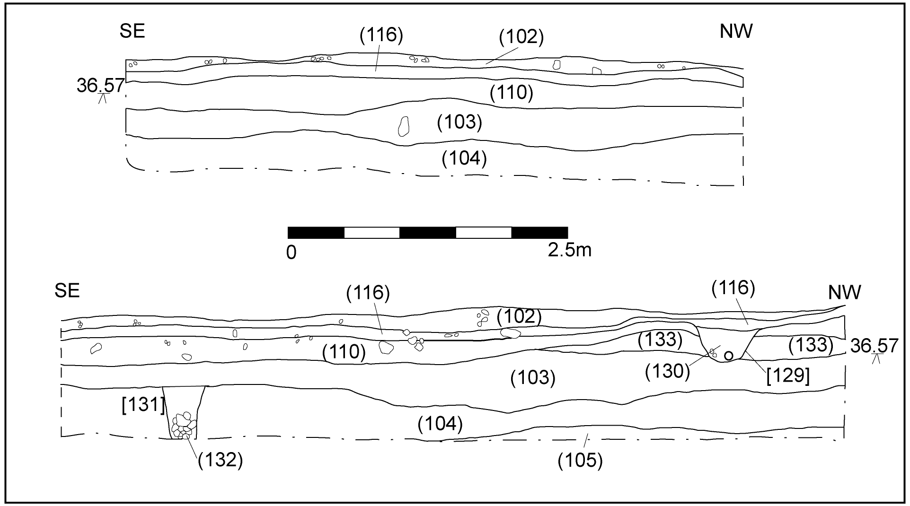

Fig 8. NE facing section across grid squares A5, B5, C5

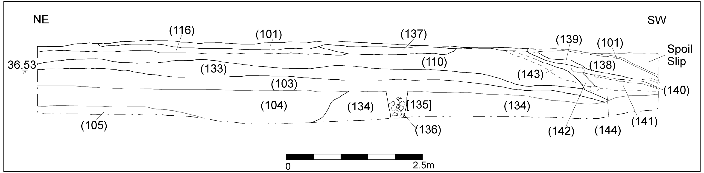

Fig 9. NW facing section across grid squares C5, C6, C7

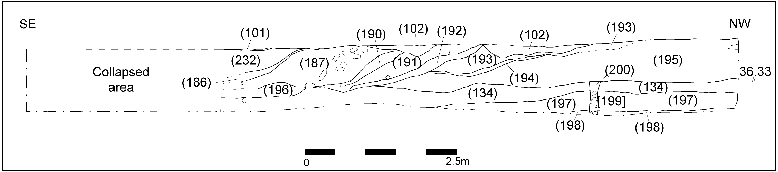

Fig 10. NE facing section across grid squares C7, D7, E7

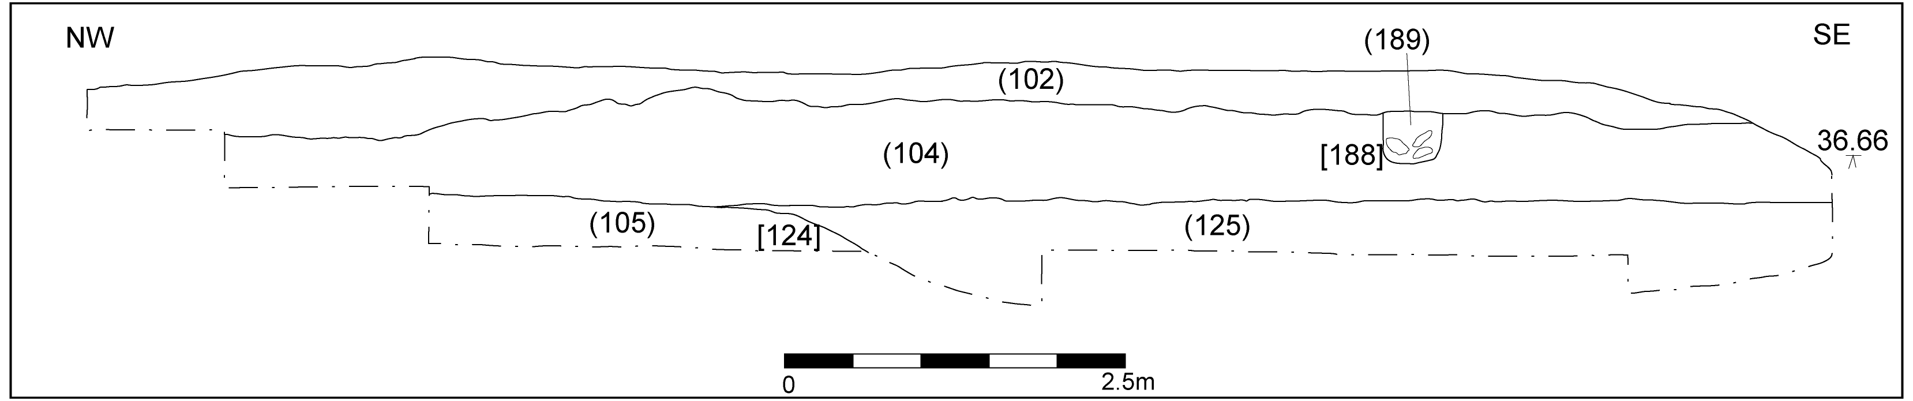

Fig 11. SW facing section across grid squares E1, D1, C1

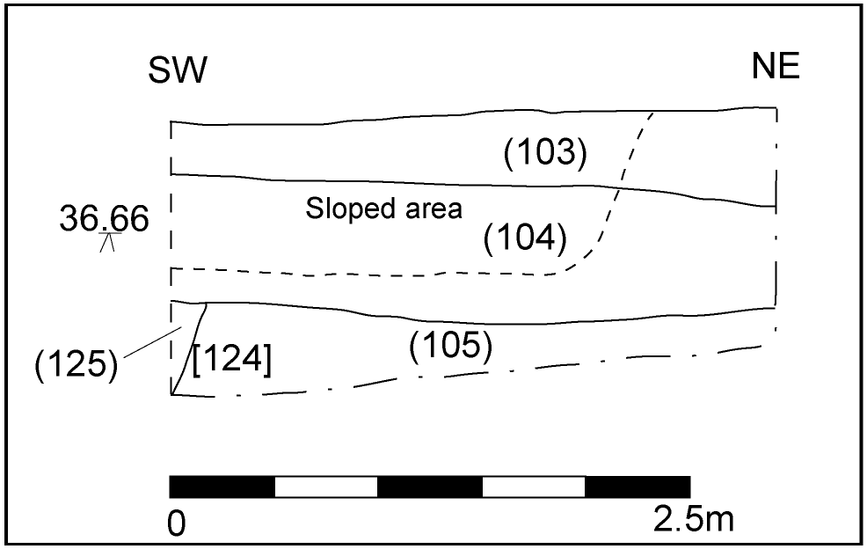

Fig 12. SE facing section grid square C1

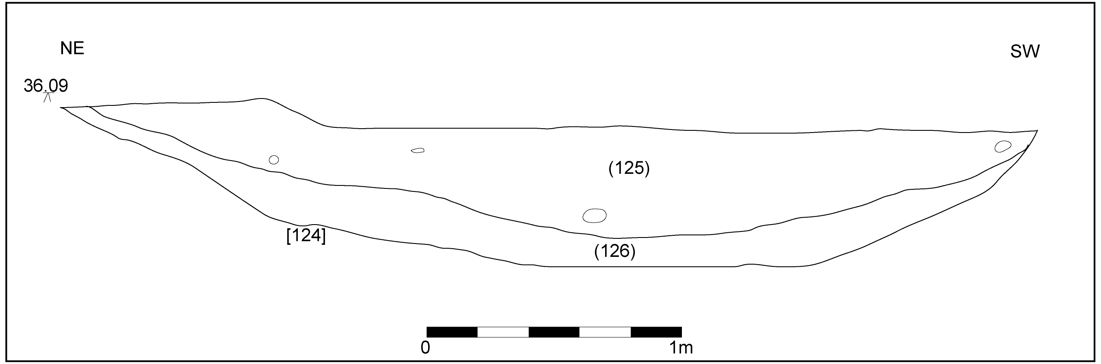

Fig 13. NW facing section across ditch in grid square B2

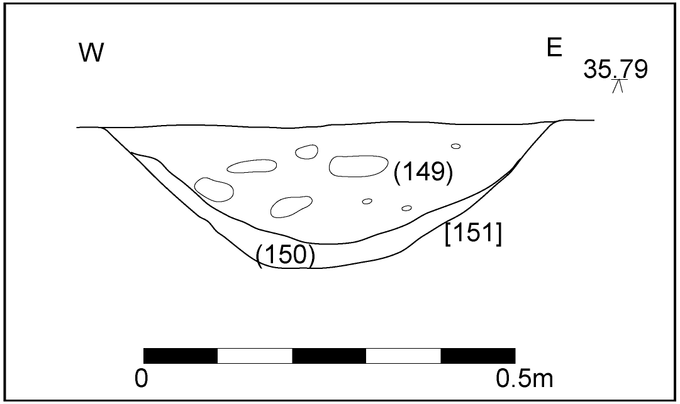

Fig 14. S facing section across ring ditch in grid square A4

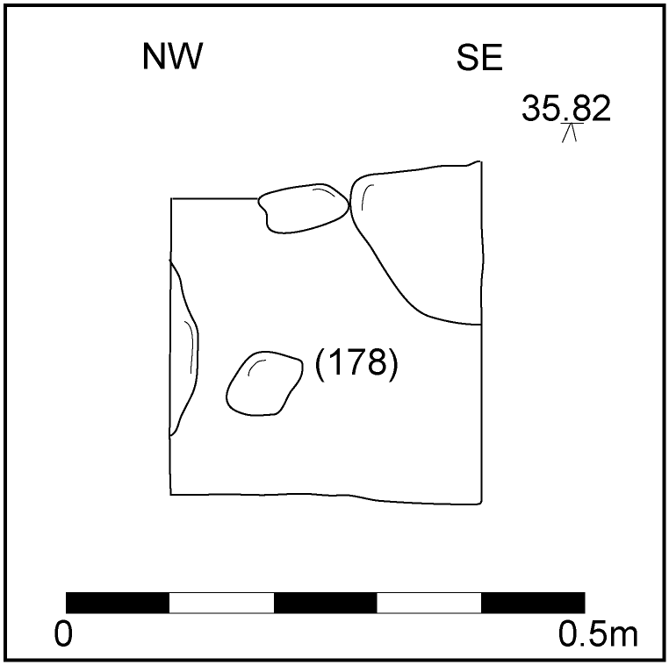

Fig 15. SW facing section of stone lined pit [179]

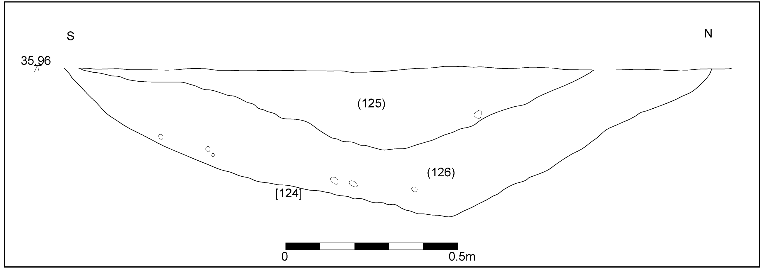

Fig 16. E facing section of ditch [124]

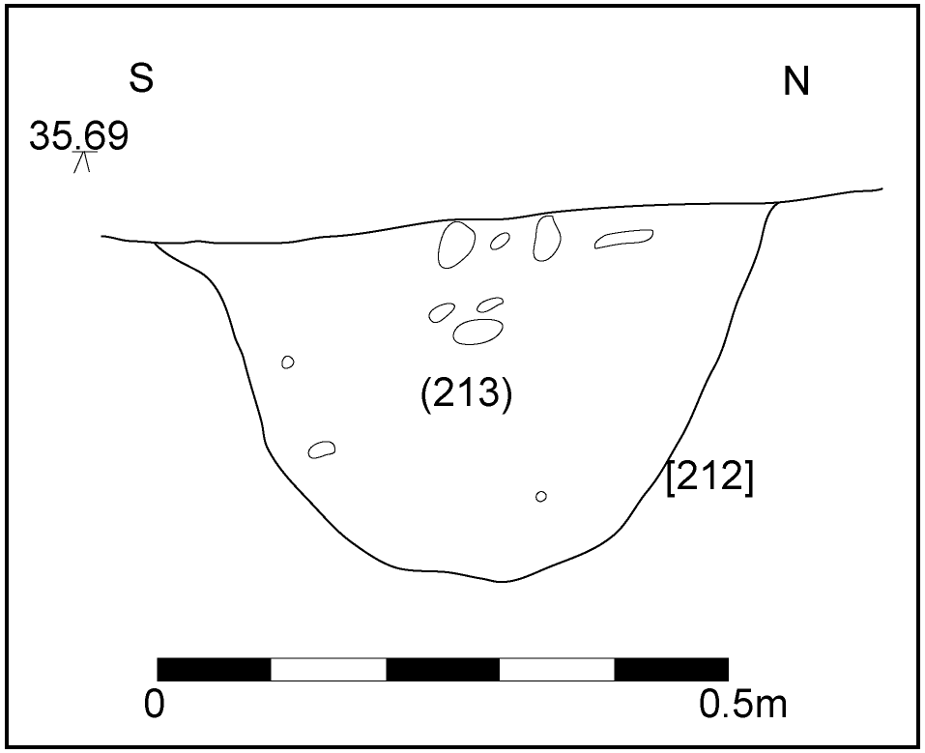

Fig 17. E facing section through [212]

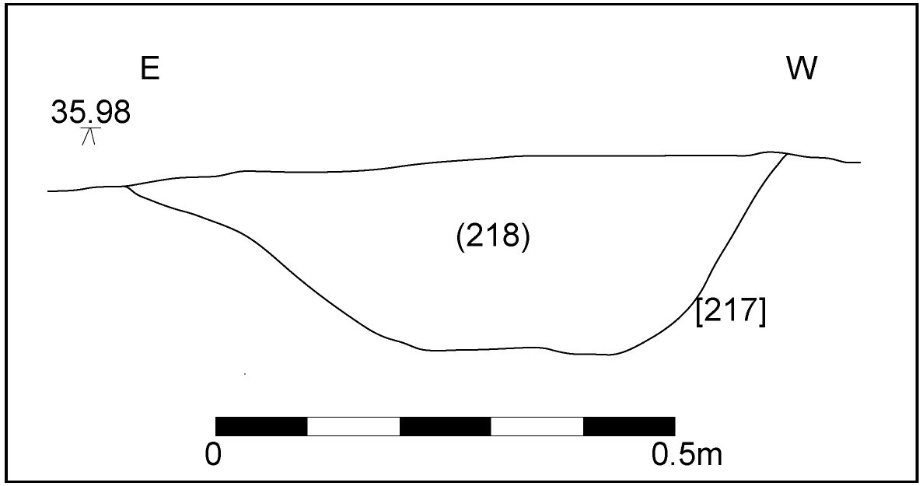

Fig 18. N facing section through [217]

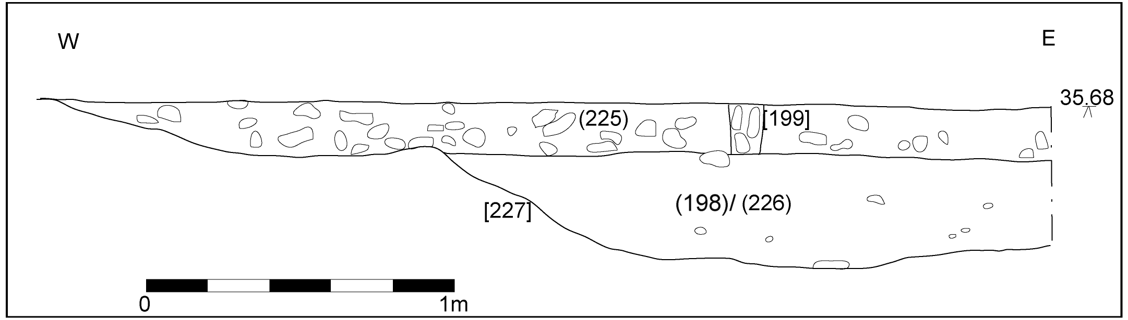

Fig 19. S facing section through [227]

- APPENDIX 1: Context Register

CONTEXT | DESCRIPTION
(101) | Tarmacadam layer, 0.1m deep and extending across the wide. Cut by [108], [114] and [201]. Overlies (102), (137), (138) & (232)
INTERPRETATION | Modern yard
(102) | Moderately compacted mid pinkish-red gravel. Moderate CBM fragments. Occasional Fe fragments and modern debris. 0.2m deep. Underlies (101). Overlies (107), (116), (118), (170) & (189)
INTERPRETATION | Sub-base material for (101)
(103) | Moderately compacted dark greyish-brown silty sand. Moderate CBM and stones. Occasional charcoal flecking and modern debris. 0.6m thick. Cut by [106], [119], [171], [188] & [216]. Underlies (133) & (233). Overlies (104), (107), (121), (123), (128), (132), (136) & (230)
INTERPRETATION | Buried garden soil/plough soil
(104) | Moderately compacted mid reddish-brown silty sand. Occasional small-medium angular and rounded stones. Occasional charcoal flecks. Maximum 0.5m thick. Underlies (103). Overlies (125), (146), (149), (152), (155), (158), (160), (162), (166), (168), (172), (176), (178), (180), (182), (184), (218), (219) & (223). Cut by [127], [131], [188]. Probably same as (134)
INTERPRETATION | Alluvium/colluvium
(105) | Moderately compacted dark reddish-brown sandy gravel. Occasional quartzite pebbles. Occasional patches of light yellowish-brown silty sand. Occasional bands of firm, light reddish-brown sandy gravel. Unexcavated. Underlies (111). Cut by [124], [169], [175], [177], [179], [181], [185], [208], [210], [212], [214], [217], [222] & [227]
INTERPRETATION | Site natural
[106] | Sub-circular cut measuring 0.64m x 0.74m x 0.54m. Break of slope at top sharp, sides straight, break of slope at base gradual, base concave. Filled by (107). Cuts (103).
INTERPRETATION | Modern waste disposal pit, probably relating to activity at Welsh Water works
(107) | Moderately compacted mid reddish-brown silty sand. 0.54m thick. Frequent modern glass shards. Underlies (102). Fills [106]
INTERPRETATION | Dump of modern waste material within pit [106]
[108] | Rectilinear cut measuring >4m x 1.5m x 0.82m. Break of slope at top and base sharp, sides vertical, base flat. Oriented NW-SE. Filled by (109). Cuts (101)
INTERPRETATION | Evaluation trench 5b
(109) | Very mixed deposit, predominantly loose mid greyish-brown silty clay with tarmacadam, gravel, sandstone and CBM. Fills [108]
INTERPRETATION | Backfill of evaluation trench
(110) | Moderately compacted mid pinkish-grey gravel measuring 13m x 12.5m x 0.2m in extent. Underlies (143). Cut by [129]. Overlies (117) & (133)
INTERPRETATION | Gravel sub-base for Welsh Water yard
(111) | Moderately compacted mid reddish-brown sandy clay revealed as patches of various size across site. Underlies (104). Overlies (105)
INTERPRETATION | Naturally formed clay patches throughout gravelly natural (105)
112 | VOID
INTERPRETATION | VOID
113 | VOID
INTERPRETATION | VOID
[114] | Roughly rectilinear cut with rounded corners. >0.5m x 0.43m x 0.9m. Break of slope at top gradual, sides vertical, base not reached. Aligned NW-SE. Filled by (115). Cuts (101)
INTERPRETATION | Modern test pit
(115) | Loose mixed deposit of tarmacadam and gravel in a sandy clay matrix. 0.9m deep. Fills [114]
INTERPRETATION | Backfill of modern test pit
(116) | Well compacted mid greyish-brown gravel and sand. Moderate tarmacadam, CBM and medium angular stones. 5.4m x 0.3m. Underlies (102) & (137). Overlies (130)
INTERPRETATION | Ground make-up
(117) | Moderately compacted mid greyish-brown silty sand. Frequent mid to large angular stones. Occasional post-medieval CBM. 3.8m x 0.4m. Underlies (110). Fills [216]
INTERPRETATION | Modern backfill of [216]
[118] | Linear measuring 0.6m wide & 0.54m deep. Break of slope at top gradual, sides convex, break of slope at base gradual, base concave. Filled by (119). Cuts (103)
INTERPRETATION | Modern pipe trench
(119) | Moderately compacted mid greyish-brown sand and gravel. Occasional small and medium angular stones. 0.54m deep. Underlies (102). Fills [118]
INTERPRETATION | Pipe trench backfill
[120] | Feature recorded in section. 0.64m wide & 0.35m deep. Break of slope at top sharp, sides straight 45º, break of slope at base gradual, base tapered, V-shaped. Filled by (121) & (234). Cuts (104)
INTERPRETATION | V-shaped cut of a non-diagnostic feature
(121) | Well compacted mid reddish-brown silty sand. 0.35m deep. Underlies (103). Overlies (234). Fills [120]
INTERPRETATION | Single fill of uncertain feature [120]
[122] | Linear cut measuring 0.24m wide & 0.52m deep. Break of slope at top and base sharp, sides steep and straight, base flat. Filled by (123). Cuts (104)
INTERPRETATION | Gravel land drain
(123) | Moderately compacted mid brownish-grey clayey sand between frequent rounded stones of various sizes. 0.52m thick. Underlies (103). Fills [122]
INTERPRETATION | Stony fill of land drain
[124] | N-S linear, turning 90º to E-W at northernmost visible extent. Extends beyond limit excavation to W, N & S. Within excavation area measures 20.15m N-S x c.13m E-W (assuming linear continuation through the area of diesel contamination) x 2.9m (max) wide x 0.65m (max) deep. Break of slope at top sharp, sides 45º concave, break of slope at base gradual, base flat. Filled by (125) & (126). Cuts (105)
INTERPRETATION | Boundary or enclosure ditch, possibly relating to roundhouse. Possibly continues N beyond junction with E-W ‘return’ in which case is likely to be a field division rather than an enclosure ditch
(125) | Moderately compacted mid greyish-brown sandy clay silt. Occasional small – medium angular stones. Occasional charcoal flecks and patches. Scatter of medium rounded and angular stones in southernmost visible extent in what appears to be a localised dump. Small quantity of pottery associated with this dump. Maximum 0.5m thick. Finds include pottery and animal bone. Environmental sample <1>. Underlies (104). Cut by [120]. Overlies (126). Fills [124]
INTERPRETATION | Possible re-cut or cleaning episode but no direct profile evidence found. To avoid over-complicating the feature at this stage, (125) is best interpreted as an upper fill of [124]. Comparison of samples from (125) and (126) may help to clarify this
(126) | Moderately compacted mid yellowish-brown sandy silt. Occasional small-medium angular stones. Occasional charcoal patches. Maximum 0.4m thick. Environmental sample <5>. Underlies (125). Fills [124].
INTERPRETATION | Primary fill of [124]. This deposit produced no finds and its interpretation, together with an indication of the lifespan of [124], will thus rely on sample analysis, especially with reference to that from (125).
[127] | Feature recorded in section. 0.48m wide & 0.25m deep. Break of slope at top and base sharp, sides steep and straight, base flat. Filled by (128). Cuts (104)
INTERPRETATION | Pit of uncertain function. The twigs lining the base suggest intentional placement, although for what purpose is unclear
(128) | Moderately compacted mid brownish-grey silty sand. Base of deposit appears to be lined with twigs. Single oyster shell noted in the section. 0.25m thick. Underlies (103). Fills [127]
INTERPRETATION | Single dumped fill. Presence of twigs and oyster shell difficult to interpret. Twigs evidently deposited intentionally
[129] | Linear cut, 0.58m wide & 0.28m deep. Break of slope at top sharp, sides gradual and straight, break of slope at base gradual, base flat. Filled by (130). Cuts (110)
INTERPRETATION | Modern pipe cut
(130) | Loose mid yellowish-brown sandy clay. Occasional charcoal flecks. Occasional small angular stones. 0.28m thick. Contains a modern pipe. Underlies (116). Fills [129]
INTERPRETATION | Modern sewage pipe
[131] | Linear cut, 0.38m wide & 0.48m deep. Break of slope at top and base sharp, sides steep and straight, base flat. Filled by (132). Cuts (104)
INTERPRETATION | Land drain
(132) | Loose mid reddish-grey sandy silt with frequent small angular sandstone gravel and stones and frequent voids. Underlies (103). Fills [131]
INTERPRETATION | Land drainage fill to facilitate water flow
(133) | Moderately compacted mid pinkish-brown sandy silt. 1.48m NW-SE & 0.22m thick maximum. Underlies (110). Overlies (103)
INTERPRETATION | Ground make-up layer
(134) | Moderately compacted mid reddish-brown silty sand. Occasional charcoal flecks and patches. Maximum 0.48m thick. Underlies (196). Cut by [135] and [199]. Overlies (205). Probably same as (104)
INTERPRETATION | Broad homogenous layer, possibly a flooding deposit
[135] | N-S linear cut, 6m x 0.36m x 0.5m. Break of slope at top and base sharp, sides steep and straight, base flat. Filled by (136). Cuts (134)
INTERPRETATION | Land drain
(136) | Loose mid reddish-brown silty sand. Frequent sandstones and voids. 0.5m thick. Underlies (103). Fills [135]
INTERPRETATION | Land drainage fill
(137) | Loose light yellowish-brown sandy gravel. 0.15m thick. Underlies (101). Overlies (116)
INTERPRETATION | Gravel dump, probably used as levelling material
(138) | Loose grey tarmacadam and concrete mix. Occasional CBM fragments. 0.3m thick. Underlies (101). Overlies (139)
INTERPRETATION | Levelling layer
(139) | Moderately compacted mid brownish-grey clayey sand. Occasional gravels. 0.09m thick. Underlies (138). Overlies (140)
INTERPRETATION | Levelling layer
(140) | Well compacted light brownish-red clay. Frequent gravel. 0.05m thick. Underlies (139). Overlies (141)
INTERPRETATION | Levelling layer
(141) | Moderately compacted mid brownish-grey sandy silt. Occasional small-large angular stones. Occasional gravel. 0.19m thick. Underlies (140). Overlies (142)
INTERPRETATION | Levelling layer
(142) | Loose mid yellowish-brown sandy gravel. Frequent small angular stones. 0.22m thick. Underlies (141). Overlies (143) & (144)
INTERPRETATION | Levelling layer
(143) | Loose black tarmacadam and gravel. Occasional small-medium angular stones. 0.14m thick. Underlies (142). Overlies (110)
INTERPRETATION | Tipping layer
(144) | Well compacted light brownish-red clay. Occasional tarmacadam fragments. Occasional small angular stones. 0.21m thick. Underlies (142). Overlies (133)
INTERPRETATION | Levelling layer
145 | VOID
INTERPRETATION | VOID
(146) | Moderately compacted light yellowish-brown sandy silt. Occasional small-medium angular stones. 0.21m wide & 0.08m deep. Underlies (104). Overlies (147). Fills [148]
INTERPRETATION | Upper fill of roundhouse gully [231] in segment [148]
(147) | Moderately compacted light reddish-brown sandy silt. Occasional small angular stones. 0.39m wide & 0.12m thick. Underlies (146). Fills [148]
INTERPRETATION | Primary silting of roundhouse gully [231] in segment [148]
[148] | Curvilinear segment cut through [231]. 1m x 0.39m x 0.12m. Break of slope at top sharp, sides steep and concave, break of slope at base gradual, base concave. Filled by (146) & (147). Underlies (147). Cuts (105)
INTERPRETATION | Segment cut through northern arc of [231]
(149) | Moderately compacted mid brownish-grey sandy silt. Moderate charcoal flecks and patches. Occasional small-medium angular stones. 0.13m deep & 0.4m wide. Underlies (104). Overlies (150). Fills [151]. Sample <3>
INTERPRETATION | Terminal fill of gully [231] in segment [151]
(150) | Moderately compacted mid pinkish-brown slightly sandy silt. 0.04m thick. Underlies (149). Fills [151]
INTERPRETATION | Primary silting of gully [231] terminal in segment [151]
[151] | Curvilinear with rounded terminal, 1.5m N-S x 0.7m E-W x 0.2m. Break of slope at top sharp, sides steep and straight, break of slope at base gradual, base flat. Filled by (149) & (150). Cuts (174)
INTERPRETATION | Terminal section through gully [231]. Probably contemporary with posthole [175], with (174) and (149) being deposited when gully and posthole fell into disuse. As this could not be confirmed, [151] is described as cutting (174), although they are included in the same phase
(152) | Moderately compacted mid brownish-grey sandy silt. Moderate charcoal flecks and patches. Occasional small-medium angular stones. 0.15m deep & 0.51m wide. Underlies (104). Overlies (153). Fills [154]
INTERPRETATION | Upper fill of gully [231] in segment [154]
(153) | Moderately compacted mid pinkish-brown slightly sandy silt. 0.25m thick. Underlies (152). Fills [154
INTERPRETATION | Primary silting of gully [231] terminal in segment [154]
[154] | Curvilinear. 1m x 0.52m x 0.25m deep. Break of slope at top sharp. Sides steep and straight. Break of slope at base gradual. Base concave. Filled by (152) and (153). Cuts (105)
INTERPRETATION | Segment cut through NE arc of [231]
(155) | Moderately compacted light yellowish-brown sandy silt. Occasional small-medium angular stones. 0.35m wide & 0.14m deep. Underlies (104). Overlies (156). Fills [157]
INTERPRETATION | Upper fill of roundhouse gully [231] in segment [157]
(156) | Moderately compacted light reddish-brown sandy silt. Occasional small angular stones. 0.5m wide & 0.18m thick. Underlies (155). Fills [157]
INTERPRETATION | Primary silting of roundhouse gully [231] in segment [157]
[157] | Curvilinear, 2.12m x 0.5m x 0.18m. Break of slope at top sharp, sides irregular, generally steep and straight, break of slope at base gradual, base uneven and irregular. Filled by (155) & (156). Cuts (105)
INTERPRETATION | Segment cut through NE arc of [231]
(158) | Moderately compacted light yellowish-brown sandy silt. Occasional small-medium angular stones. 0.24m wide & 0.07m deep. Underlies (104). Fills [159]
INTERPRETATION | Single fill of roundhouse gully [231] in segment [159]
[159] | Curvilinear, 1m x 0.24m x 0.07m. Break of slope at top sharp, sides gradual and concave, break of slope at base gradual, base flat to concave. Filled by (158). Cuts (105)
INTERPRETATION | Segment cut through northern arc of [231]
(160) | Moderately compacted light yellowish-brown sandy silt. Occasional small-medium angular stones. 0.2m wide & 0.07m deep. Underlies (104). Fills [161]
INTERPRETATION | Single fill of roundhouse gully [231] in segment [161]
[161] | Curvilinear, 1m x 0.2m x 0.07m. Break of slope at top sharp, sides steep and straight, break of slope at base gradual, base concave. Filled by (160). Cuts (105)
INTERPRETATION | Segment cut through northern arc of [231]
(162) | Moderately compacted light yellowish-brown sandy silt. Occasional small-medium angular stones. 0.3m wide & 0.12m deep. Underlies (104). Fills [163]
INTERPRETATION | Single fill of roundhouse gully [231] in segment [163]
[163] | Curvilinear, 1m x 0.3m x 0.12m. Break of slope at top sharp, sides shallow and straight, break of slope at base gradual, base concave. Filled by (162). Cuts (105)
INTERPRETATION | Segment cut through northern arc of [231]
(164) | Moderately compacted light yellowish-brown sandy silt. Occasional small-medium angular stones. 0.36m wide & 0.12m deep. Cut by [183]. Fills [165]
INTERPRETATION | Single fill of roundhouse gully [231] in segment [165]
[165] | Curvilinear, 1m x 0.36m x 0.12m. Break of slope at top sharp, sides steep and straight on S edge, shallow and convex on N, break of slope at base gradual, base concave. Filled by (164). Cuts (105)
INTERPRETATION | Segment cut through NW arc of [231]
(166) | Moderately compacted light yellowish-brown sandy silt. Occasional small-medium angular stones. 0.3m wide & 0.14m deep. Underlies (104). Fills [167]
INTERPRETATION | Single fill of roundhouse gully [231] in segment [167]
[167] | Curvilinear, 1m x 0.3m x 0.14m. Break of slope at top sharp, sides steep and straight, break of slope at base sharp, base flat. Filled by (166). Cuts (105)
INTERPRETATION | Segment cut through NW arc of [231]
(168) | Moderately compacted light greyish-brown sandy silt. Occasional charcoal flecks. 0.24m in diameter & 0.06m thick. Underlies (104). Fills [169]
INTERPRETATION | Silting of possible posthole feature [169]
[169] | Circular cut, 0.24m in diameter & 0.06m deep. Break of slope at top sharp, sides steep and straight, break of slope at base gradual, base concave. Filled by (168). Cuts (105)
INTERPRETATION | Posthole possibly associated with roundhouse gully [231]
(170) | Loose mixed reddish-grey sandy clay silt. Frequent stones, charcoal, gravel, CBM and tarmacadam. Single lense of reddish clay located at approximately 0.3m depth. 0.48m thick. Underlies (102). Fills [171]
INTERPRETATION | Mixed backfill of test pit
[171] | E-W rectilinear cut with squared 90º corners. 1.7m x 0.51m x 0.48m. Break of slope at top sharp, sides steep and straight, break of slope at base sharp, base flat. Filled by (170). Cuts (103)
INTERPRETATION | Modern test pit
(172) | Moderately compacted mid greyish-brown sandy silt. Occasional charcoal flecks and patches. Occasional small angular stones. Maximum 0.2m thick. Underlies (104). Fills [173]. Sample <2>
INTERPRETATION | Possible occupation spread localised in ‘mouth’ of penannular gully [231] and within area enclosed by gully
[173] | Irregular depression, widening either side of opening in penannular gully [231] and continuing beyond excavation to S and E. 9m NW-SE x 3.3m NE-SW x 0.2m. Break of slope at top gradual, sides shallow and straight, break of slope at base non-perceptible, base undulating. Filled by (172). Cuts (209), (211), (213) & (215)
INTERPRETATION | Depression containing occupation spread (172). Probably not a cut feature but an area eroded in the manner of a holloway, through regular use, in which a trampled deposit has accumulated
(174) | Moderately compacted mid brownish-grey sandy silt. Occasional charcoal flecking. 0.28m in diameter & 0.11m thick. Underlies [151]. Fills [175]
INTERPRETATION | Slumped fill of posthole. This material and (149) are probably the same deposit, forming within [151] and [175] when these went out of use simultaneously. However, this could not be confirmed thus stratigraphically [151] is deemed to have cut (174)
[175] | Circular cut, 0.28m in diameter & 0.11m deep. Break of slope at top sharp, sides steep and straight, break of slope at base gradual, base concave. Filled by (174). Cuts (105)
INTERPRETATION | Posthole in terminus of roundhouse gully. Likely to be contemporary with cut [151], only becoming backfilled when both went out of use, as no deliberate packing material seems to survive. It is also possible that [175] predates the gully and relates to a separate phase of activity but this is by no means certain. The presence of postholes in the termini of roundhouse gullies is not uncommon, although their function is debatable. They may have supported a porch or similar overhang from the front of the roundhouse, while studies of 4-poster granaries suggest that exterior posts may have formed part of structures relating to roof construction
(176) | Moderately compacted light yellowish-brown sandy silt. Occasional small angular stones. 0.3m wide & 0.17m deep. Underlies (104). Fills [177]
INTERPRETATION | Dumped backfill of posthole
[177] | Circular cut, 0.3m in diameter & 0.11m deep. Break of slope at top sharp, sides gradual and straight, break of slope at base gradual, base concave. Underlies (176). Cuts [105]
INTERPRETATION | Posthole possibly associated with roundhouse gully [231]
(178) | Moderately compacted dark greyish-brown silty sand. Frequent medium angular sandstone. Occasional charcoal. 0.6m E-W x 0.3m N-S x 0.3m. Underlies (104). Fills [179]
INTERPRETATION | Single dumped fill containing a number of medium sandstone fragments which appear to form a lining of pit [179]
[179] | Sub-ovoid cut, 0.6m E-W x 0.3m N-S x 0.3m. Break of slope at top and base sharp, sides vertical and regular, base slightly concave. Filled by (178). Cuts (105)
INTERPRETATION | Small pit, lined with sandstone embedded into natural (105). These stones do not appear to be burnt and no direct function could be assigned to either the stones or the feature. The stones may represent packing material for a substantial post but no similar postholes were located in the vicinity
(180) | Moderately compacted mid greyish-brown silty sand. 0.18m N-S x 0.12m E-W x 0.09m. Underlies (104). Fills [181]
INTERPRETATION | Single fill of stake-hole [181]
[181] | Sub-circular cut, 0.18m N-S x 0.12m E-W x 0.09m. Break of slope at top sharp, sides steep, concave, break of slope at base sharp, base concave. Underlies (180). Cuts (105)
INTERPRETATION | Possible stake-hole or similar feature
(182) | Moderately compacted light reddish-brown sandy silt. Maximum 0.1m thick. Underlies (104). Fills [183]
INTERPRETATION | Natural silting of feature [183]
[183] | Curvilinear cut, 2.15m NW-SE x 0.5m x 0.1m. Break of slope at top sharp, sides gradual and irregular, break of slope at base gradual, base irregular and uneven. Curving from SE-NW to S-N. Filled by (182). Cuts (164)
INTERPRETATION | Poorly defined irregular linear feature, possibly of natural origin, such as a tree throw
(184) | Moderately compacted mid greyish-brown silty sand. Moderate charcoal flecks. Occasional manganese flecks. Occasional small angular stones, especially at base. 0.21m thick. Underlies (104). Fills [185]
INTERPRETATION | Dumped pit fill, quantity of charcoal may indicate a raking deposit, although no source for this was located
[185] | Circular cut, 0.74m in diameter & 0.21m deep. Break of slope at top sharp, sides steep and straight, break of slope at base gradual, base concave. Filled by (184). Cuts (105)
INTERPRETATION | Probable domestic waste pit
(186) | Loose mid brownish-grey tarmacadam and gravel mix. 0.13m thick. Underlies (232). Overlies (187)
INTERPRETATION | Tipped tarmacadam layer relating to site levelling
(187) | Loose mid reddish-brown clayey sand. Frequent gravel. Moderate small-large angular stones. 0.65m thick. Underlies (102) & (186). Overlies (190) & (196)
INTERPRETATION | Levelling layer
[188] | Cut feature, 0.44m wide & 0.38m deep. Break of slope at top and bottom sharp, sides steep and straight, base flat. Filled by (189). Cuts (104)
INTERPRETATION | Modern pit or posthole. Revealed only in section thus full extent uncertain
(189) | Loose mid brownish-grey clayey sand. Occasional small angular stones. Moderate small-medium concrete lumps. 0.38m thick. Underlies (102). Fills [188]
INTERPRETATION | Dumped fill of modern pit [188]
(190) | Loose light greenish-grey clayey gravel. Frequent medium angular stones. Maximum 0.18m thick. Underlies (187). Overlies (191)
INTERPRETATION | Levelling layer
(191) | Loose tarmacadam and gravel. Single lense of friable mid reddish-brown sandy clay. 0.31m thick. Underlies (190). Overlies (192)
INTERPRETATION | Levelling layer
(192) | Loose mid reddish-brown clayey sand. Tarmacadam and gravel and frequent small-large angular stones. 0.17m thick. Underlies (191). Overlies (193)
INTERPRETATION | Levelling layer
(193) | Moderately compacted light yellowish-brown clayey sand. Frequent gravel. 0.4m thick. Underlies (192). Overlies (194)
INTERPRETATION | Levelling layer. Apparent ‘cutting’ by (192) a result of tipping rather than cutting
(194) | Well compacted black tarmacadam. 0.07m thick. Underlies (193). Overlies (195).
INTERPRETATION | Slump/dump of tarmacadam slab during levelling
(195) | Moderately compacted mid greyish-brown clayey sand. Frequent small-medium angular stones. Occasional concrete fragments. Occasional modern debris (plastic sheeting etc.). 0.72m thick. Finds noted but not collected included the remains of a vehicle. Underlies (194). Overlies (200) and (228)
INTERPRETATION | Modern dumping fill relating to either levelling or demolition
(196) | Moderately compacted mid brownish-grey sandy silt. Occasional charcoal flecks and patches. 0.24m thick. Underlies (187). Overlies (134)
INTERPRETATION | Levelling layer
(197) | Moderately compacted mid reddish-brown sandy silt. Occasional charcoal flecks and patches. 0.3m thick. Underlies (134). Overlies (198)
INTERPRETATION | Levelling or flooding layer
(198) | Loose mid reddish-brown sandy silt. Frequent, mainly rounded, sandstone gravel. Maximum 0.1m thick. Underlies (197). Same as (226). Fills [227]
INTERPRETATION | Primary fill of pit feature [227]. Material could be differentiated from natural (105) only by its lack of compaction, suggesting that this may be natural weathering and slumping into [227] from banked-up natural material. (198) represents a slight overcut into (226) during machining, as this feature was not readily identifiable from the surface due to the similarity between (198)=(226) and (105)
[199] | E-W linear cut, C.20m E-W x 0.2m N-S x 0.6m. Break of slope at top sharp, sides steep and straight, break of slope at base sharp, base flat. Filled by (200). Cuts (134)
INTERPRETATION | Land drain
(200) | Loose dark greyish-brown sandy silt. Frequent small-large angular sandstone. Frequent voids. 0.6m thick. Underlies (195). Fills [199]
INTERPRETATION | Fill of land drain
[201] | NW-SE rectilinear cut. Protrudes into excavation area 8m NW-SE x 2m NE-SW x 1.3m. Break of slope at top sharp, sides steep and straight, break of slope at base sharp, base flat. Filled by (202) & (203). Underlies (203). Cuts (101). Truncates (206)
INTERPRETATION | Trench 2 of 2003-4 evaluation
(202) | Loose mid greyish-brown sandy clay. Occasional small-large angular stones. 0.84m thick. Overlies (203). Fills [201]
INTERPRETATION | Upper backfill of evaluation trench
(203) | Loose dark greyish-brown sandy silt. Moderate small-large angular stones. 0.84m thick. Underlies (202). Fills [201]
INTERPRETATION | Backfill of evaluation trench
[204] | Roughly semicircular feature, as seen within extent of excavation, 4.5m x 8.8m x 0.5m (as seen). Break of slope at top gradual, sides gradual and straight, break of slope at base non-perceptible, base flat. Filled by (205). Cuts (197)
INTERPRETATION | Naturally silted depression rather than a cut feature.
(205) | Moderately compacted light reddish-grey sandy silt. Occasional small rounded gravel. 0.5m thick. Underlies (134). Fills [204]
INTERPRETATION | Natural silting of [204]
(206) | Moderately compacted mid reddish-brown clayey silt. Frequent flecks and fragments of charcoal, especially around base of [207]. 0.22m thick. Truncated by [201]. Fills [207]
INTERPRETATION | Remnant charcoal rich fill of pit feature partially excavated during 2003-4 evaluation. This was described as a dark brown silty loam with abundant charcoal and two very small sherds of mudstone tempered ware, dated between the C5 BC and the latest Iron Age and an iron object. However, no finds were recovered from the remnant fill when the feature was fully cleaned out
[207] | Ovoid pit cut. 0.95m SW-NE x 0.92m NW-SE x 0.22m deep. Break of slope at top sharp, sides 45º, concave, break of slope at base gradual, base concave. Filled by (206). Cuts (225)
INTERPRETATION | Small pit of no obvious function. More than 85% of the fill was removed during the evaluation. No attempt was made at that time to interpret the feature, although it was noted that it cut the fill of ‘ditch’ [2006] This ‘ditch’ appears to be an element of large feature [226] described below.
[208] | Ovoid cut, 0.32m E-W x 0.3m N-S x 0.15m. Break of slope at top and base sharp, sides slightly concave, base slightly concave. Filled by (209). Cuts (105)
INTERPRETATION | Posthole possibly associated with part of roundhouse
(209) | Moderately compacted dark greyish-brown silty sand. Occasional medium angular sandstone. Occasional degraded sandstone flecks. 0.15m thick. Cut by [173]. Fills [208]
INTERPRETATION | Dumped fill of posthole [208]
[210] | Circular cut, 0.2m in diameter & 0.1m deep. Break of slope at top sharp, sides concave, break of slope at base gradual, base concave. Filled by (211). Cuts (105)
INTERPRETATION | Posthole possibly associated with part of roundhouse
(211) | Moderately compacted mid greyish-brown silty sand. Occasional degraded sandstone flecking. 0.1m thick. Cut by [173]. Fills [210]
INTERPRETATION | Dumped fill of posthole [210]
[212] | Ovoid pit cut, 0.72m NW-SE x 0.5m NE-SW x 0.33m. Break of slope at top sharp, sides steep and concave, break of slope at base gradual, base concave. Filled by (213). Cuts (105)
INTERPRETATION | Domestic waste pit or large posthole utilised as such after abandonment
(213) | Moderately compacted mid brownish-grey sandy silt. Occasional small angular sandstone. Occasional charcoal flecks. Fragment of post-medieval tile. 0.33m thick. Cut by [173]. Fills [212]
INTERPRETATION | Dumped waste backfill of feature [212]
[214] | Circular cut, 0.5m in diameter & 0.2m deep. Break of slope at top sharp, sides gradual, slightly concave, break of slope at base gradual, base concave. Filled by (215). Cuts (105)
INTERPRETATION | Small pit of uncertain function
(215) | Moderately compacted mid greyish-brown silty sand. Occasional degraded sandstone flecking. 0.2m deep. Cut by [173]. Fills [214]
INTERPRETATION | Dumped fill of pit feature [214]
[216] | Irregular cut, 3.8m & 0.4m deep. Break of slope at top gradual, sides irregular, break of slope at base gradual, base undulating. Filled by (117). Cuts (103)
INTERPRETATION | Part of levelling or construction activity relating to Welsh Water works
[217] | Sub-circular cut with circular bowl at NE end and a long shallow slope extending to SW. 2.1m SW-NE x 0.66m (across bowl) x 0.23m (maximum). Breaks of slope at top and base gradual, sides concave, base concave in bowl, sloping down from SW-NE. Filled by (218). Cuts (105)
INTERPRETATION | Pit of uncertain function. Large quantity of pottery recovered from bowl of feature. Function or nature of sloped edge unclear
(218) | Moderately compacted mid greyish-brown sandy silt. Occasional small rounded sandstone and quartzite fragments. 0.23m thick. Large pottery fragments. Sampled as <4> (Sample contaminated). Underlies (104). Fills [217]
INTERPRETATION | Single dumped fill containing substantial fragments of pottery in ‘bowl’ of feature. These do not appear to have been intact at time of deposition and comprise at least two separate vessels.
(219) | Moderately compacted light yellowish-brown sandy silt. Occasional small angular sandstone and quartzite. Occasional charcoal and manganese flecks. 0.17m thick. Finds include pottery, animal bone and iron slag. Underlies (104). Fills [220]
INTERPRETATION | Possibly base fill of truncated feature or silting of natural depression
[220] | Kidney-shaped cut, 5.2m NE-SW x 2.1m NW-SE x 0.17m. Break of slope at top sharp, sides shallow and straight, break of slope at base non-perceptible, base very slightly concave, deeper at NE end. Filled by (219). Cuts (221)
INTERPRETATION | Possible natural depression (kidney-shaped features often represent tree throws) but evidence that the sides have been shaped suggests a truncated pit. The finds assemblage comprises pottery, animal bone and iron slag. The presence of similar quantities of iron slag to (225) may indicate a relationship between [220] and [227]. [220] appears to have been truncated by Trench 2 of the 2003-4 evaluation, in which case it may have been partially excavated at that time as (2009), described as mid brown silt containing a single sherd of Severn Valley ware variant but otherwise very clean. The evaluation report mentions steep edges, although the edges of [220] are shallow, except around the narrowing of the depression, where the slope becomes shorter and steeper
(221) | Moderately compacted mid greyish-brown sandy silt. Occasional charcoal flecks and patches. 0.26m thick. Cut by [220]. Fills [222]
INTERPRETATION | Accumulated fill of pit [222]
[222] | Elliptical pit with rounded termini, 3.08m E-W x 1.15m N-S x 0.26m. Break of slope at top sharp, sides gradual and concave, break of slope at base non-perceptible, base concave. Filled by (221). Cuts (105)
INTERPRETATION | Pit of no clear function. No finds were gathered from the half-section excavated to facilitate dating or understanding of the feature
(223) | Moderately compacted mid greyish-brown sandy silt. Occasional small-medium angular stones. 0.33m wide & 0.09m deep. Underlies (104). Fills [224]
INTERPRETATION | Single fill of roundhouse gully [231] in segment [224]
[224] | Curvilinear, 1m x 0.33m x 0.09m. Break of slope at top sharp, sides steep and concave, break of slope at base gradual, base concave. Filled by (223). Cuts (105)
INTERPRETATION | Segment cut through western arc of gully [231]
(225) | Moderately compacted light reddish-grey sandy silt. Frequent medium (average 0.12m x 0.09m x 0.05m) angular sandstone. Occasional charcoal flecks. Maximum 0.26m thick. Cut by [207]. Overlies (226). Fills [227]
INTERPRETATION | Upper fill of broad shallow feature. The presence of a large quantity of sandstone, occasionally heated, as well as iron slag, may indicate dumping of industrial waste, although the source of this was not located during the excavation
(226) | Loose mid reddish-brown sandy silt. Frequent, mainly rounded, sandstone gravel. Maximum 0.2m thick. Underlies (225). Same as (198). Fills [227]
INTERPRETATION | Primary fill of feature [227], similar to natural (105) but more loosely compacted, suggesting that this may be natural weathering and slumping into [227] from banked-up natural material
[227] | Irregular feature, 3.2m NE-SW x 5.08m NW-SE x 0.42m, excavated by means of a slot through the section N of the point of truncation by a land drain and W of where it was truncated by Trench 2 from the 2003-4 evaluation. Difficult to define where unexcavated due to similarities between fill (226) and natural (105). Break of slope at top gradual, sides gradual and straight, break of slope at base gradual, base flattish. Continues beyond excavation to the SW. Filled by (225) & (226). Cuts (105)
INTERPRETATION | Large, irregular pit feature. Excavated in part within Trench 2 of the 2003-4 evaluation, where it was interpreted as linear (2012). As more of the feature was revealed it appears more likely to be a pit, although its full extent lay beyond the limit of excavation. Primary fill (226) was quite a clean silty deposit, which suggests the feature was open for some time, during which this deposit was weathered or slumped inwards. Secondary fill (225) contains a quantity of burnt material and a large number of sandstone cobbles and some iron slag, suggesting this might be waste tipped from a nearby industrial site. It seems unlikely that this was the original function of [227] due to the accumulation of (226) prior to deposition of the waste and this material thus appears to be a deliberate deposition, perhaps to level the ground prior to subsequent activity, such as [207]
(228) | Loose mid yellowish-brown sand and gravel. 0.97m wide & 0.05m thick. Underlies (195). Overlies (233)
INTERPRETATION | Levelling layer
[229] | N-S linear. 0.25m wide & 0.5m deep. Breaks of slope at top and base sharp, sides steep and straight, base flat. Filled by (230). Cuts (104)
INTERPRETATION | Land drain
(230) | Loose mid reddish-brown sand with frequent medium angular sandstone and voids. 0.5m thick. Underlies (103). Fills [229]
INTERPRETATION | Land drainage material
[231] | Penannular curvilinear, 14.58m (maximum diameter) & 0.2m (maximum depth). Feature does not form a perfect circle and profile varies along its length, deeper and more rounded at the visible terminus, becoming sharper and irregular prior to truncation on the northern arc results in shallower profiles. Profile then squarer to W. Feature evaluated by means of 10 segment cuts [148], [151], [154], [157], [159], [161], [163], [165], [167] and [224]. Eastern segments all contain two fills while those to N & W have single fills. Truncated by [183]. Cuts (174)
INTERPRETATION | Roundhouse drip gully. Irregular profile of [231] likely to point to simplistic excavation followed by heavy weathering. Posthole [175] located in terminus of visible gully is likely to be contemporary with the roundhouse rather than an earlier feature, although this could not be confirmed. Spread (172) in depression [173] appears to respect the outline of the gully and is likely to be an occupation spread relating to the active life of the gully and thus the roundhouse. The location of Trench 4 of the 2003-4 evaluation may be an indicator as to the full dimensions of the roundhouse and to the aperture in its circuit. Based on the trench plan from the evaluation report, and assuming the gully continues in a roughly circular fashion, it ought to have entered Trench 4 in the area where a sondage was excavated. This suggests either that the break in the drip gully circuit is over 5m wide, which would be an unusually wide entranceway for a domestic structure, or that a similar truncation appears on the southern arc of the gully as on the northern and in the area of Trench 4 no trace of the gully survives. Alternatively, given that ‘the depth of aggregates in the trench [meant] the edges were extremely unstable and close examination of deposits in the trench was not undertaken’, a small gully could have been missed.
(232) | Loose dark greyish-brown sand, gravel and tarmacadam. Maximum 0.42m thick. Underlies (101). Overlies (186)
INTERPRETATION | Levelling layer
(233) | Loose mid reddish-brown clayey sand. Tarmacadam and gravel and frequent small-large angular stones. 0.17m thick. Underlies (228). Overlies (103)
INTERPRETATION | Levelling layer
(234) | Moderately compacted dark brownish-grey clayey silt. Occasional small angular stones. Occasional medium angular and rounded stones. Occasional charcoal flecks and patches. Occasional CBM flecks. 0.65m thick. Underlies (121). Fills [120]
INTERPRETATION | Homogenous backfill of large feature [120]
- APPENDIX 2: Pottery Analysis

Dr Jane Timby

INTRODUCTION

The archaeological work at Coughton resulted in the recovery of 534 sherds of Roman pottery weighing 5905g and with a total estimated vessel equivalence (rim) of 357. In addition, two pieces of ceramic building material were recovered, one of Roman and one of post-medieval date.

The assemblage was in relatively good condition, with an overall average sherd size of 11g. Sherds were generally well preserved in terms of surface treatments. Pottery was recorded from 10 individual contexts with a further 21 sherds from unstratified collection.

Following a brief note on the methodology employed, the assemblage is discussed by fabric and form. The concluding discussion focuses on the site and places the assemblage in its regional context.

1. METHODOLOGY

The assemblage was sorted into fabrics and quantified by sherd count and weight for each recorded context. Rims were measured for percentage present to establish the estimated vessel equivalents (EVE). The fabrics, where possible, were coded using the national Roman fabric reference collection codes (Tomber and Dore 1998) (T & D) and these are not described further. Fabric codes in square brackets refer to the established fabric series for Hereford and Worcester (Hurst and Rees 1992). Forms were recorded for rims only. The resulting data was entered into a MS Excel spreadsheet, a copy of which is deposited with the site archive. A selection of material from the largest group has been illustrated.

2. FABRICS AND ASSOCIATED FORMS

Table 1: Pottery catalogue

 | Fabric | H&W fab | Description | No | % | Wt | % | EVE | %
Native | MAL RE A | 3 | Malvernian rock-tempered | 25 | 4.7 | 377 | 6.4 | 47 | 13.2
 | MAL RE B | 4.1 | Palaeozoic limestone | 174 | 32.6 | 1110 | 18.8 | 93 | 26.1
 | GROG | 16A | grog-tempered | 25 | 4.7 | 125 | 2.1 | 0 | 0.0
Import | CGSAM | 43.2 | Central Gaulish samian | 2 | 0.4 | 2 | 0.0 | 0 | 0.0
Regional | DOR BB1 | 22 | Dorset black burnished ware | 29 | 5.4 | 270 | 4.6 | 28 | 7.8
 | OXFWHM | 33 | Oxon whiteware mortaria | 2 | 0.4 | 88 | 1.5 | 13 | 3.6
Local | SVW OX | 12 | Severn Valley ware (oxidised) | 265 | 49.6 | 3698 | 62.6 | 159 | 44.5
 | SVW RE | 12R | Severn Valley ware (reduced) | 4 | 0.7 | 160 | 2.7 | 0 | 0.0
 | MAL RO | 19 | wheelmade Malvernian | 1 | 0.2 | 10 | 0.2 | 0 | 0.0
Unknown | GREY | 15 | grey sandy ware | 5 | 0.9 | 40 | 0.7 | 17 | 4.8
 | BWSY | 98 | black sandy ware | 2 | 0.4 | 25 | 0.4 | 0 | 0.0
TOTAL |  |  |  | 534 | 100.0 | 5905 | 100.0 | 357 | 100.0

Malvernian metamorphic rock-tempered ware (T & D 1998, 147, MAL REA; [fabric 3]): This ware accounts for 4.7% by sherd count, 6.4% by weight. All the sherds come from Phase 2 contexts. Forms: vessels are handmade, usually simple tubby jar forms (Fig. 1) usually with a smoothed or burnished finish. Also present is an everted rim jar with a zone of infilled triangular panels (Fig. 2).

Malvernian limestone-tempered (T & D 1998, MAL REB; [fabric 4.1]): This is the second commonest fabric encountered in the assemblage accounting for 32.6% by sherd count, 18.8% by sherd weight overall. Forms: exclusively handmade jars with everted or thickened rims (Fig. 3).

Grog-tempered [fabric 16A]: A handmade grog-tempered ware often found with the Malvernian wares but usually more common to the S of the Gloucestershire region. Forms: No featured sherds here but handmade vessels often with an overall or burnished line finish. Dating evidence elsewhere would suggest this ware appears in the early 1st century AD continuing into the post-conquest period.

2.1 Roman: continental imports

Central Gaulish samian [fabric 43.2]: Two small abraded sherds only both from Phase 2.

2.2 Roman: regional wares

Dorset black burnished ware (T & D 1998, 127, DOR BB1; [fabric 22]): By count this is the third commonest fabric on the site although less so by weight. It first appears in Phase 2. Forms: the forms present date from the 2nd through to the 3rd century. Most of the sherds are from jars or flat-rimmed bowls. A single plain-sided dish was also present in deposit (172).

Oxfordshire white ware mortaria (T & D 1998, 175;l OXF WH; [fabric 33]): Two sherds, one from a mortarium Young (1977), type M10 is present from enclosure ditch [124] (Fig. 7); the other sherd from deposit (172). These are usually later 2nd -3rd century in date.

2.3 Roman wares: local Severn Valley wares

Severn Valley ware (T & D 1998, 148-9, SVW OX; [fabric 12]): This fabric was by far the commonest accounting for 49.6% by sherd count, 62.6% by weight of the total assemblage (Figs. 4-6, 8). A number of sherds of the reduced greyware version are also present (SVW RE [fabric 12R]) accounting for a further 2.7% by weight. Forms: a diverse range of forms is present spanning the 1st to late 2nd/ early 3rd centuries. Jars and tankards dominate. The former include both wide-mouthed narrow necked versions with everted, flared rims. The tankards include both oxidised and reduced example and a carinated cup. Other forms include various flat rim bowls and a dish with a flanged rim.

2.4 Roman: local wares

Wheelmade Malvernian wares ([fabric 19]): Typical of the later Malvernian industry, only a single sherd is present here from Phase 7.

2.5 Roman: source unknown

Grey sandy ware [fabric 15]: A miscellaneous group of five sherds of unknown provenance but probably local. Forms: Sherds include a platter and a simple everted rim jar.

Black sandy ware [fabric 98]: Two unfeatured sherds from Phase 2, one with sparse limestone.

3. POTTERY BY PHASE

3.1 Phase 1

The only Phase 1 feature to produce pottery was pit [212] which produced just three sherds of MAL RE B and a piece of post-medieval tile, presumably intrusive. The pottery could date to anytime between the late Iron Age and early 2nd century.

3.2 Phase 2

Most of the pottery was recovered from this phase of activity, the largest group coming from the upper fill (125) of enclosure ditch [124] with some 339 sherds, 63.6% of the total assemblage. Fill (172) within depression [173] produced a further 96 sherds. The assemblage from ditch [124] produced a mixture of native handmade wares (MAL RE A and MAL RE B) alongside large quantities of Severn Valley ware. The terminus post quem for the fill comes from the few imported regional wares, which include a DOR BB1 jar and an Oxfordshire mortarium, both of which suggest later 2nd century or early 3rd century date. In addition to the pottery, a single piece of Roman roofing tile (imbrex) came from (125).

The DOR BB1 from [173] indicates a similar date of accumulation. This also had an unfeatured Oxford mortarium sherd, just possibly from the same vessel as [124].

3.3 Phase 3

The single feature allocated to Phase 3 with pottery is pit [217], the fill of which (218) produced 18 sherds, all of which probably date to the 2nd century.

3.4 Phases 5-7

The remaining assemblage, some 41 sherds, came from post-Roman features or unstratified deposits. The range of material basically reflects that recovered from the stratified deposits.

4. DISCUSSION

With the exception of a single piece of ?intrusive post-medieval tile from (213) the entire recovered assemblage dates to the Romano-British period. The range of wares present is very limited and mostly local in origin, suggesting a fairly modest, rural settlement, possibly not that long-lived and largely dating to the second half of the 2nd century. The assemblage comprises a mixture of handmade types in the later Iron Age tradition, which are known to persist in this region well into the Roman period, and a large quantity of oxidised (SVW OX) and reduced (SVW RE) Severn Valley wares accompanied by a small amount of traded ware. The pottery could suggest a later 1st century / early 2nd century start date when the indigenous local wares were still in circulation. The Malvernian rock tempered ware is known to survive well into the Roman period but the limestone variant and grog-tempered wares are generally becoming scarce by the 2nd century. There is nothing present in the assemblage dating to the later Roman period.

The traded wares include two small fragments of Central Gaulish samian from (172), two pieces of Oxfordshire whiteware mortarium (OXF WHM), one a rim, Young (1977), type M10 dated with a production date of AD 180-240 ([124] and (172)) and Dorset black burnished ware (DOR BB1). Twenty-nine sherds of DOR BB1 are present, mostly from jars, one with an acute lattice decoration from (218) suggesting a 2nd-century date and from plain-rimmed dishes from (172) suggesting a late 2nd or 3rd century date.

A significant proportion of the total assemblage, 49.6% by sherd count, and 62.6% by weight, comprises Severn Valley ware. This is a long-lived industry with fairly conservative forms often difficult to date closely from unfeatured bodysherds. Vessels present include storage jar, several tankards, a carinated cup, various wide-mouthed jars and flanged bowls.

In terms of form composition jars dominate accounting for 63.6% by EVE followed by tankards at 17.9%. Bowls/ dishes account for 11.8% with the remaining 6.5% accounted for by a single platter and mortarium. Such a preponderance of jars is, again, very typical of a rural settlement.

The range of material recovered from Coughton is very typical for the area and can be replicated at a number of sites. Recent work at Longdon on the Worcestershire border produced a very similar complement of material with a similar terminal date in the early 3rd century although was probably established slightly earlier (Timby 2006). As at Coughton, the Longdon assemblage mainly comprised local native Malvernian wares and Severn Valley ware with negligible continental imports. The regional imports similarly included DOR BB1 and Oxfordshire mortaria.

Other comparable local rural assemblages include the area SE of Tewkesbury (Walker et al. 2004) and Childswickham, S of Evesham (Timby 2004). At all these sites Malvernian wares dominate the early sequences. The Childswickham assemblage is of slightly longer duration commencing in the pre-Roman Iron Age extending through to the 4th century and is more diverse with a greater range of continental and imported wares, unusual for this area and suggesting a slightly different status. The site near Tewkesbury where the Roman occupation is largely of 2nd to 3rd century date, the assemblage is similarly dominated by SVW OX and Malvernian wares. Dorset black burnished ware was the main regional import accounting for 11%.

5. REFERENCES

Hurst, J D, and Rees, H, 1992 Pottery fabrics: a multi-period series for the County of Hereford and Worcestershire, in S G Woodiwiss (ed), Iron Age and Roman salt production and the medieval town of Droitwich, CBA Res Rep 81, 200-9

Timby, J R, 2004a Prehistoric pottery, in G. Walker, A. Thomas and C. Bateman, Bronze Age and Romano-British sites south-east of Tewkesbury: evaluations and excavations 1991-7, Trans Bristol Gloucestershire Archaeol Soc 122, 29-94, esp. 59-62

Timby, J R, 2004b The Pottery (from Childswickham, Hereford and Worcester). Publication report prepared for Worcestershire County Council Archaeol Service

Timby, J R, 2006 The Pottery (from Hillcourt Farm, Longdon, Worcs). Report prepared for Oxford Archaeology

Tomber, R, and Dore, J, 1998 The national Roman fabric reference collection: a handbook, Museum of London / English Heritage/ British Museum

Young, C J, 1977, Oxfordshire Roman pottery, BAR 43, Oxford

6. CATALOGUE OF ILLUSTRATED SHERDS

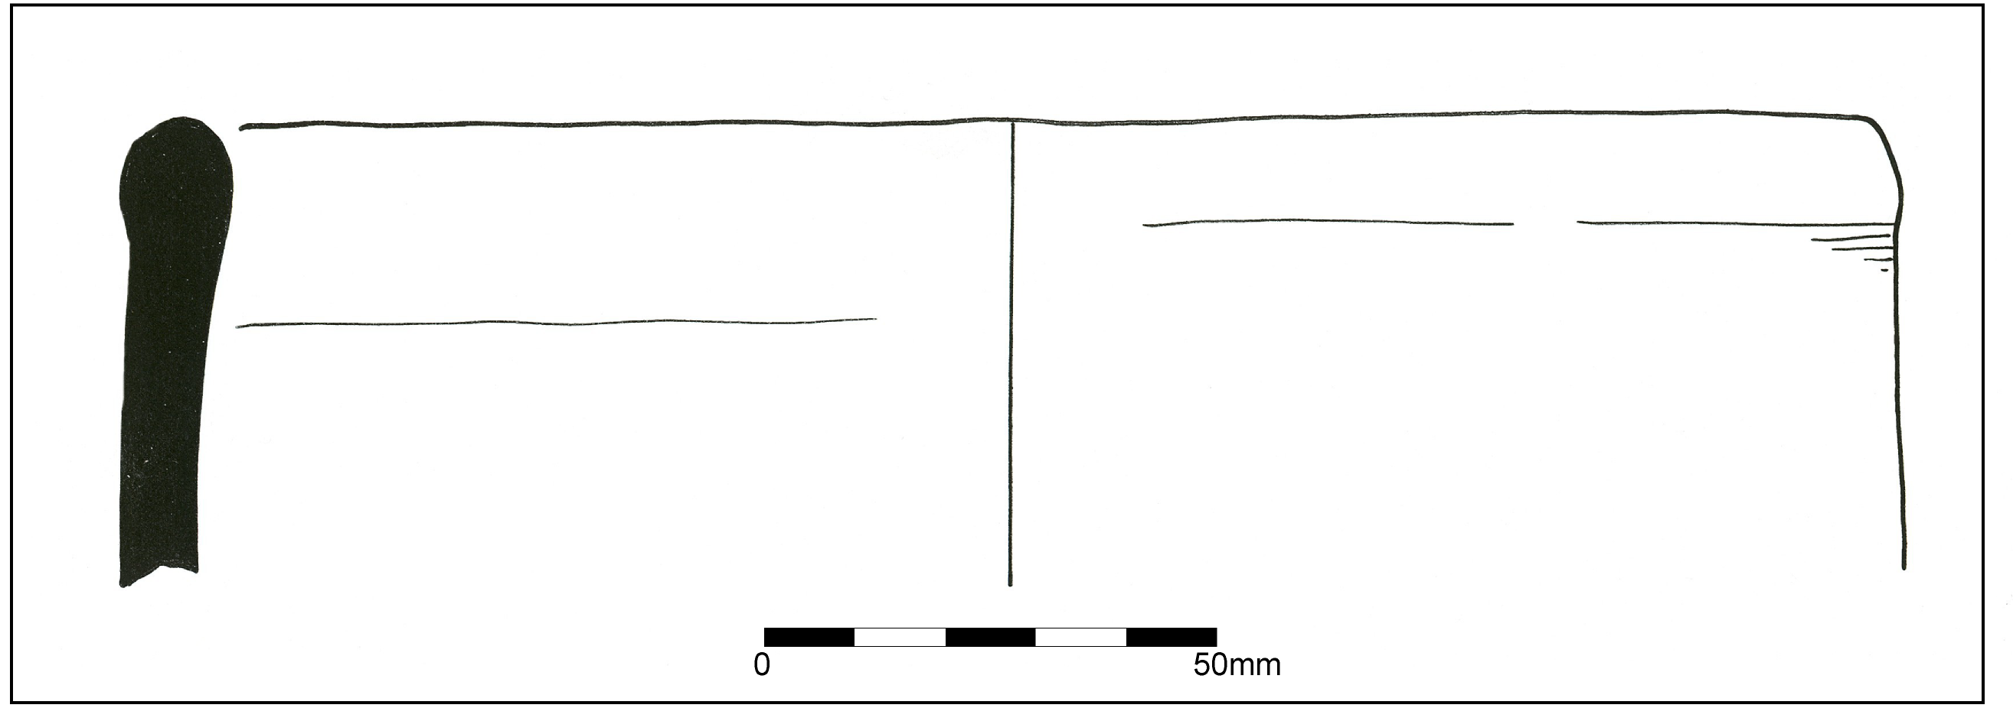

Fig. 1. Handmade jar. Fabric: MAL RE A. Smoothed exterior and interior rim. Enclosure ditch [124]. Phase 2.

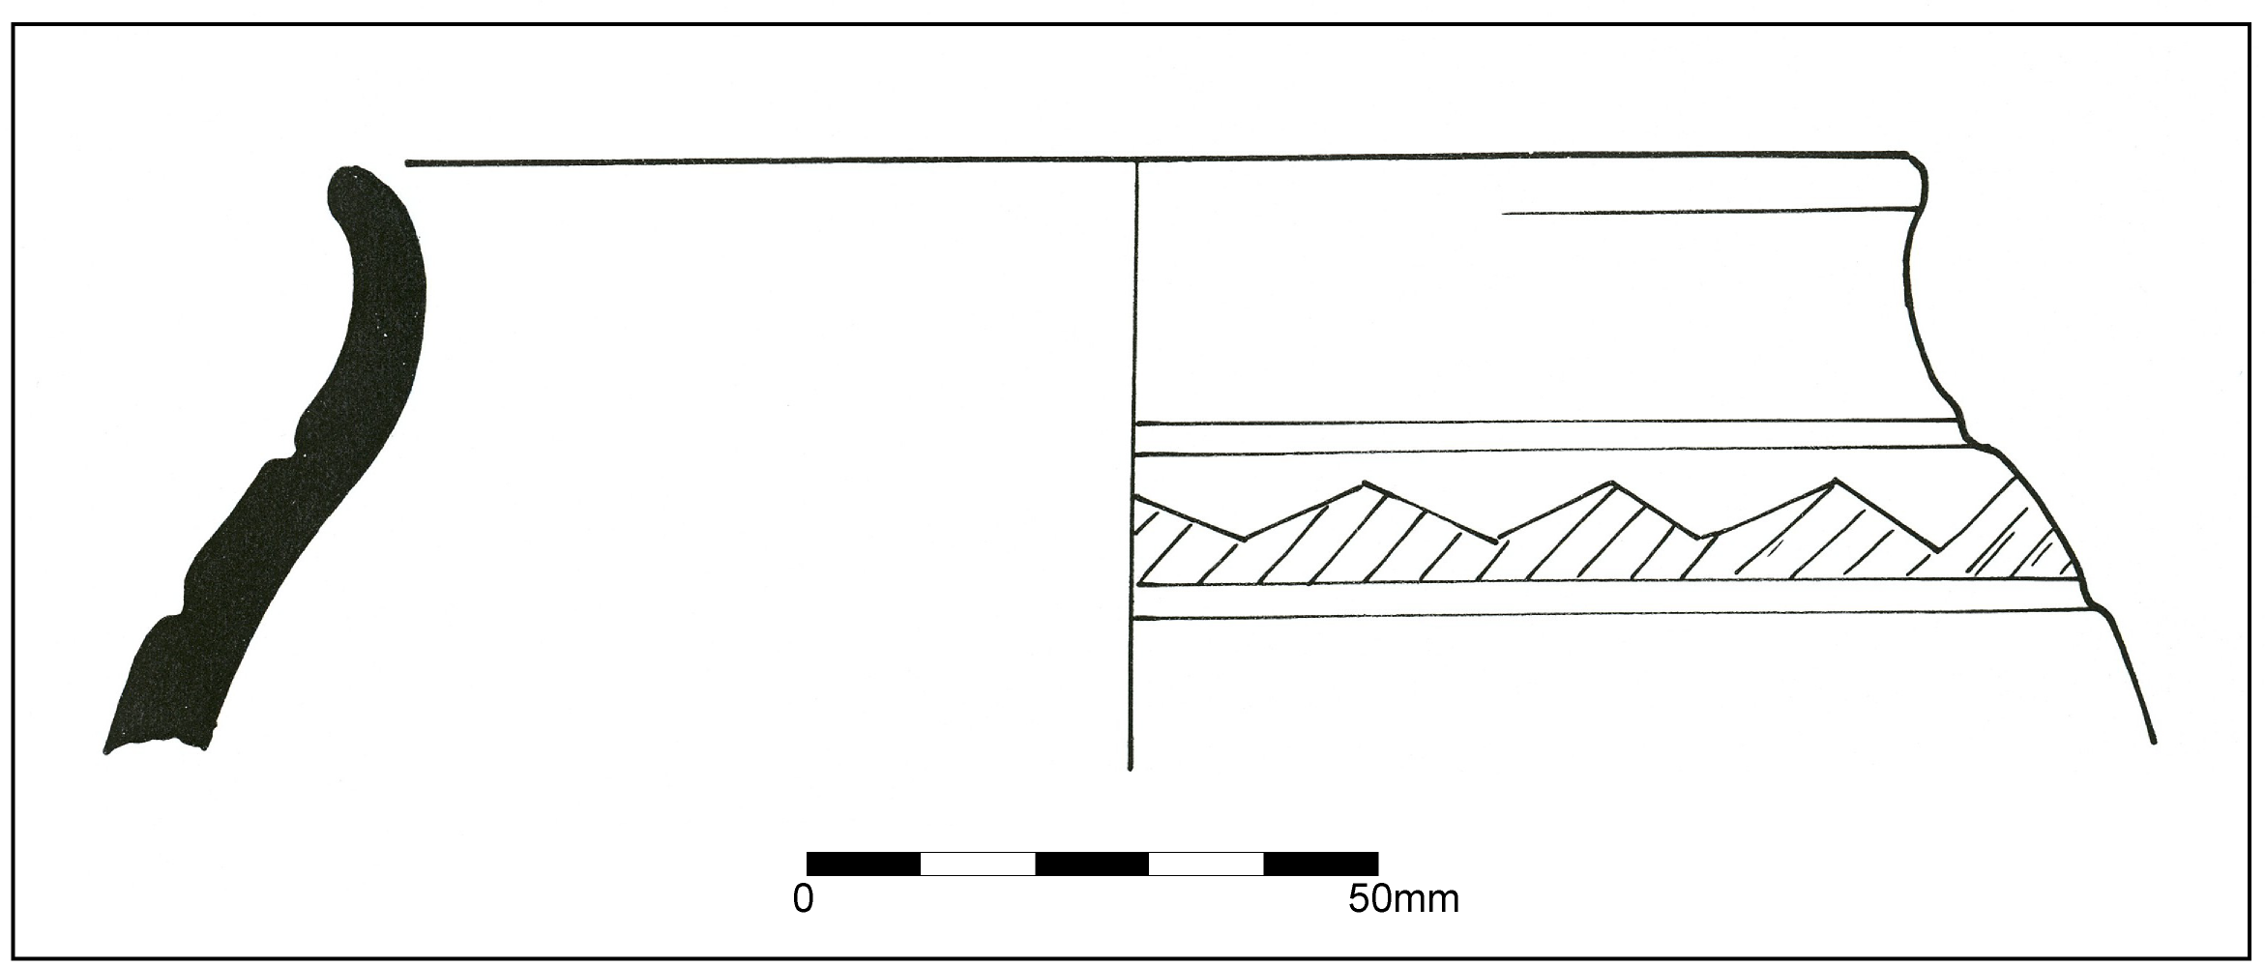

Fig. 2. Handmade everted rim jar with a zone of incised decoration. Burnished exterior finish. Fabric: MAL RE A. Enclosure ditch [124]. Phase 2.

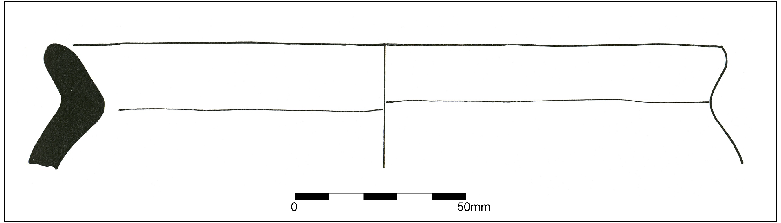

Fig. 3. Handmade sharply everted rim jar. Fabric: MAL RE B. Enclosure ditch [124]. Phase 2.
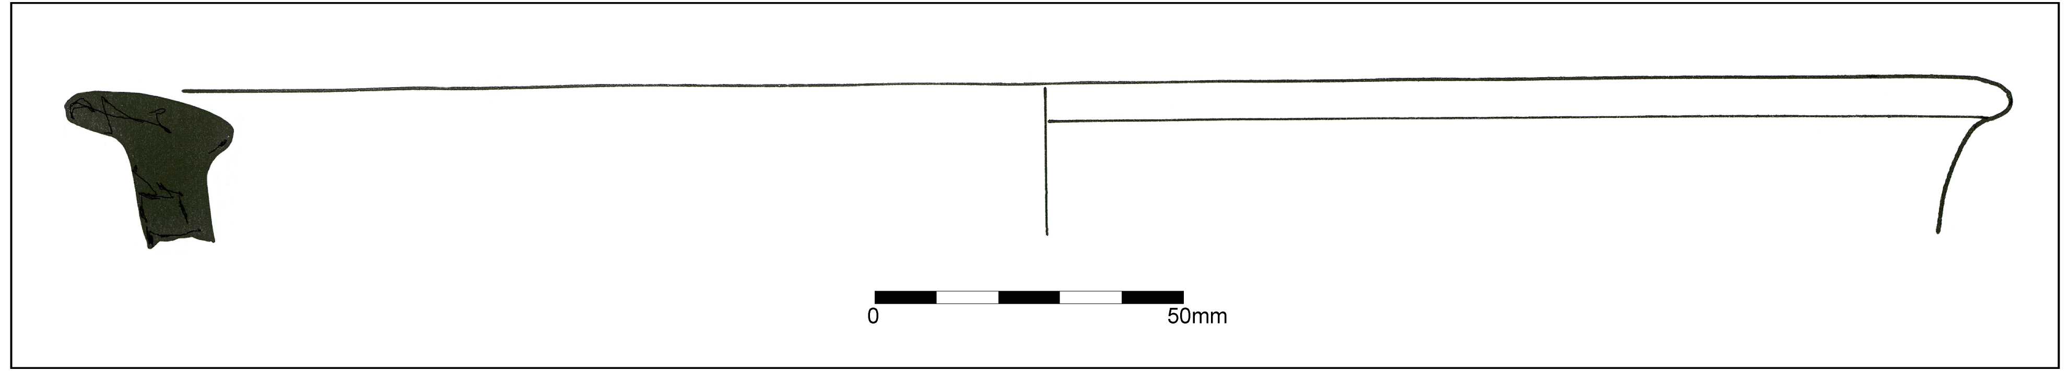

Fig. 4. Hammer rim bowl. Fabric: SVW OX. Enclosure ditch [124]. Phase 2.

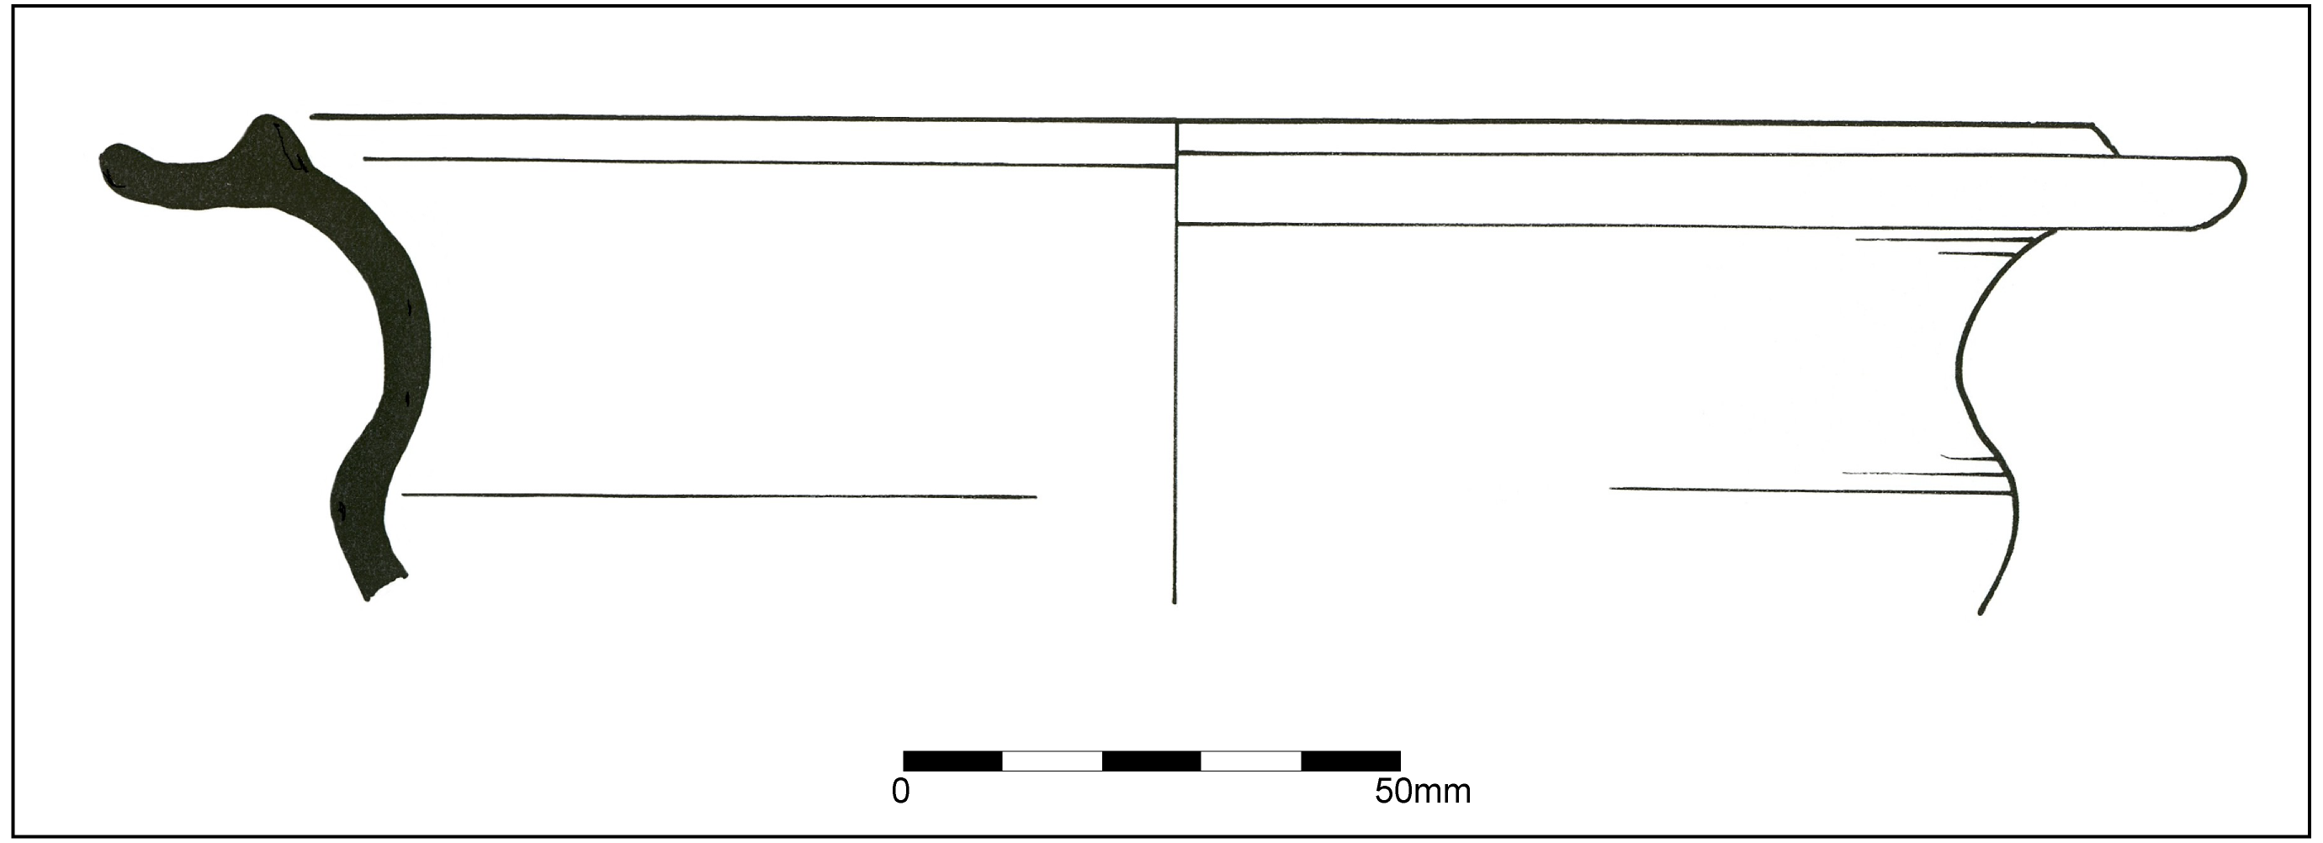

Fig. 5. Flanged rim carinated bowl. Fabric: SVW OX. Enclosure ditch [124]. Phase 2.

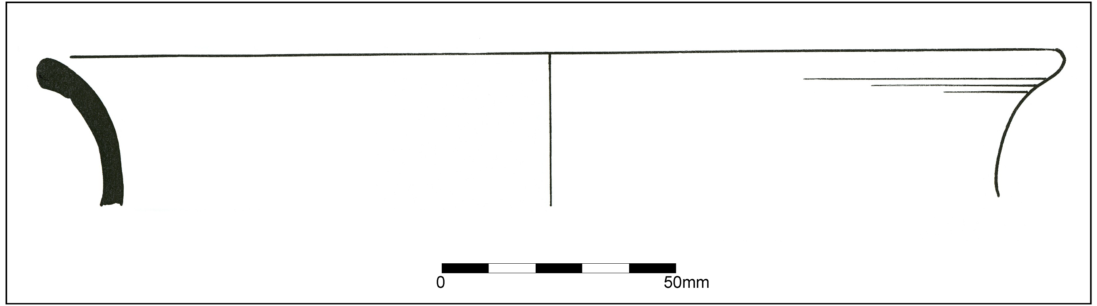

Fig. 6. Flared rim jar. Fabric: SVW OX. Enclosure ditch [124]. Phase 2.

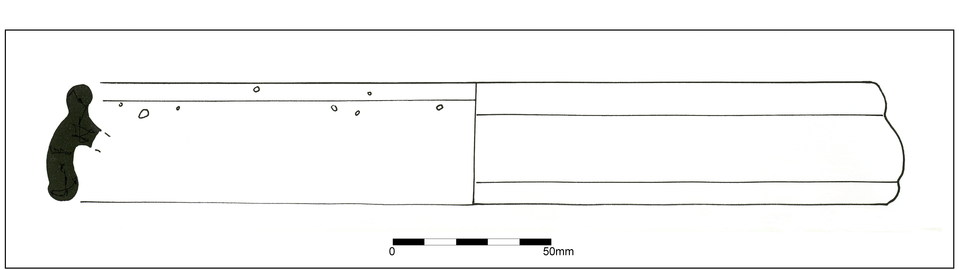

Fig. 7. Oxfordshire white ware mortarium. OXF WH. Young 1977, type M10. AD 180-240. Enclosure ditch [124]. Phase 2.

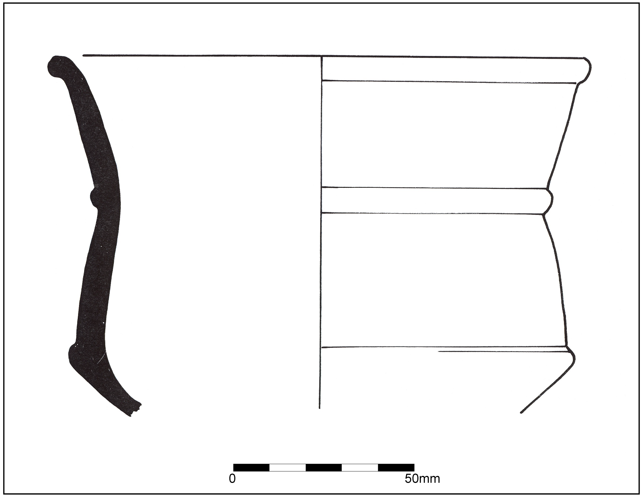

Fig. 8. Carinated bowl. Fabric: SVW OX. Round gully [148]. Phase 2.

- APPENDIX 3: Palaeoenvironmental Analysis
Dr Charlotte O’Brien, Dr David Webster & Mr Lorne Elliott Archaeological Services University of Durham (ASUD)

SUMMARY

This report presents the results of a plant macrofossil assessment of four environmental samples taken from possible Iron Age/Romano-British features on a former Welsh Water site at Coughton, Ross on Wye.

The samples produced very small flots in which the only charred plant macrofossils were a few weeds seeds in (172) and (149).

No further plant macrofossil work is recommended for the samples due to the low flot volumes and absence of charred cereal grains. No suitable material for radiocarbon dating was recovered from the samples.

1. PROJECT BACKGROUND

1.1 Location & Background

Four environmental samples were collected and this report presents the results of plant macrofossil assessment of the samples by Archaeological Services of Durham University. Contexts (126) and (125) were the primary and upper fills of an enclosure or boundary ditch, possibly relating to the roundhouse. Context (149) was the terminal fill of the roundhouse gully [231] and (172) was a trampled occupation spread respecting the curve of [231].

1.2 Objective

The objective was to assess the nature, extent and potential of the macrofossil evidence within the samples and to provide an appropriate recommendation.

1.3 Dates

Samples were submitted to Archaeological Services on 15th May 2006. Assessment and report preparation were conducted between 15th May-7th June 2006.

1.4 Personnel

Dr David Webster carried out the sample processing and Dr Charlotte O’Brien and Mr Lorne Elliott undertook the assessment and report preparation.

2. METHOD STATEMENT

Five litres of each sample were manually floated and sieved through a 500µm mesh. The residues were retained, described and scanned using a magnet for ferrous fragments. The flots were dried slowly and scanned at × 40 magnification for waterlogged and charred botanical remains. Identification of these was undertaken by comparison with modern reference material held in the Environmental Laboratory at Archaeological Services Durham University. Plant taxonomic nomenclature follows Stace (1997).

3. RESULTS

The samples produced very small flots in which the only charred plant macrofossils were a few weed seeds in (172) and (149). Uncharred seeds of fat-hen, redshank and knotgrass were recorded and small amounts of charcoal, coal, bone and modern roots occurred in the flots. The results are presented in Table 1.

Table 1: Plant macrofossils from the site

Context | (125) | (172) | (149) | (126)
Sample | 1 | 2 | 3 | 5
Volume processed (ml) | 5000 | 5000 | 5000 | 5000
Volume of flot (ml) | 3 | 2 | 3 | 1
Volume of flot assessed (ml) | 3 | 2 | 3 | 1
Flot matrix (relative abundance)
Bone |  |  | 1
Charcoal | 1 | 1 | 2 | 1
Coal | 1 | 1
Modern roots | 1 |  |  | 1
Waterlogged remains (total counts)
(a) Anthemis cotula (Stinking chamomile) |  | 3
(x) Caryophyllaceae sp (Pink family) |  |  | 1
(x) Rumex sp (Dock) |  | 1
Waterlogged remains (total counts)
(a) Chenopodium album (Fat-hen) | 2 | 1 | 2
(r) Persicaria maculosa (Redshank) |  | 1
(r) Polygonum aviculare (Knotgrass) | 1
(a: arable weed; r: ruderal; x: wide niche)
Relative abundance is based on a scale from 1 (lowest) to 5 (highest)

4. DISCUSSION
The only charred macrofossils were a few seeds of stinking chamomile and dock in (172) and a seed from the pink family in (149). These are likely to have grown in areas of waste or disturbed ground near the site. In view of the well-drained nature of the site and the presence of modern roots, the uncharred seeds of fat-hen, redshank and knotgrass are probably modern. Due to the absence of charred cereal remains, the samples have no potential to provide chronological or economic information about the site. The assessment was unable to clarify issues of phasing relating to the samples and provided no information about the palaeoenvironment at the time of their deposition.

5. RECOMMENDATIONS

No further plant macrofossil work is recommended for the samples due to the low flot volumes and absence of charred cereal grains. No suitable material for radiocarbon dating was recovered from the samples.

6. SOURCES

Stace, C., (1997) New Flora of the British Isles, 2nd edition, Cambridg

- APPENDIX 4: Drawing Register

Drawing Number | Plan / Section | Scale | Direction | Description | Phase/ Stage | Grid Number | Sheet Number | Scanned | Traced | Complete
1 | P | 1.20 | N/A | Pre ex A1 | Pre ex | A1 | 1 | Checked & ready to archive
2 | P | 1.20 | N/A | Pre ex A4 | Pre ex | A4 | 2 | Checked & ready to archive
3 | P | 1.20 | N/A | Post ex A2 | Post ex | A2 | 3 | Yes | Yes | Yes
4 | P | 1.20 | N/A | Pre ex A3 | Pre ex | A3 | 4 | Checked & ready to archive
5 | P | 1.20 | N/A | Pre ex B4 | Pre ex | B4 | 5 | Checked & ready to archive
6 | P | 1.20 | N/A | Pre ex E2 | Pre ex | E2 | 6 | Checked & ready to archive
7 | P | 1.20 | N/A | Post ex A1 | Post ex | A1 | 7 | Yes | Yes | Yes
8 | S | 1.10 |  | Context 111 |  |  | 8 | Checked & ready to archive
9 | S | 1.10 |  | Cut 106 |  |  | 8 | Checked & ready to archive
10a | S | 1.20 | NW | Across A1,A2,A3,A4 |  |  | 9 | Yes | Yes | Section 1
10b | S | 1.20 | NW | Across A1,A2,A3,A4 |  |  | 10 | Yes | Yes | Section 1
11 | P | 1.20 | N/A | Pre ex C2 | Pre ex | C2 | 11 | Checked & ready to archive
12 | P | 1.20 | N/A | Pre ex C1 | Pre ex | C1 | 12 | Checked & ready to archive
13a | S | 1.20 | NE | Across A5,B5,C5 |  |  | 13 | Yes | Yes | Section 2
13b | S | 1.20 | NE | Continuation of above |  |  | 14 | Yes | Yes | Section 2
14 | S | 1.20 | SW | Across A1,B1,C1 |  |  | 15 | Yes | Yes | Section 8
15 | S | 1.20 | NE | Across C7,D7,E7 |  |  | 16 | Yes | Yes | Section 4
16 | S | 1.20 | NW | Across C5,C6,C7 |  |  | 17 | Yes | Yes | Section 3
17 | S | 1.20 | SE | Across E7,E6,E5 |  |  | 18 | Yes | Yes | Section 5
18 | S | 1.20 |  | Cut 124 |  |  | 19 | Yes | Yes | Section 9
19 | S | 1.20 | SE | Across E4,E3 |  |  | 20 | Yes | Yes | Section 5
20 | S | 1.20 | SE | Across E2,E1 |  |  | 21 | Yes | Yes | Section 5
21 | S | 1.20 | SW | Across D1,C1 |  |  | 22 | Yes | Yes | Section 6
22 | S | 1.20 | SW | Continuation of above |  |  | 23 | Yes | Yes | Section 6
23 | P | 1.20 | N/A | Post ex A5 & B5 | Post ex | A5 & B5 | 24 | Yes | Yes | Yes
24 | P | 1.20 | N/A | Post ex A4 | Post ex | A4 | 25 | Yes | Yes | Yes
25 | S | 1.10 | S | Ring ditch |  | A4 | 26 | Yes | Yes | Section 10
26 | S | 1.10 | S | Ring ditch |  | A4 | 26 | Checked & ready to archive
27 | S | 1.10 | SE | Ring ditch |  | B3 | 26 | Checked & ready to archive
28 | S | 1.10 | SE | Ring ditch |  | B3 | 26 | Checked & ready to archive
29 | S | 1.10 | SE | Ring ditch |  | C3 - C4 | 26 | Checked & ready to archive
30 | S | 1.10 |  |  |  |  | 27 | Checked & ready to archive
31 | P | 1.20 | N/A | Post ex B4 | Post ex | B4 | 28 | Yes | Yes | Yes
32 | S | 1.10 |  | Pit 179 |  |  | 29 | Yes | Yes | Section 11
33 | P | 1.10 | N/A | Pit 179 |  |  | 29 | Checked & ready to archive
34 | S | 1.10 | SE | Pit 185 |  |  | 30 | Checked & ready to archive
35 | S | 1.10 | E | Pit 124 |  |  | 31 | Yes | Yes | Section 12
36 | P | 1.20 | N/A | Pit 185 |  | A3 | 32 | Checked & ready to archive
37 | S | 1.10 | E | Ring ditch |  | A4 | 27 | Checked & ready to archive
38 | S | 1.10 | E | Ring ditch |  | C4 | 27 | Checked & ready to archive
39 | S | 1.10 | E | Ring ditch |  | C4 | 27 | Checked & ready to archive
40 | P | 1.20 | N/A |  | Post ex | B3 | 33 | Yes | Yes | Yes
41 | S | 1.10 | NNE | Ring ditch |  | C4 | 27 | Checked & ready to archive
42 | S | 1.10 | NNE | Ring ditch |  | C5 & D5 | 27 | Checked & ready to archive
43 | P | 1.20 | N/A |  | Post ex | C3 | 34 | Yes | Yes | Yes
44 | P | 1.20 | N/A |  | Post ex | C4 | 35 | Yes | Yes | Yes
45 | S | 1.20 | SE | Across C1 |  | C1 | 36 | Yes | Yes | Section 7
46 | S | 1.10 | E | Sub linear |  |  | 27 | Checked & ready to archive
47 | S | 1.10 | W | Pit |  |  | 37 | Checked & ready to archive
48 | S | 1.10 | S | Post hole |  | A4 | 37 | Checked & ready to archive
49 | S | 1.10 | E | Post hole |  | A4 | 37 | Checked & ready to archive
50 | S | 1.10 | E | Stake hole |  | C4 | 37 | Checked & ready to archive
51 | P | 1.20 | N/A |  | Post ex | C5 | 41 | Yes | Yes | Yes
52 | P | 1.20 | N/A |  | Post ex | C6 | 42 | Yes | Yes | Yes
53 | P | 1.20 | N/A |  | Post ex | C7 | 43 | Yes | Yes | Yes
54 | P | 1.20 | N/A |  | Post ex | D5 | 44 | Yes | Yes | Yes
55 | P | 1.20 | N/A |  | Post ex | D6 | 45 | Yes | Yes | Yes
56 | P | 1.20 | N/A |  | Post ex | D7 | 46 | Yes | Yes | Yes
57 | P | 1.20 | N/A |  | Post ex | E5 | 48 | Yes | Yes | Yes
58 | P | 1.20 | N/A |  | Post ex | E6 | 47 | Yes | Yes | Yes
59 | P | 1.20 | N/A | Test slot within pit 204 | Post ex | E7 | 49 | Yes | Yes | Yes
60 | S | 1.10 | W | Post hole |  | B4 - C4 | 37 | Checked & ready to archive
61 | S | 1.20 |  |  |  |  | 38 | Checked & ready to archive
62 | S | 1.20 |  | Test slot within pit 204 |  |  | 38 | Checked & ready to archive
63 | S | 1.10 | E | Pit |  | A5 | 38 | Yes | Yes | Section 13
64 | S | 1.10 | W | Pit |  | A4 | 39 | Checked & ready to archive
65 | S | 1.10 | E | Post hole |  | A4 | 39 | Checked & ready to archive
66 | S | 1.10 | S | Post hole |  | B4 | 39 | Checked & ready to archive
67 | S | 1.10 | N | Pit |  |  | 39 | Yes | Yes | Section 14
68 | S | 1.10 | E | Pit 222 |  |  | 39 | Checked & ready to archive
69 | S | 1.10 | SE & NW | Pit 220 |  |  | 30 | Checked & ready to archive
70 | S | 1.10 | NE & SW | Pit 220 |  |  | 30 | Checked & ready to archive
71 | S | 1.10 | N | Pit 224 |  |  | 40 | Checked & ready to archive
72 | S | 1.20 | SW | Spread 172 |  |  | 31 | Checked & ready to archive
73 | S | 1.20 | S | Broad pit |  |  | 50 | Yes | Yes | Section 15
74 | P | 1.20 | N/A | Post ex A4 | Post ex | A4 | 51 | Yes | Yes | Yes
75 | P | 1.20 | N/A | Post ex E2 | Post ex | E2 | 52 | Yes | Yes | Yes
76 | P | 1.20 | N/A | Post ex D1 | Post ex | D1 | 53 | Yes | Yes | Yes
77 | P | 1.20 | N/A | Post ex D2 | Post ex | D2 | 54 | Yes | Yes | Yes
78 | P | 1.20 | N/A | Post ex E1 | Post ex | E1 | 55 | Yes | Yes | Yes
79 | P | 1.20 | N/A | Post ex C2 | Post ex | C2 | 56 | Yes | Yes | Yes
80 | P | 1.20 | N/A | Post ex C1 | Post ex | C1 | 57 | Yes | Yes | Yes
81 | P | 1.20 | N/A | Post ex B1 | Post ex | B1 | 58 | Yes | Yes | Yes
82 | P | 1.20 | N/A | Post ex B2 | Post ex | B2 | 59 | Yes | Yes | Yes
83 | P | 1.20 | N/A | Post ex A5 | Post ex | A5 | 60 | Yes | Yes | Yes
84 | P | 1.20 | N/A | Post ex B5 | Post ex | B5 | 61 | Yes | Yes | Yes
85 | P | 1.20 | N/A | Post ex B4 | Post ex | B4 | 62 | Yes | Yes | Yes
 |  |  |  |  |  | TOTAL |  |  |  | 85
 |  |  |  |  |  | NUMBER TO BE DIGITISED, THEN ARCHIVED |  |  |  | 47
 |  |  |  |  |  | NUMBER DIRECT TO ARCHIVE |  |  |  | 38
- Site summary

Report Name & Title | Archaeological Excavation at the former Welsh Water site Coughton Ross-on-Wye Herefordshire
Contractors Name and Address | Border Archaeology PO Box 36 Leominster Herefordshire HR6 OYQ
Site Name | Former Welsh Water site Coughton Ross-on-Wye Herefordshire
Grid Reference  (8 fig) | SO 5956 2125 Planning Application  Number: ---
SMR number/s of site | 43283
Date of Field Work | January-February 2006
Date of Report | August 2006
 | NUMBER AND TYPE OF FINDS
Pottery  Other | Period: IA/R-B Number of sherds: 521  Period: P-M Quantity: 1 tile fragment
 | NUMBER AND TYPE OF SAMPLES COLLECTED
Sieving for charred plant remains | No of features sampled: 4  No of buckets: 8
C14/scientific dates | No suitable material for radiocarbon dating was recovered from the samples
Pollen | No of columns/spot samples: N/A  Name of pollen specialist: N/A
Bone | Number of buckets sieved for bone: N/A  Quantity recovered: N/A Period: N/A
Insect | No of columns/spot samples: N/A  Name of pollen specialist: N/A
Other | Type and specialist: N/A
Summary of the report | The site is located on the outskirts of the village of Walford, to the rear of Fowbridge Gardens. The earliest occupation identified appears to be of Iron Age/Romano-British date while the upper layers were indicative of late C19/early C20 activity, together with more recent activity relating to the construction and demolition of the former Welsh Water facility and subsequent exploratory work in advance of the current development. The early occupation evidence and later activity were separated by a sustained period of flooding or hillwash.  The early features comprised a probable settlement enclosure boundary encompassing a posted structure that was replaced by a roundhouse. The enclosure boundary may also have had a second phase of usage, although this may be misleading. Revealed within a break in the circuit of the roundhouse was a deposit interpreted as an occupation layer.  Iron slag and burnt stones found within two pits located in the western portion of the enclosure suggest the presence of light industrial activity in this area. At least two phases of such activity were identified and these may well be comparable to the two phases of domestic occupation.

- Document Control

Job title | Former Welsh Water Site Coughton Ross-on-Wye Herefordshire | Job No | BA0529KRCRW
Report written by | Stephen Priestley MA & Neil Shurety
Report edited by | George Children MA
Issue No | Status | Date | Approved for issue
1 | Final | August 2006 | Neil Shurety

