CPAT Report No. 1911

Shugborough Estate Car Park
Archaeological Evaluation

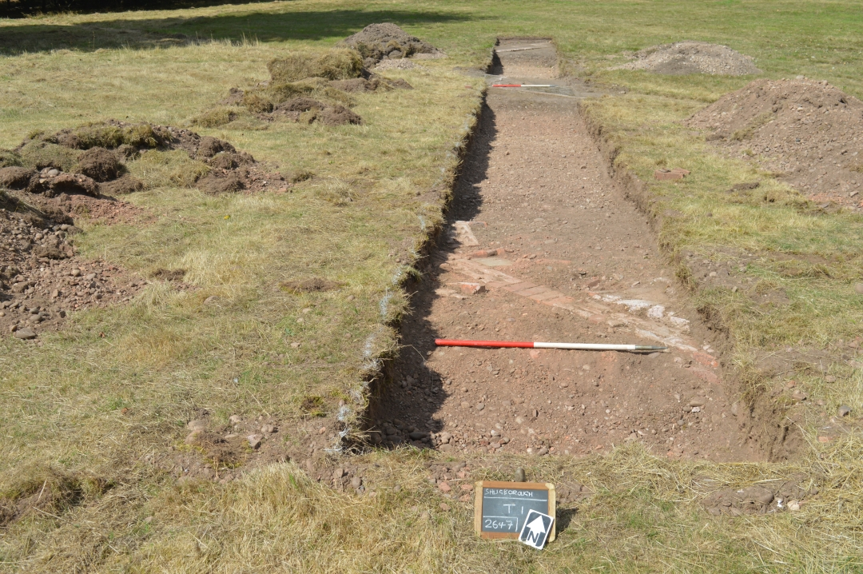

Organisation | Clwyd-Powys Archaeological Trust
Client Name | National Trust
CPAT Project No | 2647
Project Name | Shugborough Estate car park
Project Type | Archaeological Evaluation
Project Manager | Tim Malim
Project Supervisor | Ian Grant
Grid Reference | SJ99347 21476
County/LPA | Staffordshire
CPAT Report No | 1911

Report prepared by: | Report checked by: | Report approved by:
 | 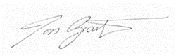 | 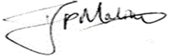
Evon Kirby  Project Archaeologist | Ian Grant  Senior Archaeologist | Tim Malim  Principal Archaeologist
31/10/2022 | 16/11/2022 | 16/11/2022
Report Status | Final
Confidential until | N/A

Bibliographic reference: Kirby, E., 2022. Shugborough Estate car park: Archaeological Evaluation. Unpublished report. CPAT Report No. 1911.
CONTENTS

Summary ii
1 Introduction 1
2 Historic Background 2
3 Archaeological Evaluation 3
4 Conclusions 14
5 Sources 15
6 Archive deposition Statement 15
Documentary Archive 16
Appendix 1: CPAT WSI 2647 17
Appendix 2: Section Drawings 22

Summary
An archaeological evaluation was conducted by the Clwyd-Powys Archaeological Trust during August 2022 in respect of potential plans to construct a car park in the area of the old Outdoor Education Centre, south-east of the walled gardens within the Shugborough Estate grounds.
Five trenches were excavated to evaluate the area proposed for development. The evaluation revealed remains of archaeological significance relating to the WWII military hospital complex. An exploratory trench located to investigate potential prehistoric archaeology contained no remains of archaeological significance.
It was noted that above-ground remains of path networks servicing the WWII huts, in addition to a concrete hut base, remain visible. Similar sub-surface remains survive below the topsoil.
The topsoil, and demolition deposits therein, in the area of Trench 1 and 2 contained notable amounts of asbestos.
The archaeological remains encountered largely consisted of brick and concrete building foundations with demolition backfill.

Introduction
The Clwyd-Powys Archaeological Trust (CPAT) were invited by the National Trust to undertake an archaeological evaluation at Shugborough Estate, Staffordshire (SJ 99347 21476) following consultation with the Staffordshire County archaeologist (Shane Kelleher). An archaeological evaluation was recommended to help inform pre-application advice and determination of planning application. The proposal is to construct a new car park in the area of the old Outdoor Education Centre, south-east of the walled gardens (Fig 1). The designs have not yet been finalised and could potentially be influenced by the results of archaeological works.
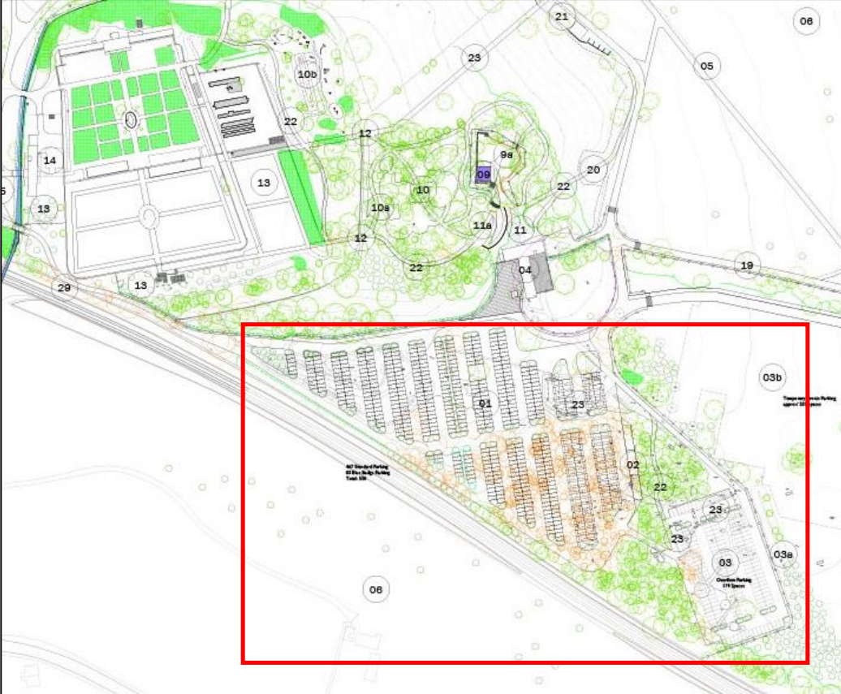
Fig. 1: Proposed development, area of evaluation indicated in red.
The proposed development is located within an area of the estate where, during WWII, an army camp was constructed behind the walled garden to house American troops (the site of the old outdoor Education Centre). Little was known about the survival of military archaeological assets within the area. An RAF aerial image (1945) of the Shugborough US Army Station (Image Ref.106g-uk-646-Fr-4410), shows the layout of the camp and it was clear that some of the military buildings extended into the area of the proposed car park but it was unclear as to what extent they survive.
The area was partially included in a geophysical survey of the Parkland at Shugborough Estate, undertaken in 2017 (TigerGeo, 2018 Park Farm, Shugborough Geophysical Survey Report), the results of which were incorporated into the design of the archaeological mitigation for the evaluation with targeted trenches (Fig 2).
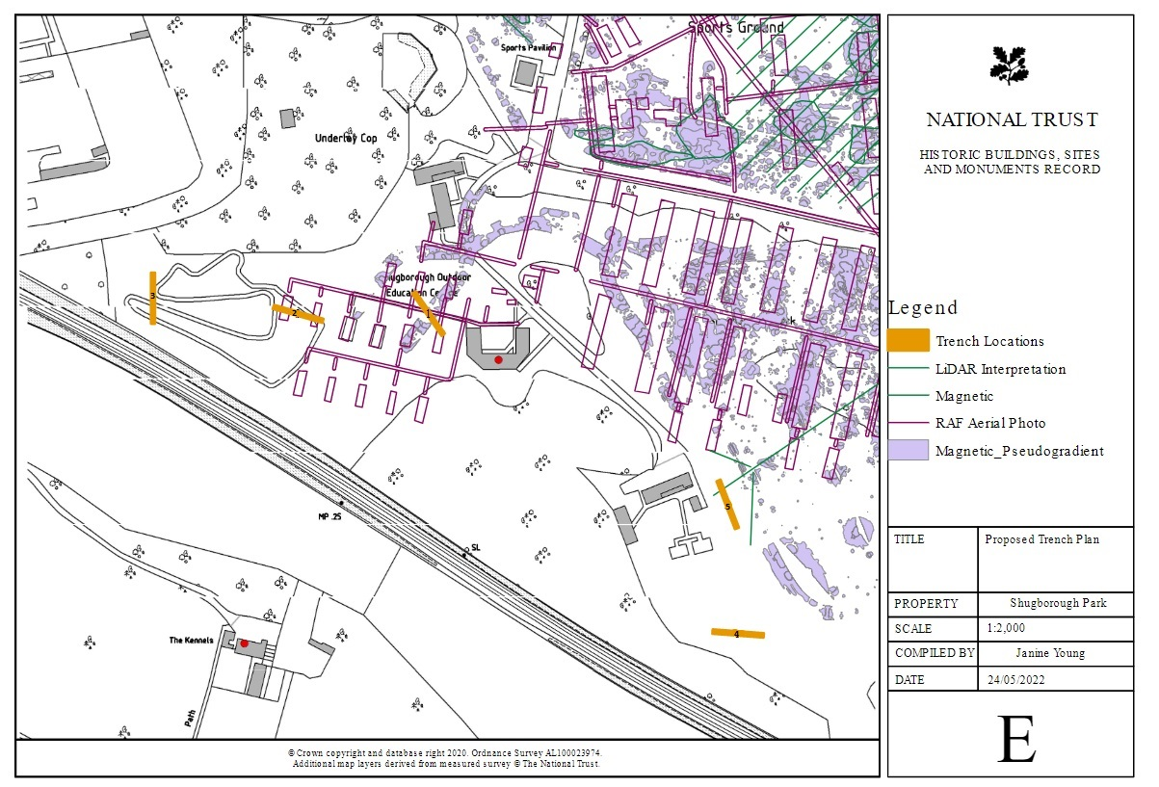Fig. 2: Proposed trench locations

Historical Background
Prehistoric remains have been found in the surrounding area of the development site including ring ditches, a pit alignment and sub-rectangular enclosure, and trial trenching in 2005 revealed Bronze Age features sealed beneath alluvial deposits.
Shugborough Estate is the location of a medieval moated mansion thought to be the mid-way residence of the Bishop of Lichfield, between their Eccleshall castle and Lichfield palace. By the end of the 17th century the mansion and moat had become the property of William Anson and the building was partially pulled down and its materials recycled for the erection of a new house.
During the 17th and 18th centuries much of the estate and parkland were developed as the Anson family prospered. The proposal area represents the eastern extent of the 18th century estate and historic mapping suggests it did not form a major part of the designed landscape (Biles 2022).
During the late 18th and 19th century the estate underwent remodelling by the then Earl of Lichfield. In 1918 the 3rd Earl’s death resulted in the estate being passed to the 4th Earl, who oversaw the estate during the Second World War.
In 1943 the 312th Station Hospital was built on Shugborough Park, on the proposal site area, for use as a military hospital by the United States Army during the Secondar World War. This hospital specialised as a psychiatric unit and contained a thousand hospital beds. The hospital was under the command of Colonel Ernest Parsons who oversaw over 500 medical personnel. In 1945 the war Office took over and the premises became a war crimes hospital in addition to the part use as Prisoner of War Camp 99, in use until 1948. Very little remains of the camp, as is common for this monument type, as the land was often reclaimed post-war (Thomas 2003).
During the late 1960’s the area of the camp was landscaped and laid out as a sports field for Staffordshire County Council.

Archaeological Evaluation
The archaeological evaluation, comprising of 5 trenches (Fig 3), was conducted between 30 and 31 August 2022 in accordance with the Chartered Institute for Archaeologists’ (CIfA) (2014) Standard and Guidance for Archaeological Field Evaluation. All groundworks were excavated using a mechanical excavator, down to either natural subsoil or the first deposit of archaeological significance and thereafter were hand-cleaned and recorded in accordance with the methodology outlined in CPAT WSI 2647 (Appendix 1). The locations of the trenches and the features therein were recorded digitally using a GPS.
Trench 1 (Fig 4-5 & Appendix 2, 25m x 1.6m)
Trench 1 was located to the north-west of the outdoor Education Centre and was oriented roughly north-west/south-east (Fig 4 and 5). The trench was located in an area where RAF aerial photographs (c.1945) recorded the site of military buildings associated with the U.S Army Station.
At the southern end of the trench a brick and concrete building footing [104] was uncovered (Fig 6), interpreted as the remains of a WWII hut. At the northern end of the trench two concrete paths were present [102, 103]. Path 102 was covered by a thin layer of topsoil while 103 survived visibly at ground level (Fig 7). 102 and 103 represent a network of paths servicing the WWII hut complex, with some visible above-ground remains surviving at surface level.
A natural subsoil deposit (107), consisting of gravel, was encountered to the north and south of 104 and 103 with an overlying deposit of compact fine orangey brown sand (106), 0.11m thick. Two adjoining sherds of Roman amphorae ceramic were recovered from the deposit (106). A deposit of gravel and mixed demolition rubble (105), 0.4m thick, sealed the deposit 106. The deposit has been interpreted as the disturbed remains of the foundations for the hut site. The topsoil (101), a mid-greyish brown sandy soil 0.1m thick, contained fragments of asbestos, likely from the demolition of the WWII camp.

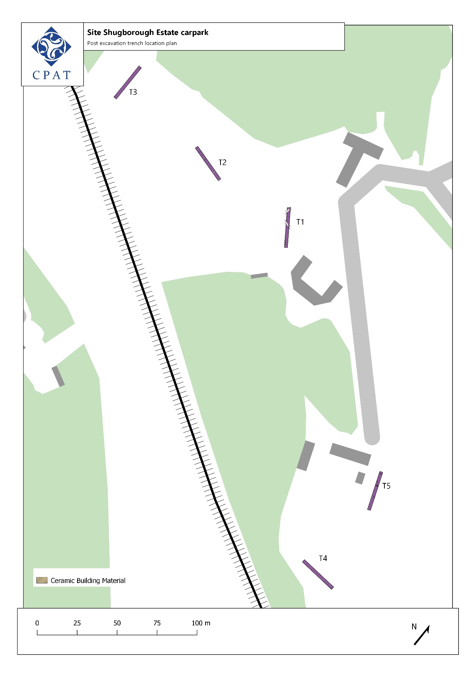
Fig. 3: Trench locations.

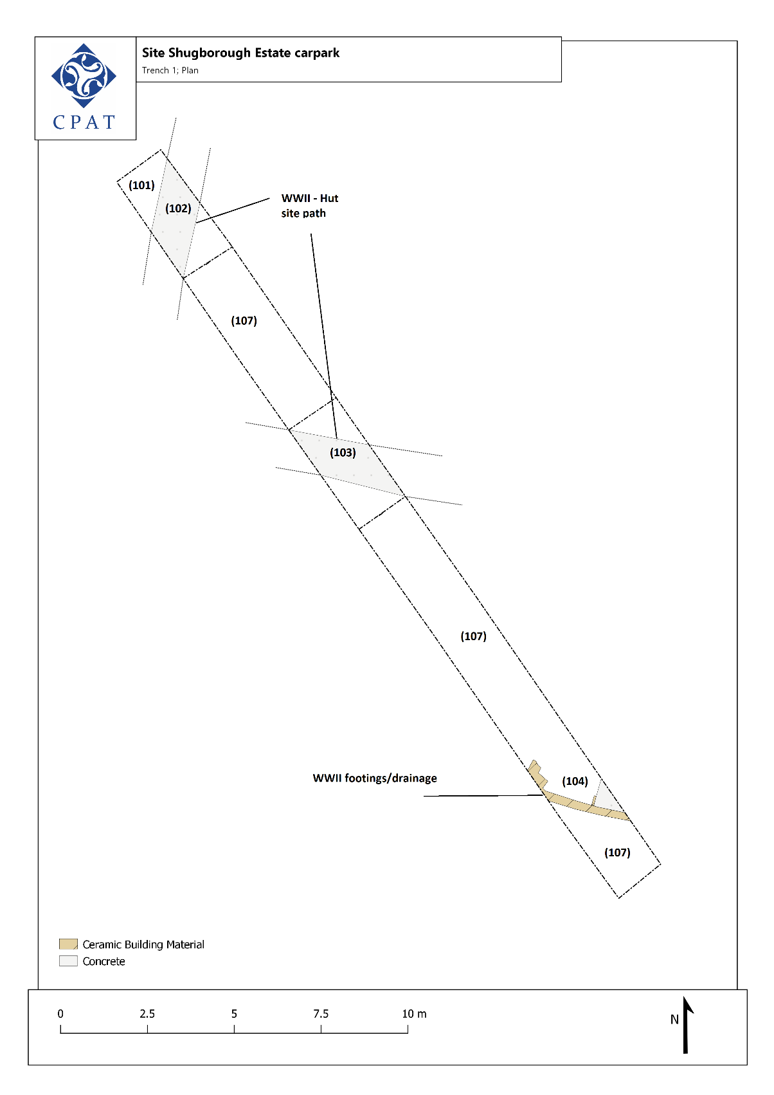
Fig. 4: Plan of trench 1

Fig. 5: Overview of trench 1. CPAT Photo 5011-0009
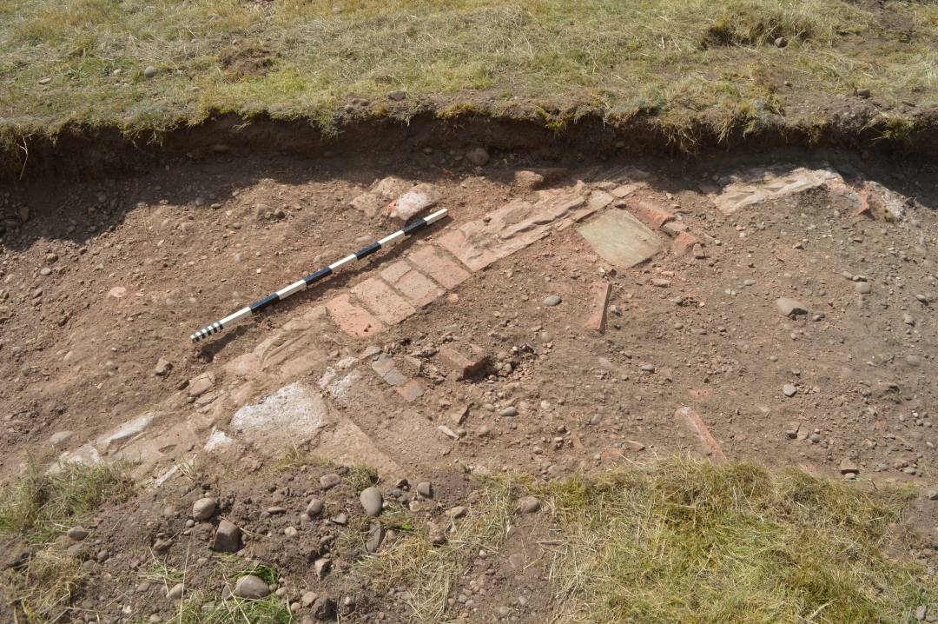
Fig. 6: Remains of WWII hut., viewed from the east. CPAT Photo 5011-0010.
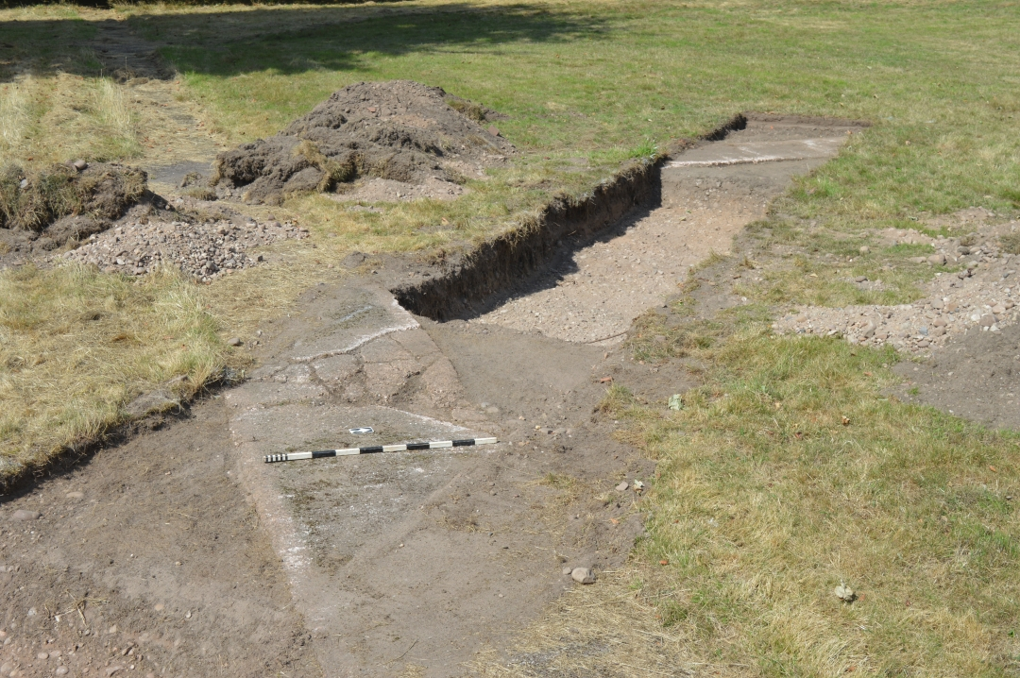
Fig. 7: Paths identified in trench 1, viewed from the south-east. CPAT Photo 5011-0008.
Trench 2 (Fig 8, 9 & Appendix 2, 26m x 1.6m)
Trench 2 was located to the north-east of Trench 1 aligned roughly east/west, in area also identified as the possible site of the WWII army camp (Figure 8 and 9). A previous test pit, measuring 2.6m x 4.5m and of unknown but recent origin, was recorded beyond the eastern extent of the trench along with the remains of a concrete pad, measuring 11m x 5.3m. The latter is part of the WWII camp complex,
The natural undisturbed subsoil, a deposit of gravel (208), was recorded at the centre and western end of the trench. This was sealed by a deposit of mixed gravel and mid-brown silty sand (207), 0.12m thick, and a firm orangish-brown fine sand (206), 0.06m thick.
At the western end of the trench a demolition deposit (202) was observed within a construction cut that truncated deposits 208, 207 and 206. This was interpreted as the western edge of one of the WWII huts (hut A – 6.5m wide) identified in the aerial photography. The partial remains of a brick wall, possibly not in-situ, were also recorded within the deposit 202 (Fig 10).
Two parallel concrete building footings [204, 205], each 0.3m wide, aligned north to west and 5m apart, were recorded at the eastern end of the trench. The footings have also been interpreted as the partial remains of a second WWII hut (hut B – Fig. 9). The hut site contained demolition rubble (203) 0.35m thick, overlaying natural subsoil deposits (208). It was noted that both demolition deposits 203 and 202 contained asbestos. Across the extent of the trench the overlying topsoil consisted of a mid-brownish grey silty sand (201), 0.05-0.1m thick.
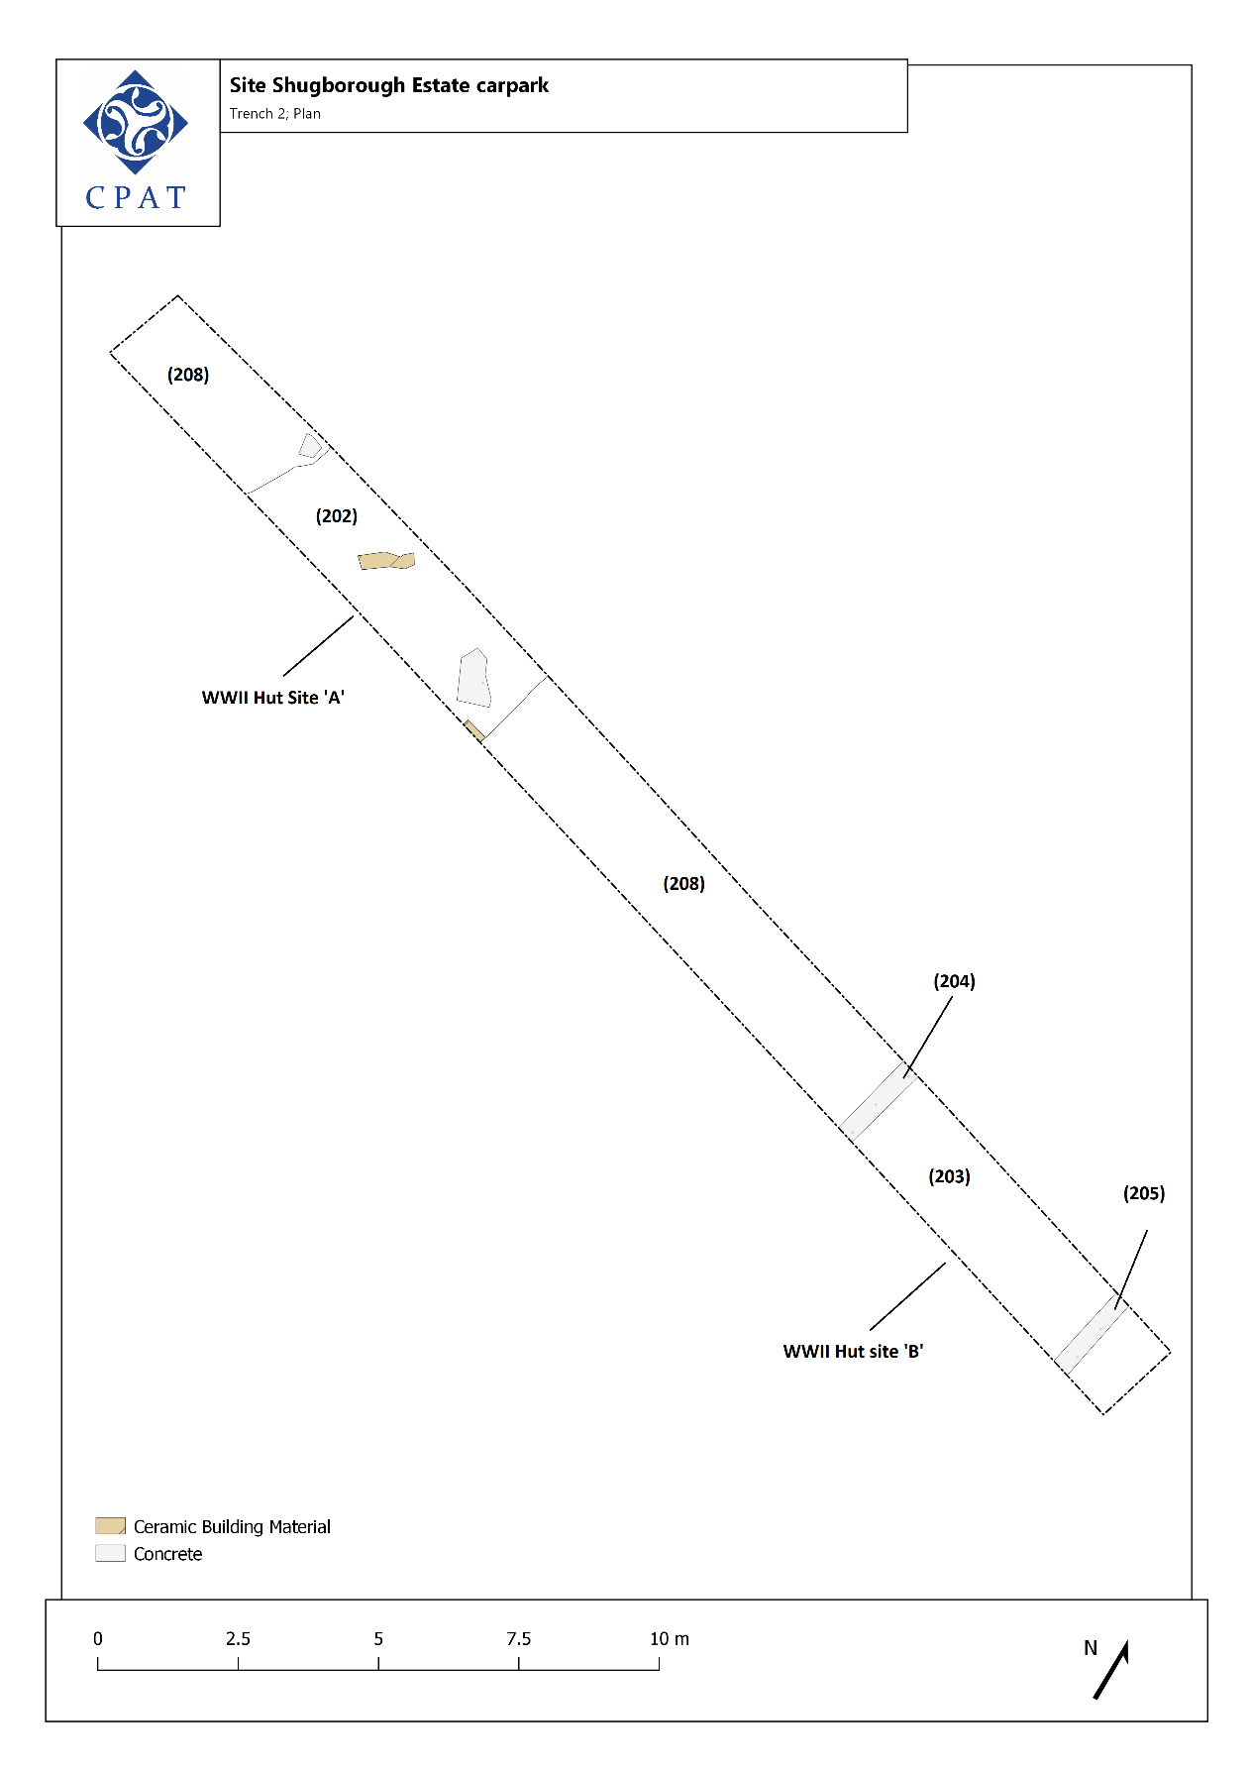
Fig. 8: Plan of trench 2.
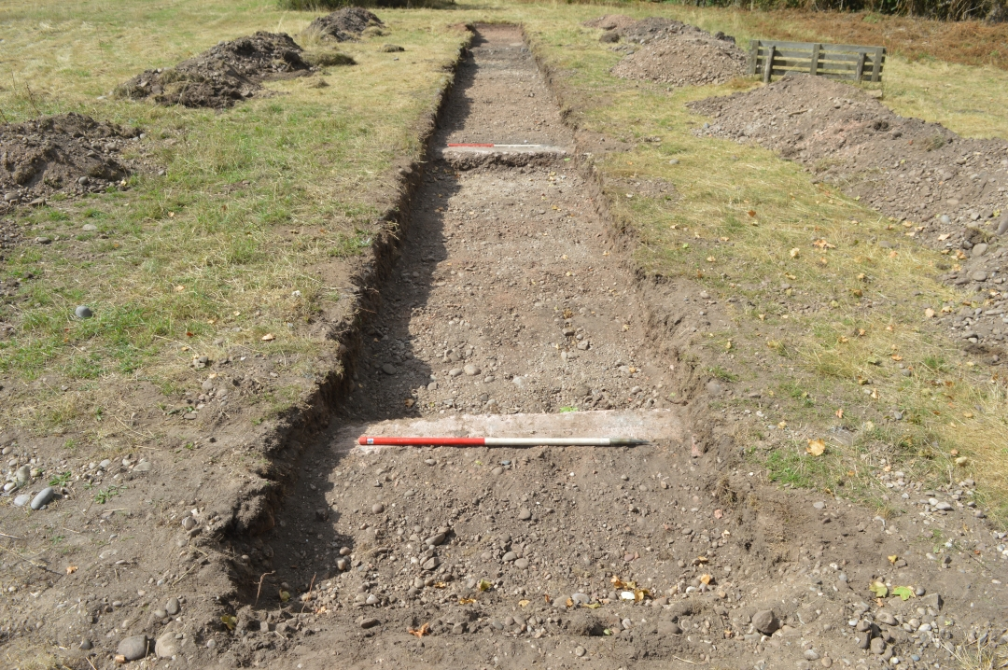
Fig. 9: Overview of trench 2, (hut site ‘B’ in the foreground) viewed from the east. CPAT Photo 5011-0013
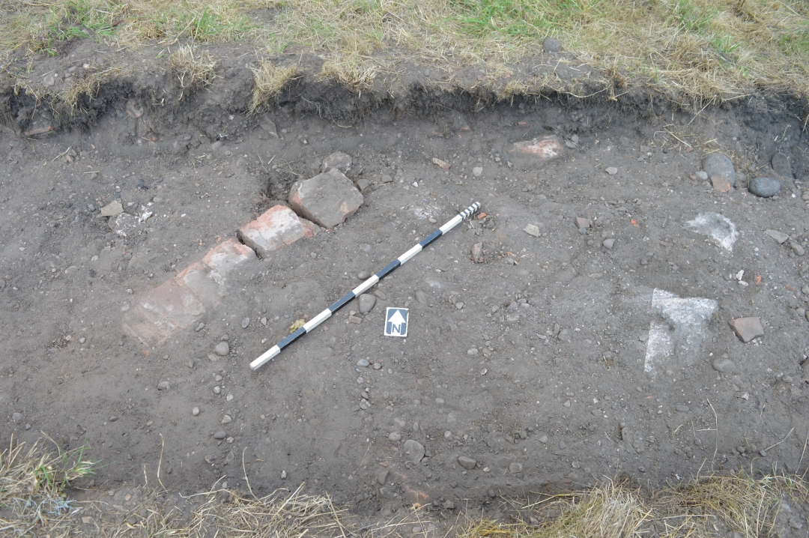
Fig.10: In-situ bricks within demolition rubble. (202), hut site ‘A’. CPAT Photo 5011-0019.

Trench 3 (Fig 11 & Appendix 2, 22.7m x 1.6m)
Trench 3 was located along the north-western boundary of the proposed development area (Fig 11). The trench, aligned north to south, was located in an area where there had been a modern bike track. A test pit, measuring 2.2m x 4.m and of unknown but recent origin, was also recorded 8m east of the trench.
Natural subsoil deposits, recorded at the base of the trench, consisted of gravel and sand (305) at the centre and northern end of the trench and compacted light orangish brown fine sand (304) at the southern end. The natural subsoil at the northern end was sealed by a re-deposited layer of gravel and sand (303) 0.25m thick. The natural subsoil at the southern end was sealed by a layer of fine compacted sand and mortar (302) 0.25m thick. This deposit was interpreted as the remains of sub-base associated with the modern bike track.
The overlying topsoil (301) consisted of mid greyish-brown sandy soil. It is noted that no asbestos was observed within the topsoil. No remains of archaeological significance were found.
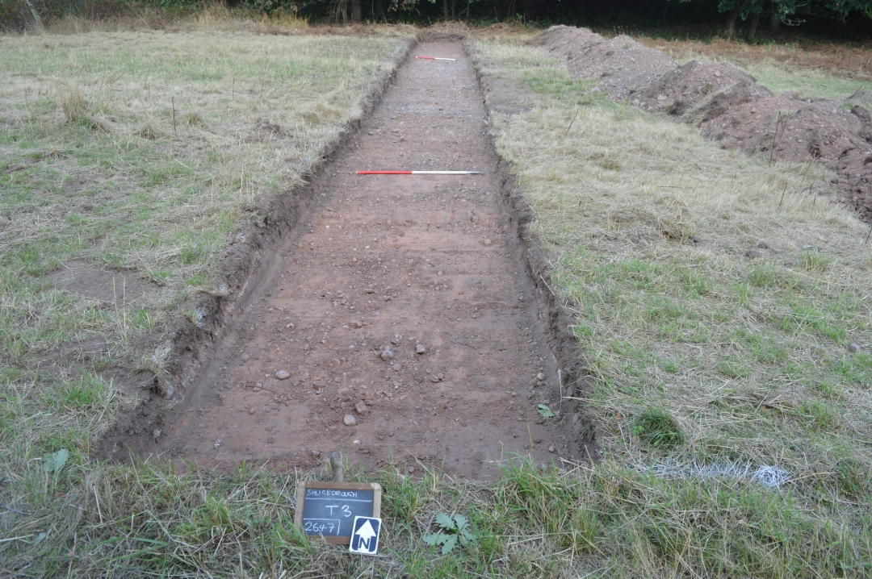
Fig. 11: Overview of trench 3. CPAT Photo 5011-0027
Trench 4 (Fig 12 & Appendix 2, 25.2m x 1.6m)
Trench 4 was located at the eastern-most limit of the evaluation area, to the south-east of the outdoor education centre, oriented east to west (Fig 12). The trench, located on the verge of rough grassland, was in an area that lay beyond the results of the geophysical survey (TigerGeo 2018) and the known extent of the WWII camp.
The undisturbed natural subsoil (402) a light pinkish brown sand and gravel, was recorded at the base of the trench at a depth of 0.21m. This was sealed by a deposit (401) of a mid-greyish brown sand, 0.15m thick, with an additional band of brownish-black sand, 10mm thick, recorded at the eastern end. It was noted that the soil change corresponded with the ground level vegetation, where the nature of the site altered from improved/landscaped to rough grassland. A single abraded body sherd of c.15th century ceramic was recovered from the deposit 401.
The overlying topsoil (401) consisted of a mid-greyish brown sandy soil, 0.06m thick. No remains of archaeological significance were recorded.
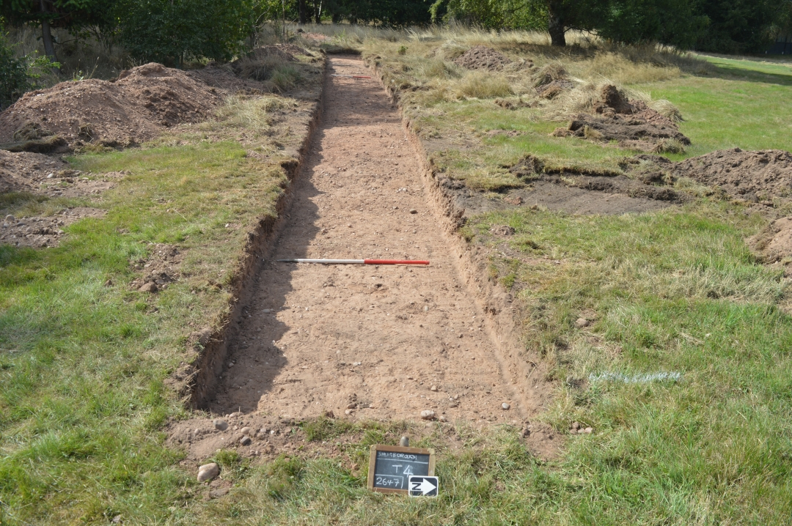
Fig. 11: Overview of trench 4. CPAT Photo 5011-00032
Trench 5 (Fig 12, 13 & Appendix 2, 30m x 1.6m)
Trench 5 was located to the southeast of the outdoor education centre aligned roughly north to south (Fig 12 and 13). The trench was located to investigate a linear feature, a possible field drain aligned north-east to south-west, identified by the geophysical surveying (see Fig.2).
At the base of the trench was revealed the undisturbed natural subsoil (502). This consisted of a compact light orangish-brown fine sand changing to sand and gravel at the eastern end of the trench. Several modern features were identified, cutting the natural deposits.
At the centre of the trench, 0.21m below ground level, was a field drain [507], aligned east to west, lined with modern ceramic tile, and sealed with fragmented brick and redeposited gravel (Fig 14). The western end of the drain also truncated a pit feature that contained a backfill of modern demolition rubble (506). It is probable that the drain is the linear feature identified in the geophysical survey.
At the eastern end of the trench were a group of circular features [508, 509, 510]. The post holes, measuring between 0.25-0.28m in diameter, have been interpreted as the remains of possible post settings for telegraph/communications poles associated with the WWII camp.
An additional rectangular feature [511], was recorded at the eastern end of the trench, running into the north facing section. The feature was backfilled with redeposited gravel and was interpreted as contemporary with the WWII base. Two linear features [503, 504], recorded at the western end of the trench, have been identified as modern service trenches of unknown use.
The natural subsoil and recorded features were sealed by a deposit (501) of mixed demolition rubble, redeposited natural gravel, and light greyish-brown fine sand, 0.15m thick. This deposit represents a modern landscaping event. The overlying topsoil (500), 0.19m thick, consisted of a mid-greyish-brown fine sandy soil.
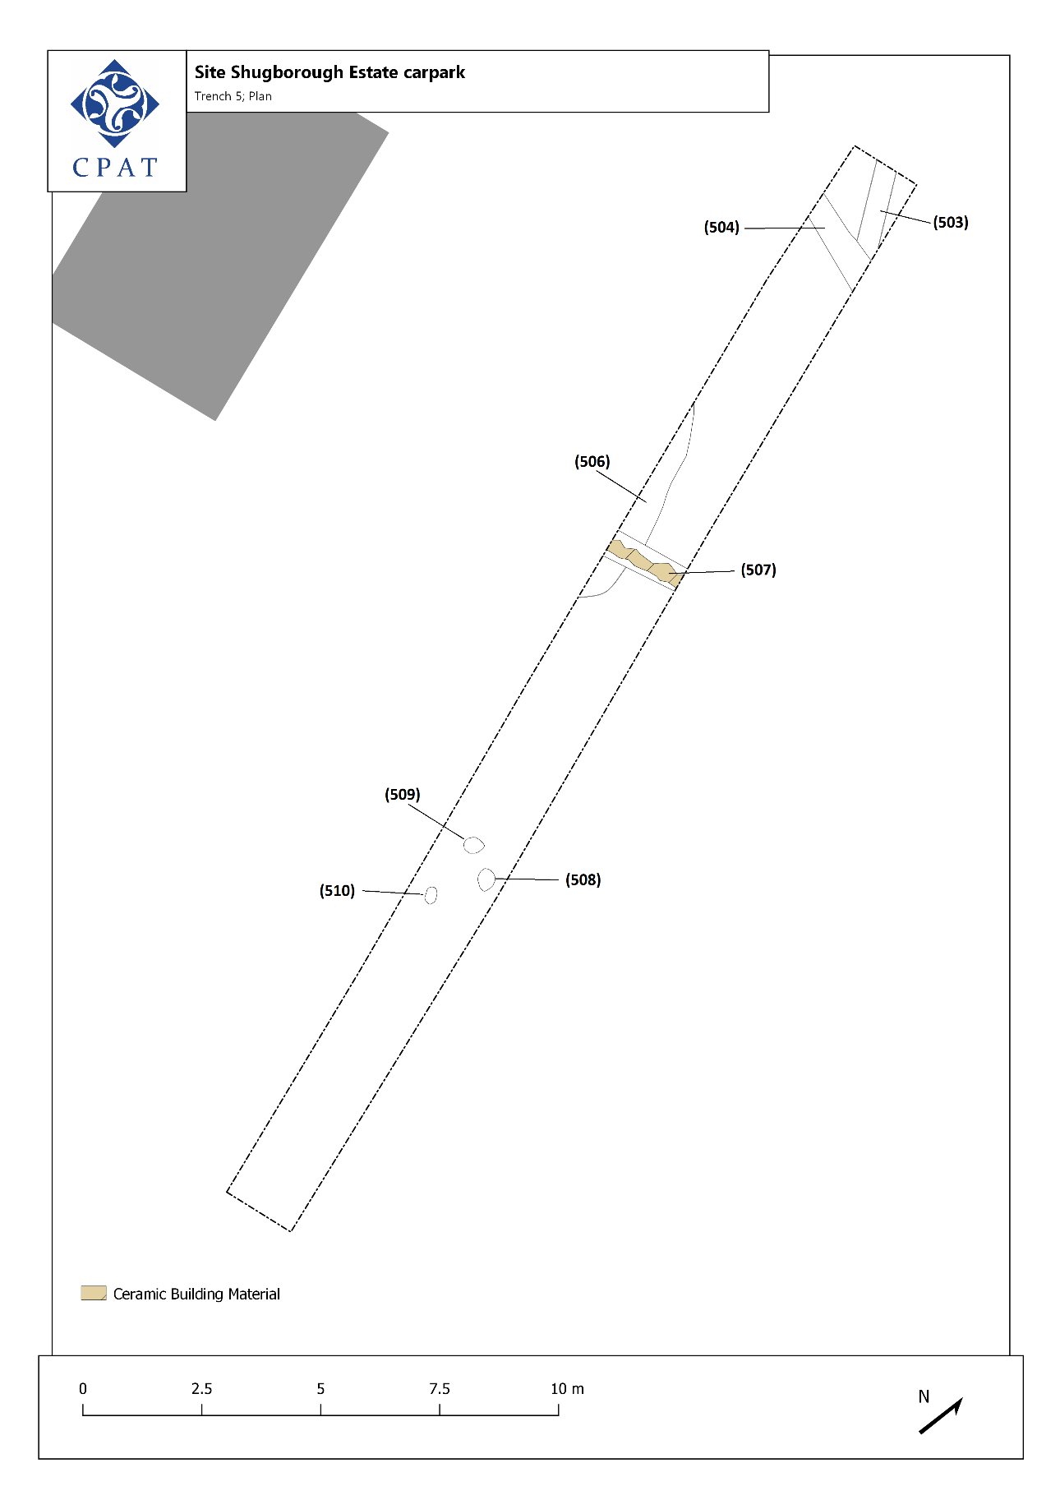
Fig. 12: Plan of trench 5.

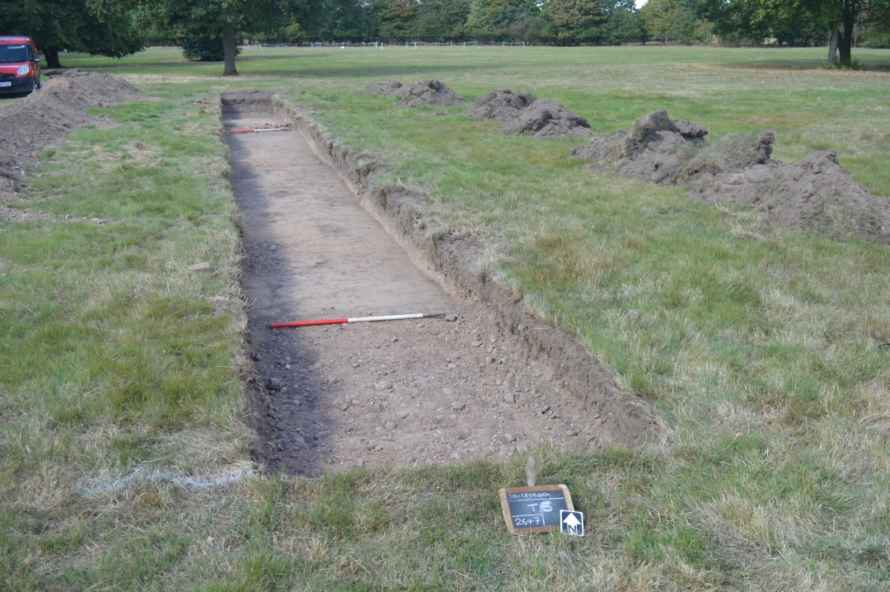
Fig. 13: Overview of trench 5. CPAT Photo 5011-0040.
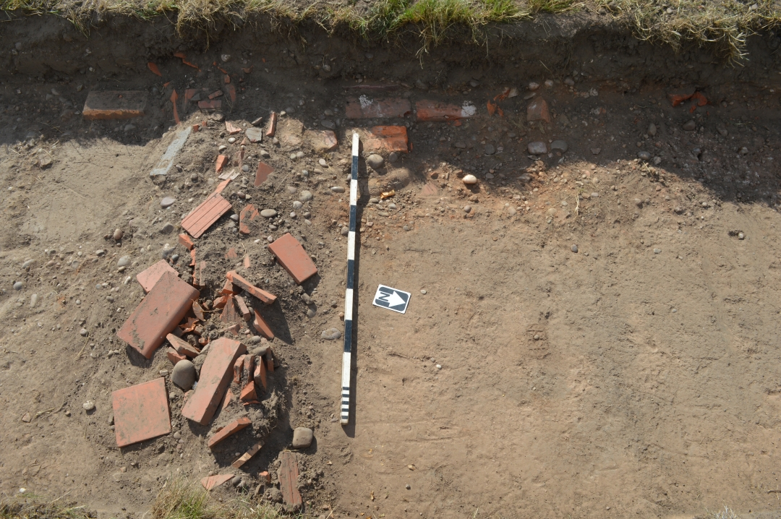
Fig. 14: Field drain (507) within trench 5. CPAT Photo 5011-0045.

Conclusions
The evaluation found remains of archaeological significance relating to the WWII military hospital complex.
The archaeological remains of WWII huts and associated paths were encountered in trenches 1 and 2. The remains of the huts consisted of brick and concrete building foundations in varying conditions and lay under a shallow layer of topsoil. The locations of the huts correlated with aerial photography, demonstrating the accuracy of this resource for locating further archaeological remains relating to the buildings.
A path servicing the hut complex was identified in trench 1 under a shallow layer of topsoil in addition to a path that was visible above-ground and survived at ground level.
Small fragments of abraded asbestos were encountered in the topsoil deposits within trenches 1 and 2 with additional material noted in the underlying demolition layers encountered in trench 2. The asbestos is probably building material associated with the WWII camp. It is therefore likely that further asbestos material would be encountered in topsoil across all locations related to the WWII complex.
Trench 3 identified the remains of a modern bike track, but no remains of archaeological significance were recorded.
Trench 4 revealed no significant archaeological material.
Additional linear features identified in the geophysical survey and investigated within Trench 5 were confirmed to part of a network of modern field drainage, possibly associated with the WWII camp.

Sources
Unpublished sources
Biles, A., 2022. Shugborough Estate: Brief for Archaeological Evaluation. National Trust.
Thomas, R. J. C., 2003. Twentieth Century Military Recording Project: Prisoner of War Camps (1939-1948). English Heritage Project Report.

Archive deposition Statement
The project archive has been prepared according to the CPAT Archive Policy and in line with the CIfA Standard and guidance for the creation, compilation, transfer and deposition of archaeological archives guidance (2020b).
Archive Summary
Archives Officer | Sophie Watson
HER Enquiry No | N/A
HER Event PRN | N/A
OASIS Reference No | clwydpow3-511129
Digital Archive Repository | ADS
Documentary Archive Repository | N/A
Finds Archive Repository | N/A
Accession Numbers | N/A

Digital Archive
 | Sub folder | Contents | Retained by  CPAT | Selected for  Archive
 |  Finds data | N/A | N | N
 | GIS data | N/A | N | N
 | Metadata | 2647_Metadata.docx | Y | Y
 | Photography |  | Y | Y
 | Film_5011 | 0001-0047.jpg  5011_Photo_Reg | Y | Y
 | Report | 2647_CPAT_Report_1911.docx  2647_CPAT_Report_1911.pdf | Y | Y
 | Site data | 2647_Trench_Form.pdf x 10  2647_Drawing_Register.pdf  2647_Drw1-2.jpg  2647_Drw4-5.jpg | Y | Y
 | Survey data | 2647_Shugborough_GPS | Y | Y

Documentary Archive
 | Hard copy | Digital | Retained by CPAT | Selected for Archive
Trench record forms | 5 |  | Y | Y
A4 Section drawings | 2 |  | Y | Y

Finds Archive

Pottery/Ceramics | collected | processed | catalogued | specialist | conserved | discarded
Prehistoric
Roman | Y
Medieval | Y
Post-medieval
Modern
Undated
CBM
Clay Pipe
Other (specify)
 | yes/no
Finds Catalogues | no
Box Catalogue | no |  |  | Number of boxes

Appendix 1: CPAT WSI 2647

Introduction
The Clwyd-Powys Archaeological Trust (CPAT) have been invited by the National Trust to prepare a Written Scheme of Investigation (WSI) for undertaking an evaluation at Shugborough Estate, Staffordshire (SJ 99307 21465). Following consultation with the Staffordshire County archaeologist (Shane Kelleher), an archaeological evaluation has been recommended to help inform pre-application advice and determination of planning application. The proposal is to construct a new car park in the area of the old Outdoor Education Centre, south-east of the walled gardens (Fig. 01). The designs have not yet been finalised and could potentially be influenced by the results of archaeological works.
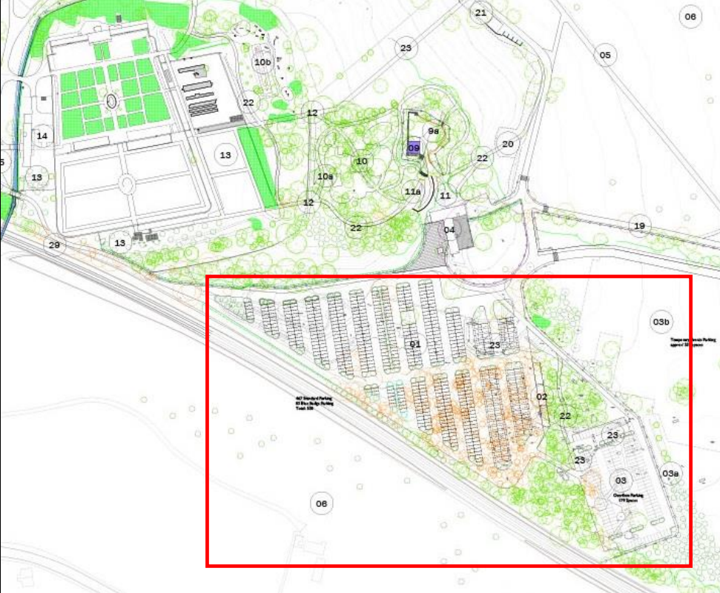
Fig. 01 Proposed development, area of evaluation indicated in red.
The proposed development is located within an area of the estate where, during WWII, an army camp was constructed behind the walled garden to house American troops (the site of the old outdoor Education Centre). Little is known about the survival of military archaeological assets within the area. An RAF aerial image (1945) of the Shugborough US Army Station (Image Ref.106g-uk-646-Fr-4410), shows the layout of the camp and it is clear that some of the military buildings extend into the area of the proposed car park but it is unclear as to what extent they survive.
The area was partially included in a geophysical survey of the Parkland at Shugborough Estate, undertaken in 2017 (TigerGeo, 2018 Park Farm, Shugborough Geophysical Survey Report), the results of which were incorporated into the design of the archaeological mitigation proposed for the evaluation.

Objectives
The objectives of the evaluation are:
• to determine the presence, nature, character and date of any archaeological remains in the footprint of the proposed car park;
• Specifically, ascertain whether or not any of the RAF structures mapped from aerial photography survive, at what depth, level of preservation and to determine what impact the construction design will have upon the remains;
• to prepare a report outlining the results of the evaluation and the research potential of the site archive;
• to prepare a final publication of the results in an appropriate regional or national journal, depending on the nature and significance of any archaeology.

Methodology
Fieldwork
The evaluation will be conducted according to the Chartered Institute for Archaeologists’ (CIfA) Standard and Guidance for an Archaeological Watching Brief (revised 2020). Five evaluation trenches of 2m x 25m will be excavated in order to fulfil the aims of the project (Fig. 02). Any alteration to the position of the trenches will be agreed with Staffordshire County Archaeologist (Shane Kelleher) and the NT archaeologist (Janine Young).
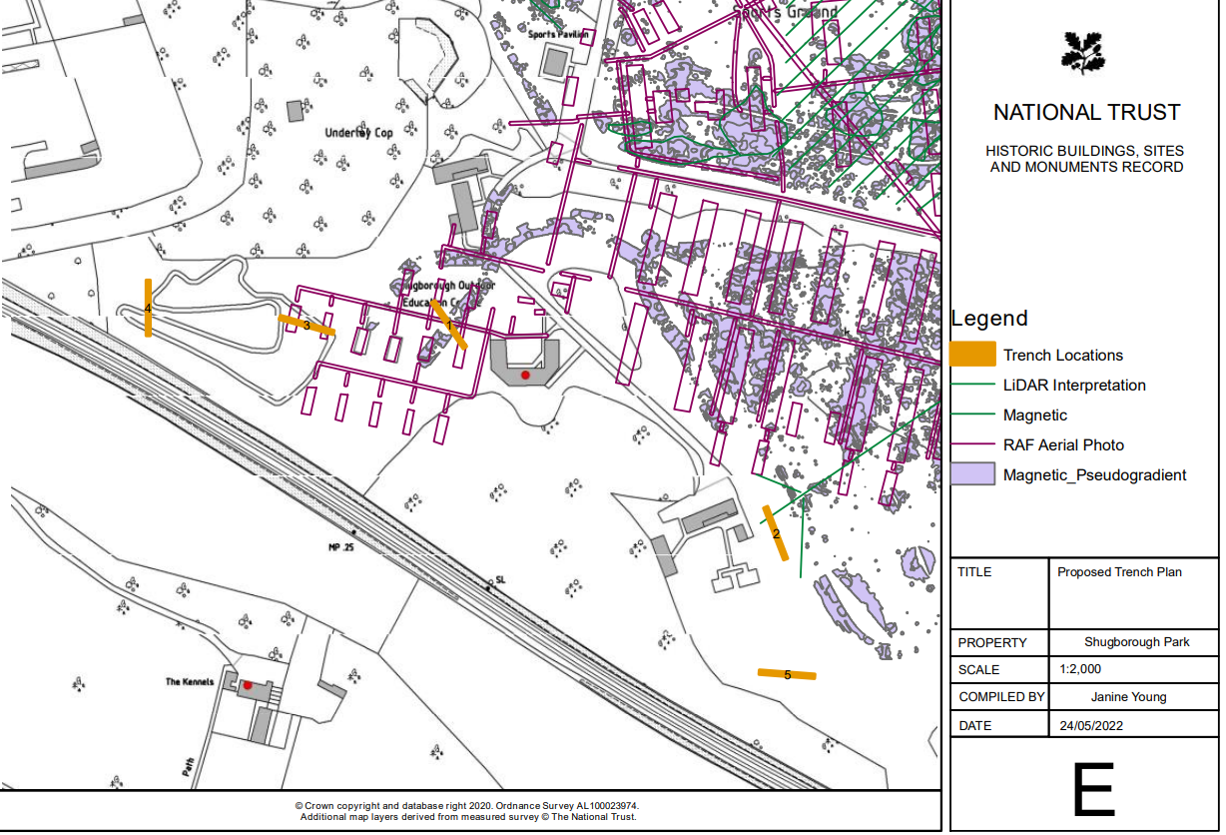
Fig. 02 Proposed location of trenches

Excavation of the trenches will be undertaken carefully using a machine with a flat, toothless bucket under the direction of the archaeologist to ensure that the correct level is reached whereby any archaeological features can be identified. The exposed sub-soil or archaeological horizon will be cleaned by hand after machine stripping, if required. The excavation of any archaeological features or deposits will be undertaken by hand using the conventional techniques for archaeological excavation:
- The presence or absence of archaeological features encountered during the ground works will be noted.
- Where features of archaeological interest are identified during the ground works they will be systematically investigated by hand with sufficient work being undertaken to determine their date, character and function, using the conventional techniques for archaeological excavation and in accordance with CIfA Standard and Guidance.
- All features will be located as accurately as possible on an overall plan of the development at an appropriate scale, showing boundaries depicted on Ordnance Survey mapping.
- Contexts will be recorded on individual record forms, using a continuous numbering system, and be drawn and photographed as appropriate.
- Plans will be drawn on permatrace to a scale of 1:10, 1:20 or 1:50, as appropriate.
- All photography will be taken using a digital SLR camera with a minimum resolution of 12 mega pixels, including a metric scale in each view, with views logged in a photographic register.
- In the event of human burials being discovered the Ministry of Justice (MoJ) will be informed. The remains will initially be left in situ, and if removal is required, a MoJ licences will be applied for under the Burial Act 1857.
- In the event of finding any artefacts covered by the provisions of the Treasures Act 1996, the appropriate procedures under this legislation will be followed.

Finds and Sampling
The Finds Selection Criteria and sampling strategy is in accordance with the brief issued by the National Trust.
All identified finds, artefacts, industrial and faunal remains will be collected and retained. Certain classes of building material can sometimes be discarded after recording if an appropriate sample is retained. No finds will, however, be discarded without the prior approval of the Staffordshire County Archaeologist and the National Trust Archaeologist.
The finds assemblage will be retained for deposition with the site archive in the recipient museum.
Finds which constitute Treasure under the 1996 Treasure Act for England and Wales will be reported to the coroner by the finder within 14 days of discovery.
Should finds that require immediate conservation be encountered, they will be exposed, lifted, cleaned, conserved, marked, bagged and boxed in accordance with the guidelines set out in the United Kingdom Institute for Conservation “Conservation Guideline No. 2” (UKIC 1983). Appropriate guidance set out in the Museums and Galleries Commissions “Standards in the Museum Care of Archaeological Collections (MGC 1992)” and the current CIfA guidelines (CIfA 2001A and 2020 updated text) will also be followed. Packaging of all organic finds and metalwork will follow the UKIC/Rescue guidelines, ‘First Aid for Finds’ (LEIGH ET AL 1993). Any necessary conservation and treatment of metalwork will be arranged in conjunction with specialist conservators.
Should significant environmental deposits be encountered, samples will be taken and processed in line with Historic England guidelines (Historic England 2002).

Post-excavation and reporting
All artefacts and environmental samples will be treated in a manner appropriate to their composition and a sampling strategy will be developed as appropriate:
- All stratified finds will be collected by context, or where appropriate, individually recorded in three dimensions. Unstratified finds will only be collected where they contribute significantly to the project objectives or are of particular intrinsic interest.
- All finds and samples will be collected, processed, sorted, quantified, recorded, labelled, packed, stored, marked, assessed, analysed and conserved in a manner appropriate to their composition and in line with appropriate guidance.
- Arrangements to assess and study any artefacts, assemblages and environment samples.
- Any artefacts recovered during the evaluation will be deposited with an appropriate museum, subject to the permission of the National Trust.
Following the on-site work an illustrated report will be prepared containing conventional sections to include:
- Non-technical summary
- Introduction
- Site location
- Archaeological Background
- Watching brief
- Conclusions
- References
- Appropriate appendices on archives and finds
A copy of the completed OASIS form will be included in the final report along with the OASIS ID number for the project.

Site archive
The overall archive will conform to guidelines described in Management of Research Projects in the Historic Environment (MoRPHE), Historic England 2015, the CIfA (2020) Standard and Guidance for the Creation, Compilation, Transfer and Deposition of Archaeological Archives.

Data management plan
The project will be conducted in accordance with CPAT’s data management policy. All paper records will be collated, catalogued and labelled with the unique project code. All digital data will follow strict file naming, to include the unique project code, and be sorted into a standard series of sub-folders. The digital data will be catalogued, including a list of file types and relevant software.

Resources and programming
The evaluation will be undertaken by two skilled archaeologists under the overall supervision of Tim Malim, a senior member of CPAT's staff who is also a member of the Chartered Institute for Archaeologists (CIfA). CPAT is also a CIfA Registered Organisation (RAO No. 6) and as such agrees to abide by their Code of Conduct (2019) and Standard and guidance for commissioning work or providing consultancy advice on archaeology and the historic environment (2014).
All report preparation will be completed by or with the assistance of the same field archaeologist(s) who conducted the site work. Copies of the report will be deposited with the client, and the regional Historic Environment Record within one month of the completion of on-site works.
The client should be aware that in the event that significant archaeological remains are revealed there may be a requirement for more detailed excavation and specialist services. Any further work over and above the original evaluation and report would be the subject of a separate WSI and costing. The following figures provide an indication of the types of additional services and indicative costs which might be required, for which the client is advised to make some provision.
Finds conservation etc £350 per day
Radiocarbon dating £500 each
Finds specialist £350 per day

Requirements relating to Health and Safety regulations will be adhered to by CPAT and its staff.
CPAT is covered by appropriate Public and Employer's Liability insurance, as well as Professional Indemnity insurance.

I Grant
20 August 2022

Appendix 2: Section Drawings
