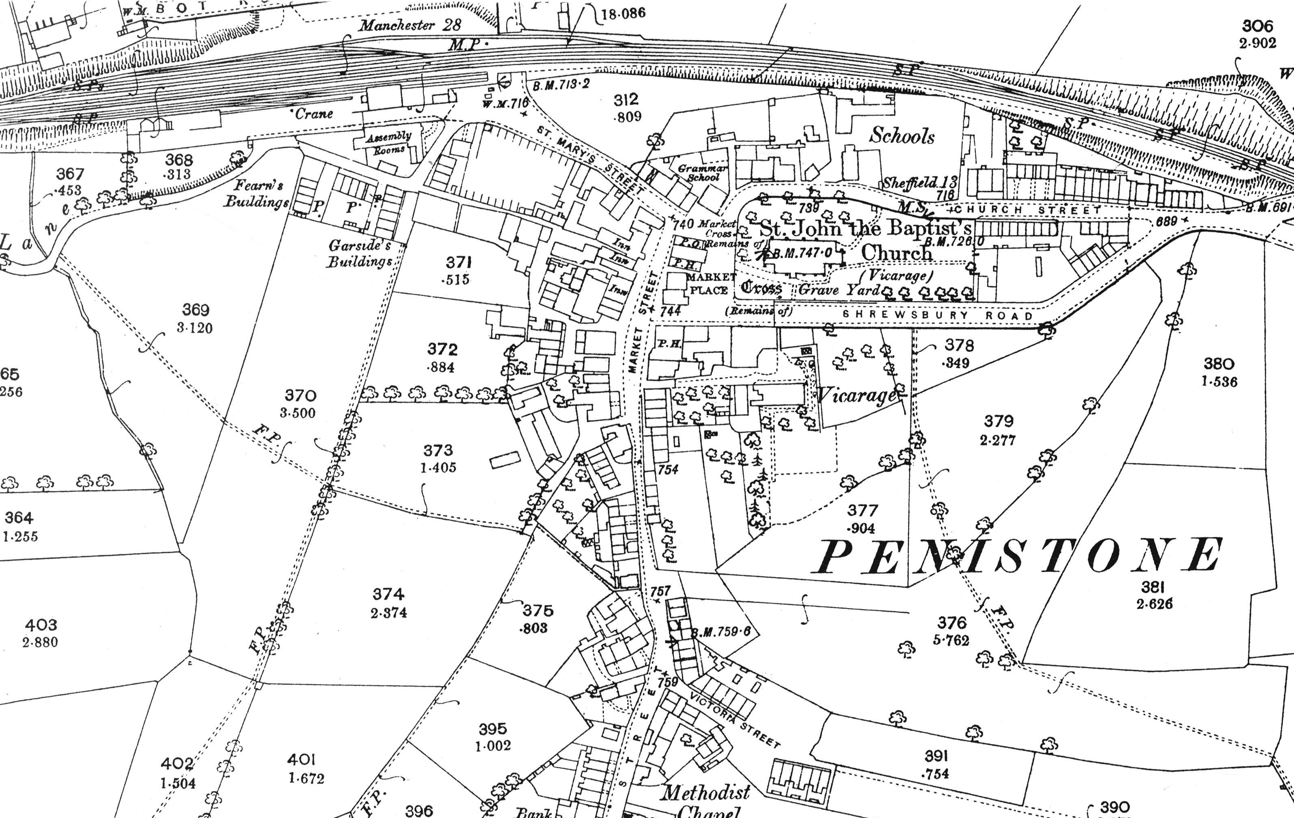
Figure 6: Extract from the 25" Ordnance Survey map of 1893, at the original scale of 1:2500. The approximate location of the site is shown in red.

