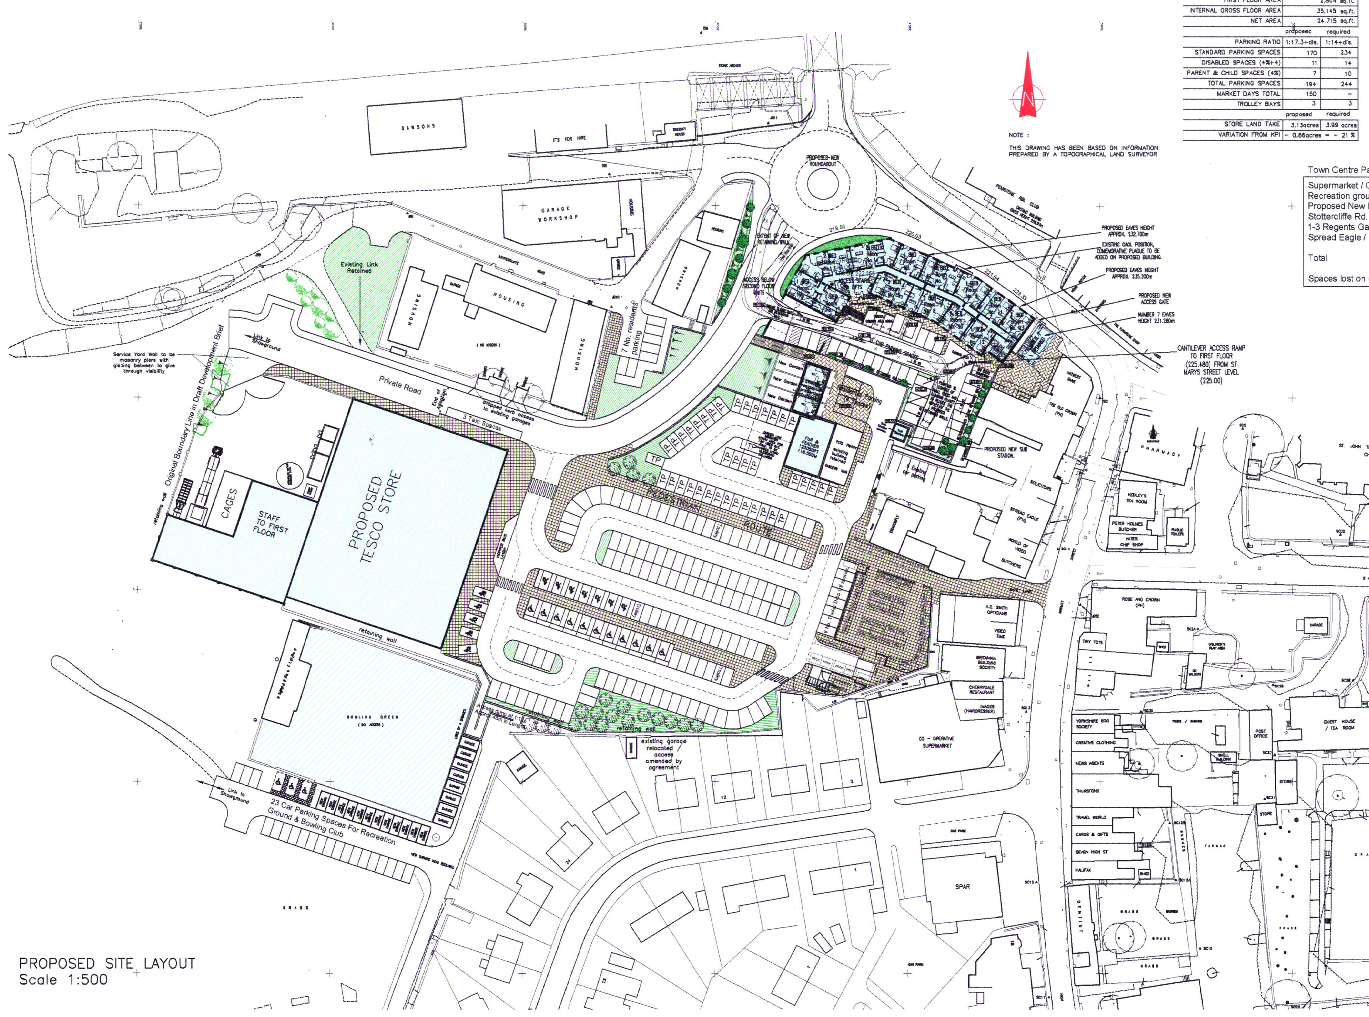
Figure 7: Copy of the developer’s site plan (not to scale), showing the proposed development.

