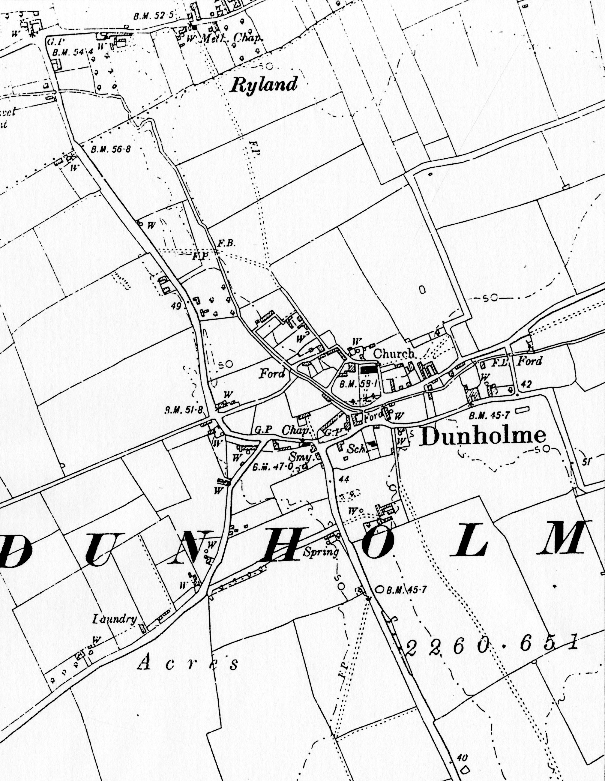
Figure 5: Extract from the 6" to the mile 2nd edition Ordnance Survey map of 1907. The site is outlined in red.

