Summary

- This archaeological desk based assessment has been prepared for Mr and Mrs Lundy in support of a planning application for the construction of a new equestrian training centre with associated stabling, services, car parking facilities and access road on land at Caistor Moor Farm, Moor Lane, Caistor, Lincolnshire.

- It is considered that the assessment site has low potential for the prehistoric period, being situated well away from known sites and settlements, and despite a single flint flake being recovered during the walkover survey. There were no indications on the ground of any concentrations of such material.

- Similarly, there is negligible potential for the Romano-British to the early post-medieval periods, given the location of the site at some distance from contemporary settlements and sites. There is low post-enclosure potential that comprises two field boundary ditches, but these are not considered to be significant.

- A geophysical survey appended to this report did not detect any archaeological anomalies at the site.

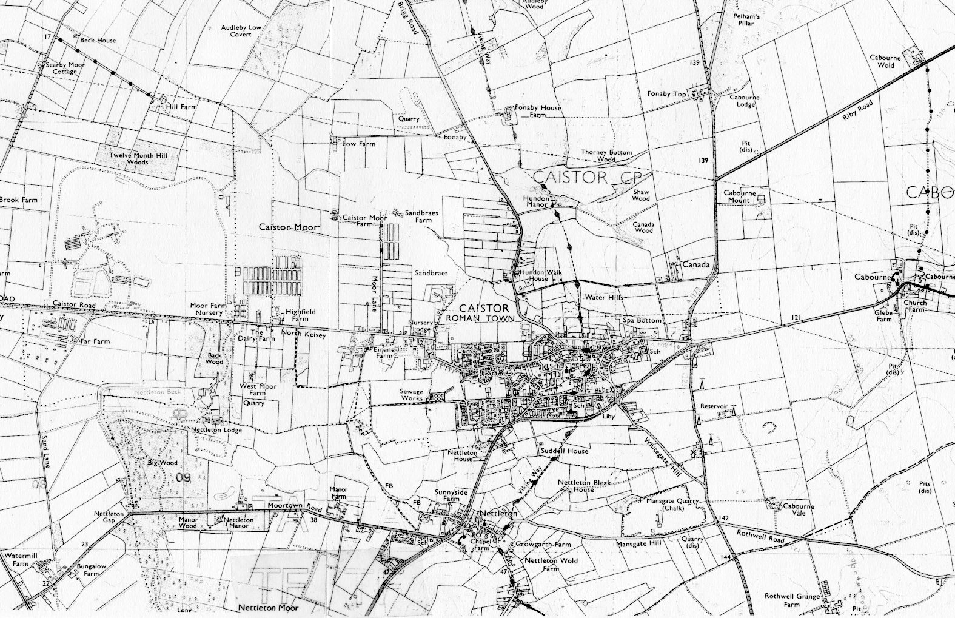
The Site
N
1
2
3
4
5
6
7
8
9 & 15
10
11
12
13/14
Figure 1: General site location at scale 1:25,000 showing the site highlighted in red and archaeological sites in the study area in blue (O.S. copyright licence no. AL 515 21 A0001)

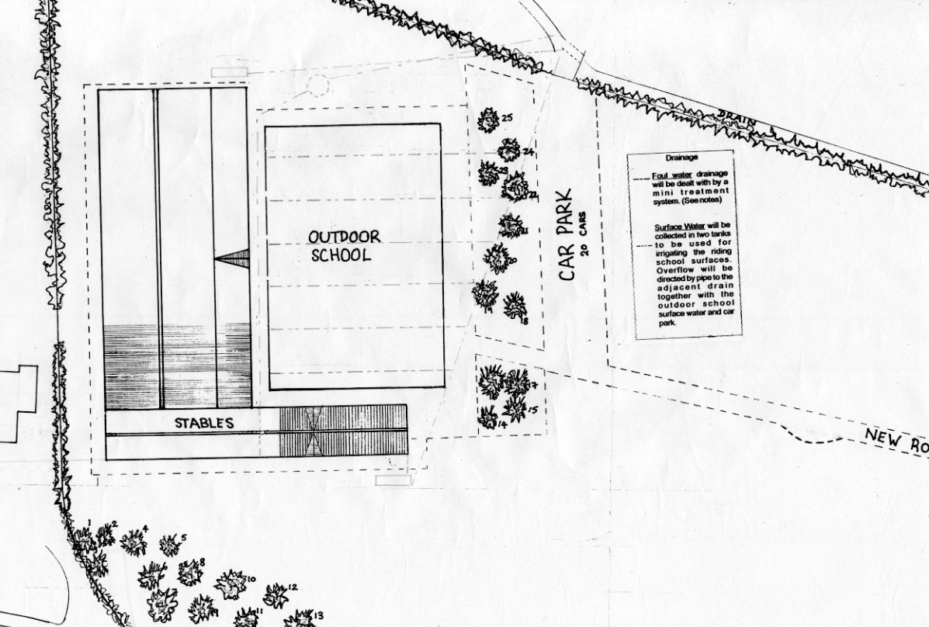
Figure 2: Site layout plan and development proposal, scale 1:500
N

1.0 Introduction

This desk-based assessment was commissioned by Mr and Mrs Lundy. Its purpose is to assess the archaeological potential of an area of land to the east of Caistor Moor Farm, Moor Lane, Caistor, Lincolnshire, to calculate the likely impact of development on any areas of archaeological significance, and to suggest possible strategies for the reduction or mitigation of any possible damage to archaeological remains.

2.0 Location and description (Figure 1, Plates 1-4)

Caistor Moor Farm, as its name implies, is situated within Caistor Moor. This is an area of low grade farmland located in the northwestern portion of the parish of Caistor, and approximately 1.5km to the northwest of the town of Caistor. Caistor Moor is situated to the west of the Lincolnshire Wolds chalk and sandstone escarpment, and comprises an area of land that gradually slopes westwards from this escarpment.

The proposed development site comprises a field, which is located to the immediate east of Caistor Moor Farm, and approximately 1.2km to the west of the foot of the Lincolnshire Wolds. The western area of the site comprises rough grassland, and at the time of the site walkover survey was also occupied by various items of farm machinery. The eastern portion of the site was until recently under a crop of maize, and now exhibits the remnants of this crop as well as weeds. The site lies at a height of approximately 35mAOD.

The local soils are of the Blackwood Association, typically deep permeable sandy and coarse loamy soils that have developed on drift deposits of blown sand of the Quaternary, which in turn overlie a solid geology of Elsham Sandstones of the Ancholme Clay Group of the Upper Jurassic (BGS, 1982).

Central National Grid Reference: TA 1010 0238.

3.0 Objectives and methods

The purpose of this report is to establish the likelihood of there being archaeological remains that may be vulnerable to proposed development; to assess their potential significance and the extent to which development is likely to affect them, and, if necessary, to suggest further methods by which the site may be evaluated in advance of such works, or by which the works can be mitigated to minimise the impact to any surviving archaeological remains.

The report is based on information derived from a variety of research sources based on a 1km radial search area centred on the site at national grid reference TA 1010 0238 (the Study Area): -

The Historic Environment Record (HER) of the County of Lincolnshire, including documentary archive material, archaeological reports and aerial photographs;

Records held by the Lincolnshire Archives;

The Lincoln Central Library; and

A site walkover survey by the author.

In addition, a geophysical survey was undertaken by Pre-Construct Geophysics, the results of which form Appendix 3 of this report.

4.0 Planning background

A planning application for the construction of a new equestrian training centre with associated stabling, car parking facilities, services and access road on land at Caistor Moor Farm, Moor Lane, Caistor, Lincolnshire has been submitted to and granted consent by West Lindsey District Council. However, as the proposed development site is situated within a perceived archaeologically sensitive area, an archaeological condition has been attached to this consent requiring a desk based assessment and geophysical survey be undertaken prior to construction to inform any further decisions which may be made by the District Authority in respect of the potential impact of development on the archaeological remains.

5.0 General archaeological and historical background

The town of Caistor is situated on the northwestern edge of the Lincolnshire Wolds, and to the immediate west of Caistor High Street, an important prehistoric trackway. This provided communication along the western edge of the Wolds between the Humber and the south. Its significance, at least from the Bronze Age onwards, is evidenced by the number of round barrows that cluster along its route.

Prehistoric worked flint artefacts are common on the light soils in the area. There have been many finds outside Caistor from the Mesolithic to the Bronze Age, the majority of which have been chance finds.

Approximately 500m to the southeast of the assessment site is a multi-period prehistoric site at Sandbraes (Site No. 2, Appendix 1). This has long been a centre of sand extraction. During such excavations in 1957, a Bronze Age round barrow was destroyed prior to the construction of the Cherry Valley Duck Farm. This barrow yielded a total of five burial urns each containing a cremation. From 1950 until the early 1960s, a number of other prehistoric finds have also been made from this area. This has included an Upper Palaeolithic hand axe dating to c10,000BC found at Sandbraes Farm; flint scapers, microliths, pygmy knives, and borers from the Early Neolithic to the Late Bronze Age, as well as Bronze Age pottery and burnt human remains.

The findspot of a Mesolithic blade and microlith (Site No. 4, Appendix 1) occurs approximately 1km to the northeast of the site at Fonaby.

Cropmarks of a later prehistoric settlement site have been identified approximately 1km to the northwest of the assessment site (Site No. 13, Appendix 1) from aerial photographic analysis. This complex includes hut circles, enclosures and linear boundaries. At the same general location, although undated, and probably part of the same settlement complex, occur further cropmarks of pits, boundaries and enclosures (Site No. 14, Appendix 1).

Situated to the immediate south of the North Kelsey Road are undated cropmarks of linear ditches forming rectangular plots, indicating potential field systems (Site No. 10, Appendix 1). These cropmarks also extend further to the west and to the north of North Kelsey Road where other parallel linear features are also present. These do not correspond to the enclosure field systems of the early 19th century, and so are likely to be late prehistoric or Romano-British in origin on morphological grounds. To the northwest of the assessment site is the cropmark of an undated linear boundary (Site No. 12, Appendix 1), which may be associated with the prehistoric settlement complex to the north (Sites 13 and 14).

The place name of Caistor is derived from the Old English caester or ‘Roman Station’ (Cameron, 1998) indicating the early establishment of this settlement. The Roman name for Caistor was possibly Bannovallum. A town of that name is listed next to Lincoln in the 7th century document – Ravenna Cosmography. This has been attributed to Caistor by Professors O.G.S. Crawford and Ian Richmond rather than Horncastle, to which it was associated by William Stukeley in the 18th century.

The Romans arrived in this area at round AD48, and quickly established a fort at Caistor. Coins found in the area testify to continuous occupation from the time of the Emperor Claudius onwards. The military site, like many others, then evolved into a fortified civilian settlement enclosed by a substantial limestone curtain wall with external bastions (Whitwell, 1992). This settlement became the administrative and market centre for the surrounding area, and remained so until the end of the Roman Empire in England.

The Ordnance Survey (O.S.) map of 1956 (Figure 5) shows the line of the North Kelsey Road as a ‘Roman Road’ as it appears as a straight stretch of road, and because of this, it was assumed that it must be Roman in origin. However, this road was laid out during the enclosure of Caistor Moor in 1814 (Figure 3). The enclosure map clearly shows the line of this road making a right angled turn in order to avoid the contemporary House of Industry (Site No. 11). No road metalling has also been found further to the west indicating that the North Kelsey Road was not constructed on top of an earlier Roman road (Whitwell, 1992).

A scatter of Romano-British pottery (Site No. 5, Appendix 1) has been found to the southwest of Fonaby House Farm.

Following the collapse of Roman rule in England, the former fortified town of Caistor untypically remained in continuous occupation during the Anglo-Saxon period. This may be indicated by a bronze bowl found at an Anglo-Saxon cemetery to the south of Caistor at Nettleton. This had decoration that imitated earlier Roman forms and was thought to be sub-Roman in origin – dating to the late 4th-early 5th centuries. This suggests that Caistor may have remained a regionally important centre after the end of Roman rule (Whitwell, 1992). Bede, writing in AD679, speaks of a town called Tunnacester, which has been identified with Caistor. By the 7th century AD there is some evidence that Caistor and its environs had become a royal estate with the establishment of a Minster church, which are typically attached to such estates (Sawyer, 1998). An inscribed stone or titulus found at Castle Hill in Caistor in 1770 refers to a dedication of a church in the town in the 8th century (Pevsner & Harris, 1989). A mint was established at Caistor towards the end of the 10th century, and operated during the reigns of Edward the Martyr, Ethelred II and King Cnut, who died in AD1035. Contemporary coins dated to AD975-8 found in the area bear the name of Castr, as evidence for the presence of the mint here.

An Anglo-Saxon cemetery was accidentally discovered at Fonaby in 1956 (Site No. 3, Appendix 1) during sand extraction. Local amateur archaeologists excavated a number of grave groups before the site was systematically excavated by P. Gathercole of the Scunthorpe Museum. In addition to sherds of Iron Age and early Romano-British pottery, the Anglo-Saxon cemetery yielded both inhumation and cremation burials. Subsequent analysis of the site records has established that there was an assemblage of 49 grave groups and 28 pots and cremation vessels along with a large number of unstratified objects. Most of the finds were 6th century in date, though some of the pots may be earlier. The quality of these finds indicates the prosperous nature of the contemporary settlement at Fonaby, which later became a shrunken medieval settlement (SMV).

The Domesday Survey of AD1086 states that prior to the Norman Conquest the Earl Morcar held 3 carucates of land in Caistor and Hundon. Following the Conquest, the King held the manor of Caistor or Castre for himself, with Domesday detailing the land holding for six ploughs, 60 acres of meadow with 40 villagers and 12 freemen and three ploughs, together valued at £50. In AD1072, the King granted the church at Caistor to Remigius, the Bishop of Lincoln (Morgan & Thorn, 1986).

The town of Caistor was situated in the Wapentake of Yarborough. By the time of the Norman Conquest, it was of some significance and had four water mills. Later medieval documentary references variously refer to the medieval settlement as Castra (1110-1161), Castr (1159-1169), Caster (1270), and Caister (1485). Caistor was recorded as a Borough in 1197-8. Figure 6 (below) shows the reconstruction by Rex Russell of the pre-enclosure medieval and early post-medieval open field systems from original surveyor’s plans and relevant enclosure awards (Russell, 1987). This map shows a North Field and a South Field, to the north and south of the settlement of Caistor respectively. The assessment site is situated within the common lands to the west known as ‘Caistor Moor’. Between the Moor and the South Field are detailed several ‘ings’ or meadow/pasture land, (perhaps the 60 acres detailed in the Domesday Survey).

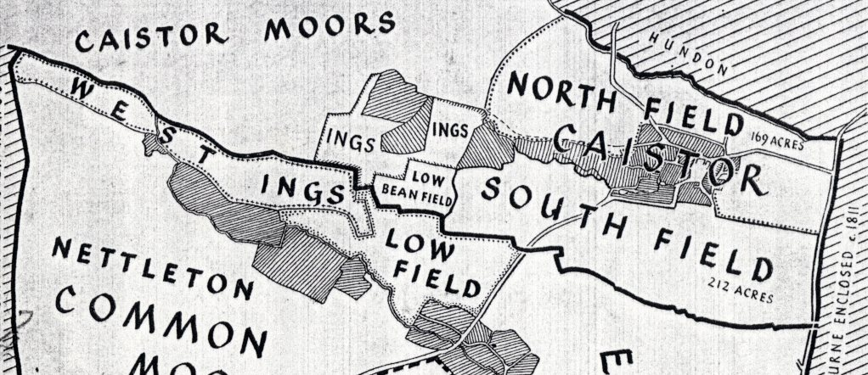

N

Figure 6: Reconstruction of the medieval open field systems of Caistor (from Russell,1987) (not to scale)

To the north of the assessment site are situated the cropmarks of possible medieval boundary ditches identified by aerial photographic analysis (Site No. 6, Appendix 1).

To the west of Caistor, a House of Industry was built between 1800-1802 by the benefaction of William Dixon of Holton le Moor (Site No. 11, Appendix 1). This was one of the earliest examples of a surviving workhouse with a supervisory hub, later to become a significant model for later workhouse layout and design. The design had originally been used for prisons from the 1770s onwards, and was probably first applied to the workhouse at Caistor in 1800. The House began to be occupied in 1802, with the aim of improving the condition of the local poor. The Poor Law Amendment Act of 1834 enabled the newly established Poor Law Commission to reorganise parishes into Poor Law Unions. The Caistor Poor Law Union was thus formed in 1836, and embraced 76 parishes with the House of Industry becoming the Union Workhouse. New buildings were added to the original House of Industry including an entrance block in 1837, a new school with a master’s house in 1863, a chapel in 1866 and an infirmary in 1871. It continued in this usage until 1937, when it became a mental institution under the auspices of the County Council. Major improvements were then carried out including a new boiler house, laundry and kitchen. The hospital was finally closed in 1990, and has remained empty since that time (RCHME, 1995).

A geophysical survey was carried out at rear of the hospital site in 2001, at the southern end of the site and beyond the building complex. No archaeological anomalies were found (WYAS, 2001).

As noted earlier, the parliamentary enclosure of Caistor Moor took place in 1814 (Figure 3). The pre-enclosure Caistor Moor encompassed an area of 2132 acres and 24 perches. The Moor comprised an area of flat and sandy land, which by 1811 was common grazing land along with some open meadow enjoyed by the population of at least six local parishes including Caistor, Clixby, Searby cum Owmby, South Kelsey, North Kelsey and Grasby. The objective of the enclosure of the Moor was to divide up these lands between these various parishes, and in turn to sub-divide the parochial shares between the individual owners who had enjoyed these former common rights. By May 1814, the enclosure had been completed, and with regard to Caistor, the area of the Moor here was just over 611 acres. The Enclosure Commissioners were also charged with the laying out of new roads such as the North Kelsey Road and Moor Lane as well as the digging of new drains over the Moor. The new enclosure roads were laid out straight over former grazing lands and are typical of the type.

As also noted earlier, sand extraction for the construction of local buildings and roads has long been a significant local economic activity as at Sandbraes and at the site of the Cherry Valley Duck Farm. The Lincolnshire Heritage Record (HER) notes the location of the earthworks of former post-medieval sand pits at Sandbraes (Site Nos. 9 and 15, Appendix 1). These are featured on the O.S. map of 1956 (Figure 5). On the clays adjoining the Wolds to the northeast of the assessment site is the site of a former brickworks at Fonaby (Site No. 1, Appendix 1). This site is featured on both the O.S. maps of 1907 and 1956 as ‘disused’ (Figures 4-5).

To the north and northeast of the assessment site are the cropmarks of probable post-medieval linear boundary ditches and enclosures (Site Nos. 7 and 8, Appendix 1).

6.0 Site-specific search/investigation results

Information relating to the immediate area of the proposed development was researched and collated from several sources, and is summarised below.

6.1 Cartographic information (Figures 3-5)

The assessment site was situated in the area of former common land known as Caistor Moor, which was enclosed in 1814. The earliest map consulted in this study was the enclosure award map of that date held at the Lincolnshire Archives, from which a tracing was made, and which comprises Figure 3. The boundaries of the assessment site are shown in red. This map shows the new layout of field plots on the former Caistor Moor relating to the parish of Caistor, which is entitled ‘Caistor Parochial Allotment’. The boundaries of the Townships of Fonaby, Hundon and Caistor are shown to the northeast and southeast respectively. To the west are field plots of the Moor allocated to the neighbouring parish of Clixby. This map details the name of each landowner, acreage and plot number within each enclosure, but does not detail any field names. The accompanying enclosure award similarly does not detail field names. A sand pit is featured at the extreme eastern end of the map, which may be part of the sand pit complex making up Site No. 9 (Appendix 1). The recently completed ‘House of Industry’ (Site No. 11, Appendix 1), is also shown to the south. Moor Lane is also show extending northwards from the North Kelsey Road, with a trackway extending to the west.

An extract from the 2nd Edition 6” – 1 mile scale map of 1907 is reproduced as Figure 4. This map details Caistor Moor Farm, a 19th century farmhouse. The arrangement of fields in the immediate vicinity of this farm is also shown; there having been a sub-division of the 1814 enclosures into smaller field plots. This process was probably contemporary with the construction of the farmhouse. The trackway shown on the 1814 map has moved northwards to its present course. There has been further subdivision of enclosures elsewhere, particularly to the east at Sandbraes, and to the southwest of the site. The sand pit (Site No. 9, Appendix 1) remains in being, while the brickworks (Site No. 1, Appendix 1) is featured to the northeast. The former House of Industry (Site No. 11, Appendix 1), has by 1907 become the ‘Caistor Union Workhouse”, and has greatly expanded with the addition of an infirmary and a chapel dedicated to St. Lawrence. The brickworks (Site No. 1, Appendix 1) at Fonaby is shown as ‘disused’.

The Provisional Edition map of 1956 (Figure 5) shows the current layout of the assessment site, with relatively minor changes to the layout of the enclosures in the vicinity. The former Caistor Union Workhouse (Site No. 11, Appendix 1) has by 1956 become the ‘Caistor Institution’, a mental hospital. The North Kelsey Road is also featured for the first time as a ‘Roman Road’ extending eastwards into the Roman Town of Caistor. The sand pit extraction at Sandbraes has also expanded eastwards, with a large extraction feature detailed.

By the present time (Figure 1), there has been a reversal in the layout of the fields with the removal of a number of former field boundaries to create larger enclosures, a process apparent to the south and southeast of the site. The Cherry Valley complex is also shown to the east of the site as six large north-south orientated buildings.

6.2 Site Walkover Survey (Appendix 2, Plates 1-4)

A site visit was made by the author on the 8th of December 2006, for the purpose of recording the present appearance and condition of the assessment site, and noting any surface indications that archaeological remains may be present. A digital photographic record, extracts from which are reproduced in Appendix 2, was also made.

The assessment site is a roughly trapezoidal shaped area of land situated to the immediate east of Caistor Moor Farm. The weather conditions were sunny though cold, with good visibility.

The western portion of the site comprised rough grassland over which were various items of farm machinery. The whole of this area, which roughly coincided with the area of the proposed indoor training centre and the western portion of the stables, was walked over with no apparent signs of archaeological remains or artefacts on the ground.

The eastern area of the site coinciding with the area of the outdoor school, the car park, and the eastern part of the stables, (and the remainder of the field) had until relatively recently been under a crop of maize. The remnants of this crop along with weeds and immature nettles covered the ground. However, there was sufficient ground visibility (approximately 60%) to enable a reasonable assessment of the ground conditions to be made. The whole of this area of the site was walked over with a rapid scan of the ground surface, made to primarily look for artefacts. The exposed topsoil, which comprised a dark grey brown sandy silt, contained occasional small-medium sized brick fragments and irregular shaped flints, most of which had been plough struck. However, one small flint flake of possible Neolithic or Bronze Age date was recovered from the ground surface.

The geophysical survey took place at the same time as the site visit, and was undertaken by Pre-Construct Geophysics Limited.

7.0 Assessment of archaeological potential

The potential for prehistoric activity at the assessment site is considered to be low. The multi-period prehistoric site at Sandbraes is some 500m to the southeast, while a prehistoric settlement site and other possible contemporary cropmarks are situated approximately 600m and 300m to the northwest and west of the site respectively. Apart from the single flint flake picked up during the course of the site walkover survey, there is no definite evidence for prehistoric activity at the site. Although other such single finds may be made from the ground surface in this area, it is considered that there would be insufficient to constitute a scatter or a sufficient concentration of such material to definitively identify the location of a prehistoric site. It should also be noted that as the topsoil horizon has been considerably built up over the past fifty years through the input of much organic material, the flint flake may have been imported from outside the site, and so could be residual.

The assessment site is situated well away from the Romano-British, Anglo-Saxon and medieval settlements at Caistor and the Anglo-Saxon cemetery at Fonaby. Its location within the former common lands of Caistor Moor used for grazing, and well to the west of the medieval and early post medieval open fields of Caistor suggests that the potential for Romano-British, medieval and early post-medieval activity is negligible.

The potential for late post-medieval activity such as post enclosure field boundary ditches may also be low. Two such north-south orientated ditches may be located extending across the site, but the position of these relative to the site could be fairly easily plotted from the enclosure award map. These are also very common and therefore relatively insignificant landscape features. It is also probably worth noting that they may have already been ploughed out.

- Impact on archaeological resources

At the time of writing, a planning application for development has been submitted and detailed development proposals are available. It is therefore possible to make fairly precise considerations concerning the potential impact of development on the archaeological resource.

In general terms, the potential impact of development on the archaeological resource is derived from any below ground excavations and earth movements. This would include excavations for foundations, services, new access road construction as well as other landscaping activities such as topsoil stripping and mounding.

The potential impact of development on the archaeological resource can be rendered minimal or non-existent by the pursuit of design and development considerations that can achieve this.

It is understood that since the present farmer started working on this land in 1955, there has been a very substantial build up of the topsoil by constant manuring and the application of humic material such that this deposit has reached an average depth of some 600mm over the field.

The foundations for the main building and stables will be piled and sunk within 1m square holes. Should ground beams be required, these would be excavated to a depth of approximately 600mm, (which corresponds to the average depth of the topsoil horizon). As the foundations required for these buildings are not substantial, the potential impact should be minimal, and would be non-existent if the excavation of ground beams could be avoided.

A shallow topsoil strip will take place within the footprint of the main building and the stable block to facilitate the construction of a sand and rubber floor within the main building and a concrete floor within the stables. If this strip is shallow enough, and is kept within the topsoil horizon, there would be no impact.

Similar considerations would apply to the outdoor exercise area where a sand and rubber floor would be laid down over the existing ground surface, and to a shallow topsoil strip for the car park and access road.

The excavation of services such as drains and sewers could similarly have no impact if these excavations are kept within the topsoil horizon.

9.0 Conclusions

As the assessment site is situated well away from known prehistoric sites, the potential for prehistoric activity is considered to be low. Despite the single find of a flint flake, and that other similar finds may be made here, no definite scatter or concentration of such material was identified, which could indicate the presence of a site. As noted earlier, this find may have been imported to the site by the input of manuring over a long period.

The potential for Romano-British to early post-medieval activity is negligible as the site is similarly situated well away from contemporary settlements and sites and the medieval and early post-medieval open field systems, and the site was located within former open, common land.

There may be potential for two post enclosure field boundary ditches to traverse the site, but these may well have been already ploughed out and are not considered to be significant.

Crucially, the geophysical survey did not identify any traces of archaeological activity at the site.

Given these considerations and the substantial depth of the topsoil horizon built up over many years, there should be no impact.

10.0 Mitigation

It is not considered necessary to mitigate against the effects of this development.

11.0 Acknowledgements

Pre-Construct Archaeology (Lincoln) would like to thank Mr and Mrs Lundy for this commission.

12.0 References

Binnall, P., G., (1934), Caistor Church & Town, Some Historical Notes, typescript.

British Geological Survey, 1982, Brigg, Sheet 89, Drift Edition, 1:50,000 scale map series.

Caistor, Former Hospital Site, North Kelsey Road, Archaeological Desk Based Assessment, TA 1025 0140. Site code COH 98. LAS report no. 305, July 1998.

Cameron, K., 1998, A Dictionary of Lincolnshire Place Names.

Davies, I. S. (1998), Roman Caistor, Lincolnshire, Some Archaeological Notes.

Enclosure Award Map, Caistor Moor, (1814), no scale (Archive ref. Lindsey Enclosure 16).

Gardner, R., 2005, Land off Brigg Road, Caistor, Lincolnshire, Archaeological Watching Brief Report. PCA (Lincoln) client report.

I.F.A. 1999, Standards and guidance for archaeological desk-based assessment.

Mills, A., 1993, A Dictionary of English Place Names.

Morgan, P., Thorn, C., 1986, Domesday Book: Lincolnshire.

Ordnance Survey, 1907: 2nd Edition 6”-1 mile scale map.

Ordnance Survey, 1956: Provisional Edition 1:10,560 scale map.

Pevsner, N., Harris, J., 1989, The Buildings of England: Lincolnshire.

RCHME report, (1995), Caistor House of Industry at the Former Caistor Hospital Site, TA 101 012. The Case for Listing.

Russell, R., Russell, E., (1987), Parliamentary Enclosure and New Lincolnshire Landscapes.

Rylatt, J., 2003, Archaeological Evaluation Report, Caistor Grammar School Playing Field, Caistor, Lincolnshire. PCA (Lincoln) client report.

Sawyer, P, 1998, Anglo-Saxon Lincolnshire.

Soil Survey of England and Wales, Soils of Eastern England, Map Sheet 4, 1:250,000 scale.

Watts, V (ed), 1998, A Dictionary of Lincolnshire Place Names, English Place Name Society, Vol. 1.

West Yorkshire Archaeological Service (WYAS), 2001, Caistor Hospital, Caistor, Lincolnshire, Geophysical Survey, August 2001, report no. 922.

Whitwell, J., 1992, Roman Lincolnshire.

