LAND AT CAISTOR MOOR FARM,
MOOR LANE,
CAISTOR,
LINCOLNSHIRE

ARCHAEOLOGICAL
DESK-BASED ASSESSMENT

NGR: TA 1010 0238
Contract ref.: 06/322
Planning ref.: M06/P/1075

Report prepared for
Mr & Mrs Lundy

by

Neville Hall MIFA

December 2006

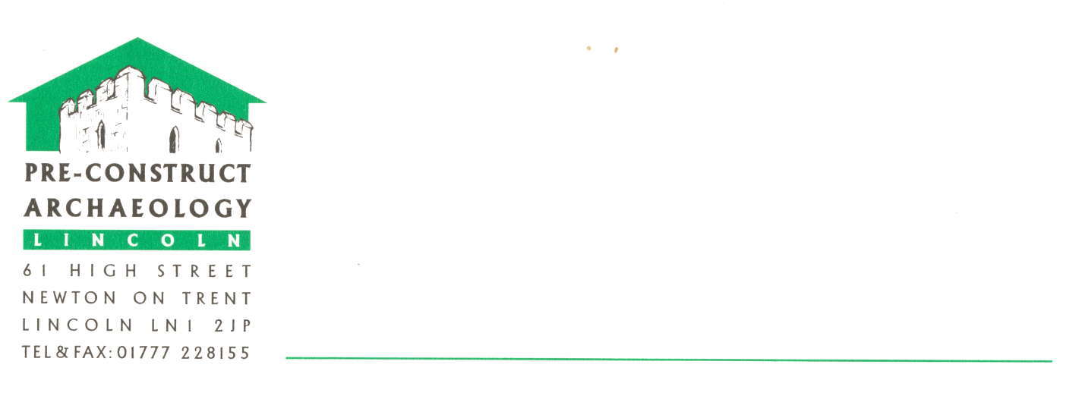
L I N C O L N

Pre-Construct Archaeology (Lincoln)
Unit G
William Street Business Park
Saxilby
Lincoln
LN1 2LP
Tel. & Fax. 01522 703800
e-mail mail.pca@virgin.net
©Pre-Construct Archaeology (Lincoln)

