Appendix 2: Colour Plates
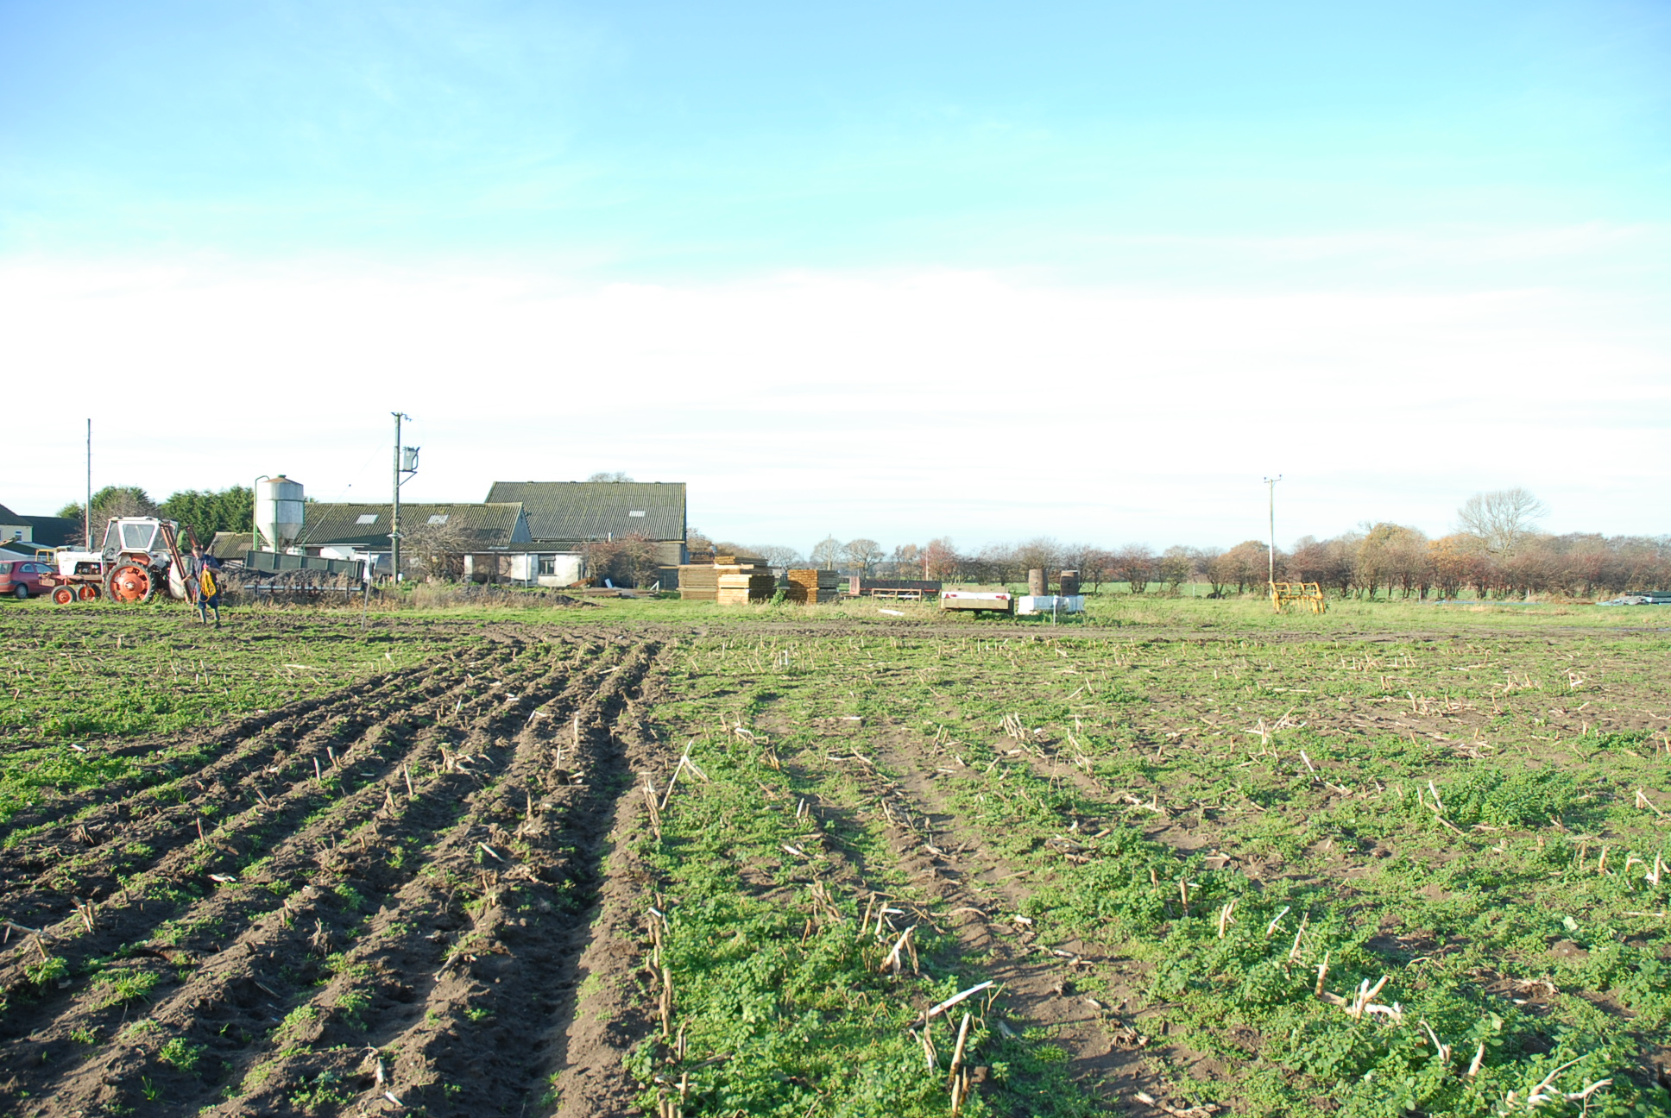

Plate 1: General View of the Development Site, looking west

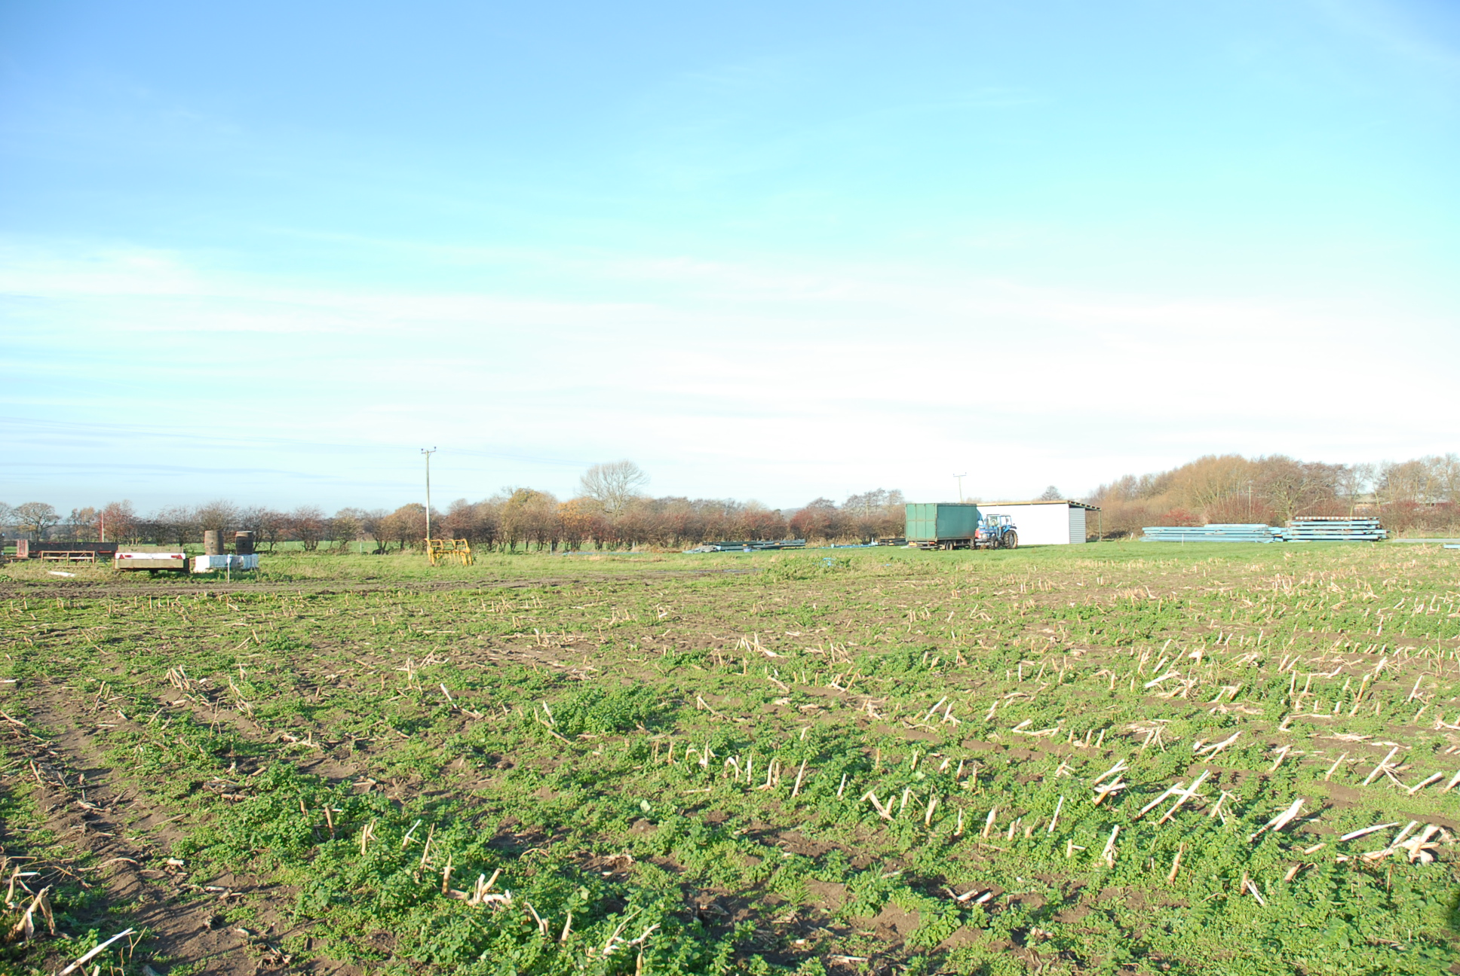

Plate 2: As Plate 1, looking northwest

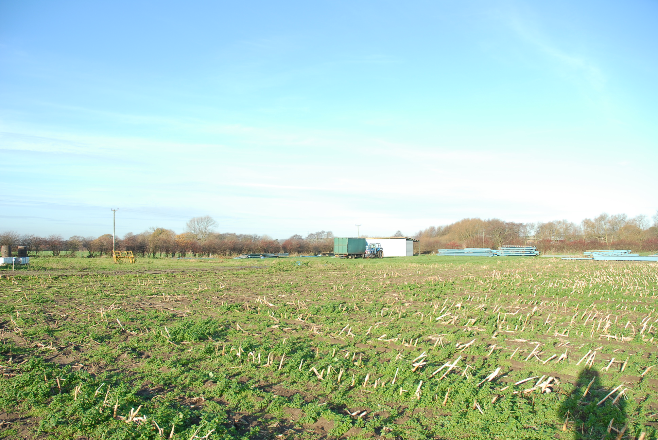

Plate 3: As Plate 1, looking northwest

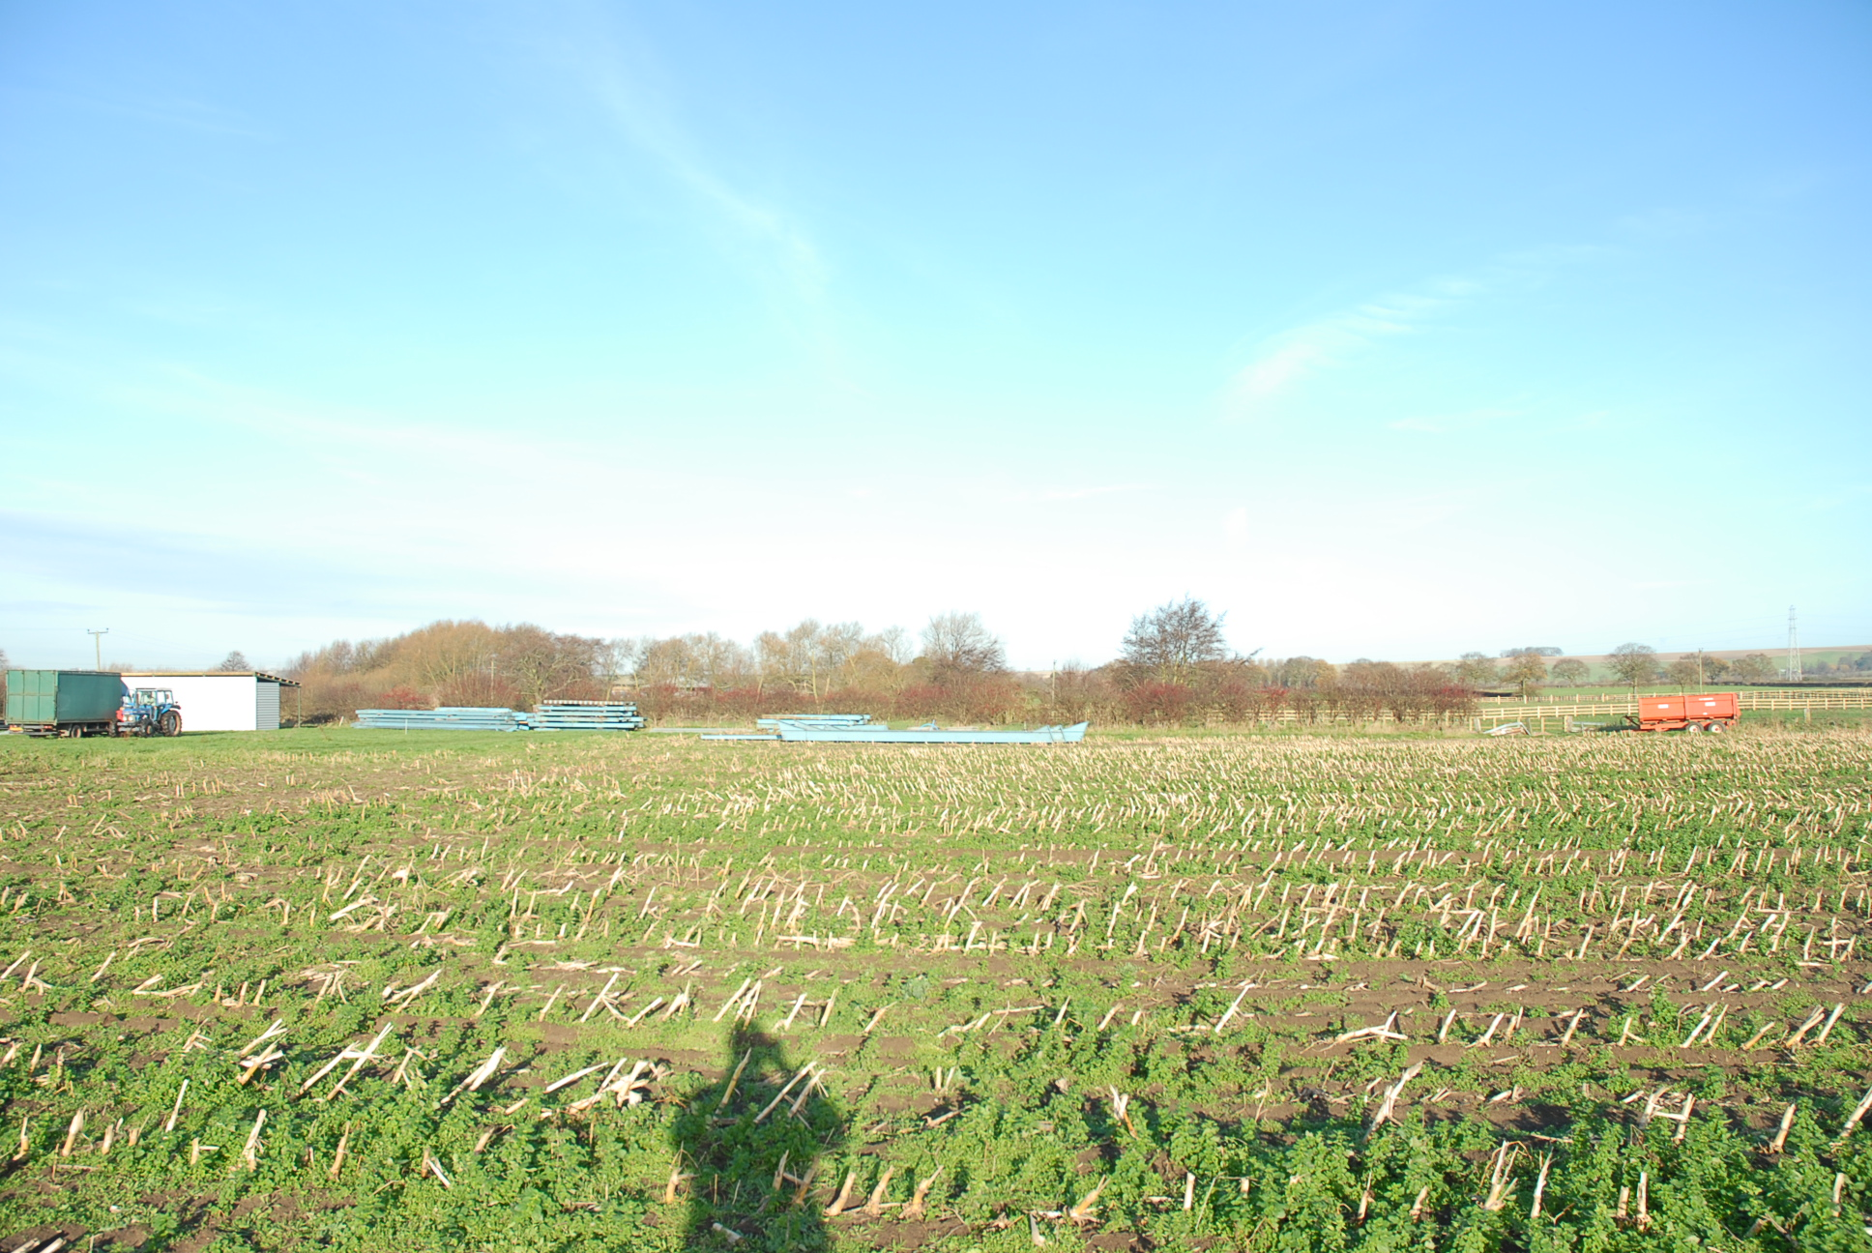

Plate 4: As Plate 1, looking north

