Appendix 1: Colour Plates
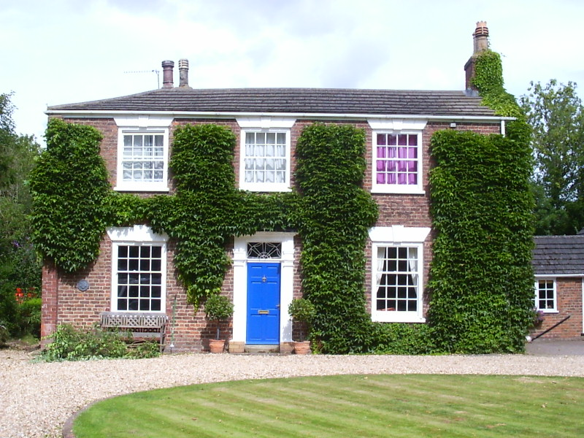
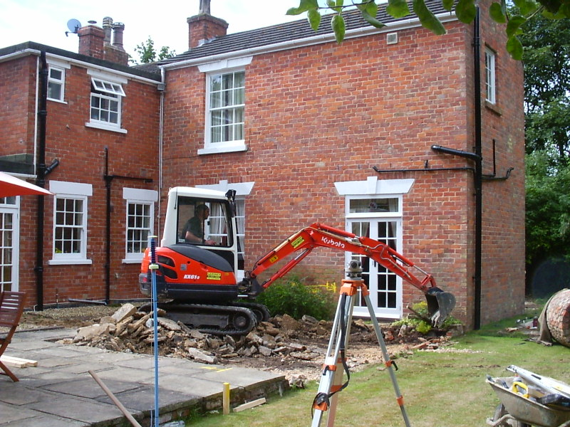
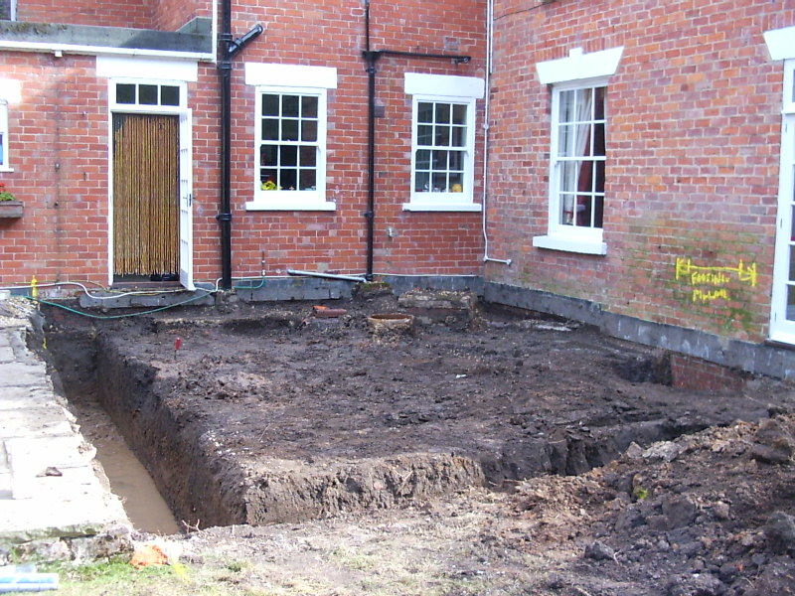
Plate 1 (left): General view of the frontage of the Old Vicarage, looking northwest.
Plate 2 (right): General view of the site during the machining, looking south.

Plate 3 (left): General view of the completed footings trenches for the extension, looking south.
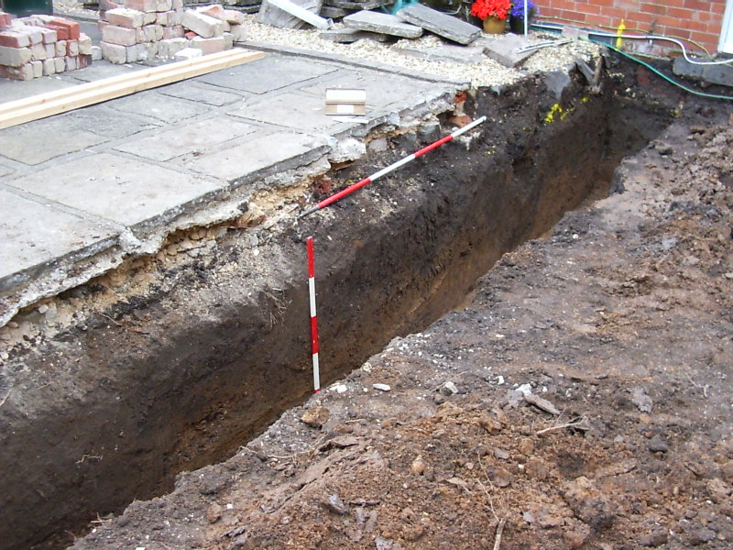
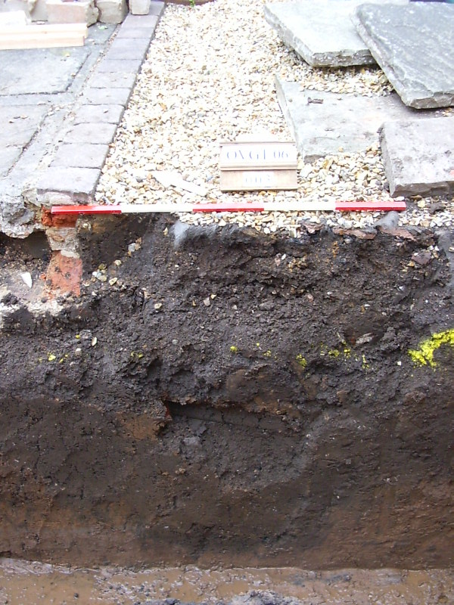
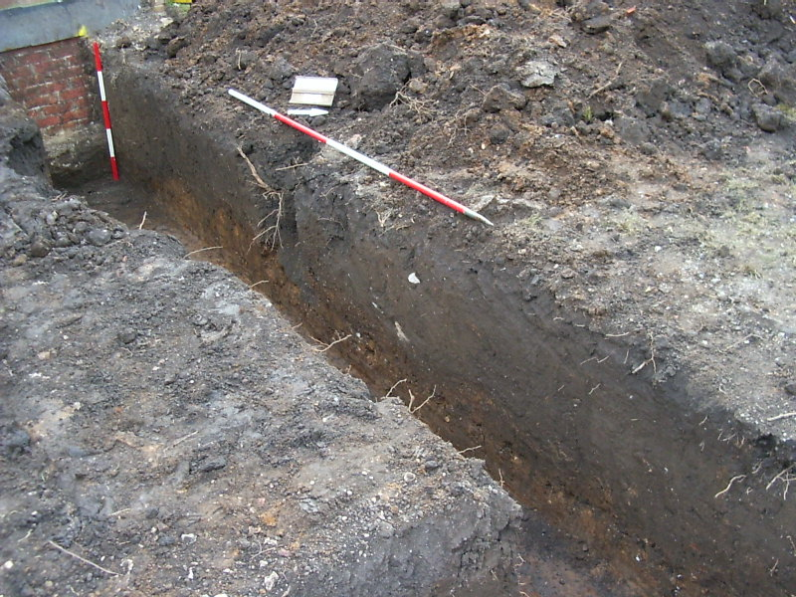
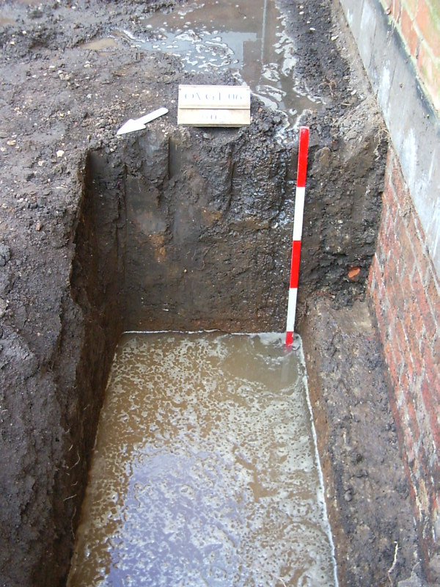
Plate 4 (above): The northeastern foundation trench, looking east.
Plate 5 (above right): Pit [003], looking northeast.
Plate 6 (above): The northwestern foundation trench, looking west.
Plate 7 (above right): Footing trench for stanchion against the sitting room wall, looking southeast.

