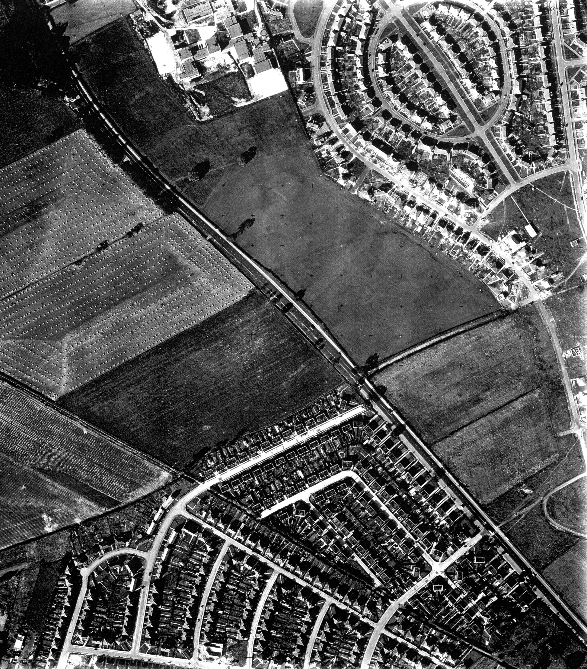
N
Roman Ridge
A638
Pipering Lane West
Figure 13: Aerial photograph taken in September, 1956. The position of the site is outlined in orange. The field boundary bisecting the site can clearly be seen: a darker area to the north of it may represent the position of pits shown on the 1st edition Ordnance Survey map.

