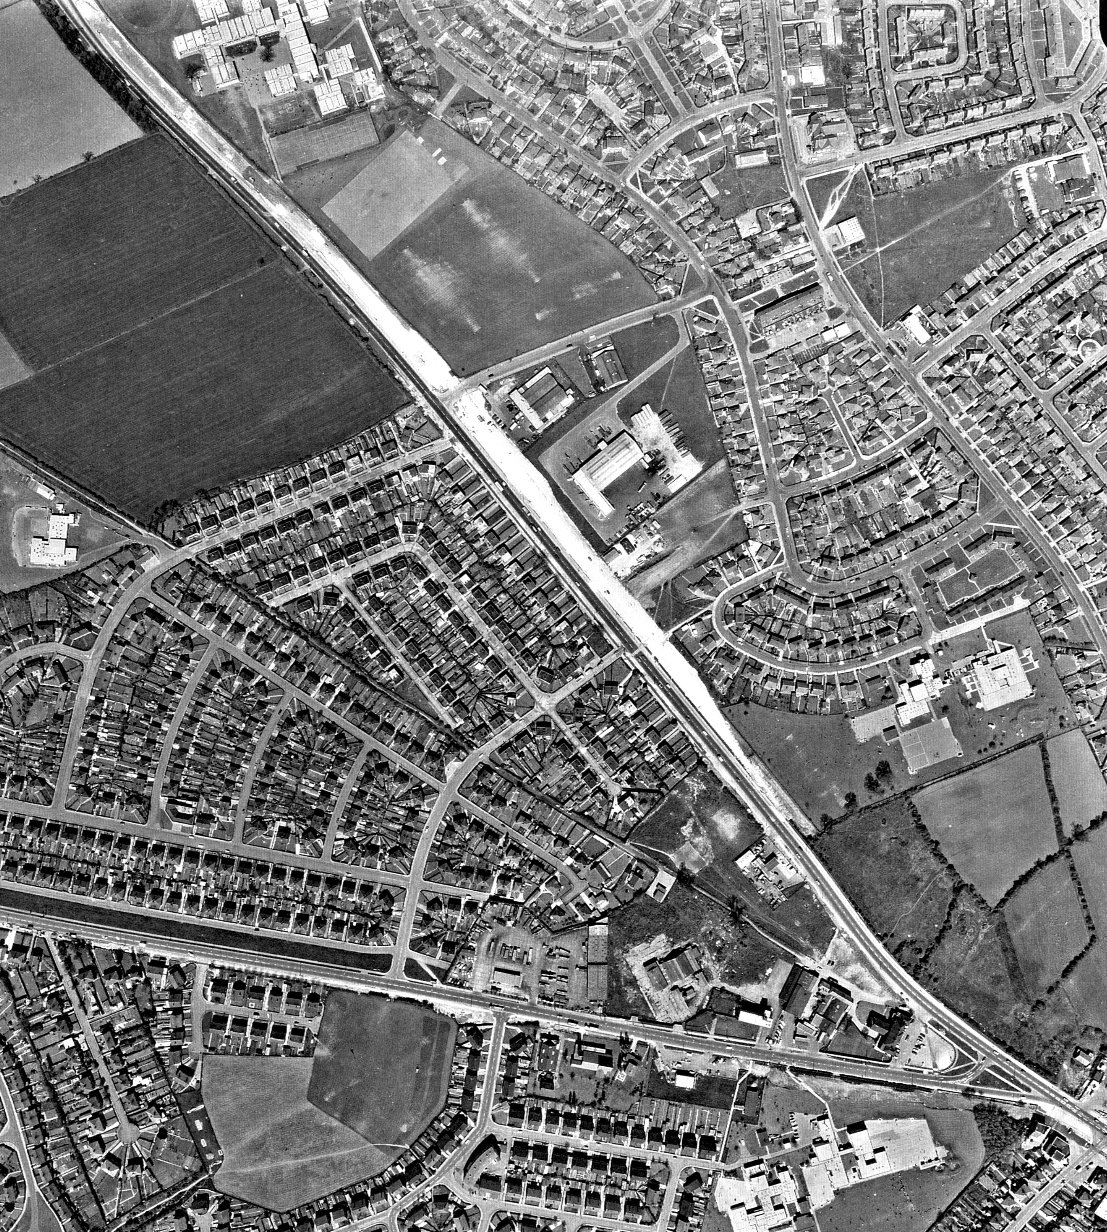
Roman Ridge
A635
A638
N
Pipering Lane West
Figure 14: Aerial photograph taken in May, 1971. The dualling of the A638 is in progress: the new roadbed shows up as a broad white stripe. The site is outlined in orange. The area to the north of Pipering Lane West is in use as a playing field: the light-coloured shapes visible in this area are patterns of wear from play on two football pitches.

