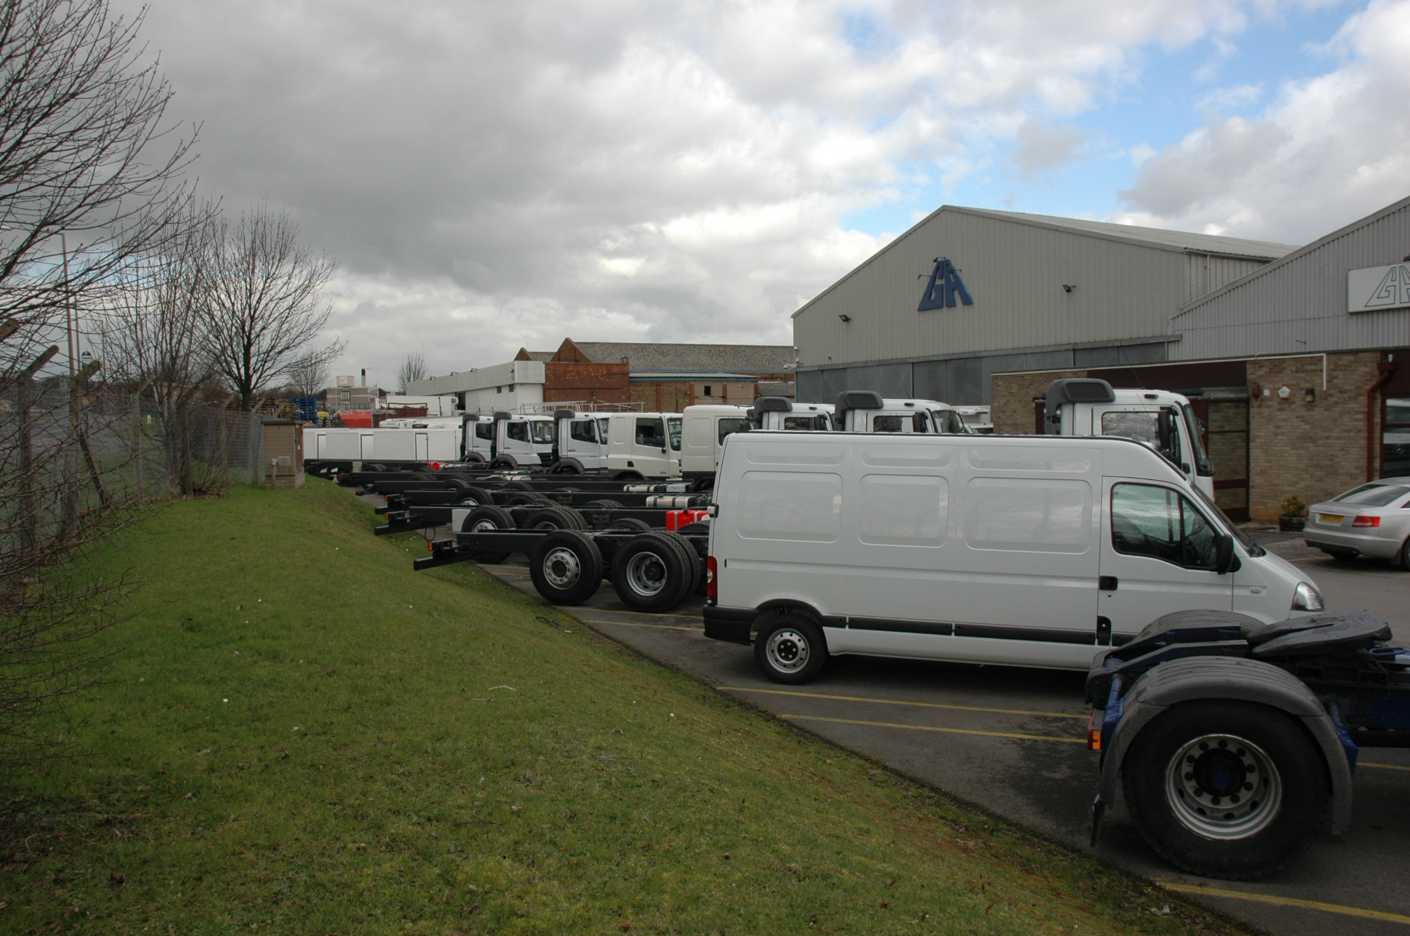
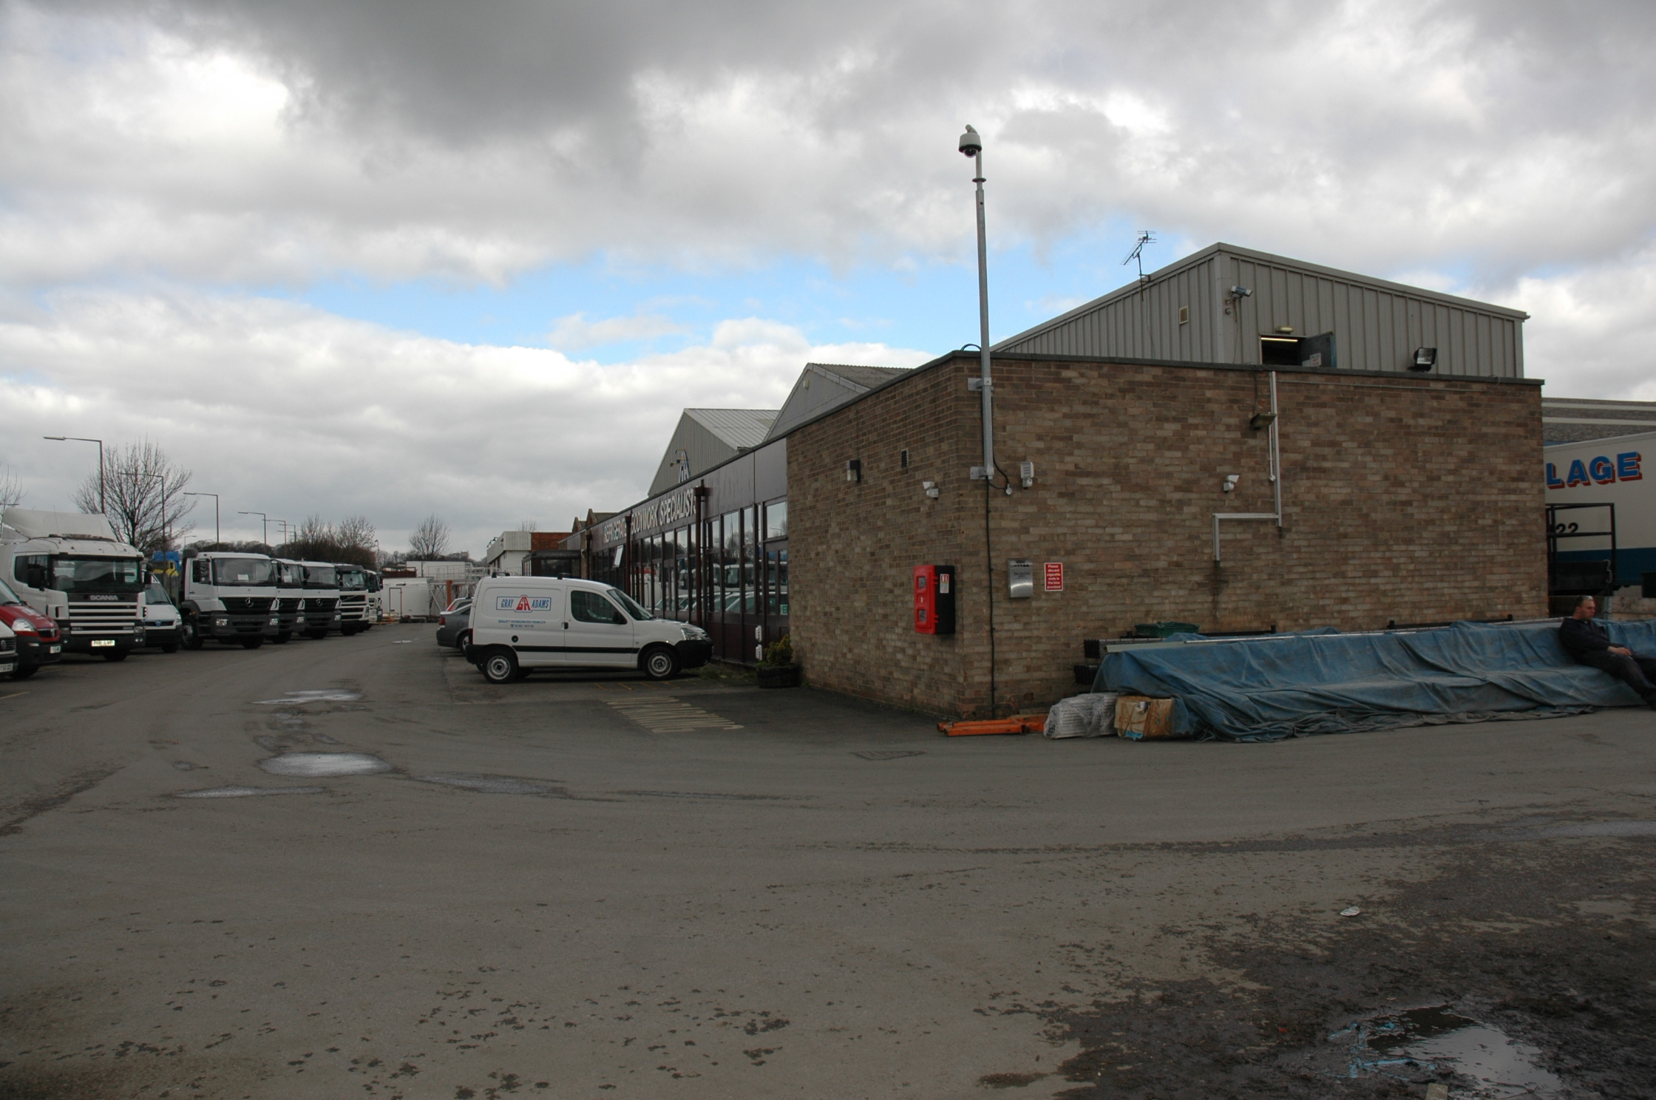
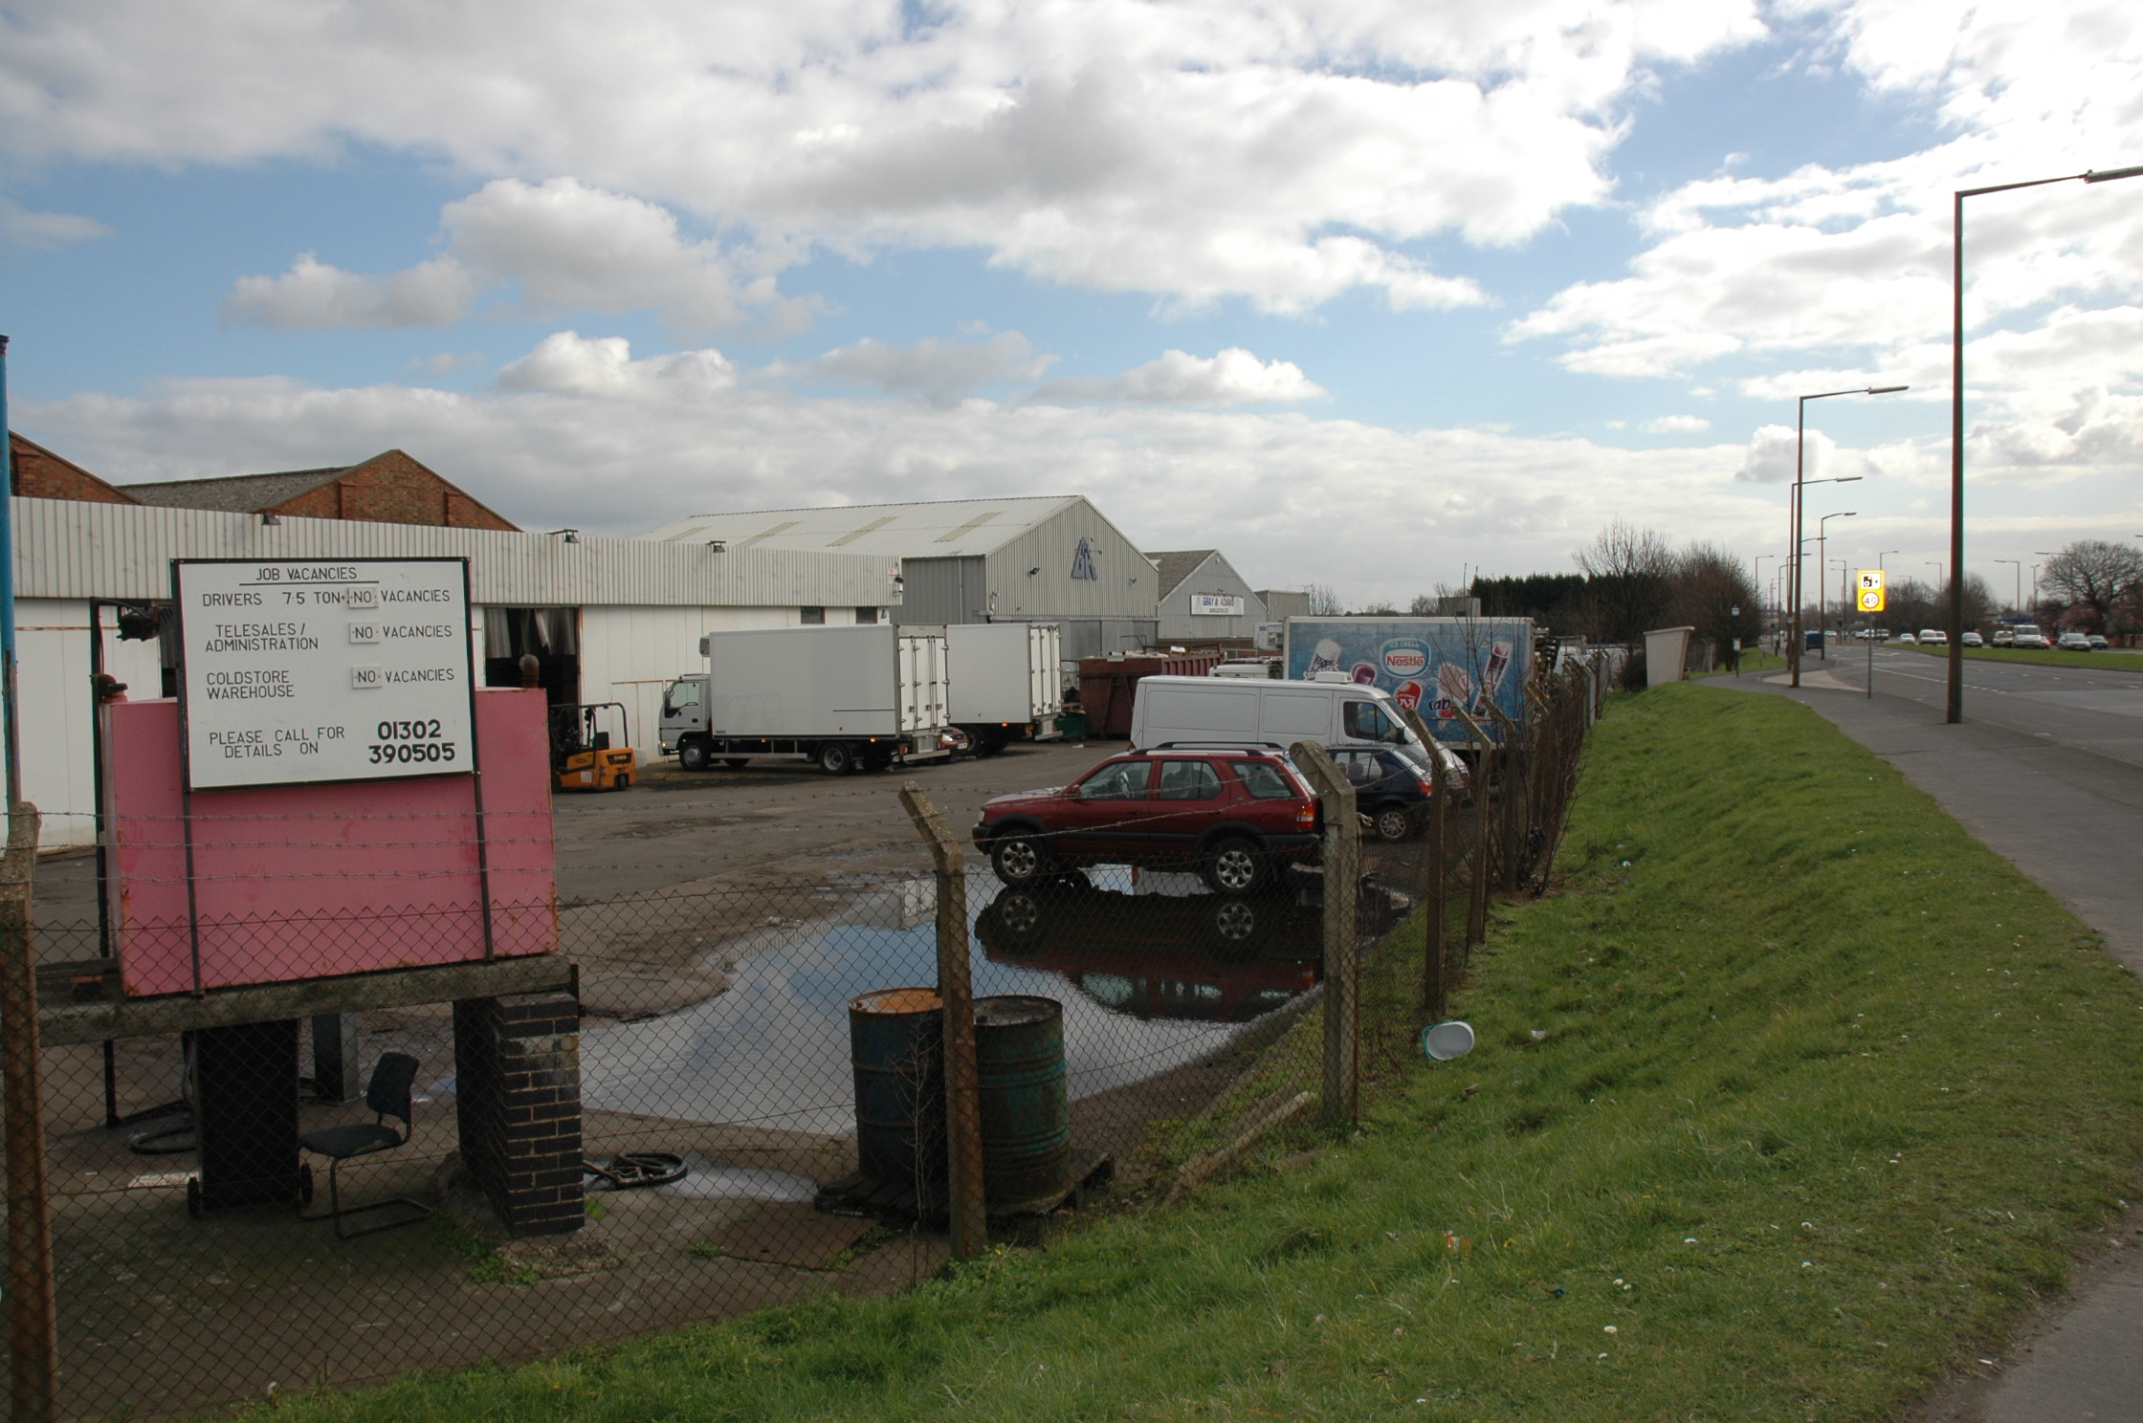
Appendix 1: Colour Plates
Plate 2: The south-western frontage of the main Gray & Adams building complex, looking north-west along the site boundary, showing the difference in height between the site and the York Road to the left of the picture.
Plate 3: The main Gray & Adams building complex, looking north-west from the south corner of the site, showing the frontage on to the York Road.
Plate 1: The frontage of the site on to York Road, looking south-east from the junction with Pipering Lane West. The brick buildings of Hulleys & MAS are closest to the camera, with Gray & Adams’ premises beyond.

