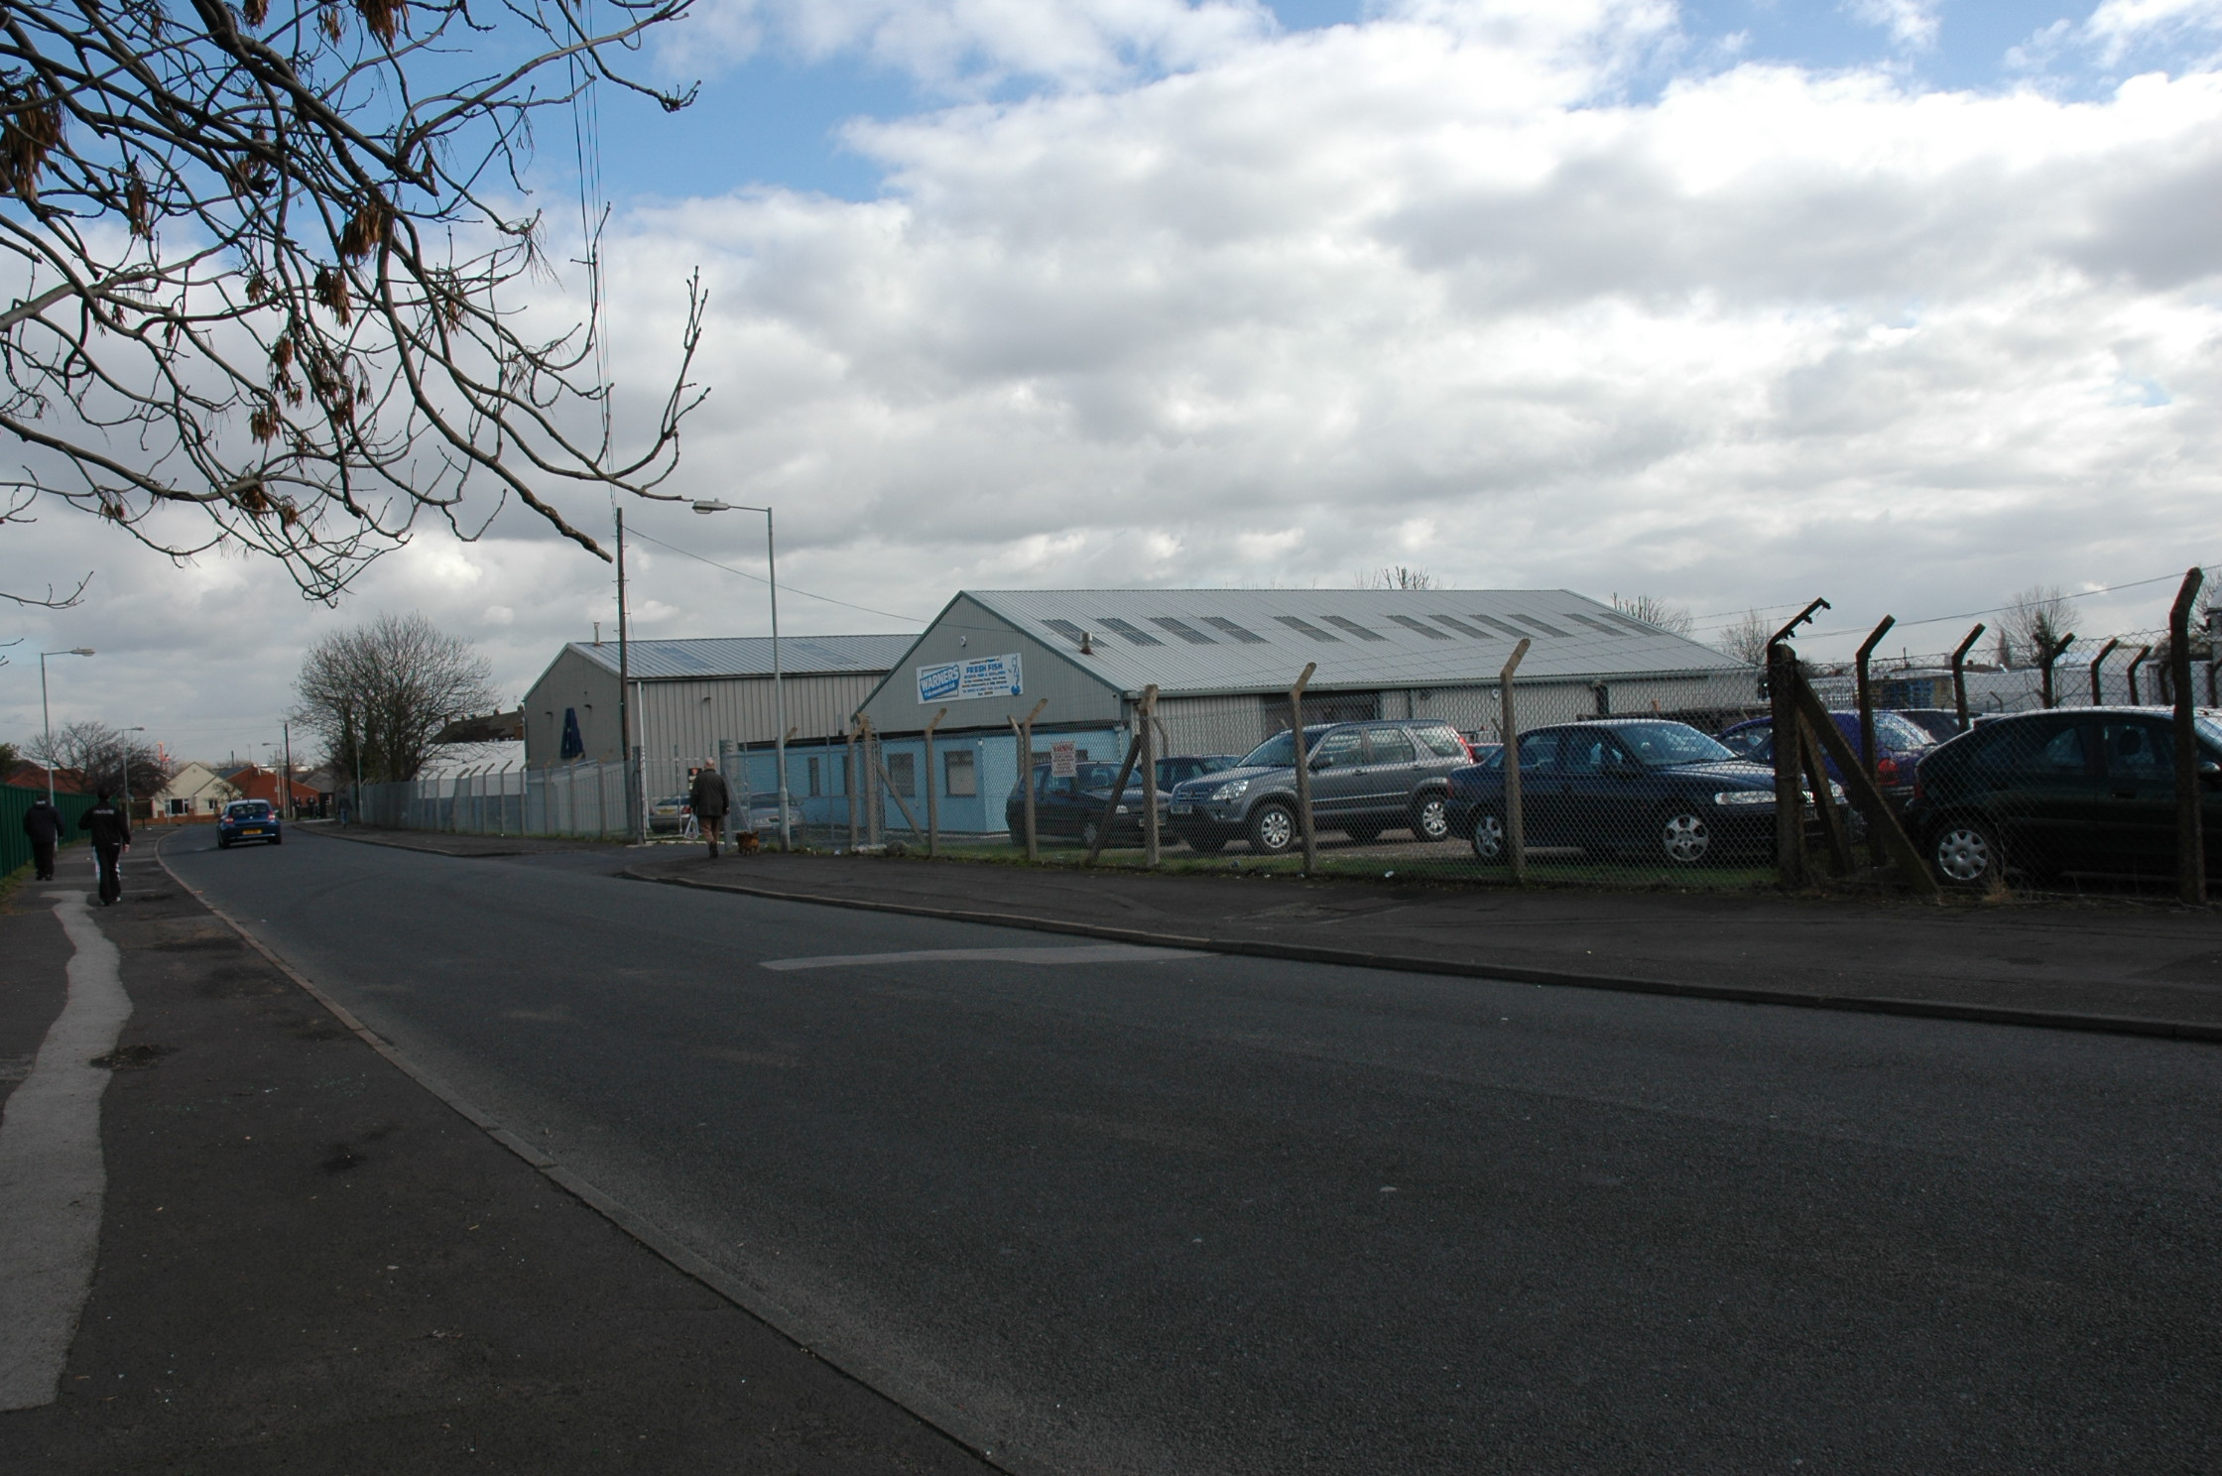
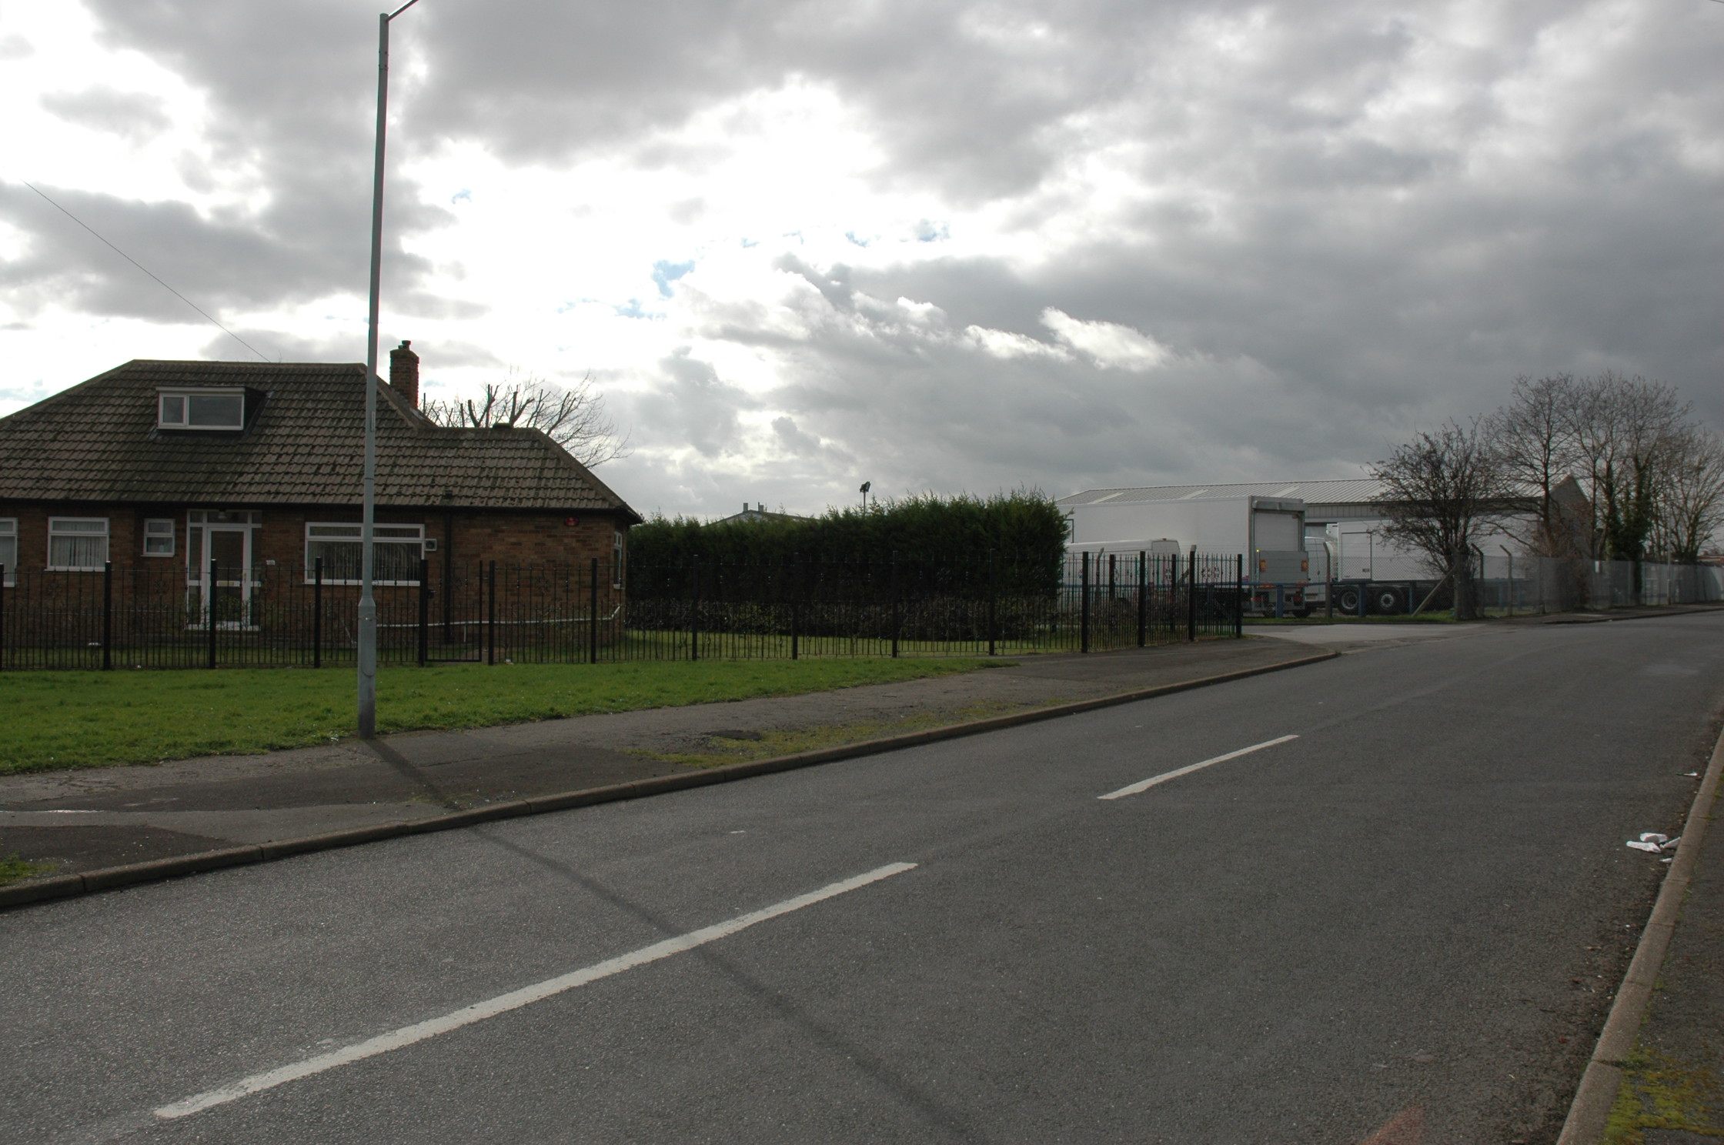
Plate 7: The Warners site, with the most northerly of the Gray & Adams buildings beyond, looking east from the far side of Pipering Lane West.
Plate 8: The bungalow adjacent to the entrance of the Gray & Adams site, looking south-west from the junction of Pipering Lane West and Stonehill Rise.

