- A programme of archaeological trial excavation was undertaken for Halletec Associates prior to a quarry extension on land northwest of Highfield Farm, Welton le Marsh, Lincolnshire.

- The trial trenching has confirmed that the geophysical survey results reflect a faithful footprint of the buried archaeological remains: two ditched enclosures situated towards the north and west of the proposed development area were sample excavated, and these appear to be of later Iron Age date. These enclosures are undoubtedly of local archaeological interest, although their state of preservation is relatively poor, and their potential to yield quality economic and environmental information is limited.

- No remains have been identified at the site to preclude the proposed development, and it is recommended that this development be conditioned.

- It is recommended that a programme of soil stripping, mapping and recording should be undertaken at the site over the footprints of the two enclosures, as well as smaller strategic cuts across a boundary ditch extending south-eastwards of the larger of the two enclosures at an appropriate time to accord with the working programme of the quarry.
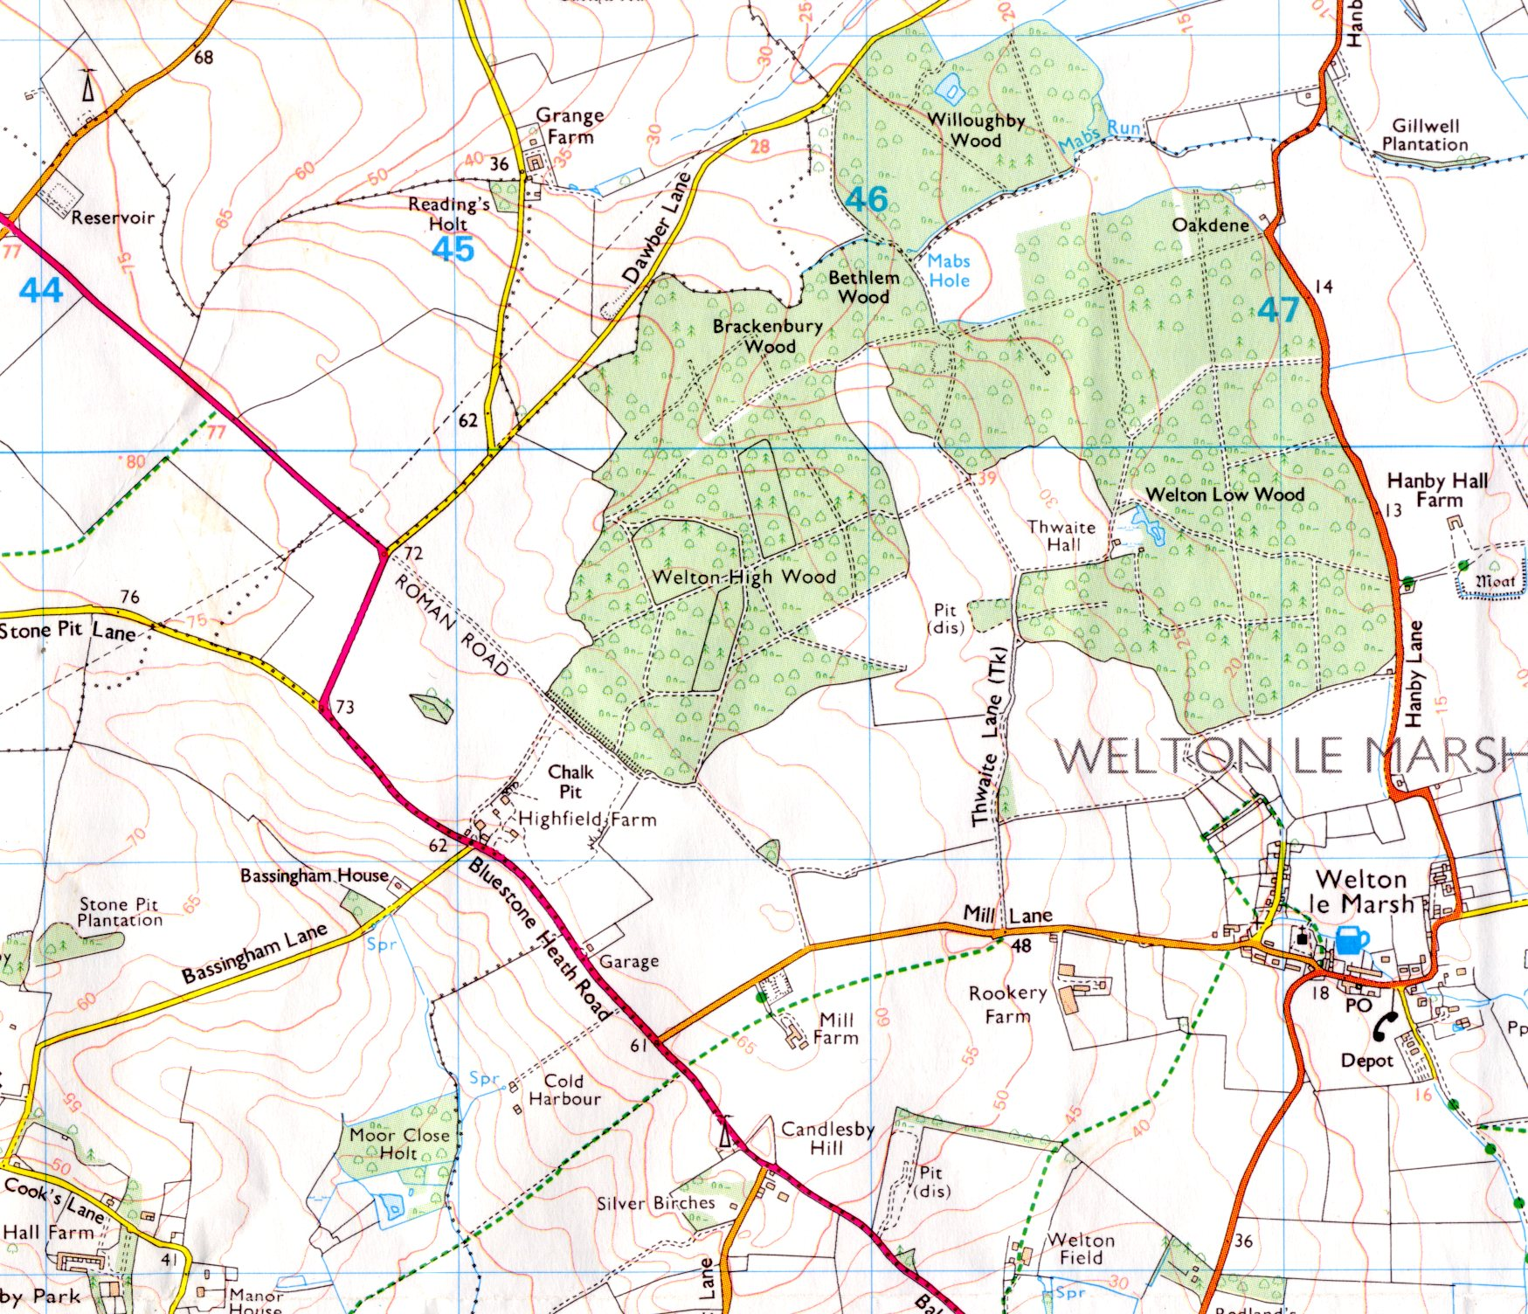
Site
Fig. 1 General site location. Scale 1:25 000. Site area outlined in red.
(O.S. Copyright licence no. AL 515 21 A0001)
1.0 Introduction

Pre-Construct Archaeology (Lincoln) was commissioned by Halletec Associates to undertake an archaeological evaluation on land adjacent to Welton le Marsh Quarry in Lincolnshire. This work was undertaken to inform a proposal to extend the quarry, within a zone that is covered by a 1947 IDO consent.

The site investigations described in this report were undertaken to meet the advice of Lincolnshire County Council, where the general evaluation approach was consistent with the recommendations of Archaeology and Planning: Planning Policy Guidance Note 16 (PPG16) and standards and guidance for Archaeological evaluations (IFA, 1999).

2.0 Site location and description

Welton le Marsh is in the administrative district of East Lindsey, approximately 13km north-west of Skegness and 20km east of Horncastle, on the south-east edge of the Lincolnshire Wolds.

The proposed quarry extension covers an area approximately 6ha in area that is currently agricultural. It is situated on a north-east facing slope, where the mean elevation is approximately 70.00m OD. The central national grid reference is TF 4520 6935 (fig. 1).

The site is bounded to the north by a farm track (on the line of a former prehistoric/Roman road); this track deviates to define the eastern edge of the site. To the southeast is Highfield Farm, and to the south is the Bluestone Heath Road (A 1028). Arable fields delineate the western boundary (figs 1 and 2).

The geology of the area comprises of Cretaceous deposits of Welton and Ferriby Chalk (B.G.S, 1996).

3.0 Planning background

There are currently two planning consents relating to the quarry:

- A 1954 planning permission covering the southeast area of the quarry (which is currently operational)
- A 1947 IDO consent that includes both the current investigation area and a previously worked area to the east.

In order to quarry the unworked IDO area, Lincolnshire County Council require that modern conditions should be applied; to include archaeological investigation.

4.0 Archaeological and historical background

Various archaeological sites and finds have been reported in the area, extending in date between the prehistoric and the Post-medieval periods.

To the north-west of the site, Neolithic long barrows are known at Skendleby. The Bluestone Heath Road (the original line of which was to the immediate north of the site) is thought to have been a prehistoric trackway, followed in part by a later Roman road that linked the settlements at Lincoln and Burgh le Marsh. A remnant of the original road can still be seen within Welton High Wood, in the form of the ‘agger’ and its flanking ditches. Just north-east of this, a pottery scatter dating to the 3rd-4th century AD has been recorded.

With specific regard to this scheme, it is the results of a geophysical survey of the site that are of greatest relevance (Bunn 2004). This survey revealed a number of magnetic anomalies with morphological characteristics that are likely to indicate past human occupation of the area. Primarily, these features amounted to:

- A rectangular enclosure-type anomaly towards the north of the site, approximately 65m x 50m in plan; possible sub-division on east side. The long axis of the enclosure, which incorporates a central entrance, aligns approximately with the former line of the Bluestone Heath Road, as does an offshoot linear boundary, extending south-eastwards from the southeast corner of the enclosure to beyond the survey limits. Pit-like anomalies were identified within the interior, as were two semi-circular anomalies – tentatively, circular structures.

- A second smaller and less regular enclosure approximately 38m south of the above; again with possible internal features. There are possible outer ditches associated with this feature.

- A tentatively identified ‘enclosure’ at the south-east corner of the survey; possibly an attachment to the linear ditch that almost parallels the line of the Bluestone Heath Road.

- An array of amorphous, sometimes extensive anomalies; believed to be of natural origin (eg palaeochannels)

- Isolated/discontinuous anomalies of uncertain origin.

5.0 Methodology

Seventeen trial trenches were positioned across the site using a Leica GS50 global positioning system. These measured between 10m and 36m in length, where the group was situated to traverse a range of magnetic anomalies picked up by geophysics, and also to assess areas of the site that appeared to be archaeologically sterile (see fig 2).

Following hand cleaning of the trench sides and base, any archaeological deposits identified were subjected to limited excavation to record their nature, dimensions, extent etc, and to attempt to recover datable materials. These investigations resulted in the production of written accounts, colour photographic records and scale drawings, in both plan and section.

The work was undertaken over a course of 22 days: between the 19th-20th of September 2006, 12th-20th December 2006, and 3rd-5th of January 2007. A team of up to six field archaeologists was employed, headed by one Site Supervisor.

6.0 Results

The general stratigraphy

The natural geology encountered across the site (3000) comprised of fragmented chalk within a matrix of mid reddish-brown clay, sealed by a mid reddish clay subsoil (2000). The latter was everywhere present at approximately 200mm depth; the exception being Trench 15, where it was 500mm. The subsoil contained occasional round and sub-round stone inclusions with occasional chalk fragments. Ploughsoil (1000) sealed this deposit and ranged in depth between 100mm – 380mm.

In trenches 3, 5, 6, 7, 9, 15 and 17, no archaeological deposits or horizons were exposed, even though some of the trenches had been positioned to intercept specific magnetic anomalies.

Trench 1

This was positioned to intercept a wide, slightly sinuous anomaly; believed to be a possible palaeochannel.

One linear ditch-like feature, [101], was exposed towards the east end of the trench, orientated approximately northwest to southeast. This feature traversed a deposit of brown sandy clay, (103). The fill of [101] was relatively ‘clean’ and devoid of finds, indicating a probable natural origin.

It is of note that deposit (103) was local only to Trench 1, suggesting that this itself was some form of fill. The geophysical survey displays a wide sinuous feature in this area; believed to be of natural origin. In this context, it is very likely that context (103) was the fill of the suggested palaeochannel, and that feature [101] post-dated its in-filling. The gradiometer survey results do in fact indicate a feature projecting to the north-west of the channel, and this could well be [101].

Trench 2

This was approximately 60m to the northwest of Trench 1; to intercept a linear anomaly orientated broadly east-west.

A very shallow, difficult to define, linear ditch-like feature was exposed, [201], aligned north-east to south-west, and cut through the natural stratum. Its fill (202), was virtually indistinguishable from the natural horizon (fig. 3). This feature could be the anomaly referred to above, although is of incorrect position and orientation.
Trench 3

Archaeologically sterile.

Trench 4

This was positioned to traverse an irregular linear anomaly (believed to be a natural feature), as well as an apparently sterile area of the site.

Archaeological sterility was confirmed in this area, excluding an isolated small pit-like feature towards the east end of the trench, [401] (fig 4). This contained a charcoal rich fill (402), which was bulk sampled to assess its archaeo-environmental potential (Appendix 5). Charcoal fragments were identified in the sample flots, and the sediment contained 86 small bone fragments, including caprivoid (sheep/goat) and human teeth. With regard to the latter, the environmental assessment records the occurrence of both mandibular and maxilla dentition, citing this as a possible indication that a whole skull may have been placed in the pit (the majority of bone having degraded in what were unfavourable soil conditions for the preservation of bone).

Trench 5

Archaeologically sterile.

Trench 6

Archaeologically sterile.

Trench 7

Archaeologically sterile.

Trench 8

Positioned to investigate the southernmost of the two enclosures, including possible internal features.

Six archaeological features were exposed, cut through the natural chalk and also the subsoil (fig. 5).

One shallow ditch-like feature close to south end of the trench, [801], was orientated east-west, was probably the south edge of the enclosure. Its fill, (802), contained charcoal inclusions and sherds of Late Iron Age pottery. A small feature was investigated a short distance to the north of the suggested enclosure ditch [815], but this could not be dated by any associated finds.

Approximately 8.5m north of the enclosure ditch, two more ditches were exposed, [804] and [806]. These were parallel features orientated east-west. Ditch [804] was 1.50m wide and 0.50m deep and contained two fills: (817) and (803). The latter, the bulk fill, contained 16 sherds of Late Iron Age pottery (Appendix 3). Ditch [806] contained one fill (805), identical to the tertiary fill of [804] but devoid of finds. The geophysical survey evidence (fig 2) suggests that the two ditches formed part of the enclosure complex.

At the north end of the trench, two undated pits, [810] and [812], were recorded; these possibly having been associated with the occupation/use of the enclosure. The smaller of the two, [810], was circular; it was 0.40m in diameter and 0.08m deep and contained a fill of dark clay mixed with charcoal flecks, (809) A bulk soil sample from this pit identified charcoal and ash and some poorly preserved seed remains (wheat and cultivation weed). The other pit, [812], was sub-rectangular, 0.40m deep with near-vertical sides. It contained two fills; (811) over (813) and its sides and base were lined with clay, 4mm thick (812). The lower fill, (813), was silty clay, intermingled with occasional chalk fragments. Above this, (811) was dark silty clay, incorporating stone fragments, charcoal flecks and fired clay. A processed bulk sample from this material indicated the occurrence of charcoal fragments, some wheat grains, charred crop weed seeds, unidentified bone fragments and one pig tooth. A sample of the actual lining identified poorly preserved cereal grains.

Trench 9

Archaeologically sterile.

Trench 10

Positioned to intercept an extensive linear boundary extending southeastwards from the southeast corner of the larger enclosure.

A ditch [1002] orientated northwest - southeast was exposed towards the northeast limit of the trench (fig 4). This feature survived to only 300mm deep, where it cut through both the natural and subsoil. Its fill (1001) contained no finds but the ditch is presumed to be the one provisionally identified by geophysics.

Trench 11

This was positioned to traverse a possible sub-division within the larger enclosure.

A linear ditch, [11-100], was exposed towards the centre of the trench, orientated northeast-southwest (fig. 6). It was comparatively deep at 1.20m and had shallow sides and a U shaped base. Two distinct fills were identified: an initial silting, (11-101), and an upper fill containing Late Iron Age pottery (11-102). The latter was beneath the ploughsoil.

Trench 12

This was positioned to investigate the southern boundary ditch of the larger enclosure, as well as possible internal features.

A ditch, [1200], corresponding with the projection of the enclosure ditch was identified (fig 6). It survived to 500mm deep, and contained two fills: a primary deposit (1201), and a bulk deposit, (1202). The latter contained Late Iron Age pottery sherds.

Trench 13

This was to sample the west boundary of the larger enclosure

The western return of ditch [1200] was encountered towards the east end of the trench, recorded as [1300] (fig 6). This section of enclosure ditch also exposed two fills: an initial silting, (1302), and an upper deposit (1301), which again contained Late Iron Age pottery sherds.

Trench 14

This was to assess the internal area of the larger enclosure.

A linear gully [14-100] was exposed towards the southeast limit of the trench (fig 7). The was relatively shallow and had suffered some root disturbance. Its fill (14-101) contained no finds, but its form suggested that it may have been a segment associated with a cirgular building (ie eves gully).

Trench 15

Archaeologically sterile.

Trench 16

Positioned to traverse the southeast element of the larger enclosure as well as its interior.

Two features were exposed; a narrow linear ditch orientated northeast to southwest, [16-100], and a part of a narrow curved feature [16-102] at the opposite end of the trench (fig. 7). The linear ditch appears to be the south eastern enclosure ditch, here surviving to 400mm deep. Although this segment contained no finds, the fill of the other feature (16-103) incorporated sherds of Late Iron Age pottery. A bulk sample from this deposit identified ash and charcoal within the soil matrix, two grains of barley and a few cereal grains that could not be identified to species level.

7.0 Conclusion and discussion

The evaluation has established the cultural origins of the two enclosures identified by geophysical survey. Both have an association with Late Iron Age tradition ceramic materials, indicating a possible origin in the pre-Roman era (Late Iron Age pottery has been recorded in post-Conquest contexts in Lincolnshire and elsewhere, although at Welton le Marsh, an origin in the pre-Roman era appears to be very likely (Appendix 3)).

The features associated with the two enclosures sampled by this evaluation were generally poorly preserved (truncated by ploughing and presumably affected in some areas by resultant soil creep/colluviation, although deposits of colluvial origin were not positively identified by the trenching programme). In some instances, cut feature survival was to just a few centimetres, although greater survival was occasionally recorded (to maximum1.2m). It seems inevitable that some archaeology has been lost to the plough altogether, and this could explain a dearth of features in Trenches 7, 9, 15 and 17, where some archaeological remains had been anticipated.

The broad objective of the evaluation has been achieved: it has confirmed the archaeological significance of the two enclosures, which have a demonstrable association with Iron Age tradition pottery (this applies to attached/related features). Within these enclosures, there is some evidence to show that internal arrangements are at least partially intact.

The trenching programme has also confirmed the natural origin of anomalies situated towards the south end of the site: Trench 1 exposed a deposit believed to be the fill of a large natural channel, and a later shallow feature that also resembled a natural watercourse.

Two residual/unstratified Late Neolithic to Early Bronze Age flint flakes were recovered (Trenches 8 and 16, Appendix 4), although these artefacts alone cannot be taken to indicate anything other than some form of transient exploitation of the area prior to settlement in the later Iron Age.

8.0 Mitigation

The evaluation has established that much of the site does not contain archaeological remains, although geophysical survey followed by target trial excavation has identified two late prehistoric enclosures to the south-west of a former prehistoric route, the Bluestone Heath Road.

No archaeological remains have been identified to preclude the proposed development, although the two enclosures are considered to be of local archaeological significance and interest. Their presence would support the theory that the Bluestone Heath Road was of prehistoric origin, where one linear boundary extending south-eastwards from the larger enclosure appears to parallel the original line of the trackway.

The archaeology is not well preserved, where depth survival ranges from just a few centimetres to maximum1.2m. This level of truncation can be put down mainly to the effects of modern ploughing. Similarly, the survival of organic remains at the site is poor: hand-collected bone amounted to only 20 fragments, allowing little more than a basic species assessment (identified species included horse, dog, pig and caprovid). Charred botanical remains have been identified in bulk samples, although species counts are low, and cereal grains distorted. It has been possible to identify wheat and barley, as well as weed seeds that are associated with cultivation.

It is therefore suggested that the archaeological remains that survive at the site (principally the two enclosures and related features) can be effectively preserved by record, and that this should be achievable by a standard strip, map and record exercise, involving:

- Controlled soil stripping over the enclosure footprints
- Selective excavation of the enclosure ditches and internal features
- Detailed planning and photographic recording of the excavated remains
- Further sampling to recover biological remains
- A programme of assessment and analyses
- Reporting

9.0 Effectiveness of methodology

The methodology required the excavation of fifteen evaluation trenches: two additional judgemental trenches were also investigated. A detailed record of the archaeology within each trench was established using standard methods, and a comprehensive record was made, confirming that the significant archaeological remains relate to the two enclosures that had been recorded initially by geophysical survey.

10.0 Acknowledgements

Pre-Construct Archaeology (Lincoln) would like to thank Halletec Associates for this commission.

11.0 References

British Geological Survey, 1996, Skegness, Sheet 116, Solid and Drift Geology, 1:50 000 Provisional Series. Keyworth, Nottingham: British Geological Survey.

Bunn, D., 2004, Fluxgate Gradiometer Survey: Land Adjacent to Highfield Quarry, Welton le Marsh, Lincolnshire. Pre-Construct Geophysics.

Mills, A. D., 1998, English Place-Names. Oxford University Press.

Tann, G., 2001, Highfield Quarry, Welton le Marsh: Proposed Quarry Extension. Archaeological Desk-Based Assessment. Lindsey Archaeological Services.

12.0 Site archive

An archive of written, drawn, photographic and object elements is in preparation and will be deposited at the Lincoln City and County museum within six months of the completion of this report.

Access can be gained by quoting the L.C.C. Museum accession number 2007.12.

