Summary

- An archaeological evaluation was undertaken on behalf of Mr B. Duke during the development of land off Nursery Street, Market Rasen, Lincolnshire.

- The evaluation involved the monitoring of one trench.

- Only natural sand and modern garden soil were exposed during this evaluation. No archaeology was found during this evaluation and even the possibility of unearthing earth-cut features such as kilns is unlikely on this site.

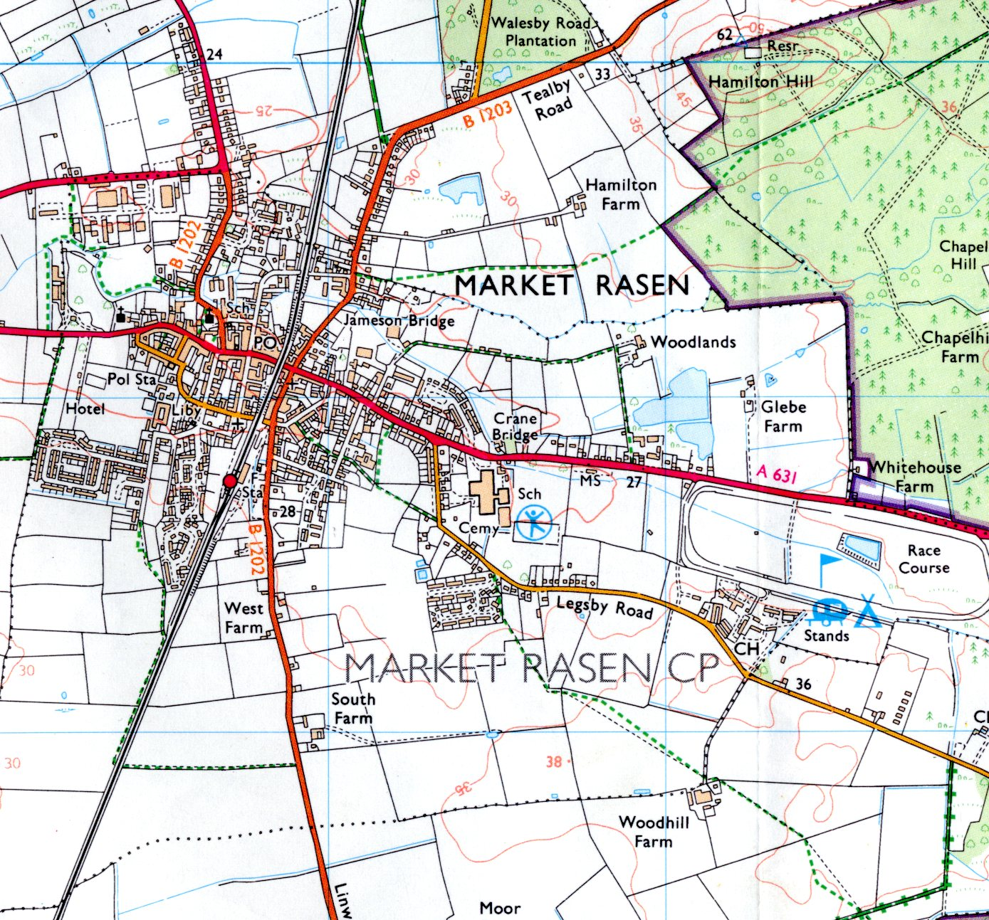
Site

Fig.1: General site location. Scale 1:25 000 and 1: 10 000.
The site is outlined in red (O.S. Copyright licence no. AL 51521 A0001)

1.0 Introduction

Pre-Construct Archaeology (Lincoln) was commissioned by Mr B. Duke to undertake an archaeological evaluation during the development of land off of Nursery Street, Market Rasen, Lincolnshire. These works were requested by West Lindsey District Council. This approach is consistent with the recommendations of Archaeology & Planning: Planning Policy Guidance Note 16 (Department of the Environment, 1990), Standard and guidance for archaeological Field Evaluations (IFA, 1999 as revised) and the LCC document Lincolnshire Archaeological Handbook: A manual of Archaeological Practice, 1998.

2.0 Site location and description

Market Rasen is situated approximately 18km north-east of Lincoln in the administrative district of West Lindsey. The site is located roughly half way along Nursery Street close to where it turns north. The development area is bounded to the north by housing and gardens, as is the west, while the east is occupied by a small commercial premises and the south by Nursery Street and housing (Figs. 1 and 2). The site was formerly used as a garden and forms a rectangular parcel of land measuring 230m². It has a mean elevation of 25.00m AOD and is centred on TF 10700 88912. The underlying geology consists of blown sand drift deposits overlying a solid geology of Upper Jurassic Kimmeridge Clay (BGS, 1999).

3.0 Planning background

Planning permission was granted for the erection of a dorma bungalow at Nursery Street, Market Rasen, Lincolnshire. The development was subject to a scheme of archaeological works; to include the monitoring and recording of all soil stripping and groundworks. Because this condition was not fulfilled by the developer, it was agreed with the archaeological advisor to West Lindsey District Council Planning authority to excavate a single 3.00m x 1.80m trench to the formation level of the development area retrospectively (Planning Ref: 121455).

4.0 Archaeological and historical context

During the Roman period an extensive pottery production industry developed in Market Rasen, mostly concentrated to the south of the town within the Linwood Road area (Whitwell, 1992). It is also believed that the town was a minor market centre during the early medieval period, although the focus for this is unknown.

5.0 Methodology

The primary methodology required a program of works to monitor and record soil stripping and other excavations during development. However, as already stated this was not fulfilled by the developer and so a single trench measuring 3.00m x 1.80m was excavated down to the formation level of the development area in retrospect. A wheeled excavator was used for this using a 2.00m wide blade. These investigations resulted in the production of written descriptions, colour slides and scale drawings, in both plan and section.

One site visit was made by the author on the 17th April 2008.

6.0 Results

The earliest deposit encountered was a natural sand layer (100), 0.10m below the current ground level and in excess of 0.30m thick. Covering this was a contemporary garden soil (101), which was 0.10m in depth (Fig. 3).

No archaeological deposits or features were encountered within the trench, neither were any archaeological artefacts seen from the resulting spoilheap.

7.0 Discussion and conclusion

Although no archaeology was present, there is always a chance of unearthing earth-cut features such as kilns in an area known for this type of archaeology, although this was not the case on this site.

8.0 Effectiveness of methodology

The methodology was effective, where adequate time was given by the developer to fully record the excavated trench, enabling an accurate interpretation to be made.

9.0 Acknowledgements

Pre-Construct Archaeology (Lincoln) would like to thank Mr B. Duke for this commission.

10.0 References

British Geological Survey, 1999, Market Rasen 102, Solid and Drift Geology, 1: 50 000 Provisional Series. Keyworth, Nottingham: British Geological Survey.

Whitwell, J.B, 1992, Roman Lincolnshire, History of Lincolnshire II. History of Lincolnshire Committee, Lincoln.

11.0 Site archive

The site archive for this project is in preparation and will be deposited at the Lincoln City and County Museum within six months of the completion of this report. Access to it can be gained by quoting accession number 2008.62

