CHAPEL OF STONEYWOOD WELL

Introduction

Following work at St Mary’s Chapel, Stoneywood in June 2003 which involved a small amount of excavation around the well in the south-west corner of the graveyard, it was decided to carry out a fuller excavation. The earlier excavation had failed to reveal the full outline of the well, which was clearly seen at its north end but was still buried at the south. Interpretative panels were being designed for the churchyard and it was intended to complete a reconstruction drawing of the well in use.

The excavation

The excavation consisted of revealing the stones of the southern part of the well and excavating into the feature until the water table was reached. The well was sub-oval in shape, 2.44m long and 0.94m at its widest.

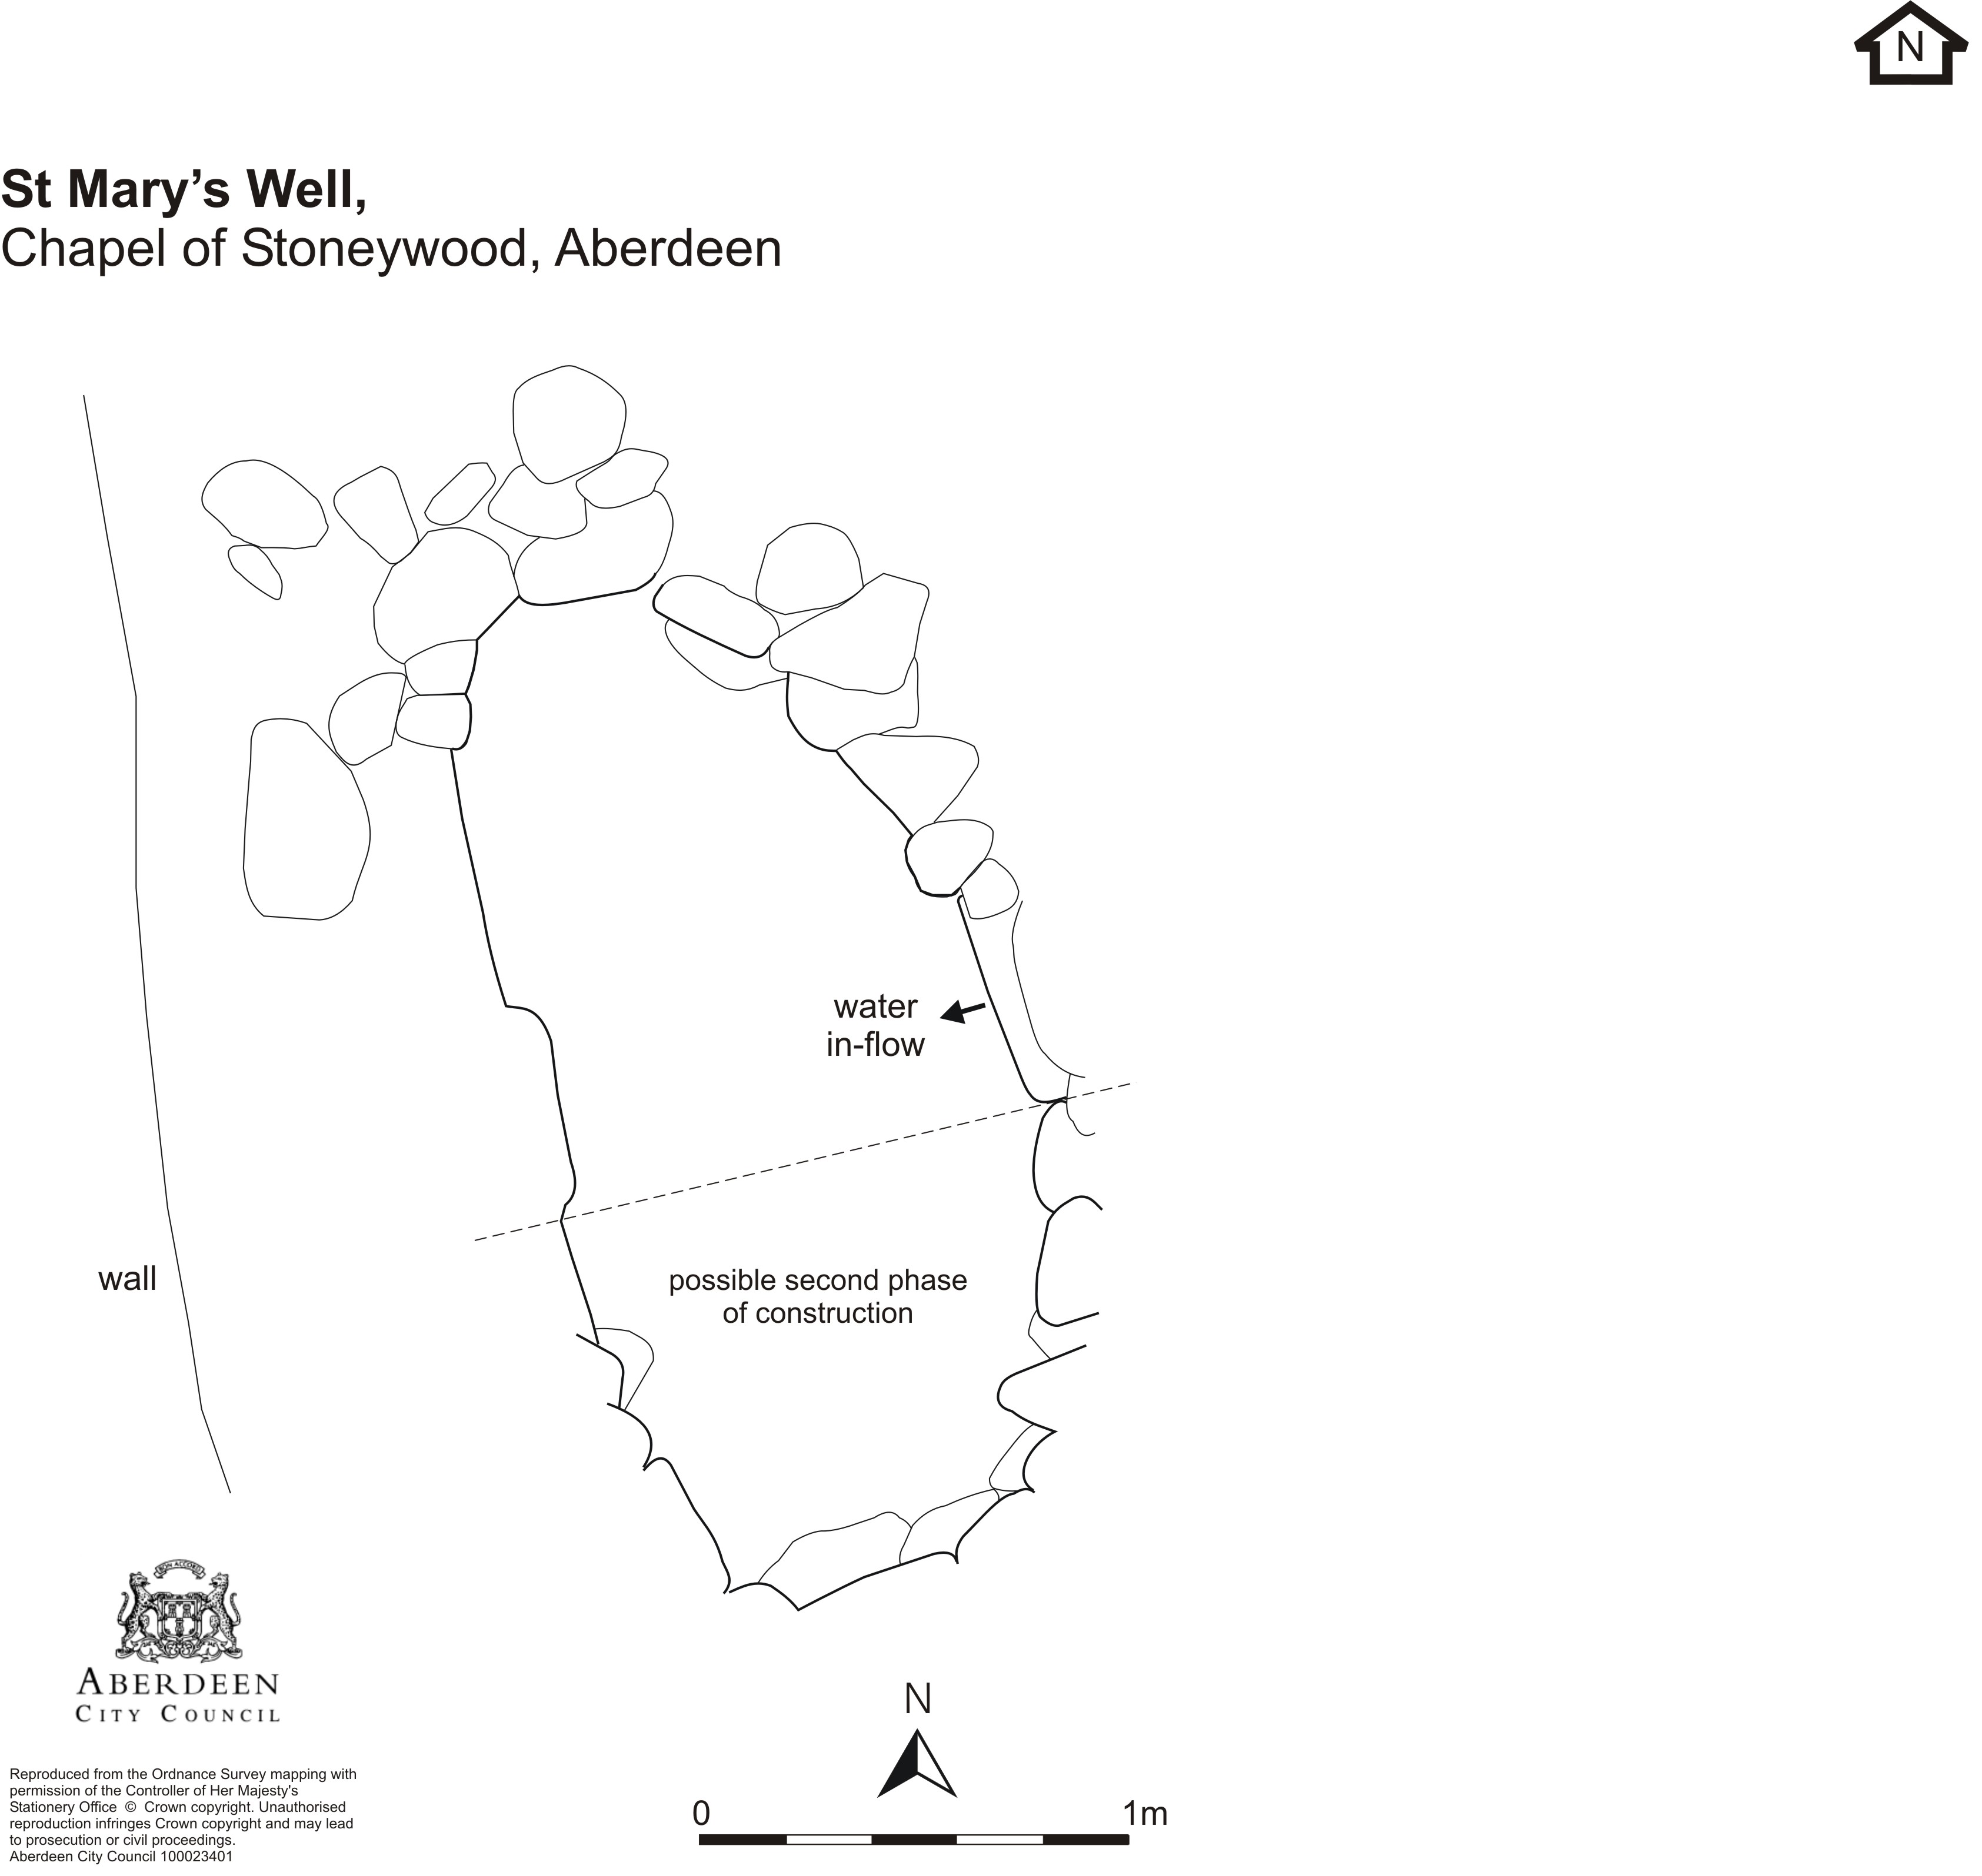

Phase 1

It appeared that the northern part of the well was constructed first. It consisted of well-constructed C-shaped section of drystone walling. It was excavated to a depth of c 0.5m, when the water table was located. A water source was still entering the well under a flat stone on the east side of the feature. No dating evidence for this phase of construction was found during the excavation.

Phase 2

In a later period, a further C-shaped section was added, completing the oval shape. It was less well constructed and the stones were roughly bonded with mortar in places. This was similar in appearance to repairs to the nearby boundary wall. The construction of this phase of the feature may have taken place in the 19th century.

Discussion

It is most likely that the first phase of construction of this well was for a well-head and that the oval ‘bath-like’ feature was constructed at a later date due to a change of use of the well. It is unlikely that the well was used as a drinking point for animals as it was within consecrated ground. It would also not have been feasible for the animals to reach the water unless the water table had been substantially higher at that time.

