Archaeological Evaluation
64 Kenneth Street
Stornoway
Isle of Lewis

SUAT Ltd
55 SOUTH METHVEN STREET
PERTH PH1 5NX
Tel: 01738 622393
Fax: 01738 631626
E-mail :director@suat.co.uk

Archaeological Evaluation
64 Kenneth St

Stornoway

SW04
1 Background 1
2 Details of Work 1
3 Interpretation 3
4 Conclusions and Recommendations 3

Appendix 1 Context Register 4
Appendix 2 Photographic Register 5
Appendix 3 Drawing Register 6
Appendix 4 Late 19th or Early 20th century photos of the site 7
Appendix 5 Discovery & Excavation in Scotland Entry 8
Appendix 6 Standard Terms of Reference for all Fieldwork 9

Illustration 1: Location of Stornoway
Illustration 2: Trench Location Plan

Authors Claire Casey, MA, Tamlin Barton, MA
Illustrator Tamlin Barton, MA
Editor David Bowler, BA, MPhil, MIFA, FSA Scot.
Abstract
SUAT Ltd was commissioned by Donald MacFarlane (Stornoway) Ltd to carry out an evaluation at 64, Kenneth Street, Stornoway, prior to the redevelopment of the site. The site was located north of the Royal Hotel and included Smith’s Shoe Shop (now vacant) and a garden. It was thought possible that either medieval archaeology or deposits relating to the 17th century Cromwellian occupation of Stornoway might be encountered.
The evaluation took place on the 24th April 2008, in the garden as the old shoe shop had yet to be demolished. Three 7 x 1.6 metre long trenches were excavated, but no significant archaeology was discovered.
The site code was SW04.

Background

Introduction
Donald MacFarlane (Stornoway) Ltd commissioned SUAT Ltd to undertake an archaeological evaluation at 64 Kenneth Street in Stornoway. The proposed development area is an urban plot 344 square metres in size located in between Kenneth Street and Cromwell Street, centred on NGR NB 4233 3306. The work (SUAT site code SW04) was undertaken on the 24th April 2008 in good weather conditions. The requirement was to evaluate 10% of the available area, ie 34.4m².
The work was designed to satisfy the archaeological condition on development application reference 07/00403/FUL.

Aims and Objectives
The main aim of this investigation was to establish the presence/absence, date, character and quality of any archaeological remains surviving within the development area.

Reporting
The present document has been prepared as the final report on this evaluation. Copies will be sent to the client, The Royal Commission on the Ancient and Historical Monuments of Scotland and the Western Isles Sites and Monuments Record.

Acknowledgements
SUAT wish to thank Donald MacFarlane, Jackie McNicol, Andy Meikle and Dr Mary MacLeod for their assistance and guidance throughout this project. Donald MacFarlane (Stornaway) Ltd funded this evaluation.

Details of Work

The Site (Illus 2)
The site lies towards the north end of Kenneth Street and occupies the land between Kenneth Street and Cromwell Street, just to the north of the Royal Hotel. The site includes several buildings that belonged to Smith’s Shoe Shop (now closed) and a garden to the south. The land naturally slopes steeply downhill from Kenneth Street to the west, but the garden has been made artificially level by the building of a large retaining wall which separates the garden from Cromwell Street.

Archaeological Potential

During the Cromwellian period, a fort was constructed by the English government to guard Stornoway harbour. A contemporary sketch-plan of the fort is owned by Worcester College, Oxford, and shows it occupying part of a peninsula presumed to be that now bounded by the north and south beaches. It was thought that the proposed development site might contain archaeology related to the fort and possibly remains of the medieval settlement. There has been no known archaeological work carried out on this site previously.

Archaeological Method
The presence of buildings on the site meant that only the garden could be evaluated. A JCB digger equipped with a toothless ditching bucket was used to excavate three trenches, each covering an area of 12 square metres. The first two trenches measured 7m by 1.6m, and the third was slightly shorter and wider at one end. All excavation was monitored by two SUAT archaeologists, and all archaeological features thus exposed were investigated by hand and recorded photographically and in detailed notes, and drawn at an appropriate scale in plan and section. Levels of features were taken and the locations of trenches were recorded using a total station and a tablet PC running Penmap.

Results of Investigations

Trench 01
This trench ran north-south, next to the retaining wall that separated the garden from Cromwell Street. A degraded mortar deposit (0102) and a gritty layer (0303) were found in the garden soil (0101) at the northern end of the trench. No other features were discovered in this trench. The natural sloped steeply downhill to the west and consisted of two layers, a reddish brown sandy rocky silt (0105) and a greenish rocky silt (0104) which ran underneath. The garden soil in the north-west corner of this trench lay up to 1.05m deep.

Trench 02
This trench ran south-west to north-east and was 0.55-0.64m deep. A linear cut feature [0202] with a square profile was discovered in the south-west end of the trench. This feature contained 19th century pottery and plastic. A small covered drain [0204] running east-west was discovered at the north-east end of the trench. The drain was constructed from two lines of stones which had been capped with thin square stones. The bottom of the drain had no stone lining. The fills surrounding and above the drain contained 19th century pottery.

Trench 03
This trench ran north-west to south-east and was 0.55m deep. Two large flat stones (0302) were revealed in the north-west end of the trench and seemed to be laid in a north-south orientation. The stones were found within the garden soil and had not been laid onto natural deposits. In the middle of the trench there lay a linear deposit of modern rubble, bricks and corrugated iron (0303) running north-south. This deposit lay on the surface, was 35cm deep and had been dumped on or cut into the garden soil. The trench was widened at the south-east end because of the difficulties associated with excavating a full 7m long trench in this restricted area.

Interpretation

Trench 01
The two thin deposits (0102) and (0303) probably represent the remains of a path around the west side of the garden. The layers disappear into the east facing section about one third of the way down the trench, probably because the trench was at a slight angle to the garden boundary (see Illus 2). The path is not very deep and is probably modern or dates to the 19th century. The garden soil in this area seems to have been built up to considerable depth in order to make the garden roughly level on what is naturally steep sloping topography.

Trench 02
The square cut and width of linear feature [0202] suggests that it is the remains of a modern garden path. The stone covered drain [0204] seems to be a 19th century attempt to provide drainage for the garden.

Trench 03
The two stones (0302) possibly represent the remains of a garden path running north-south. This interpretation is supported by the old photo in Appendix 4 which shows a path running on the same alignment. The deposit of rubble and bricks (0303) seems to represent a modern dump of waste material into the garden.

Conclusions and Recommendations
The evaluation revealed several features which relate to the use of the garden during the 19th and 20th centuries but no significant archaeology was discovered.
There are no recommendations for further work; however, the final decision ultimately rests with Dr Mary MacLeod the Western Isles area Archaeologist, Comhairle nan Eilean Siar (Western Isles Council).

- Context Register
No: | Description | Phase
0101 | A rich, humic garden soil with small pea sized gravel stones. Trench 1 | Modern
0102 | A thin patch of weathered gritty mortar in the NW corner of Trench 1, probably representing the upper layer of a garden path. True length and width unknown. This deposit lay within (0101). Trench 1 | Modern
0103 | A hard yellow compact deposit underneath (0102), probably representing the lower layer of a garden path. This deposit lay within (0101). True width and length unknown. Trench 1 | Modern
0104 | A green and brown gritty silt with frequent fragmentary angular rocks. Natural deposit below (0105). Trench 1 | Natural
0105 | A reddish brown gritty sandy silt with fragmentary rocks. Natural deposit. Above (0104). Trench 1 | Natural
0201 | A rich, humic garden soil with small pea sized gravel stones. Trench 2 | Modern
0202 | Cut for linear feature, probable path. Square cut in section and flat base. Feature continued into SW edge of trench 2. E end of feature is squared off. Feature is 34cm deep and is cut through topsoil and into natural. Width was 50-60cm. Trench 2 | Modern
0203 | Fill of [0202]. Mixed, fairly loose yellow clay and reddish grit. Fill of probable garden path. 19th century pottery and plastic found within fill. Trench 2 | Modern
0204 | Linear cut for stone covered drain, up to 70cm wide, running E-W. Gently sloping cut. The drain was built at the S side of this cut. Trench 2 | 19th century
0205 | Drain structure. The thin square stones covering the drain and stones forming the sides of the drain, various sizes. Cap stones up to 30cm by 20cm. Trench 2 | 19th century
0206 | Lower fill of drain cut [0204] (in between drain structure and cut). Brown gritty loam with 19th century pottery. Trench 2 | 19th century
0207 | Upper fill of drain cut [0204] (above 0205). Brown-grey humic deposit similar to topsoil but much firmer. 19th century pottery present. Trench 2 | 19th century
0208 | Fill of drainage channel. Medium brown silty clay. Bone present. Trench 2 | 19th century - Modern
0209 | Natural. A stoney brown gritty silty clay. Trench 2 | Natural
0301 | A rich, humic garden soil with 19th century pottery and plastic. Trench 3 | Modern
0302 | Two large flat squarish stones (up to 60m long) in the NW corner of Trench 3. The stones were found within (0301) and seemed to be laid in a N-S orientation. They possibly formed a part of a garden pathway or patio outside the house. Stones were covered by topsoil. The stones may relate to the pathway seen in the late 19th or early 20th century photo (Appendix 4). Trench 3 | 19th century - Modern
0303 | A layer half way along Trench 3 containing rubble, bricks and corrugated iron. This deposit lay on the surface, was 35cm deep and ran N-S across the trench. It probably represents modern dumping of waste material. Trench 3 | 19th century - Modern
- Photographic Register
Frames | Description | View
001 | Shot of (0103) | N
002 | A section at the NW end of Trench 1. Deposits (0102) and (0103) can clearly be seen as lenses in topsoil (0101). | W
003 | General shot of Trench 1 showing the natural green deposit (0204) on the right and the natural brown deposit (0205) on the left. Originally (0205) was taken to be subsoil but test pitting showed this deposit to be natural and very deep to the west. Green deposit (0204) ran under (0205). Both deposits fell away steeply to the west near the retaining wall. | N
004 | Same as above | N
005 | Shot of (0202) | SE
006 | Same as above | SE
007 | Shot of the 19th century stone slate drain (0205) [0204] | NE
008 | Same as above | NE
009 | General shot of of Trench 2. | NE
010 | Same as above | NE
011 | Same as above | NE
012 | General shot of Trench 2. | SE
013 | Same as above | SE
014 | General shot of Trench 3. The possible path stones (0302) can be seen in the bottom left of the photo. | E
015 | General shot of Trench 3. | NE
016 | General shot of Trench 3. | E
017 | General shot of Trench 3 looking towards Lews Castle | W
018 | Same as above | W
019 | General shot of site | SW
020 | General shot of site looking towards house | NNW
021 | General shot of site looking towards harbour | WSW
022 | General shot of site | NW
023 | Same as above | NE
024 | General shot looking towards house | N
025 | Same as above | N
026 | Shot looking up Kenneth Street towards the east entrance to the site | S
027 | Shot taken from Cromwell Street looking at the retaining wall of the garden and the western entrance into Smith’s shoe shop | SE
028 | Same as above | SE
029 | Shot taken from Kenneth Street looking into the garden through a recently demolished gap in the wall. The rich built up garden soil can be seen clearly. | WSW
030 | Shot taken from Kenneth Street looking at the eastern entrance to the site | WNW
031 | Same as above | NW
032 | The shed (garage) in the SE corner of the garden. This shed or one similar can be seen on one of the early photos (Appendix 4) | SW
- Drawing Register
Sheet No. | Description | Scale
1 | Plans and sections and descriptions of features and deposits in Trenches 1 and 2. | 1:50, 1:10
2 | Plan of Trench 3 and descriptions of deposits. Levels for all trenches | 1:50

- Late 19th or Early 20th century photos of the site
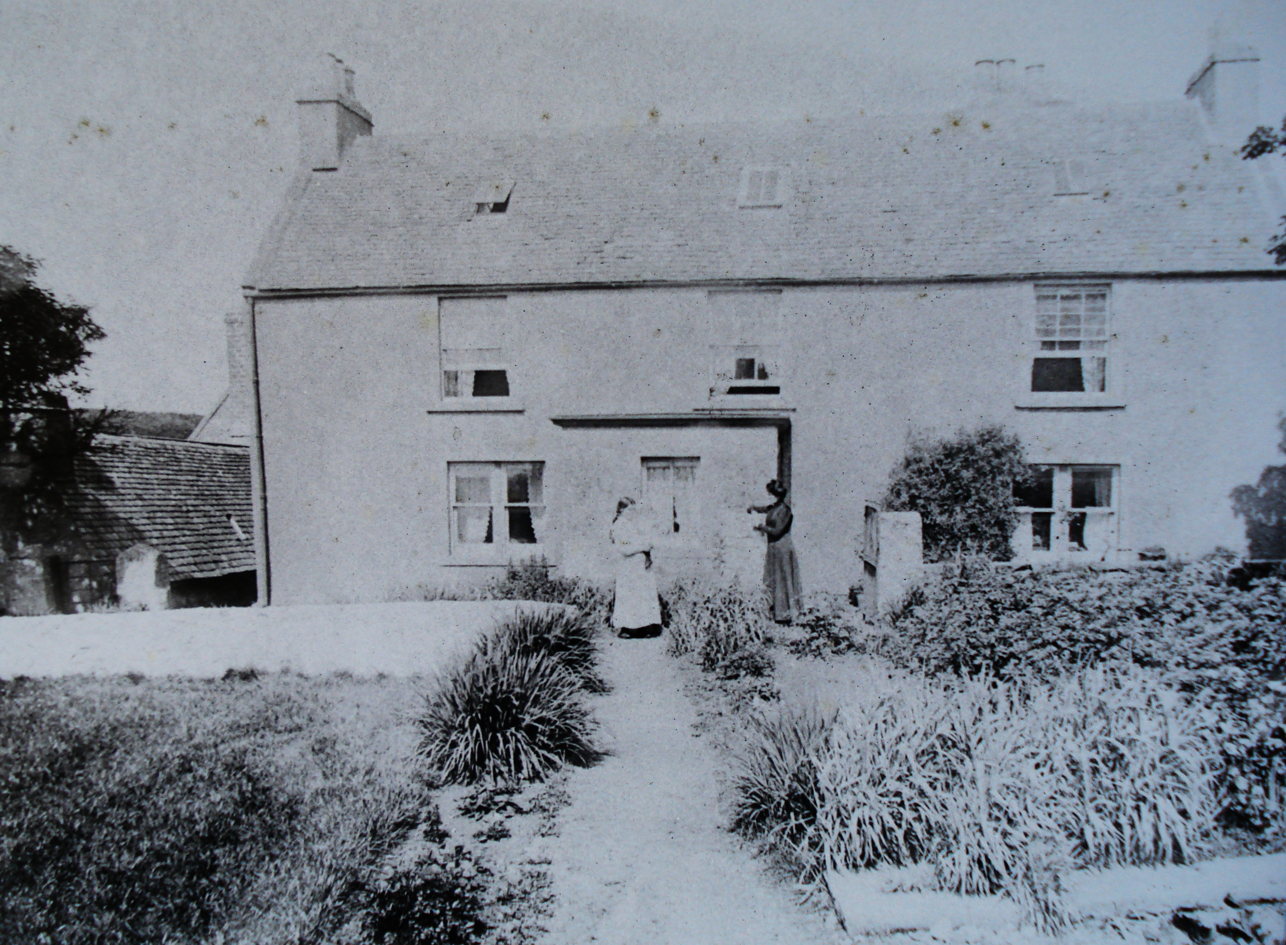
Plate 1. Photo of the garden showing a path, probably relating to stones (0302) that were discovered in the evaluation.

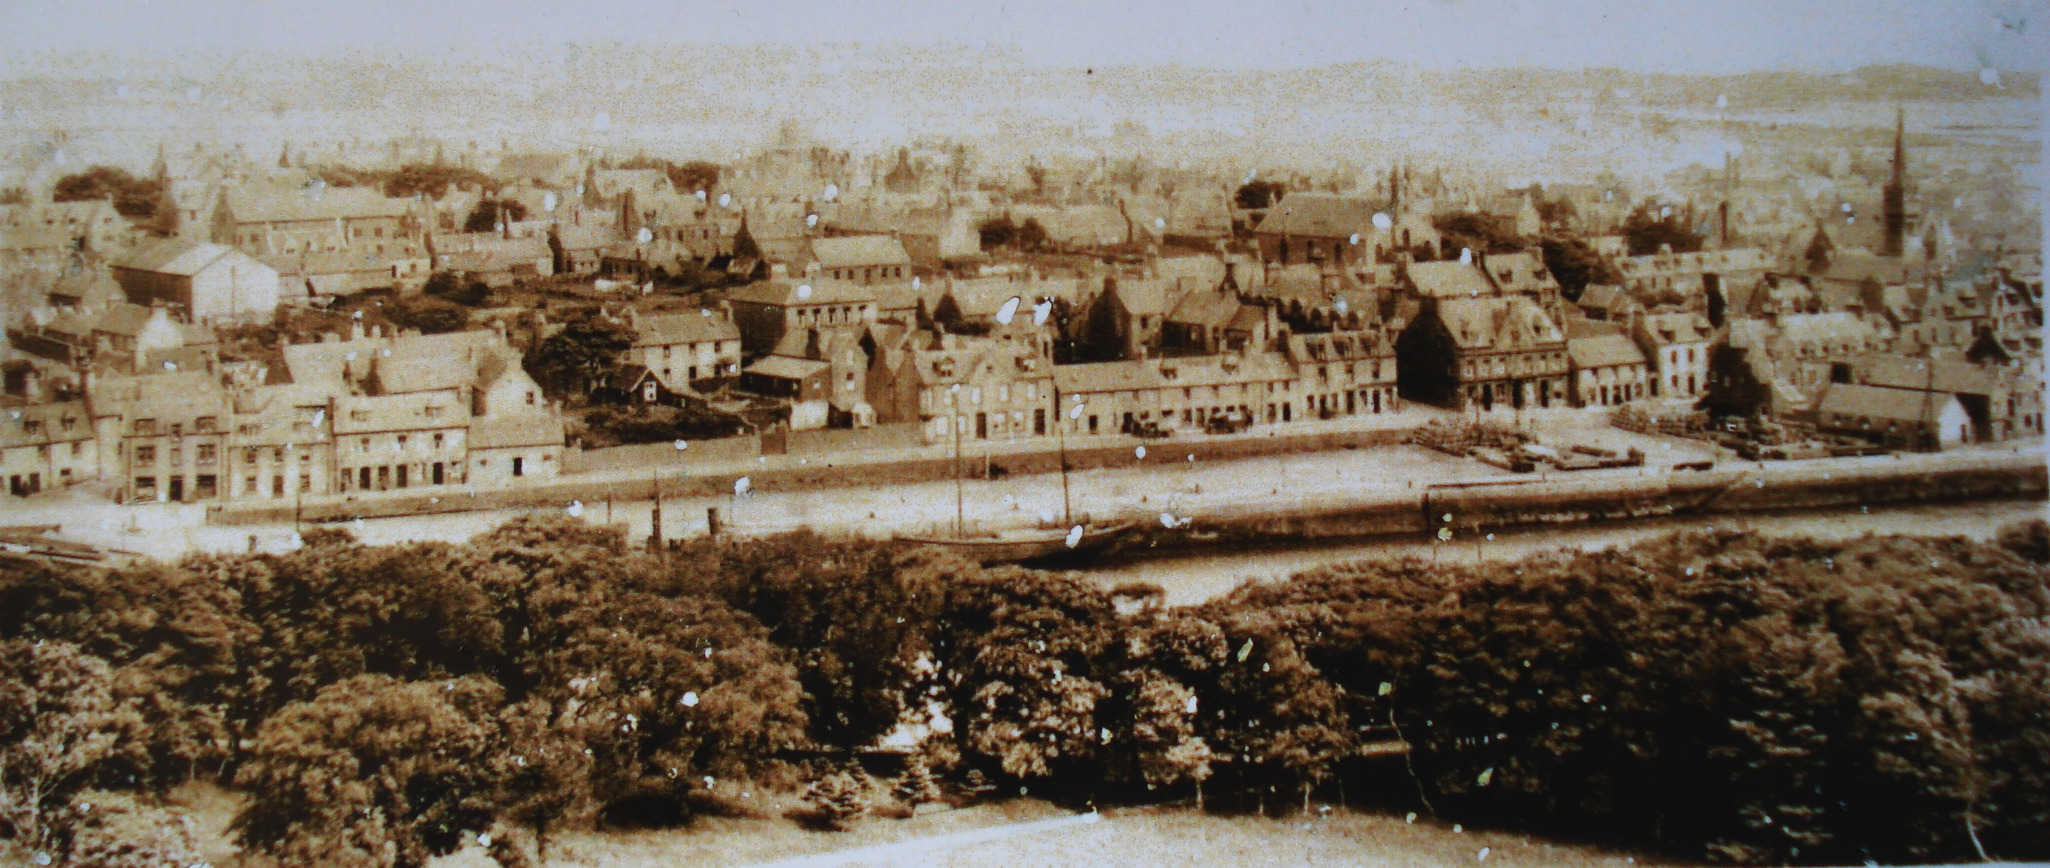
Plate 2. Photo of the site before the construction of the Royal hotel (south of the site). The shed in the south-east corner of the garden is visible in this photo.

- Discovery & Excavation in Scotland Entry
LOCAL AUTHORITY: | Western Isles/Comhairle nan Eilean Siar
PROJECT TITLE/SITE NAME: | Archaeological Evaluation 64 Kenneth Street, Stornoway, Isle of Lewis
PROJECT CODE: | SW04
PARISH: | Stornoway
NAME OF CONTRIBUTOR(S): | Tamlin Barton and Claire Casey
NAME OF ORGANISATION: | SUAT Ltd
TYPE(S) OF PROJECT: | Evaluation
NMRS NO(S): | -
SITE/MONUMENT TYPE(S): | N/A
SIGNIFICANT FINDS: | N/A
NGR (2 letters, 6 figures) | NO 4233 3303
START DATE | 24 April 2008
END DATE | 24 April 2008
PREVIOUS WORK (incl. DES ref.) | None
MAIN (NARRATIVE) DESCRIPTION:  (May include information from other fields) | SUAT Ltd was commissioned by Donald MacFarlane (Stornoway) Ltd to carry out an evaluation at 64 Kenneth Street, Stornoway, prior to the redevelopment of the site. The site was located north of the Royal Hotel and included Smith’s Shoe shop (now vacant) and a garden. It was thought possible that either medieval archaeology or deposits relating to the 17th century Cromwellian occupation of Stornoway might be encountered. The evaluation took place on the 24th April 2008 in the garden as the old shoe shop had yet to be demolished. Three 7 by 1.6metre long trenches were excavated revealing several 19th century features relating to the garden, but no significant archaeology was encountered.
PROPOSED FUTURE WORK: | None
SPONSOR OR FUNDING BODY: | Donald MacFarlane (Stornoway) Ltd
CAPTIONS FOR ILLUSTRS | -
ADDRESS OF MAIN CONTRIBUTOR: | SUAT Ltd, 55 South Methven Street, Perth PH1 5NX
ARCHIVE LOCATION (intended) | NMRS
EMAIL ADDRESS: | Director@suat.co.uk
- Standard Terms of Reference for all Fieldwork
  - Recording Methodology
SUAT employs a Single Context Recording System that allows full cross-referencing of stratigraphy, finds and environmental samples, as well as site-wide phasing. All features will be planned at scale 1:20, and sections drawn at scale 1:10. Sections and profiles will be drawn and all features will be photographed with metric scale included. Environmental samples will be taken from archaeologically significant contexts, if the analysis of these samples would aid significantly in the interpretation of any features identified.
  - Human Remains
If human remains are encountered they will be left in situ and the local police will be informed. If removal is required this will take place in compliance with Historic Scotland’s Policy Paper The Treatment of Human Remains in Archaeology.
  - Products and Reporting
A Data Structure Report will normally be prepared within a period agreed within the Written Scheme of Investigation/ Project Design, after the completion of the fieldwork. This forms the basic level of reporting. Further reporting may be required on the basis of discoveries made during excavations.
A copy of the report and the project archive will be deposited in the NMRS. Further copies will be sent to the client, LAAO and others, as appropriate.
  - Artefacts
Finds of objects will be subject to the Scots Laws of Treasure Trove and Bona Vacantia. SUAT will report such finds, if recovered, with supporting documentation to the Secretariat of the Treasure Trove Panel for disposal to the appropriate museum.
  - Discovery and Excavation in Scotland
A brief summary of the results will be submitted to Discovery and Excavation in Scotland.
  - General Conditions and Health and Safety
SUAT adheres to the Code of Conduct of the Institute of Field Archaeologists.
SUAT has public liability insurance of £5,000,000. Details of this can be provided on request.
SUAT operates a strict health and safety policy and conforms to the Health and Safety at Work Act. SUAT undertakes Risk Assessments on all fieldwork carried out.
All SUAT representatives will at all times wear protective footwear, high visibility clothing and other appropriate clothing. Hard hats will be worn if there is active plant on site or at all times if the site is deemed a hard hat area.
If lightly contaminated deposits are uncovered disposable boiler suits and gloves will be worn. A source of clean water will be made available for staff to clean hands with. If the health risk posed by site contamination is felt to be too high all further archaeological work will stop in that area.

