**Local Listing and the North East Lincolnshire HER**

In 2010 work began on integrating the List of Buildings of Local Architectural or Historic Interest for Great Grimsby into the designations module of North East Lincolnshire’s HER database. A Local List had existed for the former County Borough since 1973, as a reaction to the de-designation of the Grade Three listed buildings. Most of the buildings covered had good quality descriptions, backed up by the Ministry of Housing and Local Government’s draft list for the borough which included descriptions of the Grade Three buildings even though they were to be de-designated as part of the update.

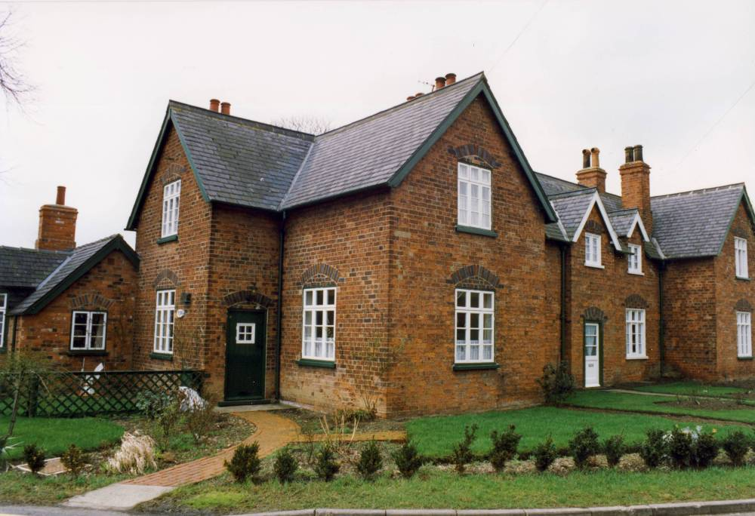

6-10 The Avenue, Great Coates – a former Grade III listed building

Although some of these buildings had monument records since the time when the HER was part of the Humberside SMR (c.1983-1996), losses from the list, upgrades to the national list and an increased importance of local designations in the planning process meant that it was important to know, at the push of a couple of buttons, which were still locally listed. It was therefore decided to create designation records for those buildings known to still be considered locally listed. The most up to date list existed in North East Lincolnshire’s Local Plan, published in 2003, which also contained policies relating to the list.

**NELC Local Plan (2003) Policy BH8: Locally Listed Buildings**

A development proposal in respect of a locally listed building will be permitted provided it will not have an unduly adverse effect on the character or appearance of the building.

Although the Local List was first published in 1973 no original copies seem to exist, only copies of an update made in 1982 could be found. This contained 218 buildings or groups of buildings, including a number that were noted as having been demolished since the original list was created. Each of the remaining entries was checked against the National List and up-to-date mapping to get a basic impression of what was still listed (see graph below for results).

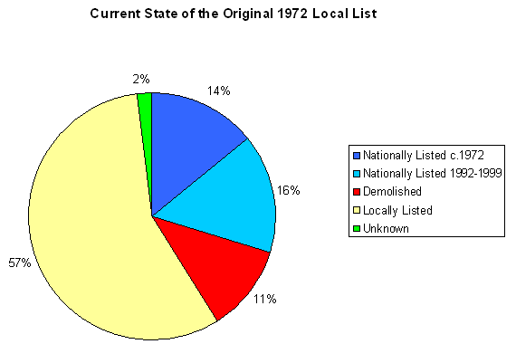

Working through the 1982 local list revealed several quirks. Firstly, two entries had been added to the list in pencil with no dates or definite confirmation of their status.

Secondly, there were 6 “gaps” in the numbering system; a partial collection of photos of the Local List, taken in 1972 during its compilation, revealed three buildings which were not mentioned in the 1982 update which probably relate to these gaps. Although two of these were demolished, one is still standing and therefore raises questions as to when and why it was removed from the list.

Thirdly, two buildings could not initially be found because their street names and numbers had been changed following new road construction.

It is important for HER officers to set themselves limits as to how far they will chase quirks like this, as hours can be spent just to find out that the building was demolished long ago.

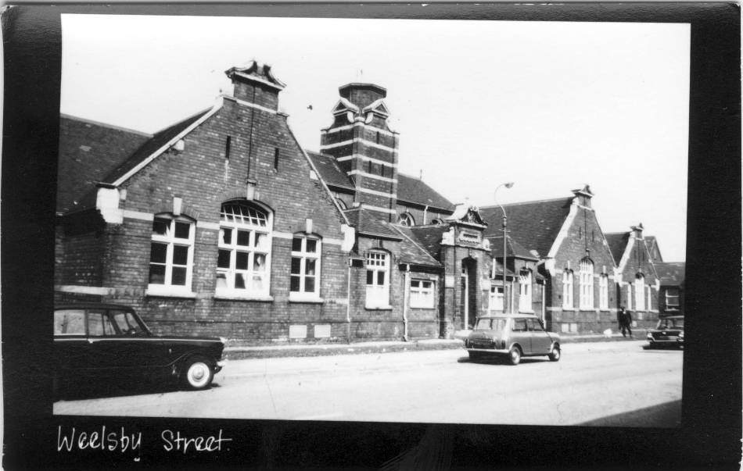

Weelsby Street School, Grimsby in 1972 – Although photographed as part of the survey for the 1973 Local List, it is absent from the 1982 amendment

Once the list had been refined down to those that were definitely still locally listed, the process of creating records began. Each entry was filled in with a name, reference number, date of designation, date of amendment (where applicable), designating authority, a description, location/parish and grid reference. GIS files were created with records linking to points and polygons. The designation record was then linked to it’s appropriate monuments record and source, creating them when necessary.

Unfortunately the normally straight-forward process of creating entries for these buildings was complicated by the addition of several hundred entries to the Local List in 2009 as part of a number of Conservation Area Appraisals. None of these later entries had descriptions, and no clear criteria had been set for their addition, so their value in the planning system and to the HER was extremely low. They had however been approved by the Council’s Cabinet system, who have the appropriate level of authority to make policy decisions (in some Councils a committee system may be used with policy decisions, such as the adoption of a local list, carried out by a committee with delegated powers coming from Cabinet or Full Council).

Advice was sought from the HER forum as to how to deal with these listings, and the opinion that they should still be in the HER seemed to be the dominant view, with the decision on their importance left to third parties.

This, however, caused problems with the dilution of the pre-existing local list and the HER itself. As a small unitary authority, the Borough’s record still only contains c.3200 monument records, and the remains of the 1973 list (with a couple of additions in 1990) amounted to just over 70 entries.

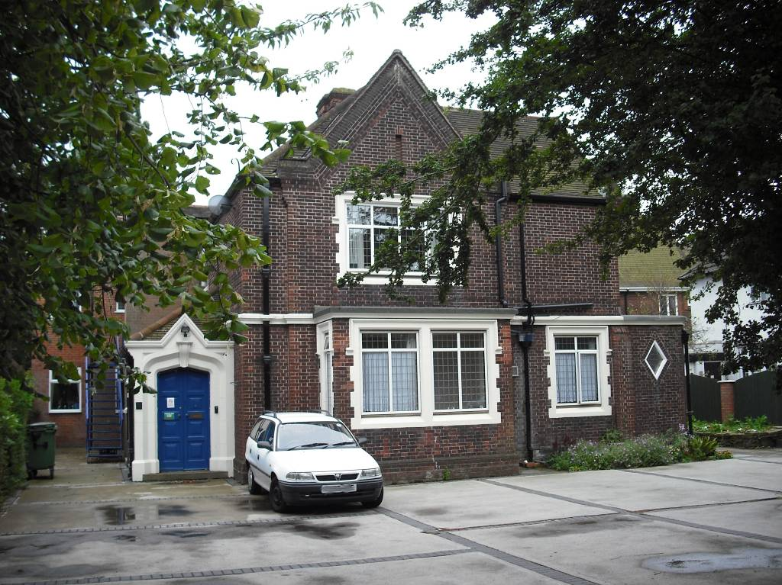

71 Bargate, Grimsby – Added to the Local List in 2009 with no description or selection criteria.

Using a very basic knowledge of architecture garnered from the digitisation of SMR/HER records related to national list and Pevsner entries, and information already existing within the HER (e.g. mapping evidence), rough descriptions were drafted and appended to some of the more prominent additions to the list. The same was applied to a draft set of additions to the list that had been prepared for Cleethorpes, the other Borough that had merged with Great Grimsby to form North East Lincolnshire.

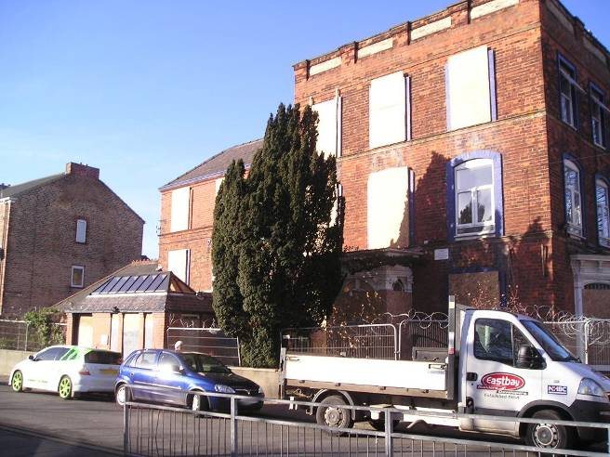 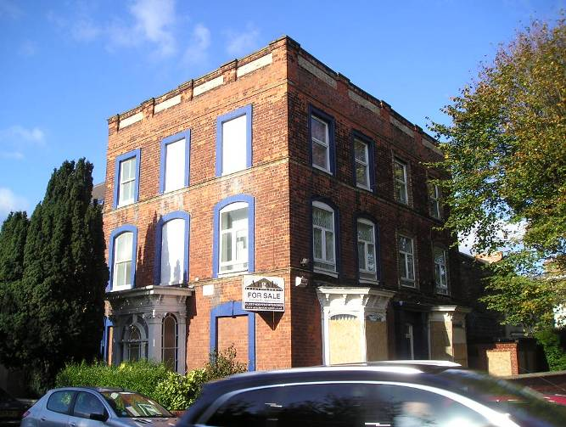

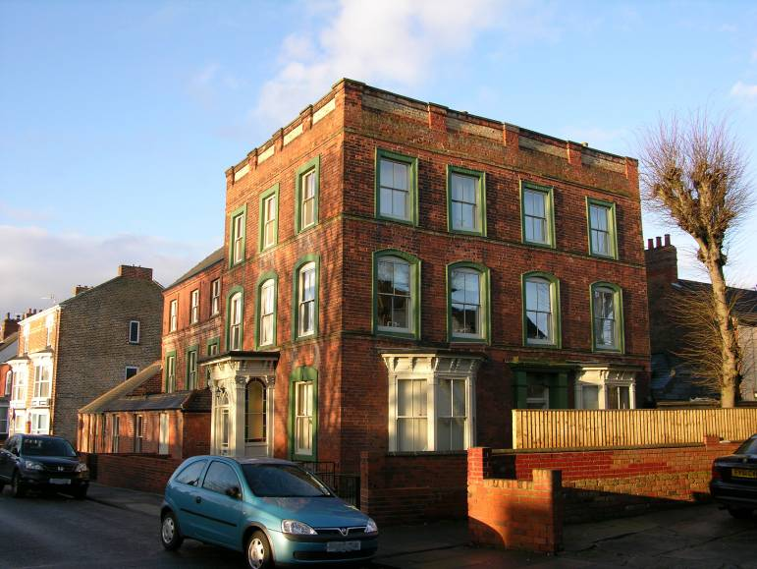

Former Doctor’s Surgery, Albert Road, Cleethorpes – One of the draft additions to the Local List, the description created by the HER was used to support restorations (before shown above, after shown below) and formal adoption into the Local List in 2013

At this point the lists for Great Grimsby and Cleethorpes had enough substance to them that they did not cause too much damage to the integrity of the pre-existing list and the HER and the project could have stopped here. It was however decided, after discussions with the new Conservation Officer, that the value of the entries would be greatly increased if a set of criteria was drafted upon which any third party could judge them. The project was now morphing from a purely HER entry issue to a major enhancement and outreach program that is still ongoing.

As well as documents that actually call themselves Local Lists there are other kinds of local heritage lists that HER officers may want to be aware of.

One type of such lists exists within Conservation Areas Appraisals. These documents will often contain assessments of individual buildings, marking them as “essential”, “of merit”, “positive” or other similar phrases and titles, although the actual amount of information presented to justify these titles varies. As an enhancement project for the HER it may well be worth adding the contents of these lists to the HER as they can provide a valuable starting point for anyone looking at the specific details of what is important to the character of an area. These lists may also, depending on the way in which they were presented and incorporated into the appraisals, have similar standing in the planning process to more formal local lists.

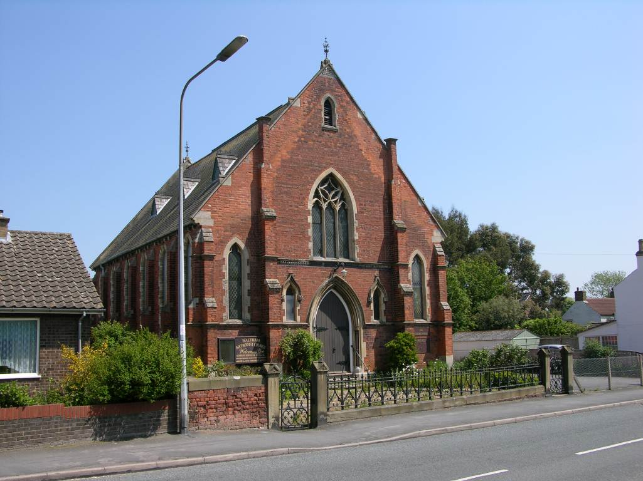

Waltham Methodist Church is marked as an “Essential” building in the Conservation Area Appraisal of 1976.

Local Lists are an important part of heritage protection, and should form part of a legible and coherent hierarchy of heritage assets, supporting the idea that whilst not all heritage assets are of national interest that does not mean that they are not significant in other ways. As providers of information HERs should aim to incorporate Local Lists, but must also be aware of the potential problems associated with some of these datasets, carefully considering the value of adding poor quality lists.

--------------------------

Background – The North East Lincolnshire HER is based in the Development Management section of the North East Lincolnshire Regeneration Partnership, part of Cofley GDF Suez and run in partnership with North East Lincolnshire Council.

--------------------------